|  |  |
| --- | --- |
| **AIDS** | **Lab: BDH Lab** |

|  |  |
| --- | --- |
| **Name of Students:Himanshu Dhomane** | **Semester/ Section: 7/A** |
| **Roll No: 43** | **Enroll No: 21070297** |

Practical No. 5

|  |
| --- |
| **Aim:** Hive Operations: Create, Alter and Drop Databases, Tables, Views, and Indexes. |
| **Theory:**  Apache Hive is a data warehouse software that facilitates reading, writing, and managing large datasets stored in distributed storage using SQL. It provides a SQL-like language called HiveQL (Hive Query Language) to query data, and it's typically used with Hadoop for handling and processing big data. Hive translates queries written in HiveQL into MapReduce jobs, making it efficient for large-scale data analysis.  **1) Launch Hive** |

1. **Launch Components of Hadoop**

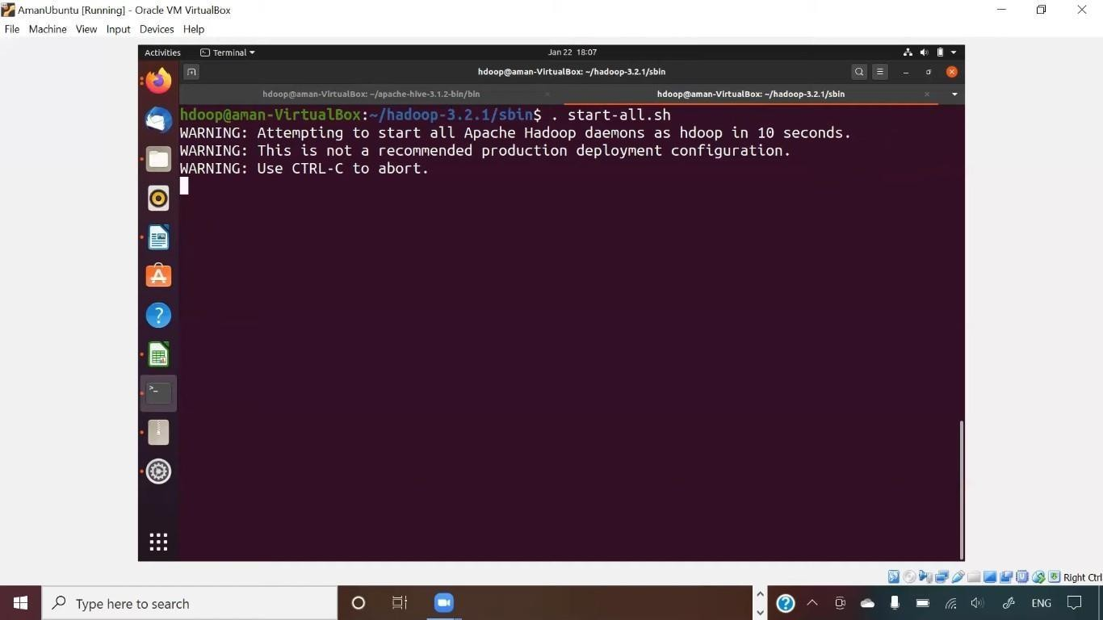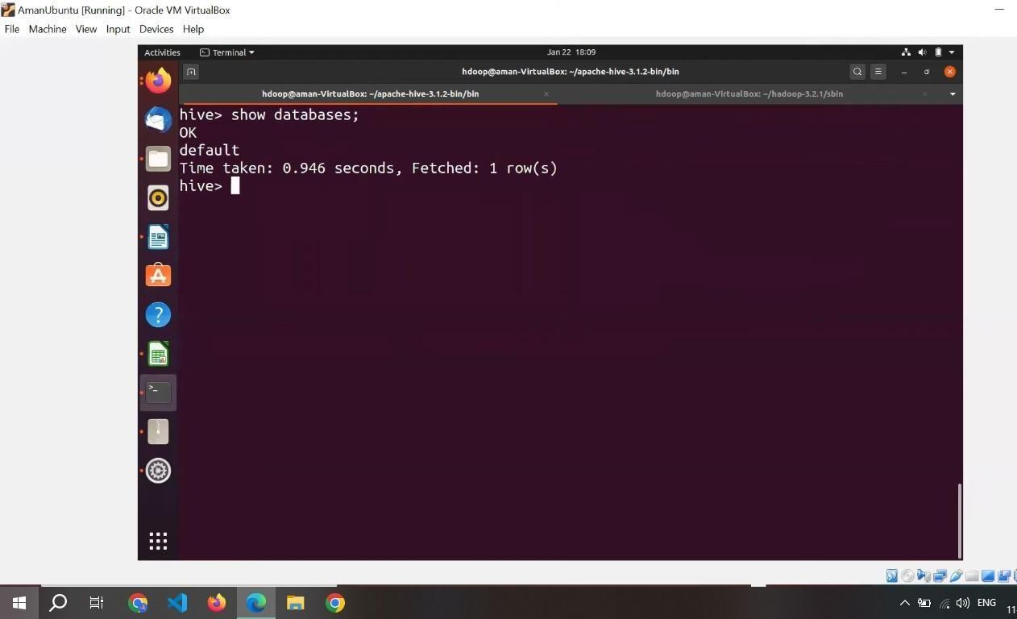

1. **Show**

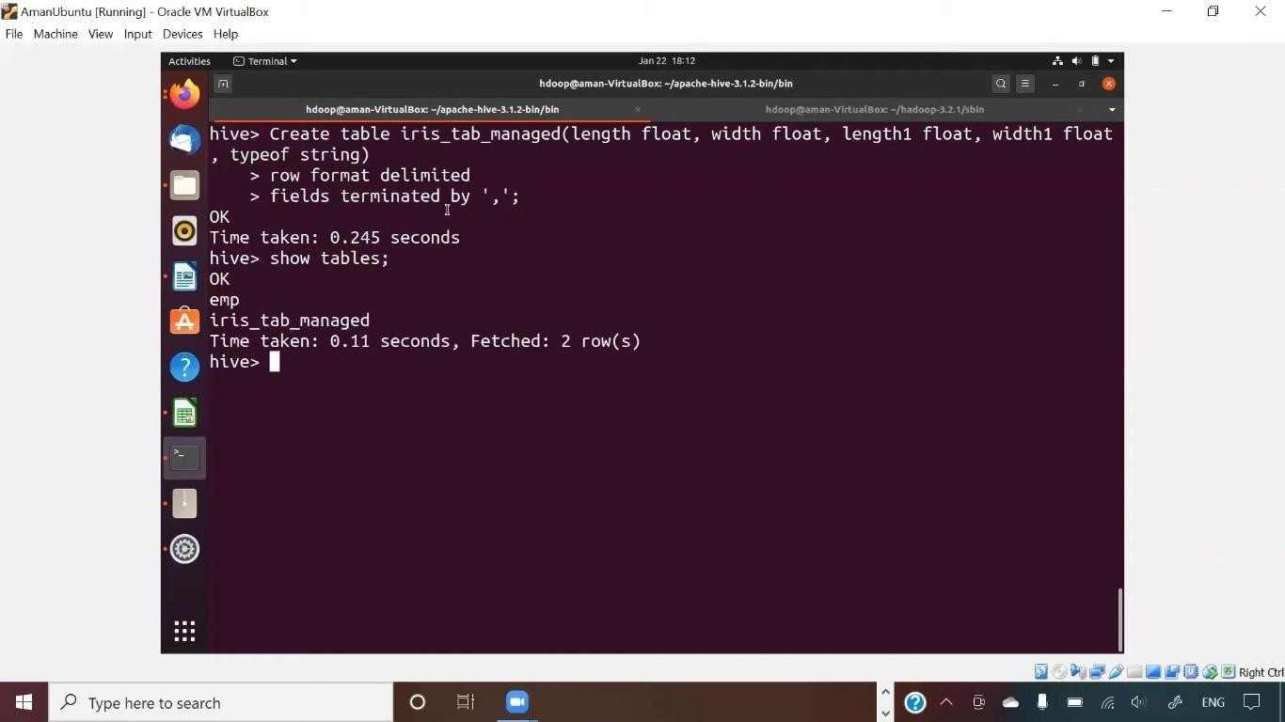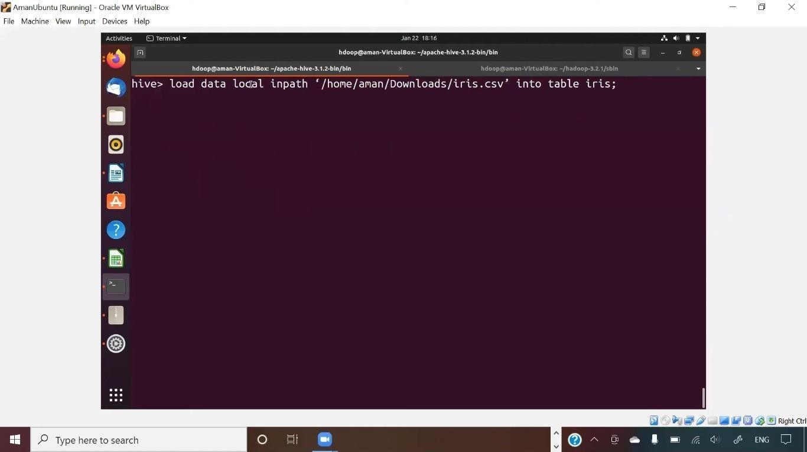

1. **Create**
2. **Load**

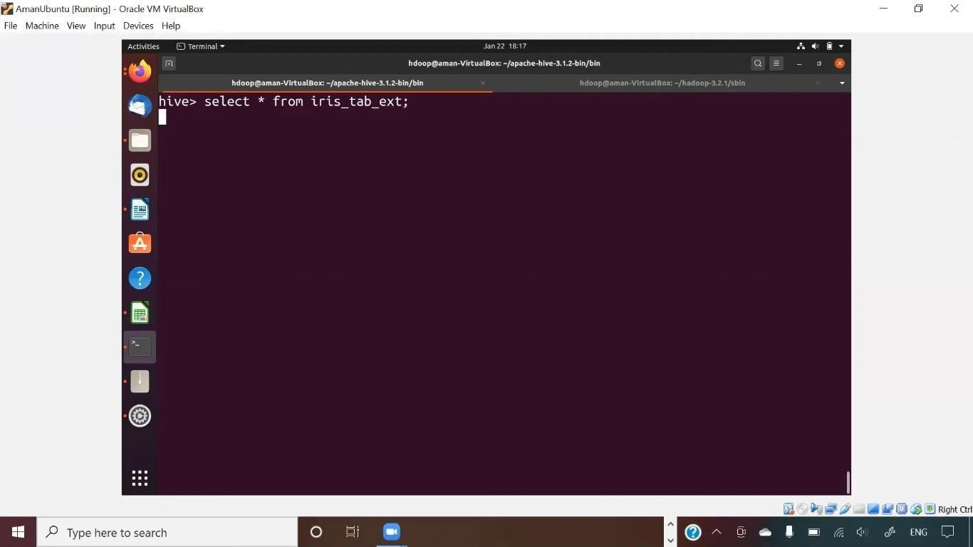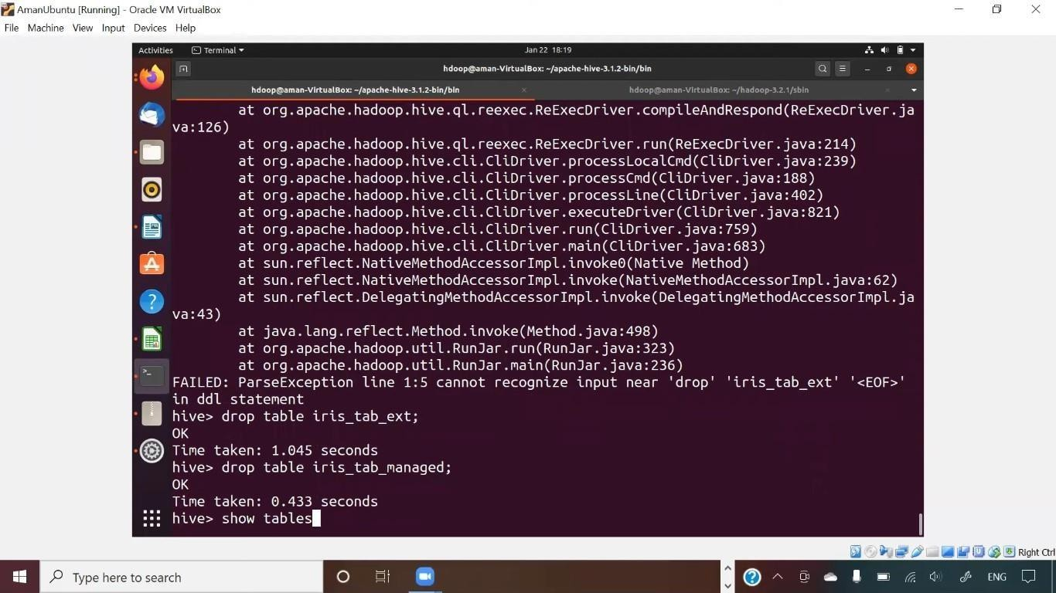

1. **Select**
2. **Drop**

**Conclusion:**

Apache Hive simplifies querying and analyzing large datasets in a distributed environment using a familiar SQL-like interface. It is an essential tool for big data management, offering scalability and ease of use in handling complex queries.