Session Takeaway (MOM)
Credit default modelling walkthrough
Dataset: UCI Taiwan credit default (LIMIT_BAL, PAY_*, BILL_AMT_*, PAY_AMT_*, AGE, …)
App: streamlit run app/streamlit_app.py

1. Process we walked (Streamlit)

1.1 Target & EDA
- Check class balance (~22% defaults).
- Look at raw feature distributions (dropdown).
- Why: understand the problem and what each column means.

1.2 Rank & Plot
- For each feature: put values into bins on the X-axis.
- Bars = number of clients in that bin.
- Line = capture rate (share of all defaults that fall in that bin).
- Why: see which feature values capture more defaults.

1.3 Feature engineering
- Build simple explainable features (e.g. utilisation = bill/limit, pay ratio, avg/max payment delay).
- Fit transforms on train only (no leakage).
- Why: give the model clearer business signals.

1.4 Modelling
- Start with simple baselines.
- Tune Random Forest and XGBoost with Optuna.
- Pick the winner using PR-AUC (better than accuracy when classes are imbalanced).
- Review feature importance in the Modelling tab.
- Why: fair comparison + a model you can explain.
One-liner: load → EDA → rank/plot → features → baselines → Optuna tune → select best → view in Streamlit / serve via FastAPI.

2. Sample plot
PAY_0 (latest repayment status): bins on X; bars = client count; line = capture rate (defaults in bin ÷ all defaults).
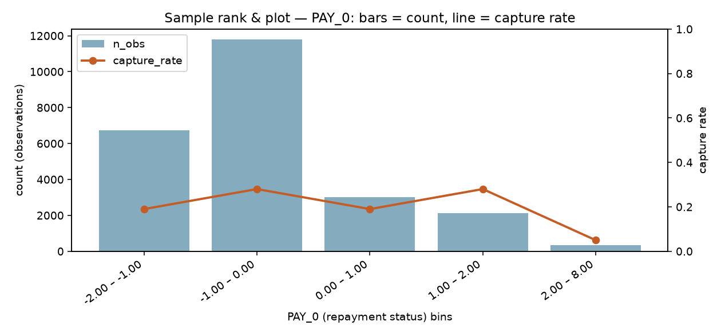
Figure: PAY_0 — bars = count, line = capture rate

How to read it
- Tall bar → that value is common.
- High line → that bin holds a large share of the defaults.
- In Streamlit → Rank & Plot, use the dropdown to change the feature (LIMIT_BAL, AGE, PAY_2, …).

3. Optuna / Bayesian optimisation (high overview)
Goal: find good hyperparameters (tree depth, learning rate, …) that maximise a score (we used PR-AUC), without trying every possible combination.

Search styles
- Grid / random search: try many settings blindly (slow / wasteful).
- Bayesian optimisation (Optuna): learn from past trials and suggest the next setting wisely.

The loop (remember this)
- Try a set of hyperparameters.
- Train and score the model.
- Update what we believe “works”.
- Suggest the next try (exploit best areas + explore uncertain areas).
- Repeat for N trials, then retrain with the best settings.
Optuna (default TPE) in one line: it samples more where past good trials lived, and less where bad trials lived.

In our session
- Separate Optuna runs for Random Forest and XGBoost.
- Compare on hold-out PR-AUC.
- Show the winner and feature importance in Streamlit → Modelling.

4. Handy commands
streamlit run app/streamlit_app.py
python -c "from credit_fraud.pipeline import run_training; run_training()"

5. Optional deeper reading
- docs/bayesian_optimization_optuna.md
- docs/xgboost_guide.md
- docs/dataset_features.md

