**Follow the Instructions**

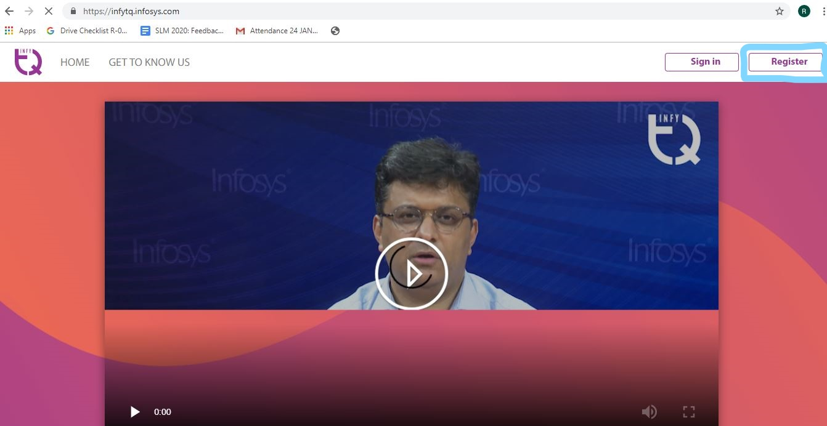

1. Click on Register on Top Right

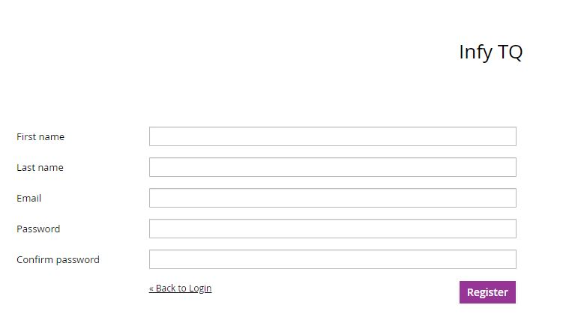

1. Fill the Details and Click on ‘**Register’**

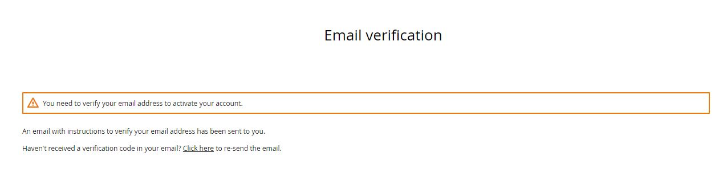

1. Verify your Email

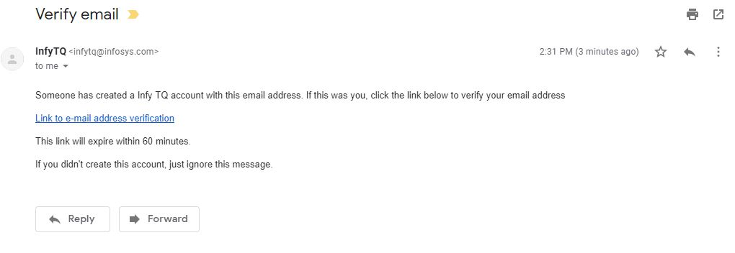

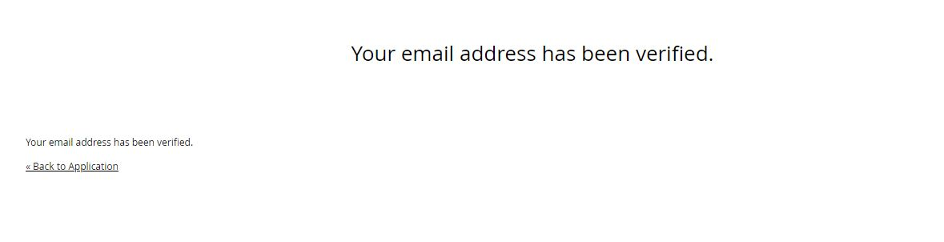

After verifying your Email, Click on ‘Back to Application’

* Click on ‘Sign in’ on Top Right.

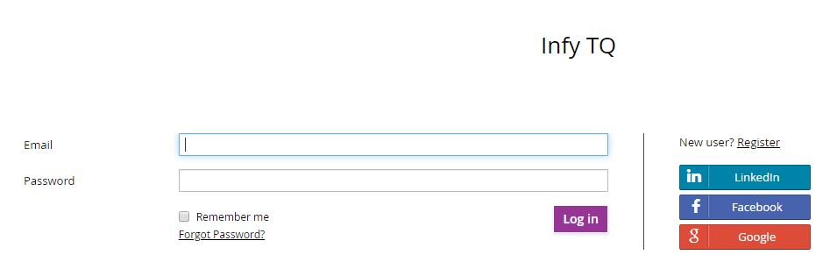

Sign in with your Login credentials that you just created.

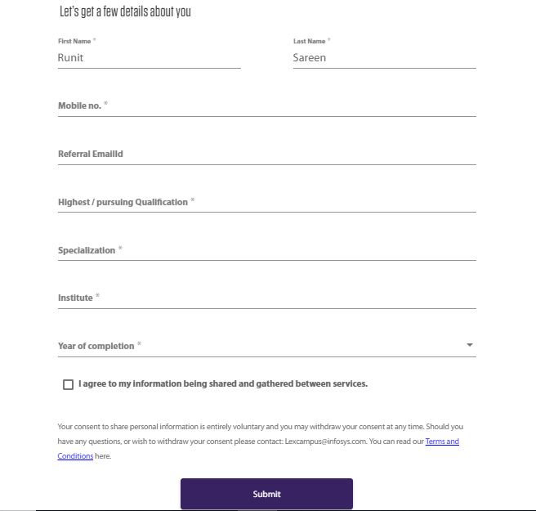

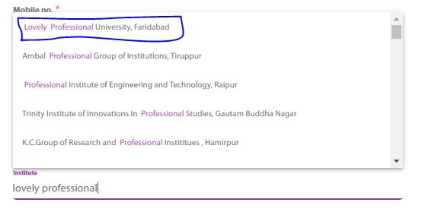

Provide all the required details. In the Institute section select the option shown above (Lovely Professional University, Faridabad). You can skip the ‘Referral’ as blank.

After filling all the details, click on ‘Submit’

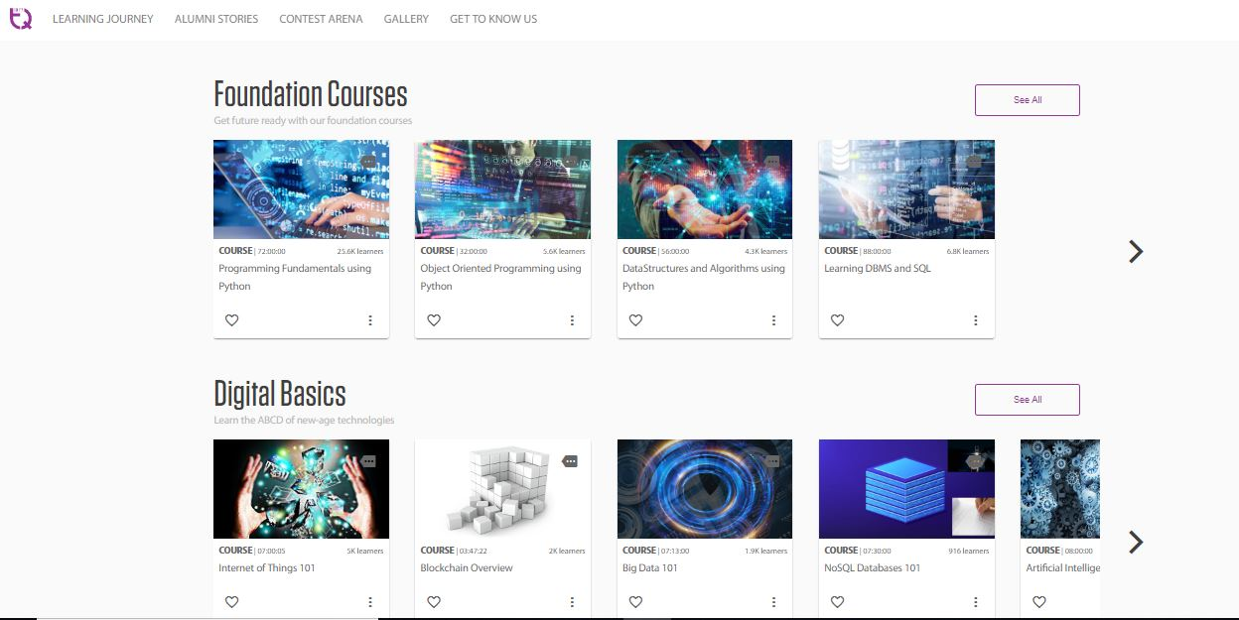

You will be able to see the courses shown in the above picture.