https://www.hackerrank.com/challenges/fizzbuzz/problem
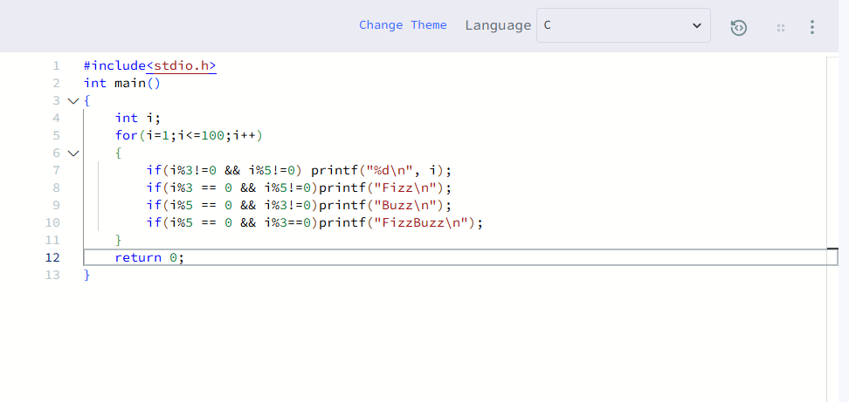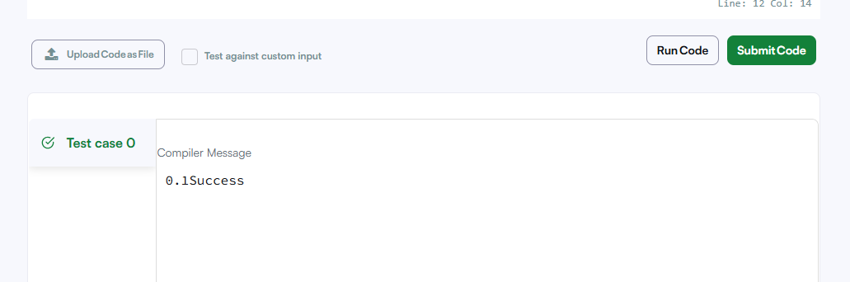

#include<stdio.h>
int main()
{
int i;
for(i=1;i<=100;i++)
{
if(i%3!=0 && i%5!=0) printf("%d\n", i);
if(i%3 == 0 && i%5!=0)printf("Fizz\n");
if(i%5 == 0 && i%3!=0)printf("Buzz\n");
if(i%5 == 0 && i%3==0)printf("FizzBuzz\n");
}
return 0;
}

