Codebook for final3

Autogenerated data summary from dataMaid

2018-04-22 18:51:03

# Data report overview

The dataset examined has the following dimensions:

|  |  |
| --- | --- |
| Feature | Result |
| Number of observations | 180 |
| Number of variables | 82 |

# Codebook summary table

|  |  |  |  |  |  |
| --- | --- | --- | --- | --- | --- |
| Label | Variable | Class | # unique values | Missing |  |
|  | **activity_id** | integer | 6 | 0.00 % |  |
|  | **activity_name** | character | 6 | 0.00 % |  |
|  | **subject_id** | integer | 30 | 0.00 % |  |
|  | **timeBodyAccelerometer-mean()-X** | numeric | 180 | 0.00 % |  |
|  | **timeBodyAccelerometer-mean()-Y** | numeric | 180 | 0.00 % |  |
|  | **timeBodyAccelerometer-mean()-Z** | numeric | 180 | 0.00 % |  |
|  | **timeGravityAccelerometer-mean()-X** | numeric | 180 | 0.00 % |  |
|  | **timeGravityAccelerometer-mean()-Y** | numeric | 180 | 0.00 % |  |
|  | **timeGravityAccelerometer-mean()-Z** | numeric | 180 | 0.00 % |  |
|  | **timeBodyAccelerometerJerk-mean()-X** | numeric | 180 | 0.00 % |  |
|  | **timeBodyAccelerometerJerk-mean()-Y** | numeric | 180 | 0.00 % |  |
|  | **timeBodyAccelerometerJerk-mean()-Z** | numeric | 180 | 0.00 % |  |
|  | **timeBodyGyroscope-mean()-X** | numeric | 180 | 0.00 % |  |
|  | **timeBodyGyroscope-mean()-Y** | numeric | 180 | 0.00 % |  |
|  | **timeBodyGyroscope-mean()-Z** | numeric | 180 | 0.00 % |  |
|  | **timeBodyGyroscopeJerk-mean()-X** | numeric | 180 | 0.00 % |  |
|  | **timeBodyGyroscopeJerk-mean()-Y** | numeric | 180 | 0.00 % |  |
|  | **timeBodyGyroscopeJerk-mean()-Z** | numeric | 180 | 0.00 % |  |
|  | **timeBodyAccelerometerMagnitude-mean()** | numeric | 180 | 0.00 % |  |
|  | **timeGravityAccelerometerMagnitude-mean()** | numeric | 180 | 0.00 % |  |
|  | **timeBodyAccelerometerJerkMagnitude-mean()** | numeric | 180 | 0.00 % |  |
|  | **timeBodyGyroscopeMagnitude-mean()** | numeric | 180 | 0.00 % |  |
|  | **timeBodyGyroscopeJerkMagnitude-mean()** | numeric | 180 | 0.00 % |  |
|  | **frequencyBodyAccelerometer-mean()-X** | numeric | 180 | 0.00 % |  |
|  | **frequencyBodyAccelerometer-mean()-Y** | numeric | 180 | 0.00 % |  |
|  | **frequencyBodyAccelerometer-mean()-Z** | numeric | 180 | 0.00 % |  |
|  | **frequencyBodyAccelerometer-meanFreq()-X** | numeric | 180 | 0.00 % |  |
|  | **frequencyBodyAccelerometer-meanFreq()-Y** | numeric | 180 | 0.00 % |  |
|  | **frequencyBodyAccelerometer-meanFreq()-Z** | numeric | 180 | 0.00 % |  |
|  | **frequencyBodyAccelerometerJerk-mean()-X** | numeric | 180 | 0.00 % |  |
|  | **frequencyBodyAccelerometerJerk-mean()-Y** | numeric | 180 | 0.00 % |  |
|  | **frequencyBodyAccelerometerJerk-mean()-Z** | numeric | 180 | 0.00 % |  |
|  | **frequencyBodyAccelerometerJerk-meanFreq()-X** | numeric | 180 | 0.00 % |  |
|  | **frequencyBodyAccelerometerJerk-meanFreq()-Y** | numeric | 180 | 0.00 % |  |
|  | **frequencyBodyAccelerometerJerk-meanFreq()-Z** | numeric | 180 | 0.00 % |  |
|  | **frequencyBodyGyroscope-mean()-X** | numeric | 180 | 0.00 % |  |
|  | **frequencyBodyGyroscope-mean()-Y** | numeric | 180 | 0.00 % |  |
|  | **frequencyBodyGyroscope-mean()-Z** | numeric | 180 | 0.00 % |  |
|  | **frequencyBodyGyroscope-meanFreq()-X** | numeric | 180 | 0.00 % |  |
|  | **frequencyBodyGyroscope-meanFreq()-Y** | numeric | 180 | 0.00 % |  |
|  | **frequencyBodyGyroscope-meanFreq()-Z** | numeric | 180 | 0.00 % |  |
|  | **frequencyBodyAccelerometerMagnitude-mean()** | numeric | 180 | 0.00 % |  |
|  | **frequencyBodyAccelerometerMagnitude-meanFreq()** | numeric | 180 | 0.00 % |  |
|  | **frequencyBodyAccelerometerJerkMagnitude-mean()** | numeric | 180 | 0.00 % |  |
|  | **frequencyBodyAccelerometerJerkMagnitude-meanFreq()** | numeric | 180 | 0.00 % |  |
|  | **frequencyBodyGyroscopeMagnitude-mean()** | numeric | 180 | 0.00 % |  |
|  | **frequencyBodyGyroscopeMagnitude-meanFreq()** | numeric | 180 | 0.00 % |  |
|  | **frequencyBodyGyroscopeJerkMagnitude-mean()** | numeric | 180 | 0.00 % |  |
|  | **frequencyBodyGyroscopeJerkMagnitude-meanFreq()** | numeric | 180 | 0.00 % |  |
|  | **timeBodyAccelerometer-std()-X** | numeric | 180 | 0.00 % |  |
|  | **timeBodyAccelerometer-std()-Y** | numeric | 180 | 0.00 % |  |
|  | **timeBodyAccelerometer-std()-Z** | numeric | 180 | 0.00 % |  |
|  | **timeGravityAccelerometer-std()-X** | numeric | 180 | 0.00 % |  |
|  | **timeGravityAccelerometer-std()-Y** | numeric | 180 | 0.00 % |  |
|  | **timeGravityAccelerometer-std()-Z** | numeric | 180 | 0.00 % |  |
|  | **timeBodyAccelerometerJerk-std()-X** | numeric | 180 | 0.00 % |  |
|  | **timeBodyAccelerometerJerk-std()-Y** | numeric | 180 | 0.00 % |  |
|  | **timeBodyAccelerometerJerk-std()-Z** | numeric | 180 | 0.00 % |  |
|  | **timeBodyGyroscope-std()-X** | numeric | 180 | 0.00 % |  |
|  | **timeBodyGyroscope-std()-Y** | numeric | 180 | 0.00 % |  |
|  | **timeBodyGyroscope-std()-Z** | numeric | 180 | 0.00 % |  |
|  | **timeBodyGyroscopeJerk-std()-X** | numeric | 180 | 0.00 % |  |
|  | **timeBodyGyroscopeJerk-std()-Y** | numeric | 180 | 0.00 % |  |
|  | **timeBodyGyroscopeJerk-std()-Z** | numeric | 180 | 0.00 % |  |
|  | **timeBodyAccelerometerMagnitude-std()** | numeric | 180 | 0.00 % |  |
|  | **timeGravityAccelerometerMagnitude-std()** | numeric | 180 | 0.00 % |  |
|  | **timeBodyAccelerometerJerkMagnitude-std()** | numeric | 180 | 0.00 % |  |
|  | **timeBodyGyroscopeMagnitude-std()** | numeric | 180 | 0.00 % |  |
|  | **timeBodyGyroscopeJerkMagnitude-std()** | numeric | 180 | 0.00 % |  |
|  | **frequencyBodyAccelerometer-std()-X** | numeric | 180 | 0.00 % |  |
|  | **frequencyBodyAccelerometer-std()-Y** | numeric | 180 | 0.00 % |  |
|  | **frequencyBodyAccelerometer-std()-Z** | numeric | 180 | 0.00 % |  |
|  | **frequencyBodyAccelerometerJerk-std()-X** | numeric | 180 | 0.00 % |  |
|  | **frequencyBodyAccelerometerJerk-std()-Y** | numeric | 180 | 0.00 % |  |
|  | **frequencyBodyAccelerometerJerk-std()-Z** | numeric | 180 | 0.00 % |  |
|  | **frequencyBodyGyroscope-std()-X** | numeric | 180 | 0.00 % |  |
|  | **frequencyBodyGyroscope-std()-Y** | numeric | 180 | 0.00 % |  |
|  | **frequencyBodyGyroscope-std()-Z** | numeric | 180 | 0.00 % |  |
|  | **frequencyBodyAccelerometerMagnitude-std()** | numeric | 180 | 0.00 % |  |
|  | **frequencyBodyAccelerometerJerkMagnitude-std()** | numeric | 180 | 0.00 % |  |
|  | **frequencyBodyGyroscopeMagnitude-std()** | numeric | 180 | 0.00 % |  |
|  | **frequencyBodyGyroscopeJerkMagnitude-std()** | numeric | 180 | 0.00 % |  |

# Variable list

## activity_id

|  |  |
| --- | --- |
| Feature | Result |
| Variable type | integer |
| Number of missing obs. | 0 (0 %) |
| Number of unique values | 6 |
| Median | 3.5 |
| 1st and 3rd quartiles | 2; 5 |
| Min. and max. | 1; 6 |

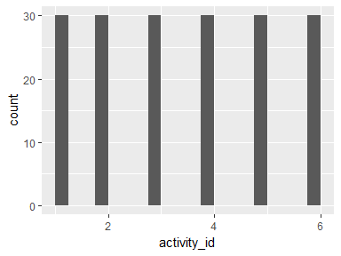

## activity_name

|  |  |
| --- | --- |
| Feature | Result |
| Variable type | character |
| Number of missing obs. | 0 (0 %) |
| Number of unique values | 6 |
| Mode | “LAYING” |

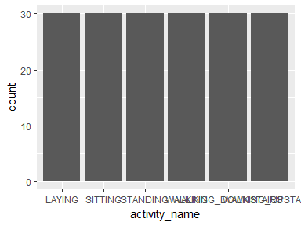

* Observed factor levels: "LAYING", "SITTING", "STANDING", "WALKING", "WALKING_DOWNSTAIRS", "WALKING_UPSTAIRS".

## subject_id

|  |  |
| --- | --- |
| Feature | Result |
| Variable type | integer |
| Number of missing obs. | 0 (0 %) |
| Number of unique values | 30 |
| Median | 15.5 |
| 1st and 3rd quartiles | 8; 23 |
| Min. and max. | 1; 30 |

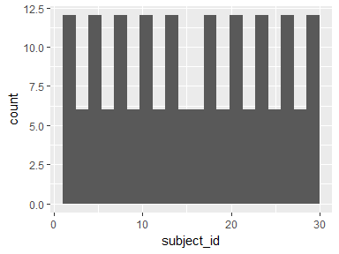

## timeBodyAccelerometer-mean()-X

|  |  |
| --- | --- |
| Feature | Result |
| Variable type | numeric |
| Number of missing obs. | 0 (0 %) |
| Number of unique values | 180 |
| Median | 0.28 |
| 1st and 3rd quartiles | 0.27; 0.28 |
| Min. and max. | 0.22; 0.3 |

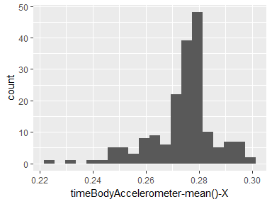

## timeBodyAccelerometer-mean()-Y

|  |  |
| --- | --- |
| Feature | Result |
| Variable type | numeric |
| Number of missing obs. | 0 (0 %) |
| Number of unique values | 180 |
| Median | -0.02 |
| 1st and 3rd quartiles | -0.02; -0.01 |
| Min. and max. | -0.04; 0 |

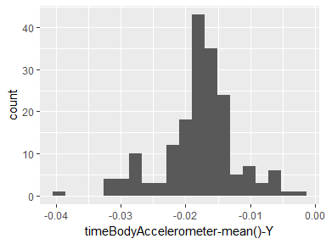

## timeBodyAccelerometer-mean()-Z

|  |  |
| --- | --- |
| Feature | Result |
| Variable type | numeric |
| Number of missing obs. | 0 (0 %) |
| Number of unique values | 180 |
| Median | -0.11 |
| 1st and 3rd quartiles | -0.11; -0.1 |
| Min. and max. | -0.15; -0.08 |

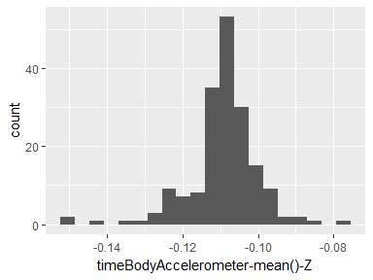

## timeGravityAccelerometer-mean()-X

|  |  |
| --- | --- |
| Feature | Result |
| Variable type | numeric |
| Number of missing obs. | 0 (0 %) |
| Number of unique values | 180 |
| Median | 0.92 |
| 1st and 3rd quartiles | 0.84; 0.94 |
| Min. and max. | -0.68; 0.97 |

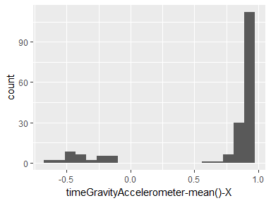

## timeGravityAccelerometer-mean()-Y

|  |  |
| --- | --- |
| Feature | Result |
| Variable type | numeric |
| Number of missing obs. | 0 (0 %) |
| Number of unique values | 180 |
| Median | -0.13 |
| 1st and 3rd quartiles | -0.23; 0.09 |
| Min. and max. | -0.48; 0.96 |

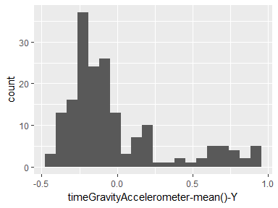

## timeGravityAccelerometer-mean()-Z

|  |  |
| --- | --- |
| Feature | Result |
| Variable type | numeric |
| Number of missing obs. | 0 (0 %) |
| Number of unique values | 180 |
| Median | 0.02 |
| 1st and 3rd quartiles | -0.12; 0.15 |
| Min. and max. | -0.5; 0.96 |

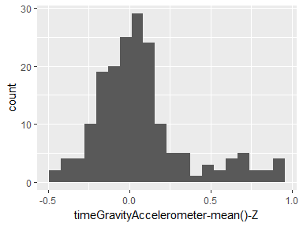

## timeBodyAccelerometerJerk-mean()-X

|  |  |
| --- | --- |
| Feature | Result |
| Variable type | numeric |
| Number of missing obs. | 0 (0 %) |
| Number of unique values | 180 |
| Median | 0.08 |
| 1st and 3rd quartiles | 0.07; 0.08 |
| Min. and max. | 0.04; 0.13 |

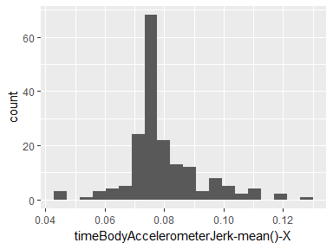

## timeBodyAccelerometerJerk-mean()-Y

|  |  |
| --- | --- |
| Feature | Result |
| Variable type | numeric |
| Number of missing obs. | 0 (0 %) |
| Number of unique values | 180 |
| Median | 0.01 |
| 1st and 3rd quartiles | 0; 0.01 |
| Min. and max. | -0.04; 0.06 |

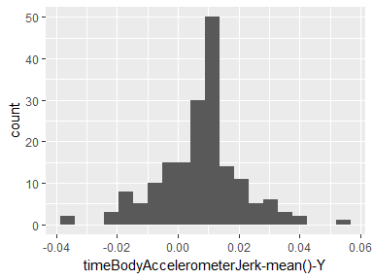

## timeBodyAccelerometerJerk-mean()-Z

|  |  |
| --- | --- |
| Feature | Result |
| Variable type | numeric |
| Number of missing obs. | 0 (0 %) |
| Number of unique values | 180 |
| Median | 0 |
| 1st and 3rd quartiles | -0.01; 0 |
| Min. and max. | -0.07; 0.04 |

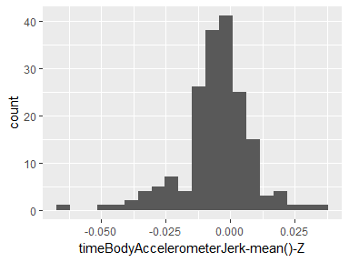

## timeBodyGyroscope-mean()-X

|  |  |
| --- | --- |
| Feature | Result |
| Variable type | numeric |
| Number of missing obs. | 0 (0 %) |
| Number of unique values | 180 |
| Median | -0.03 |
| 1st and 3rd quartiles | -0.05; -0.02 |
| Min. and max. | -0.21; 0.19 |

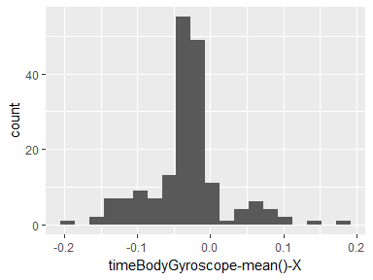

## timeBodyGyroscope-mean()-Y

|  |  |
| --- | --- |
| Feature | Result |
| Variable type | numeric |
| Number of missing obs. | 0 (0 %) |
| Number of unique values | 180 |
| Median | -0.07 |
| 1st and 3rd quartiles | -0.09; -0.06 |
| Min. and max. | -0.2; 0.03 |

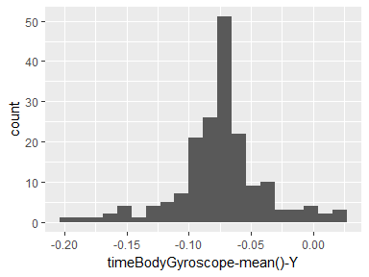

## timeBodyGyroscope-mean()-Z

|  |  |
| --- | --- |
| Feature | Result |
| Variable type | numeric |
| Number of missing obs. | 0 (0 %) |
| Number of unique values | 180 |
| Median | 0.09 |
| 1st and 3rd quartiles | 0.07; 0.1 |
| Min. and max. | -0.07; 0.18 |

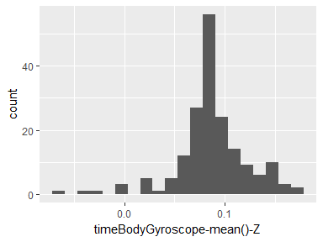

## timeBodyGyroscopeJerk-mean()-X

|  |  |
| --- | --- |
| Feature | Result |
| Variable type | numeric |
| Number of missing obs. | 0 (0 %) |
| Number of unique values | 180 |
| Median | -0.1 |
| 1st and 3rd quartiles | -0.1; -0.09 |
| Min. and max. | -0.16; -0.02 |

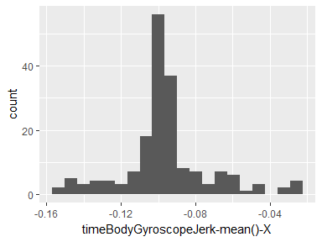

## timeBodyGyroscopeJerk-mean()-Y

|  |  |
| --- | --- |
| Feature | Result |
| Variable type | numeric |
| Number of missing obs. | 0 (0 %) |
| Number of unique values | 180 |
| Median | -0.04 |
| 1st and 3rd quartiles | -0.05; -0.04 |
| Min. and max. | -0.08; -0.01 |

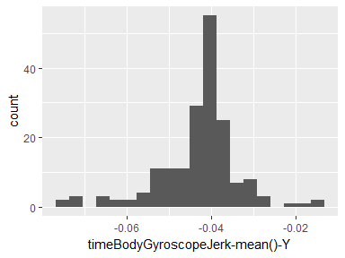

## timeBodyGyroscopeJerk-mean()-Z

|  |  |
| --- | --- |
| Feature | Result |
| Variable type | numeric |
| Number of missing obs. | 0 (0 %) |
| Number of unique values | 180 |
| Median | -0.05 |
| 1st and 3rd quartiles | -0.06; -0.05 |
| Min. and max. | -0.09; -0.01 |

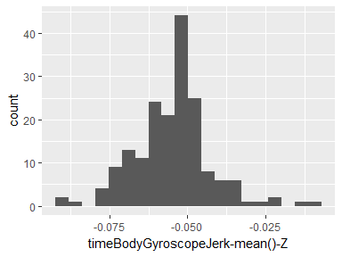

## timeBodyAccelerometerMagnitude-mean()

|  |  |
| --- | --- |
| Feature | Result |
| Variable type | numeric |
| Number of missing obs. | 0 (0 %) |
| Number of unique values | 180 |
| Median | -0.48 |
| 1st and 3rd quartiles | -0.96; -0.09 |
| Min. and max. | -0.99; 0.64 |

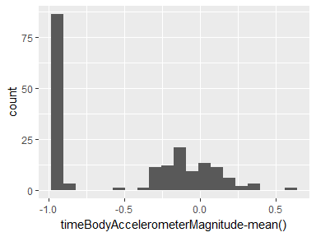

## timeGravityAccelerometerMagnitude-mean()

|  |  |
| --- | --- |
| Feature | Result |
| Variable type | numeric |
| Number of missing obs. | 0 (0 %) |
| Number of unique values | 180 |
| Median | -0.48 |
| 1st and 3rd quartiles | -0.96; -0.09 |
| Min. and max. | -0.99; 0.64 |

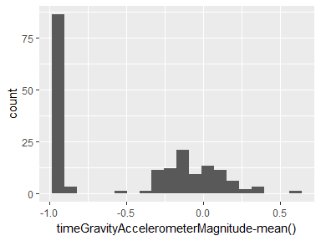

## timeBodyAccelerometerJerkMagnitude-mean()

|  |  |
| --- | --- |
| Feature | Result |
| Variable type | numeric |
| Number of missing obs. | 0 (0 %) |
| Number of unique values | 180 |
| Median | -0.82 |
| 1st and 3rd quartiles | -0.98; -0.25 |
| Min. and max. | -0.99; 0.43 |

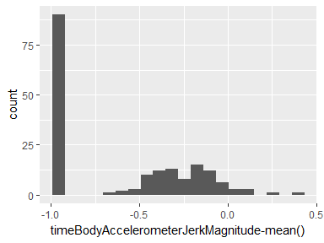

## timeBodyGyroscopeMagnitude-mean()

|  |  |
| --- | --- |
| Feature | Result |
| Variable type | numeric |
| Number of missing obs. | 0 (0 %) |
| Number of unique values | 180 |
| Median | -0.66 |
| 1st and 3rd quartiles | -0.95; -0.22 |
| Min. and max. | -0.98; 0.42 |

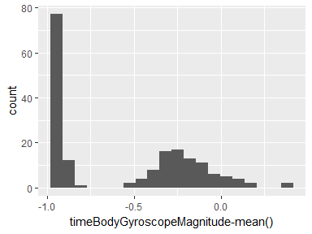

## timeBodyGyroscopeJerkMagnitude-mean()

|  |  |
| --- | --- |
| Feature | Result |
| Variable type | numeric |
| Number of missing obs. | 0 (0 %) |
| Number of unique values | 180 |
| Median | -0.86 |
| 1st and 3rd quartiles | -0.99; -0.51 |
| Min. and max. | -1; 0.09 |

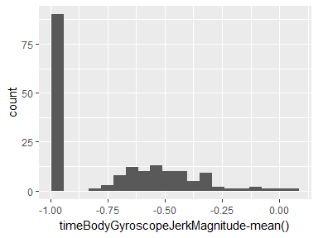

## frequencyBodyAccelerometer-mean()-X

|  |  |
| --- | --- |
| Feature | Result |
| Variable type | numeric |
| Number of missing obs. | 0 (0 %) |
| Number of unique values | 180 |
| Median | -0.77 |
| 1st and 3rd quartiles | -0.98; -0.22 |
| Min. and max. | -1; 0.54 |

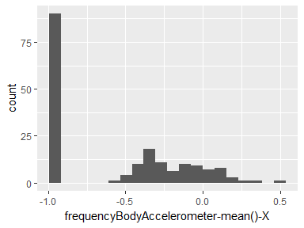

## frequencyBodyAccelerometer-mean()-Y

|  |  |
| --- | --- |
| Feature | Result |
| Variable type | numeric |
| Number of missing obs. | 0 (0 %) |
| Number of unique values | 180 |
| Median | -0.59 |
| 1st and 3rd quartiles | -0.95; -0.06 |
| Min. and max. | -0.99; 0.52 |

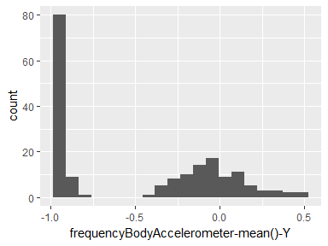

## frequencyBodyAccelerometer-mean()-Z

|  |  |
| --- | --- |
| Feature | Result |
| Variable type | numeric |
| Number of missing obs. | 0 (0 %) |
| Number of unique values | 180 |
| Median | -0.72 |
| 1st and 3rd quartiles | -0.96; -0.32 |
| Min. and max. | -0.99; 0.28 |

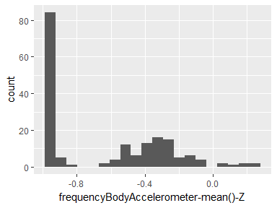

## frequencyBodyAccelerometer-meanFreq()-X

|  |  |
| --- | --- |
| Feature | Result |
| Variable type | numeric |
| Number of missing obs. | 0 (0 %) |
| Number of unique values | 180 |
| Median | -0.26 |
| 1st and 3rd quartiles | -0.39; -0.06 |
| Min. and max. | -0.64; 0.16 |

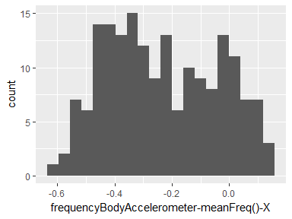

## frequencyBodyAccelerometer-meanFreq()-Y

|  |  |
| --- | --- |
| Feature | Result |
| Variable type | numeric |
| Number of missing obs. | 0 (0 %) |
| Number of unique values | 180 |
| Median | 0.01 |
| 1st and 3rd quartiles | -0.08; 0.09 |
| Min. and max. | -0.38; 0.47 |

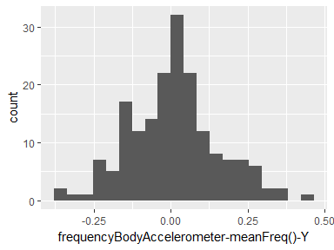

## frequencyBodyAccelerometer-meanFreq()-Z

|  |  |
| --- | --- |
| Feature | Result |
| Variable type | numeric |
| Number of missing obs. | 0 (0 %) |
| Number of unique values | 180 |
| Median | 0.07 |
| 1st and 3rd quartiles | -0.04; 0.18 |
| Min. and max. | -0.52; 0.4 |

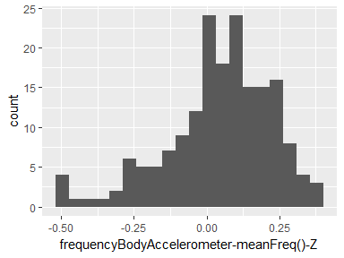

## frequencyBodyAccelerometerJerk-mean()-X

|  |  |
| --- | --- |
| Feature | Result |
| Variable type | numeric |
| Number of missing obs. | 0 (0 %) |
| Number of unique values | 180 |
| Median | -0.81 |
| 1st and 3rd quartiles | -0.98; -0.28 |
| Min. and max. | -0.99; 0.47 |

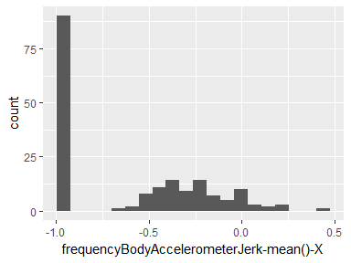

## frequencyBodyAccelerometerJerk-mean()-Y

|  |  |
| --- | --- |
| Feature | Result |
| Variable type | numeric |
| Number of missing obs. | 0 (0 %) |
| Number of unique values | 180 |
| Median | -0.78 |
| 1st and 3rd quartiles | -0.97; -0.2 |
| Min. and max. | -0.99; 0.28 |

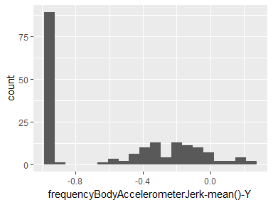

## frequencyBodyAccelerometerJerk-mean()-Z

|  |  |
| --- | --- |
| Feature | Result |
| Variable type | numeric |
| Number of missing obs. | 0 (0 %) |
| Number of unique values | 180 |
| Median | -0.87 |
| 1st and 3rd quartiles | -0.98; -0.47 |
| Min. and max. | -0.99; 0.16 |

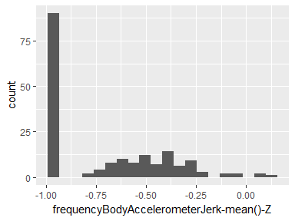

## frequencyBodyAccelerometerJerk-meanFreq()-X

|  |  |
| --- | --- |
| Feature | Result |
| Variable type | numeric |
| Number of missing obs. | 0 (0 %) |
| Number of unique values | 180 |
| Median | -0.06 |
| 1st and 3rd quartiles | -0.29; 0.18 |
| Min. and max. | -0.58; 0.33 |

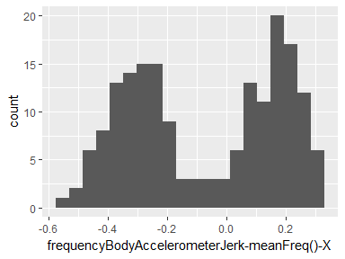

## frequencyBodyAccelerometerJerk-meanFreq()-Y

|  |  |
| --- | --- |
| Feature | Result |
| Variable type | numeric |
| Number of missing obs. | 0 (0 %) |
| Number of unique values | 180 |
| Median | -0.23 |
| 1st and 3rd quartiles | -0.4; -0.05 |
| Min. and max. | -0.6; 0.2 |

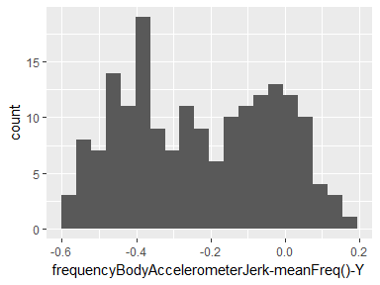

## frequencyBodyAccelerometerJerk-meanFreq()-Z

|  |  |
| --- | --- |
| Feature | Result |
| Variable type | numeric |
| Number of missing obs. | 0 (0 %) |
| Number of unique values | 180 |
| Median | -0.09 |
| 1st and 3rd quartiles | -0.31; 0.04 |
| Min. and max. | -0.63; 0.23 |

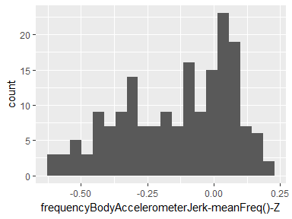

## frequencyBodyGyroscope-mean()-X

|  |  |
| --- | --- |
| Feature | Result |
| Variable type | numeric |
| Number of missing obs. | 0 (0 %) |
| Number of unique values | 180 |
| Median | -0.73 |
| 1st and 3rd quartiles | -0.97; -0.34 |
| Min. and max. | -0.99; 0.47 |

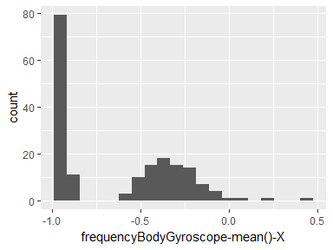

## frequencyBodyGyroscope-mean()-Y

|  |  |
| --- | --- |
| Feature | Result |
| Variable type | numeric |
| Number of missing obs. | 0 (0 %) |
| Number of unique values | 180 |
| Median | -0.81 |
| 1st and 3rd quartiles | -0.97; -0.45 |
| Min. and max. | -0.99; 0.33 |

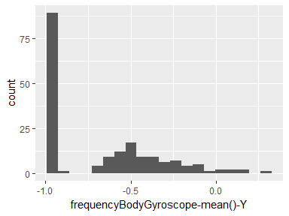

## frequencyBodyGyroscope-mean()-Z

|  |  |
| --- | --- |
| Feature | Result |
| Variable type | numeric |
| Number of missing obs. | 0 (0 %) |
| Number of unique values | 180 |
| Median | -0.79 |
| 1st and 3rd quartiles | -0.96; -0.26 |
| Min. and max. | -0.99; 0.49 |

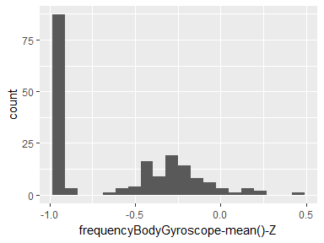

## frequencyBodyGyroscope-meanFreq()-X

|  |  |
| --- | --- |
| Feature | Result |
| Variable type | numeric |
| Number of missing obs. | 0 (0 %) |
| Number of unique values | 180 |
| Median | -0.12 |
| 1st and 3rd quartiles | -0.21; 0 |
| Min. and max. | -0.4; 0.25 |

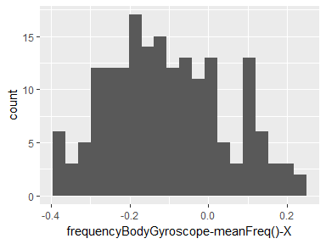

## frequencyBodyGyroscope-meanFreq()-Y

|  |  |
| --- | --- |
| Feature | Result |
| Variable type | numeric |
| Number of missing obs. | 0 (0 %) |
| Number of unique values | 180 |
| Median | -0.16 |
| 1st and 3rd quartiles | -0.29; -0.04 |
| Min. and max. | -0.67; 0.27 |

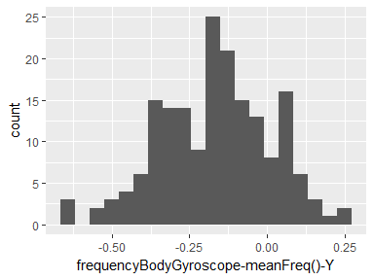

## frequencyBodyGyroscope-meanFreq()-Z

|  |  |
| --- | --- |
| Feature | Result |
| Variable type | numeric |
| Number of missing obs. | 0 (0 %) |
| Number of unique values | 180 |
| Median | -0.05 |
| 1st and 3rd quartiles | -0.15; 0.04 |
| Min. and max. | -0.51; 0.38 |

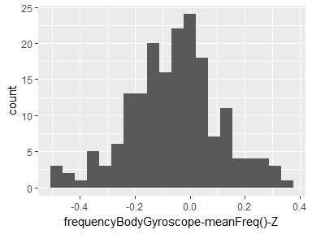

## frequencyBodyAccelerometerMagnitude-mean()

|  |  |
| --- | --- |
| Feature | Result |
| Variable type | numeric |
| Number of missing obs. | 0 (0 %) |
| Number of unique values | 180 |
| Median | -0.67 |
| 1st and 3rd quartiles | -0.96; -0.16 |
| Min. and max. | -0.99; 0.59 |

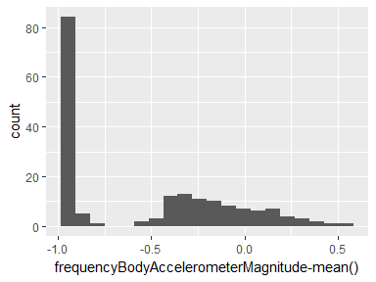

## frequencyBodyAccelerometerMagnitude-meanFreq()

|  |  |
| --- | --- |
| Feature | Result |
| Variable type | numeric |
| Number of missing obs. | 0 (0 %) |
| Number of unique values | 180 |
| Median | 0.08 |
| 1st and 3rd quartiles | -0.01; 0.17 |
| Min. and max. | -0.31; 0.44 |

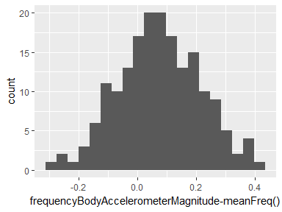

## frequencyBodyAccelerometerJerkMagnitude-mean()

|  |  |
| --- | --- |
| Feature | Result |
| Variable type | numeric |
| Number of missing obs. | 0 (0 %) |
| Number of unique values | 180 |
| Median | -0.79 |
| 1st and 3rd quartiles | -0.98; -0.19 |
| Min. and max. | -0.99; 0.54 |

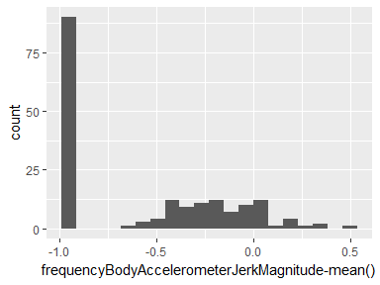

## frequencyBodyAccelerometerJerkMagnitude-meanFreq()

|  |  |
| --- | --- |
| Feature | Result |
| Variable type | numeric |
| Number of missing obs. | 0 (0 %) |
| Number of unique values | 180 |
| Median | 0.17 |
| 1st and 3rd quartiles | 0.05; 0.28 |
| Min. and max. | -0.13; 0.49 |

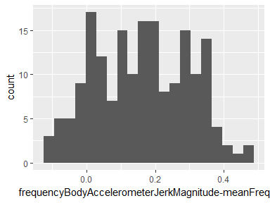

## frequencyBodyGyroscopeMagnitude-mean()

|  |  |
| --- | --- |
| Feature | Result |
| Variable type | numeric |
| Number of missing obs. | 0 (0 %) |
| Number of unique values | 180 |
| Median | -0.77 |
| 1st and 3rd quartiles | -0.96; -0.41 |
| Min. and max. | -0.99; 0.2 |

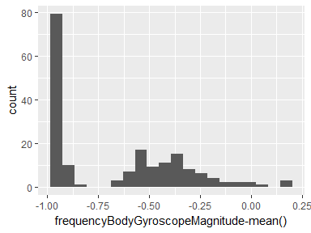

## frequencyBodyGyroscopeMagnitude-meanFreq()

|  |  |
| --- | --- |
| Feature | Result |
| Variable type | numeric |
| Number of missing obs. | 0 (0 %) |
| Number of unique values | 180 |
| Median | -0.05 |
| 1st and 3rd quartiles | -0.17; 0.08 |
| Min. and max. | -0.46; 0.41 |

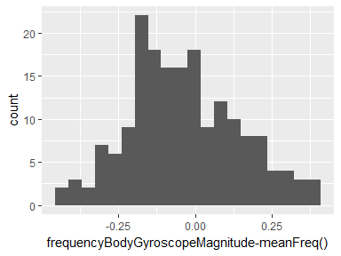

## frequencyBodyGyroscopeJerkMagnitude-mean()

|  |  |
| --- | --- |
| Feature | Result |
| Variable type | numeric |
| Number of missing obs. | 0 (0 %) |
| Number of unique values | 180 |
| Median | -0.88 |
| 1st and 3rd quartiles | -0.98; -0.58 |
| Min. and max. | -1; 0.15 |

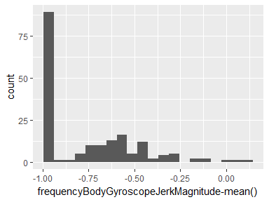

## frequencyBodyGyroscopeJerkMagnitude-meanFreq()

|  |  |
| --- | --- |
| Feature | Result |
| Variable type | numeric |
| Number of missing obs. | 0 (0 %) |
| Number of unique values | 180 |
| Median | 0.11 |
| 1st and 3rd quartiles | 0.05; 0.21 |
| Min. and max. | -0.18; 0.43 |

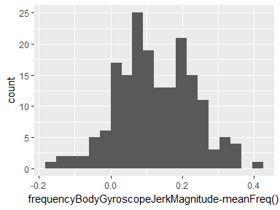

## timeBodyAccelerometer-std()-X

|  |  |
| --- | --- |
| Feature | Result |
| Variable type | numeric |
| Number of missing obs. | 0 (0 %) |
| Number of unique values | 180 |
| Median | -0.75 |
| 1st and 3rd quartiles | -0.98; -0.2 |
| Min. and max. | -1; 0.63 |

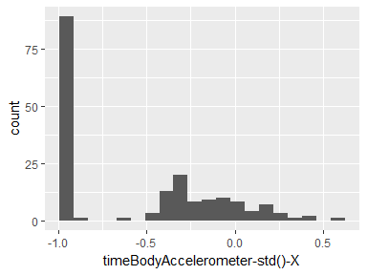

## timeBodyAccelerometer-std()-Y

|  |  |
| --- | --- |
| Feature | Result |
| Variable type | numeric |
| Number of missing obs. | 0 (0 %) |
| Number of unique values | 180 |
| Median | -0.51 |
| 1st and 3rd quartiles | -0.94; -0.03 |
| Min. and max. | -0.99; 0.62 |

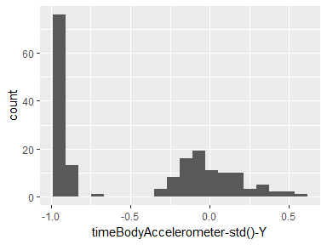

## timeBodyAccelerometer-std()-Z

|  |  |
| --- | --- |
| Feature | Result |
| Variable type | numeric |
| Number of missing obs. | 0 (0 %) |
| Number of unique values | 180 |
| Median | -0.65 |
| 1st and 3rd quartiles | -0.95; -0.23 |
| Min. and max. | -0.99; 0.61 |

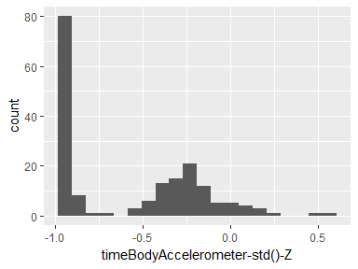

## timeGravityAccelerometer-std()-X

|  |  |
| --- | --- |
| Feature | Result |
| Variable type | numeric |
| Number of missing obs. | 0 (0 %) |
| Number of unique values | 180 |
| Median | -0.97 |
| 1st and 3rd quartiles | -0.98; -0.95 |
| Min. and max. | -1; -0.83 |

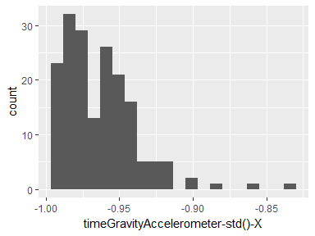

## timeGravityAccelerometer-std()-Y

|  |  |
| --- | --- |
| Feature | Result |
| Variable type | numeric |
| Number of missing obs. | 0 (0 %) |
| Number of unique values | 180 |
| Median | -0.96 |
| 1st and 3rd quartiles | -0.97; -0.94 |
| Min. and max. | -0.99; -0.64 |

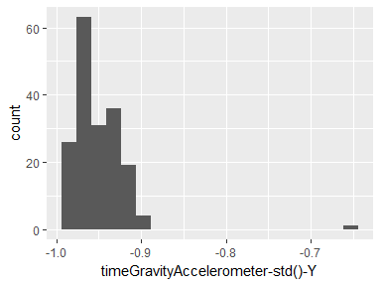

## timeGravityAccelerometer-std()-Z

|  |  |
| --- | --- |
| Feature | Result |
| Variable type | numeric |
| Number of missing obs. | 0 (0 %) |
| Number of unique values | 180 |
| Median | -0.95 |
| 1st and 3rd quartiles | -0.96; -0.92 |
| Min. and max. | -0.99; -0.61 |

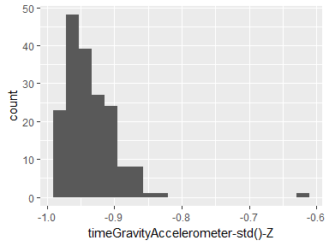

## timeBodyAccelerometerJerk-std()-X

|  |  |
| --- | --- |
| Feature | Result |
| Variable type | numeric |
| Number of missing obs. | 0 (0 %) |
| Number of unique values | 180 |
| Median | -0.81 |
| 1st and 3rd quartiles | -0.98; -0.22 |
| Min. and max. | -0.99; 0.54 |

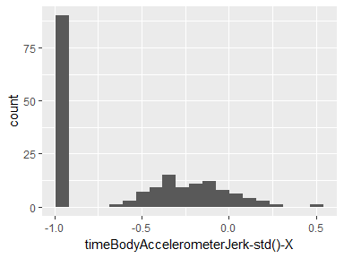

## timeBodyAccelerometerJerk-std()-Y

|  |  |
| --- | --- |
| Feature | Result |
| Variable type | numeric |
| Number of missing obs. | 0 (0 %) |
| Number of unique values | 180 |
| Median | -0.78 |
| 1st and 3rd quartiles | -0.97; -0.15 |
| Min. and max. | -0.99; 0.36 |

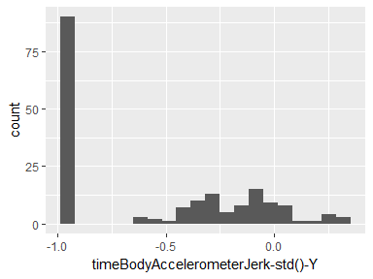

## timeBodyAccelerometerJerk-std()-Z

|  |  |
| --- | --- |
| Feature | Result |
| Variable type | numeric |
| Number of missing obs. | 0 (0 %) |
| Number of unique values | 180 |
| Median | -0.88 |
| 1st and 3rd quartiles | -0.98; -0.51 |
| Min. and max. | -0.99; 0.03 |

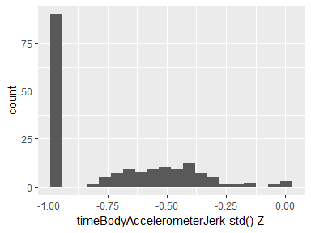

## timeBodyGyroscope-std()-X

|  |  |
| --- | --- |
| Feature | Result |
| Variable type | numeric |
| Number of missing obs. | 0 (0 %) |
| Number of unique values | 180 |
| Median | -0.79 |
| 1st and 3rd quartiles | -0.97; -0.44 |
| Min. and max. | -0.99; 0.27 |

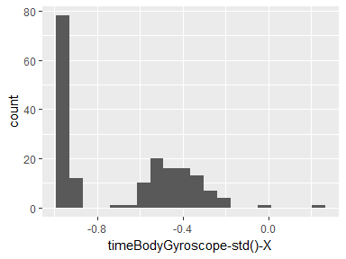

## timeBodyGyroscope-std()-Y

|  |  |
| --- | --- |
| Feature | Result |
| Variable type | numeric |
| Number of missing obs. | 0 (0 %) |
| Number of unique values | 180 |
| Median | -0.8 |
| 1st and 3rd quartiles | -0.96; -0.42 |
| Min. and max. | -0.99; 0.48 |

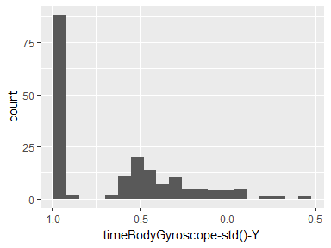

## timeBodyGyroscope-std()-Z

|  |  |
| --- | --- |
| Feature | Result |
| Variable type | numeric |
| Number of missing obs. | 0 (0 %) |
| Number of unique values | 180 |
| Median | -0.8 |
| 1st and 3rd quartiles | -0.96; -0.31 |
| Min. and max. | -0.99; 0.56 |

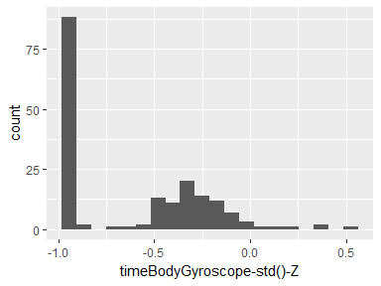

## timeBodyGyroscopeJerk-std()-X

|  |  |
| --- | --- |
| Feature | Result |
| Variable type | numeric |
| Number of missing obs. | 0 (0 %) |
| Number of unique values | 180 |
| Median | -0.84 |
| 1st and 3rd quartiles | -0.98; -0.46 |
| Min. and max. | -1; 0.18 |

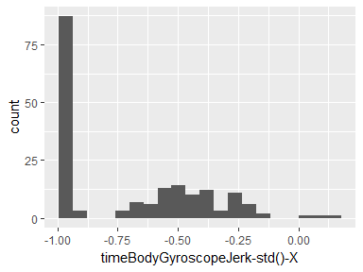

## timeBodyGyroscopeJerk-std()-Y

|  |  |
| --- | --- |
| Feature | Result |
| Variable type | numeric |
| Number of missing obs. | 0 (0 %) |
| Number of unique values | 180 |
| Median | -0.89 |
| 1st and 3rd quartiles | -0.98; -0.59 |
| Min. and max. | -1; 0.3 |

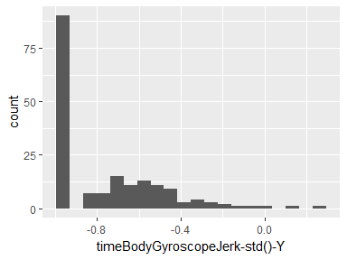

## timeBodyGyroscopeJerk-std()-Z

|  |  |
| --- | --- |
| Feature | Result |
| Variable type | numeric |
| Number of missing obs. | 0 (0 %) |
| Number of unique values | 180 |
| Median | -0.86 |
| 1st and 3rd quartiles | -0.98; -0.47 |
| Min. and max. | -1; 0.19 |

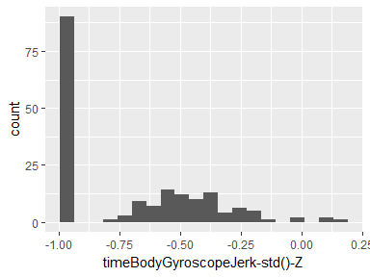

## timeBodyAccelerometerMagnitude-std()

|  |  |
| --- | --- |
| Feature | Result |
| Variable type | numeric |
| Number of missing obs. | 0 (0 %) |
| Number of unique values | 180 |
| Median | -0.61 |
| 1st and 3rd quartiles | -0.94; -0.21 |
| Min. and max. | -0.99; 0.43 |

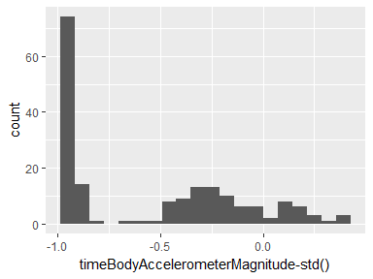

## timeGravityAccelerometerMagnitude-std()

|  |  |
| --- | --- |
| Feature | Result |
| Variable type | numeric |
| Number of missing obs. | 0 (0 %) |
| Number of unique values | 180 |
| Median | -0.61 |
| 1st and 3rd quartiles | -0.94; -0.21 |
| Min. and max. | -0.99; 0.43 |

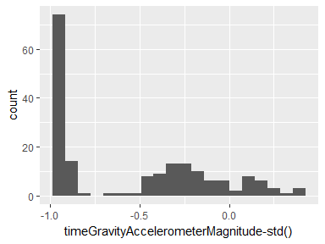

## timeBodyAccelerometerJerkMagnitude-std()

|  |  |
| --- | --- |
| Feature | Result |
| Variable type | numeric |
| Number of missing obs. | 0 (0 %) |
| Number of unique values | 180 |
| Median | -0.8 |
| 1st and 3rd quartiles | -0.98; -0.22 |
| Min. and max. | -0.99; 0.45 |

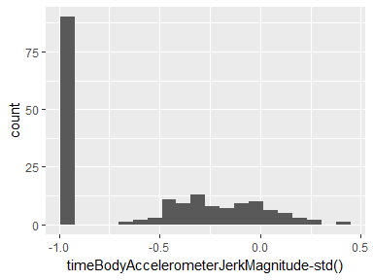

## timeBodyGyroscopeMagnitude-std()

|  |  |
| --- | --- |
| Feature | Result |
| Variable type | numeric |
| Number of missing obs. | 0 (0 %) |
| Number of unique values | 180 |
| Median | -0.74 |
| 1st and 3rd quartiles | -0.95; -0.36 |
| Min. and max. | -0.98; 0.3 |

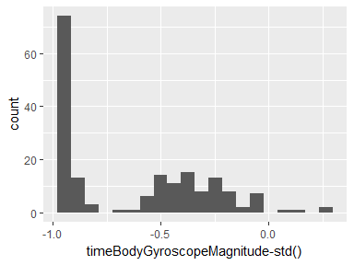

## timeBodyGyroscopeJerkMagnitude-std()

|  |  |
| --- | --- |
| Feature | Result |
| Variable type | numeric |
| Number of missing obs. | 0 (0 %) |
| Number of unique values | 180 |
| Median | -0.88 |
| 1st and 3rd quartiles | -0.98; -0.58 |
| Min. and max. | -1; 0.25 |

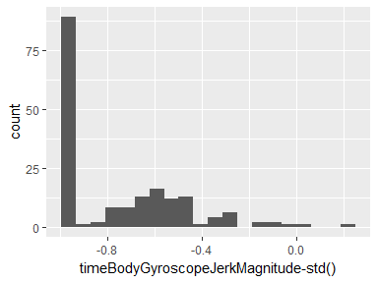

## frequencyBodyAccelerometer-std()-X

|  |  |
| --- | --- |
| Feature | Result |
| Variable type | numeric |
| Number of missing obs. | 0 (0 %) |
| Number of unique values | 180 |
| Median | -0.75 |
| 1st and 3rd quartiles | -0.98; -0.2 |
| Min. and max. | -1; 0.66 |

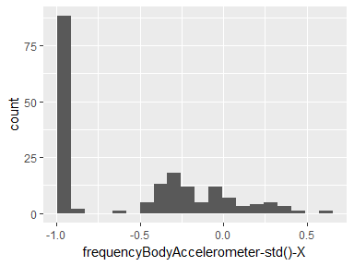

## frequencyBodyAccelerometer-std()-Y

|  |  |
| --- | --- |
| Feature | Result |
| Variable type | numeric |
| Number of missing obs. | 0 (0 %) |
| Number of unique values | 180 |
| Median | -0.51 |
| 1st and 3rd quartiles | -0.94; -0.08 |
| Min. and max. | -0.99; 0.56 |

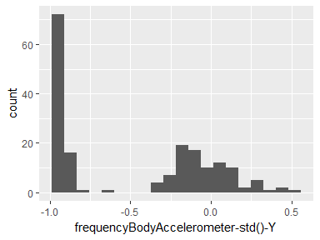

## frequencyBodyAccelerometer-std()-Z

|  |  |
| --- | --- |
| Feature | Result |
| Variable type | numeric |
| Number of missing obs. | 0 (0 %) |
| Number of unique values | 180 |
| Median | -0.64 |
| 1st and 3rd quartiles | -0.95; -0.27 |
| Min. and max. | -0.99; 0.69 |

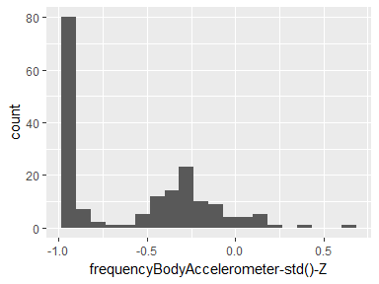

## frequencyBodyAccelerometerJerk-std()-X

|  |  |
| --- | --- |
| Feature | Result |
| Variable type | numeric |
| Number of missing obs. | 0 (0 %) |
| Number of unique values | 180 |
| Median | -0.83 |
| 1st and 3rd quartiles | -0.98; -0.25 |
| Min. and max. | -1; 0.48 |

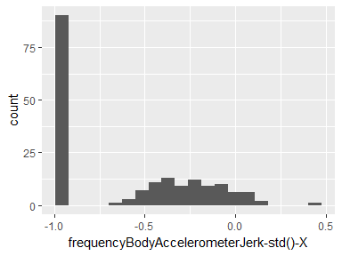

## frequencyBodyAccelerometerJerk-std()-Y

|  |  |
| --- | --- |
| Feature | Result |
| Variable type | numeric |
| Number of missing obs. | 0 (0 %) |
| Number of unique values | 180 |
| Median | -0.79 |
| 1st and 3rd quartiles | -0.97; -0.17 |
| Min. and max. | -0.99; 0.35 |

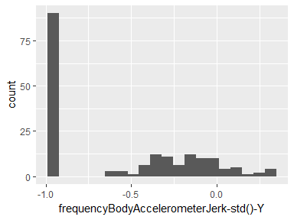

## frequencyBodyAccelerometerJerk-std()-Z

|  |  |
| --- | --- |
| Feature | Result |
| Variable type | numeric |
| Number of missing obs. | 0 (0 %) |
| Number of unique values | 180 |
| Median | -0.9 |
| 1st and 3rd quartiles | -0.98; -0.54 |
| Min. and max. | -0.99; -0.01 |

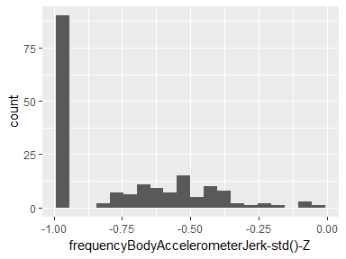

## frequencyBodyGyroscope-std()-X

|  |  |
| --- | --- |
| Feature | Result |
| Variable type | numeric |
| Number of missing obs. | 0 (0 %) |
| Number of unique values | 180 |
| Median | -0.81 |
| 1st and 3rd quartiles | -0.98; -0.48 |
| Min. and max. | -0.99; 0.2 |

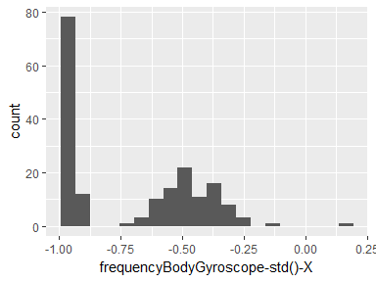

## frequencyBodyGyroscope-std()-Y

|  |  |
| --- | --- |
| Feature | Result |
| Variable type | numeric |
| Number of missing obs. | 0 (0 %) |
| Number of unique values | 180 |
| Median | -0.8 |
| 1st and 3rd quartiles | -0.96; -0.42 |
| Min. and max. | -0.99; 0.65 |

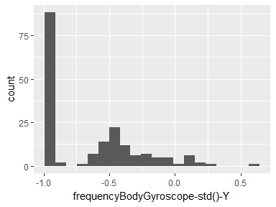

## frequencyBodyGyroscope-std()-Z

|  |  |
| --- | --- |
| Feature | Result |
| Variable type | numeric |
| Number of missing obs. | 0 (0 %) |
| Number of unique values | 180 |
| Median | -0.82 |
| 1st and 3rd quartiles | -0.96; -0.39 |
| Min. and max. | -0.99; 0.52 |

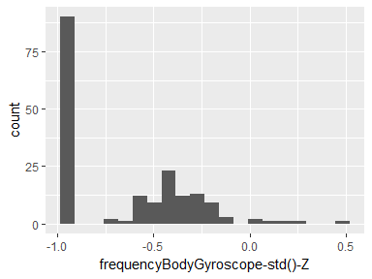

## frequencyBodyAccelerometerMagnitude-std()

|  |  |
| --- | --- |
| Feature | Result |
| Variable type | numeric |
| Number of missing obs. | 0 (0 %) |
| Number of unique values | 180 |
| Median | -0.65 |
| 1st and 3rd quartiles | -0.95; -0.37 |
| Min. and max. | -0.99; 0.18 |

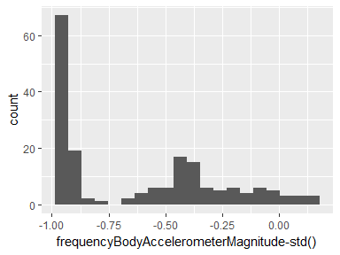

## frequencyBodyAccelerometerJerkMagnitude-std()

|  |  |
| --- | --- |
| Feature | Result |
| Variable type | numeric |
| Number of missing obs. | 0 (0 %) |
| Number of unique values | 180 |
| Median | -0.81 |
| 1st and 3rd quartiles | -0.98; -0.27 |
| Min. and max. | -0.99; 0.32 |

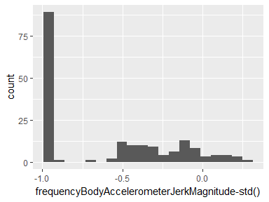

## frequencyBodyGyroscopeMagnitude-std()

|  |  |
| --- | --- |
| Feature | Result |
| Variable type | numeric |
| Number of missing obs. | 0 (0 %) |
| Number of unique values | 180 |
| Median | -0.77 |
| 1st and 3rd quartiles | -0.95; -0.43 |
| Min. and max. | -0.98; 0.24 |

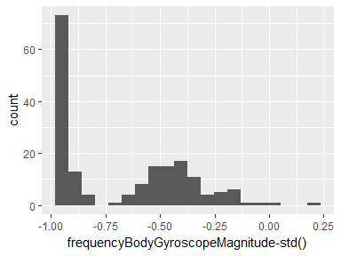

## frequencyBodyGyroscopeJerkMagnitude-std()

|  |  |
| --- | --- |
| Feature | Result |
| Variable type | numeric |
| Number of missing obs. | 0 (0 %) |
| Number of unique values | 180 |
| Median | -0.89 |
| 1st and 3rd quartiles | -0.98; -0.61 |
| Min. and max. | -1; 0.29 |

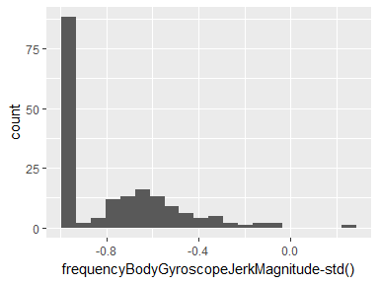

Report generation information:

* Created by No Instance(s) Available..
* Report creation time: Sun Apr 22 2018 18:51:15
* dataMaid v1.1.0 [Pkg: 2018-02-06 from CRAN (R 3.4.4)]
* R version 3.4.3 (2017-11-30).
* Platform: x86_64-w64-mingw32/x64 (64-bit)(Windows 7 x64 (build 7601) Service Pack 1).
* Function call: makeDataReport(data = data, mode = c("summarize", "visualize", "check"), smartNum = FALSE, file = normalizeFileName(paste0("codebook_", dfname, vol, ".Rmd")), replace = ..1, checks = setChecks(character = list("showAllFactorLevels"), factor = list("showAllFactorLevels"), labelled = list("showAllFactorLevels"), numeric = NULL, integer = NULL, Date = NULL, logical = NULL), listChecks = FALSE, maxProbVals = Inf, codebook = TRUE, reportTitle = paste0("Codebook for ", dfname))