EV BATTERY-SWAP NETWORK
Service Reliability & Rider Churn Risk
An exploratory review of service reliability, energy-only economics and rider retention, with a corrected analytical workflow and explicit validation limits
Data period: January 2024 – June 2025 (18 months)
Coverage: 6 cities · 152 stations · 19,950 active riders · 3.88M swap attempts
Prepared by: Himanshu Mital & Vedansh Mittal
Evidence status: historical figures retained; corrected full-data results pending. Google Drive returned quota-exceeded errors for five source files. This report distinguishes exploratory outputs from verified operational findings. The original report and notebook are preserved in the archive.
1. Executive Summary
The original notebook reports 3.88 million swap attempts across 152 stations in six cities over 18 months, a 3.47% no-battery failure rate and a 33.88% retrospective inactivity rate. These are historical, uncorrected outputs, not newly verified results. The corrected workflow excludes test stations, handles logging issues and compares retention using equal follow-up. A full rerun was blocked by Google Drive download quotas on September 26, 2026.

Network scale | Historical raw scope: 3.88M attempts; 6 cities; 152 stations; 19,950 observed riders; 18 months
Service reliability | Historical no-battery failure rate: 3.47%; Jaipur peak 12.94%; cleaning rerun pending
Rider churn | 33.88% retrospective inactivity (6,760 riders); causes and cohort retention not established
Revenue concentration | Top 66 historically flagged riders account for 27% of flagged historical revenue; not a loss forecast
Unit economics | 69.5% historical energy-only contribution; site costs, battery wear and other costs excluded
Pipeline performance | No reproducible benchmark supports the earlier approximately 100x speedup claim

Heat and grid instability are associated with reliability failures in the original city-month analysis. Jaipur reached 12.94% in May 2024, and April–June peaks appear in both observed years. Newer expansion-wave stations show lower raw failure rates, but differences in city, exposure period and site selection prevent a causal claim that the hardware fix is proven.
Low cumulative usage is associated with retrospective inactivity in the original notebook, but usage was accumulated over the same period used to define the outcome. This does not establish that onboarding is the primary cause or that service quality is unimportant. The corrected analysis measures early experience in days 0–29 and return activity in days 30–59, with full follow-up required for every included rider.
The original random-split experiment reports 73.3% recall for Random Forest and 49.9% for Gradient Boosting. These are not deployment results: features overlap the inactivity outcome window. The later risk-band calculations actually use Gradient Boosting scores on the 3,990-rider test set, not monthly Random Forest scores for every rider. Historical high-risk revenue concentration is descriptive and is not a forecast of preventable revenue loss.
Processing 3.88 million records creates a practical resource constraint. The revised workflow uses grouped calculations and compressed repeated dimensions, but the repository contains no reproducible benchmark supporting a 100x end-to-end speedup. Timestamp parsing remains necessary to correct the documented firmware error and construct valid observation windows.
2. Problem Understanding & Data Sources
The business operates a battery-swap charging network for electric two- and three-wheelers across six Indian cities — Bengaluru, Delhi NCR, Hyderabad, Jaipur, Mumbai and Pune. Riders visit a station, exchange a depleted battery for a charged one, and pay per swap; some ride independently and some are affiliated with one of 12 fleet partners.
Two problems
- Service reliability. The original outputs show no charged battery available in roughly 3.5% of attempts. The distribution varies across cities, stations and seasons. The relative importance of this issue to overall rider experience requires comparison with queues, system errors, battery range and complaints.
- Rider retention. The original 33.88% figure measures inactivity in a fixed final 60-day window among observed riders. It does not establish a fair new-rider retention rate. The corrected workflow reports activation and subsequent return by sign-up cohort, separately identifying riders without enough follow-up.
Questions covered by the original analysis and extended in the corrected notebook
- What operational and environmental factors drive no-battery failures, and can the failure rate be predicted well enough to plan ahead?
- Which stations, cities and station expansion waves underperform, and why?
- What are the network's core unit economics — revenue, energy cost, contribution margin?
- What actually predicts rider churn — service quality, usage behavior, or rider segment?
- Which riders account for the greatest revenue at risk, and how should retention effort be prioritized?
Data sources
The hackathon provides eight linked datasets, including city_daily_context.csv (3,282 city-day rows), which was omitted from the original report’s seven-file source list. The original notebook reports zero orphan references in its checks. The corrected pipeline checks keys and joins again before analysis; that full-data verification remains pending.

Dataset | Rows | What it captures
stations.csv | 152 | Station metadata: city, host type, expansion wave, charger generation, rent and tariff economics
station_hourly_status.csv | 1,487,712 | Hourly telemetry per station: charged packs, quarantined packs, chargers online, temperature, outage minutes
swap_events.csv | 3,877,013 | Every swap attempt: outcome, pricing, battery state of charge/health, queue wait, payment
riders.csv | 20,000 | Rider profile: vehicle class, plan type, fleet affiliation, sign-up channel, home city
batteries.csv | 6,500 | Battery pack inventory: supplier, cost, rated capacity, state of health
fleet_partners.csv | 12 | B2B partner contract terms and discount structures
support_tickets.csv | 44,000 | Rider support interactions: category, priority, resolution time, CSAT
city_daily_context.csv | 3,282 | Daily city weather, outages, calendar events and competitor context
3. Analytical Approach & Technical Performance
Track A — Service Reliability & Network Economics
- Merged 18 months of hourly station telemetry with the swap-attempt log and station metadata, aggregated by city and month.
- Correlated the no-battery failure rate against nine candidate drivers: temperature, grid outages, heat-alert days, rainfall, flood days, packs quarantined/charging, chargers online, low-battery hours.
- The original notebook fitted a multiple linear regression using a random split of city-month observations. Its R² is a retrospective test statistic, not evidence of forward forecasting performance. Temporal holdout evaluation is required before operational use.
- Compared failure rates across station expansion waves (Launch vs. two later rollout cohorts) to test whether newer stations perform better.
- Built a station-level anomaly score blending failure rate and low-battery hours to flag priority stations, and reconstructed monthly network financials from completed-swap pricing.
Track B — Rider Churn Prediction
- The original label uses no swap attempt in the final 60 days, but its eligible_for_churn field duplicates the churn condition and is never used to enforce eligibility. The corrected notebook instead requires 60 days of follow-up after sign-up and measures completed-swap return in days 30–59, separately from activation in days 0–29.
- The original features include usage, failures, queue waits, support tickets and revenue over the full observation period. Because these overlap the label window, the old classifier cannot support prospective claims. Corrected retention comparisons use only early experience measured before the return window.
- The archived notebook trained Logistic Regression, Random Forest and Gradient Boosting on 19,950 rows and 38 processed features using a random 80/20 split. Those historical outputs are retained for traceability; the corrected notebook does not reuse them as validated predictions.
- Historical accuracy, precision, recall, F1 and ROC-AUC remain visible below, with the limitation that target-overlapping features undermine prospective interpretation. Feature importance describes the fitted model and does not identify causes of churn.
- Historical risk bands were calculated from Gradient Boosting scores on the test subset. The associated revenue is observed historical revenue belonging to flagged riders, not probability-weighted future revenue or avoidable loss. The corrected workflow produces cohort retention tables rather than an unvalidated operational risk list.
Tools & techniques
Python (pandas, numpy) for data preparation; Pearson correlation and ordinary least-squares regression for driver analysis; scikit-learn Logistic Regression, Random Forest and Gradient Boosting classifiers for churn prediction; precision, recall, F1 and ROC-AUC with confusion matrices for model evaluation.
Engineering for scale and reproducibility
The original workflow repeatedly reads large source files and mixes relative paths with a machine-specific Downloads directory. The corrected notebook uses one configurable data directory, supports CSV and gzip, includes the full implementation, and exports auditable tables. The full-data runtime and memory footprint have not been benchmarked.
- Timestamp handling. String slicing can extract a month from a correctly formatted timestamp, but does not repair the v3.2.0 logging error. The corrected workflow parses timestamps and adds 5 hours 30 minutes for the documented affected interval before deriving month, date or hour.
- Grouped calculations. Queue means are calculated from individual observations using sums and valid counts. This corrects the original unweighted mean of chunk-level means. Precomputed outcome flags support efficient grouped counts without changing the rate denominators.
- Integrity and retry checks. Exact duplicate rows are removed, conflicting duplicate event IDs are rejected, and strict offline-retry candidates are identified using battery and transaction details within 120 seconds. Missing telemetry remains missing rather than becoming zero stock. The conservative retry rule may leave some duplicates and should be checked in sensitivity analysis.
No measured speedup is claimed. The repaired logic passed targeted validation tests. A full dataset run remains blocked by source download quotas, so neither the original 100x claim nor a new end-to-end performance claim is supported.
4. Reliability Insights
What drives no-battery failures
The original network-wide no-battery failure rate is 3.47%. The following historical correlations describe city-month associations before the corrected cleaning pass. Temperature, outages and heat alerts are interrelated, so their individual correlations should not be interpreted as independent causal effects.

Driver | Correlation | Relationship
Average maximum temperature | 0.65 | Strong positive
Grid outage hours | 0.59 | Moderate positive
Heat-alert days | 0.57 | Moderate positive
Average packs quarantined | 0.55 | Moderate positive
Low-battery hour % | 0.43 | Moderate positive
Flood days / total rainfall | −0.05 to −0.06 | Negligible
Packs charging / chargers online | ≈0.02 | Negligible

The original randomly split city-month regression reports R² = 0.663, MAE = 1.02 percentage points and RMSE = 1.49 percentage points. Reported city errors are under 0.9 points in Mumbai and Bengaluru and about 1.3–1.4 points in Delhi NCR and Jaipur. These results suggest uneven fit, but require time-based validation and baseline comparison before a forecasting recommendation.
Where failures concentrate
City | Failure rate | Attempts | Failures
Jaipur | 4.78% | 487,634 | 23,303
Delhi NCR | 4.41% | 768,913 | 33,892
Hyderabad | 3.97% | 711,930 | 28,274
Pune | 2.80% | 552,910 | 15,480
Bengaluru | 2.50% | 825,327 | 20,602
Mumbai | 2.42% | 530,299 | 12,838

The original worst city-month was Jaipur in May 2024 at 12.94%, nearly four times the original network average. April–June peaks appear in the 18-month series alongside heat and grid stress. This is an association observed in two summer periods, not proof of a permanent annual pattern or a single causal mechanism.
Newer stations have lower raw failure rates
Original rollout-cohort failure rates are 3.55% for Launch, 2.77% for the first later wave and 2.72% for the most recent wave. These unadjusted differences may reflect city, season, site selection, inventory or hardware. The original top-15 anomaly/failure lists are concentrated in Launch-wave Gen1 8-slot sites in Jaipur and Delhi NCR, with over 200 low-battery hours per month at the worst sites. Inspect these sites first, but validate rates, telemetry coverage and comparable exposure before choosing a retrofit.
Energy-only network economics
Metric | Value
Total revenue (18 months) | ₹23.31 Cr
Total energy cost | ₹7.11 Cr
Total energy-only contribution | ₹16.20 Cr (69.5% of revenue)
Avg. energy-only contribution per completed swap | ₹43.25
Overall failure rate | 3.47%
Overall abandonment rate | 1.77%

The original notebook reports roughly 3x growth in revenue and energy-only contribution, and contribution per completed swap increasing from about ₹38 to ₹48. Its contribution measure subtracts recharge energy but excludes battery wear, station rent, maintenance and other costs. It therefore cannot establish overall profitability, rule out fully loaded margin erosion or prove that the network can afford a particular investment. The corrected workflow reports energy-cost coverage and prorated station costs separately.
5. Churn Prediction & Revenue Risk
What actually drives churn
Among 19,950 riders with observed activity, the original final-window inactivity label classifies 6,760 (33.88%) as inactive. The original eligibility flag does not establish adequate history. Historical segment rates are 33.95% for fleet-partner riders, 33.78% for independents, 33.3–34.0% across plans, and 33.55% for 2W versus 35.87% for 3W. These are unadjusted descriptive comparisons, not proof that segment has no effect.
The original notebook reports inactivity of 47.4% for 1–25 total attempts and 10.4% for 401–1,000 attempts. It also reports 49.3% for riders with 0–2% personal failure rates versus 28.8% for 15%+, and 1.33 versus 2.65 tickets for inactive versus retained riders. Activity and tickets include the outcome window, so continued activity itself contributes to these differences. Importantly, a rider who first appears after the cutoff cannot be labelled inactive by the original last-activity rule; the earlier explanation that recent signups mechanically become churners was incorrect. Equal follow-up and pre-outcome features are needed to interpret retention.
The original category figures—billing 31.7%, queues 23.0%, no battery 22.4% and app issues 16.9%—are means over ticket rows after attaching rider inactivity labels. Riders with multiple tickets are counted repeatedly, so these are ticket-weighted associations, not unique-rider churn rates. The corrected workflow deduplicates rider-category pairs and restricts tickets to the early observation window. Billing remains a reasonable process-review candidate, but its ranking must be recalculated.
Model performance
Model | Accuracy | Precision | Recall | F1 | ROC-AUC
Logistic Regression | 64.3% | 48.1% | 68.9% | 56.7% | 70.6%
Random Forest | 75.6% | 61.9% | 73.3% | 67.1% | 83.5%
Gradient Boosting | 81.5% | 91.8% | 49.9% | 64.6% | 86.6%

The archived model table reports higher accuracy and ROC-AUC for Gradient Boosting, 49.9% recall for Gradient Boosting and 73.3% for Random Forest. It does not establish which model should be deployed: features overlap the outcome period, thresholds are not calibrated to campaign costs, and incremental retention benefits have not been measured. Original Random Forest importance values—revenue per swap 24.6%, total revenue 8.8% and failure rate 4.8%—describe that model, not causal drivers. Deployment should wait for prospective temporal validation.
Where the revenue risk concentrates
The original Gradient Boosting test-set scoring places 656 of 3,990 riders (16.44%) in High Risk, 1,072 (26.9%) in Medium Risk and 2,262 (56.7%) in Low Risk. Those high-risk riders account for ₹47.79 lakh of observed test-set historical revenue (10.41%, averaging ₹7,285 per rider). These amounts are not validated future revenue at risk.
Within those historical classifications, the top 66 high-risk riders represent 27% of flagged revenue (approximately ₹12.9 lakh), and 2W, partner-billed, fleet-partner riders account for 54.7%. Fourteen riders fall in the Very High Risk + High Revenue group (₹18,244 average historical revenue); 440 fall in Very High Risk + Lower Revenue (50.8% of flagged revenue). These remain provisional prioritisation descriptions. The previous approximately ₹2.4 crore network-wide extrapolation is not a validated loss forecast and must not be used for budgeting.
6. Actionable Recommendations
A. Network reliability
- 1. Pilot summer battery buffers at validated hotspots. Use the original Jaipur and Delhi NCR pattern to prioritise inspection. Treat the proposed 20–30% increase during March–June as a test scenario, not an estimated optimum. Compare failure rates, demand and cost against matched sites before expanding.
- 2. Inspect backup-power and inventory constraints at the roughly 15 historically flagged sites. Confirm outage exposure, stockouts, quarantine reasons and telemetry coverage, then compare UPS, battery-buffer and maintenance options on cost per avoided failed attempt.
- 3. Evaluate targeted retrofits. The original 0.8–1.0 percentage-point cohort gap is unadjusted. Compare Launch and later-wave stations within city and comparable periods, then test the most plausible hardware, siting or inventory change.
- 4. Validate any planning model forward in time. The historical R² = 0.66 is insufficient to establish forecasting reliability. Compare a time-held-out model with seasonal baselines and report city-specific error before using it to allocate batteries or staff.
B. Retention & revenue protection
- 5. Test onboarding improvements alongside reliability improvements. Evaluate activation and return for equal-follow-up signup cohorts. Milestones such as the first 25/50/100 swaps may be useful interventions, but the current evidence does not prove that service reliability is unimportant.
- 6. Do not deploy the current churn classifier. Rebuild any future model using features available at the scoring date, a later outcome window and chronological validation. Assess calibration, campaign capacity and incremental benefit before issuing risk-based offers.
- 7. Treat the historical 14-rider and top-66 groups as exploratory examples, not a production contact list. Recalculate value and risk on a current, prospectively scored population before committing retention spend; historical revenue is not expected recoverable revenue.
- 8. Review billing-dispute handling and recalculate category rates. Audit tariff and discount logic and resolution delays, but use unique-rider, pre-outcome ticket measures instead of the original ticket-weighted 31.7% figure when comparing retention associations.
- 9. Include fleet partners in retention planning. The original flagged-revenue share of about 55% for 2W partner-billed fleet riders is a historical test-set statistic. Reassess this segment using equal follow-up and partner economics before setting incentives or SLA commitments.
C. Measurement & next steps
- 10. Use explicit retention eligibility and separate activation from return. Require 60 days of observable follow-up, measure early behaviour in days 0–29 and completed-swap return in days 30–59. Report recent signups as right-censored, and include never-activated riders in activation denominators.
- 11. Complete the remaining evidence before a major budget commitment. The corrected notebook adds supplier/lot/SOH, station cost and pricing/contract comparisons. Full-data validation, battery-wear allocation, adjusted swap-frequency comparisons and a controlled pricing-pilot evaluation remain incomplete. Any later failure model should also test local station factors and temporal generalisation.

Supporting visualisations from the original analysis
All charts below are preserved from the original report as historical exploratory outputs. They have not been regenerated after the methodological corrections. Model and revenue-risk charts must not be interpreted as validated prospective predictions. Repeated copies are retained where present in the original.
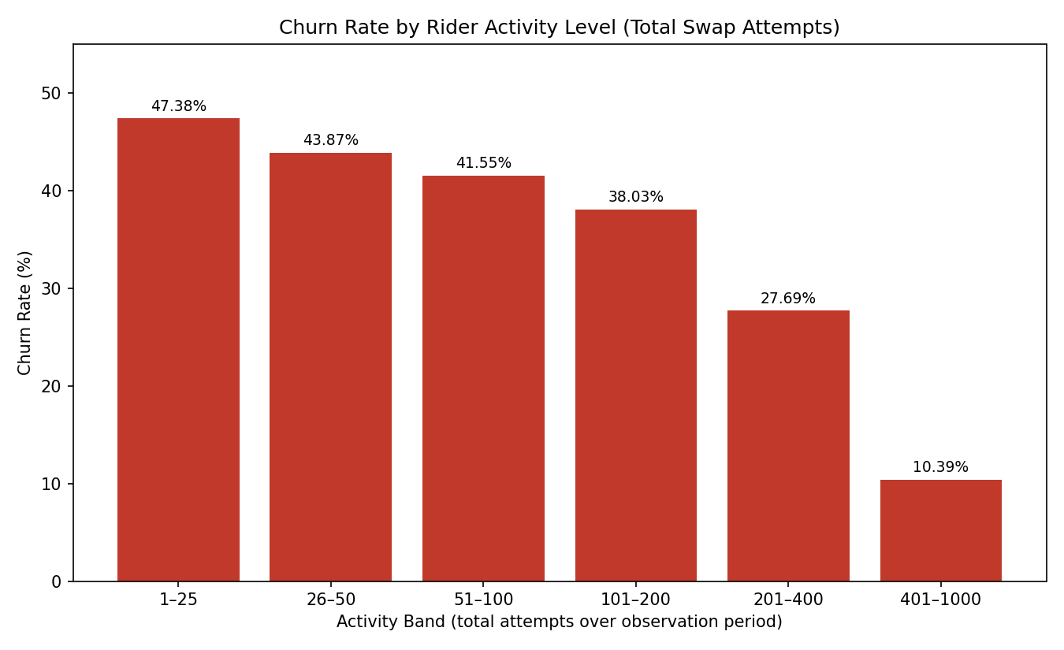
Figure 10. Churn rate by total swap attempts over the observation period. Historical output; pending corrected rerun.
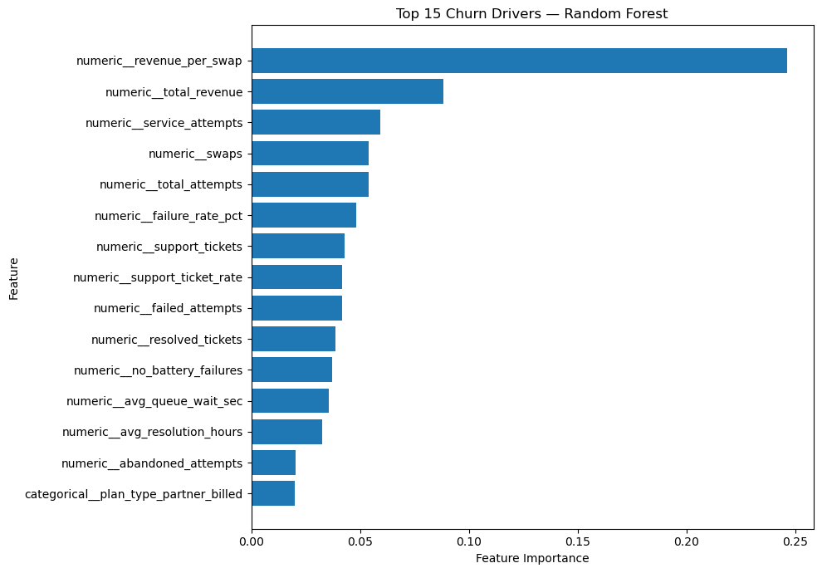
Figure 9. Top churn drivers by Random Forest feature importance. Historical output; pending corrected rerun.
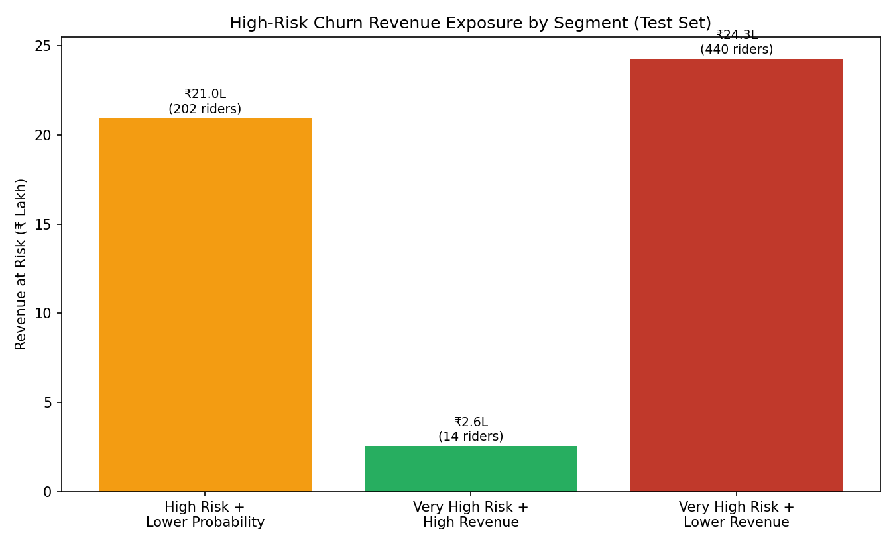
Figure 11. Revenue at risk split by churn-probability / revenue segment (test set). Historical output; pending corrected rerun.
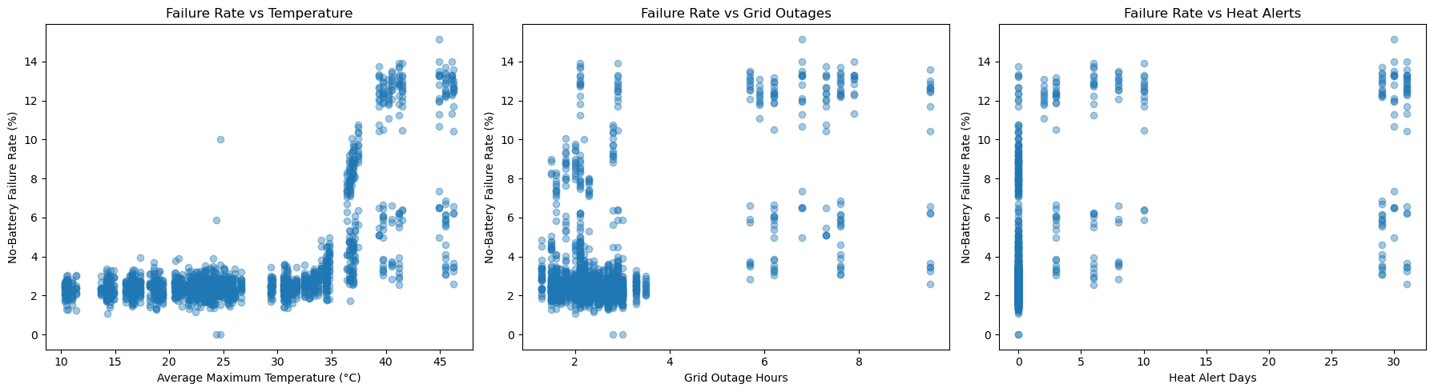
Figure 1. No-battery failure rate vs. temperature, grid outages, and heat-alert days (city-month level). Historical output; pending corrected rerun.
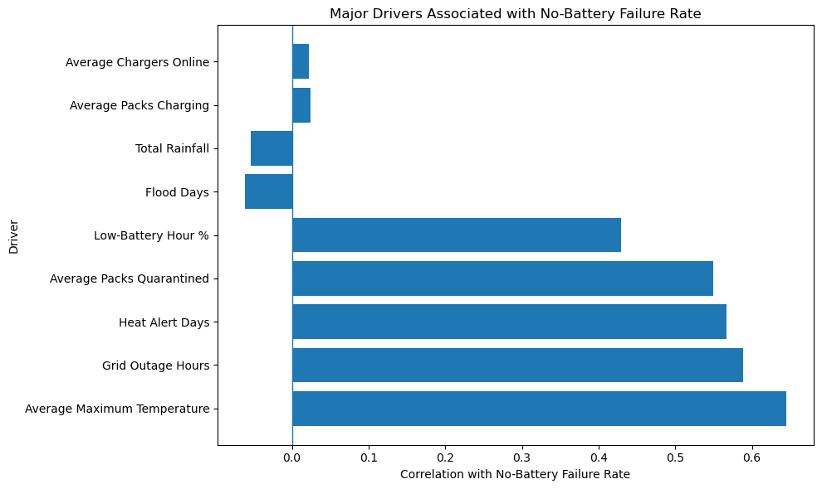
Figure 2. Correlation strength of each operational/environmental driver with failure rate. Historical output; pending corrected rerun.
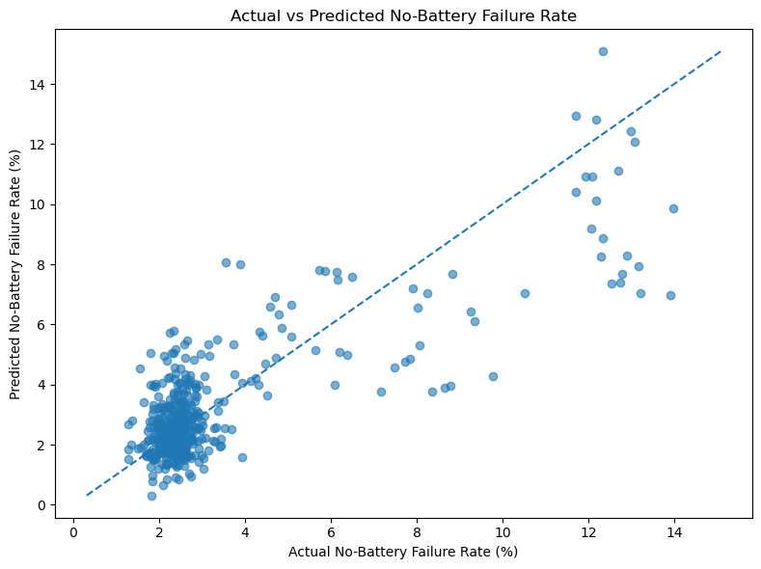
Figure 3. Actual vs. predicted failure rate from the regression model (R² = 0.66); points near the dashed line are well-predicted. Historical output; pending corrected rerun.
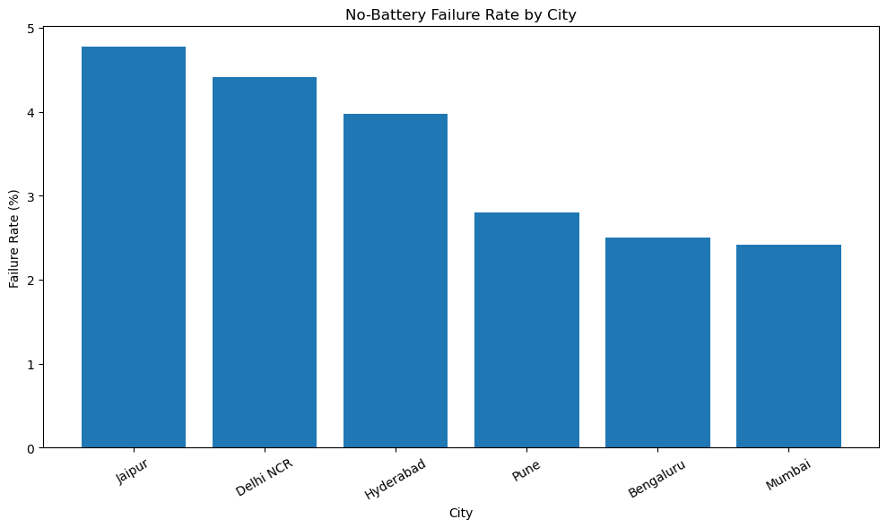
Figure 4. No-battery failure rate by city. Historical output; pending corrected rerun.
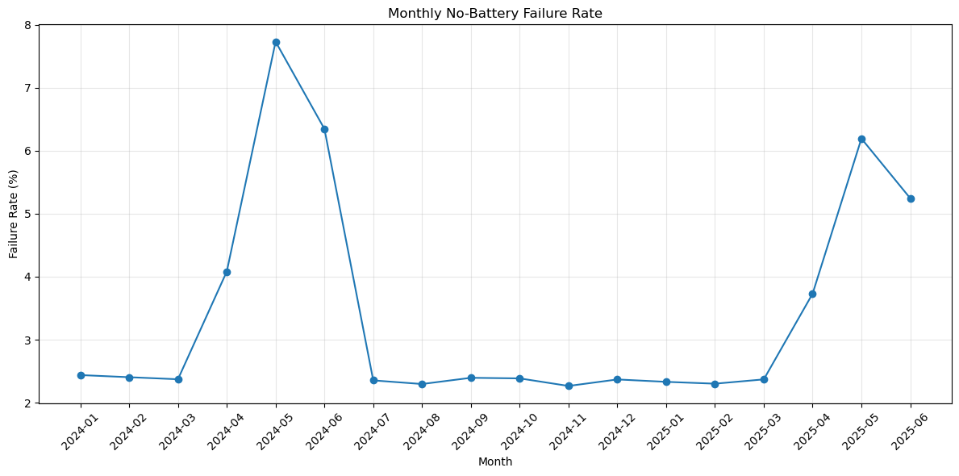
Figure 5. Monthly no-battery failure rate, Jan 2024 – Jun 2025 — note the repeating April–June spike. Historical output; pending corrected rerun.
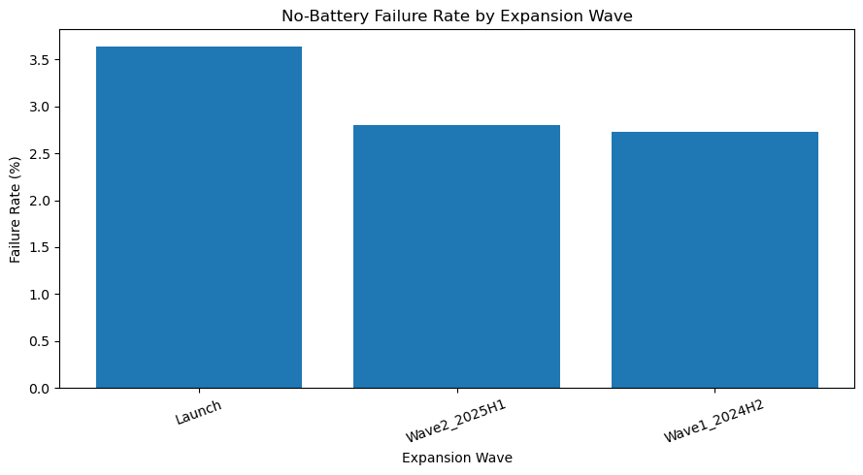
Figure 6. Failure rate by station expansion wave — later cohorts outperform the original Launch wave. Historical output; pending corrected rerun.
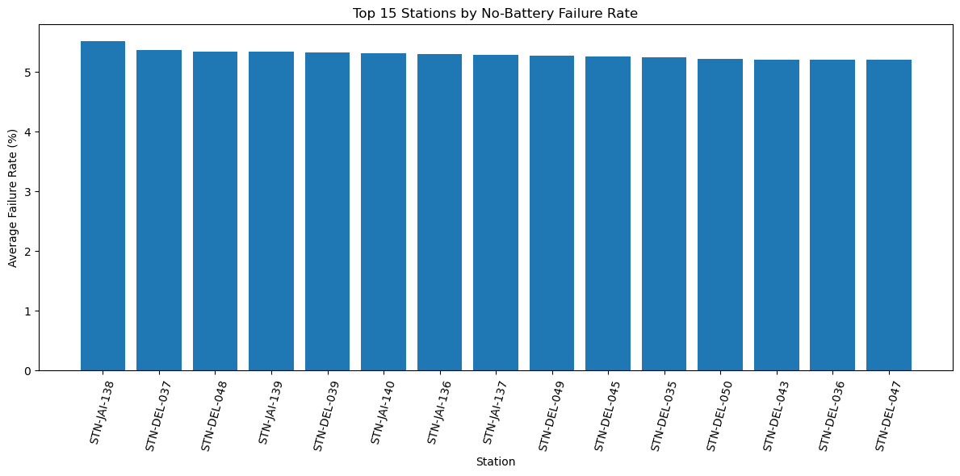
Figure 7. Top 15 stations by average no-battery failure rate. Historical output; pending corrected rerun.
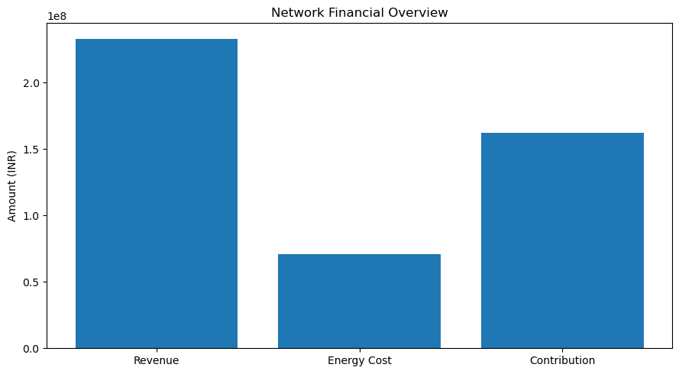
Figure 8. Network revenue, energy cost, and contribution margin (18-month total). Historical output; pending corrected rerun.
Figure 9. Top churn drivers by Random Forest feature importance. Historical output; pending corrected rerun.
Figure 10. Churn rate by rider activity level (total swap attempts). Historical output; pending corrected rerun.
Figure 11. Revenue at risk by churn-risk / revenue segment (test set). Historical output; pending corrected rerun.

