ANALYSIS REPORT
EV Battery-Swap Network:
Service Reliability Diagnostics & Rider Churn Risk
Diagnosing no-battery failure drivers, quantifying network economics, and
predicting rider churn to prioritize retention and reliability investment
Data period: January 2024 – June 2025 (18 months)
Coverage: 6 cities • 152 stations • 19,950 active riders • 3.88M swap attempts
Prepared by: Vedansh Mittal

1. Problem Understanding
The business operates a battery-swap charging network for electric two-wheelers and three-wheelers across six Indian cities — Bengaluru, Delhi NCR, Hyderabad, Jaipur, Mumbai and Pune. Riders visit a station, exchange a depleted battery for a charged one, and pay per swap. Over the 18-month observation window the network recorded 3.88 million swap attempts across 152 stations, serving 19,950 active riders who are either independent riders or affiliated with one of 12 fleet partners.
Two business-critical problems motivated this analysis:
- Service reliability — in ~3.5% of visits, a rider finds no charged battery available (a “no-battery failure”). This is the single largest controllable driver of a poor rider experience, and it is not evenly distributed across cities, stations or seasons.
- Rider retention — roughly one in three riders churns (goes inactive) within the observation window, taking recurring revenue with them. Not all churned riders are equally valuable, so the business needs to know who is at risk and how much revenue that represents.

Business questions this report answers
- What operational and environmental factors drive no-battery failures, and can the failure rate be predicted well enough to plan ahead?
- Which stations, cities and station “expansion waves” (rollout cohorts) underperform, and why?
- What are the network's core unit economics (revenue, energy cost, contribution margin)?
- What actually predicts rider churn — is it service quality, usage behaviour, or rider segment?
- Which riders carry the greatest revenue-at-risk, and how should retention effort be prioritized?

Data sources
Seven linked datasets were used, cross-validated for referential integrity (zero orphaned rider, station or battery references across all joins):
Dataset | Rows | What it captures
stations.csv | 152 | Station metadata: city, location/host type, expansion wave, charger generation, rent & tariff economics
station_hourly_status.csv | 1,487,712 | Hourly telemetry per station: charged packs, quarantined packs, chargers online, temperature, outage minutes
swap_events.csv | 3,877,013 | Every swap attempt: outcome, pricing, battery state-of-charge/health, queue wait, payment
riders.csv | 20,000 | Rider profile: vehicle class, plan type, fleet affiliation, signup channel, home city
batteries.csv | 6,500 | Battery pack inventory: supplier, cost, rated capacity, state of health
fleet_partners.csv | 12 | B2B partner contract terms and discount structures
support_tickets.csv | 44,000 | Rider support interactions: category, priority, resolution time, CSAT

2. Analytical Approach
The analysis was split into two linked tracks that share the same station, rider and financial context:

Track A — Service Reliability & Network Economics
- Merged 18 months of hourly station telemetry with the swap-attempt log and station metadata, then aggregated to city-month grain.
- Ran correlation analysis between the no-battery failure rate and nine candidate drivers (temperature, grid outages, heat-alert days, rainfall, flood days, packs quarantined/charging, chargers online, low-battery hours).
- Fit a multiple linear regression model to predict failure rate from the strongest drivers, then examined residuals to find where and why the model over/under-predicts.
- Compared failure rates across station “expansion waves” (Launch vs. two later rollout cohorts) to test whether newer stations perform better.
- Built a station-level anomaly score (blending failure rate and low-battery hours) to flag the highest-priority stations.
- Reconstructed monthly network financials — revenue, energy cost and contribution margin — from completed-swap pricing data.

Track B — Rider Churn Prediction
- Defined “churn” as no swap activity in the final 60 days of the observation window, for riders with enough history to be evaluated fairly.
- Built a rider-level feature set: usage volume, service experience (failure rate, queue wait), support-ticket history, revenue, and segment (fleet vs. independent, plan type, vehicle class).
- Ran univariate churn-rate breakdowns across every segment and behavioural cut to find which factors actually separate churners from retained riders.
- Assembled a 24-column, 19,950-row modelling dataset and trained three classifiers — Logistic Regression, Random Forest and Gradient Boosting — on an 80/20 train-test split with one-hot encoded categoricals.
- Evaluated models on accuracy, precision, recall, F1 and ROC-AUC, then extracted feature importances to identify true churn drivers.
- Converted model output into a churn-probability score, banded riders into Low/Medium/High risk, and quantified revenue exposure by risk band and by rider segment.

Tools & techniques
Python (pandas, numpy) for data preparation; Pearson correlation and ordinary least-squares regression for driver analysis; scikit-learn Logistic Regression, Random Forest and Gradient Boosting classifiers for churn prediction; precision/recall/F1/ROC-AUC and confusion matrices for model evaluation.

3. Key Insights

3.1 What drives no-battery failures
The overall network no-battery failure rate is 3.47% of all swap attempts, but this masks large, structured variation. Correlating the city-month failure rate against operational and environmental factors gives a clear ranking of drivers:
Driver | Correlation | Relationship
Average maximum temperature | 0.65 | Strong positive
Grid outage hours | 0.59 | Moderate positive
Heat-alert days | 0.57 | Moderate positive
Average packs quarantined | 0.55 | Moderate positive
Low-battery hour % | 0.43 | Moderate positive
Flood days / total rainfall | − 0.05 to − 0.06 | Negligible
Packs charging / chargers online | 0.02 – 0.02 | Negligible

A multiple linear regression built on these drivers explains a substantial share of the variation in monthly city failure rate: R² = 0.663, MAE = 1.02 percentage points, RMSE = 1.49 points. Model error is not uniform — it is lowest in Mumbai and Bengaluru (avg. error < 0.9pp) and highest in Delhi NCR and Jaipur (avg. error ~1.3–1.4pp), meaning a single national model under-serves the hottest, most volatile cities and city-specific tuning would help there.
Failure rate is heavily concentrated by city:
City | Failure rate | Attempts | Failures
Jaipur | 4.78% | 487,634 | 23,303
Delhi NCR | 4.41% | 768,913 | 33,892
Hyderabad | 3.97% | 711,930 | 28,274
Pune | 2.80% | 552,910 | 15,480
Bengaluru | 2.50% | 825,327 | 20,602
Mumbai | 2.42% | 530,299 | 12,838

The single worst city-month was Jaipur, May 2024, at 12.94% — nearly 4x the network average — and the monthly trend shows a clear, repeating summer spike every April–June, driven by heat and coincident grid stress rather than a one-off event.
Newer stations are structurally more reliable. Grouping stations by rollout cohort (“expansion wave”) shows the original Launch-wave stations failing at 3.55%, versus 2.77% for the first later wave and 2.72% for the most recent wave — roughly a full percentage point of improvement, consistent with better hardware generation, siting, or battery-buffer sizing learned after launch.
The top 15 highest-failure and highest-anomaly stations are overwhelmingly Jaipur and Delhi NCR, Launch-wave, Gen1 8-slot stations with unusually high “low-battery hours” (over 200 hours/month at the worst sites) — the same sites appear on both the failure-rate and anomaly-score leaderboards, confirming these are structural, fixable problem locations rather than random noise.

3.2 Network economics
Metric | Value
Total revenue (18 months) | ₹23.31 Cr
Total energy cost | ₹7.11 Cr
Total contribution margin | ₹16.20 Cr (69.5% of revenue)
Avg. contribution per completed swap | ₹43.25
Overall failure rate | 3.47%
Overall abandonment rate | 1.77%

Revenue and contribution both grew roughly 3x from the first month to the last, and contribution-per-swap has been rising too (from ~₹38 to ~₹48) — the network's variable-cost economics are healthy and improving, which matters directly for how much reliability and retention investment it can justify.

3.3 What actually drives rider churn
Across the 19,950 riders with enough history to evaluate, 33.88% churned (6,760 riders) within the observation window. Splitting churn by segment shows almost no meaningful difference by fleet affiliation (Fleet Partner 33.95% vs. Independent 33.78%), plan type (33.3–34.0% across all three plans), or vehicle class (2W 33.55% vs. 3W 35.87%) — none of the obvious commercial segments explain churn on their own.
The strongest — and most counter-intuitive — signal is usage intensity, not service quality:
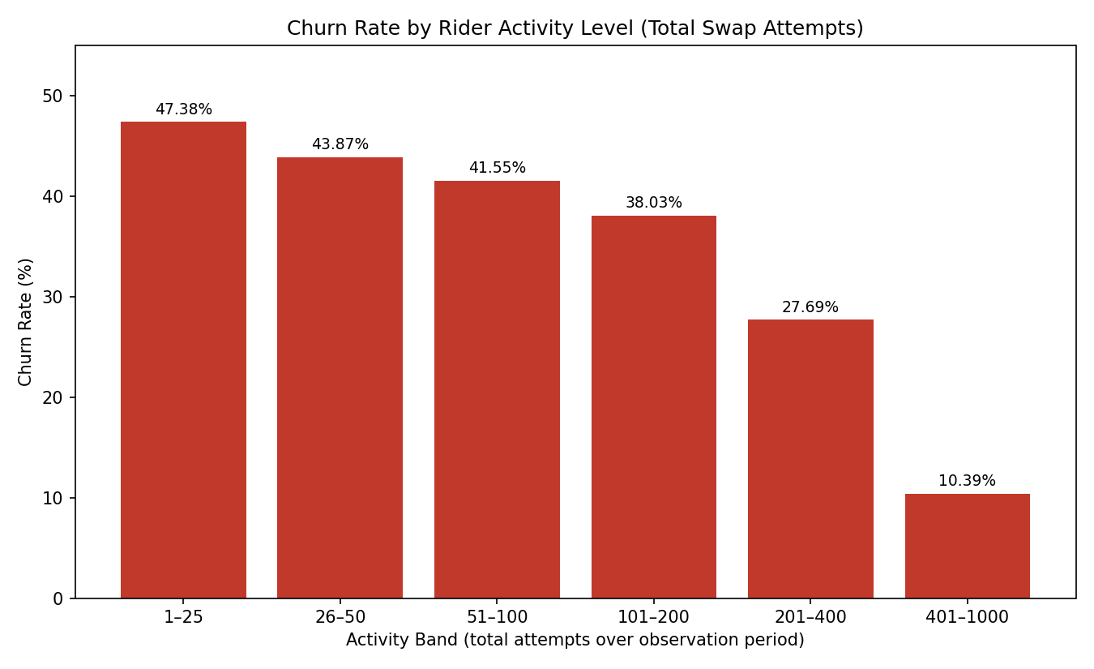
Figure 10. Churn rate by total swap attempts over the observation period.
Riders with only 1–25 total attempts churn at 47.4%, falling steadily to just 10.4% for riders with 401–1,000 attempts. By contrast, churn is inversely related to failure rate experienced — riders with a 0–2% personal failure rate churn more (49.3%) than riders with 15%+ failure rate (28.8%), and churned riders logged fewer support tickets on average (1.33 vs. 2.65) than retained riders. This pattern is consistent with a tenure/cohort effect: riders who signed up recently have simply had less time to accumulate attempts, tickets and failures before the churn cutoff, and so mechanically look like “churners” in a fixed-window definition even though nothing about their experience necessarily drove them away. This is flagged explicitly as a modelling caveat in Section 6.
That said, the failure signal is not entirely absent: among riders who did raise a support ticket, the ticket category is informative — billing disputes carry the highest churn-association of any category (31.7%), ahead of long-queue complaints (23.0%) and no-battery-available reports (22.4%), and well above generic app issues (16.9%) or “other” (16.0%). Billing friction looks like a real, fixable retention lever even though aggregate failure rate is not.

3.4 Predicting churn: model results
Three classifiers were trained on the same 38 processed features (19 numeric, rest one-hot encoded categoricals):
Model | Accuracy | Precision | Recall | F1 | ROC-AUC
Logistic Regression | 64.3% | 48.1% | 68.9% | 56.7% | 70.6%
Random Forest | 75.6% | 61.9% | 73.3% | 67.1% | 83.5%
Gradient Boosting | 81.5% | 91.8% | 49.9% | 64.6% | 86.6%

Gradient Boosting has the best headline accuracy and ROC-AUC, but its recall on the churn class is only 49.9% — it misses roughly half of all riders who actually churn. Random Forest trades some precision for a much higher 73.3% recall, catching most at-risk riders while remaining reasonably accurate — the better choice for an early-warning retention system, where missing a churner is more costly than one extra false alarm.
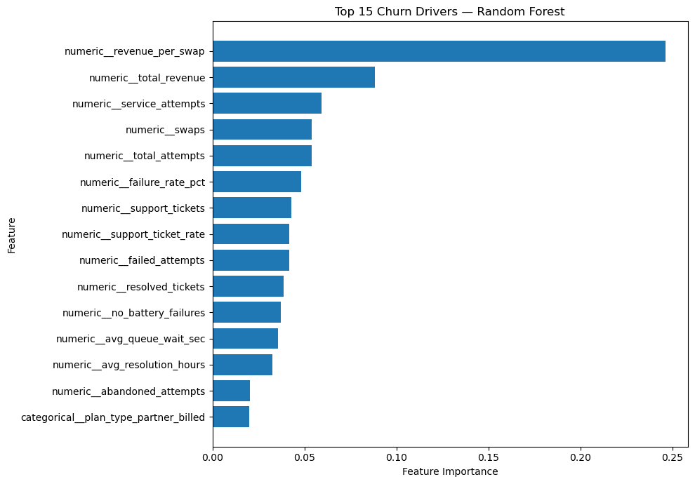
Figure 9. Top churn drivers by Random Forest feature importance.
Feature importance confirms the usage-intensity story: revenue-per-swap (24.6%) and total revenue (8.8%) are by far the strongest predictors, followed by service attempts, total swaps and total attempts. Failure rate (4.8%) and support-ticket metrics rank meaningfully lower — the model is, in effect, mostly learning “how much does this rider use the service,” not “how good is their service experience.”

3.5 Where the revenue risk is concentrated
Scoring the 3,990-rider test set, 656 riders (16.44%) fall into the High-Risk churn band, 1,072 (26.9%) Medium, and 2,262 (56.7%) Low. High-risk riders account for ₹47.79 lakh of test-set revenue — 10.41% of the total — at an average of ₹7,285 per rider.
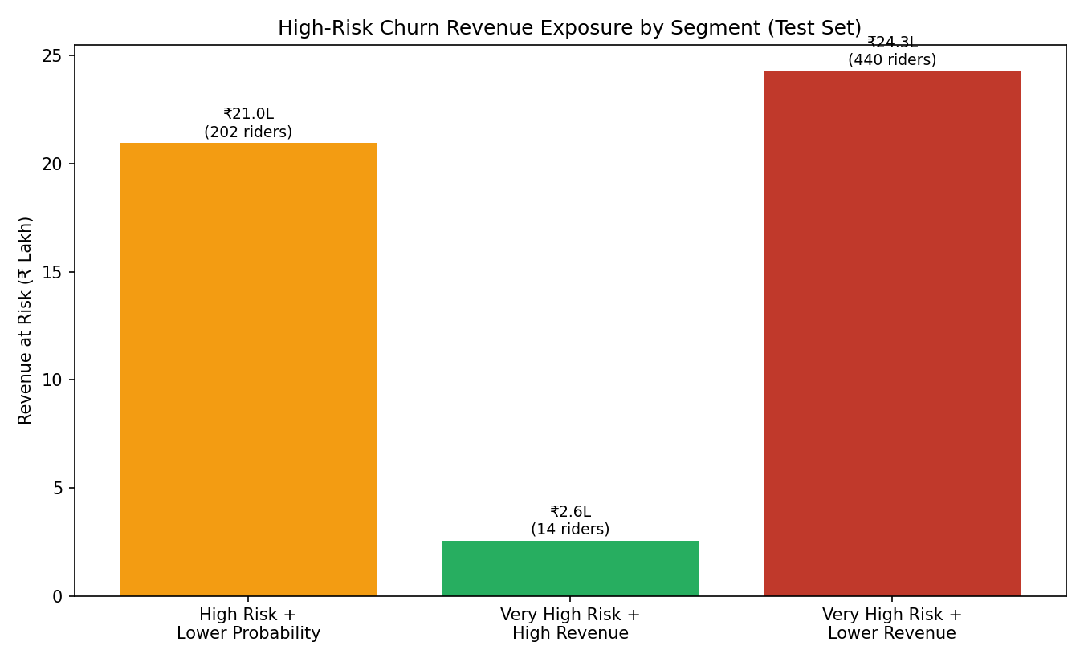
Figure 11. Revenue at risk split by churn-probability / revenue segment (test set).
Revenue-at-risk is itself concentrated: the top 66 high-risk riders (90th percentile by revenue) represent 27% of all at-risk revenue, and 2W, partner-billed, fleet-partner riders make up 54.7% of the at-risk revenue pool — by far the largest single exposure segment. Segmenting risk further: a small group of 14 “Very High Risk + High Revenue” riders (avg. ₹18,244 revenue each) is worth individual, white-glove retention attention, while the much larger 440-rider “Very High Risk + Lower Revenue” group (50.8% of at-risk revenue) is better served by automated, lower-cost retention offers.

4. Supporting Visualizations
The charts below were produced directly from the underlying analysis and are referenced throughout Section 3; they are collected here for easy review.

Reliability & Operations
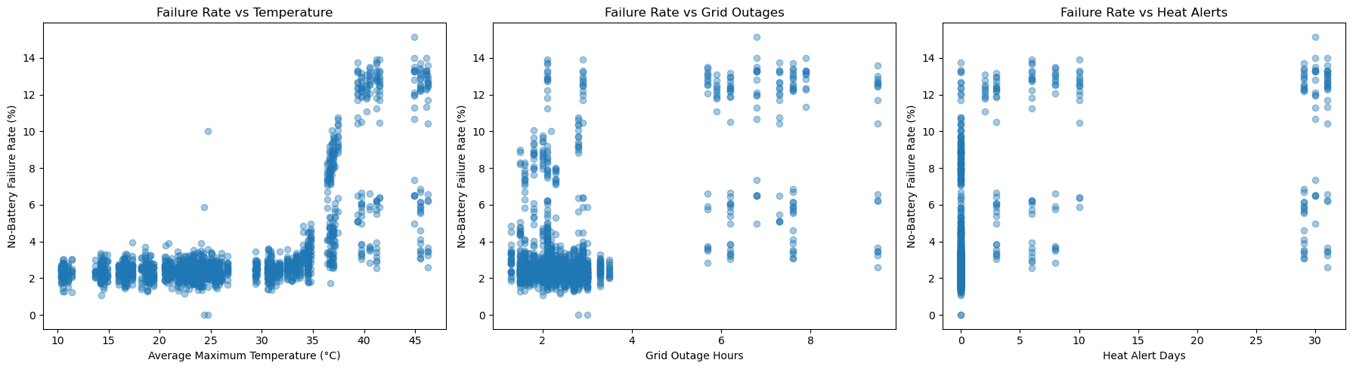
Figure 1. No-battery failure rate vs. temperature, grid outages, and heat-alert days (city-month level).
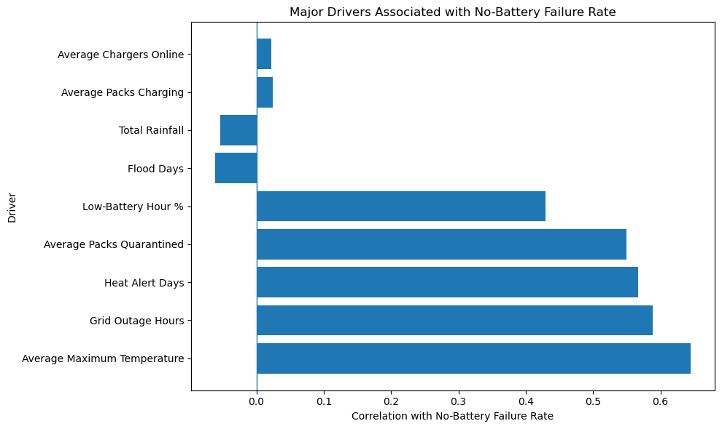
Figure 2. Correlation strength of each operational/environmental driver with failure rate.
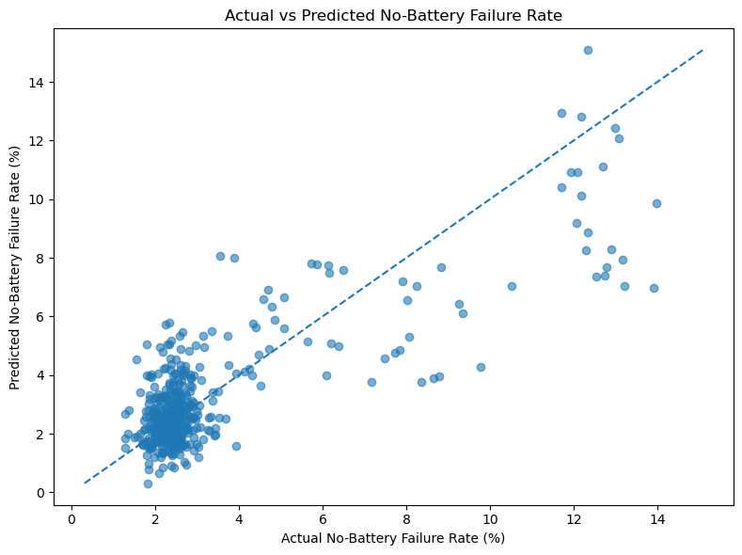
Figure 3. Actual vs. predicted failure rate from the regression model (R² = 0.66); points near the dashed line are well-predicted.
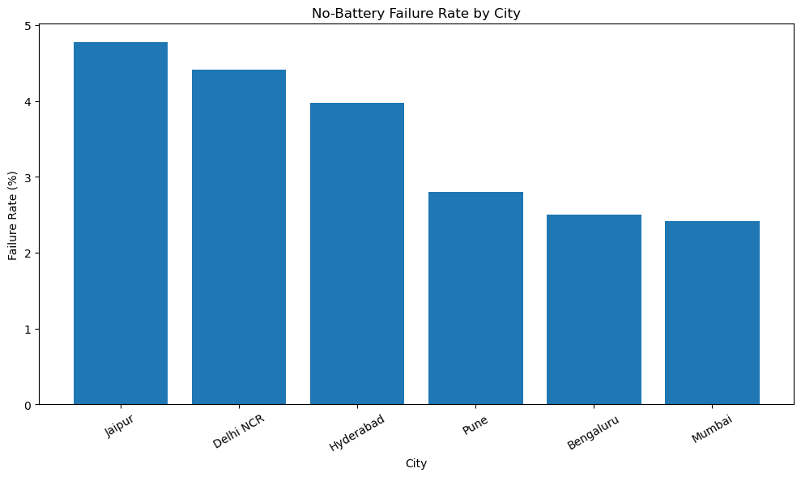
Figure 4. No-battery failure rate by city.
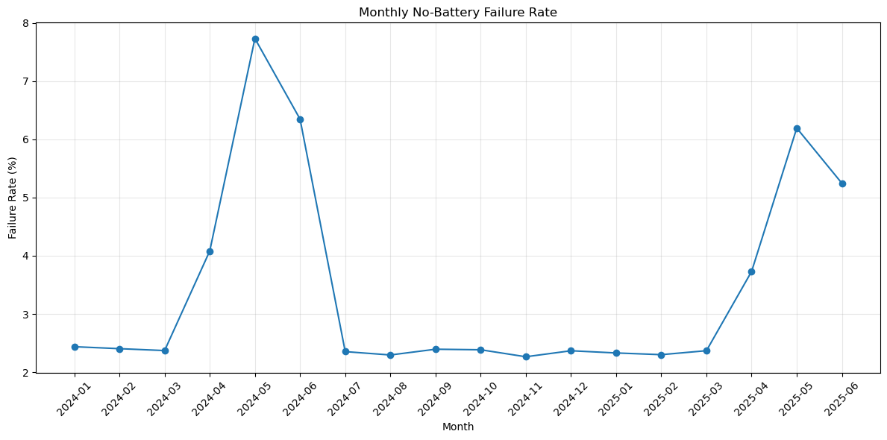
Figure 5. Monthly no-battery failure rate, Jan 2024 – Jun 2025 — note the repeating April–June spike.
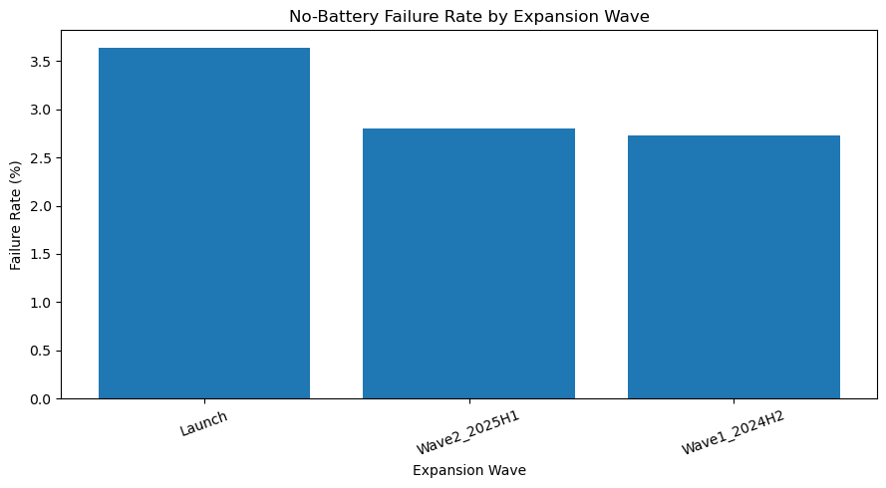
Figure 6. Failure rate by station expansion wave — later cohorts outperform the original Launch wave.
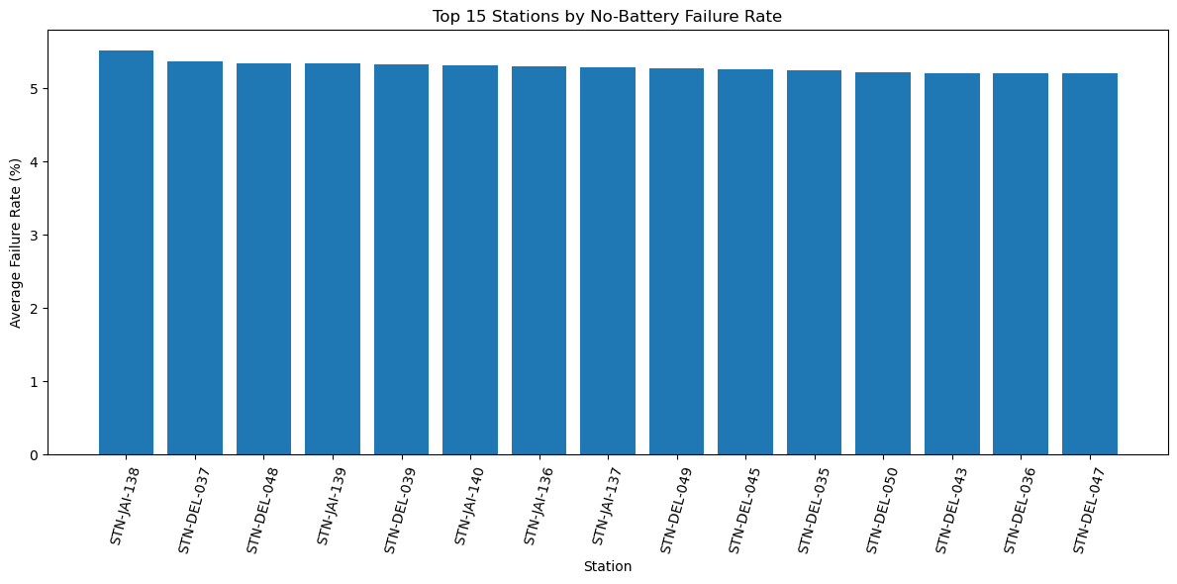
Figure 7. Top 15 stations by average no-battery failure rate.
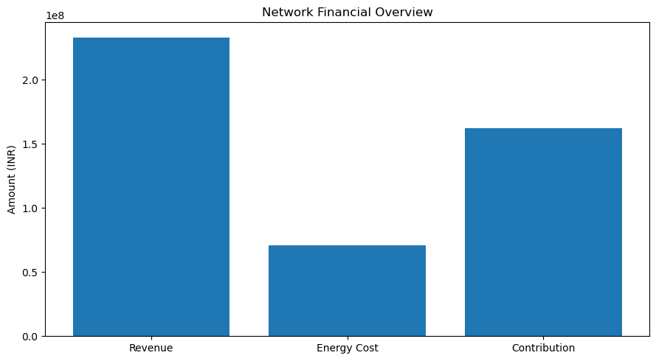
Figure 8. Network revenue, energy cost, and contribution margin (18-month total).

Rider Churn
Figure 9. Top churn drivers by Random Forest feature importance.
Figure 10. Churn rate by rider activity level (total swap attempts).
Figure 11. Revenue at risk by churn-risk / revenue segment (test set).

5. Business Findings
Translating the analysis into what it means for the business:
Heat is the single biggest, most predictable operational risk
Failure rate does not rise gradually with temperature — it steps up sharply above roughly 35°C, and the network's two hottest, most heat-exposed cities (Jaipur, Delhi NCR) carry both the highest average failure rate and the worst individual city-months. Because this is seasonal and recurring (every April–June), it is a planning problem, not a surprise.
Grid instability compounds the heat problem
Grid outage hours correlate with failures almost as strongly as temperature itself (0.59 vs. 0.65), and the two tend to occur together. This points to insufficient battery buffer or backup power at exactly the stations and times when demand for charged batteries is highest.
The network has structurally “learned” — newer stations are better
Post-launch expansion waves fail roughly one percentage point less often than the original Launch cohort, and the worst-performing stations today are almost all old, Gen1, Launch-wave sites in Jaipur and Delhi NCR. This is good news operationally: the fix (better siting, buffer sizing, hardware) is already known to work — it simply hasn't been retrofitted to the legacy fleet.
The business can afford to invest in fixing this
At a 69.5% contribution margin and roughly 3x revenue growth over 18 months, the network's unit economics are healthy and improving. The case for spending on station upgrades and retention programs is strong because the underlying business can absorb the cost.
Churn is a scale/engagement problem, not primarily a quality problem
With roughly a third of riders churning and virtually no relationship to failure rate or fleet/plan segment, blanket “reduce failures to cut churn” messaging will not move the needle much. Churn is concentrated among low-usage, likely newer riders — this looks like an onboarding and habit-formation problem more than a service-quality one, and should be measured and targeted as such (see Section 6's note on churn-definition bias).
Billing friction is a real, fixable exception to that pattern
Even though overall failure rate doesn't predict churn well, riders who raise a billing dispute churn at the highest rate of any support-ticket category (31.7%). This is a specific, addressable process issue rather than a broad reliability one.
Retention effort has an 80/20 structure
A small number of riders account for a disproportionate share of at-risk revenue: the top 66 high-risk riders alone represent 27% of at-risk revenue, and over half of all at-risk revenue sits with 2W, partner-billed, fleet-partner riders. Spreading retention budget evenly across all flagged riders would waste effort relative to targeting these pockets.
Random Forest is the more useful churn model for this business, despite lower headline accuracy
Because a missed churner (lost recurring revenue) is more costly than one extra unnecessary retention offer, the model that catches the most true churners — Random Forest, at 73.3% recall — is more valuable operationally than Gradient Boosting's higher but narrower 49.9% recall, even though Gradient Boosting scores better on raw accuracy.

6. Actionable Recommendations

A. Network Operations & Reliability
- 1. Pre-position battery buffer ahead of summer, not during it. Increase charged-battery stock and quarantine-clearing priority at Jaipur and Delhi NCR stations by an estimated 20–30% from March through June, using the observed April–June spike as the planning trigger rather than reacting after failure rates climb.
- 2. Target backup power at the highest-anomaly stations first. The ~15 stations flagged as top failure/anomaly outliers (mostly Jaipur/Delhi NCR, Gen1, Launch-wave) are where outage hours and battery quarantine rates compound — prioritize UPS/backup-power and battery-buffer upgrades there before a network-wide rollout.
- 3. Retrofit legacy Launch-wave stations with what later waves already do better. Since Wave1/Wave2 stations run ~0.8–1.0 point lower failure rates, treat the highest-anomaly Launch-wave sites as priority candidates for the same hardware, siting or battery-allocation changes used in later cohorts, rather than commissioning only new stations.
- 4. Operationalize the regression model as a monthly planning input. Feed forecast temperature and grid-outage data into the model each month to flag city-months likely to spike, and use it to pre-position batteries and staff. At R² = 0.66 it is reliable enough for city-level planning, not for single-station decisions — pair it with local judgment in Delhi NCR and Jaipur specifically, where model error is highest.

B. Retention & Rider Experience
- 5. Prioritize early-tenure engagement over failure-reduction messaging. Since churn is dominated by low usage/short tenure rather than failure exposure, invest in onboarding nudges and usage milestones (e.g., first 25/50/100 swaps) for new riders — service-reliability fixes alone are unlikely to move overall churn.
- 6. Fix billing-dispute handling as a standalone workstream. Billing disputes have the highest churn-association of any ticket category (31.7%) — audit discount/tariff logic and shorten time-to-resolution specifically for this category.
- 7. Deploy the Random Forest risk score as an operational early-warning system. Score active riders monthly and route the ~16% flagged “High Risk” into a retention workflow (targeted offer, priority support), since it catches roughly three-quarters of eventual churners at acceptable precision.
- 8. Concentrate retention spend on the two highest-value at-risk pockets, not all 656 flagged riders evenly. Give the 14 “Very High Risk + High Revenue” riders (~₹18K average revenue) individual, human-touch outreach; give the top-66-by-revenue high-risk cohort (27% of at-risk revenue) targeted, proactive win-back offers before they lapse.
- 9. Work through fleet partners, not just individual riders, for the biggest segment. 2W, partner-billed, fleet-partner riders are 55% of at-risk revenue — pair rider-level retention offers with partner-level SLA and incentive conversations for this segment.

C. Measurement & Next Steps
- 10. Re-examine the churn definition before acting further on it. The current 60-day-inactivity label is confounded with rider tenure — new signups mechanically look like “churn” before they've had time to build usage history. A cohort-adjusted or survival-analysis approach would separate genuine attrition from natural ramp-up and materially sharpen every downstream churn insight.
- 11. Extend the failure model with station-specific variables. The largest prediction errors (up to ~7 percentage points) and city-level error differences suggest missing local factors — staffing levels, footfall, or nearby competitor density are natural next additions.

