CS 4444 Parallel Computing – Spring 2016
Homework 1
Himanshu Ojha

Problem Description:
The goal of this assignment was to optimize a sequential program running on a uniprocessor. The program simply runs a mathematical expression on a variable set of data.

Approach:
My approach was to try an optimization, make sure that the result was not changed due to the optimization, and then run the optimization on slurm. If the optimization successfully decreased time, then I continued using that optimization. In order to discover my optimizations, I used the lecture hints along with optimizations I knew about from other courses. I also looked through the optimization flags for the compiler to determine which optimizations I could do.
A key thing to note is that numerous optimization that I tried ended up changing the resulting answer. In this case, I did not record the time for these broken optimizations, but did mention some of them in this approach section. Many of these optimizations failed because of differing floating point densities leading to numbers being rounded off differently than in the original version of the program, and floating point cancellation when subtracting very large numbers from numbers close to 0.
The optimizations I tried using were:
- Compilers O2 flag - This flag performs numerous compiler optimizations, but tries to maintain the code size.
- Compilers O3 flag - This flag performs numerous compiler optimizations on top of the O2 optimization, and increases the code size if need be.
- Removing one of the if statements in the for loop by making the statement a guard for the loop. - This optimization is intended to reduce the number of conditional branches within the for loop in hopes that this allows the compiler to better parallelize instructions. The issue with this optimization was that there were multiple conditional clauses within the loop so removing only a single one may not have as much of an impact as desired. In addition, the desired parallel effects also may not occur because this program is being run on a single processor, and not the optimal vector processors for this type of task.
- += instead of = - This optimization allows to decrease the number of fetch instructions to a given variable by simply adding to that variable rather than fetching the variable, adding to it and then setting this result to the original variable.
- Move lookups out of for loops – This optimization was used with both the 2D coords array and the q array. This optimization decreased the number of array lookups that were required for the coords array. A lookup for each desired row was done and stored in a temporary variable prior to entering the inner for loop. In the inner for loop, this temporary variable was used instead of the coords array. A similar approach was used for the q array. This optimization took advantage of the memory hierarchy because it was more likely able to store the desired portions (desired rows) of memory in cache. For the q array case, the temporary variable prior to the inner for loop actually stored the floating point number directly which may have allowed this variable to be stored in a register thus effectively using the memory hierarchy.
- Reduce the main expression to use a single exponential function - Exponentiation is very slow, thus I simplified the e^(rij*qi)*e^(rij*qj) expression into e^(rij * qi + rij * qj). I tried to also simplify this second expression by distributing out the rij term, however, this led to different results so I did not move further with this optimization.
- Convert the pow(expression, 2.0) function into multiplication – This optimization was intended to reduce the number of exponents used, but failed due to differing result answers.
- Convert division into multiplication – 1.0/a was a commonly used expression in the double for loop. It was optimized out by creating a temporary variable at the start of the program that stored the result of 1.0/a and simply multiplying by this temporary variable in the double for loop. This optimization was meant to take advantage of the fact that division is much slower than multiplication. In addition, this optimization also takes advantage of the fact that recomputing an expression in the double for loop is much slower than simply calculating the expression once and storing the result.
- Aggregating the 1.0/a summation – The summation expression could be split into two where the second summation was simply adding together 1.0/a the number of times that the summation occurred. I removed the subtraction from the double for loop and placed it after the double for loop and multiplied it by the number of times the summation occurred. This optimization was meant to take advantage of reducing mathematical expressions and not performing the same expression numerous time. This optimization, however, did not work as the resulting answer was different. This is likely because of floating point cancellation that occurs at each individual summation in the original program which likely does not occur when aggregating.
- Selectively using sqrt – In the inner for loop, this optimization changes the if statement from if(rij <= cut) where rij is a square root of vec2 to if(vec2 <= cut*cut) since this allows for not using a square root at each iteration of the double for loop. This optimization was intented to take advantage of the fact that taking the square root is much slower than multiplication. Note that the square root would still be taken inside the if condition because rij did need to be calculated for the mathematical expression to work, but it would not be calculated in the numerous cases where the internal mathematical expression was not reached. This optimization led to different results thus was not used.

Results:
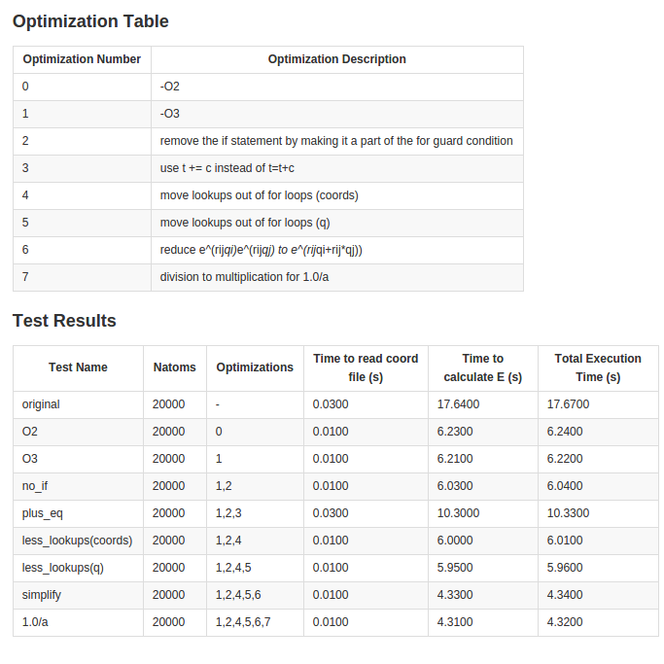

Analysis:
These results are from Rivanna when running a single task on a single node. The load may vary at times but given that repeated trials for a given test case yielded similar results, the load likely did not influence my calculations too frequently.
These results reveal that the optimizations done by the compiler with simply level 2 optimizations led to the greatest decrease in speed. In terms of code changes, the greatest decrease in speed was due to the decreasing number of array lookups in coords.
Simplifying the equation also led to a sizable decrease in speed.
The plus-equals optimization ended up slowing down the speed of the program, but seems to be the only optimization that does so.

Conclusions:
Above all, it is best to write code in a way that allows the compiler to optimize. The compiler's optimizations certainly are the best.
Once that is done, it is best to focus on the memory hierarchy. The key optimization that decreased time is the changing array lookups to store a row in a temporary variable. This likely allowed for the rows to be stored in cache which led to much faster time. Notably, doing something similar with the q array did not yield such a magnificent speedup because it likely only moved variables from cache to registers. While this is a significant improvement, it is not as significant as moving data from disk or even main memory to cache.
Finally, simplifying equations in order to reduce use of expensive functions is certainly a key way to increase the speed of a program.

Pledge:

On my honor as a student, I have neither given nor received aid on this assignment.

Files:
run.slurm – this is the SLURM file I used to submit the job
speedup.c – this is the optimized version of the original c file

run.slurm:

#!/bin/bash
#SBATCH -N 1
#SBATCH -n 1
#SBATCH -t 01:00:00
#SBATCH -o output_filename
#SBATCH -p training
#SBATCH -A parallelcomputing

gcc -O3 -lm -o speedup speedup.c ; ./speedup large_input.txt 0.5

speedup.c:
/*+++++++++++++++++++++++++++++++++++++++++++++++++++++++++++++++++++++
! Bad coding example 1
! !
! Shamefully written by Ross Walker (SDSC, 2006)
!
! This code reads a series of coordinates and charges from the file
! specified as argument $1 on the command line.
!
! This file should have the format:
! I9
! 4F10.4 (repeated I9 times representing x,y,z,q)
!
! It then calculates the following fictional function:
!
! exp(rij*qi)*exp(rij*qj) 1
! E = Sum( ----------------------- - - ) (rij <= cut)
! j<i r(ij) a
!
! where cut is a cut off value specified on the command line ($2),
! r(ij) is a function of the coordinates read in for each atom and
! a is a constant.
!
! The code prints out the number of atoms, the cut off, total number of
! atom pairs which were less than or equal to the distance cutoff, the
! value of E, the time take to generate the coordinates and the time
! taken to perform the calculation of E.
!
! All calculations are done in double precision.
!+++++++++++++++++++++++++++++++++++++++++++++++++++++++++++++++++++++*/

#include <stdio.h>
#include <stdlib.h>
#include <time.h>
#include <math.h>
double **alloc_2D_double(int nrows, int ncolumns);
void double_2D_array_free(double **array);

int main(int argc, char *argv[])
{
long natom, i, j;
long cut_count;

/* Timer variables */
clock_t time0, time1, time2;

double cut; /* Cut off for Rij in distance units */
double **coords;
double *q;
double total_e, current_e, vec2, rij;
double a;
FILE *fptr;
char *cptr;
double * coords_0;
double * coords_1;
double * coords_2;
double coords_0_i_minus_1;
double coords_1_i_minus_1;
double coords_2_i_minus_1;
double q_i_minus_1;
double one_over_a;
a = 3.2;
one_over_a = 1.0/a;

time0 = clock(); /*Start Time*/
printf("Value of system clock at start = %ld\n",time0);

/* Step 1 - obtain the filename of the coord file and the value of
cut from the command line.
Argument 1 should be the filename of the coord file (char).
Argument 2 should be the cut off (float). */
/* Quit therefore if iarg does not equal 3 = executable name,
filename, cut off */
if (argc != 3)
{
printf("ERROR: only %d command line options detected", argc-1);
printf (" - need 2 options, filename and cutoff.\n");
exit(1);
}
printf("Coordinates will be read from file: %s\n",argv[1]);

/* Step 2 - Open the coordinate file and read the first line to
obtain the number of atoms */
if ((fptr=fopen(argv[1],"r"))==NULL)
{
printf("ERROR: Could not open file called %s\n",argv[1]);
exit(1);
}
else
{
fscanf(fptr, "%ld", &natom);
}

printf("Natom = %ld\n", natom);

cut = strtod(argv[2],&cptr);
printf("cut = %10.4f\n", cut);

/* Step 3 - Allocate the arrays to store the coordinate and charge
data */
coords=alloc_2D_double(3,natom);
if ( coords==NULL )
{
printf("Allocation error coords");
exit(1);
}
q=(double *)malloc(natom*sizeof(double));
if ( q == NULL )
{
printf("Allocation error q");
exit(1);
}

/* Step 4 - read the coordinates and charges. */
for (i = 0; i<natom; ++i)
{
fscanf(fptr, "%lf %lf %lf %lf",&coords[0][i],
&coords[1][i],&coords[2][i],&q[i]);
}

time1 = clock(); /*time after file read*/
printf("Value of system clock after coord read = %ld\n",time1);

/* Step 5 - calculate the number of pairs and E. - this is the
majority of the work. */
total_e = 0.0;
cut_count = 0;
for (i=1; i<=natom; ++i)
{
coords_0 = coords[0];
coords_1 = coords[1];
coords_2 = coords[2];
coords_0_i_minus_1 = coords_0[i-1];
coords_1_i_minus_1 = coords_1[i-1];
coords_2_i_minus_1 = coords_2[i-1];
q_i_minus_1 = q[i-1];

for (j=1; j<=natom && j<i; ++j)
{

vec2 = pow((coords_0_i_minus_1-coords_0[j-1]),2.0)
+ pow((coords_1_i_minus_1-coords_1[j-1]),2.0)
+ pow((coords_2_i_minus_1-coords_2[j-1]),2.0);

/* X^2 + Y^2 + Z^2 */
rij = sqrt(vec2);

/* Check if this is below the cut off */
if ( rij <= cut )
{
/* Increment the counter of pairs below cutoff */
++cut_count;
current_e = (exp(rij*q_i_minus_1+rij*q[j-1]))/rij;
total_e = total_e + current_e - one_over_a;
}

} /* for j=1 j<=natom */
} /* for i=1 i<=natom */

time2 = clock(); /* time after reading of file and calculation */
printf("Value of system clock after coord read and E calc = %ld\n",
time2);

/* Step 6 - write out the results */
printf(" Final Results\n");
printf(" -------------\n");
printf(" Num Pairs = %ld\n",cut_count);
printf(" Total E = %14.10f\n",total_e);
printf(" Time to read coord file = %14.4f Seconds\n",
((double )(time1-time0))/(double )CLOCKS_PER_SEC);
printf(" Time to calculate E = %14.4f Seconds\n",
((double )(time2-time1))/(double )CLOCKS_PER_SEC);
printf(" Total Execution Time = %14.4f Seconds\n",
((double )(time2-time0))/(double )CLOCKS_PER_SEC);

/* Step 7 - Deallocate the arrays - we should strictly check the
return values here but for the purposes of this tutorial we can
ignore this. */
free(q);
double_2D_array_free(coords);

fclose(fptr);

exit(0);
}

double **alloc_2D_double(int nrows, int ncolumns)
{
/* Allocates a 2d_double_array consisting of a series of pointers
pointing to each row that are then allocated to be ncolumns
long each. */

/* Try's to keep contents contiguous - thus reallocation is
difficult! */

/* Returns the pointer **array. Returns NULL on error */
int i;

double **array = (double **)malloc(nrows*sizeof(double *));
if (array==NULL)
return NULL;
array[0] = (double *)malloc(nrows*ncolumns*sizeof(double));
if (array[0]==NULL)
return NULL;

for (i = 1; i < nrows; ++i)
array[i] = array[0] + i * ncolumns;

return array;

}

void double_2D_array_free(double **array)
{
/* Frees the memory previously allocated by alloc_2D_double */
free(array[0]);
free(array);
}

