Customer Relationship Management

Display all Customers: First Page

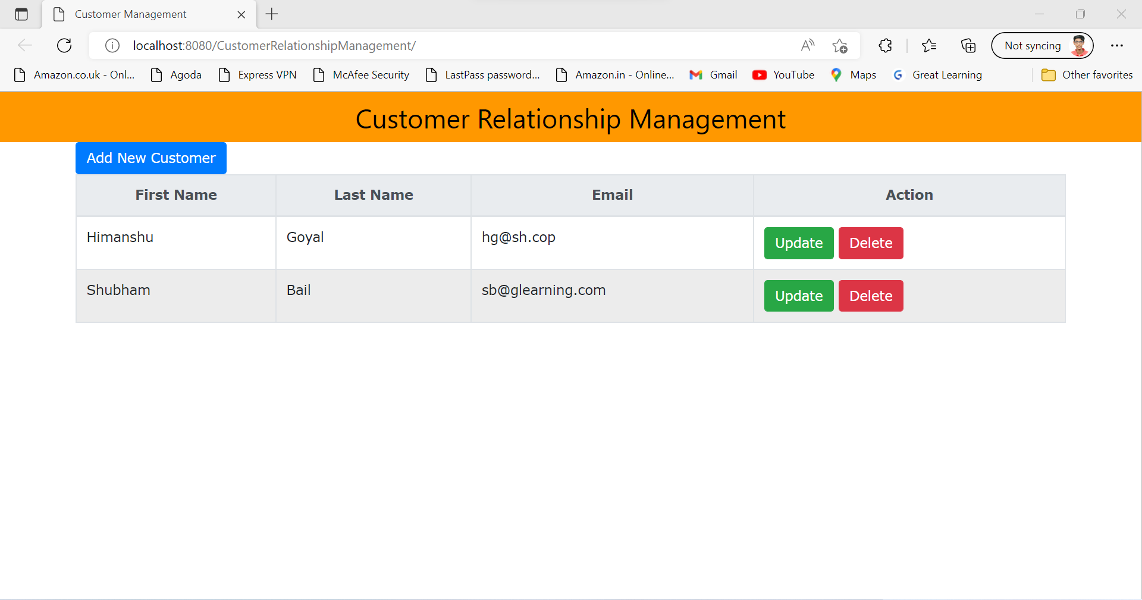

Add new Customer -> on click on Add New Customer button

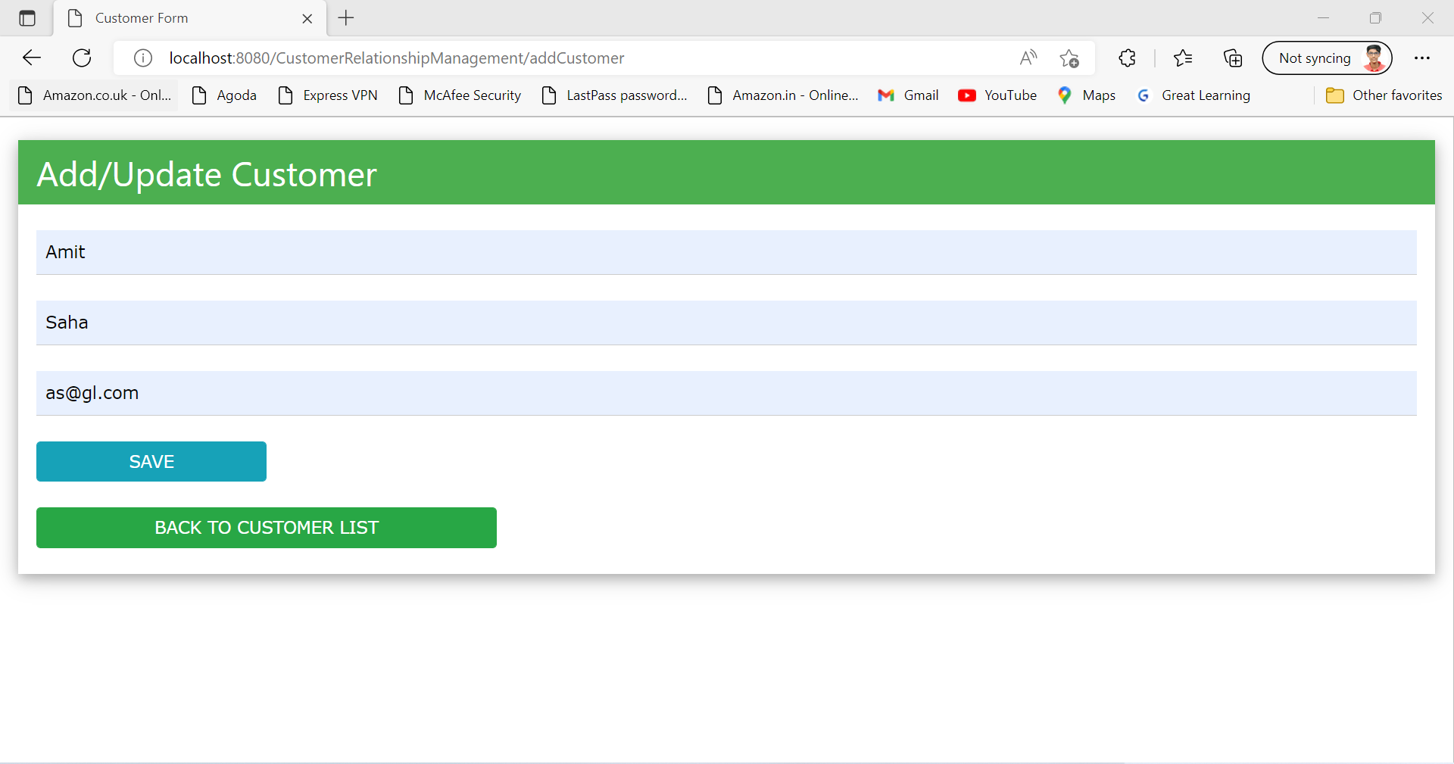

Saving New Customer -> on click on Save button

New Customer will be added as displayed on below screenshot.

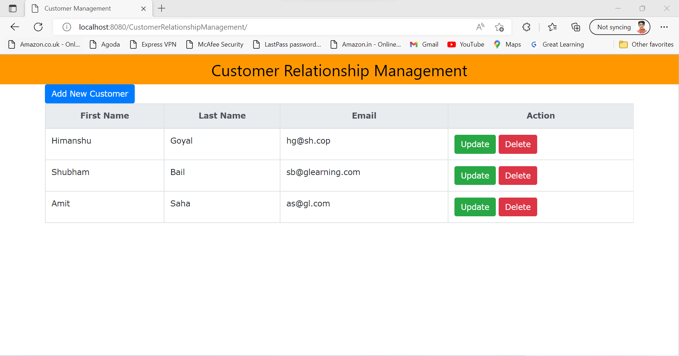

Update -> To update customer click on update button infront of customer details.

Let’s update Amit.



Already saved details will be loaded in the fields as above change the details

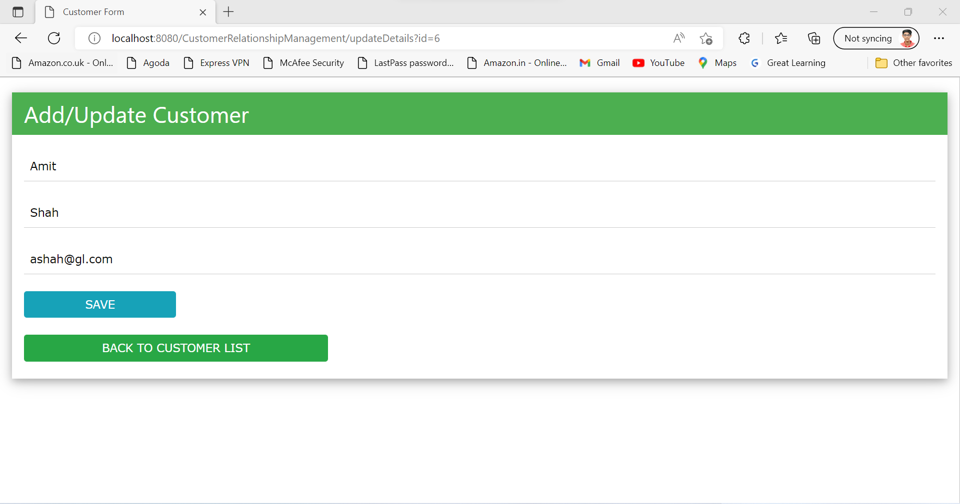

Click on save button to save the details

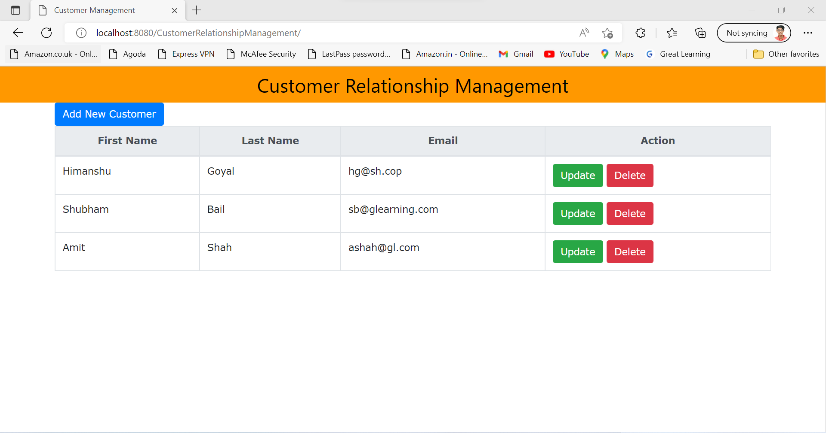

Delete-> On click on delete button pop will come where you want to delete the customer?

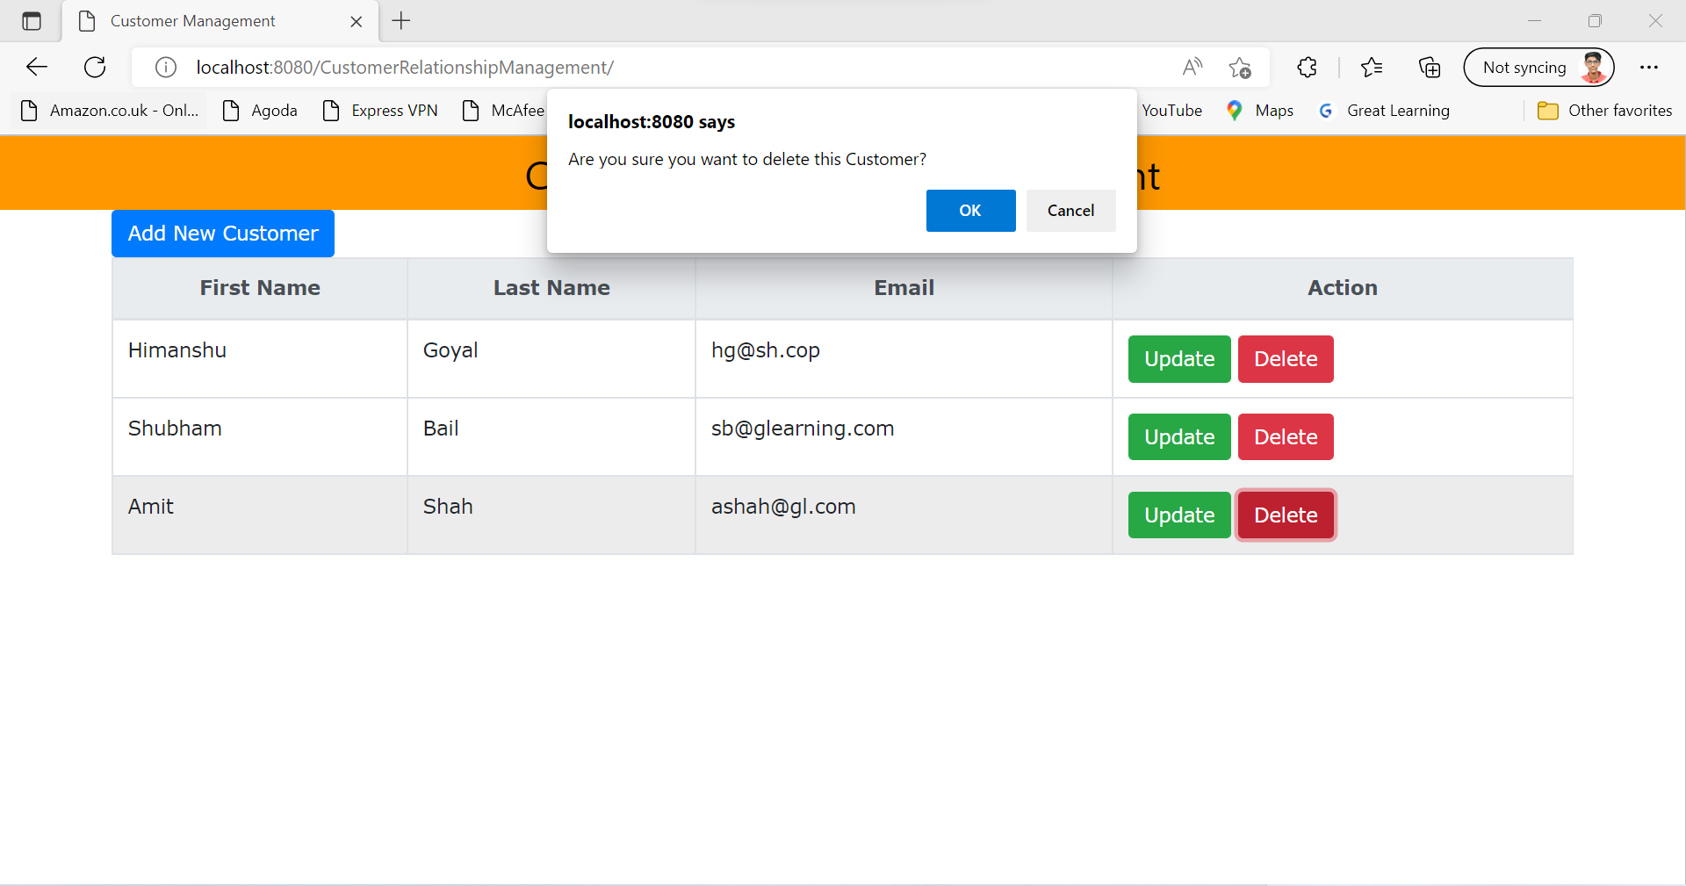

On click on cancel the record will not get deleted



Click on delete then click yes on popup

