Architecture

**FIFA World Cup**

Author: Himanshu Ranjan

Version: 1.0

**INDEX**

|  |  |  |
| --- | --- | --- |
| **Sl. No.** | **Title** | **Page No.** |
| 1 | Introduction | 3 |
| 2 | Scope | 3 |
| 3 | Architecture | 3 - 4 |
| 4 | Deployment | 5 |

# Introduction:

FIFA World Cup Analysis is a project that analyses the data of World Cup. Theme can be any of the choices. Data is divided into three forms Basic Info, Breakthrough Info and Final Info.

Users can add additional data accordingly to their choice and make meaningful data.

# Scope:

Users can make an informative, beautiful and attractive dashboard showing charts and also can make a web application using machine learning based on the additional data they added.

# Architecture:

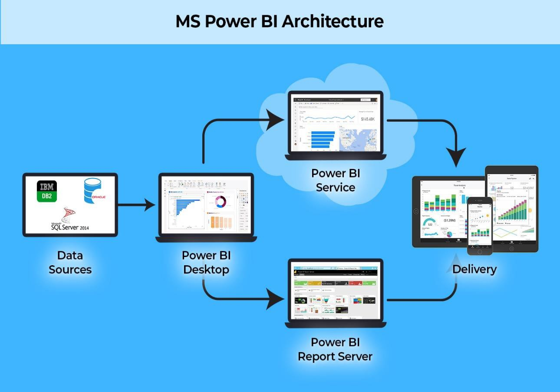

* + **Power Query:**

Power Query is a data transformation and preparation engine. Power Query comes with a graphical interface for getting data from sources and a Power Query Editor for applying transformation.

# Power Pivot:

Power Pivot is used to model the data and perform more complex calculations than Excel can handle. Power Pivot is great when working with huge data sets.

# Power View:

Power View is a data visualization technology that create interactive charts, graphs, maps, and other visuals that bring data to life. Power View is available in Excel, SharePoint, SQL Server, and Power BI.

# Power Map:

Microsoft Power Map for Excel is a three-dimensional (3-D) data visualization tool that looks at information in new ways. A power map discover insights might not see in traditional two-dimensional (2-D) tables and charts.

# Power BI Desktop:

Power BI Desktop is built for the analyst. It combines state-of-the-art interactive visualizations, with industry-leading data query and modelling built-in. Create and publish reports to Power BI. Power BI Desktop helps empower others with timely critical insights, anytime, anywhere.

# Power BI Services:

Power BI service is the Software as a Service (SaaS) part of Power BI. It is known as Power BI Online. To access Power BI Service, you need to log in to Power BI service.

# Power Q&A:

The Power Q&A feature in Power BI explore data in your own words. The first part of this article shows how you use Q&A in dashboards in the power BI service. The second part shows what you can do with Q&A when creating reports in either the Power BI service or Power BI Desktop.

# Deployment:

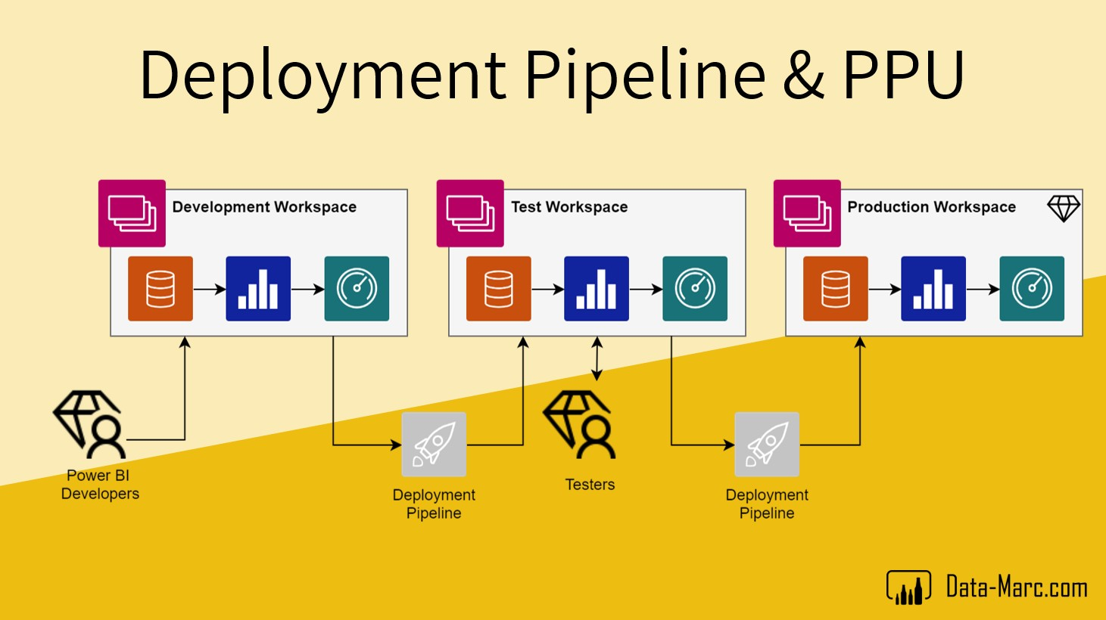

* + There are multiple ways to deploy the dashboard in Power BI. The simplest way is to publish directly on Power BI Services server from online mode. One can easily publish the work from the desktop and then it will open in browser. The user must sign in to publish the work.
  + This work can be viewed by all the viewers around the world. You can share it via a sharable link.
  + Thus, user can deploy a dashboard using Power BI Services.