*FIFA World Cup Dashboard* ***Wireframe Documentation***

Homepage

As per the problem statement, we have divided analysis into four sections: -

**1. Overview of FIFA World Cup:** 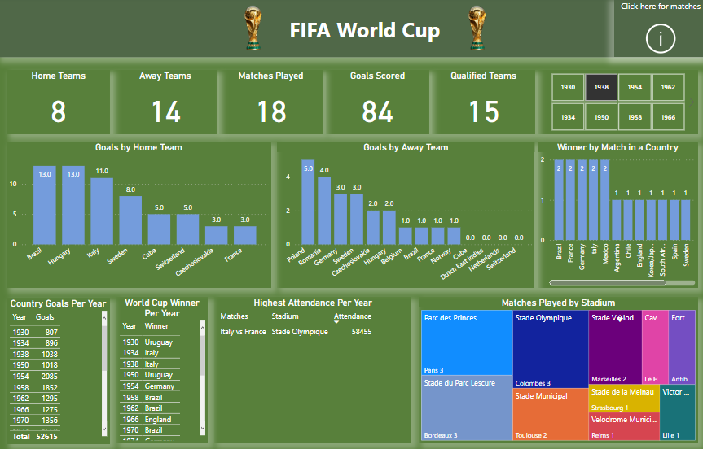

In this section we designed our first dashboard and tried to interpret the followings

◼ Home Teams: The visual show the number of home teams.

◼ Away Teams: The visual show the number of away teams.

◼ Matches Played: The visual show the number of matches played.

◼ Goals Scored: The visual show the number of goals scored.

◼ Qualified Teams: The visual show the number of Qualified teams.

◼ Year Slicer: Slicer consists of Years of world cup.

◼ Goals by Home Teams: The visual show the number of goals made by home teams.

◼ Goals by Away Teams: The visual show the number of goals made by away teams.

◼ Winners by Match in a Country: Winners by country where matches played.

◼ Country Goals per Year: The visual show the number of goals by year.

◼ World Cup Winner per Year: The visual show the winner by year.

◼ Highest Attendance Per Year: The visual show the highest attendance.

◼ Matches Played by Stadium: The visual show the number of matches played by stadium and city.

**2. Matches Played in FIFA World Cup :**

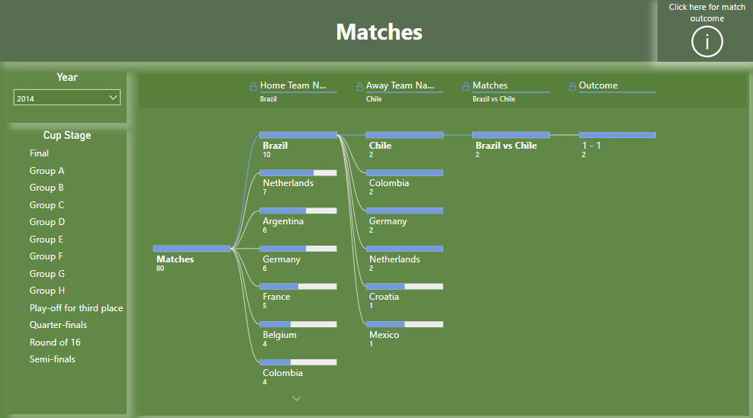

◼ Year Slicer: Slicer consists of Years of world cup.

◼ Cup Stage Slicer: Slicer consists of cup stages of world cup.

◼ Decomposition tree: The visual show all the matches played by teams with their goal scored.

**3. Outcome of FIFA World Cup:**

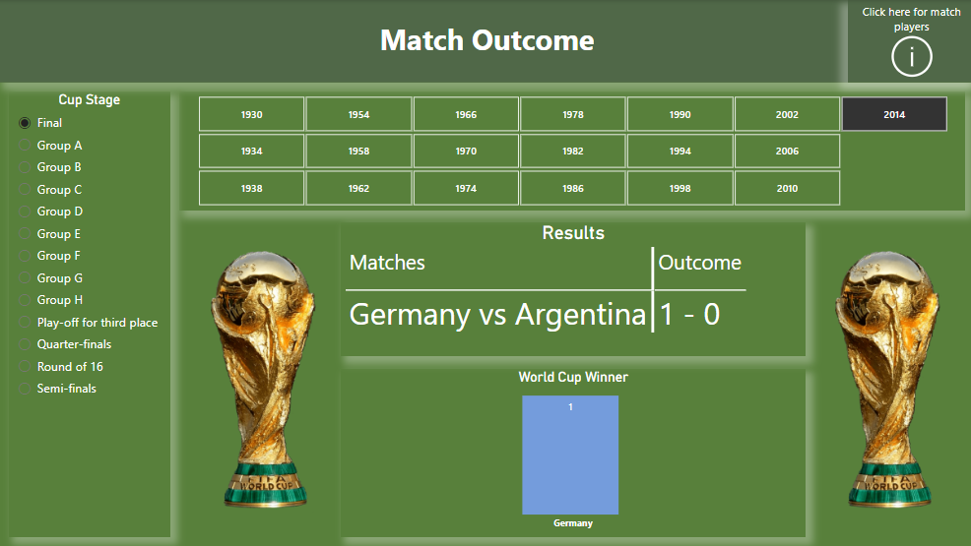

◼ Year Slicer: Slicer consists of Years of world cup.

◼ Cup Stage Slicer: Slicer consists of cup stages of world cup.

◼ Results: The visual show the result of winning match with goals scored.

◼ World Cup Winner: The visual show the winning team name.

**4. Players of FIFA World Cup:**

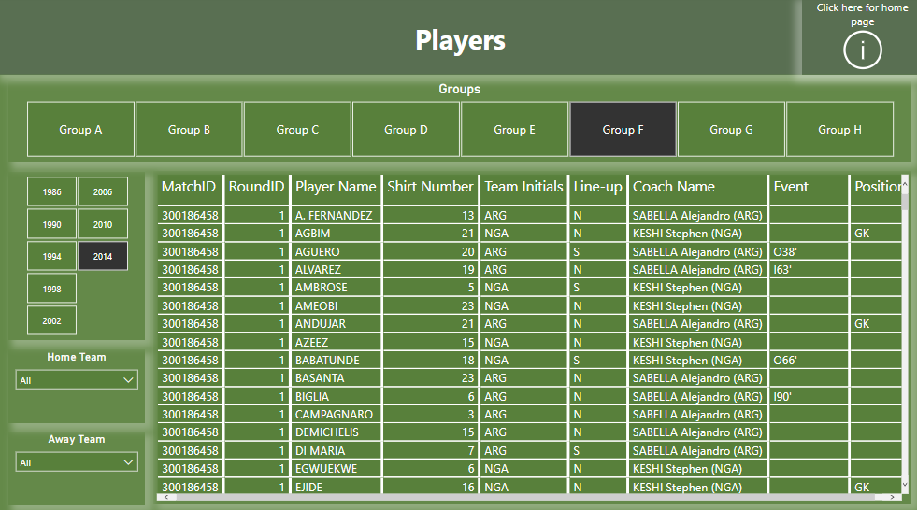

◼ Groups: Slicer consists of Groups of stages of world cup.

◼ Year Slicer: Slicer consists of Years of world cup.

◼ Home Team: Slicer consists of home team name.

◼ Away Team: Slicer consists of away team name.

◼ Player Details: The visual show all the details related to players of a world cup.