/*Tables creation*/

/*Creation of main table*/

CREATE TABLE alerts (

message_id int,

state_name varchar2(12) NOT NULL,

priority number(2) NOT NULL,

message varchar2(35) NOT NULL

);

/*Setting primary key*/

ALTER TABLE alerts

ADD CONSTRAINT pk_alerts PRIMARY KEY (message_id);

/*Creation of user ver_u1 (Vertical user1) */

create table ver_u1(

message_id number,

state_name varchar2(12),

message varchar2(35)

);

/*Setting primary key*/

alter table ver_u1

add constraint pk_ver_u1 primary key(message_id);

/*creation of table ver_u2 (vertical user2)*/

create table ver_u2(

message_id number,

state_name varchar2(12),

priority number(2)

);

/*Adding primary key constraint to ver_u2*/

alter table ver_u2

add constraint pk_ver_u2 primary key(message_id);

/*Links creation*/

create public database link link_to_maharashtra

connect to maharashtra identified by main using 'XE';

create public database link link_to_gujrat

connect to gujrat identified by main using 'XE';

/*Trigger for vertical fragmentation*/

create trigger ver_dist

after insert on alerts

for each row

begin

insert into ver_u1@link_to_maharashtra

values(:new.message_id,:new.state_name,:new.message);

insert into ver_u2@link_to_gujrat

values(:new.message_id,:new.state_name,:new.priority);

end;

/

/*Committing creation*/

commit;

/*Inserting data*/

insert into alerts

values (1,'maharashtra',6,'Air borne disease');

/*Committing insert*/

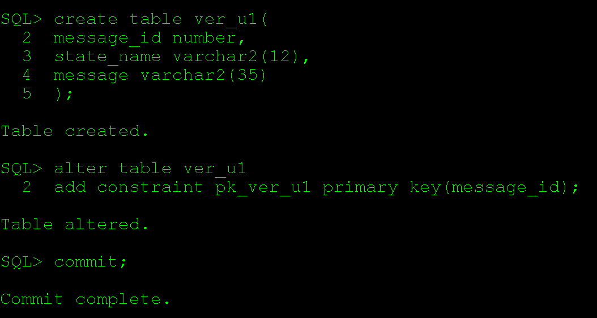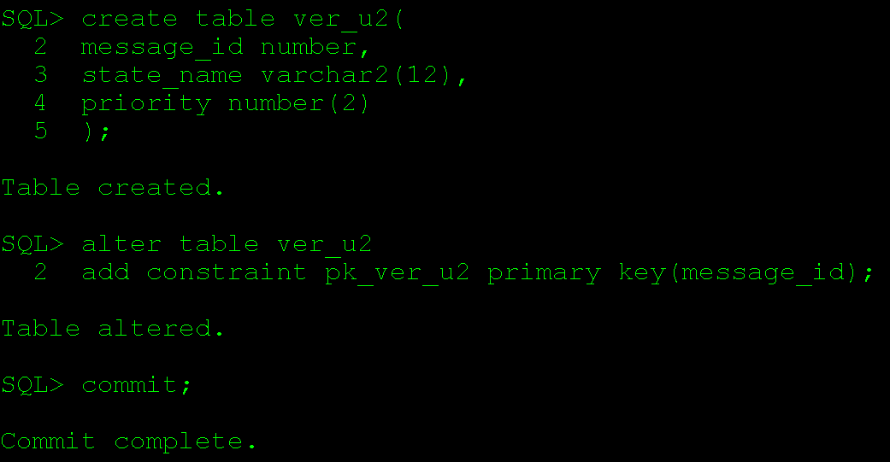commit;

