Project: Diamond Prices

Complete each section. When you are ready, save your file as a PDF document and submit it here: [https://classroom.udacity.com/nanodegrees/nd008/parts/235a5408-0604-4871-8433-a6d670e37bbf/project#](https://classroom.udacity.com/nanodegrees/nd008/parts/235a5408-0604-4871-8433-a6d670e37bbf/project)

# Step 1: Understanding the Model

*Answer the following questions:*

1. According to the model, if a diamond is 1 carat heavier than another with the same cut, how much more should I expect to pay? Why?

* It is given in the linear regression equation, coefficient for carat is 8413, so if a diamond is 1 carat heavier than another with the same cut, increase in the price would be $8413.

1. If you were interested in a 1.5 carat diamond with a **Very Good** cut (represented by a 3 in the model) and a **VS2** clarity rating (represented by a 5 in the model), how much would the model predict you should pay for it?

* Putting the given values in equation we get,

price =(-5269+(8413*1.5)+(158.1*3)+(454*5))

=$10094.8

# Step 2: Visualize the Data

Make sure to plot and include the visualizations in this report. For example, you can create graphs in Excel and copy and paste the graphs into this Word document.

1. Plot 1 - Plot the data for the diamonds in the database, with carat on the x-axis and price on the y-axis.

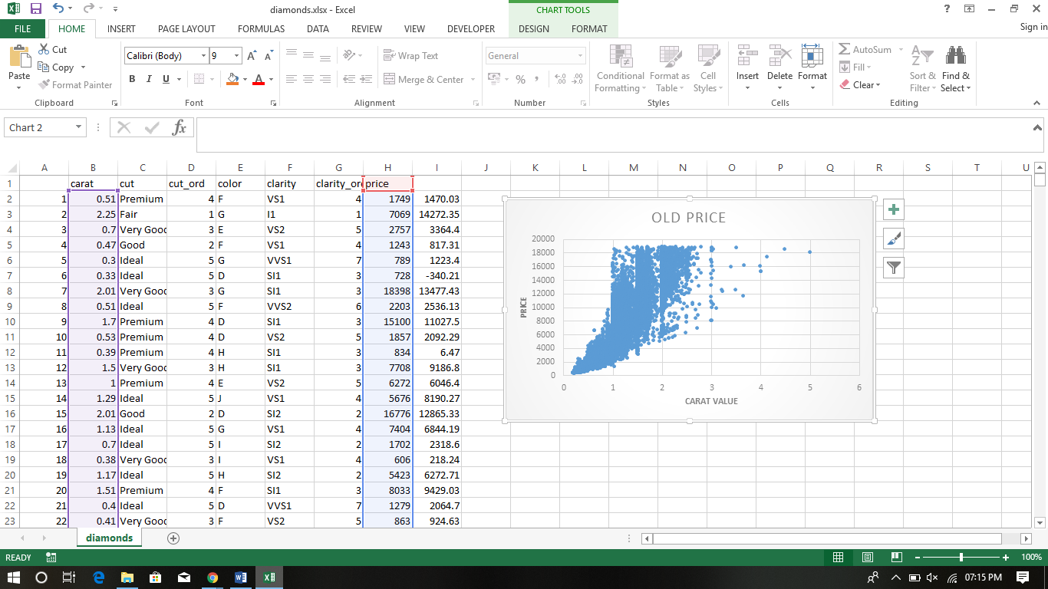

1. Plot 2 - Plot the data for the diamonds for which you are predicting prices with carat on the x-axis and predicted price on the y-axis.

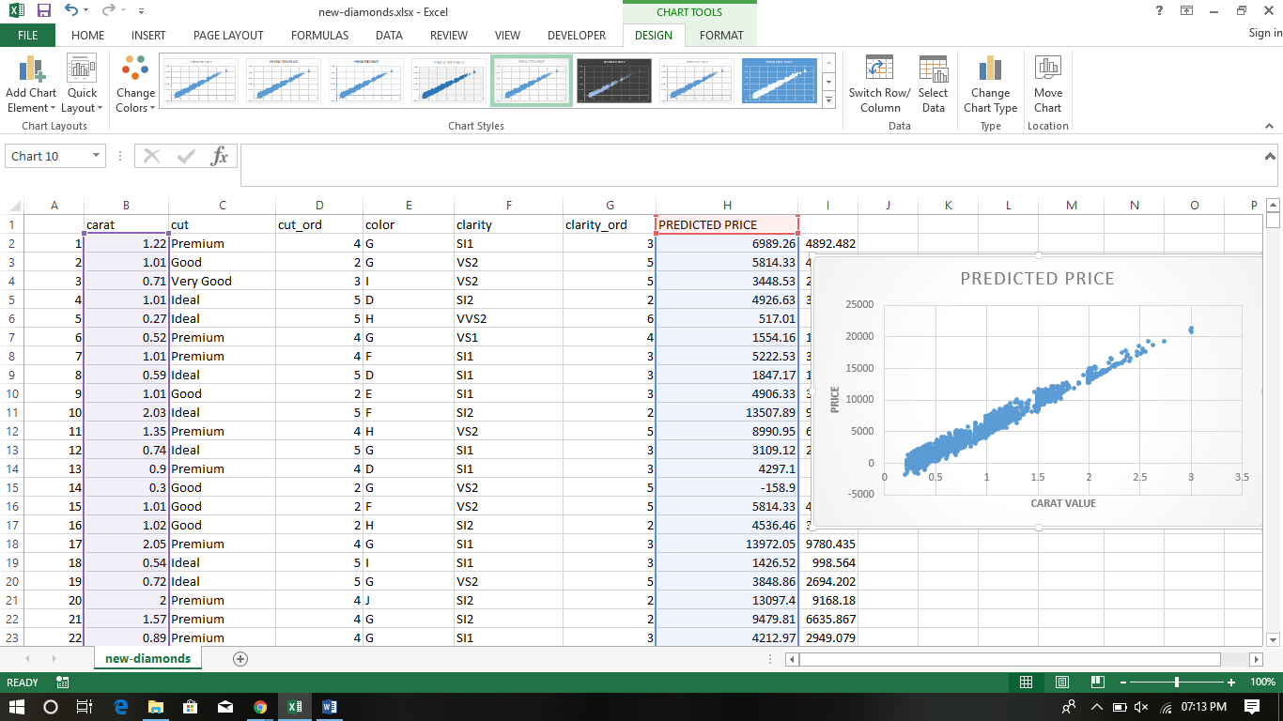

1. What strikes you about this comparison? After seeing this plot, do you feel confident in the model’s ability to predict prices?

* The given data has a positive co-relation between the carat and diamond price. As the carat value is increasing ,the price for diamond is also increasing.
* Prices for some diamonds are coming out to be –ve which I think is can’t possible . So we need to look for some other model or formula.
* Yes,I am confident now and is familiar with handling data.

# Step 3: Make a Recommendation

*Answer the following questions:*

1. What price do you recommend the jewelry company to bid? Please explain how you arrived at that number.

* sum on all the predicted prices is $11670938. I arrived at this number by applying the formula given and then summing up all the values.

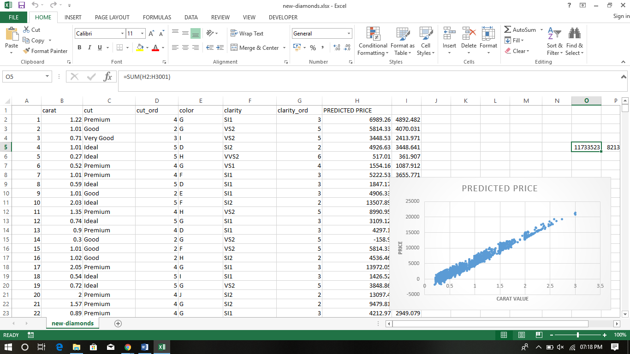

* Since company take overs at 70% of the sum and that amount is $8169657.