Project: Create a Tableau Story

# Summary

* I have chosen the baseball dataset from the given options from udacity. This data set contains data of 1,157 baseball players including their handedness (right or left handed), height (in inches), weight (in pounds), batting average, and home runs.
* While Exploring the data, it is drawn that there is no co-relation between avg and home runs.Although the avg of the most players fall in the range from 0.20 to 0.30.
* Height plays an important role in affecting the performace of a player. Players having height b/w 69 and 75 perform better with respect to other players. And also players having weight 170 to 200 perform better than the rest of them.
* Left Hand Players Perform better than Right Hand Players. Although the count of players having above average and having below average is more of right hand players , but left hand players show better average performance.
* It seems that Above Average players are a bit taller than the below average Players. Also the Above Average players are a little lighter in terms of weight with respect to players possessing below average performance.

# Design

* I have drawn histogram for the batting average to show where most of the values fall and I have also drawn scatter plot between average and home runs to show if there is any correlation between them.
* I have created a calculated field for players having above average batting performance and players having below average batting performance.
* As there are limited distinct height values, I have drawn bar graph to show the relationship between height and average.
* I have drawn pie charts to show the composition of right handed, left handed and both handed players for above average players and below average players.

# Feedback

* Initial Story ->

<https://public.tableau.com/profile/himanshu.sharma3138#!/vizhome/Udacity_Dand_Project_8A/Story1?publish=yes>

**Feedback** :- Hi! Your story is missing any insights or findings. For e.g. what does the

scatter plot show? You may also need to add more visuals to complete the

story.

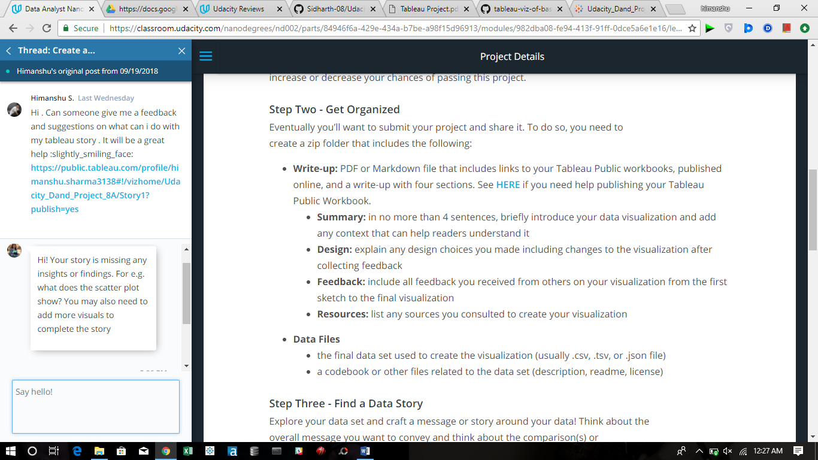

* Final Story -> <https://public.tableau.com/profile/himanshu.sharma3138#!/vizhome/Udacity_Dand_Project_8A/Story2?publish=yes>