VENDOR AGREEMENT
This Vendor Agreement (“Agreement”) is made and entered into on March 3, 2025, by and between:
1. MPCT INDIA (the “Client”), having its registered office at 24, st 1, Dhaula Kuan, Delhi 173001
2. Digital India pvt. ltd. (the “Vendor”), having its registered office at Electronics Niketan Annexe, 6 CGO Complex, Lodhi Road, New Delhi-110003.

1. PURPOSE OF AGREEMENT
The purpose of this Agreement is to define the terms and conditions under which the Vendor shall provide products/services to the Client. This Agreement grants specific powers, rights, and access necessary for the Vendor to perform its obligations.

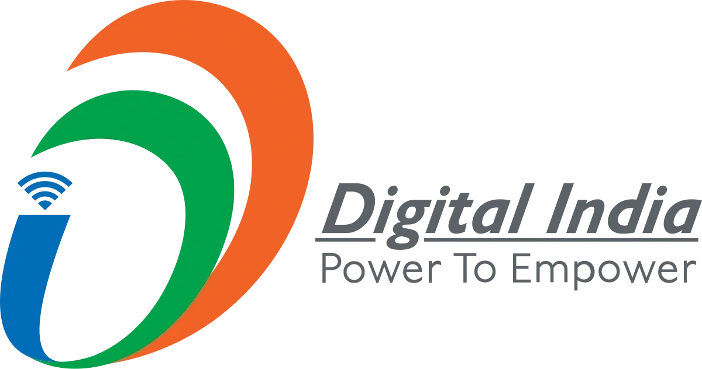
2. SCOPE OF WORK & DELIVERABLES
- The Vendor agrees to provide the following deliverables/products/services:
-e-Governance Platforms: Creating and managing citizen-centric services like myScheme, UMANG, and DigiLocker.
- Infrastructure: Expanding internet connectivity and setting up public internet centers.
- Innovation: Fostering innovation and encouraging Public-Private Partnerships (PPP) to advance the Digital India mission.

3. RIGHTS & AUTHORIZATIONS
The Client grants the Vendor the necessary rights to access systems, data, software, premises, or other resources required for providing services, subject to confidentiality and security compliance.

4. CONFIDENTIALITY
Both parties shall maintain strict confidentiality regarding confidential information shared under this Agreement. Information shall not be disclosed to any third party without prior written consent.

5. TERM & TERMINATION
This Agreement shall remain in effect for a period of 2 Years unless terminated earlier by mutual agreement or due to breach of contract by either party.

6. LIABILITY & LIMITATIONS
The Vendor shall perform services with due skill and care. However, liability for indirect, incidental, or consequential damages is excluded, except in cases of willful misconduct.

7. GOVERNING LAW & DISPUTE RESOLUTION
This Agreement shall be governed by the laws of Digital India. Any disputes shall be resolved through arbitration or courts of competent jurisdiction in MPCT India.
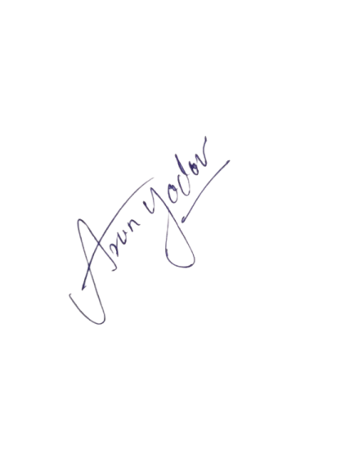
SIGNATURES
Client Representative: DIGIAL INDIA PVT LTD Vendor Representative:
(DIGITALLY SIGNED BY DIGIAL INDIA)
Date: 03/03/2025 Date: 03/03/2025

By affixing a digital signature to this document, the signer acknowledges and agrees that the digital signature holds the same legal validity and enforceability as a handwritten signature. The signer confirms that the information provided is true, accurate, and authorized. Any unauthorized use, alteration, or falsification of this digital signature is strictly prohibited and may result in legal action.

MEMORANDUM OF UNDERSTANDING (MOU)
This MOU is executed to define the mutual understanding between the Client and the Vendor regarding collaboration, operational activities, and resource sharing. This document is not legally binding but represents the intentions of both parties.

Objectives

- Ensure collaboration with efficiency.
- Promote mutual growth and operational support.
- Enable resource sharing as applicable.

Duration
This MOU remains valid until replaced by a formal agreement or terminated by either party with prior written notice.

