PROJECT SYNOPSIS


HOTEL MANAGEMENT SYSTEM

Submitted by - Submitted to -
1.Aditya Yadav Mr. Vikash Kumar
2.Himanshu Singh Rajput
3.Ansh Dubey
4.Satwik Vats
5. Tejendra Singh Chauhan

DECLARATION
We hereby declare that the project report entitled "Hotel Management System" submitted by us to GLA UNIVERSITY is a bona fide work completed by us under the guidance of Mr. Vikash Kumar , Department of Computer Engineering
We further declare that the project has been prepared entirely by us and that no part of it has been copied from any other project or published sources. The work is original and is not a reproduction of any previous work, except where the information is stated to be derived from published sources. We have acknowledged all sources of information and assistance in the project report. This work has not been submitted elsewhere for the award of any degree or diploma or for any other purpose.

Members | Name | Univ. Roll Number
Member 1 | Aditya Yadav | 2215000132
Member 2 | Himanshu Singh Rajput | 2215000809
Member 3 | Ansh Dubey | 2215000280
Member 4 | Satwik Vats | 2215001602
Member 5 | Tejendra Singh Chauhan | 2215001856

Acknowledgement
We are profoundly grateful for the guidance, support, and encouragement we received throughout the development of our Hotel Management Project.
First and foremost, we extend our heartfelt thanks to our project guide, [Mr. Vikash kumar], for their valuable advice, constructive feedback, and constant motivation during every phase of this project. Their insights and expertise played a crucial role in helping us achieve our objectives effectively.
We also express our sincere gratitude to [GLA University ] for providing us with the necessary resources, infrastructure, and an environment conducive to learning and innovation.
Additionally, we are thankful to our peers and friends who offered their suggestions and feedback, which helped us refine our project.
Lastly, we would like to acknowledge the unwavering support of our families for their encouragement and understanding throughout this journey.
This project has been a remarkable learning experience, allowing us to apply our skills practically and explore the fascinating domain of travel website development.

Certificate

This is to certify that
Aditya Yadav , Himanshu Singh Rajput , Ansh Dubey , Satwik Vats , Tejendra Singh Chauhan
has successfully completed the project titled
"Hotel Management System"
as part of the requirements for B.Tech course. The project has been carried out under the guidance of Mr. Vikash Kumar has met the standards expected by
GLA UNIVERSITY
The project demonstrates significant effort, dedication, and practical application of knowledge in web development and has contributed to gaining a deeper understanding of full-stack development principles.

INDEX
 | S.NO:- | Topic
 | 1 | Introduction , About the Project
 | 2 | The Main Objective of the Project
 | 3 | Frontend and Backend Software used
 | 4 | Listing Out testing technology-
 | 5 | Analysis DFD Levels
 | 6 | Module
 | 7 | Hardware and software requirement

Introduction of the project :

Hotel management system project is a software solution designed to automate and streamline the operations of a hotel, including reservation management, room assignment, billing, inventory management, and guest services. The system aims to provide an efficient and cost-effective way for hotels to manage their day-to-day activities and improve the guest experience.

The hotel management system typically includes a front-end interface for hotel staff to manage reservations, check-ins, and checkouts, as well as a back-end database to store guest information and track inventory. The system may also integrate with other software solutions, such as accounting and customer relationship management (CRM) software.

Some of the key features of a hotel management system include online booking, room availability tracking, room assignment automation, billing and invoicing, inventory management, housekeeping and maintenance management, and guest feedback management.

The benefits of using a hotel management system include increased efficiency, improved accuracy, reduced administrative costs, enhanced guest experience, and improved revenue management. With the help of a hotel management P a g e | 2 system, hotels can streamline their operations, improve guest satisfaction, and increase profitability

Objective of the project :
The main objective of a hotel management system project is to provide an efficient and reliable way to manage all the activities of a hotel. This system aims to automate and streamline the processes involved in hotel operations such as room booking, customer check-in and check-out, inventory management, staff management, and billing.

The hotel management system project can provide several benefits such as:
Improved guest experience: By automating the booking and check-in process, guests can have a smoother and hassle-free experience.

Increased efficiency: With automation, the hotel staff can save time on routine tasks, which can improve their productivity and reduce errors.
Better inventory management: The system can help manage inventory, such as room availability, food and beverage, and other hotel supplies, which can reduce waste and optimize costs.

Accurate billing and reporting: The system can generate accurate bills and financial reports, which can help in better financial management.
Overall, the main objective of the hotel management system project is to enhance the guest experience, optimize hotel operations, and increase profitability.

Project category :

Hotel management system project using php language and my sql database connectivity project category

The Hotel Management System project is a web-based application that manages the day-to-day activities of a hotel. It involves managing hotel bookings, room allocation, guest check-in, and check-out, billing, and other administrative tasks. The system is built using PHP programming language and MySQL database connectivity.

Project Category: Web Application

Project Features:
User authentication and authorization system
Dashboard for the hotel staff to manage bookings, room allocation, and guest details
Online reservation system for customers to book rooms and view available rooms
Payment gateway integration for secure online payments
Room availability and pricing management
Automated check-in and check-out process
Billing and invoicing system
Guest feedback system to improve the hotel's services
Reporting and analytics to track the hotel's performance.
System and Hardware Requirements
Technologies Used:
PHP programming language
MySQL database connectivity
HTML, CSS, and JavaScript for front-end development
Bootstrap framework for responsive web design
Apache web server for hosting the application
Payment gateway integration APIs

Project Deliverables:
Source code of the Hotel Management System web application
Database schema and sample data
User manual and installation guide
Project documentation including design, testing, and deployment details
Project Duration: Depending on the complexity of the features ,

4. Analysis :

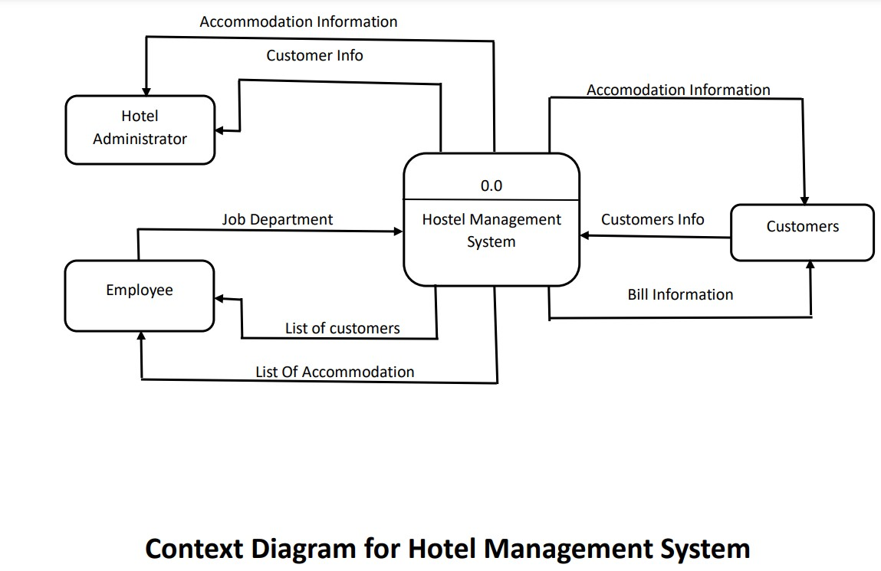

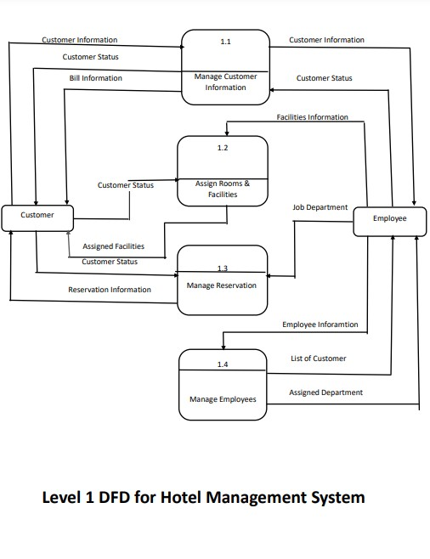
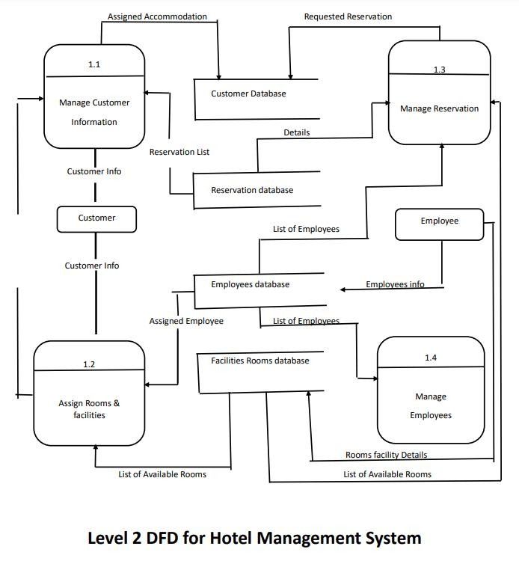

5. A complete structure which include number of module :

The Hotel Management System will consist of the following modules:

Login Module: This module will allow users to log in to the system using their username and password.

Room Management Module: This module will allow hotel managers to manage room information such as room type, availability, price, and room amenities.

Reservation Module: This module will allow hotel managers to make room reservations for guests. The module will also allow guests to view room availability, room rates, and make room reservations online.

Guest Management Module: This module will allow hotel managers to manage guest information such as guest name, address, contact details, and booking history.

Billing Module : This module will allow hotel managers to generate bills for guests based on their room reservation and other expenses such as food, laundry, etc.

Data Structures:
The following data structures will be used in the Hotel Management System:

Room Information: Room Number, Room Type, Room Price, Room Availability, Room Amenities.

Guest Information: Guest Name, Guest Address, Guest Contact Details, Booking History.

Reservation Information: Room Number, Check-in Date, Checkout Date, Number of Guests.

Billing Information: Room Charges, Additional Expenses.

Process Logic:

Login Module:

The user enters their username and password.
The system verifies the user's credentials.
The user is redirected to the dashboard.
Room Management Module:
Hotel managers can add new rooms to the system. Hotel managers can update room information such as availability and room price.
Hotel managers can delete rooms from the system.

Reservation Module:
Guests can search for available rooms based on their requirements.
Guests can book rooms online.
Hotel managers can view and manage room reservations.

Guest Management Module:
Hotel managers can add new guests to the system.
Hotel managers can update guest information.
Hotel managers can view guest booking history.

Billing Module:
Hotel managers can generate bills for guests. The system will calculate room charges and additional expenses.
Guests can view and pay their bills online.

Reporting Module:
Hotel managers can generate various reports based on different criteria such as room occupancy, revenue, and guest feedback.

Testing Process:
The Hotel Management System will be tested using the following process:

Unit Testing: Each module will be tested individually to ensure that it works as expected.

Integration Testing: All the modules will be tested together to ensure that they work together seamlessly.

User Acceptance Testing: The system will be tested by actual users to ensure that it meets their requirements.

Hardware and software requirement specifications :

Hardware requirement specification:
Processor : AMD PRO A6-7350 R5 and above
RAM : 2GB RAM
HARD DISC : 5GB

Software requirement specification :
Operating system : WINDOWS 7/8/9/10/11
Front and language : HTML , CSS , and javascript
Back End Language : PHP and MySQL

Future scope and further enhancement of the project :
The project of a hotel management system using PHP and MySQL database connectivity has a lot of potential for future scope and further enhancement. Some of the possible ways to enhance and extend the project are:
Adding more features: The hotel management system can be enhanced by adding more features to it, such as room service, housekeeping, laundry service, and billing management. This would make the system more comprehensive and useful for hotel staff.
Integrating with third-party services: The hotel management system can be integrated with third-party services such as online booking platforms and payment gateways to streamline the reservation and payment process.
Implementing machine learning algorithms: Machine learning algorithms can be used to analyze customer data and provide insights into customer behavior and preferences. This can help hotel staff to provide a more personalized and efficient service to their customers.
Mobile app development: The hotel management system can be extended to mobile devices by developing a mobile app that allows guests to book rooms, order services, and check their bill.

