Assignment 25.3

* First we will create table employee using create command

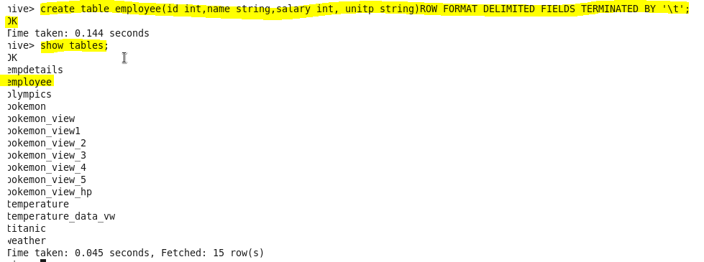

* now we will load our dataset employee.txt using LOAD command

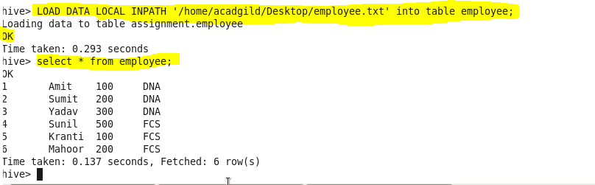

* Get a list of employees who receive a salary less than 100, compared to their immediate employee with higher salary in the same unit

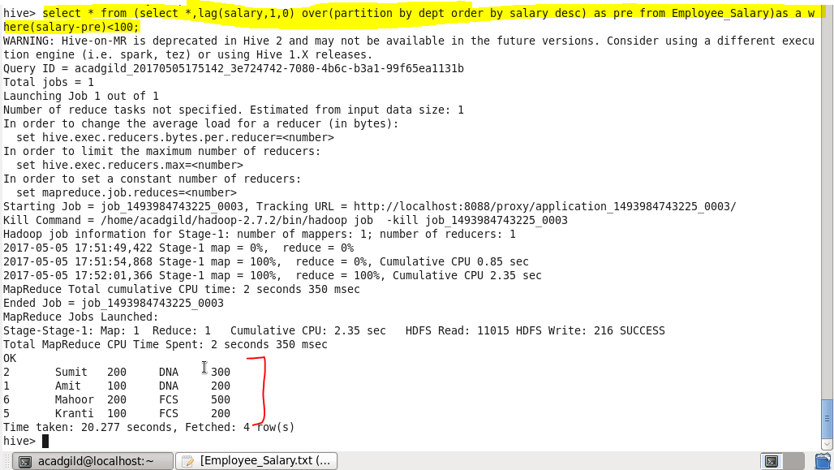

* List of all employees who draw higher salary than the average salary of that department

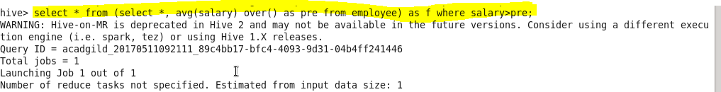

**Output:**

