**Load the data from Local**

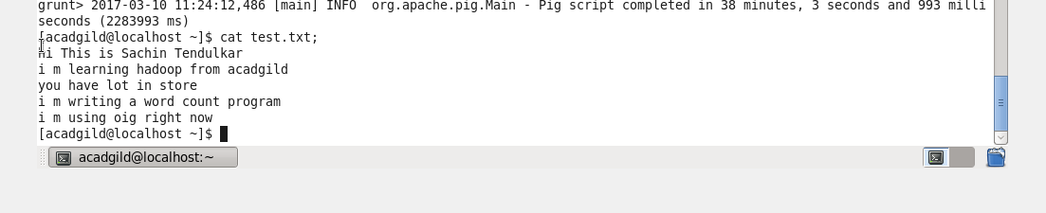

**Convert the sentence into words**



**Convert column into rows**



**Apply group by**



**Generate word count**

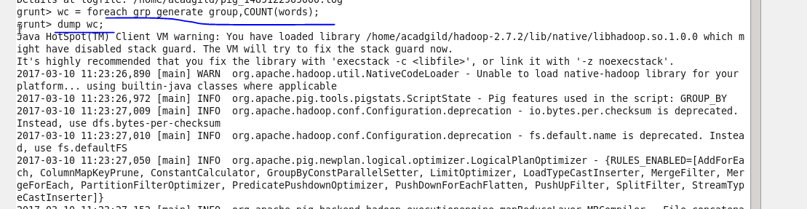

**Output**

