**1. What is the total amount of petrol in volume sold by every distributor?**

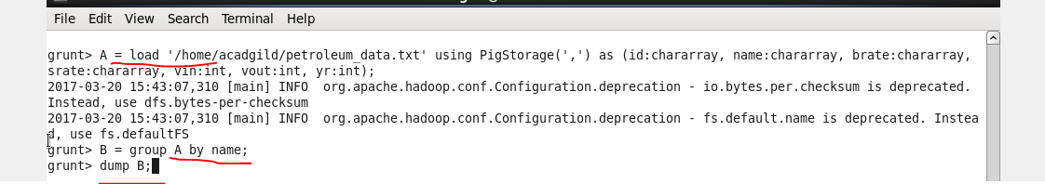

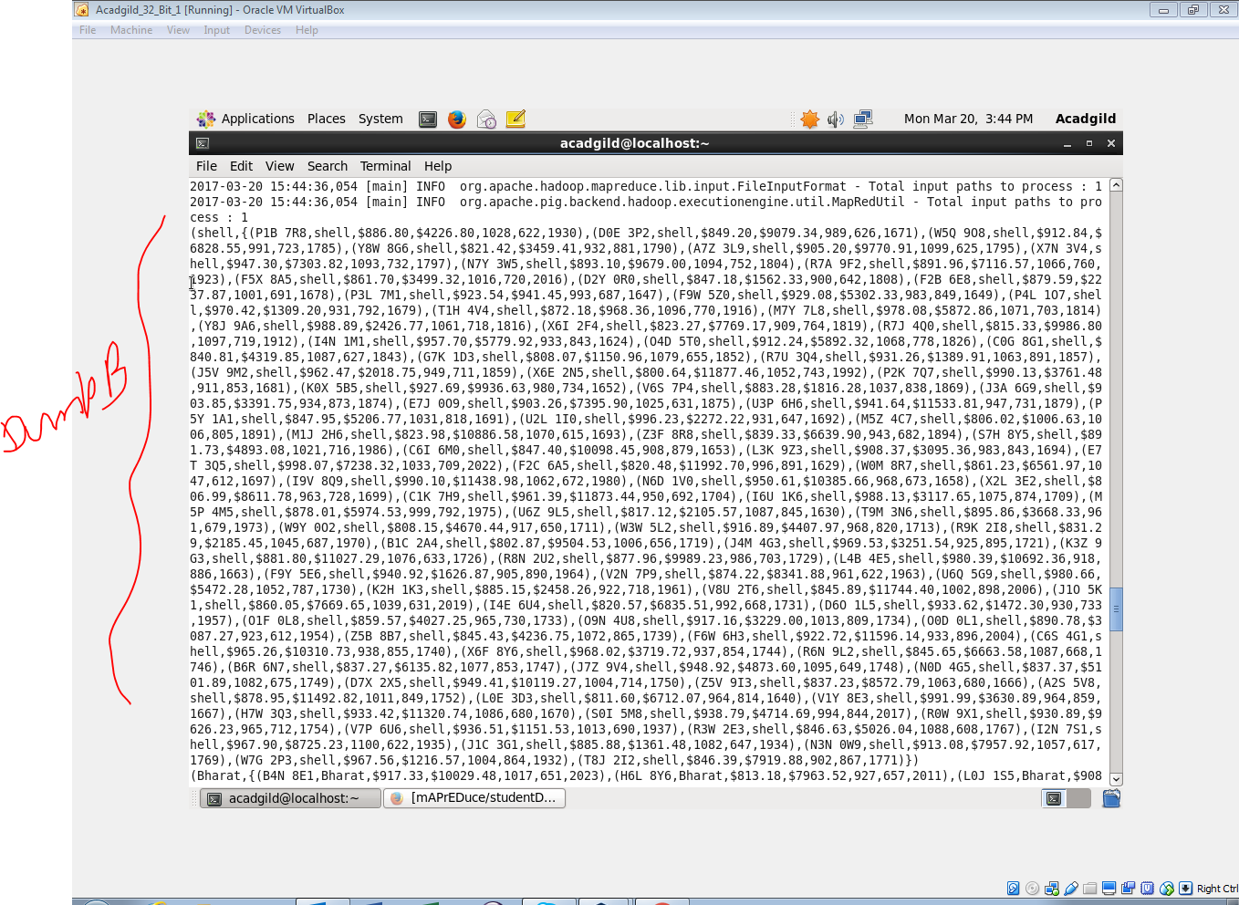

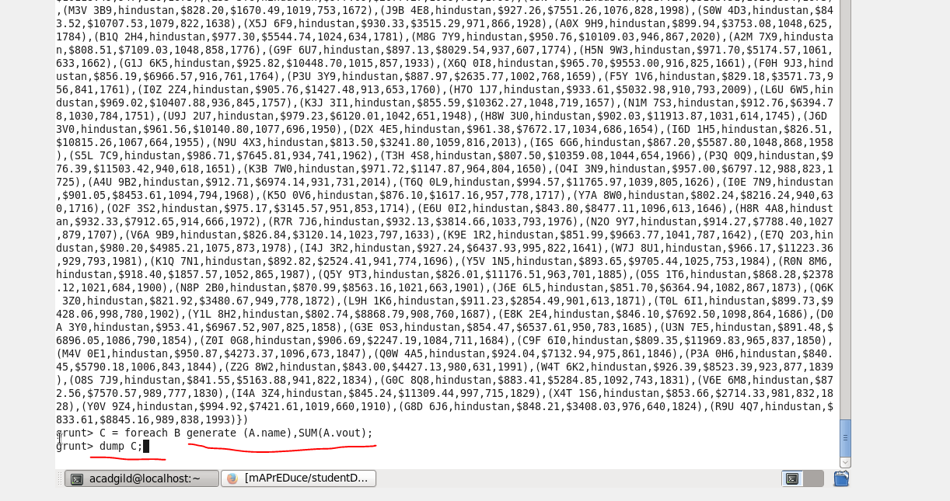

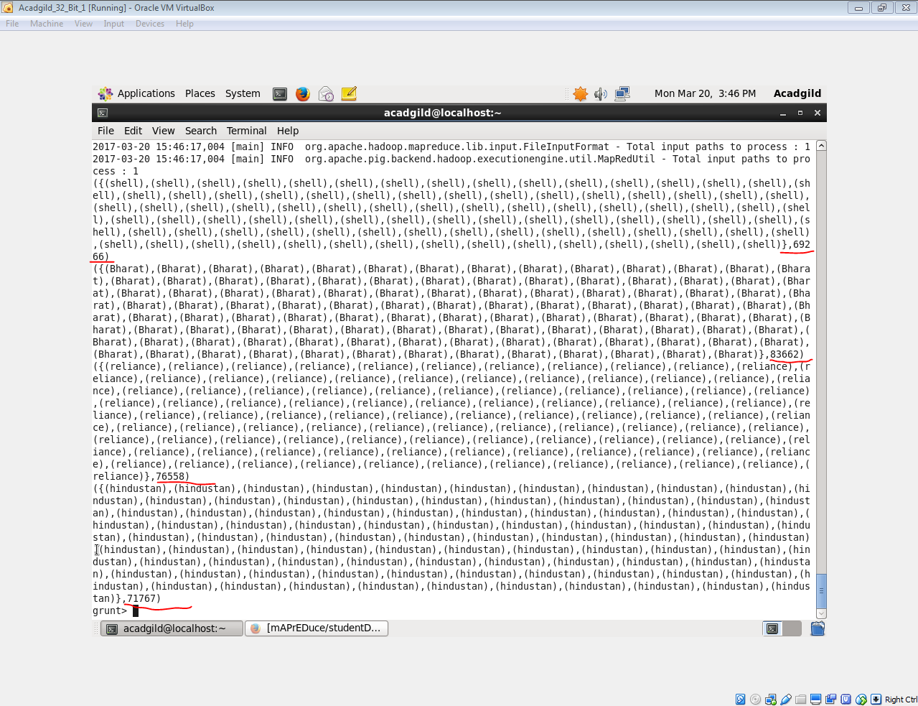

**2. Which are the top 10 distributors ID's for selling petrol? Also display the amount of petrol sold in volume**

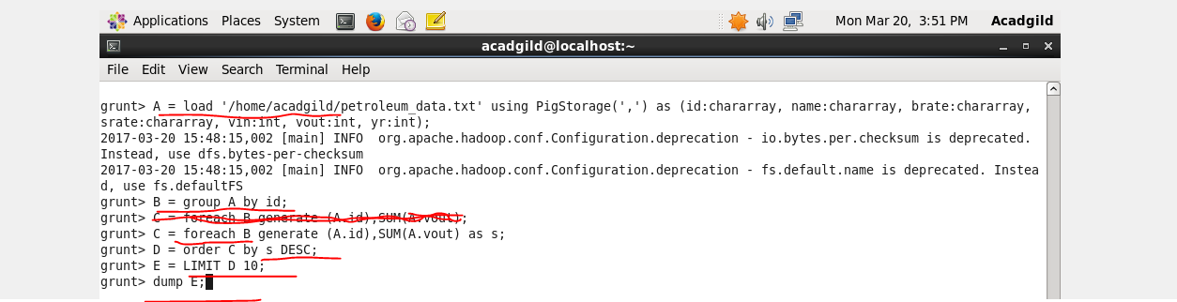

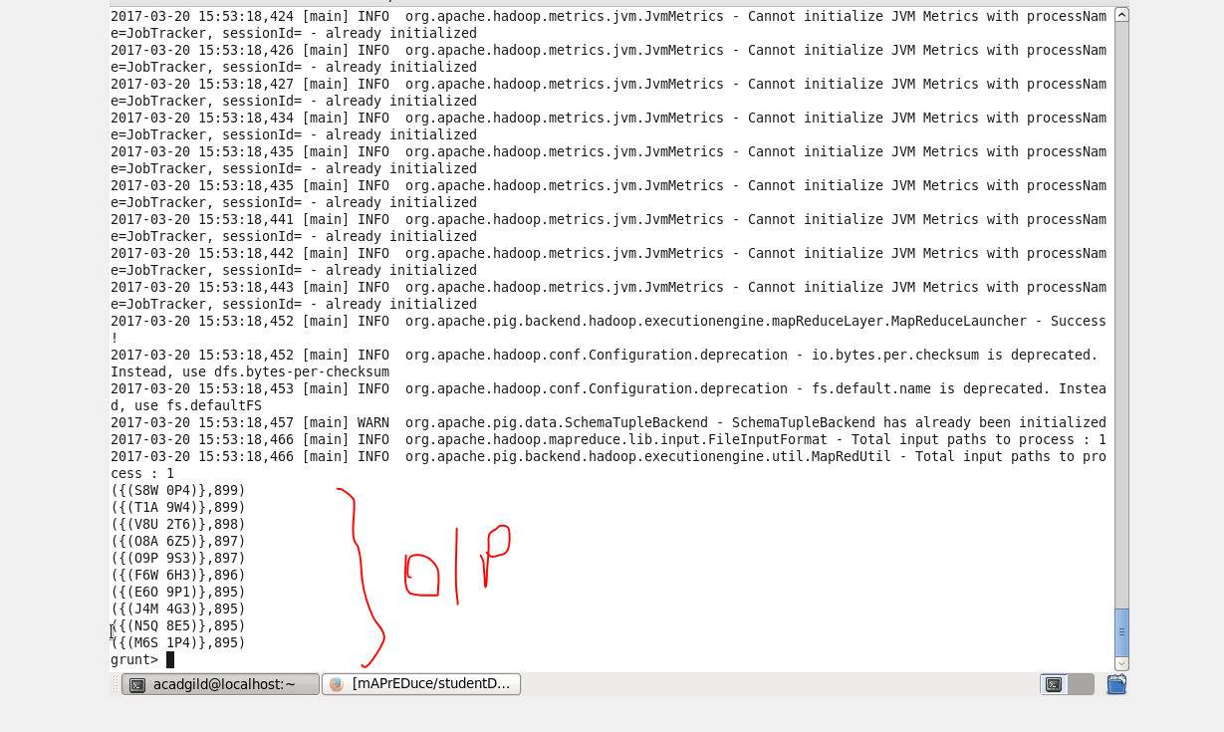

**3. List 10 years where consumption of petrol is more with the distributer id who sold it.**

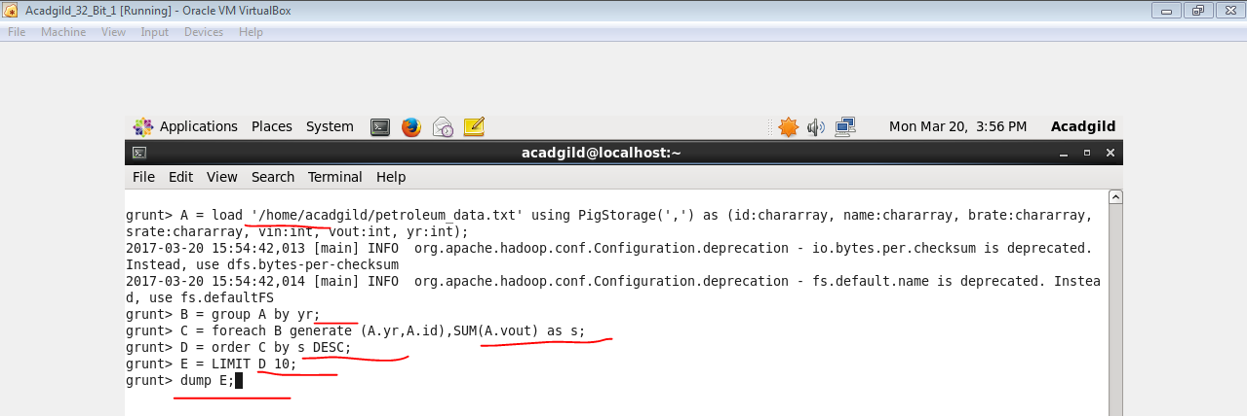

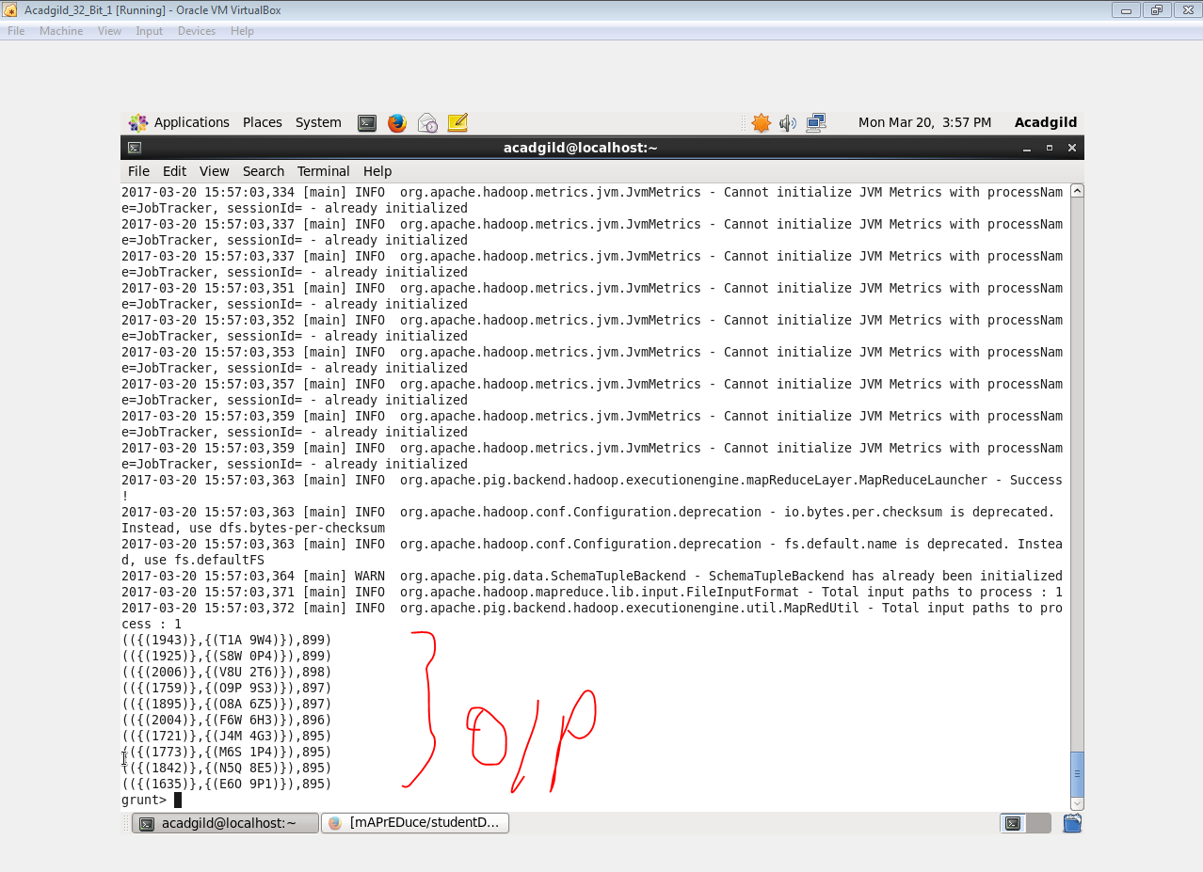

**4. Find the distributer name who sold petrol in least amount.**

