Ques:- Write a pig script to find the count of each Hashtag in the dataset. You can download the twitter data from the below link

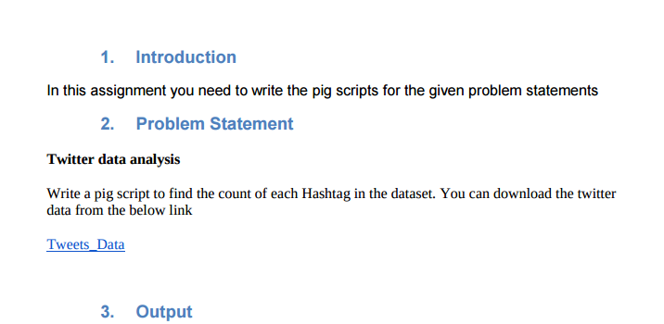

After doing unrar of our tweet.rar dataset we got following files :

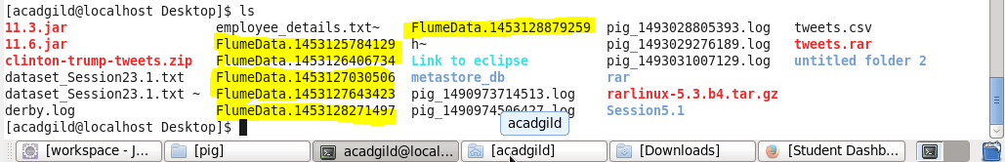

pig script

1. For file FlumeData.1453125784129

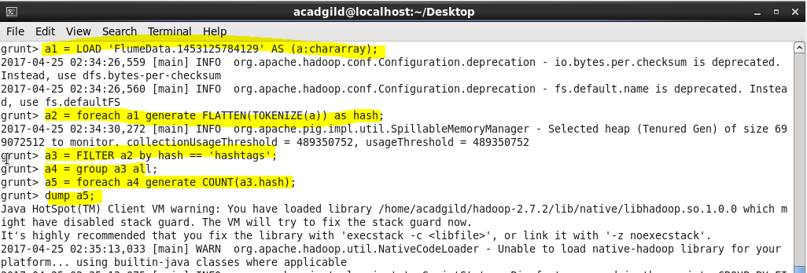

Output :

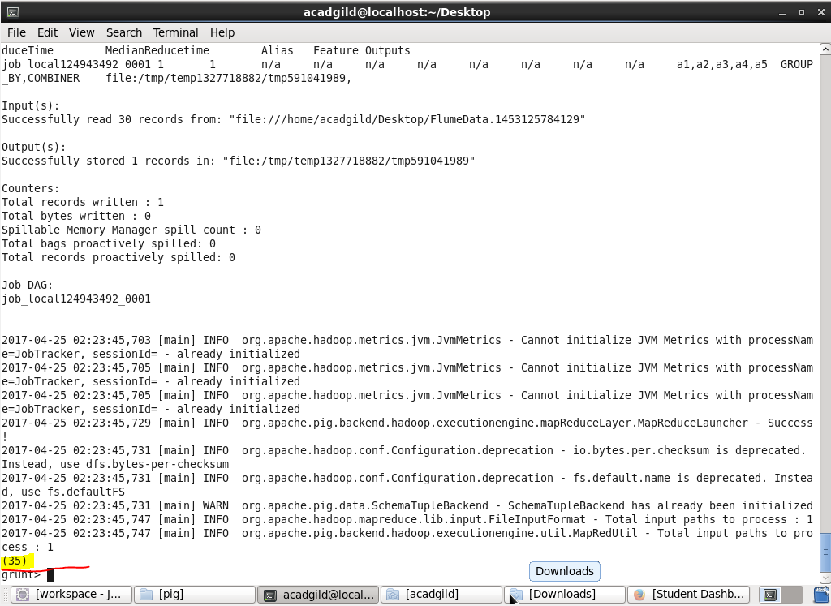

So in total 35 hashtags in file 1

1. For file FlumeData.1453126406734

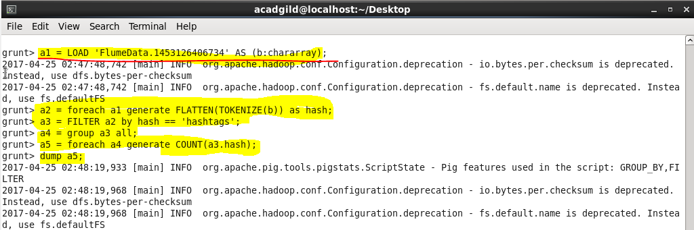

Output :

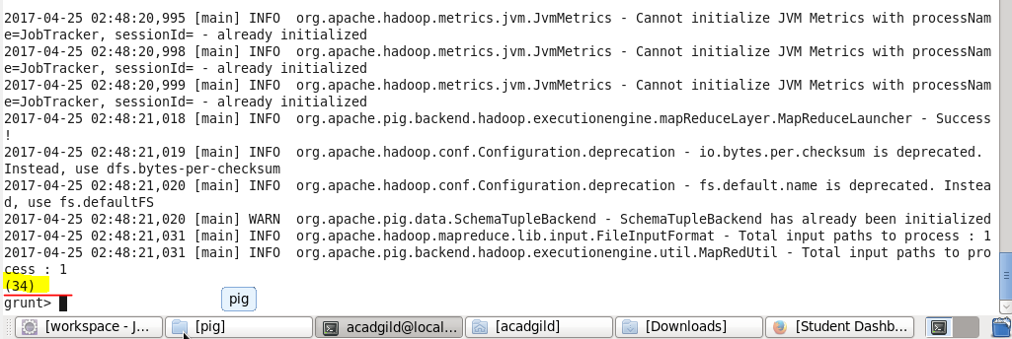

So in total 34 hashtags in file 2

1. For file FlumeData.1453127030506

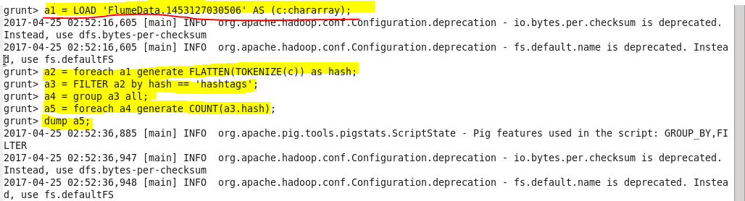

Output :

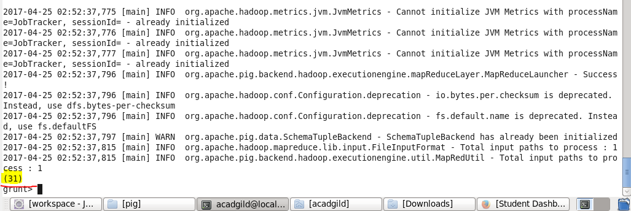

So in total 31 hashtags in file 3

1. For file FlumeData.1453127643423

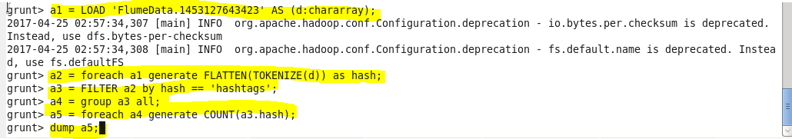

Output :

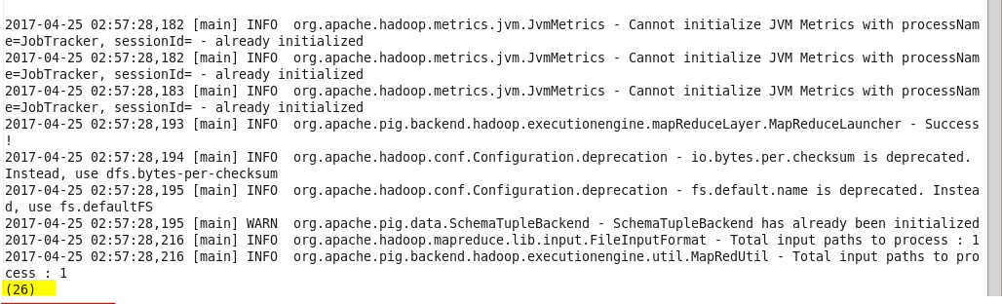

So in total 26 hashtags in file 4

1. For file FlumeData.1453128271497

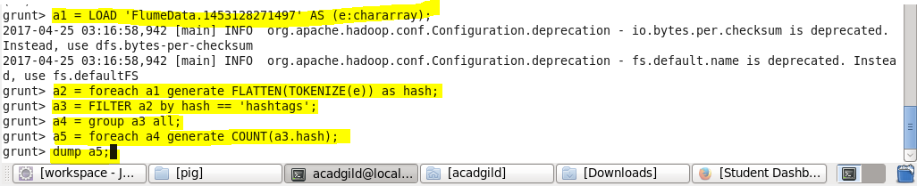

Output :

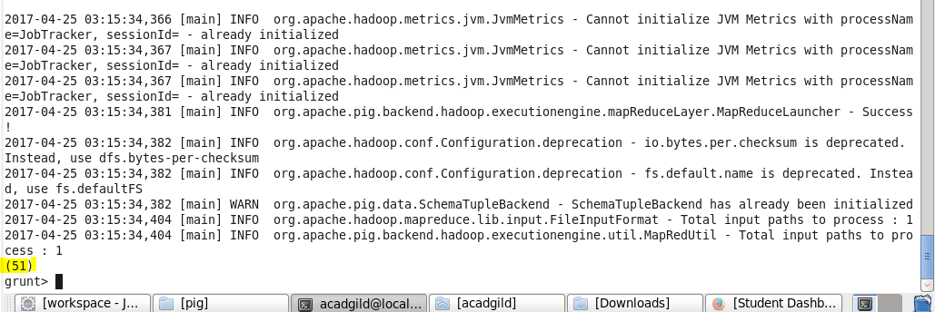

So in total 51 hashtags in file 5

1. For file FlumeData.1453128879259

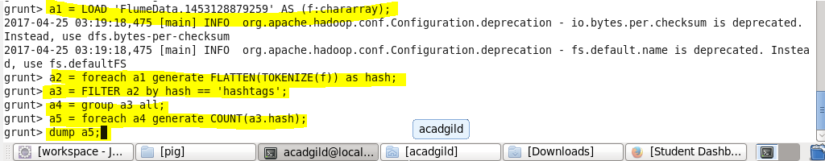

Output :

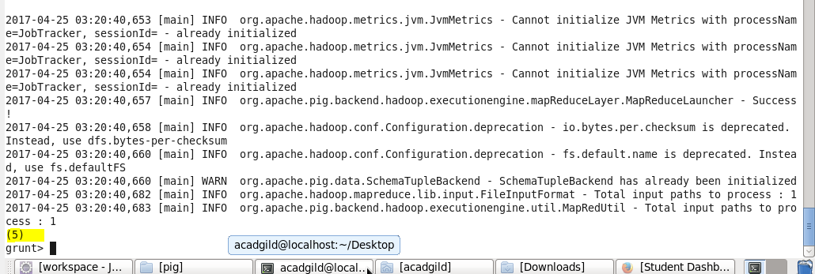

So in total 5 hashtags in file 6