*Build and Deploy Hadoop word count program using Maven:-*

***Input :-***

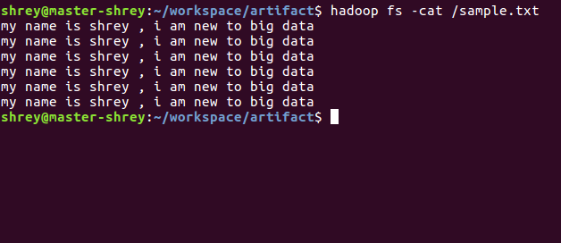

I have installed maven via given steps on Ubuntu 16.04.Lts

POM.xml :

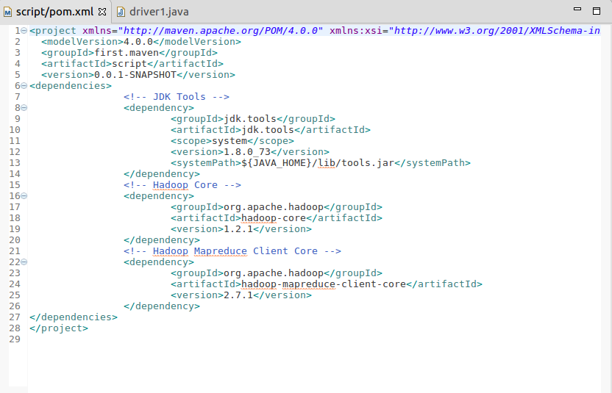

Code for WordCount :

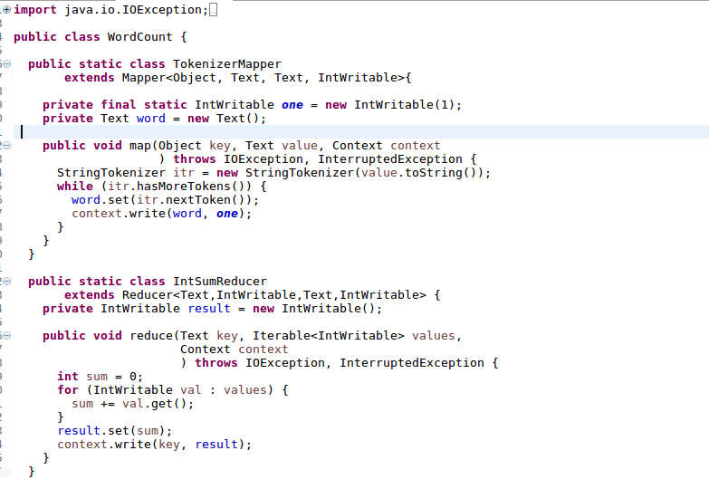

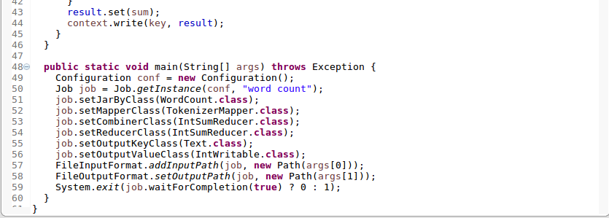

Run Cmd – mvn clean install . To build the jar .

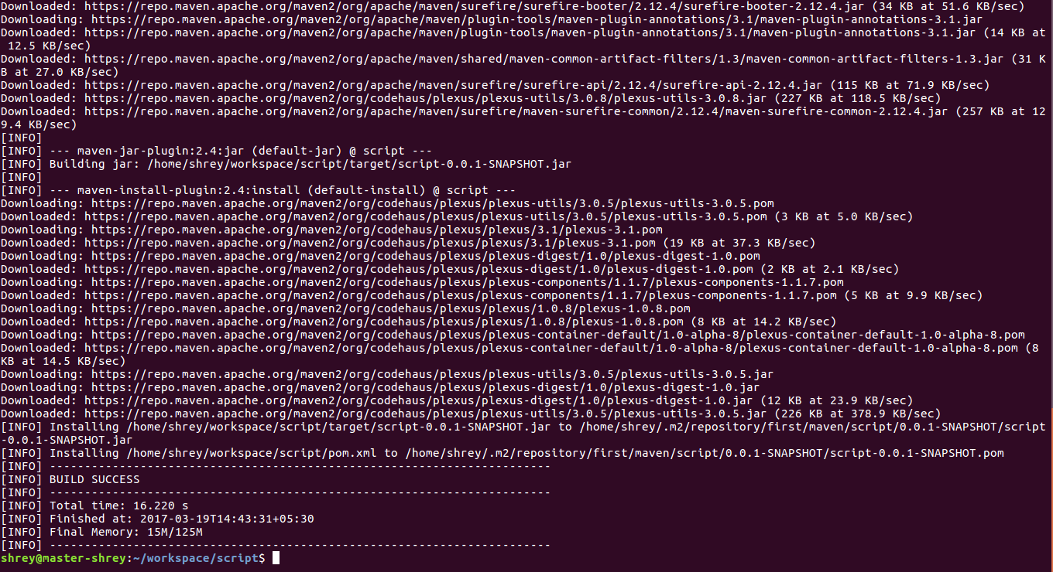

Checking for new jar File :

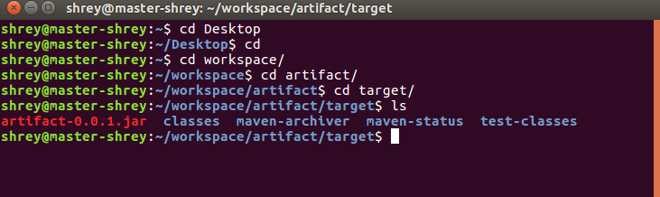

Running the jar file .

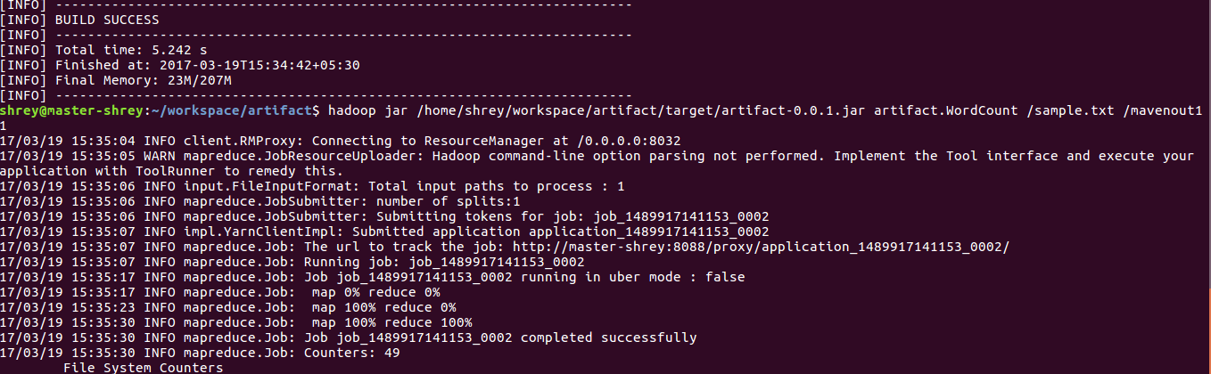

Checking for Output :

