Using Distributed cache join the two datasets and find out the number of temperature variations in each country using mapreduce.

**Driver -**

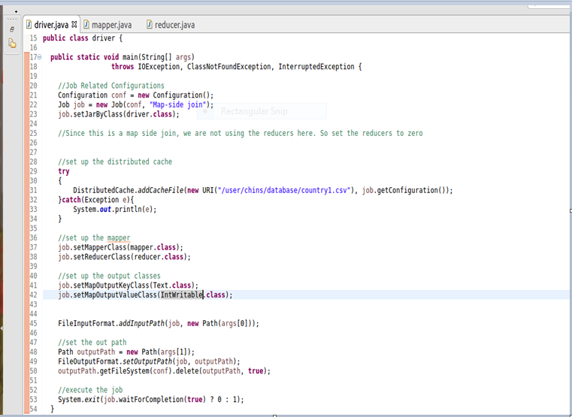

**Mapper -**

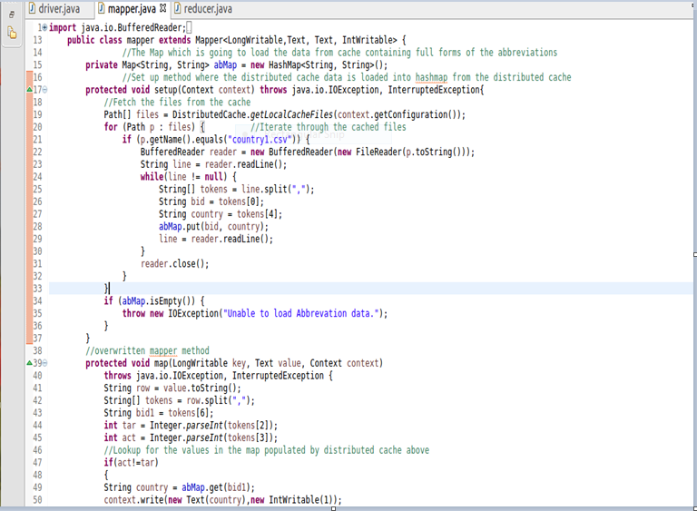

**Reducer**

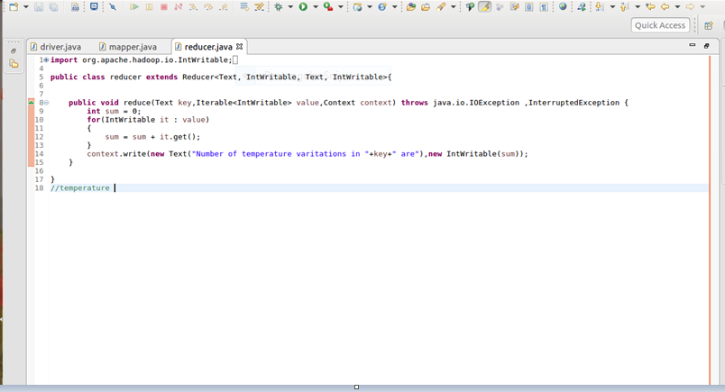

**Output**

