*Write a secondary sort program to generate the top 2 maximum temperatures corresponding to every year from the temperature dataset.*

**Driver**

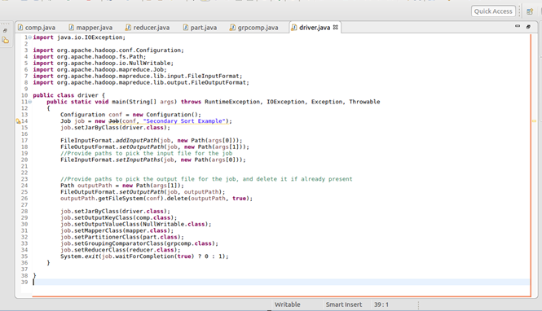

**Mapper**

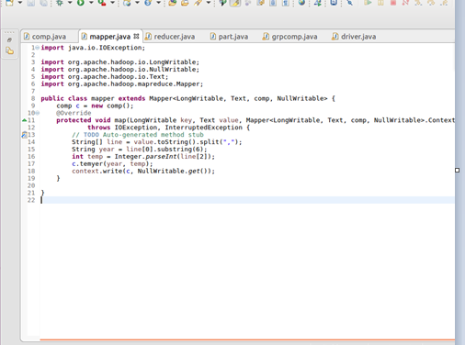

**Comparable writable**

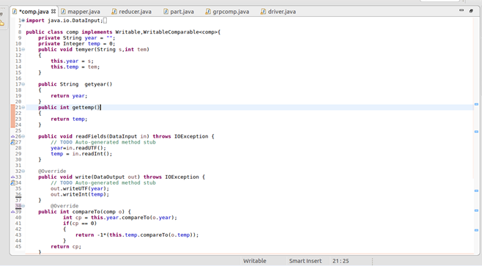

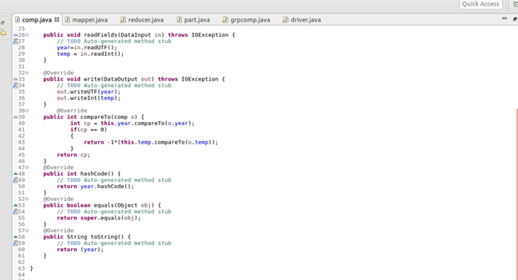

**partitioner**

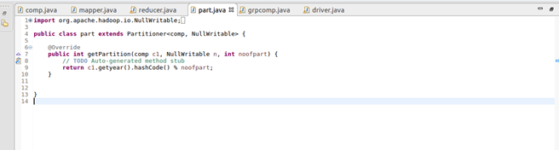

**Group comparator**

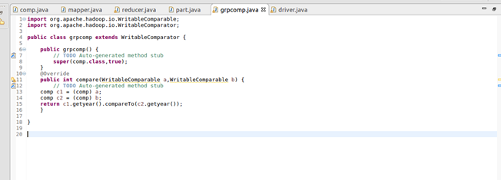

**Reducer**

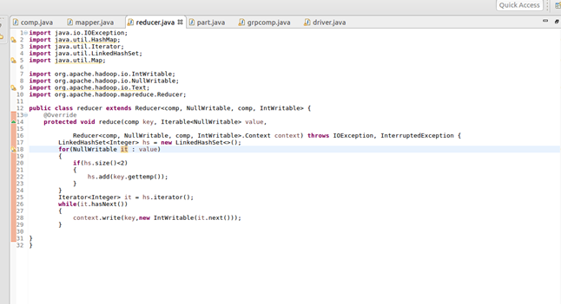

**Output**

