***Ques:- This dataset consists of two columns i,e., first_name & last_name &city use custom input format to read the key as the combination of first_name and last_name and arrange the output of the program should be the key sorted by last_name*.**

**Driver**

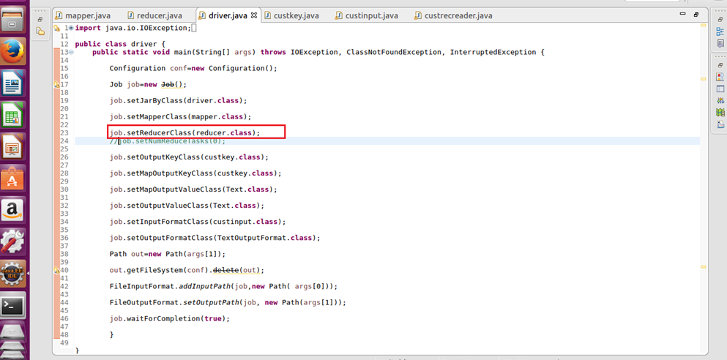

**Mapper**

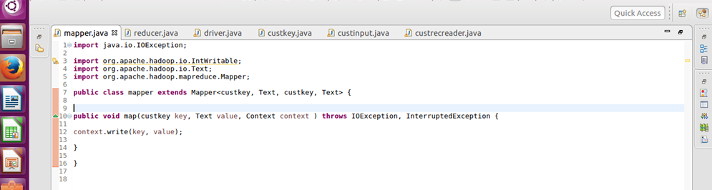

**Reducer**

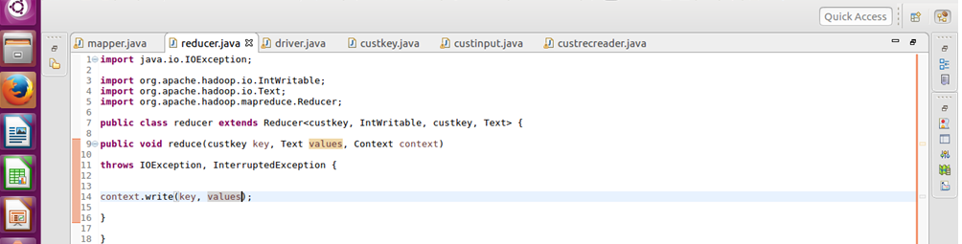

**Custom key**

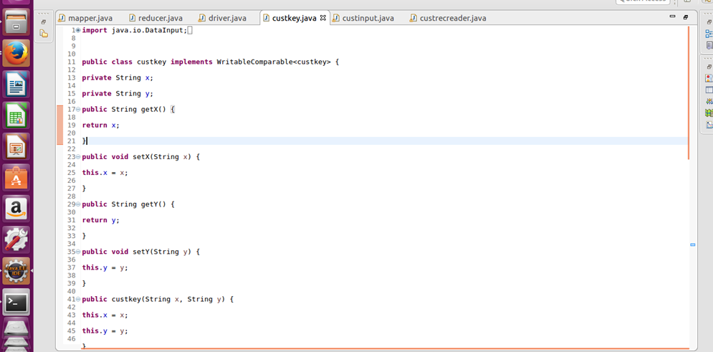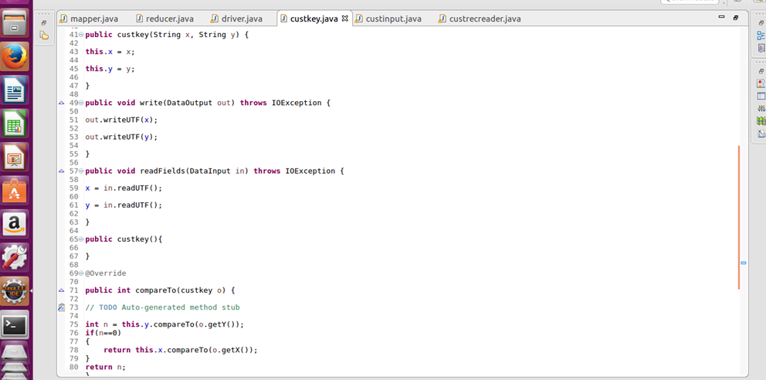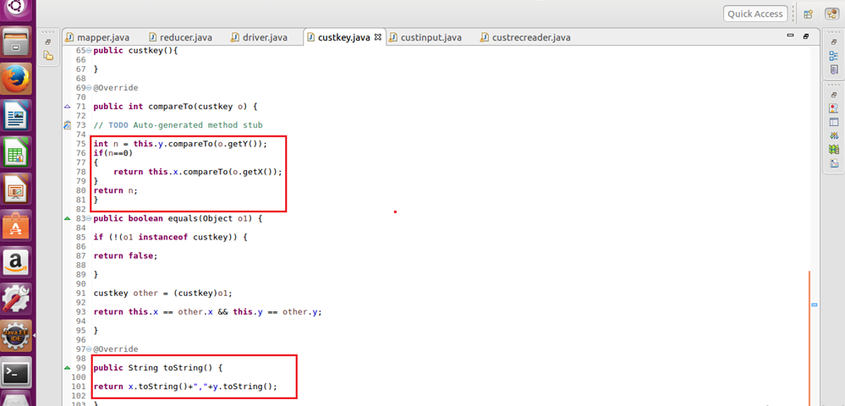

**Custom file format**

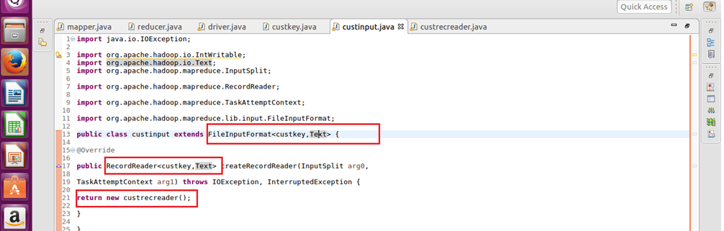

**Custom record reader**

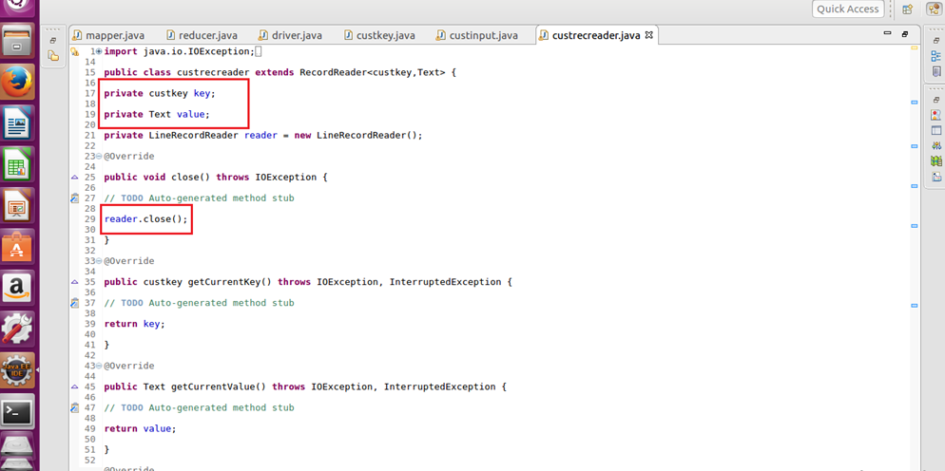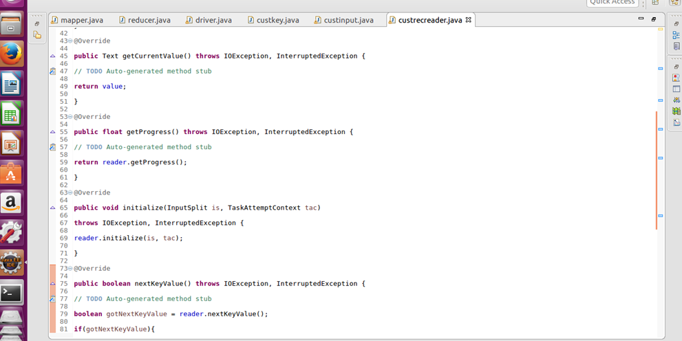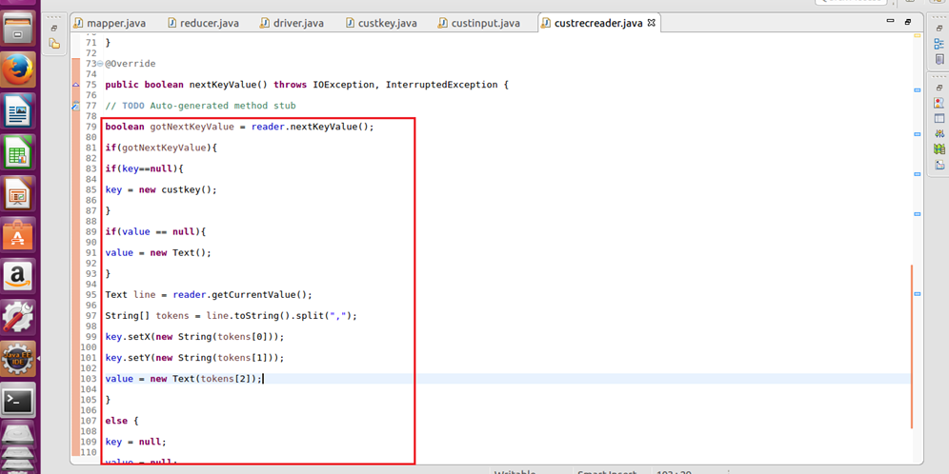

**Output**

