Ques:- Find out what are the top 5 categories with maximum number of videos uploaded.

**Driver**

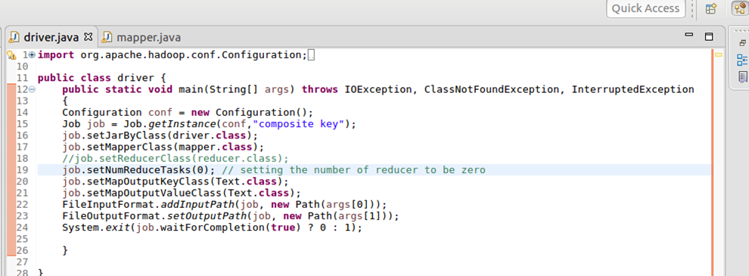

**Mapper**

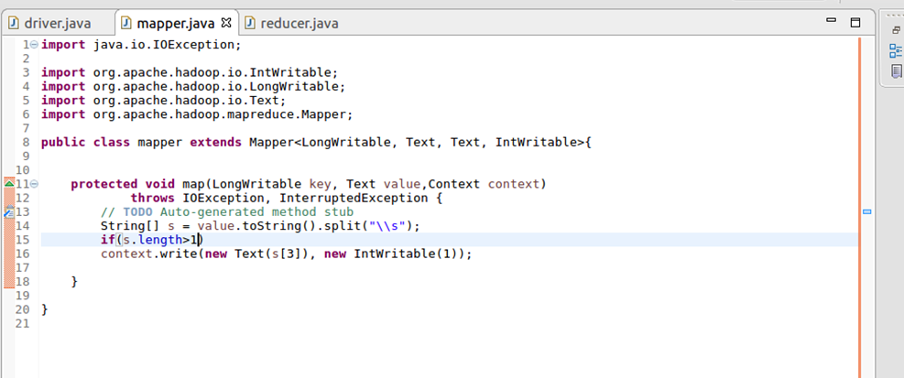

**Reducer**

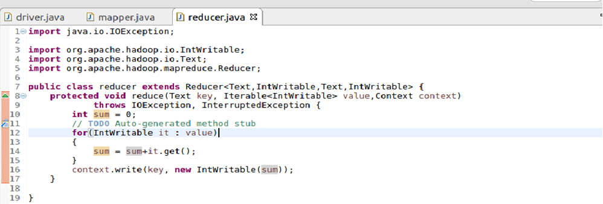

**Output**

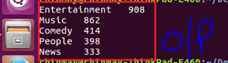

Ques:- Find the top 10 rated videos in youtube.

**Driver**

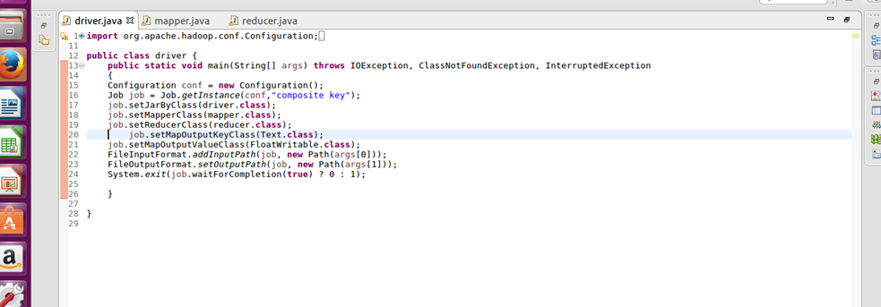

**Mapper**

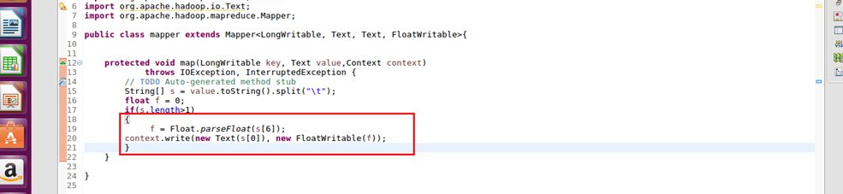

**Reducer**

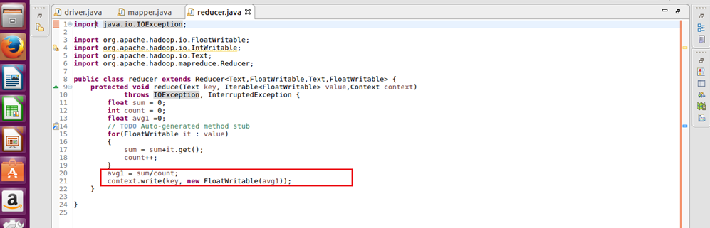

**Output**

