Insertion in the table

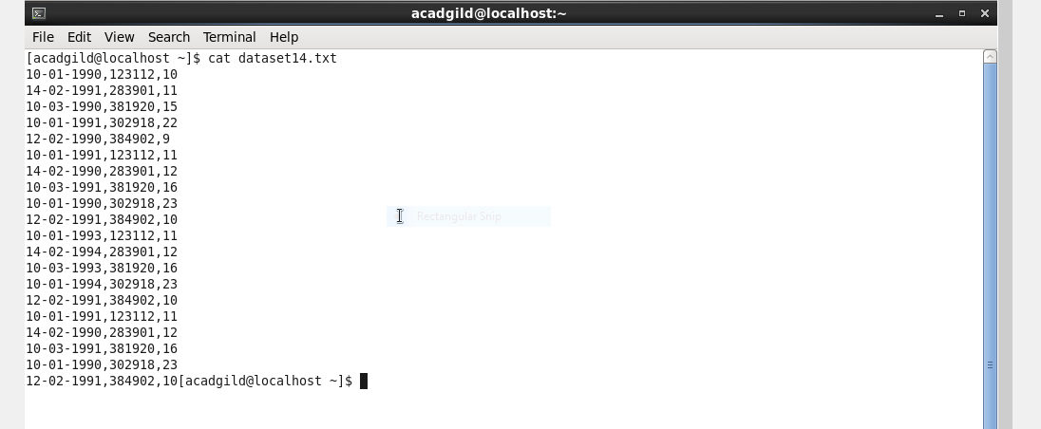

Create Database

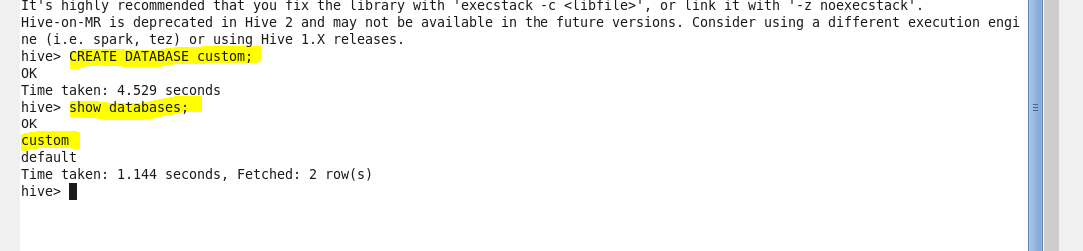

**use database custom**



Creating temp table with commas separated-

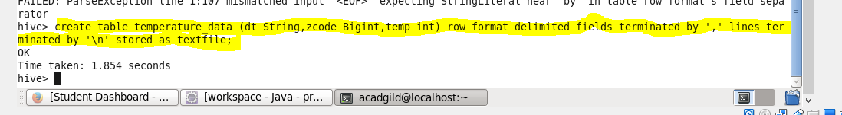

Displaying table

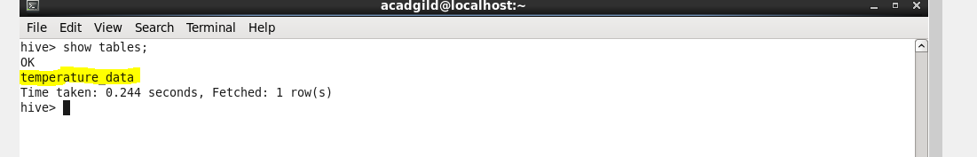

Loading Table

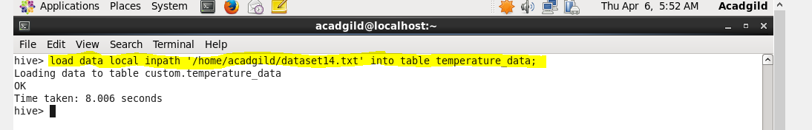

Displaying table contents

