***Ques:-Write a hive query find the average age of male and female persons died in the titanic tragedy ?***

**Input:**

Creating the table titanic_tragedy and delimited the fields by “,” and loading the data given as shown in the screen shot.

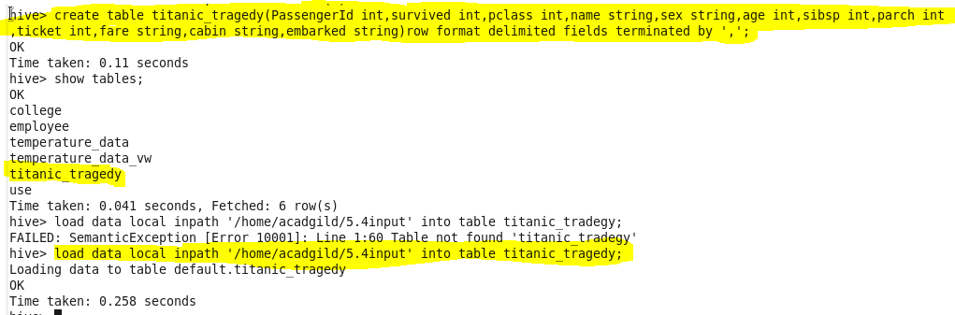

**Solution:**

Selecting the average of the male and female persons travelled in the titanic.

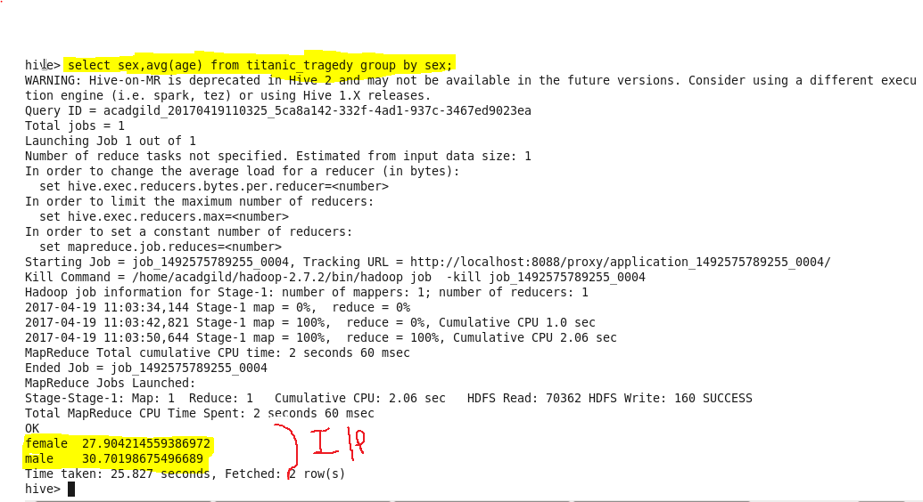

1. Write a hive query to find the number of people died and survived in each class

Solution:

Displaying the number of people died and survived in the titanic_tragedy corresponding to the class.

