Create table

Load data into table

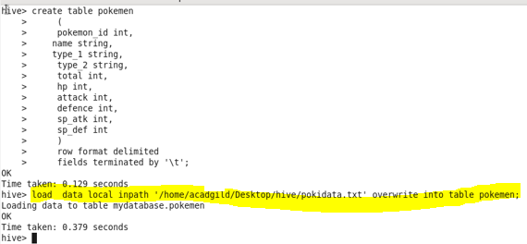

1. Find out the average HP (Hit points) of all the Pokémons

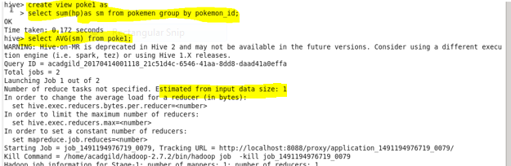

Output

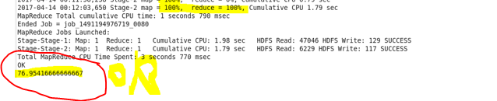

2. Find out the average Defense of all the pokemon

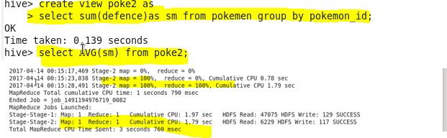

Output

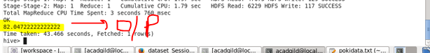

3. Find out the average Sp.Atk of all the pokemons

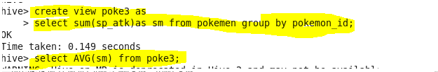

Output

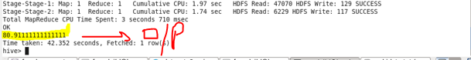

4. Find out the average sp.Def of all the pokemons

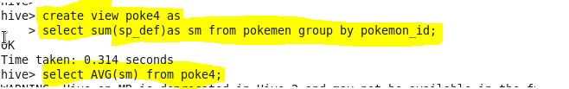

Output

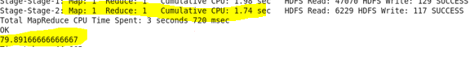

5. Find out the average Speed of all the pokemons

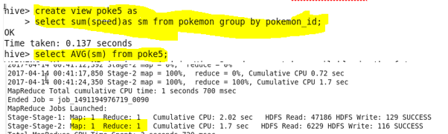

Output

