***Ques:- Write a hive query to find the minimum temperature observed in a given weather station in a particular year.***

**Input:**

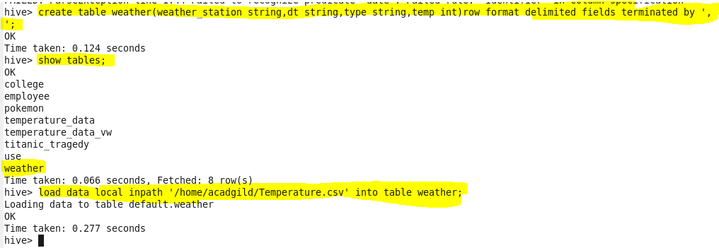

Displaying the weather station and the minimum temperature in that corresponding year. 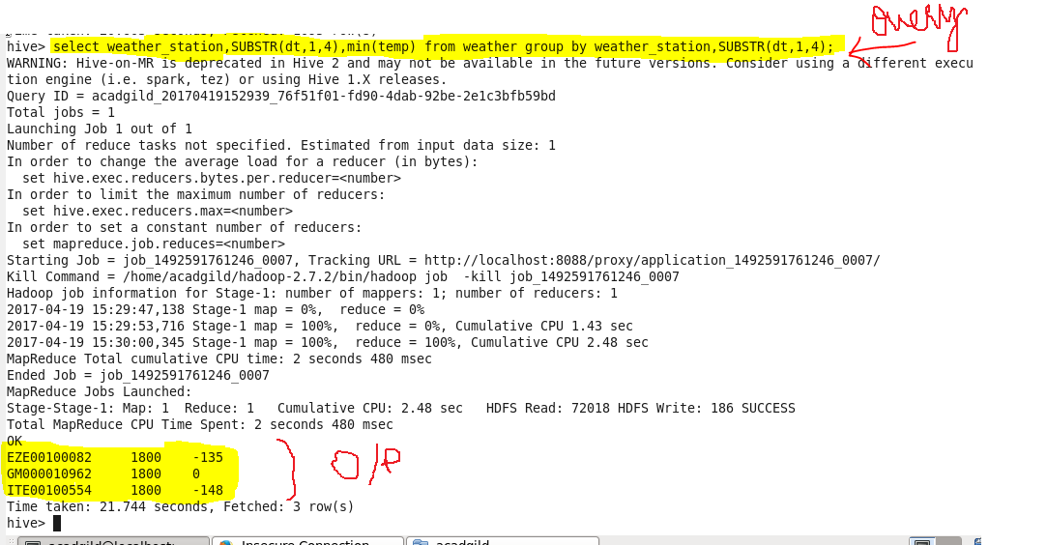

1. Write a hive query to find the maximum temperature observed in a given weather station in a particular year.

Displaying the weather station and the maximum temperature in that corresponding year.

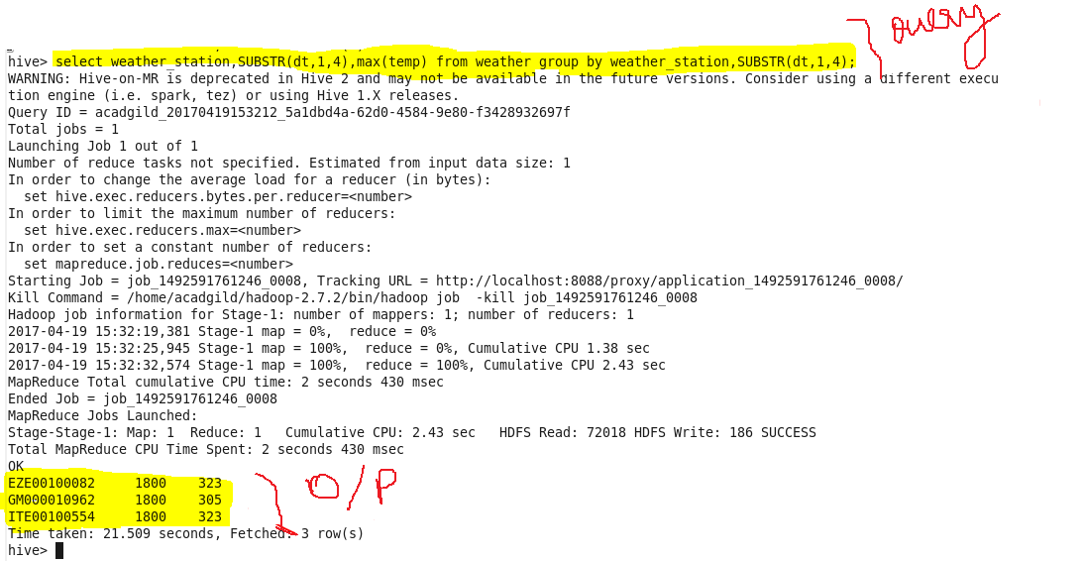

1. Write a hive query to find the number of readings given by each weather station according to the dataset.

Displaying the weather station and the number of records recorded by the corresponding weather station.

