Ques:- Write a Hive program to find the number of medals won by each country in swimming.

Input:

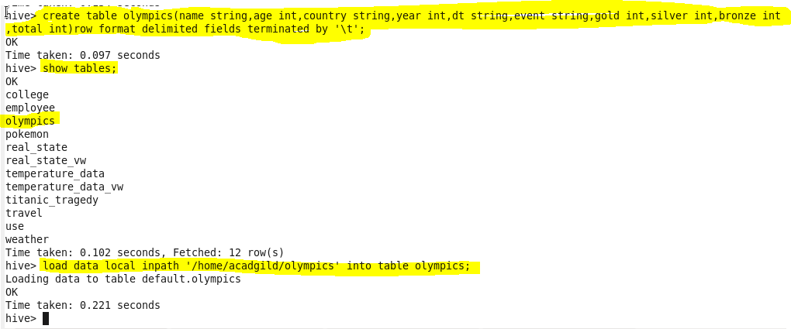

Code: 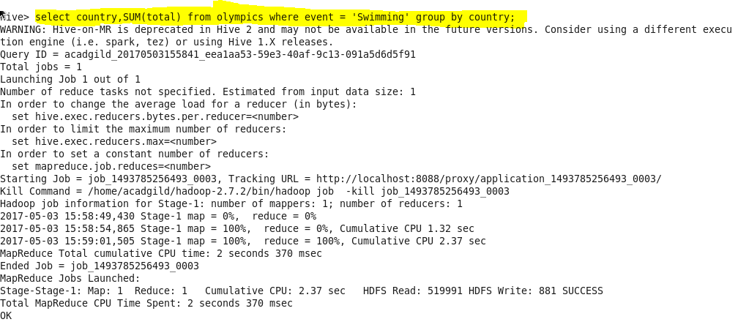

Output:

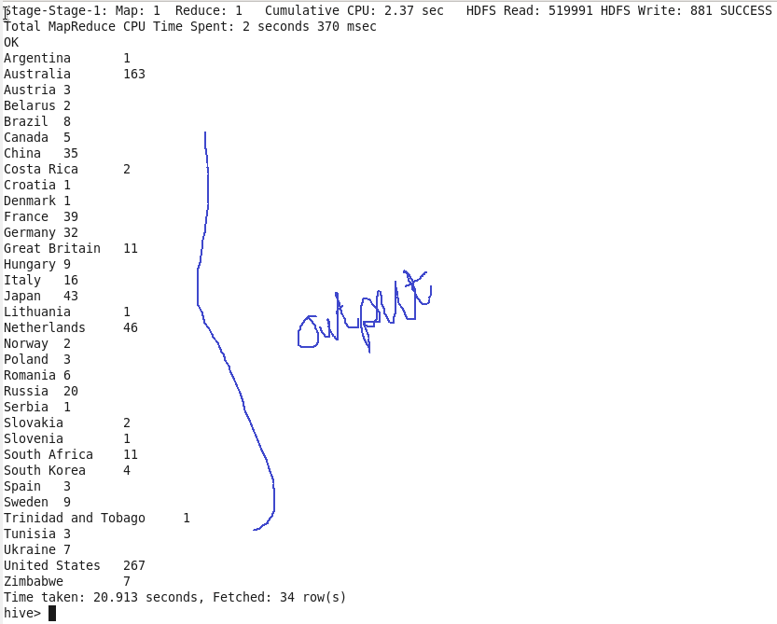

Write a Hive program to find the number of medals that India won year wise.

Code:

