***Que:- Create table travel data ?***

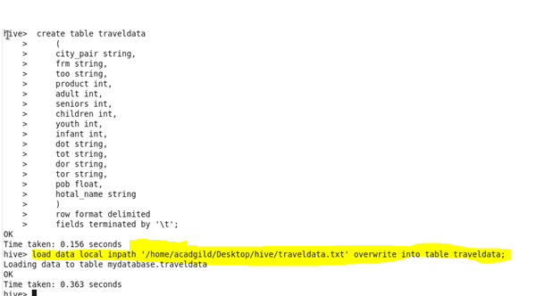

**1.Write a hive query to find the top 20 destination people travel the most: Based on the given data**

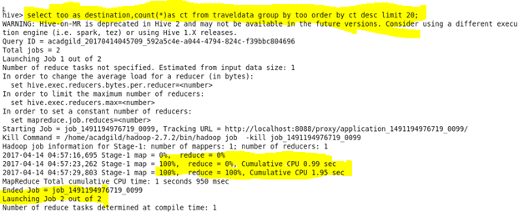

**Output**

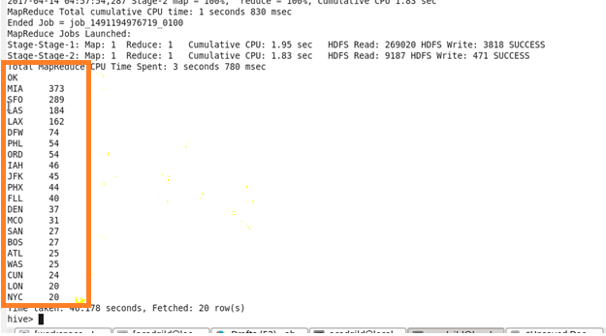

**2. Write a hive query to find the top 20 locations from where people travel the most**

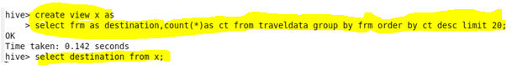

**Output**

