***Create table***

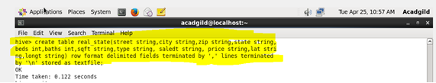

***Load data into table***

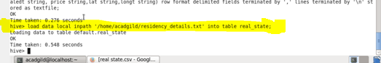

***1. Write a hive query to list top 5 residency details which lie in the budget of 60000-120000, an area more than 1450, sold after 17th may, min bedroom 3 and, min bathroom 2.***

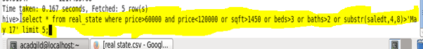

***Output***

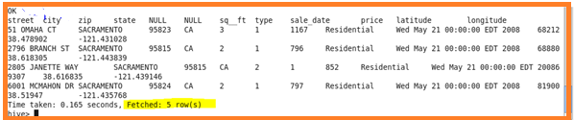

***2. Write a hive query to separate list of residential apartments with more than 2 beds. Also include columns in following order City,Baths,Sq_feet,Price,flat_type,Beds respectively.***



***Output***

