Ques:- Write a hive UDAF to find the largest integer in a column. Use your own dataset for the above problem statement and attach the steps performed, codes used with the result.

Input:

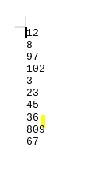

**JAR FILE FOR FINDING MAXIMUM VALUE IN THE FILE:**

Initially we are storing the output value as null. Then we are iterating the input value ,if it is null then it save with the input value and compares it with the previous value(output),if the output is empty then the maximum value is transferred to output, this is repeated until the column value ends.

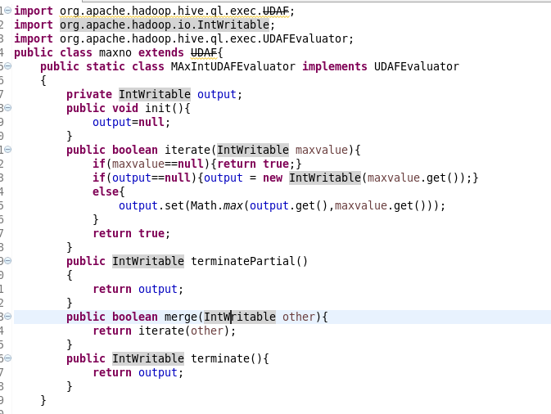

**FIRST WE ARE CREATING THE TABLE THEN WE ARE CALLING THE UDF FUNCTION TO FIND THE MAXIMUM VALUE .**

