*Ques:- Find the number of GoogleKnowlege_Occupation people who were guests in the show, in a particular time period. Take the time period as 1/11/99 to 6/11/99 i.e., 6 months?*

import org.apache.hadoop.fs.Path;  
import org.apache.hadoop.conf.*;  
import org.apache.hadoop.mapreduce.Job;  
import org.apache.hadoop.mapreduce.lib.input.TextInputFormat;  
import org.apache.hadoop.mapreduce.lib.input.FileInputFormat;  
import org.apache.hadoop.mapreduce.lib.output.TextOutputFormat;  
import org.apache.hadoop.mapreduce.lib.output.FileOutputFormat;  
import org.apache.hadoop.io.IntWritable;  
import org.apache.hadoop.io.NullWritable;  
import org.apache.hadoop.io.Text;  
public class GuestDriver{  
    @SuppressWarnings("deprecation")  
    public static void main(String[] args)throws Exception  
    {  
        Configuration conf=new Configuration();  
        Job job=new Job(conf,"Tv sales");  
        job.setJarByClass(GuestDriver.class);  
        FileInputFormat.addInputPath(job, new Path(args[0]));  
        Path outputPath =new Path(args[1]);  
        FileOutputFormat.setOutputPath(job, outputPath);  
        outputPath.getFileSystem(conf).delete(outputPath, true);  
        job.setMapperClass(GuestMapper.class);  
        job.setReducerClass(GuestReducer.class);  
        job.setInputFormatClass(TextInputFormat.class);  
        job.setOutputFormatClass(TextOutputFormat.class);  
        job.setMapOutputKeyClass(Text.class);  
        job.setMapOutputValueClass(IntWritable.class);  
        job.setOutputKeyClass(Text.class);  
        job.setOutputValueClass(IntWritable.class);  
        job.waitForCompletion(true);  
  
    }  
}import java.io.IOException;  
import java.text.ParseException;  
import java.text.SimpleDateFormat;  
import java.util.Date;  
  
import org.apache.hadoop.io.IntWritable;  
import org.apache.hadoop.io.LongWritable;  
import org.apache.hadoop.io.NullWritable;  
import org.apache.hadoop.io.Text;  
import org.apache.hadoop.mapreduce.*;  
  
public class GuestMapper extends Mapper<LongWritable,Text,Text,IntWritable>{  
    Text outkey=new Text();  
    IntWritable outvalue=new IntWritable();  
    public void map(LongWritable key, Text value, Context context)  
    throws IOException, InterruptedException{  
        String[] lineArray = value.toString().split(",");  
        if((lineArray.length > 2)&&(!lineArray[1].equalsIgnoreCase("NA")))  
        {  
            SimpleDateFormat df= new SimpleDateFormat("MM/dd/yy");  
            String s1="1/11/99";  
            String s2="6/11/99";  
            try  
            {  
            Date d1=df.parse(s1);  
            Date d2=df.parse(s2);  
            Date d3=df.parse(lineArray[2]);  
            if(d3.before(d2)&&d3.after(d1))  
            {  
            outkey.set(lineArray[1]);  
            outvalue.set(1);  
            context.write(outkey,outvalue);  
        }  
  
    }  
            catch(ParseException e)  
            {  
                e.printStackTrace();  
            }  
  
}}}import java.io.IOException;  
import java.util.StringTokenizer;  
  
import org.apache.hadoop.io.IntWritable;  
import org.apache.hadoop.io.LongWritable;  
import org.apache.hadoop.io.NullWritable;  
import org.apache.hadoop.io.Text;  
import org.apache.hadoop.mapreduce.*;  
import org.apache.hadoop.mapreduce.Mapper.Context;  
public class GuestReducer extends Reducer<Text,IntWritable,Text,IntWritable>{  
    public void reduce(Text key, Iterable<IntWritable>values, Context context)  
            throws IOException, InterruptedException{  
        int sum=0;  
        for(IntWritable value: values)  
        {  
        sum=sum+value.get();  
        }    context.write(key, new IntWritable(sum));}}

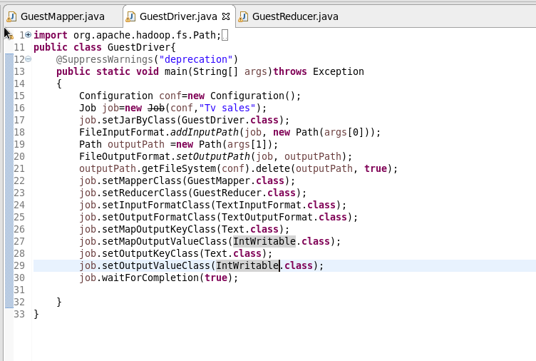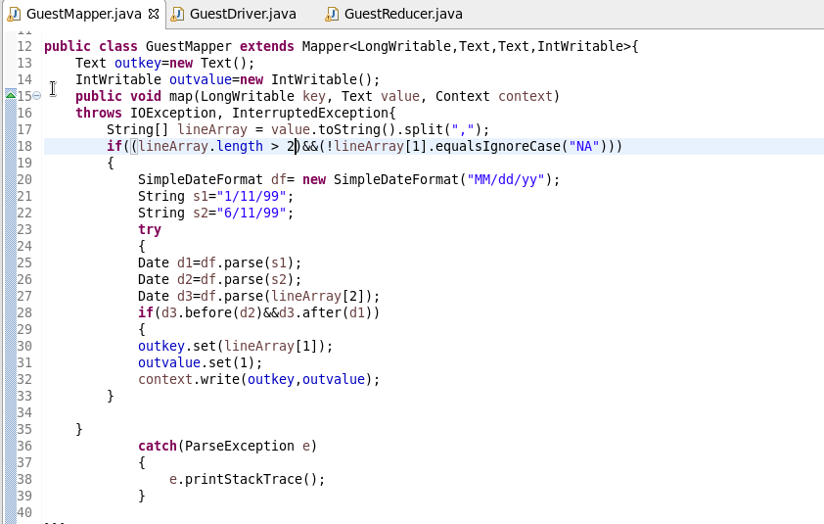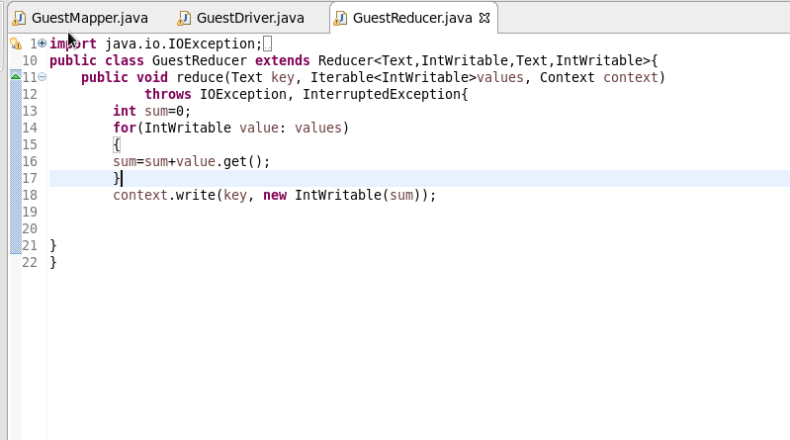

**Output:** 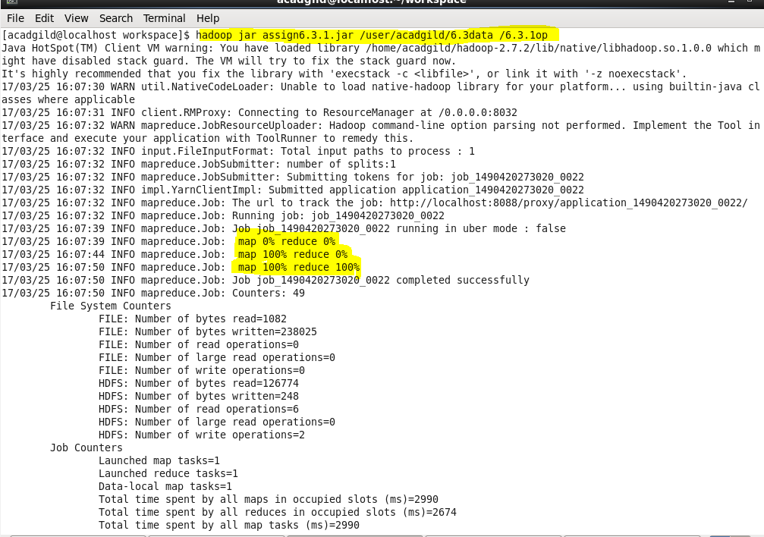

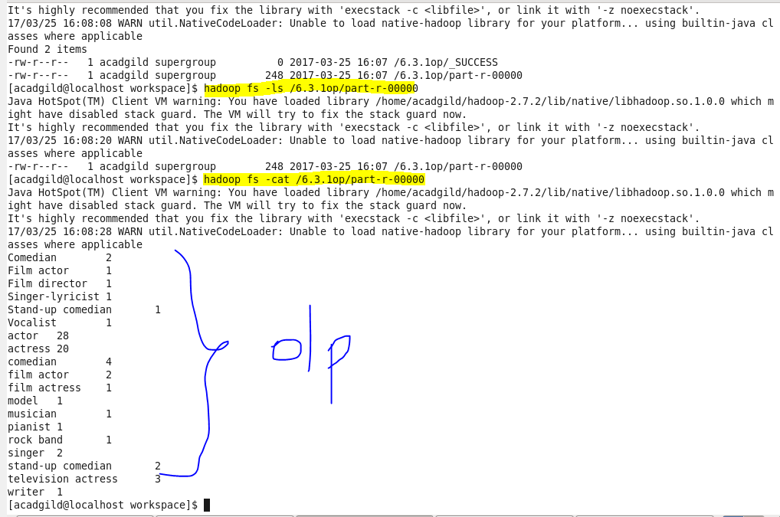

Find the number of GoogleKnowledge occupation types in each group, who have been guests on the show.

import org.apache.hadoop.fs.Path;  
import org.apache.hadoop.conf.*;  
import org.apache.hadoop.mapreduce.Job;  
import org.apache.hadoop.mapreduce.lib.input.TextInputFormat;  
import org.apache.hadoop.mapreduce.lib.input.FileInputFormat;  
import org.apache.hadoop.mapreduce.lib.output.TextOutputFormat;  
import org.apache.hadoop.mapreduce.lib.output.FileOutputFormat;  
import org.apache.hadoop.io.IntWritable;  
import org.apache.hadoop.io.NullWritable;  
import org.apache.hadoop.io.Text;  
public class GuestDriver{  
    @SuppressWarnings("deprecation")  
    public static void main(String[] args)throws Exception  
    {  
        Configuration conf=new Configuration();  
        Job job=new Job(conf,"Tv sales");  
        job.setJarByClass(GuestDriver.class);  
        FileInputFormat.addInputPath(job, new Path(args[0]));  
        Path outputPath =new Path(args[1]);  
        FileOutputFormat.setOutputPath(job, outputPath);  
        outputPath.getFileSystem(conf).delete(outputPath, true);  
        job.setMapperClass(GuestMapper.class);  
        job.setReducerClass(GuestReducer.class);  
        job.setInputFormatClass(TextInputFormat.class);  
        job.setOutputFormatClass(TextOutputFormat.class);  
        job.setMapOutputKeyClass(Text.class);  
        job.setMapOutputValueClass(IntWritable.class);  
        job.setOutputKeyClass(Text.class);  
        job.setOutputValueClass(IntWritable.class);  
        job.waitForCompletion(true);  
  
    }  
}import java.io.IOException;  
import java.text.ParseException;  
import java.text.SimpleDateFormat;  
import java.util.Date;  
  
import org.apache.hadoop.io.IntWritable;  
import org.apache.hadoop.io.LongWritable;  
import org.apache.hadoop.io.NullWritable;  
import org.apache.hadoop.io.Text;  
import org.apache.hadoop.mapreduce.*;  
  
public class GuestMapper extends Mapper<LongWritable,Text,Text,IntWritable>{  
    Text outkey=new Text();  
    IntWritable outvalue=new IntWritable();  
    public void map(LongWritable key, Text value, Context context)  
    throws IOException, InterruptedException{  
        String[] lineArray = value.toString().split(",");  
        if((lineArray.length > 3)&&(!lineArray[3].equalsIgnoreCase("NA")))  
        {  
            outkey.set(lineArray[3]);  
            outvalue.set(1);  
            context.write(outkey,outvalue);  
        }  
  
  
}}import java.io.IOException;  
import java.util.StringTokenizer;  
  
import org.apache.hadoop.io.IntWritable;  
import org.apache.hadoop.io.LongWritable;  
import org.apache.hadoop.io.NullWritable;  
import org.apache.hadoop.io.Text;  
import org.apache.hadoop.mapreduce.*;  
import org.apache.hadoop.mapreduce.Mapper.Context;  
public class GuestReducer extends Reducer<Text,IntWritable,Text,IntWritable>{  
    public void reduce(Text key, Iterable<IntWritable>values, Context context)  
            throws IOException, InterruptedException{  
        int sum=0;  
        for(IntWritable value: values)  
        {  
        sum=sum+value.get();  
        }  
        context.write(key, new IntWritable(sum));  
  
  
}  
}

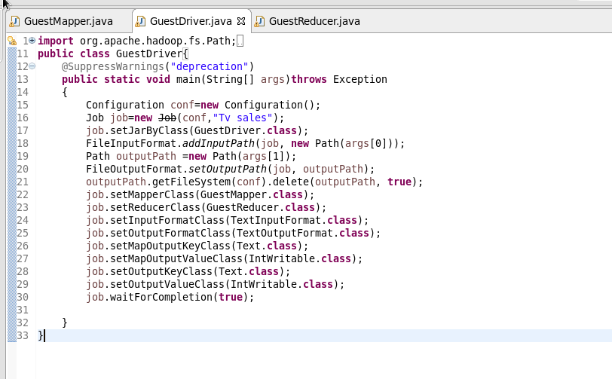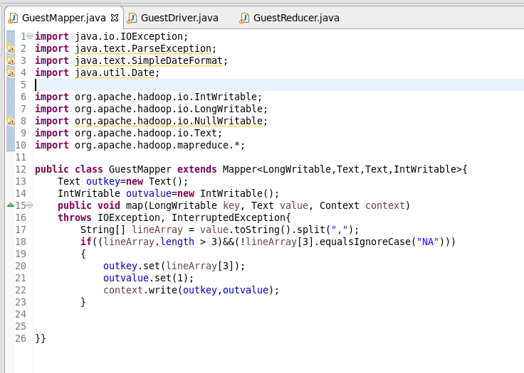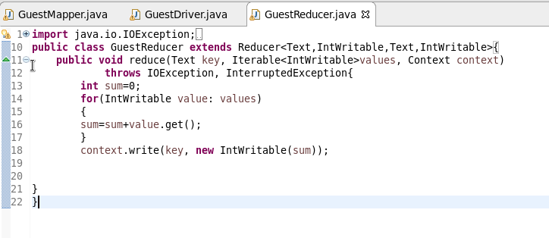

**Output:** 