Project 1:-

Input file-

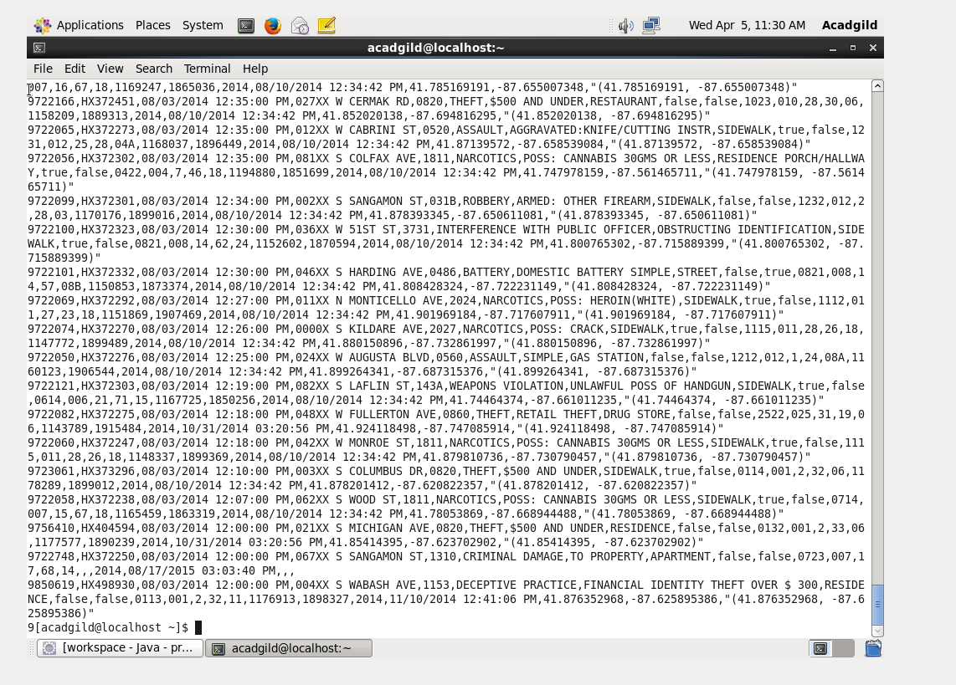

Solution by pig

1.Write a mapreduce and pig program to calculate the number of cases investigated under each FBI code-

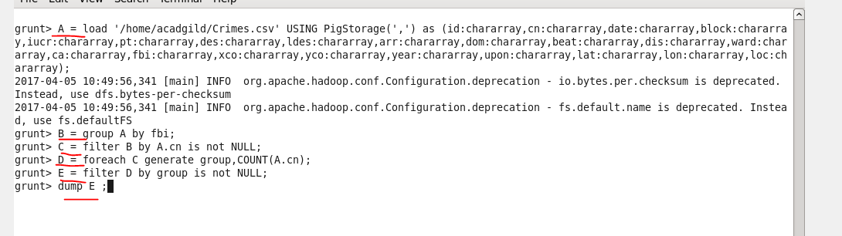

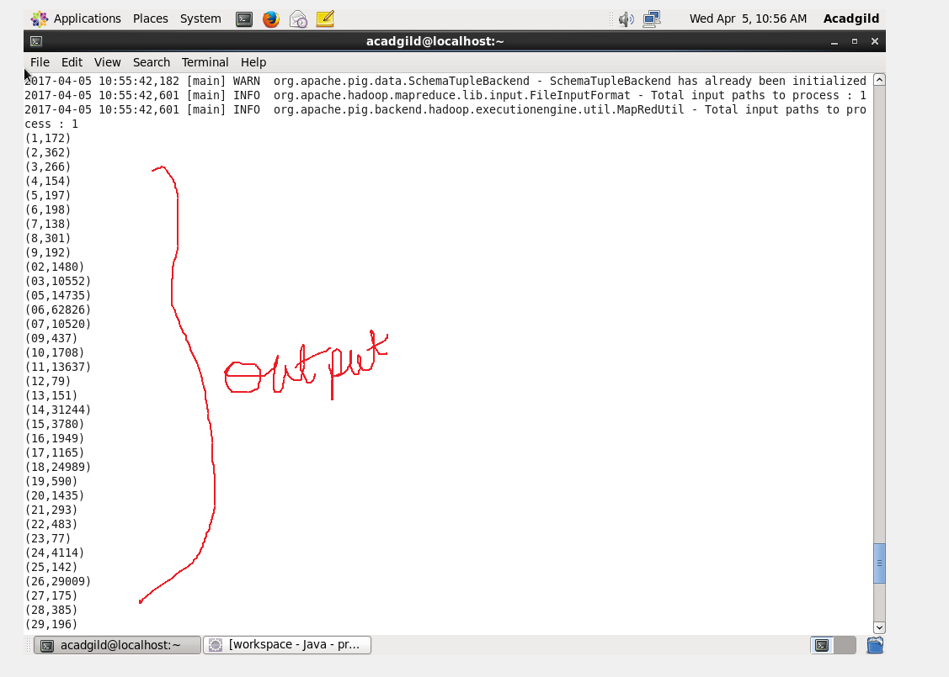

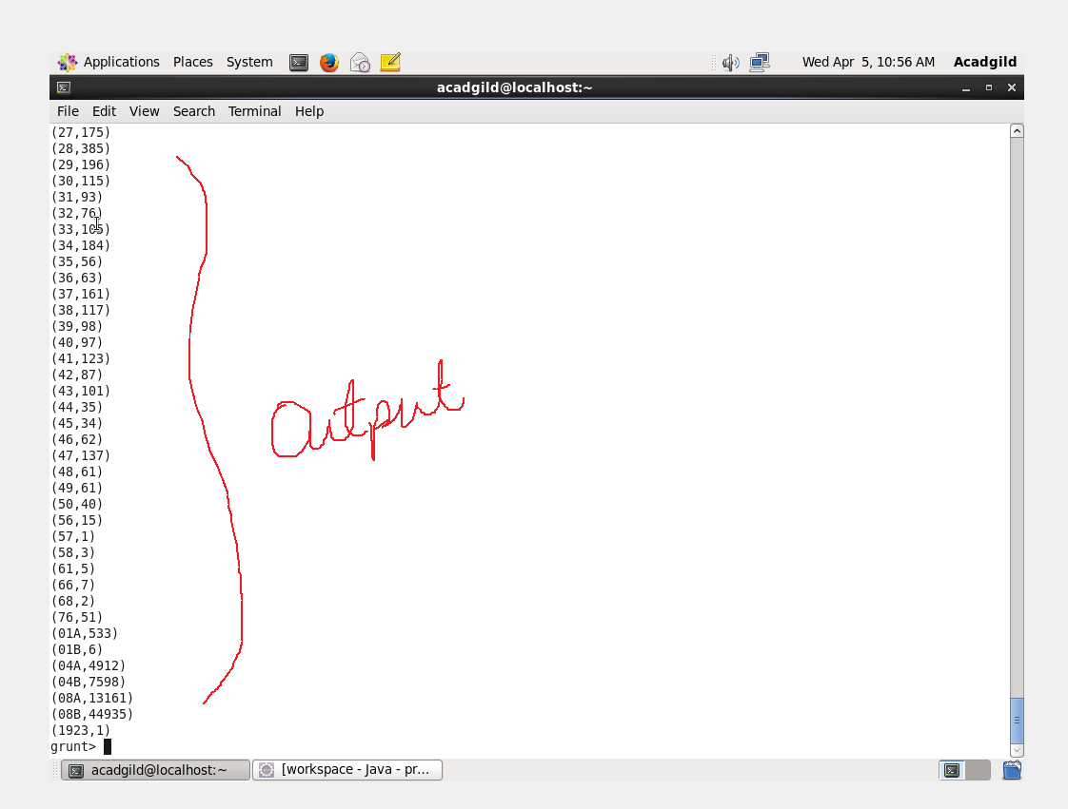

2. Write a mapreduce and pig program to calculate the number of cases investigated under FBI code 32.

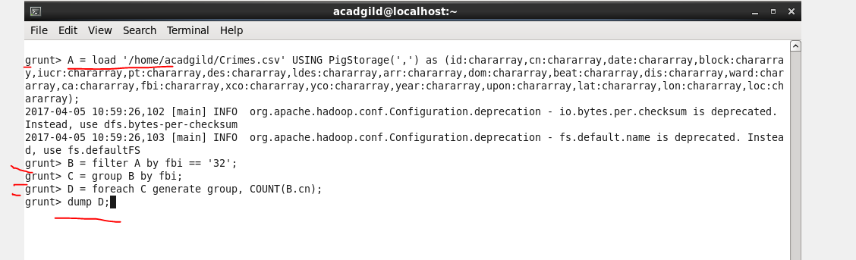

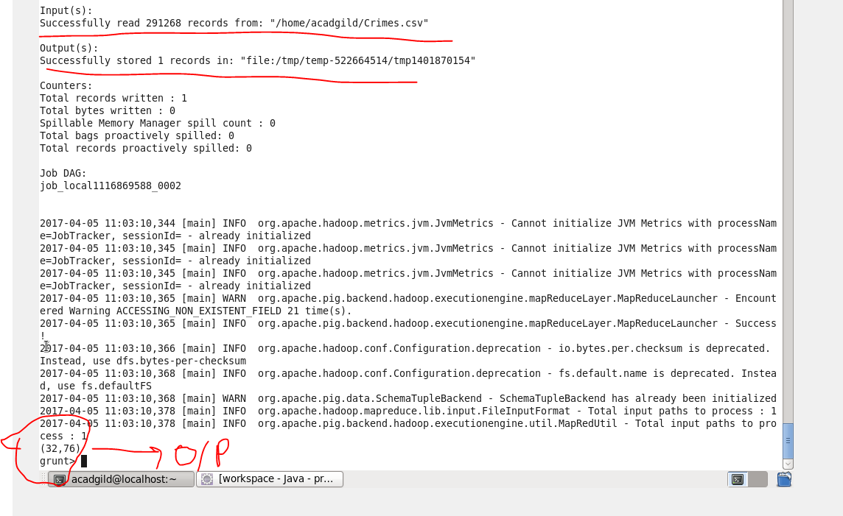

3. Write a mapreduce and pig program to calculate the number of arrests in theft district wise.

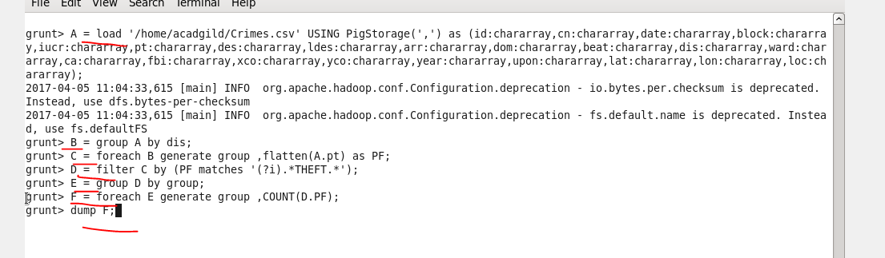

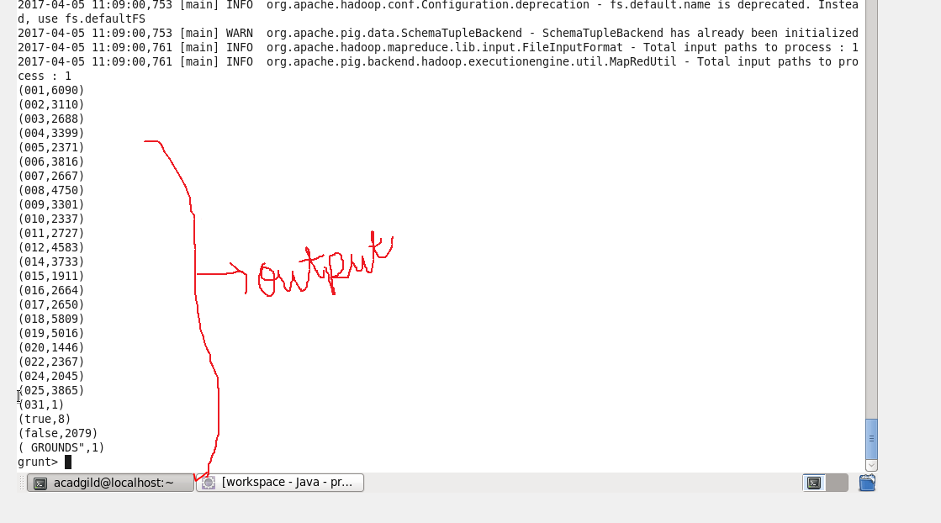

4. Write a mapreduce and pig program to calculate the number of arrests done between October 2014 and October 2015.

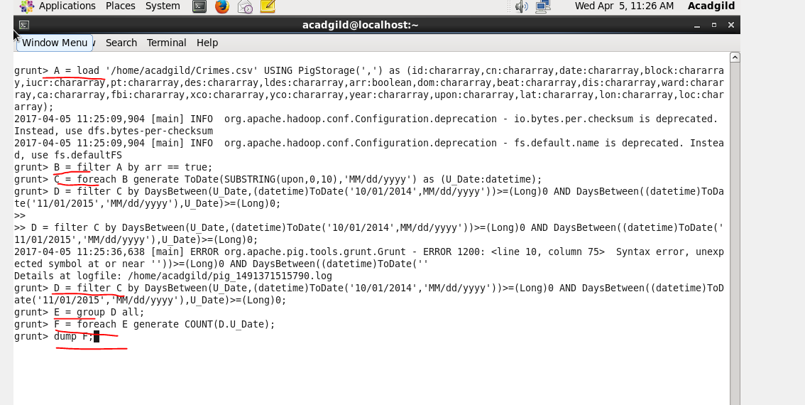

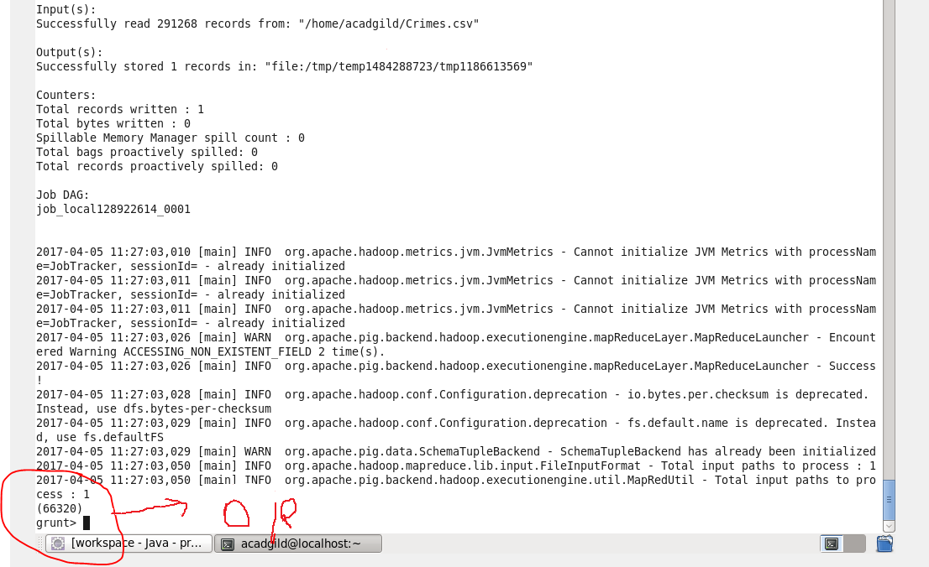

Solution by map reduce

Driver and Reducer are same for all the questions

Driver-

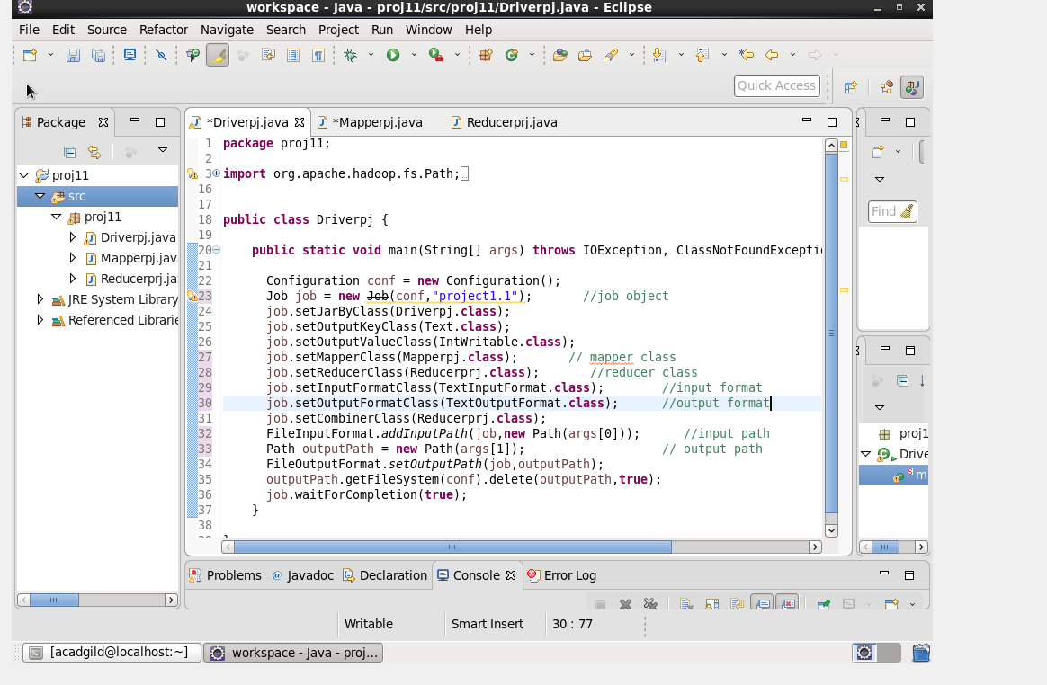

Reducer-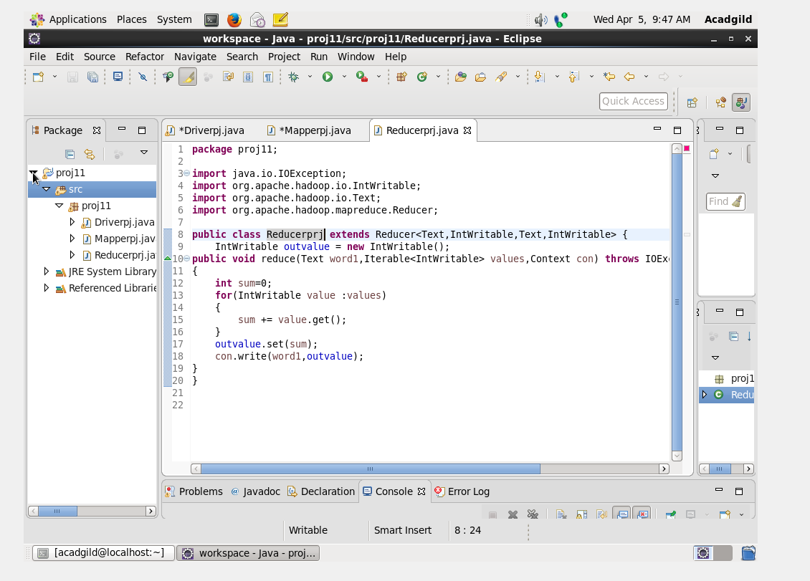

Mapper and output for each question

1.Write a mapreduce and pig program to calculate the number of cases investigated under each FBI code

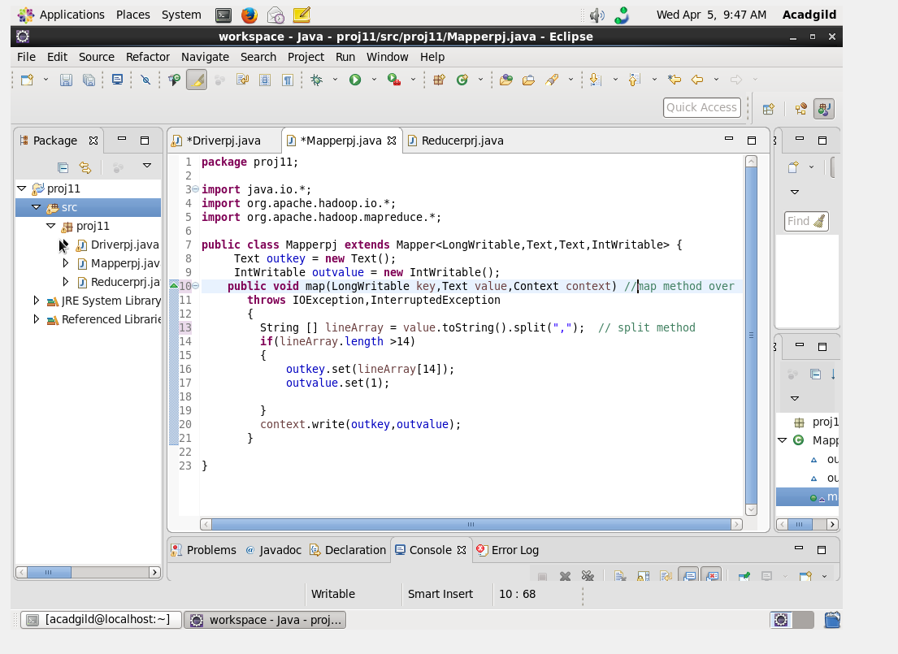

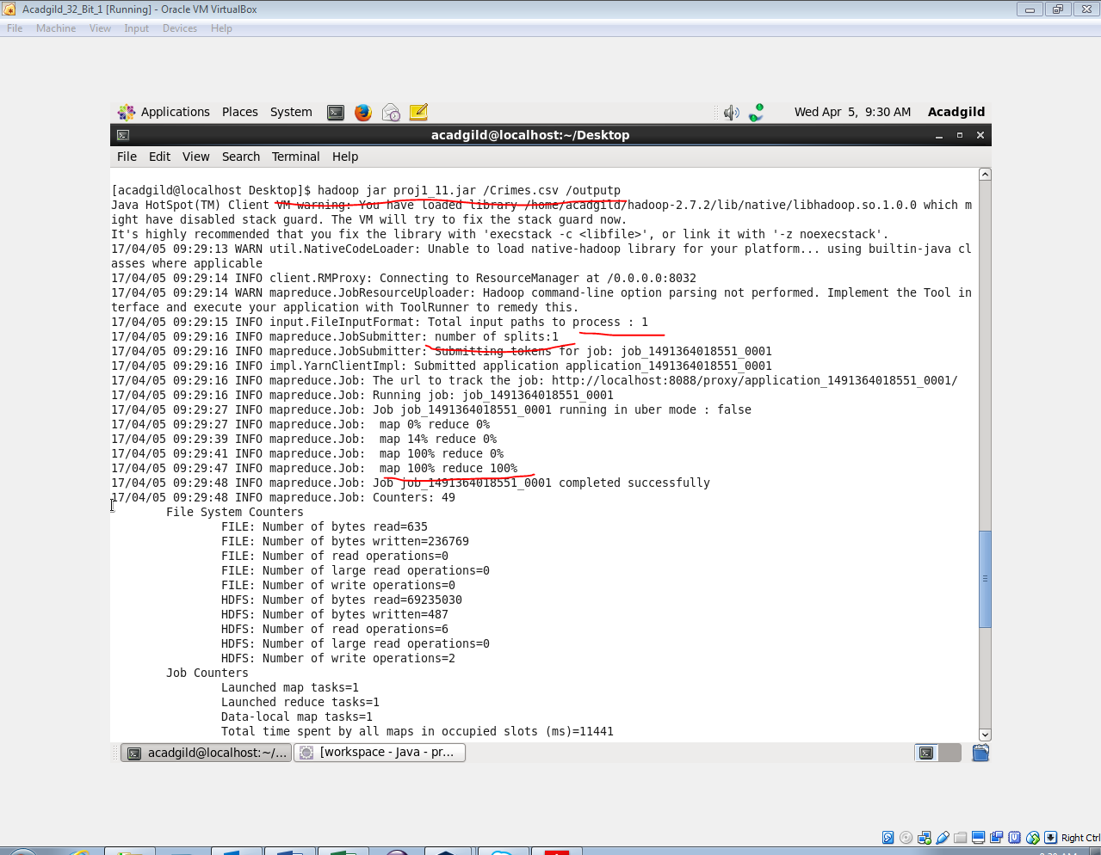

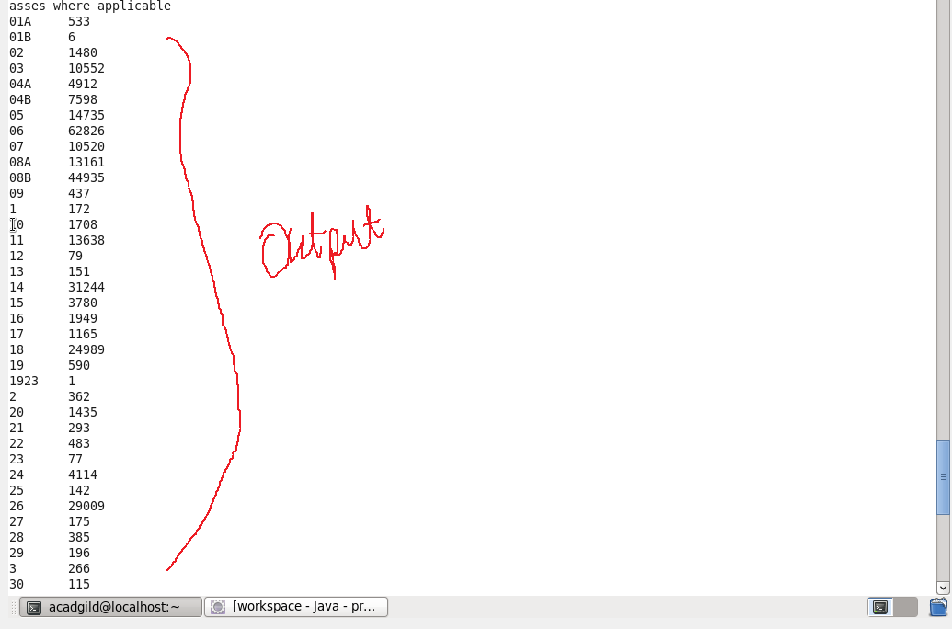

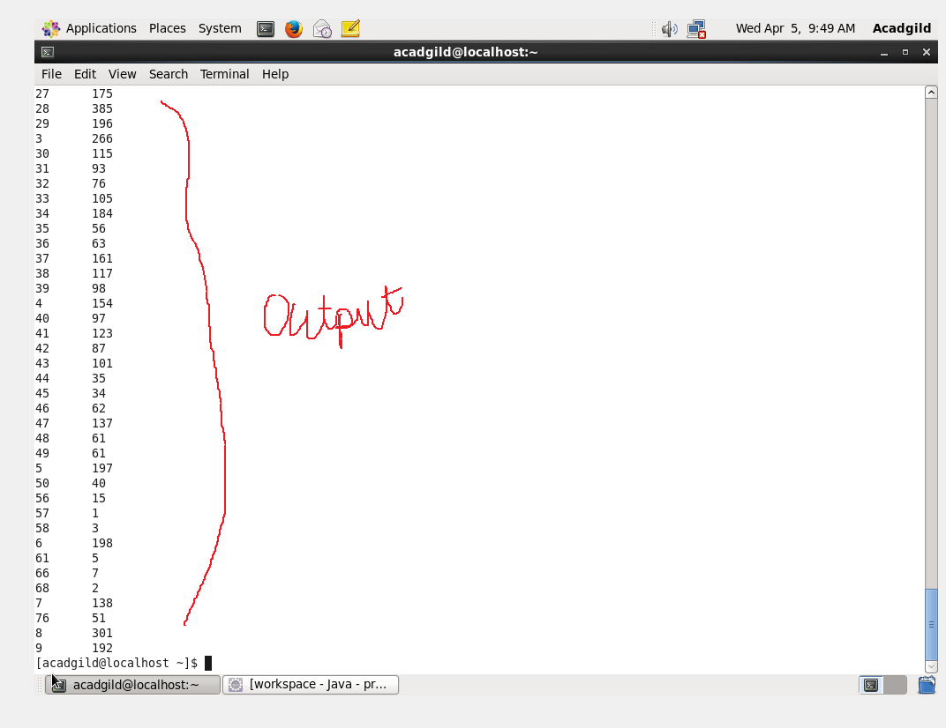

2.Write a mapreduce and pig program to calculate the number of cases investigated under FBI code 32.

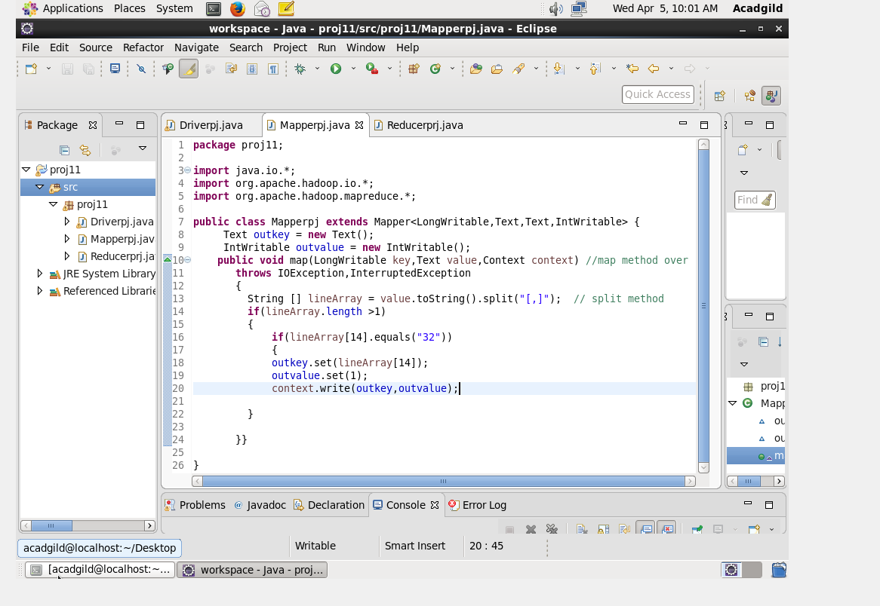

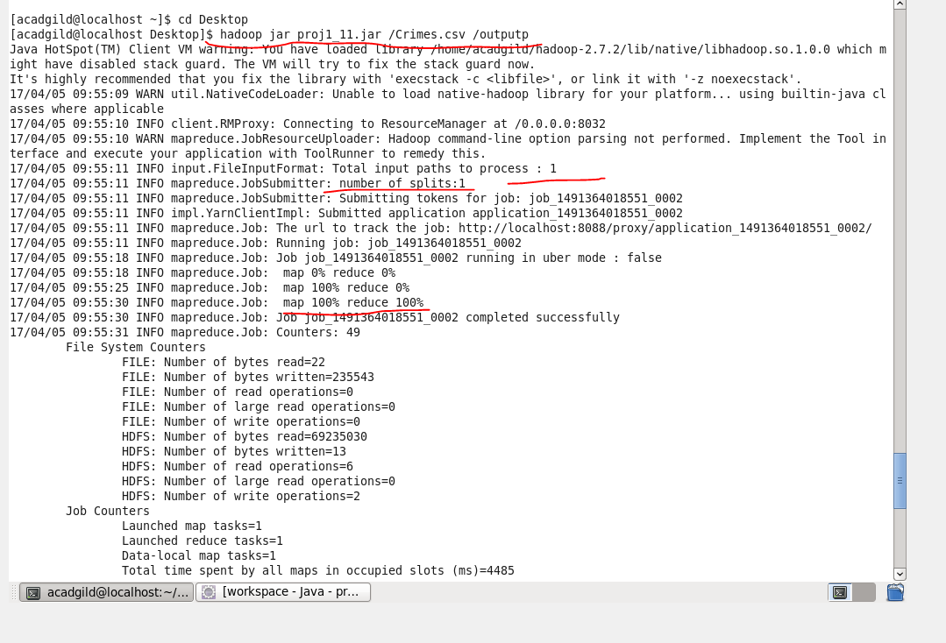

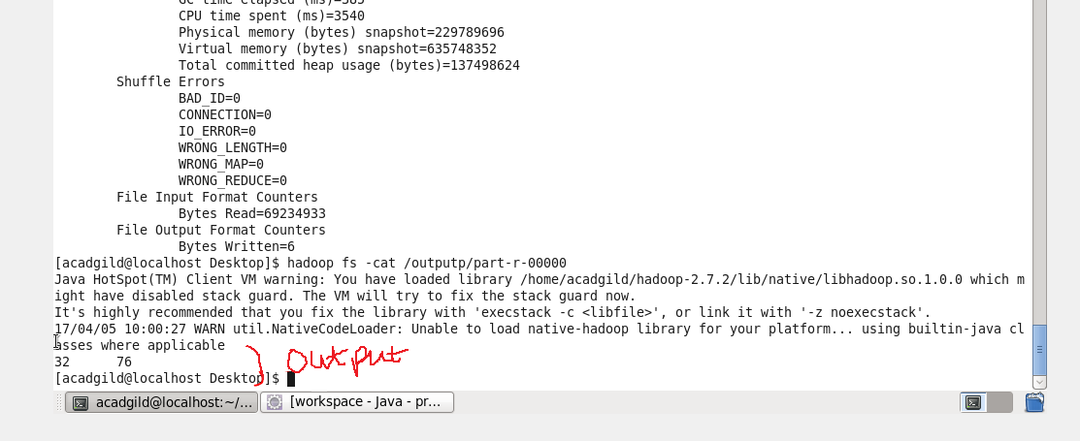

3.Write a mapreduce and pig program to calculate the number of arrests in theft district wise.

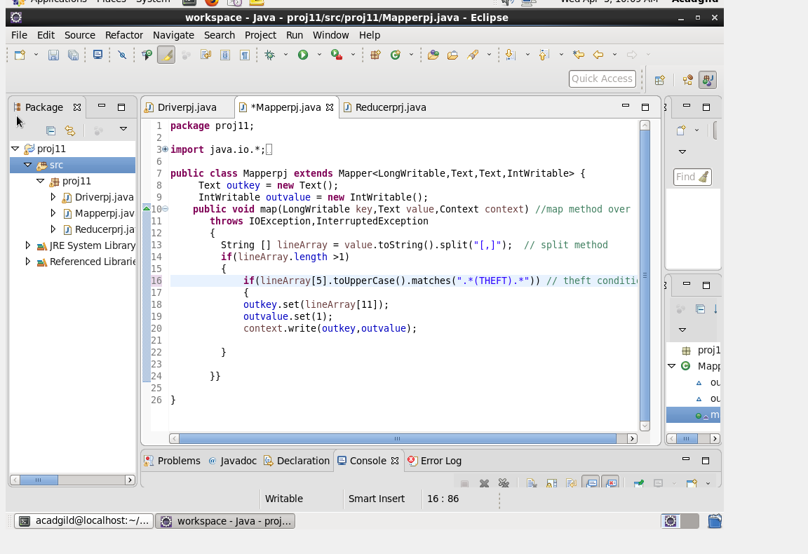

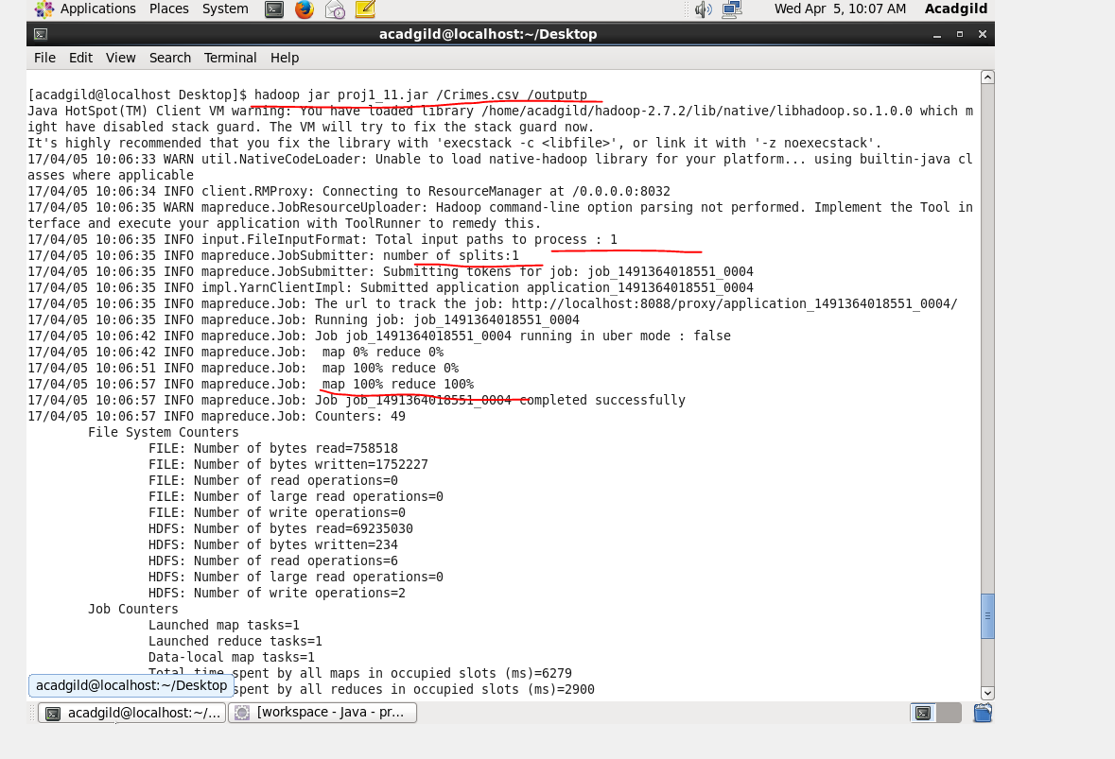

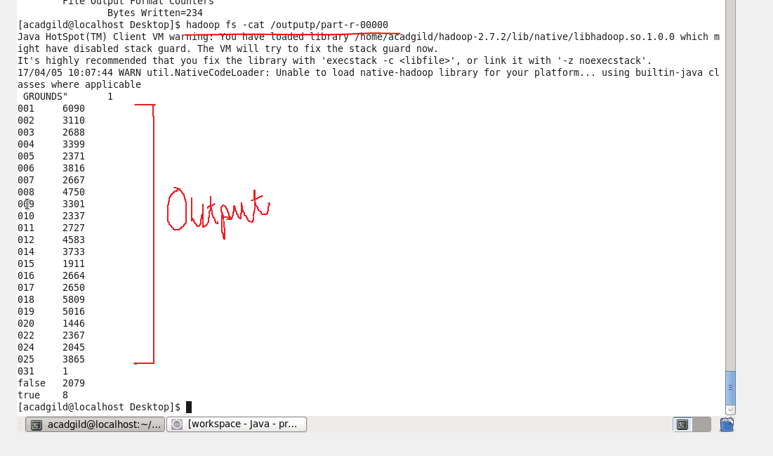

4.Write a mapreduce and pig program to calculate the number of arrests done between October 2014 and October 2015.

