Protect Electronic – Voting Technique

Himanshu Tiwari[23BCS13800] ,Arshpreet Singh , Kulwinder Singh ,
Abstract :- Within a modern democratic nation, elections play a significant role in the nation’s functioning. However, with the existing infrastructure for conducting elections using Electronic Voting Systems (EVMs), many loopholes exist, which illegitimate entities might leverage to cast false votes or even tamper with the EVMs after the voting session is complete. The need of the hour is to introduce a robust, auditable, transparent, and tamper-proof e-voting system, enabling a more reliable and fair election process. To address such concerns, we propose a novel solution for blockchain-based e-voting, focusing on the security and privacy aspects of the e-voting process. We consider the security risks and loopholes and aim to preserve the anonymity of the voters while ensuring that illegitimate votes are properly handled. Additionally, we develop a prototype as a proof of concept using the Ethereum blockchain platform. Finally, we perform experiments to demonstrate the performance of the system.

Introduction

E – Voting , short of electronic voting , refers to the use of electronic systems and technologies to conduct elections . This modern approach to voting leverages digital platforms , computers and the internet to facilitate the casting and counting of votes . E voting system varies in complexity and design , but they generally aim to streamline the voting process , enhance the accessibility , and improve the efficiency of elections.

With the introduction of several proposals for e-voting systems, which include proposals that consider a centralized architecture, as well as distributed systems considering blockchain and distributed databases, a lot of work has been going on in this direction. In [3], Zhao et al. proposed a reward or penalty scheme based on the voters’ behaviour, marking it as the first attempt to combine e-voting with blockchain. Lee et al. in [4] proposed an e-voting protocol involving a Trusted Third Party (TTP) within a blockchain to preserve voters’ choices. Voters are restricted based on their rights within the organization. Here the voters have been identified with a unique identifier, such as Social Security Number (SSN). An authenticated person is traced back to a single candidate. In [5], Bistarelli et al. presented an e-voting protocol based on Bitcoin. Their proposal is based on three phases of voting. Yi Liu et al. in [6] proposed a blockchain-based protocol for secure e-voting. To preserve voters’ choices blind signature is used. The blind signature, introduced in [7] by David Chaum, disguises the content of a message before it is signed. Similar to a digital signature, it can be compared with the original unblinded message.
Although these proposals aim at improving the trust, audibility, and transparency of the election process, their proposals fail to preserve the private and identifiable information of the voters. In this paper, we propose a novel solution for blockchain-based e-voting, focusing on the security and privacy aspects of the e-voting process. We consider the security risks and loopholes and aim to preserve the anonymity of the voters while ensuring that illegitimate votes are properly handled.
To the best of our knowledge, this proposal is one of its kind, leveraging blockchain technology and zero-knowledge proof to ensure a secure and reliable e-voting platform.
We present a comprehensive method for trustworthy and secure electronic voting that make sure of blockchain technology, zero-knowledge proofs ,and smart contracts. By taking into account all stakeholders and the beneficial services that are pertinent to them, we assess the worst-case scenario.
By implementing suitable access control and authentication systems, we address security and privacy concerns.
As proof of concept, we create a prototype on the Ethereum blockchain.
Finally, we perform experiments to demonstrate the performance of the system.

Register and Verify identity on the System
Request for Voter Access
Cast Votes
Users
RegistrationSC
Create Poll
Register Voters and Open Poll
Close Poll
Poll Creator
Verify User Identity
PollSC
Fig. 1: Overall architecture of the proposed system

Literature Survey

Let us now discuss some of the state-of-the-art proposals for e-voting. Our literature survey revealed some of the major proposals for e-voting systems, including centralized and blockchain-based proposals.
In [3], Zhao et al. proposed a reward or penalty scheme based on the voters’ behaviour, marking it as the first attempt to combine e-voting with blockchain. Their work was based on Bitcoin and satisfies the basic features of a block chain based proposal, i.e., privacy, verifiability, and auditability. Similar to [3], in 2016, Lee et al. in [4] proposed an e-voting protocol involving a TTP (trusted third party) within a blockchain network for preserving voters’ choices. Additionally, voters are restricted based on their rights within their own organizations. This paper identifies voters with identification numbers such as SSN (Social security number), leading an authenticated person to be tracked back to a single candidate.
Bistarelli et al. in [5] proposed an e-voting protocol using the Bitcoin platform. As per their proposal, the e-voting process consists of three phases, i.e., the Pre-voting phase, including the candidate nomination and registration process, and the voter registration phase. Next is the voting phase, where the voters cast their votes. Finally, when the voting process is terminated, and the results of the election are published. The complete system is based on the Bitcoin platform, and the stakeholders are identified using their public keys/wallet addresses.
Liu et al. in [6] proposed an e-voting protocol without the involvement of a third party. The protocol has been designed based on blind signatures and blockchain. To preserve the anonymity of voters’ choices, a blind signature is used.

Problem Statement

Much research has been going on in this domain of e-voting systems, but the existing proposal doesn’t address the privacy and security concerns involving an e-voting system. The blockchain-based e-voting systems aim at bridging the gaps of traditional centralized e-voting systems. However, they don’t address issues like non-repudiation, privacy, and anonymity of voters, concerning authentication and verification of votes. To this aim, we propose a novel blockchain-based e-voting system, with the aid of zero-knowledge proofs to mitigate the above-mentioned shortcomings. For Epitome:-

Privacy:-
Electronic voting systems can introduce various privacy concerns, including:
- Voter Anonymity: Ensuring that individual votes cannot be linked back to specific voters is crucial for maintaining anonymity and preventing coercion or vote-buying. However, in some electronic systems, there may be vulnerabilities that could potentially compromise voter privacy by allowing votes to be traced back to individuals.
- Ballot Secrecy: The secrecy of the ballot is essential for protecting the integrity of the voting process. In electronic systems, there is a risk that hackers or unauthorized individuals could intercept or manipulate ballots, compromising the secrecy of the vote.
- Data Breaches: Electronic voting systems require the storage and transmission of sensitive voter data, including personal information and voting choices. Inadequate security measures could make these systems vulnerable to data breaches, potentially exposing voters' personal information and undermining trust in the electoral process.
- Insider Threats: Employees or administrators with access to electronic voting systems may pose a threat to voter privacy if they misuse their privileges to access or manipulate sensitive data.
- Remote Voting: Remote electronic voting systems, such as internet or mobile voting, introduce additional privacy challenges. These systems must ensure that votes remain confidential during transmission and storage, even when voters are accessing the system from potentially insecure environments.
- Coercion and Vote Buying: Electronic voting systems may be susceptible to coercion or vote-buying schemes if voters can prove how they voted. Without proper safeguards, individuals could be pressured or incentivized to vote a certain way, undermining the fairness and integrity of the election.
Addressing these privacy concerns requires robust security measures, including strong encryption, authentication protocols, audit trails, and rigorous testing and verification processes. Additionally, transparency and oversight mechanisms are essential for building trust in electronic voting systems and ensuring that they meet the highest standards for privacy and security.

Proposed Approach

- In this section, we elucidate our proposal for the blockchain-based e-voting system. Since our primary objective is to maintain privacy while ensuring the security and authenticity of votes throughout the entire election process (commencing from election registration to revealing results). The process starts with the poll creator initiating a poll and registering the addresses of the voters to the poll using the e-voting smart contract. Next, the voters are made aware of the poll, and the process proceeds with them casting their votes. Once all of the registered voters have cast their votes, the poll is automatically closed, and the e-voting smart contract reveals the poll results. Since all of the transactions performed, including the creation of the poll, registering of the voters, the casting of votes, and the publication of poll results, are facilitated through the electronic voting smart contract on the blockchain network, every transaction performed is recorded on the distributed ledger, ensuring reliable and auditable access to the poll, and enforcing trust within the system involving untrusted parties. The recap, the overall processes of the system involve : 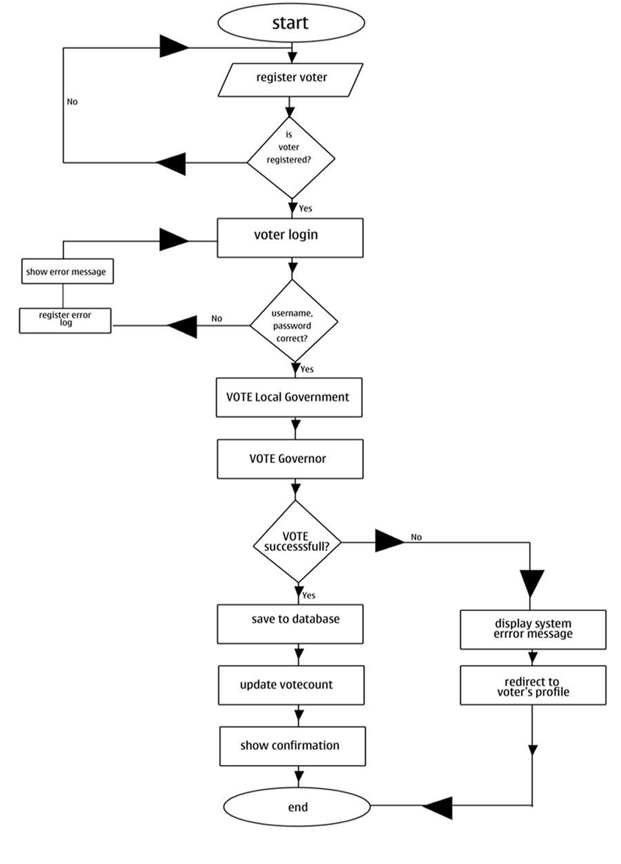

Registration & Verification of Stakeholders
This phase allows a legitimate person to register as a stakeholder and perform activities in the system. We propose a registration and verification mechanism leveraging zero-knowledge proofs (ZKP) to ensure the same. The process starts with legitimate users U_{i} approaching the system and executing the following actions in sequence:
The user U_{i} sends a registration Request Rq_{i} to the Identity Verifier V_{j}, to register on the platform. This action generates a temporary key TmpKey_{i}, for U_{i}. Here TmpKey_{i} is generated randomly based on device credentials and timestamp. TmpKey_{i} and Rq_{i} are sent over a secure HTTPS channel to V_{j}.
Extraction of TmpKey_{i} and manifesting of Rq_{i} occur once V_{j} has received Rq_{i}. Then, V_{j} creates an unverified identification called UnvID_{i}. This is given to user U_{i} and is only confirmed after completing the ZKP procedure.
For the next step, a signal flag Sig_{ZKP} is forwarded to U_{i}, indicating the start of the ZKP process.
The prover and verifier are initialized as U_{i} and V_{j}, respectively, in the ZKP process. Without disclosing sensitive information about the prover to the verifier, this approach aids in confirming the veracity of the prover.
Next, U_{i} determines the value of r, or a random number, which will later be utilized to determine the value of d. This d is now transmitted across a secure channel to the verifier V_{j}.
The V_{j} extracts d and selects two challenges for the prover. These challenges are sent to the prover U_{i} over a secure channel.
On receiving the challenges, U_{i} computes the answers for them and transmits the answers A_{i} over a secure channel to V_{j}.
Finally, after V_{j} receives the answers, they verify them, and once the verification is complete, a permanent identity ID_{i} is generated for user U_{i}.

Creation of the Poll Event

With this phase of the system, a registered user U_{x} is allowed to create a poll. This process starts with the invocation of the createPoll() method of PollSC while providing the necessary details. These details include a poll name PollName_{x}, a description of the poll PollDesc_{x}, and a list of poll options or choices denoted by PollOpts_{<x,i>}. After this is successfully done, a poll ID is returned as Poll_{x}. Next, the user U_{x} is required to register the respective users U_{i} to the poll so that U_{i} can cast their votes on the available options PollOpts_{x,i}.

Registration of Voters to the Poll_{x}
In this phase, the poll creator U_{x} invokes the registerVoters(), providing an array of registered users [U₁,U₂,....U_{j}] so that they are added to the poll Poll_{x}. Without this step, no user registered on the system U_{i} can cast their votes. With the successful completion of this phase, during a user U_{i} casting their vote, the PollSC will be verified if they are registered to the respective poll event Poll_{x}. Only their votes will be considered valid if they are registered to that respective poll Poll_{x}. However, if the poll creator wants their poll to be an open poll, then they need to invoke the setOpen() method instead to make the Poll_{x} open to all registered users on the system. Next, the user U_{x} is required to invoke the openPoll() method, which will allow the Poll_{x} to accept votes from registered and verified users U_{i}, which is manifested in the subsequent sections.

Casting of Votes
Once the poll creator U_{x} opens up the poll invoking the openPoll() method, all registered users [...U_{j}] on that respective poll Poll_{x} will be able to cast their votes for the available poll options < PollOpt₁,PollOpt₂,...PollOpt_{y} >. The registered voter U_{i} need to invoke the castVotes() supplying the required parameters < PollID,PollChoiceIndex >. Once the casting of votes is successful, granted that the required checks were successful, i.e., voter U_{i} was registered to the Poll_{x}, and that U_{i}’s identity was verified in the Registration and Verification phase, their vote Vote_{m} will be registered on the PollSC smart contract, for Poll_{x}. And this vote will be appended to the blockchain ledger permanently.

Closing of the Poll
After all the registered voters cast their votes on Poll_{x}, the poll creator can close the poll, invoking the close Poll() method of the Poll SC smart contract. Doing so will render the poll closed, i.e., no more votes can be cast, and the vote results will be declared after computing them and storing them in the smart contract. Closing the poll involves setting the poll Status to false, which, when checked against before accepting votes, will render the cast Votes() method to fail.

Publication of Poll Results
Once the poll is closed by invoking the close Poll() method, the poll results will be available to all the participants and stakeholders in the system. To access the poll results, the get Poll Results() method needs to be invoked from the Poll SC smart contract, providing the Poll ID as an argument to the method. This method invocation will return the winning choice Poll Opt_{y} if the poll is closed, else will return null.

Result
In this section, let us manifest the experimental evaluations we conducted to verify the practicality of our proposal. We conduct the experiments on a machine equipped with a 24-core Intel Xeon CPU running at a base frequency of 1.99 GHz, 128 GB of RAM, and the Ubuntu 18.04 LTS 64-bit operating system.
In the first round of experiments, we keep track of transaction costs, i.e., the gas costs of the various system operations. Gas costs are divided into two categories: (1) Gas costs associated with deploying a smart contract and (2) Gas costs associated with executing various smart contract operations.
Figure 2 represents the Gas cost with respect to different function invocations in Registration SC and Poll SC smart contracts.
Let’s now talk about the experimental findings from the second stage of our study, which was performed to test the implementation of our prototype. We assess the stability and functionality of our system, specifically under load. Utilizing the Hyperledger Caliper benchmarking tool this is accomplished.
sendReq
genKey
verifyProof
genChng
regUser
10
4
.
6
10
4
.
8
10
5
10
5
.
2
4
.
9
8
5
.
27
4
.
8
1
4
.
9
7
4
.
56
GasConsumption
Transaction Cost (Gas)
createPoll
registerVoters
OpenPoll
setOpen
castVotes
closePoll
getPollRes
10
4
10
5
5
.
33
5
.
18
3
.
5
9
4
.
89
4
.
2
8
3
.
86
4
.
84
GasConsumption
Transaction Cost (Gas)
(a) Gas Costs of Different Func- (b) Gas Costs of Different Functions in Registration SC tions in Poll SC
Fig. 2: Gas Costs of Different Functions of Different Smart Contracts
To accomplish this, we performed Hyperledger Caliper benchmarks for the metrics send rate (total transaction requests sent per second) and concurrent users (number of concurrent users at an instance). With intervals of 25 TPS, we changed the transmission rate from 25 Transactions Per Second (TPS) to 300 TPS. We altered the number of users for concurrent users from 25 to 100 with a 25-user interval. We recorded the system’s average latency and throughput for a particular ratio of concurrent users and transmit rate for evaluation metrics. Figure 3 shows the typical latency and transaction throughput.
250
500
750
1000
1250
1500
1750
2000
2250
2500
2750
3000
0
1
,
000
2
,
000
3
,
000
Send Rate (TPS)
Throughput(TPS)
0
.
9
1
1
.
1
1
.
2
·
10
−
2
AverageLatency(s)
25
50
75
100
125
150
175
200
225
250
275
300
20
25
30
35
Send Rate (TPS)
Throughput(TPS)
0
20
40
60
80
AverageLatency(s)
(a) Read Operation (b) Write Operation
Fig. 3: Caliper Ethereum Benchmark Plots

Conclusion

In the paper, employing the benefits of blockchain technology and smart contracts, we suggest an innovative approach to managing e-waste. We analyze the possible scopes of improvement in the overall e-voting system, considering the honesty of users, traceability of actions, and privacy. We provide privacy focused solutions for the system’s information sharing and validation by using zero-knowledge-proof protocols. In addition, we develop and apply the necessary access control techniques to prevent unwanted access to critical data within the system. The positive experimental findings show smart contracts perform efficiently and affordably throughout various phases.
For future scopes of work, we will consider integrating AI into the system, making it easier to do different vote management duties to make enhancements.

References

- S. Nakamoto, “Bitcoin: A peer-to-peer electronic cash system,” in ., 2008.
- Z. Zheng, S. Xie, H. Dai, X. Chen, and H. Wang, “Blockchain challenges and opportunities: a survey,” International Journal of Web and Grid Services, vol. 14, pp. 352–375, 2018.
- Z. Zhao and T.-H. H. Chan, “How to vote privately using bitcoin,” in Information and Communications Security. Springer International Publishing, 2016, pp. 82–96.
- L. K. J. J. I. E. T. G. and K. H. J., “Electronic voting service using block-chain,” Journal of Digital Forensics, Security and Law, vol. 11, 2016.
- F. Santini, S. Bistarelli, I. Mercanti, and P. Santancini, “End-to-end voting with nonpermissioned and permissioned ledgers,” Journal of Grid Computing, vol. 17, 03 2019. 6. Y. Liu and Q. Wang, “An e-voting protocol based on blockchain,” IACR Cryptol. ePrint Arch., vol. 2017, p. 1043, 2017.
- D. Chaum, “Blind signatures for untraceable payments,” in Advances in cryptology. Springer, 1983, pp. 199–203.
- J. Liu and Z. Liu, “A survey on security verification of blockchain smart contracts,” IEEE Access, pp. 77 894–77 904, 2019.
- J. Benet, “IPFS - content addressed, versioned, P2P file system,” July 2014, online.
- “SWARM,” Available: https://swarm.ethereum.org/.
- “FILECOIN,” Available: https://filecoin.io/.
- M. Blum, P. Feldman, and S. Micali, “Non-interactive zero-knowledge and its applications,” in Proceedings of the Twentieth Annual ACM Symposium on Theory of Computing, ser. STOC ’88. New York, NY, USA: Association for Computing
Machinery, 1988, p. 103–112. [Online]. Available: https://doi.org/10.1145/62212.62222
- S. Bowe, A. Gabizon, and M. D. Green, “A multi-party protocol for constructing the public parameters of the pinocchio zk-snark,” in Financial Cryptography and Data Security, A. Zohar, I. Eyal, V. Teague, J. Clark, A. Bracciali, F. Pintore, and M. Sala, Eds. Berlin, Heidelberg: Springer Berlin Heidelberg, 2019, pp. 64–77.

