**Rajnish Kumar**

Civil Engineer

Begusarai, Bihar

Email : **rajnish18.kr@gmail.com**

Contact : +91-6299547431,7563888660

# CAREER OBJECTIVE

I want a challenging career in the field of Civil Engineering in an esteemed organization. To work in an environment which provide continuous learning and allow me to use my creative and analytical skills.

To apply to a position that will fit my qualification.

To have more work experience.

# EDUCATIONAL BACKGROUND

|  |  |  |  |  |
| --- | --- | --- | --- | --- |
| **QUALIFICATION** | **INSTITUTION** | **YEAR** | **UNIVERSITY/BOARD** | **PERCENTAG**  **E** |
| **B.E.(CIVIL)** | RSR RUNGTA  COLLEGE OF  ENGINEERING  AND  TECHNOLOGY,  BHILAI,  CHATTISGARH | 2016 | SWAMI VIVEKANANDA  TECHNICAL  UNIVERSITY,  CHATTISGARH | 71.7% |
| **INTERMEDIATE** | KENDRIYA  VIDYALAYA  No.1, BOKARO,  JHARKHAND | 2011 | CENTRAL BOARD OF  SECONDARY  EDUCATION | 71% |
| **MATRICULATIO**  **N** | SARASWATI  VIDYA  MANDIR,  MUNGER,  BIHAR | 2009 | CENTRAL BOARD OF  SECONDARY  EDUCATION | 76% |

# EXPERIENCE

* **Rural Education and Development Society**

**Duration:-15-06-2016 to 28-04-2017**

**Name of Project:-** Watershed Project

**Locaion:-** Jashpur Nagar, Chhattisgarh-496331

**Position:-** Civil Engineer

**Job responsibilities :-**

* 1. Survey on hillys region.
  2. To store the water on hilly region.
  3. To slow down the flow of water to prevent different types of problem created.

* **R.S. CONSTRUCTION**

**Duration** :-04-07-2017 TO 06-05-2021

**Name of projects:- Building projects,Road projects**

**Location :-**Bihar

**Job Responsibilities** :-

1. Making the design of different types of floor design,section drawing
2. Layout the design of projects
3. Execution with safety
4. Finishing
5. Cost control of project
6. Checking daily progress report of projects

• **TATA PROJECTS LIMITED**

**Duration :-16-08-2021 to till now**

**Name of projects :-** Blast furnace#2

**Location :-**Tata Steel Limited,Kalinganagar

**Poject cost-**120 crores

**Client-**M/S Tata Steel Limited

**Position :-** Junior Engineer

**Job responsibilities :-**

1. **Execution :** Execution of different types of structure with safety.
2. Bar bending schedule
3. **Surveyor**:-Giving and checking layout,center line,point and level for excavations,foundations,structure(civil and mechanical)of different types of structure of Barrage.
4. **Instrument used** :-Total station(sokkia-fx101,sokkia cx-105,sokkia-610k,sokkia

650x,sokkia-620,sokkia b-40,Pentax-R5081N,)

1. **Auto level** (sokkia,pentax) **6.** Estimation of Excavation quantites
2. Estimation of backfilling quantites.
3. Making of protocol(pre concrete,post concrete)

# PROJECTS

• I have successfully completed and submitted the project of a **Survey On National Highway No.6.**

1. **Reconnaissance survey**: To explore site condiions and availability of infrastructures.
2. **Preliminary survey** : To collect adequate data to prepare plan/map of area to be used for panning and design.
3. **Location survey**: To set out work on the ground for actual construction/execution of the project.

• I have successfully completed and submitted the project of **Study And Analysis Of Road Accidents And Its Remedial.**

**INDUSTRIAL VISITS & TRAINING**

**Undergone Industrial Training at Public Work Department, Durg, Chhattisgarh.**

Undergone Training at **Nehru Nagar Road Construction, Bhilai, Chhattisgarh.**

# TECHNICAL SKILLS

Autocad(2D&3D)

Revit(Beginner)

M.S.Office(Excel,Powerpoint,Word)

Webtech And Multimedia

Typing

# COMPETENCIES

Leadership Quality

Positive Dicision Maker

Good Team worker

Quick Learner

Active Listener

Good Communication Skills

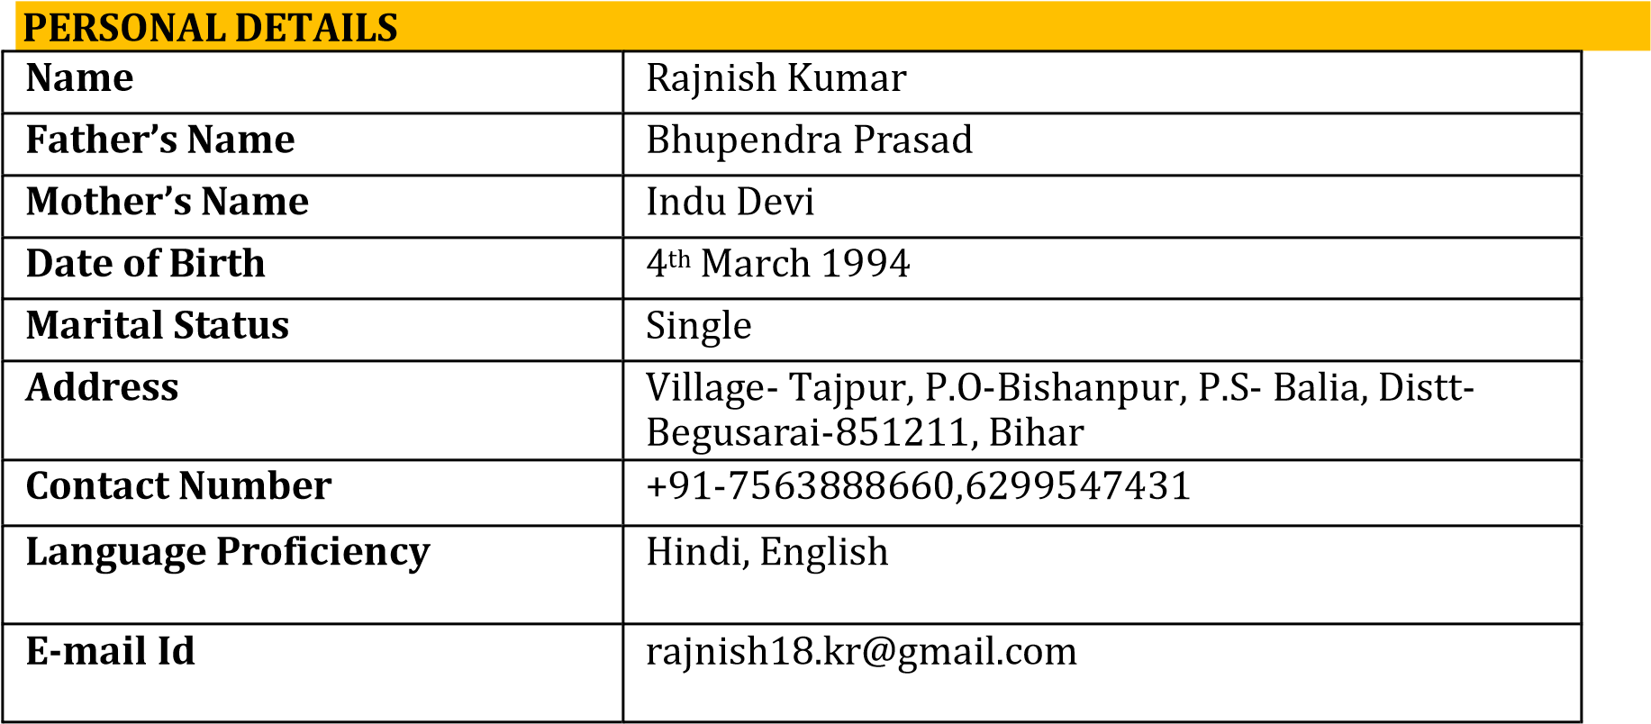

# DECLARATION

I hereby solemnly declare that all the information furnished above is factually correct and true to the best of my knowledge and belief.

**Date:**

**Place: *(Rajnish Kumar)***