

* 2 Months Internship in SS Builder in Karnal as a Site Engineering.
* Home Designer at Shell Square(Saharanpur)
* Karate
* Riding Bikes
* Exploring New Things

**HOBBIES**

**Email ID:** devkataria11@gmail.com

**Mobile:**

9718290501

**Address:**

House no. 4, Street no. 5, Devi lal Colony, Near Housing Board, Gurugram, Haryana (122001)

**PERSONAL INFORMATION**

**Date of birth:**  11 Dec 2002

**Gender:** Male

**Marital Status:** Unmarried

**Father’ Name**: Mr. Satpal

**Languages Known:** English and Hindi

**Religion:** Hindu

* AutoCAD
* MS Office
* MS Excel

**OTHER SKILLS**

**TECHNICAL SKILLS**

* Diploma in Civil Engineering
* 10th class from CBSE Board

**Dev**

**EDUCATION**

**PROFILE SUMMARY**

**CONTACT DETAILS**

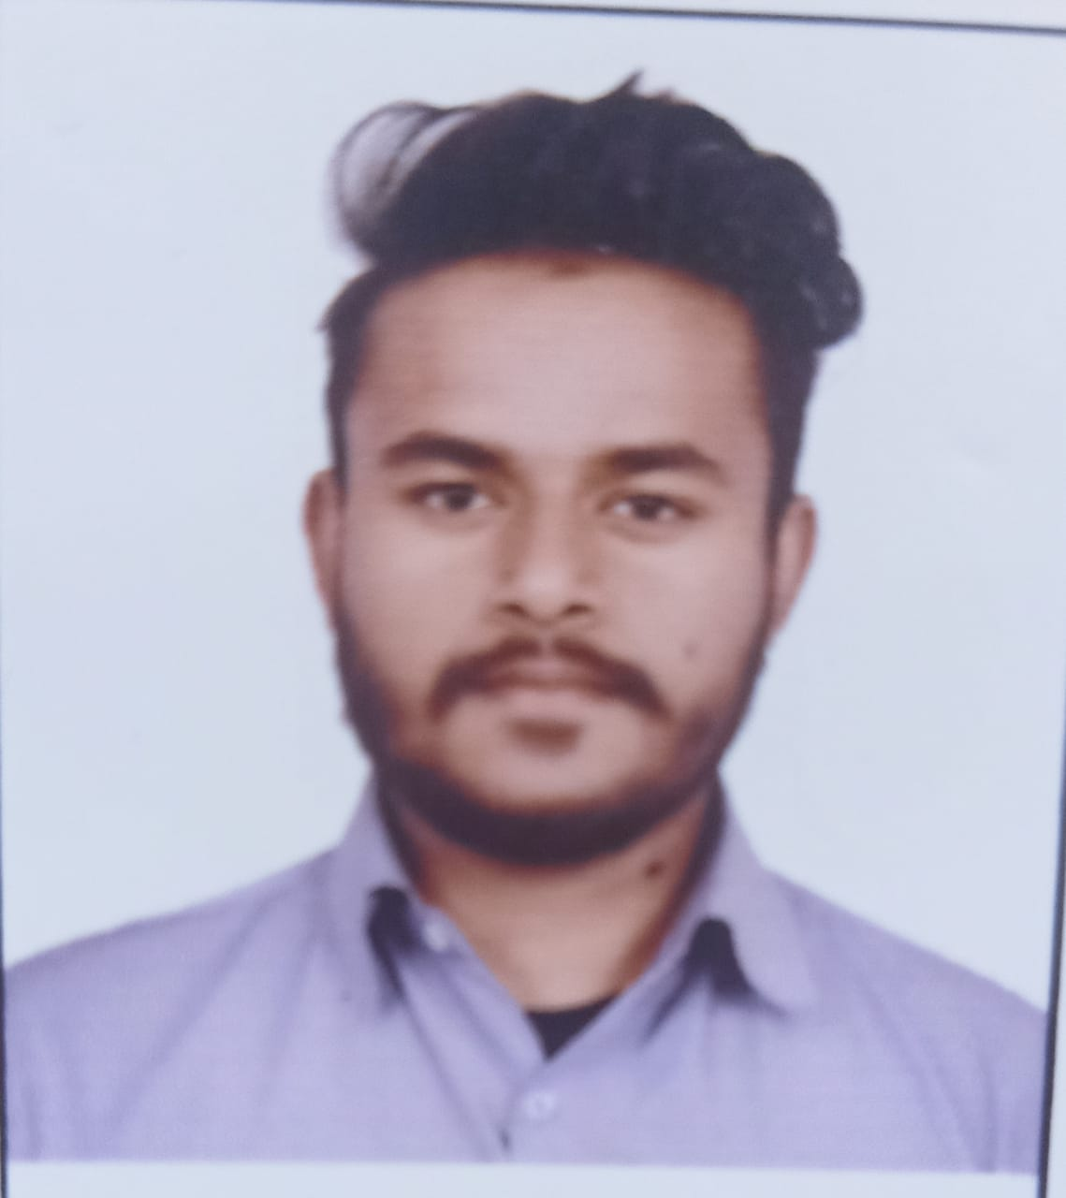

A Civil Engineering student looking to working in a growth-oriented organization which offers me challenging opportunities to enhance my profession and technical knowledge.