CKA Certification Course 2025
Detailed Study Notes — Docker and Kubernetes, Day 1 to Day 59
Notes written in plain language from the CKA-Certification-Course-2025 repository
Based on the course by Varun Joshi (Cloud With VarJosh)
Covers containers, cluster architecture, workloads, networking, storage, security, cluster setup, upgrades, troubleshooting and JSONPath

How to Use These Notes
These notes turn the 59 days of the CKA Certification Course 2025 repository into one readable study guide. Every day's README, YAML manifest, Dockerfile and command was worked through and rewritten in clear, simple language, while keeping all the important commands and manifests so you can practise along.
- Parts group related days (for example, Part 4 — Services covers Days 12–14).
- Days match the folders in the repository (Day 01 … Day 59), so you can jump between these notes, the repo and the videos.
- Code blocks contain commands and manifests you can copy. Text in angle brackets such as <pod-name> is a placeholder you replace.
- Shaded boxes hold tips, warnings and exam hints.
- Diagrams come from the repository's images folder.
- Where the original material had a small mistake or something has changed in newer Kubernetes versions, the notes give the correct behaviour.

About the course
- Course: Certified Kubernetes Administrator (CKA) Certification Course 2025 — Learn Docker and Kubernetes step by step, by Varun Joshi (YouTube channel Cloud With VarJosh).
- Playlist: https://www.youtube.com/playlist?list=PLmPit9IIdzwRjqD-l_sZBDdPlcSfKqpAt
- Hands-on, beginner-friendly (no Docker or Kubernetes experience needed) and focused on the CKA exam.
Get the code:
BASH
git clone https://github.com/CloudWithVarJosh/CKA-Certification-Course-2025.git
cd CKA-Certification-Course-2025/"Day 01"

Suggested study approach
- Read a day's notes here first to understand the idea.
- Watch the matching video.
- Run the commands and manifests yourself on a practice cluster (kind, minikube, or the kubeadm cluster from Day 54).
- Re-read the exam tips and practise the kubectl commands until they are fast.

Contents
Part 1 — Docker Foundations (Days 1–5)
Day 1 — Docker Fundamentals for Kubernetes
Day 2 — Your First Dockerfile and Pushing to Docker Hub
Day 3 — Docker Flags, Dockerfile Instructions and Exposing Containers
Day 4 — Custom Dockerfile Names, Build Context, CMD vs ENTRYPOINT
Day 5 — Multi-Stage Builds and Image Optimization
Part 2 — Kubernetes Basics (Days 6–8)
Day 6 — Why Kubernetes? What is Kubernetes?
Day 7 — Kubernetes Architecture and the Deployment Workflow
Day 8 — Local Cluster with KIND and Kubernetes Contexts
Part 3 — YAML, Workload Controllers and App Design (Days 9–11)
Day 9 — YAML for Kubernetes; Imperative vs Declarative
Day 10 — ReplicationController, ReplicaSet and Deployment
Day 11 — Monolith, 3-Tier Architecture and Microservices
Part 4 — Services, Imperative Commands and Namespaces (Days 12–14)
Day 12 — Kubernetes Services in Depth
Day 13 — Imperative Commands for Deployments, Services and Troubleshooting
Day 14 — Namespaces
Part 5 — Scheduling (Days 15–18)
Day 15 — Manual Scheduling and Static Pods
Day 16 — Taints and Tolerations
Day 17 — nodeSelector and Node Affinity
Day 18 — Taints & Tolerations vs Node Affinity (use both!)
Part 6 — Resources and Autoscaling (Days 19–20)
Day 19 — Requests, Limits, LimitRange and Metrics Server
Day 20 — Autoscaling: HPA and VPA
Part 7 — Pods in Depth (Days 21–22)
Day 21 — Multi-Container Pods: Init, Sidecar, Ambassador, Adapter
Day 22 — Pod Termination, Restart Policy, Image Pull Policy, Lifecycle and Errors
Part 8 — Health Probes, Docker Storage and Kubernetes Extensions (Days 23–25)
Day 23 — Health Probes: Readiness, Liveness, Startup
Day 24 — Docker Storage and Volumes (foundation for K8s storage)
Day 25 — Kubernetes Core vs Extensions: CRI, CNI, CSI, Add-ons
Part 9 — Kubernetes Storage (Days 26–27)
Day 26 — Ephemeral Volumes: emptyDir and the Downward API
Day 27 — Persistent Storage: hostPath, PV, PVC and StorageClass
Part 10 — Configuration and Other Workload Types (Days 28–29)
Day 28 — ConfigMaps and Secrets
Day 29 — DaemonSets, Jobs and CronJobs
Part 11 — Encryption, TLS and kubeconfig (Days 30–32)
Day 30 — How Encryption, HTTPS and SSH Work
Day 31 — Public Key Cryptography, Mutual Authentication and Certificate Authorities
Day 32 — kubeconfig, Contexts and Mutual TLS
Part 12 — TLS Inside Kubernetes, User Access and Authorization (Days 33–35)
Day 33 — Private CAs and mTLS Between Kubernetes Components
Day 34 — Giving a New User (Seema) Access with a CSR and RBAC
Day 35 — The Kubernetes API and Authorization Modes
Part 13 — RBAC and Service Accounts (Days 36–37)
Day 36 — RBAC in Depth
Day 37 — Authentication and Service Accounts
Part 14 — Admission Controllers, CRDs and Operators (Days 38–40)
Day 38 — Admission Controllers (Mutating and Validating)
Day 39 — Custom Resources (CR) and Custom Resource Definitions (CRD)
Day 40 — Kubernetes Operators
Part 15 — Pod Security and Kustomize (Days 41–42)
Day 41 — Security Context and Linux Capabilities
Day 42 — Kustomize
Part 16 — Helm and StatefulSets (Days 43–44)
Day 43 — Helm, the Kubernetes Package Manager
Day 44 — StatefulSets (Multi-AZ MySQL on Amazon EKS)
Part 17 — Private Images and Pod Priority (Days 45–46)
Day 45 — Pulling Private Images with imagePullSecrets and ServiceAccounts
Day 46 — Pod Priority, PriorityClass and Preemption
Part 18 — Network Policies and DNS (Days 47–48)
Day 47 — Network Policies
Day 48 — DNS in Kubernetes (CoreDNS)
Part 19 — Ingress (Days 49–51)
Day 49 — Ingress Part 1: What, Why and How
Day 50 — Ingress Part 2: Path-Based Routing on EKS with an ALB
Day 51 — Ingress Part 3: TLS, Custom Domain and Host-Based Routing
Part 20 — Gateway API (Days 52–53)
Day 52 — Gateway API Part 1: Concepts
Day 53 — Gateway API Part 2: Demo with NGINX Gateway Fabric on kind
Part 21 — Building a Cluster with kubeadm
Day 54 — Multi-Node Kubernetes Cluster with kubeadm (v1.32) and Calico
Part 22 — Upgrading a Cluster with kubeadm
Day 55 — Upgrade a Multi-Node Cluster (1.32.8 → 1.33.4)
Part 23 — Monitoring and Logging
Day 56 — Kubernetes Monitoring and Logging
Part 24 — Troubleshooting the Control Plane
Day 57 — Control-Plane Troubleshooting on kubeadm Clusters
Part 25 — Troubleshooting the Data Plane
Day 58 — Data-Plane Troubleshooting Guide
Part 26 — JSONPath with kubectl
Day 59 — Kubernetes JSONPath with kubectl

Part 1 — Docker Foundations (Days 1–5)

Day 1 — Docker Fundamentals for Kubernetes

The problem Docker solves
Before Docker, building and shipping software was manual and fragile:
- Development – each developer installed the language runtime, libraries and tools by hand, following long setup documents.
- Testing – test machines were configured by hand to "look like" production. Small differences caused bugs that only appeared in production.
- Deployment – apps were shipped as .tar.gz or .zip archives and installed with scripts or by hand, which led to human error and delays.
The four big pain points:
- Dependency management – different OS versions, libraries and settings in each environment. Example: dev uses Python 3.4, production has Python 3.1, and the app breaks.
- Inefficient resource usage – one VM per app wastes resources; many apps on one VM fight over resources.
- Complex, error-prone deployment – manual configuration in every environment.
- Lack of isolation – apps on the same machine conflict over shared libraries, ports or config (e.g. two apps that need different versions of the same library).
The solution: containers.
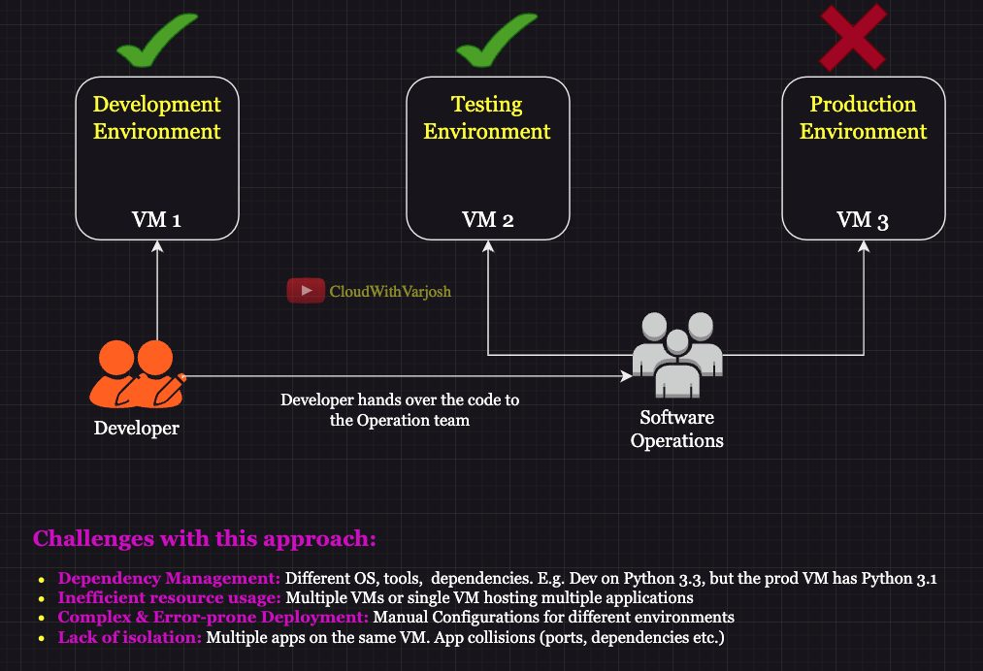
Before Docker

What is Docker?
Docker packages an application together with all of its dependencies into a single unit called a container. Because the container carries everything it needs, it behaves the same on a laptop, a test server and a production server.
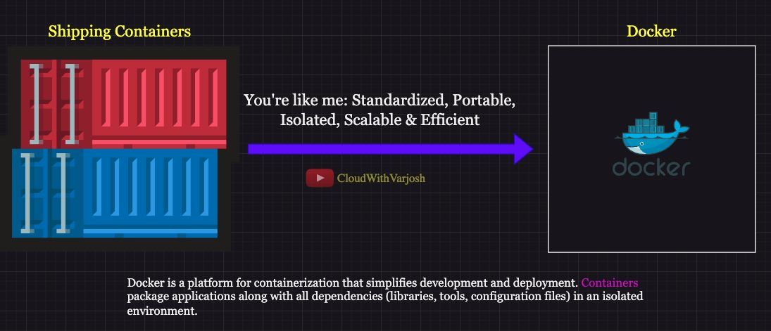
What is Docker

The shipping-container analogy
Before standard shipping containers, cargo was loaded and unloaded by hand at every port. Standard-size, stackable boxes made cargo move easily between ships, trains and trucks. Docker did the same for software.
Aspect | Shipping containers | Docker containers
Standardization | Standard sizes (20 ft, 40 ft) fit any ship, train or truck | Standard package of app + dependencies that runs anywhere
Portability | Moved between transport types without unpacking | Runs the same in dev, test and production
Isolation | Goods in one box don't mix with another | Apps and their dependencies don't conflict, but still share host resources
Scalability | Easy to ship goods in bulk | Easy to scale out; good fit for microservices
Efficiency | Less manual handling, lower cost | Automated deployment, fewer setup errors

Virtual Machines vs Docker containers
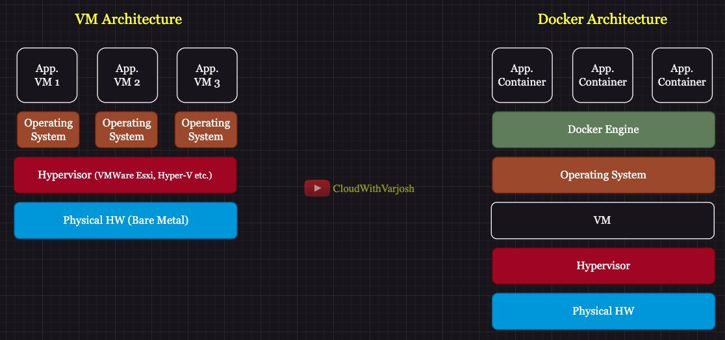
VM vs Docker
Feature | Virtual Machines | Docker Containers
Architecture | Full guest OS on top of a hypervisor | Shares the host OS kernel
Weight | Heavy (includes a whole OS) | Light (no guest OS)
Startup time | Minutes | Seconds
Resource usage | High – an OS copy per VM | Low
Isolation | Hardware-level (strong) | Process-level
Typical use | Running different OSes, legacy systems | Cloud-native apps, microservices
Example | Ubuntu VM on a Windows host (Hyper-V) | An app running in a container

Docker workflow
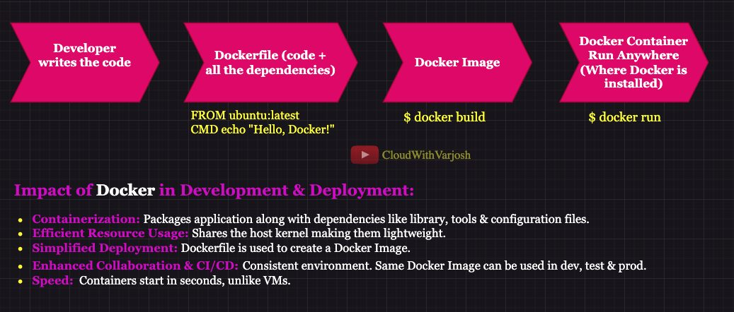
High-level workflow
Key concepts
- Image – the blueprint/template: your code plus its dependencies. Read-only.
- Container – a running instance of an image.
- Registry – a store for images (Docker Hub, AWS ECR, Azure ACR, Google GCR/Artifact Registry, JFrog, Nexus).
- Docker Engine – the core software that builds and runs containers.
Docker Engine components (car analogy)
Component | What it does | Car analogy
Docker CLI | The docker command you type | Dashboard
REST API | Turns CLI commands into HTTP calls to the daemon; also lets other tools automate Docker | Wires
Docker daemon (dockerd) | Does the real work: pulls images, builds images, runs containers | Engine

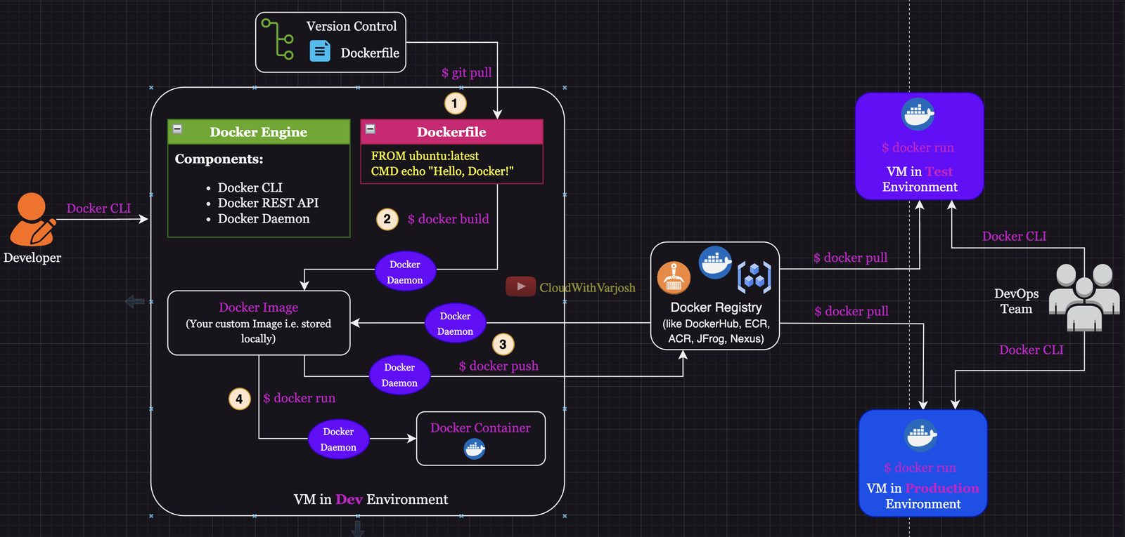
Low-level workflow
Typical end-to-end flow
- A developer writes a Dockerfile and stores it in Git.
- docker build creates an image locally.
- docker push uploads the image to a registry.
- Other teams / environments run docker pull then docker run to start containers in test and production.
Key takeaway: Docker gives consistency across environments, saving time and reducing "works on my machine" problems.

Day 2 — Your First Dockerfile and Pushing to Docker Hub

How image names work
docker pull docker.io/library/ubuntu:latest breaks down as:
- docker.io – the registry (Docker Hub, the default)
- library – the namespace for official images
- ubuntu – the repository/image name
- latest – the tag (version)
If you just type docker pull ubuntu, Docker automatically adds docker.io/library/ and :latest.
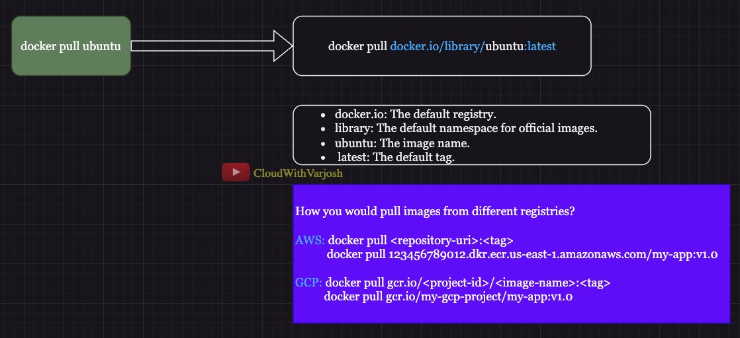
docker pull

Pulling from other registries
AWS ECR – format <account-id>.dkr.ecr.<region>.amazonaws.com/<repository>:<tag>
BASH
docker pull 123456789012.dkr.ecr.us-east-1.amazonaws.com/my-app:v1.0
Google Container Registry – format gcr.io/<project-id>/<image>:<tag>
BASH
docker pull gcr.io/my-gcp-project/my-app:v1.0
The command is the same everywhere; only the fully qualified name changes. For private registries you must log in (authenticate) first.

Essential commands
Task | Command | Notes
List local images | docker images
Build an image | docker build -t my-first-image . | -t names the image; . is the build context (folder with the Dockerfile and files)
Tag an image | docker tag my-first-image <user>/my-first-image:v1.0 | Adds a repository name + version
Push to Docker Hub | docker push <user>/my-first-image:v1.0 | Docker adds docker.io/ automatically
Run a container | docker run my-first-image | Creates and starts a container
List all containers | docker ps -a | Running and stopped

Your first Dockerfile
DOCKERFILE
FROM ubuntu:latest
CMD echo "Hello, Docker!"
- FROM ubuntu:latest – start from the Ubuntu base image.
- CMD echo "Hello, Docker!" – the command run when a container starts.
Full flow:
BASH
docker build -t my-first-image .
docker tag my-first-image cloudwithvarjosh/my-first-image:v1
docker push docker.io/cloudwithvarjosh/my-first-image:v1
docker run my-first-image # prints Hello, Docker!

Day 3 — Docker Flags, Dockerfile Instructions and Exposing Containers

Important docker run flags
BASH
docker run -d -p 8080:80 --name my-nginx-cont nginx
- -d (detached) – run in the background and give your terminal back.
- -p 8080:80 (port mapping) – hostPort:containerPort. Traffic to port 8080 on your machine goes to port 80 in the container. Open http://localhost:8080 to see Nginx.
- --name my-nginx-cont – give the container a friendly name.
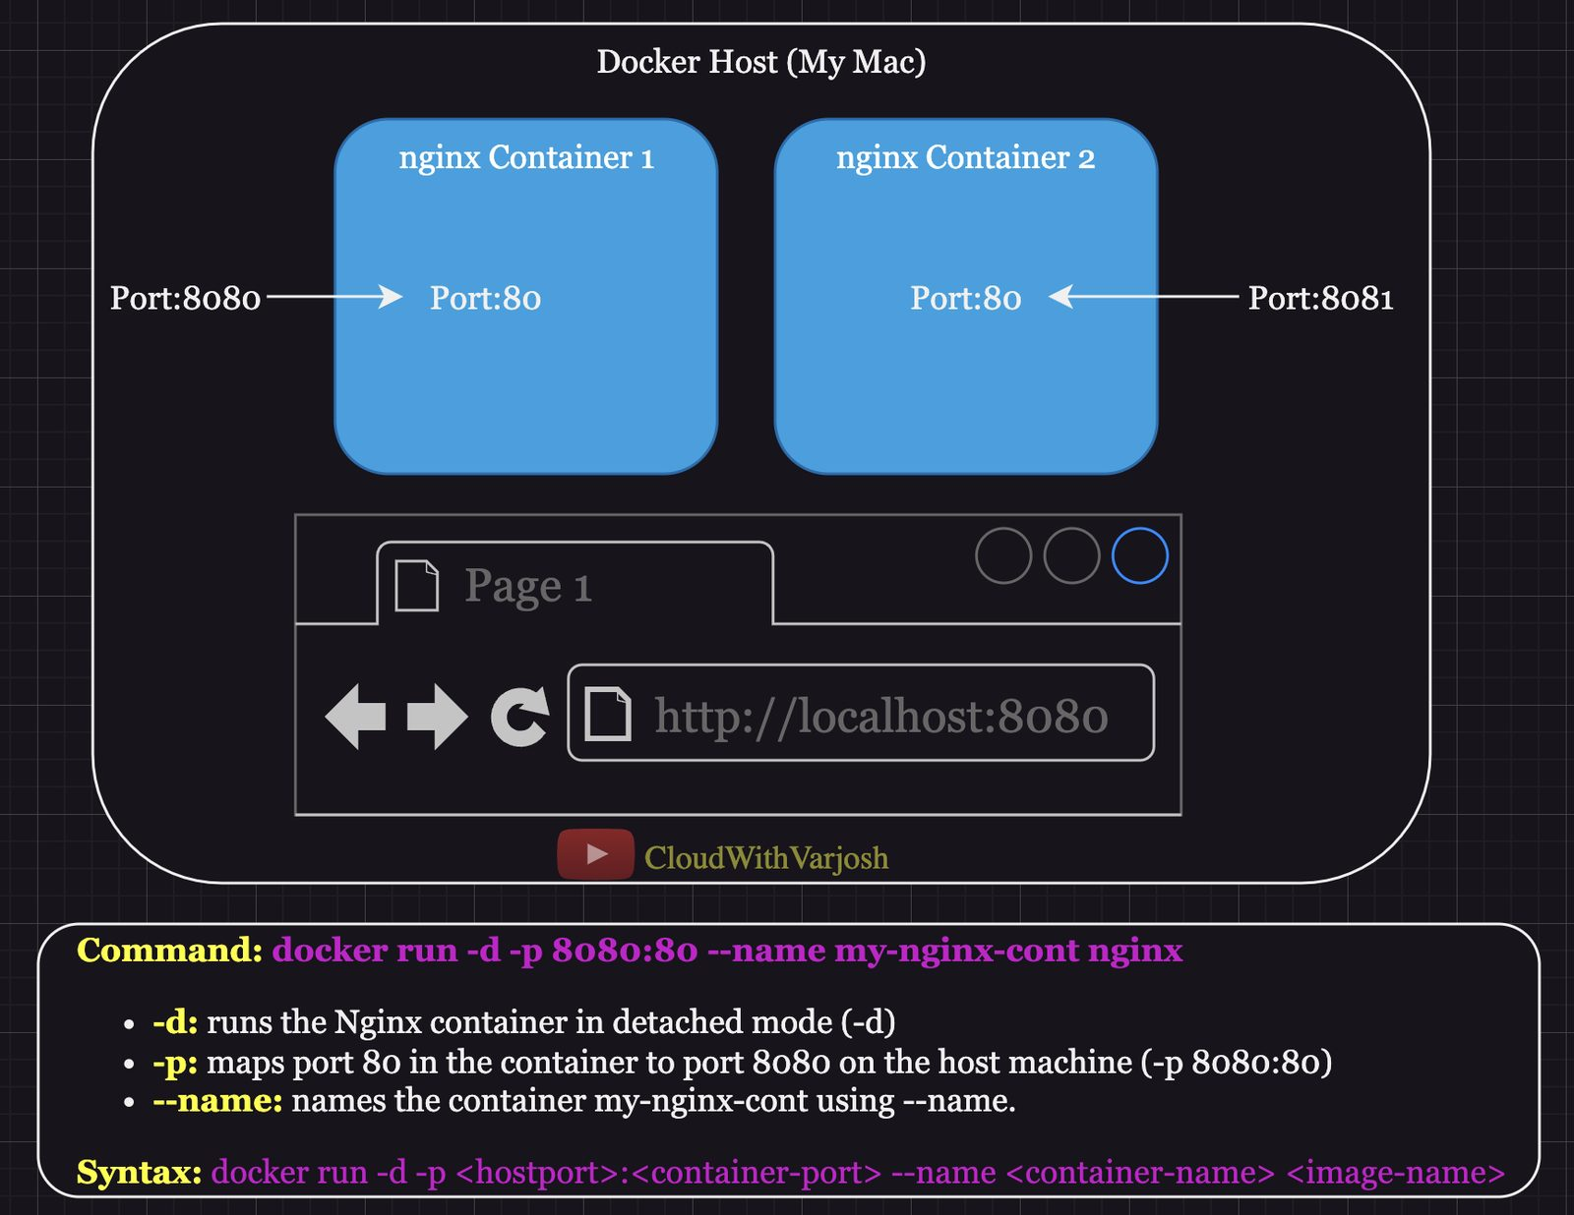
Docker flags

Dockerfile instructions
Instruction | Purpose | Example
FROM | Base image to build on | FROM ubuntu:latest
ADD | Copy files into the image; also auto-extracts archives (and can fetch URLs) | ADD app.tar.gz /app
COPY | Copy files only (no extraction, no URLs) – preferred for plain copies | COPY app.py /app/app.py
RUN | Run a command at build time (install packages, etc.) | RUN apt-get update && apt-get install -y nginx
WORKDIR | Set the working directory for following instructions | WORKDIR /app
EXPOSE | Documents the port the app listens on. It does not publish it — you still need -p | EXPOSE 5000
CMD | Default command when the container starts; can be replaced at docker run | CMD ["python", "app.py"]
ENTRYPOINT | Command that always runs; docker run arguments are appended. Replace only with --entrypoint | ENTRYPOINT ["nginx", "-g", "daemon off;"]

Example: a Python Flask app
app.py
PYTHON
from flask import Flask
app = Flask(__name__)

@app.route("/")
def home():
return "Hello, Docker!"

if __name__ == "__main__":
app.run(host="0.0.0.0", port=5000)
Dockerfile
DOCKERFILE
FROM python:3.9-slim # small Python base image
WORKDIR /app # work inside /app
ADD app.py app.py # copy the app in
RUN pip install flask # install dependency at build time
EXPOSE 5000 # document the port
CMD ["python", "app.py"] # start the app
Build and run: docker build -t flask-app . then docker run -d -p 5000:5000 flask-app and browse to http://localhost:5000.

Shell form vs Exec form
Feature | Shell form | Exec form
Syntax | CMD echo "Hello" | CMD ["echo", "Hello"]
How it runs | Wrapped in /bin/sh -c | Runs the program directly, no shell
Variables like $VAR | Expanded by the shell | Not expanded
PID 1 / signals | The shell is PID 1, so your app does not receive signals like SIGTERM directly | Your app is PID 1 and receives signals (clean shutdown)
Complex commands | Supports &&, ||, pipes | Simple commands only
When to use | Need shell features | Most cases – direct and efficient

Day 4 — Custom Dockerfile Names, Build Context, CMD vs ENTRYPOINT

Using a custom Dockerfile name
Default name is Dockerfile, but you might want Dockerfile.dev and Dockerfile.prod, or one per service. Use -f:
BASH
docker build -t <image-name> -f <path-to-dockerfile> <build-context>
docker build -t entry-image -f /path/to/custom-dockerfile /path/to/build-context

The build context
The build context is the folder whose contents are sent to the Docker daemon at build time. COPY and ADD can only see files inside it.
- Files outside the context cannot be used.
- Add a .dockerignore file to exclude junk (e.g. .git, node_modules, logs) – faster builds and smaller transfers.

CMD vs ENTRYPOINT vs RUN
Aspect | CMD | ENTRYPOINT | RUN
When it runs | Container start | Container start | Image build
Purpose | Default command | Command that always runs | Prepare the image (install software)
Override | Replaced completely by docker run <image> <cmd> | Args are appended; replace only with --entrypoint | Result is baked into the image
Forms | Shell & exec | Exec recommended (shell form ignores CMD/args) | Shell & exec
How many | Only the last CMD counts | Only the last counts | Many allowed; each makes a layer
Together | Supplies default arguments to ENTRYPOINT | Fixed executable | –

The four practice Dockerfiles
1. CMD only (cmd) – fully overridable:
DOCKERFILE
FROM ubuntu:latest
RUN apt update && apt install -y iputils-ping
CMD ["ping", "-c", "4", "google.com"]
docker run img pings google.com. docker run img echo hi replaces the whole command and prints hi.
2. ENTRYPOINT only (entrypoint) – always runs:
DOCKERFILE
FROM ubuntu:latest
RUN apt update && apt install -y iputils-ping
ENTRYPOINT ["ping", "-c", "4", "google.com"]
Anything after the image name is appended as extra arguments.
3. ENTRYPOINT + CMD (ec) – best of both:
DOCKERFILE
FROM ubuntu:latest
RUN apt update && apt install -y iputils-ping
ENTRYPOINT ["ping", "-c", "4"]
CMD ["google.com"]
docker run img → ping -c 4 google.com. docker run img yahoo.com → ping -c 4 yahoo.com (CMD replaced, ENTRYPOINT kept).
4. Practice (entrypoint-practice)
DOCKERFILE
FROM ubuntu:latest
ENTRYPOINT ["echo", "This is ENTRYPOINT"]
docker run img hello prints This is ENTRYPOINT hello. docker run --entrypoint ls img overrides it.

Everyday container and image commands
Task | Command
List all containers | docker ps -a
Inspect a container/image (JSON metadata) | docker inspect <id>
Processes inside a container | docker top <id>
Stop / start / restart | docker stop <id> / docker start <id> / docker restart <id>
Stop all running containers | docker stop $(docker ps -q)
Delete a container | docker rm <id>
Delete all stopped containers | docker container prune
Delete an image | docker rmi <id>
Delete all unused images | docker image prune -a

Dangling images are images with no tag that are not used by any container (usually left behind after rebuilds).

Day 5 — Multi-Stage Builds and Image Optimization

Compiled vs interpreted languages
 | Compiled (Java, C/C++, Go) | Interpreted (Python, Node.js, PHP)
Translation | To machine code before running | Line by line at runtime by an interpreter
Build stage | Needs compilers/tools | Usually not required
Speed | Faster | Usually slower
Portability | Binary tied to an architecture | Runs anywhere the interpreter exists

Build stage vs runtime stage
Building an app often needs heavy tools (compilers, build-essential) that are useless when the app runs. Leaving them in the final image makes it big and less secure.
 | Build stage | Runtime stage
Purpose | Prepare/compile the app | Just run the app
Contents | Compilers, build tools | Only the runtime libraries (e.g. Flask)
Size | Large | Small

Pizza analogy: to make a pizza you need measuring cups, an oven and raw ingredients (build stage). To eat it you only need the pizza (runtime stage). You don't serve the oven with the pizza.

Multi-stage Dockerfile
A multi-stage build has several FROM lines. Each starts a new stage; you copy only what you need from earlier stages into the final one. Everything else is thrown away.
DOCKERFILE
# ---- Build stage ----
FROM python:3.9-slim AS build
WORKDIR /app
COPY app.py app.py
RUN pip install flask && apt update && apt install -y build-essential

# ---- Runtime stage ----
FROM python:3.9-slim
WORKDIR /app
COPY --from=build /app . # take only the app files from the build stage
RUN pip install flask
EXPOSE 5000
ENTRYPOINT ["python"]
CMD ["app.py"]
Compare sizes: build Dockerfile (single stage, keeps build-essential) and Dockerfile.multi and run docker images – the multi-stage image is much smaller.
BASH
docker build -t single .
docker build -t multi -f Dockerfile.multi .
docker images
Benefits: smaller images, faster push/pull/deploy, smaller attack surface, cleaner debugging.

Which instructions create layers?
Create layers (add size) | Do not create layers (metadata only)
FROM, RUN, COPY, ADD | CMD, ENTRYPOINT, WORKDIR, EXPOSE, ENV, LABEL, USER, VOLUME, STOPSIGNAL, ARG

Best practices
- Chain commands in one RUN with && to reduce layers.
- Use .dockerignore.
- Use multi-stage builds to drop build tools from the final image.
- Prefer small base images (-slim, alpine, distroless).

Part 2 — Kubernetes Basics (Days 6–8)

Day 6 — Why Kubernetes? What is Kubernetes?

What Docker alone can't do
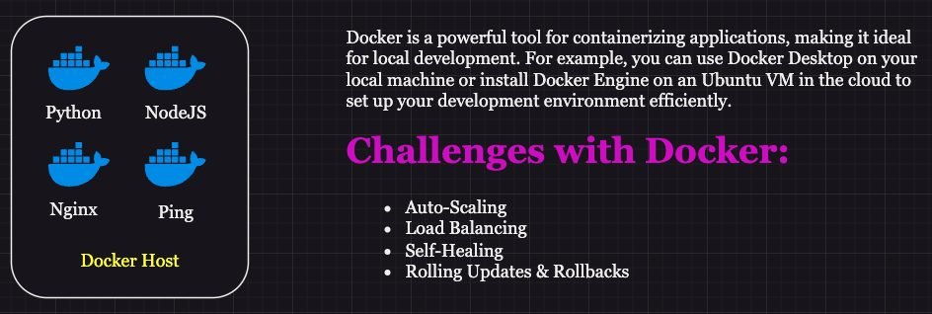
Challenges with Docker
Docker is great for packaging and running individual containers on one machine, but in production you also need:
- Auto-scaling – add/remove containers automatically as load changes. Docker has no built-in way to do this.
- Load balancing – spread traffic across many containers on many hosts. Docker has nothing advanced built in.
- Self-healing – restart or replace containers that crash. Docker on its own doesn't keep apps healthy.
- Rolling updates / rollbacks – upgrade with zero downtime and undo bad releases. Docker can't do this by itself.

What Kubernetes is
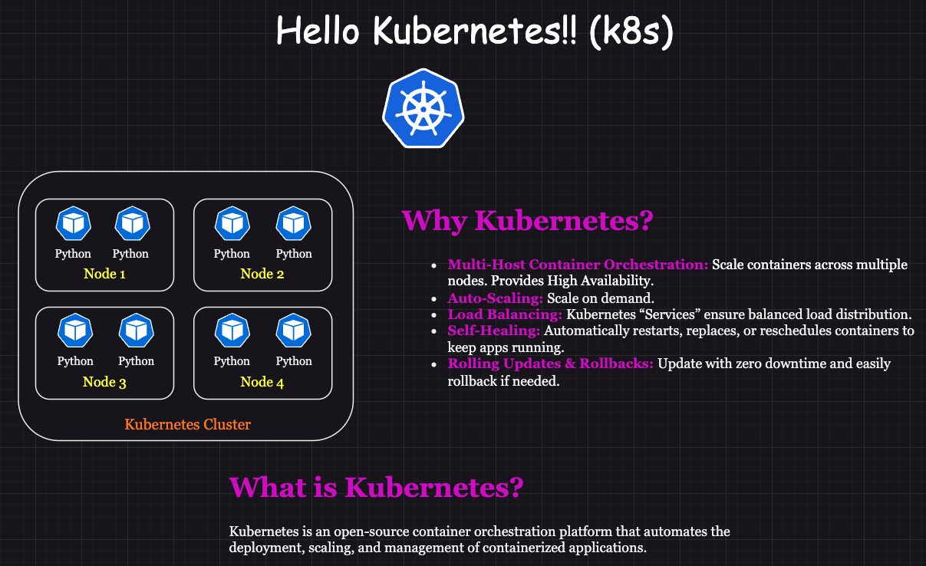
Hello Kubernetes
Kubernetes (K8s) is the industry-standard container orchestrator. Docker packages and runs a container; Kubernetes manages many containers across many machines. It automates deployment, scaling and operations, and gives you high availability, load balancing and self-healing out of the box.

Kubernetes vs Docker Swarm vs Docker Compose
Feature | Kubernetes | Docker Swarm | Docker Compose
Scope | Orchestrates apps across a cluster of machines | Basic orchestration on one host or a small cluster | Runs multi-container apps on one host using a YAML file
Complexity | High (quotas, custom schedulers, advanced networking) | Moderate | Simplest – for local dev
Scalability | Large production clusters (hundreds of nodes) | Small to medium | Single host only
Features | Auto-scaling, self-healing, service discovery, load balancing, secrets, rolling updates | Service discovery, manual scaling, rolling updates | Defines services, networks, volumes locally
Learning curve | Steep | Easier | Very easy
Ecosystem | Huge (Helm, Prometheus, Istio…) | Smaller | Large among developers
Stateful apps | Yes – StatefulSets, PersistentVolumes | External storage only | Volumes for persistence
Networking | ClusterIP, NodePort, Ingress, NetworkPolicies | Overlay networks | Default Docker networking
Setup | Complex (kubeadm or managed EKS/GKE/AKS) | Docker in Swarm mode | Just a compose YAML
Fault tolerance | High – automatic rescheduling | Moderate | Very limited

Quick summary
 | Kubernetes | Docker Swarm | Docker Compose
Orchestration | Yes, multi-host | Yes, within a Swarm | No, single host
Scaling | Automatic + manual | Manual, limited auto | Manual
Load balancing | Built-in, advanced | Basic (routing mesh) | None
Self-healing | Robust | Basic restarts | No
Best for | Large production, complex microservices | Smaller deployments | Local dev and tests

Day 7 — Kubernetes Architecture and the Deployment Workflow

Pods
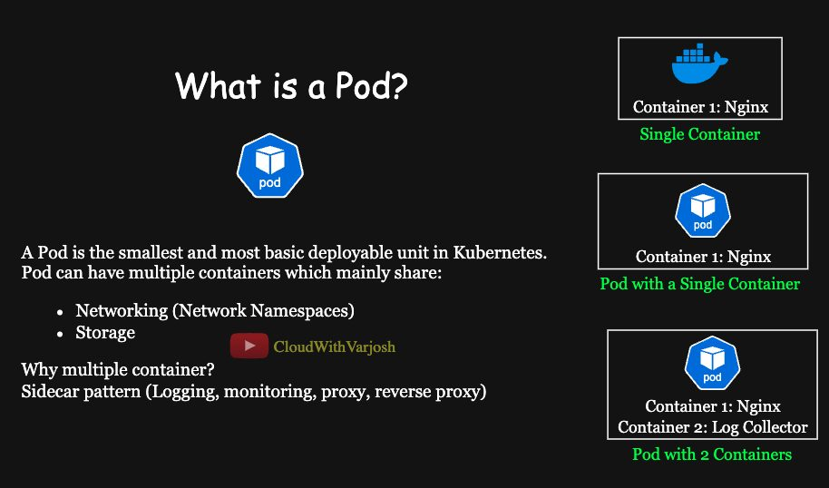
What is a Pod
A Pod is the smallest thing you can deploy in Kubernetes. It wraps one or more containers that:
- share one network namespace – one IP address, one set of ports. Containers in the same Pod talk to each other over localhost.
- can share storage volumes.
Network namespaces: every Pod gets its own isolated network stack (IP, interfaces, routing table). Pods reach each other by Pod IP but are otherwise isolated from each other's networks.

Deployments, ReplicaSets and Pods
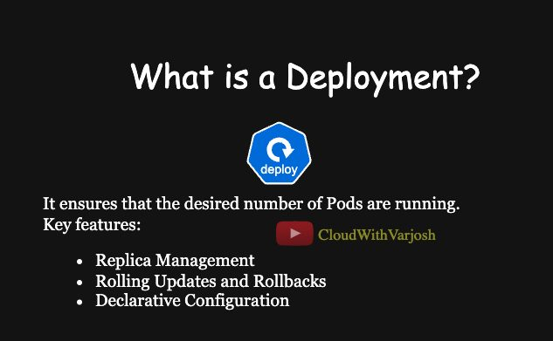
Deployment
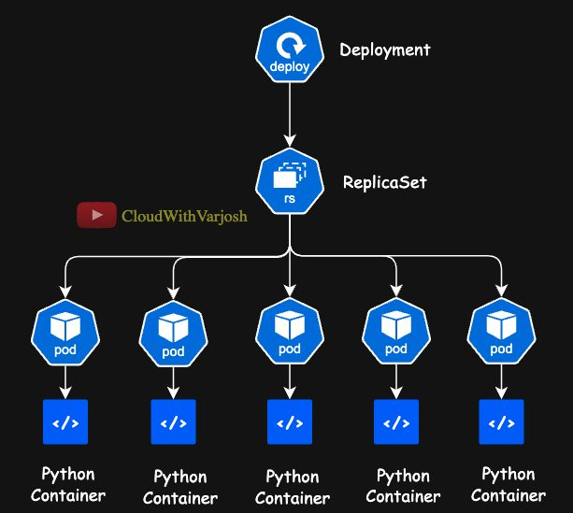
Nesting
Think of it as nesting boxes:
- Deployment wraps a ReplicaSet – handles versions, rolling updates and rollbacks.
- ReplicaSet wraps Pods – keeps the requested number of identical Pods running; replaces any that fail.
- Pod wraps containers.

Cluster architecture
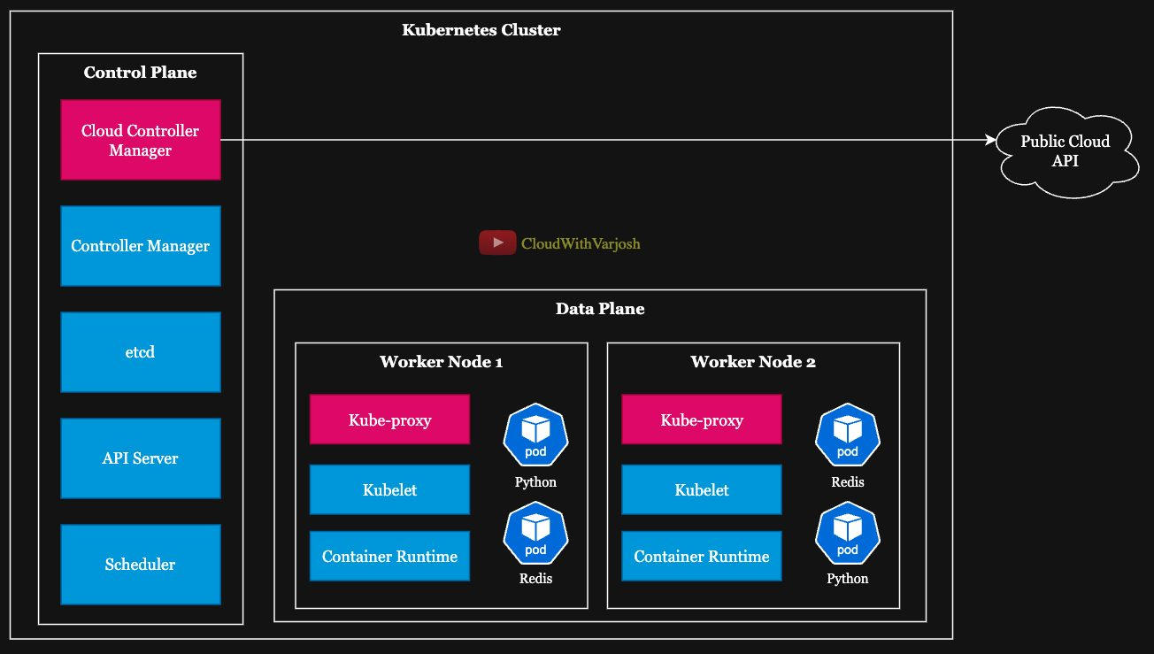
Kubernetes architecture
A cluster has a control plane (the brain) and worker nodes (where your apps run).
Control plane components
Component | What it does
etcd | Distributed key-value database holding all cluster state and configuration
kube-apiserver | Front door of the cluster. Every request (kubectl, controllers, kubelets) goes through it
kube-scheduler | Decides which node each new Pod should run on (resources, affinity, taints…)
kube-controller-manager | Runs control loops that keep actual state = desired state (replication, scaling, garbage collection…)
cloud-controller-manager | Talks to the cloud provider API (load balancers, node lifecycle, routes)

Worker node (data plane) components
Component | What it does
kubelet | Agent on each node. Gets Pod specs from the API server and makes sure the containers run and stay healthy
kube-proxy | Network proxy on each node; implements Services (routing + load balancing to Pods)
Container runtime | Actually runs containers – containerd, CRI-O, etc.

 | Control plane | Data plane
Job | Manage the cluster | Run applications
Components | etcd, API server, scheduler, controller manager, CCM | kubelet, kube-proxy, container runtime
Location | Dedicated (often HA) machines | Every worker node

How a request travels: frontend Pod → Redis Service
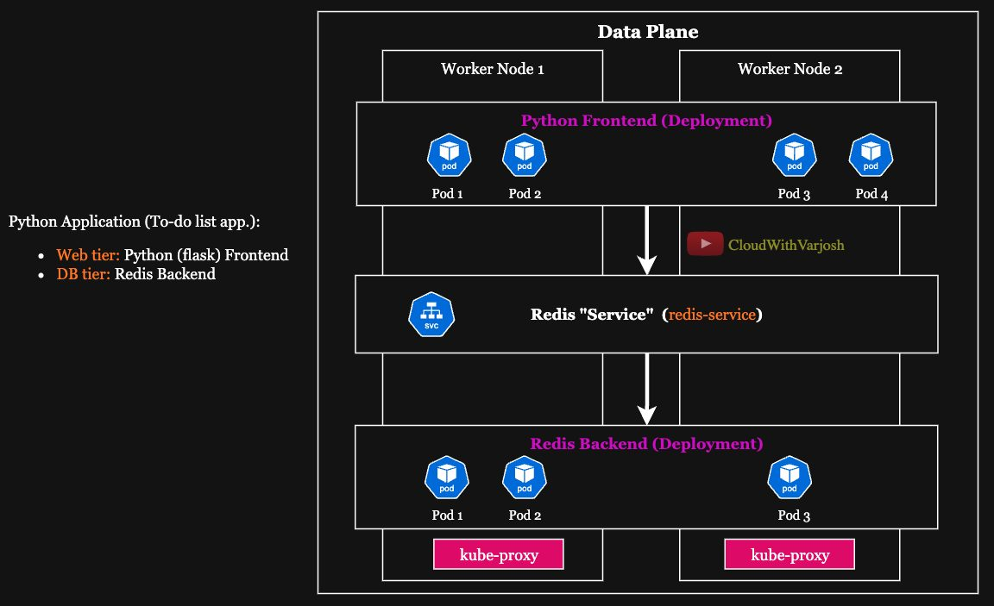
kube-proxy and CNI
- The Python frontend calls the Redis Service by DNS name (e.g. redis-service:6379). CoreDNS turns the name into the Service's ClusterIP.
- kube-proxy on the frontend's node has programmed rules that catch traffic to that ClusterIP. Using the Service's Endpoints (the list of healthy Redis Pod IPs) it picks one Pod (round-robin / IPVS algorithms) and rewrites the destination IP/port.
- The CNI plugin gives every Pod a unique IP and makes sure packets can travel between Pods, even across nodes.
- The Redis Pod answers directly to the frontend Pod; the return traffic follows the established connection.
Roles in one sentence each:
- CNI – the roads: Pod IPs, routes, connectivity.
- kube-proxy – the traffic director for Service IPs and load balancing.
- Service – a stable name/IP in front of Pods whose IPs keep changing.
Some CNIs (Calico, Cilium) can replace kube-proxy's job entirely. The path differs slightly for ClusterIP, NodePort and LoadBalancer Services (covered later).

What happens when you run kubectl apply -f deployment.yaml
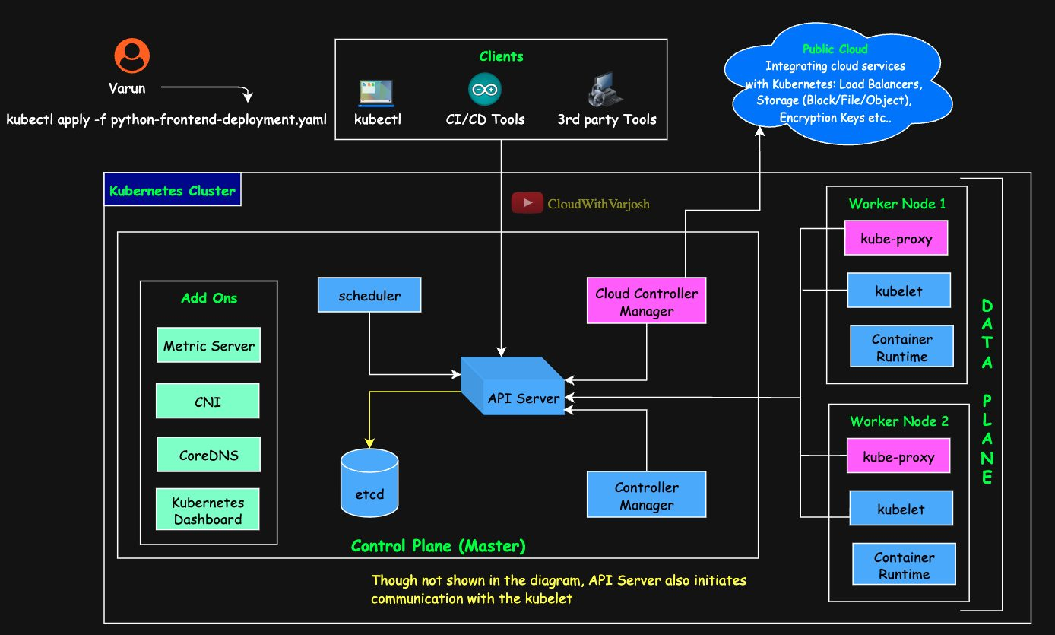
Deployment workflow
- kubectl checks the YAML syntax and basic schema, then sends it to the API server.
- API server authenticates you, authorizes you, validates the object fully, stores it in etcd, and replies "deployment created".
- Deployment controller (in the controller manager) watches the API server, sees a new Deployment and asks the API server to create a ReplicaSet (stored in etcd).
- ReplicaSet controller sees that Pods are missing and asks the API server to create Pod objects (stored in etcd). At this moment they're only records – no containers yet.
- Scheduler watches for Pods with no nodeName, chooses a node (resources, affinity, taints/tolerations) and writes the nodeName back via the API server.
- kubelet on that node sees a Pod assigned to it and, through the CRI, tells the container runtime to pull the image, sets up networking via CNI, mounts volumes, and starts the containers.
- kubelet keeps checking container health and reports status to the API server (saved in etcd). The Deployment controller updates its status (available / ready replicas).
Components never talk to etcd directly — only the API server does. Everyone else "watches" the API server.
After the Pod is running: the Deployment controller manages ReplicaSets (not Pods). The ReplicaSet controller recreates any Pod that disappears. The kubelet reports container health.

Day 8 — Local Cluster with KIND and Kubernetes Contexts

Tools
- kubectl – the Kubernetes CLI (install: kubernetes.io/docs/tasks/tools).
- kind (Kubernetes IN Docker) – runs each Kubernetes node as a Docker container. Perfect for practice (install: kind.sigs.k8s.io).

Creating a cluster with a config file (recommended)
kind-cluster.yaml – 1 control plane + 2 workers, pinned version:
YAML
kind: Cluster
apiVersion: kind.x-k8s.io/v1alpha4
nodes:
- role: control-plane
image: kindest/node:v1.37.0@sha256:a1ed56cfb0e7b93589bdf97c8cd566405a265939e3620fc4f5de89adff580ae5
- role: worker
image: kindest/node:v1.37.0@sha256:a1ed56cfb0e7b93589bdf97c8cd566405a265939e3620fc4f5de89adff580ae5
- role: worker
image: kindest/node:v1.37.0@sha256:a1ed56cfb0e7b93589bdf97c8cd566405a265939e3620fc4f5de89adff580ae5
BASH
kind create cluster --name my-first-cluster --config kind-cluster.yaml
Why a config file is better: it can be version-controlled, it's declarative and reproducible, it can be shared with the team, and it's a single source of truth. The same idea applies to Terraform, Ansible, Helm and Kubernetes manifests (usually YAML, sometimes JSON).

Creating a cluster with just a command
BASH
kind create cluster --name my-second-cluster # latest image, 1 node
kind create cluster --name x --image kindest/node:<ver> # choose a version
Quick, but no versioning or reproducibility. Note: kind names the cluster, the user and the context with the same name, which can be confusing. In real environments they are usually different.

kubeconfig and contexts
The kubeconfig file (default ~/.kube/config) lists:
- clusters – API server URL + CA certificate
- users – how you authenticate (certificate, token…)
- contexts – a named combination of cluster + user + (default) namespace
- current-context – which context kubectl uses right now
Scenario: Varun works with dev, staging and prod clusters from one laptop.
YAML
apiVersion: v1
clusters:
- name: cluster-1
cluster:
server: https://cluster-1-api-server
certificate-authority-data: <certificate-data>
- name: cluster-2
cluster:
server: https://cluster-2-api-server
certificate-authority-data: <certificate-data>
- name: cluster-3
cluster:
server: https://cluster-3-api-server
certificate-authority-data: <certificate-data>
users:
- name: varun-user
user:
client-certificate-data: <client-cert-data>
client-key-data: <client-key-data>
contexts:
- name: dev-context
context: {cluster: cluster-1, user: varun-user, namespace: dev}
- name: staging-context
context: {cluster: cluster-2, user: varun-user, namespace: staging}
- name: prod-context
context: {cluster: cluster-3, user: varun-user, namespace: prod}
current-context: dev-context
Useful context commands
Task | Command
Switch cluster | kubectl config use-context staging-context
Show current context | kubectl config current-context
List contexts | kubectl config get-contexts
Set default namespace for current context | kubectl config set-context --current --namespace=app1-ns
Override namespace for one command | kubectl get pods --namespace=dev

A namespace is a virtual cluster inside a cluster – a way to logically separate resources (covered in Day 14). Contexts prevent the classic mistake of running a command against the wrong (e.g. production) cluster.
Exam tip: the CKA allows the official Kubernetes docs during the exam – see the Linux Foundation "Certification Resources Allowed" page.

Part 3 — YAML, Workload Controllers and App Design (Days 9–11)

Day 9 — YAML for Kubernetes; Imperative vs Declarative

Two ways to tell Kubernetes what to do
- Imperative – you give step-by-step commands: "create this Pod now". Example: kubectl run my-pod --image=nginx.
- Declarative – you describe the desired end state in a file and Kubernetes works out how to get there. Example: write pod.yaml, then kubectl apply -f pod.yaml.
Aspect | Imperative | Declarative
Idea | How to do it, step by step | What the end result should be
Example | kubectl run nginx-pod --image=nginx | kubectl apply -f nginx-pod.yaml
Good for | Quick tests, one-off tasks | Long-term, repeatable infrastructure
Idempotent? | No – running twice may fail or duplicate | Yes – applying the same file again gives the same result
Scaling to many resources | Hard | Easy, files live in Git
Error risk | Higher (manual typing) | Lower (reviewed files)

Declarative is preferred in Kubernetes because it is idempotent, simpler to read, and version-controlled (easy rollback and audit).
Exam tip: In the CKA, a fast trick is to generate YAML imperatively and then edit it: kubectl run nginx --image=nginx --dry-run=client -o yaml > pod.yaml.

YAML basics
YAML ("YAML Ain't Markup Language") is a human-readable data serialization format – a way to write data structures (dictionaries, lists, values) as text that both humans and machines can read. It is used by Kubernetes, Helm, Ansible, Prometheus, CI pipelines and more.
Rules:
- Indentation (spaces, never tabs) shows structure. Use a consistent 2 spaces.
- key: value – the colon separates key and value.
- Keys: lowercase, use _ or - between words, no spaces/special characters.
- # starts a comment.
- Validate with tools like yamllint.com or a VS Code YAML extension.
Feature | YAML | JSON | XML
Readability | Very high (indentation) | Medium (braces/quotes) | Low (verbose tags)
Comments | Yes (#) | No | <!-- -->
Typical use | Config files (K8s, Ansible) | APIs, web apps | Legacy systems
Extension | .yaml / .yml | .json | .xml

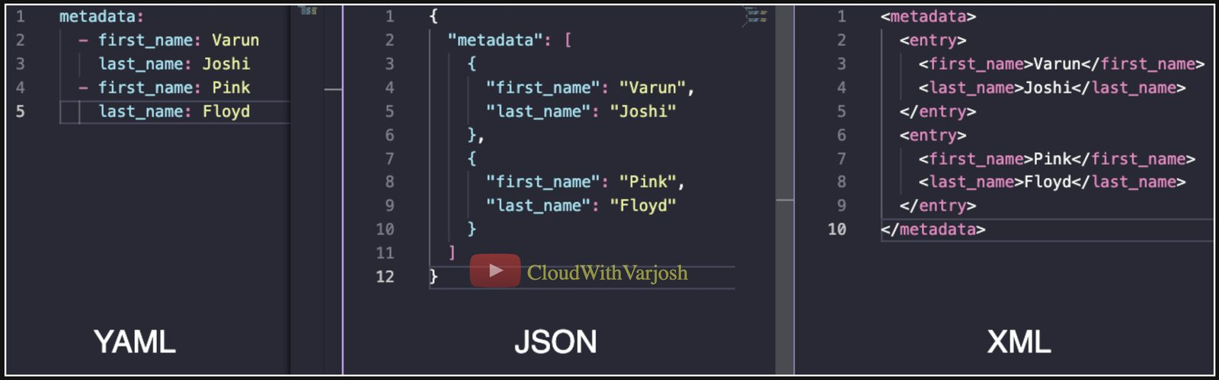
YAML vs JSON

The three YAML data structures
1. Scalars – single values: string, integer, float, boolean, null.
YAML
first_name: Prakash # string (quotes optional)
height: 5.9 # float
roll_number: 9 # integer
is_engineer: true # boolean
pending_dues: null # null
2. Dictionaries (maps) – a set of key/value pairs, nested by indentation.
YAML
address:
flat_number: x-001
street: that_street
state: that_state
country: that_country
contact: # nested dictionary
phone: 000111222
email: prakash@example.com
3. Lists – ordered items, each starting with -.
YAML
hobbies:
- singing
- traveling
- dancing
- sports: # an item that is itself a dictionary holding a list
- cricket
- football
Combining them
YAML
education: # dictionary containing a list of dictionaries
degrees:
- degree: Bachelors
field: Computer Science
- degree: Masters
field: Data Science
work_experience: # list of dictionaries
- company: ABC Corp
role: Devops Engineer
duration: 3 years
- company: XYZ Inc
role: DevOps Consultant
duration: 2 years

Reading a Pod manifest as YAML
YAML
apiVersion: v1 # which API version
kind: Pod # what kind of object
metadata: # dictionary: identity
name: my-pod-2
labels:
app: nginx
environment: development
spec: # dictionary: desired state
containers: # list of containers
- name: nginx-container
image: nginx
ports:
- containerPort: 80
- name: sidecar-container
image: busybox
args: ["sleep", "3600"]
Every Kubernetes manifest has the same four top-level keys: apiVersion, kind, metadata (name, labels…) and spec (desired state). These files are called manifests, configuration files, spec files, definition files — all the same thing.

Basic Pod commands
Task | Command
Create/update from file | kubectl apply -f pod.yaml
List Pods | kubectl get pods
More detail (IP, node) | kubectl get pods -o wide
Full details + events | kubectl describe pod <pod>
Logs | kubectl logs <pod>
Logs of one container | kubectl logs <pod> -c <container>
Follow logs live | kubectl logs -f <pod>
Shell into a Pod | kubectl exec -it <pod> -- /bin/bash
Shell into one container | kubectl exec -it <pod> -c <container> -- /bin/bash
Delete | kubectl delete pod <pod>

Day 10 — ReplicationController, ReplicaSet and Deployment

Finding object details
kubectl api-resources lists every object type, its short name, API version and whether it is namespaced.
NAME SHORTNAMES APIVERSION NAMESPACED KIND
replicationcontrollers rc v1 true ReplicationController
replicasets rs apps/v1 true ReplicaSet
deployments deploy apps/v1 true Deployment

Labels and selectors (used everywhere!)
- Labels – key/value tags attached to objects, e.g. app: nginx, environment: dev.
- Selectors – filters that pick objects by their labels.
Analogy: a DevOps team of 5 – 2 Kubernetes experts, 1 automation expert, 2 CI/CD experts. Each skill is a label. "Find all Kubernetes experts" is a selector.
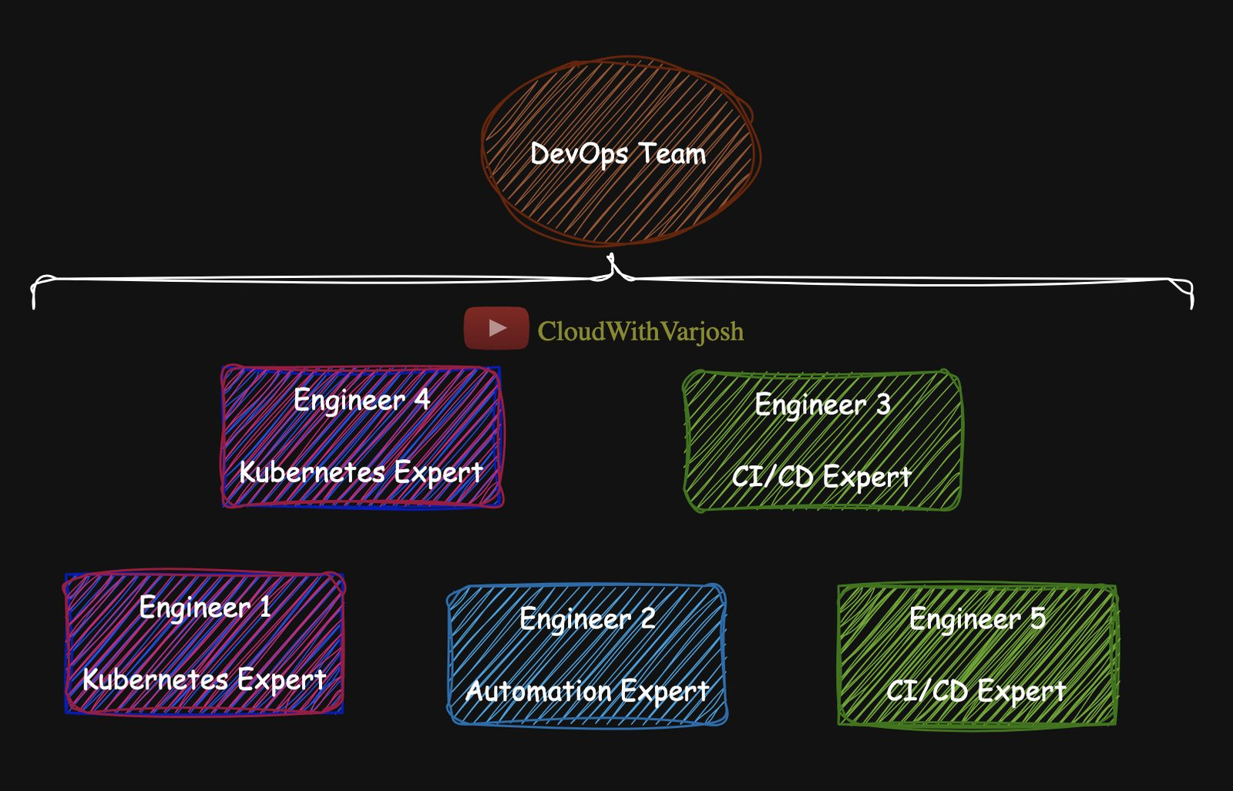
Labels analogy
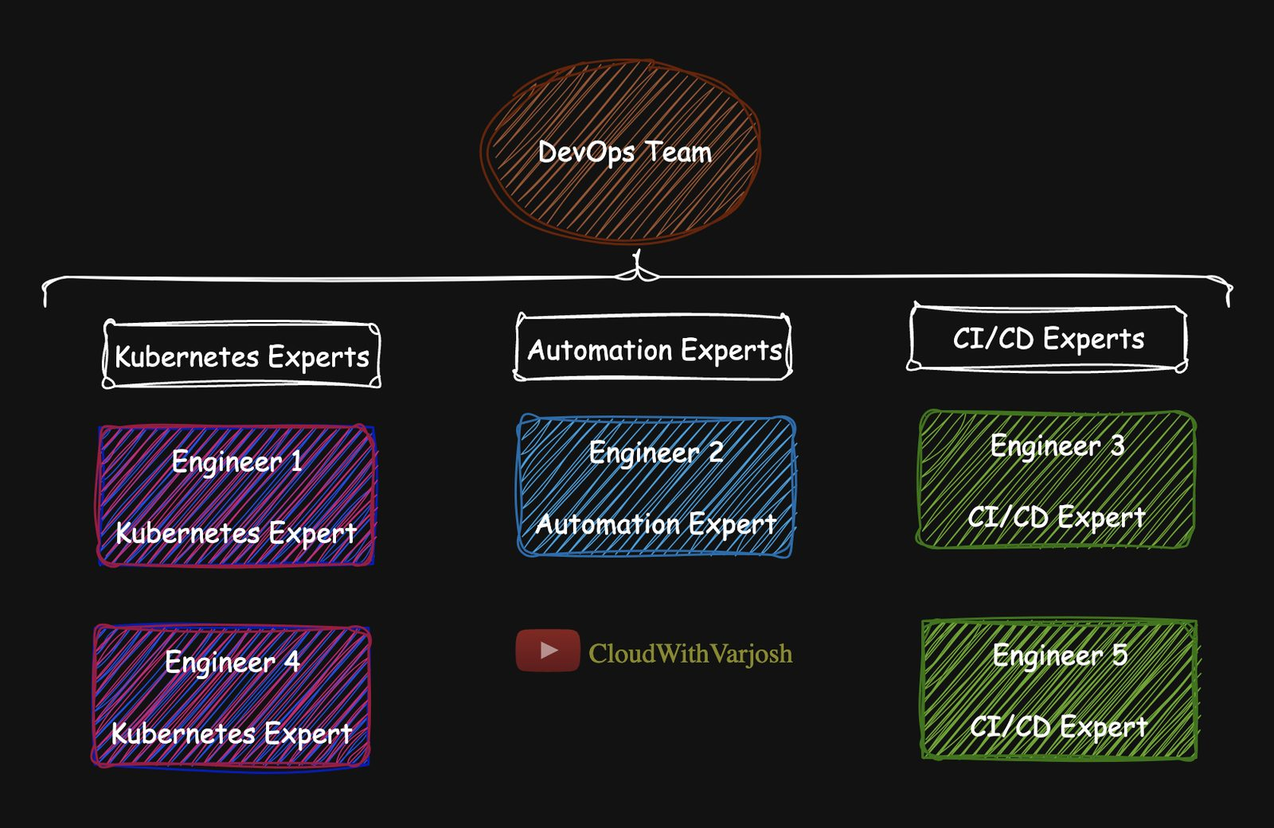
Selector analogy
Labels and selectors are used by ReplicationControllers, ReplicaSets, Deployments, StatefulSets, DaemonSets, Services, Jobs, CronJobs and NetworkPolicies.

ReplicationController (legacy)
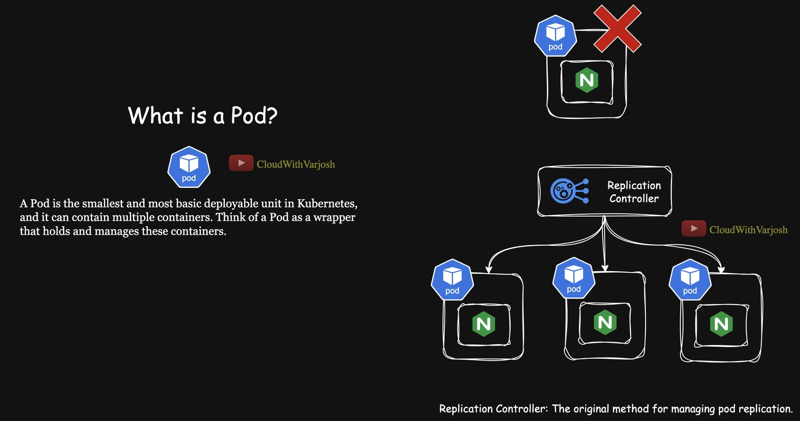
ReplicationController
Keeps a fixed number of Pod replicas running. Any Pod with matching labels is counted, however it was created.
YAML
apiVersion: v1
kind: ReplicationController
metadata:
name: nginx-rc
spec:
replicas: 3
selector:
app: nginx # equality-based only
template: # Pod template used to create replicas
metadata:
labels:
app: nginx
environment: development
spec:
containers:
- name: nginx-container
image: nginx
BASH
kubectl apply -f rc.yaml
kubectl get rc
kubectl describe rc nginx-rc
kubectl get pods --selector app=nginx
kubectl scale rc nginx-rc --replicas=4
The old imperative kubectl create rc command has been removed; RCs are rarely used today.

ReplicaSet
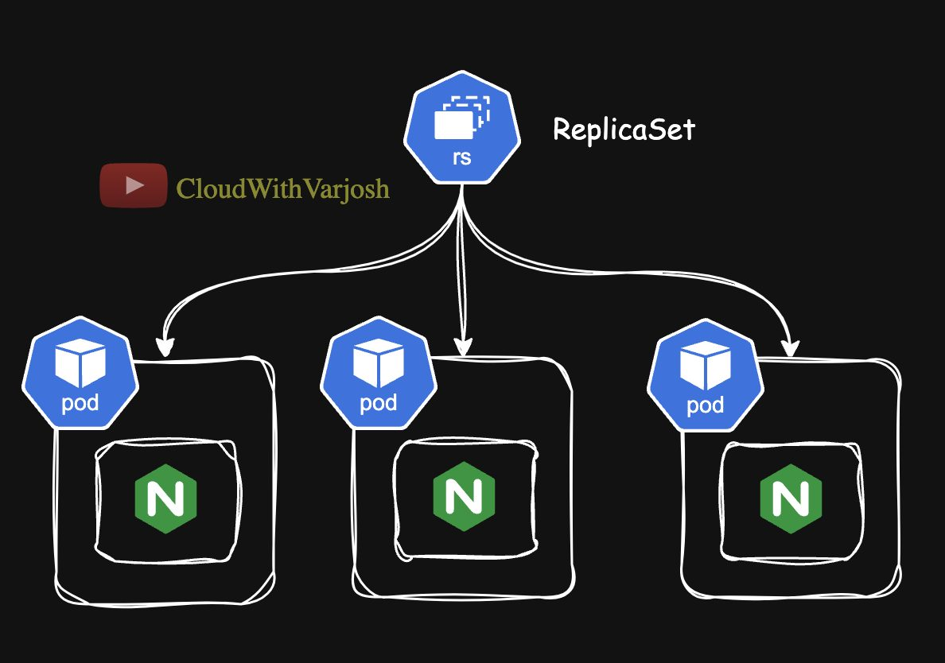
ReplicaSet
The improved RC. Main difference: supports set-based selectors. Usually you don't create it directly — a Deployment creates it for you.
YAML
apiVersion: apps/v1
kind: ReplicaSet
metadata:
name: nginx-rs
spec:
replicas: 3
selector:
matchLabels:
app: nginx
template:
metadata:
labels:
app: nginx
environment: development
spec:
containers:
- name: nginx-container
image: nginx
The Pod template labels must match the selector, otherwise the API server rejects the object.

Equality-based vs set-based selectors
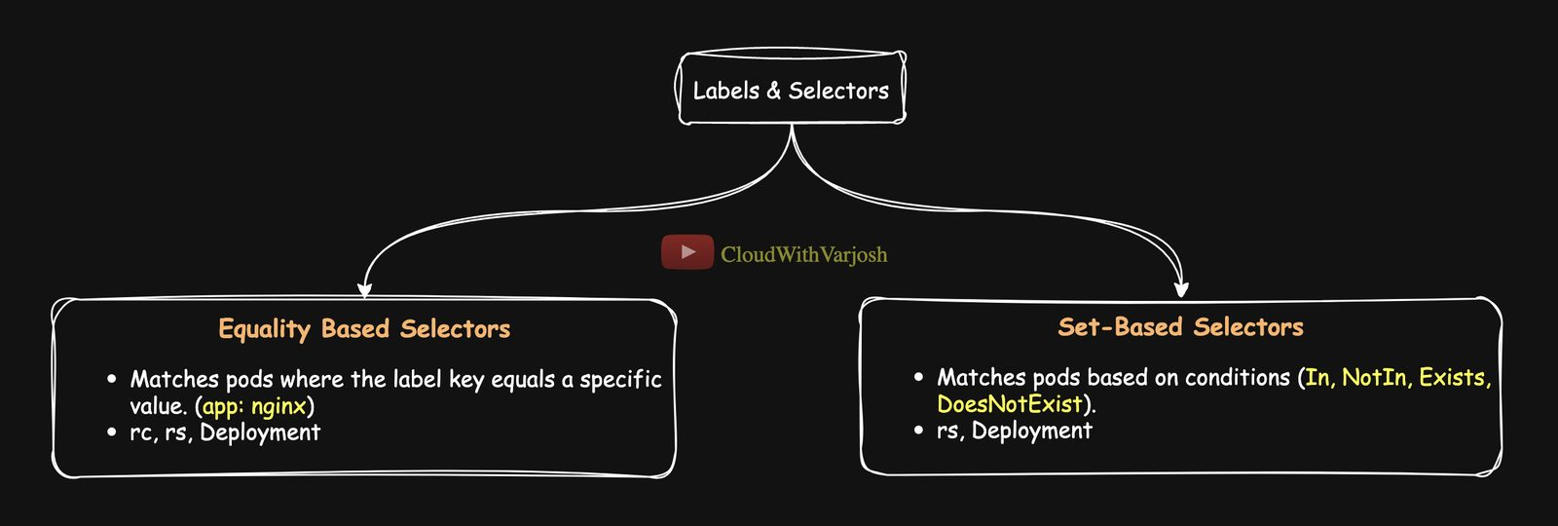
Selector types
- Equality-based – exact match: app=nginx, env!=prod. Supported by RC, RS, Deployment.
- Set-based – match against a set: In, NotIn, Exists, DoesNotExist. Supported by RS and Deployment (not RC).
Operator | Matches when | Example
In | Label value is in the list | app is nginx or apache
NotIn | Label value is not in the list | environment is not development
Exists | The key is present (any value) | has a tier label
DoesNotExist | The key is absent | no debug label

YAML
apiVersion: apps/v1
kind: ReplicaSet
metadata:
name: example-rs
spec:
replicas: 3
selector:
matchExpressions:
- {key: app, operator: In, values: [nginx, apache]}
- {key: environment, operator: NotIn, values: [development]}
- {key: tier, operator: Exists}
- {key: debug, operator: DoesNotExist}
template:
metadata:
labels:
app: nginx
environment: production
tier: frontend # do NOT add a debug label
spec:
containers:
- name: nginx-container
image: nginx
All expressions are ANDed together; the Pod template labels must satisfy every one.

Deployment
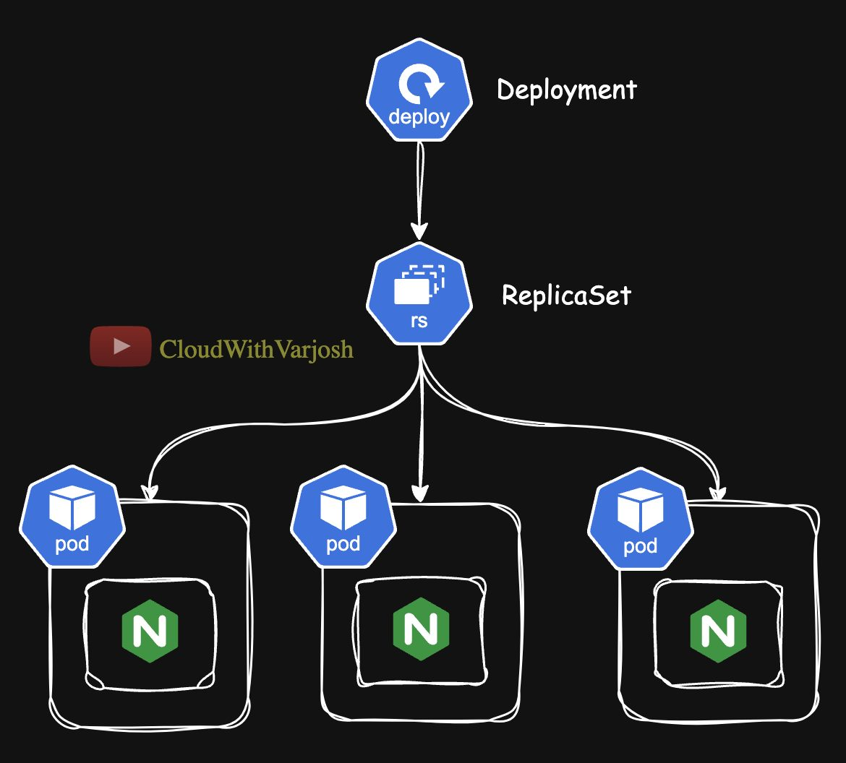
Deployment
A Deployment sits on top of ReplicaSets and adds rolling updates, rollbacks, revision history and easy scaling. Each time you change the Pod template, the Deployment creates a new ReplicaSet, scales it up and scales the old one down to 0.
YAML
apiVersion: apps/v1
kind: Deployment
metadata:
name: nginx-deployment
annotations:
kubernetes.io/change-cause: "Initial release with nginx 1.19"
spec:
replicas: 3
selector:
matchLabels:
app: nginx
template:
metadata:
labels:
app: nginx
environment: development
spec:
containers:
- name: nginx-container
image: nginx:1.19

Annotations
Annotations are key/value metadata, like labels, but not used for selection. They hold extra information for humans and tools: change reasons, build info, links, notes. The special annotation kubernetes.io/change-cause shows up in rollout history.

Rolling update and rollback walkthrough
BASH
# 1. Apply and check history
kubectl apply -f deploy.yaml
kubectl rollout history deployment nginx-deployment
# REVISION CHANGE-CAUSE
# 1 Initial release with nginx 1.19

# 2. Upgrade to 1.20 and record why
kubectl set image deployment nginx-deployment nginx-container=nginx:1.20
kubectl annotate deployment nginx-deployment kubernetes.io/change-cause="Upgraded nginx 1.19 to 1.20"

# 3. Upgrade to 1.21
kubectl set image deployment nginx-deployment nginx-container=nginx:1.21
kubectl annotate deployment nginx-deployment kubernetes.io/change-cause="Upgraded nginx 1.20 to 1.21"

kubectl rollout history deployment nginx-deployment
# 1 Initial release with nginx 1.19
# 2 Upgraded nginx 1.19 to 1.20
# 3 Upgraded nginx 1.20 to 1.21

# 4. Roll back to revision 1 (omit --to-revision to go to the previous one)
kubectl rollout undo deployment nginx-deployment --to-revision=1
kubectl describe deployment nginx-deployment
What happens under the hood: every update creates a new ReplicaSet; the old ReplicaSet is scaled to 0 but kept. A rollback simply scales the old ReplicaSet back up and the current one down.
Changing the image of an RC or a bare ReplicaSet does not replace running Pods — only new Pods get the new image. Only Deployments do rolling updates.
In production, edit the manifest (new image + change-cause) and kubectl apply it instead of using set image, so Git stays the source of truth.

Deployment command cheat sheet
Task | Command
Create imperatively | kubectl create deployment nginx-deployment --image=nginx:1.19
List | kubectl get deployments
Describe | kubectl describe deployment nginx-deployment
Change image | kubectl set image deployment/nginx-deployment nginx-container=nginx:1.20
Scale | kubectl scale deployment/nginx-deployment --replicas=5
History | kubectl rollout history deployment/nginx-deployment
Rollback | kubectl rollout undo deployment/nginx-deployment --to-revision=1
Pause / resume a rollout | kubectl rollout pause deployment/<name> / kubectl rollout resume deployment/<name>
Edit live | kubectl edit deployment <name>
Export YAML | kubectl get deployment <name> -o yaml
Delete | kubectl delete deployment nginx-deployment

Why pause a rollout? To batch several changes (image, resources, env) into one rollout instead of many, or to stop and investigate a problem mid-rollout. resume continues from where it stopped.

RC vs RS vs Deployment
Feature | ReplicationController | ReplicaSet | Deployment
Selectors | Equality only | Equality + set-based | Equality + set-based
Updates | Manual | Manual | Automated rolling updates + rollback
Use today | Legacy | Managed by Deployments | What you normally use

Day 11 — Monolith, 3-Tier Architecture and Microservices

Monolithic applications
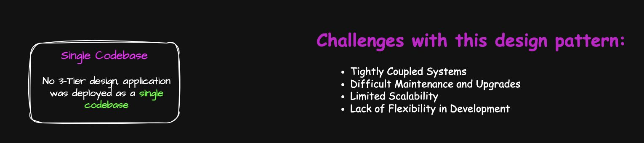
Monolith
One codebase and one deployment containing UI, business logic and data access. Easy at first, but:
- Tightly coupled – a change in one part can break another.
- Hard to maintain/upgrade – every fix redeploys everything.
- Limited scalability – you must scale the whole app even if one feature is busy.
- Slow development – teams block each other.

Three-tier architecture
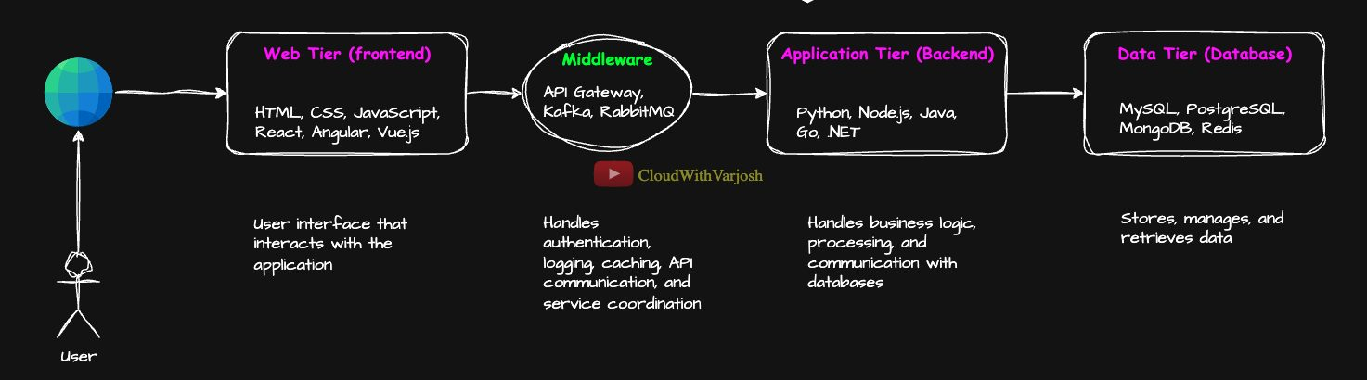
3-tier
Tier | Job | Example technologies
Frontend (web tier) | User interface | HTML, CSS, JavaScript, React, Angular, Vue
Middleware | Auth, logging, caching, API routing, messaging | Nginx, API Gateway, Express.js, Kafka, RabbitMQ
Backend (application tier) | Business logic, talks to the DB | Python, Node.js, Java, Go, .NET
Database (data tier) | Store and retrieve data | MySQL, PostgreSQL, MongoDB, Redis

E-commerce example: the product pages and cart UI are the frontend; a payment gateway or rate limiter is middleware; the order-management system is backend; user, product and order-history databases are the data tier.
How 3-tier deployment evolved
- Single server – everything on one machine. Cheap, but one crash takes all down; only vertical scaling.
- Three physical servers – better isolation and performance, but expensive.
- Virtualization – each tier in its own VM on shared hardware. Affordable isolation, easier scaling.
- Cloud + Kubernetes – tiers run as containers; frontend Pods, backend microservice Deployments, and often a managed DB (RDS, Cloud SQL).
Problems with classic 3-tier: must scale a whole tier, a tier can be a single point of failure, each tier is still a mini-monolith, slow releases, one tech stack per tier.

Microservices
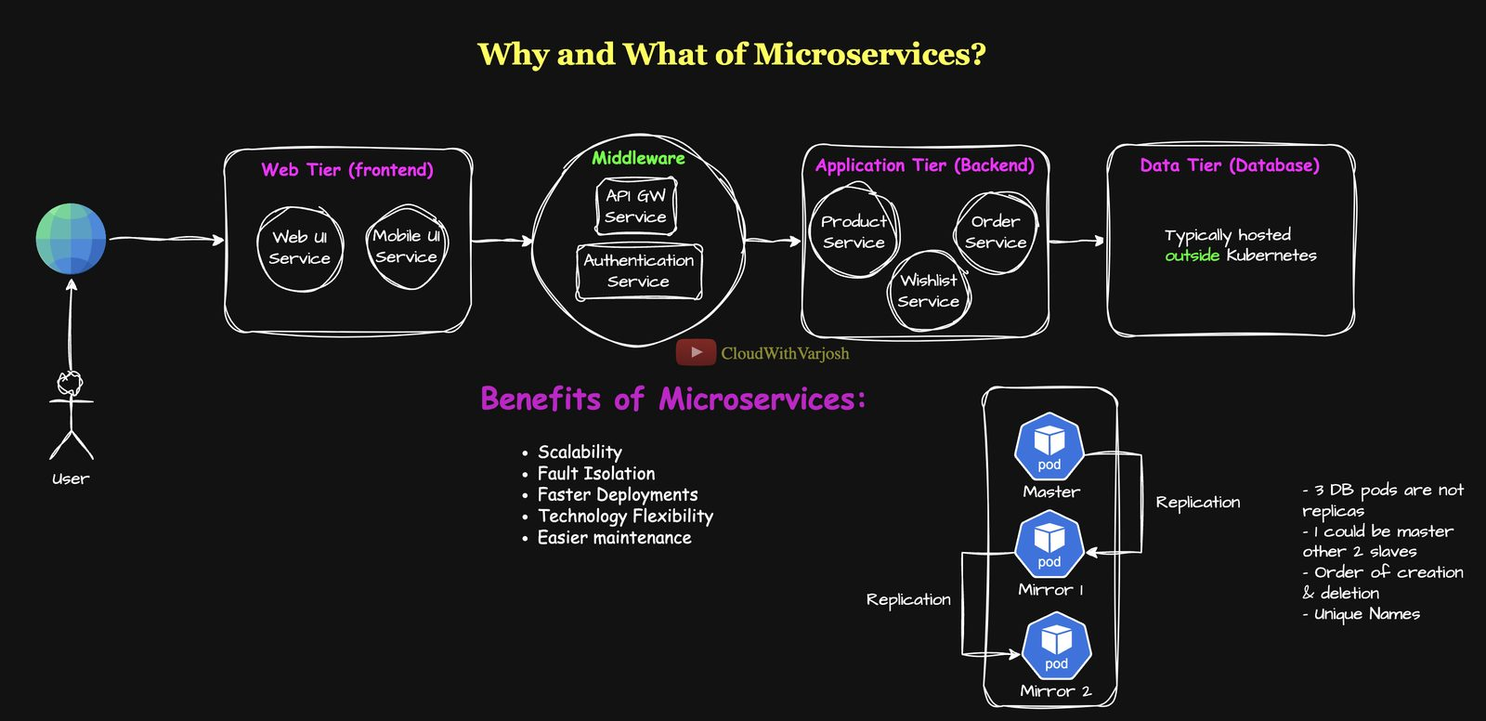
Microservices
Break the app into small independent services that talk over APIs, each with its own deployment. E-commerce: User Service, Product Service, Order Service, Wishlist Service. If the Wishlist Service fails, users can still browse and buy.
(They are usually called "Wishlist Service", not "microservice" – the word service is the industry convention.)
Benefit | Meaning
Scalability | Scale each service on its own
Fault isolation | One failure doesn't kill the whole app
Faster deployment | Teams release independently
Tech flexibility | Each service can use a different language
Easier maintenance | Small codebases

Microservices on Kubernetes
Tier | Example services | In Kubernetes
Frontend | Web UI, mobile UI | Deployments + Service
Middleware | API gateway, auth, logging, caching | Deployments
Backend | Order, payment, wishlist services | One Deployment each
Database | – | Often outside the cluster

Stateful vs stateless: stateful apps remember previous interactions (databases, sessions); stateless apps don't and are easy to scale.
Why databases are usually kept outside Kubernetes in production: they need stable network identity, persistent storage, replication, backups and failover — managed services (AWS RDS, Cloud SQL, Azure Database) or dedicated HA VMs do this better. A hybrid model (apps in K8s, DB outside) is common.
When you might run a DB in Kubernetes: dev/test, small self-managed setups, or using StatefulSets (stable identity + storage, ordered rollout — used for MySQL, PostgreSQL, Kafka, Zookeeper) and Operators (custom controllers that encode a human operator's knowledge to automate install, scaling, backup and healing).
Request flow example: user → https://example.com → Ingress controller → frontend Service → frontend calls the API gateway → gateway routes to the Wishlist Service → it queries the database → result returns to the browser. Each microservice is its own Deployment and can be scaled separately by a Horizontal Pod Autoscaler (Day 20).

Part 4 — Services, Imperative Commands and Namespaces (Days 12–14)

Day 12 — Kubernetes Services in Depth

Why Services exist
Pods are ephemeral – they get deleted, rescheduled and recreated, and each new Pod gets a new IP. Two problems follow:
- You can't hard-code Pod IPs because they keep changing.
- Some Pods must be reachable by other Pods (internal), and some by users outside the cluster (external).
A Service solves both. It gives:
- a fixed virtual IP and DNS name that never changes,
- load balancing across all matching Pods (found by label selector),
- a way to expose apps inside or outside the cluster.
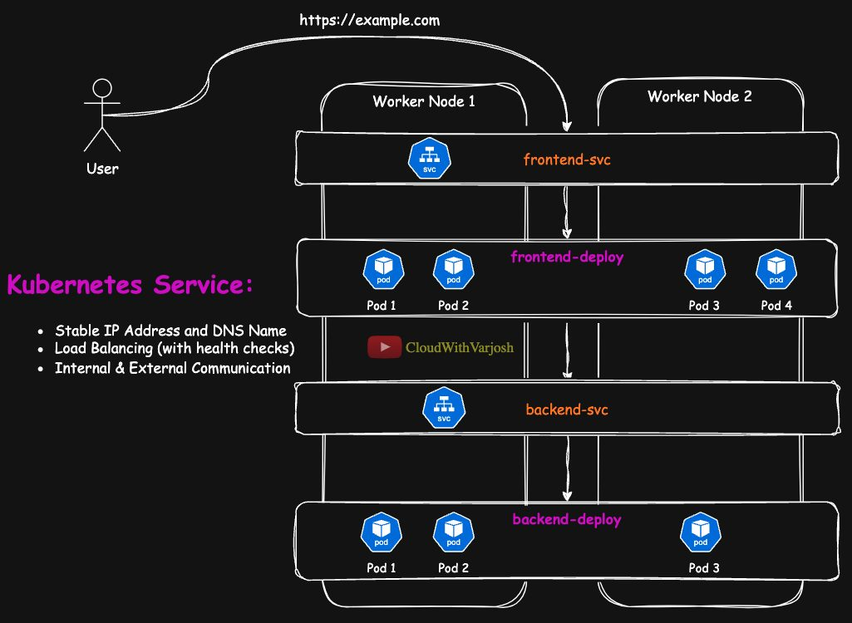
Services
Without Services: User → Frontend Pod (IP changes) → Backend Pod (IP changes) ✗
With Services: User → frontend-svc → Frontend Pod → backend-svc → Backend Pod ✓

The office-complex analogy used throughout
Analogy | Kubernetes
Office building complex | Cluster
Individual buildings | Nodes
Departments (HR, Finance…) | Pods
Internal phone extensions | ClusterIP Service
Front-desk phone numbers | NodePort Service
Call center with one number | LoadBalancer Service
IT-support speed dial "111" to an outside company | ExternalName Service

1. ClusterIP (default) — internal only
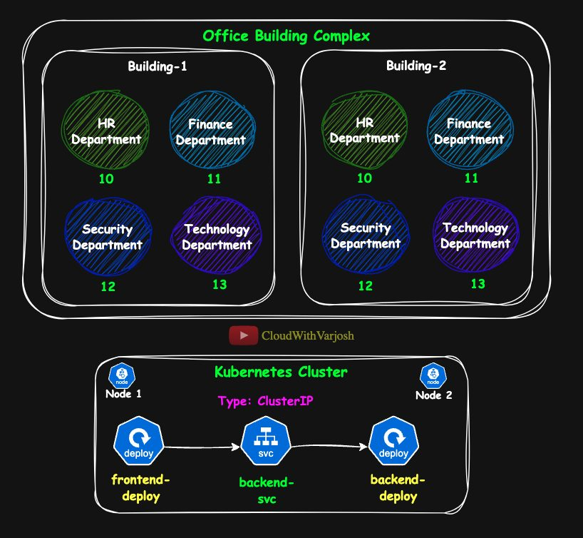
ClusterIP analogy
Like internal phone extensions: HR dials extension 11 to reach Finance, but nobody outside can dial it.
- Reachable only inside the cluster.
- Gets a stable DNS name (e.g. backend-svc) resolved by CoreDNS.
- kube-proxy load-balances across the healthy Pods.
Demo: NGINX frontend → http-echo backend
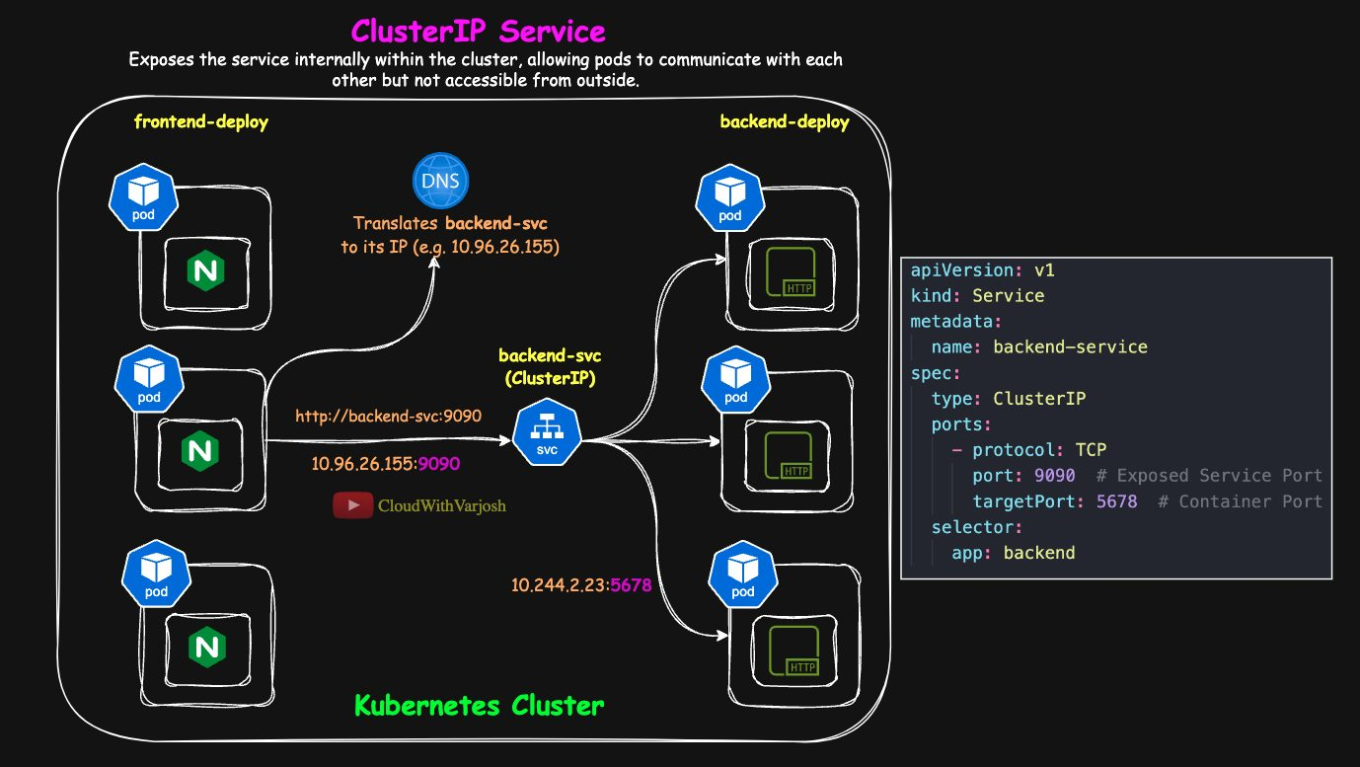
ClusterIP demo
YAML
apiVersion: apps/v1
kind: Deployment
metadata:
name: backend-deploy
spec:
replicas: 3
selector:
matchLabels:
app: backend
template:
metadata:
labels:
app: backend
spec:
containers:
- name: backend-container
image: hashicorp/http-echo
args:
- "-text=Hello from Backend" # listens on 5678 by default
---
apiVersion: v1
kind: Service
metadata:
name: backend-svc
spec:
type: ClusterIP
selector:
app: backend # sends traffic to Pods with this label
ports:
- protocol: TCP
port: 9090 # port the Service listens on
targetPort: 5678 # port the container listens on
The frontend Deployment is 3 replicas of nginx labelled app: frontend. From a frontend Pod: curl backend-svc:9090 → CoreDNS resolves backend-svc to its ClusterIP (e.g. 10.96.26.155) → kube-proxy forwards to one backend Pod (e.g. 10.244.2.23:5678) → "Hello from Backend".
Port vocabulary: port = Service port; targetPort = container port; nodePort = port opened on every node (NodePort/LoadBalancer only).

Preparing kind for NodePort access
kind nodes are Docker containers, so a NodePort is only reachable from your laptop if you map it. Recreate the cluster with extraPortMappings:
BASH
kind get clusters
kind delete cluster --name my-first-cluster
kind create cluster --name my-second-cluster --config kind-cluster.yaml
YAML
kind: Cluster
apiVersion: kind.x-k8s.io/v1alpha4
nodes:
- role: control-plane
image: kindest/node:v1.37.0@sha256:a1ed56cfb0e7b93589bdf97c8cd566405a265939e3620fc4f5de89adff580ae5
extraPortMappings:
- containerPort: 31000 # port inside the kind node container
hostPort: 31000 # port on your laptop
- role: worker
image: kindest/node:v1.37.0@sha256:a1ed56cfb0e7b93589bdf97c8cd566405a265939e3620fc4f5de89adff580ae5
- role: worker
image: kindest/node:v1.37.0@sha256:a1ed56cfb0e7b93589bdf97c8cd566405a265939e3620fc4f5de89adff580ae5
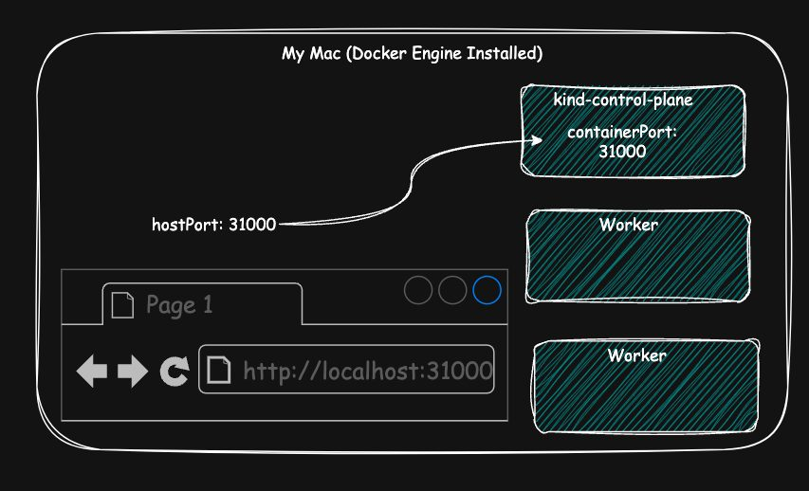
extraPortMappings
Now http://localhost:31000 on your laptop reaches NodePort 31000 in the cluster. (If hostPort were 9090, you'd use localhost:9090 instead.) That's why every NodePort example in the course pins nodePort: 31000.

2. NodePort — external access via every node
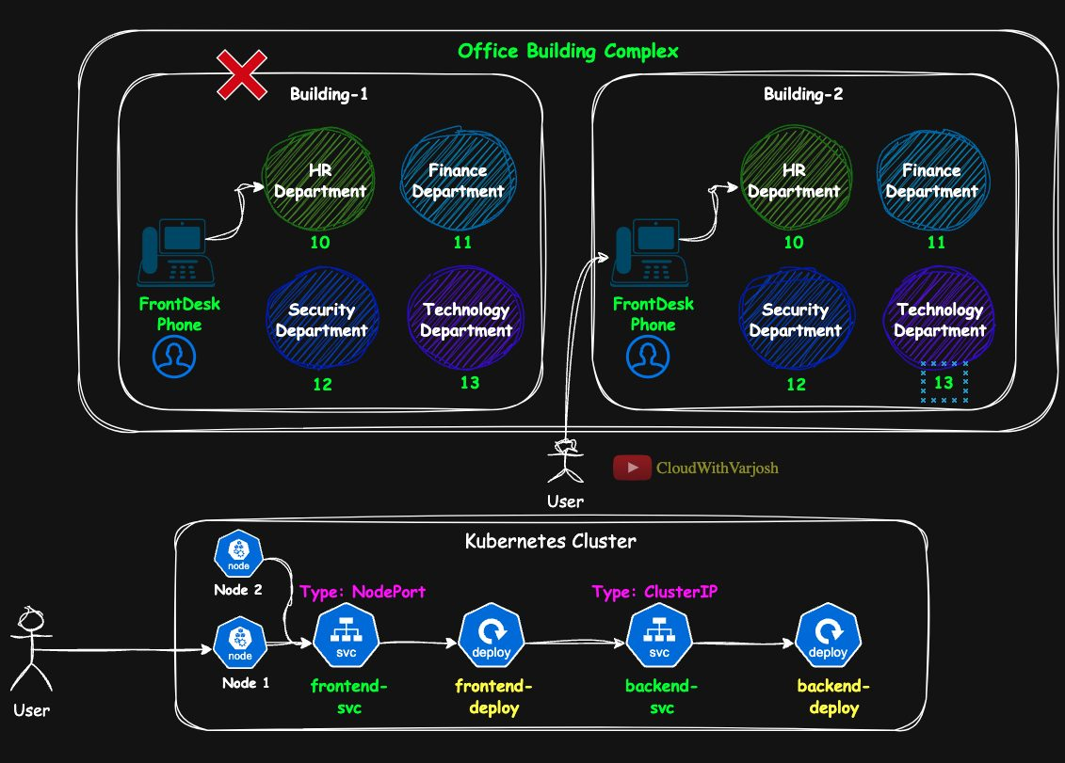
NodePort analogy
Like each building having a front-desk phone number: an outside caller dials a building's front desk, and the receptionist forwards the call using the internal extension. If one building is closed, the caller must dial the other building's number themselves.
- Opens the same port on every node (even nodes without the Pods). Access: http://<NodeIP>:<NodePort>.
- Built on ClusterIP: NodePort → ClusterIP → Pod.
- Port range 30000–32767 (configurable, but leave it). If you omit nodePort, Kubernetes picks one from the range.
- If a node dies, clients must switch to another node IP manually.
YAML
apiVersion: v1
kind: Service
metadata:
name: frontend-svc
spec:
type: NodePort
selector:
app: frontend
ports:
- protocol: TCP
port: 80 # ClusterIP port
targetPort: 80 # container port
nodePort: 31000 # external port on every node
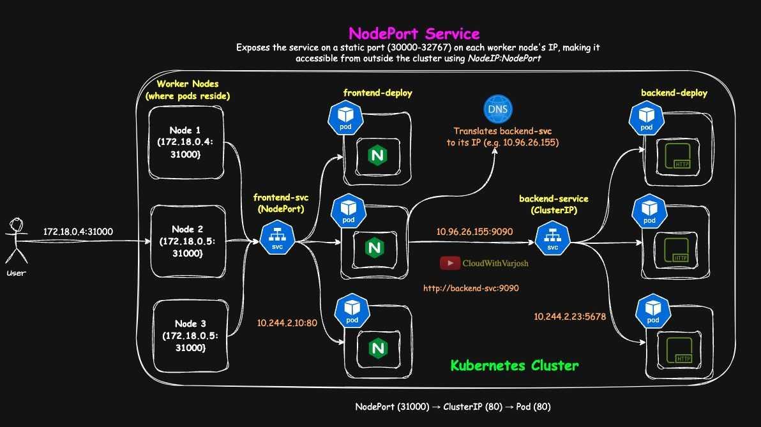
NodePort flow
Request flow: user → http://172.18.0.4:31000 (node IP) → Service ClusterIP 10.96.45.120:80 → a frontend Pod 10.244.2.10:80 → response. http://172.18.0.5:31000 (another node) works too.

3. LoadBalancer — one external IP
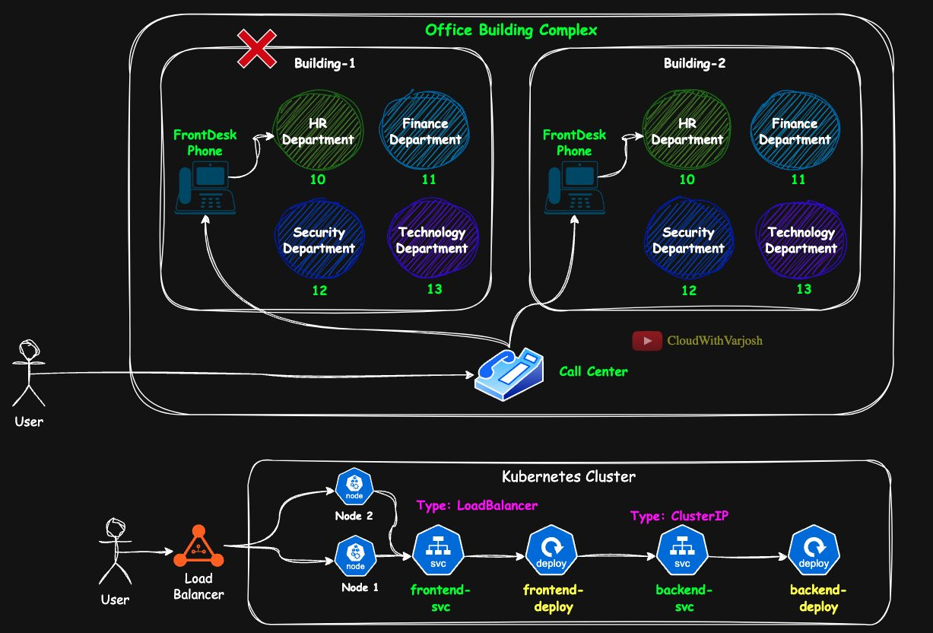
LoadBalancer analogy
Like a call center with one easy number that forwards your call to any working building's front desk.
- Kubernetes asks the cloud provider (AWS/GCP/Azure) for an external load balancer with a public IP.
- Chain: LB external IP → NodePort on any healthy node → ClusterIP → Pod.
- Gives a single address plus automatic failover between nodes.
YAML
apiVersion: v1
kind: Service
metadata:
name: frontend-svc
spec:
type: LoadBalancer
selector:
app: my-app
ports:
- protocol: TCP
port: 80
targetPort: 80
nodePort: 31000
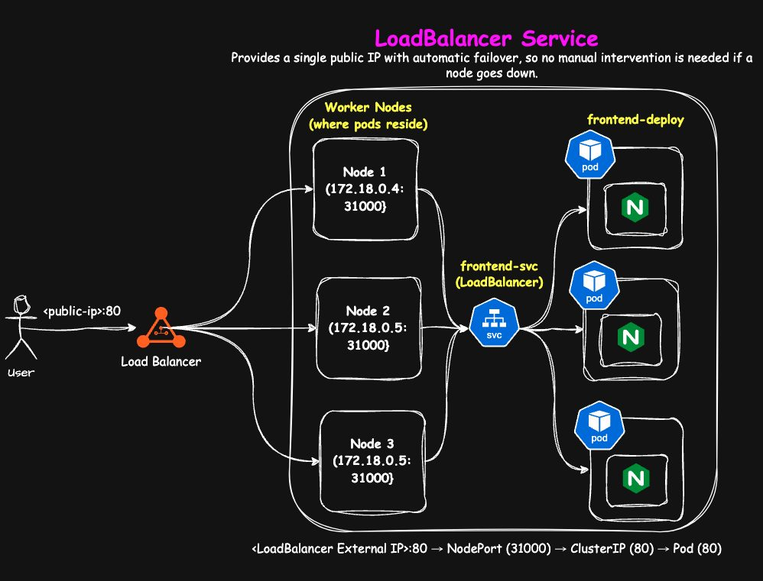
LoadBalancer flow
In real production you'll more often see an Ingress controller or Gateway API (Days 49–53) in front, because they add host/path routing, TLS termination and more — with one load balancer for many apps.

4. ExternalName — an alias for an outside DNS name
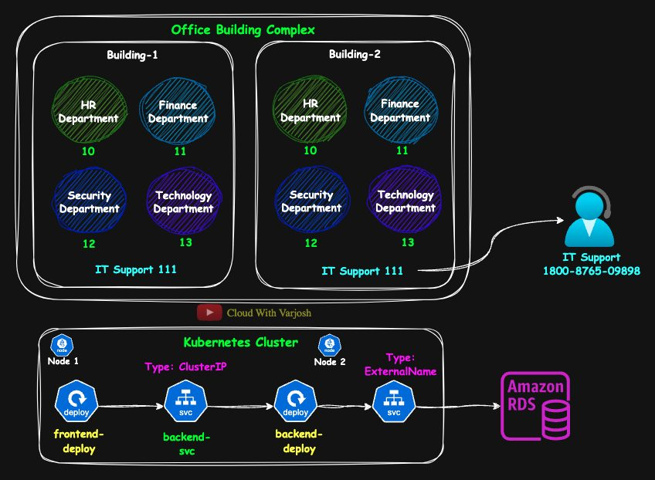
ExternalName analogy
Like dialing "111" to reach an outside IT-support company without knowing its real number.
- No ClusterIP, no proxying. CoreDNS simply returns a CNAME record pointing to the external name.
YAML
apiVersion: v1
kind: Service
metadata:
name: cka-db-svc
spec:
type: ExternalName
externalName: cka-db.judhtdmxwly6.us-east-1.rds.amazonaws.com
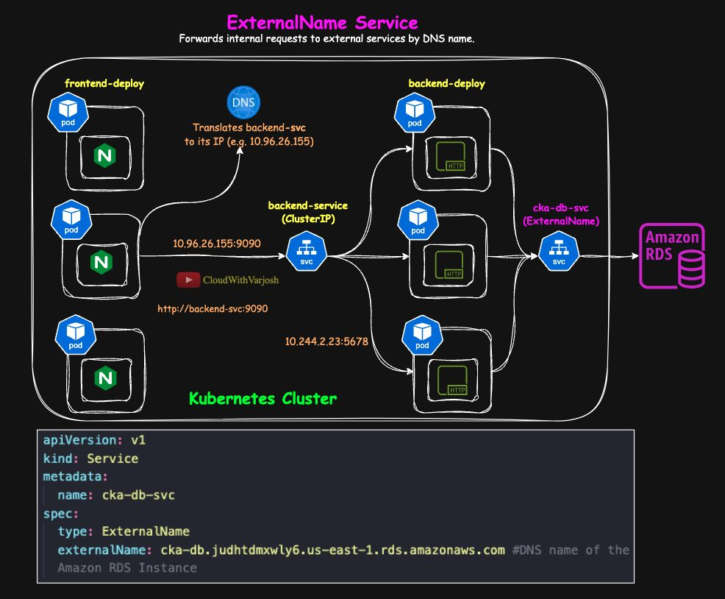
ExternalName example
Pods connect to cka-db-svc:3306. If the RDS endpoint changes, update only the Service, not the app code. Great for external databases, third-party APIs and legacy systems.

Summary of flows
Type | Path | Use
ClusterIP | Pod → ClusterIP → Pod | Internal service-to-service
NodePort | User → NodeIP:NodePort → ClusterIP → Pod | Simple external access, labs
LoadBalancer | User → cloud LB IP → NodePort → ClusterIP → Pod | Single public IP with failover
ExternalName | Pod → DNS CNAME → external host | Alias to something outside the cluster

Day 13 — Imperative Commands for Deployments, Services and Troubleshooting

Why learn imperative commands
- Troubleshooting – spin up a test Pod in seconds to check connectivity or network policies.
- CKA exam – generate YAML fast instead of typing it: ... --dry-run=client -o yaml > file.yaml.
- Real life – temporary resources and quick checks.
Key flags
Flag | Meaning
--dry-run=client | Validate locally only; nothing is sent to the API server or created
--dry-run=server | Send to the API server for full schema + admission checks, but don't persist
-o yaml | Print the object as YAML (combine with dry-run to generate manifests)
--rm | Delete the Pod when you exit its shell
-it | Interactive terminal

Backend: Deployment + ClusterIP Service
BASH
kubectl create deployment backend-deploy \
--image=hashicorp/http-echo --replicas=3 --port=5678 \
--dry-run=client -o yaml > backend-deploy.yaml

kubectl expose deployment backend-deploy \
--type=ClusterIP --port=9090 --target-port=5678 --name=backend-svc \
--dry-run=client -o yaml >> backend-deploy.yaml # >> appends
Then edit the file by hand: add the --- separator between the two objects, adjust labels, and add the container args:
YAML
args:
- "-text=Hello from Backend"

Frontend: Deployment + NodePort Service
BASH
kubectl create deployment frontend-deploy \
--image=nginx --replicas=3 --port=80 \
--dry-run=client -o yaml > frontend-deploy.yaml

kubectl expose deployment frontend-deploy \
--type=NodePort --port=80 --target-port=80 --name=frontend-svc \
--dry-run=client -o yaml >> frontend-deploy.yaml
kubectl expose has no flag for a fixed nodePort, so add nodePort: 31000 manually, plus the --- separator.

Labels with imperative commands
kubectl create deployment can't set custom Pod labels (it uses app=<name>). kubectl run can label a Pod directly:
BASH
kubectl run nginx-pod --image=nginx --restart=Never --labels="app=nginx,env=production"
kubectl get pods --show-labels

Test Pods
BASH
# Generate a Pod manifest
kubectl run my-nginx --image=nginx --restart=Never --labels=app=test-pod \
--dry-run=client -o yaml > test-pod.yaml

# Throw-away troubleshooting Pod with a shell; deleted when you exit
kubectl run test-pod --rm -it --restart=Never --labels=app=test-pod --image=nginx /bin/sh
--restart=Never creates a plain Pod that is not restarted if it exits.

Day 14 — Namespaces

What and why
A namespace is a logical partition inside a cluster. Analogy: a big house shared by four families — without rooms there is no privacy or order; give each family a room (namespace) and everyone gets space, privacy and control.
Namespaces give you:
- Isolation and security – scope RBAC permissions and NetworkPolicies per namespace.
- No name clashes – the same name can exist in different namespaces.
- Resource management – ResourceQuotas and LimitRanges per namespace.
- Environment / team separation – dev, test, prod, or per team/project (multi-tenancy).

Built-in namespaces
Namespace | Purpose
default | Where things go if you don't specify a namespace
kube-system | Kubernetes system components (CoreDNS, kube-proxy, control-plane Pods…)
kube-public | Readable by everyone, even unauthenticated users; cluster info
kube-node-lease | Node heartbeat Lease objects used to detect node health
local-path-storage | (kind only) the local-path storage provisioner

Working with namespaces
BASH
kubectl create namespace app1-ns # imperative
kubectl apply -f app1-ns.yaml # declarative (below)
kubectl get namespaces
kubectl delete namespace app1-ns # WARNING: deletes everything inside it
YAML
apiVersion: v1
kind: Namespace
metadata:
name: app1-ns
Flag | Meaning
-n <ns> / --namespace <ns> | Run against a specific namespace
-A / --all-namespaces | Run across all namespaces

BASH
kubectl apply -f frontend-deploy.yaml -n app1-ns
kubectl apply -f backend-deploy.yaml -n app1-ns
kubectl get all -n app1-ns
kubectl get services -A

Testing isolation and cross-namespace DNS
From a Pod in default:
BASH
kubectl run test-pod --image=busybox -it --rm --restart=Never -- /bin/sh
curl backend-svc:9090 # ✗ fails – short name only works in the same namespace
curl http://backend-svc.app1-ns:9090 # ✓ works
Format: http://<service-name>.<namespace>:<service-port>. (Full form: <svc>.<ns>.svc.cluster.local – see Day 48.) From a Pod in app1-ns itself, curl backend-svc:9090 works.
Namespaces separate names, not network traffic. Pods in different namespaces can still talk to each other unless you add NetworkPolicies (Day 47).

Default namespace for your context
BASH
kubectl config set-context --current --namespace=app1-ns
kubectl config get-contexts

Best practices
- Separate dev / test / prod and teams with namespaces.
- Use clear names, e.g. team-app-env → frontend-prod-ns.
- Add ResourceQuotas (CPU, memory, storage) per namespace.
- Protect namespaces with NetworkPolicies.
- Be very careful with kubectl delete namespace.

Part 5 — Scheduling (Days 15–18)

Day 15 — Manual Scheduling and Static Pods

Recap: the scheduler
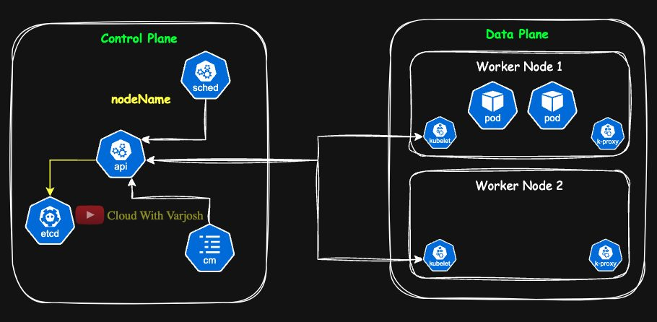
Scheduler
The kube-scheduler watches for Pods with no nodeName and picks a node based on resource availability, taints/tolerations (Day 16), and affinity rules (Day 17). It then writes the chosen node name into the Pod. (See the Day 7 deployment workflow.)

Manual scheduling with nodeName
You can skip the scheduler by setting spec.nodeName yourself. The kubelet on that node simply runs the Pod.
Why you'd do it: troubleshooting scheduling problems, forcing a workload onto a node with special hardware (e.g. SSD), or as a fallback when the scheduler is down.
BASH
kubectl get nodes
YAML
apiVersion: v1
kind: Pod
metadata:
name: nginx-manual
spec:
nodeName: my-second-cluster-worker2 # bypasses the scheduler
containers:
- name: nginx
image: nginx
BASH
kubectl apply -f nginx-manual.yaml
kubectl get pods -o wide # NODE column shows worker2
- Node doesn't exist? The Pod stays Pending (no kubelet will ever pick it up) and is eventually garbage-collected.
- On the control plane: set nodeName: my-second-cluster-control-plane and it runs there. This works even though the control plane is tainted, because taints are checked by the scheduler, and we bypassed the scheduler. Control-plane nodes also run a kubelet and kube-proxy, so they can run Pods.
nodeName can only be set at creation time; you can't change it on a running Pod. To move a Pod, delete and recreate it.

Static Pods
Static Pods are created and managed directly by the kubelet on a node from YAML files on disk – not through the API server and not by the scheduler.
- Location: /etc/kubernetes/manifests/ (the kubelet's staticPodPath).
- The control plane itself runs this way: kube-apiserver, etcd, kube-scheduler and kube-controller-manager are static Pods. That solves the chicken-and-egg problem: the kubelet can start the API server even though the API server isn't running yet.
- Can exist on any node (control plane or worker); always bound to that one node's kubelet.
Mirror Pods: so you can see static Pods with kubectl get pods, the kubelet creates a read-only mirror Pod in the API server, named <static-pod-name>-<node-name>, e.g. nginx-static-pod-my-second-cluster-worker2. You can't really control it through kubectl.
Demo (in kind, first docker exec -it my-second-cluster-control-plane bash; in a real cluster, SSH to the node):
BASH
cat <<EOF > /etc/kubernetes/manifests/static-pod.yaml
apiVersion: v1
kind: Pod
metadata:
name: nginx-static-pod
spec:
containers:
- name: nginx-container
image: nginx
ports:
- containerPort: 80
EOF

kubectl get pods -A
Deleting it: kubectl delete pod nginx-static-pod-my-second-cluster-control-plane only deletes the mirror — the kubelet immediately recreates it. To remove it for good, delete the file:
BASH
rm /etc/kubernetes/manifests/static-pod.yaml
Production clusters: nodes are real VMs/servers, so ssh user@node-ip then sudo vi /etc/kubernetes/manifests/<file>.yaml.
 | Manual scheduling | Static Pods
Created by | You, via the API server | kubelet, from a file on the node
Needs API server? | Yes | No
Scheduler involved? | No (you set nodeName) | No
Typical use | Testing, debugging, forced placement | Control-plane components, always-on node agents
How to delete | kubectl delete pod | Remove the manifest file

Day 16 — Taints and Tolerations

Idea
- A taint goes on a node and says "keep away unless you tolerate me".
- A toleration goes on a Pod and says "I can accept that taint".
A toleration allows a Pod onto a tainted node; it does not force it there (see Day 18).
When to use: dedicated nodes (e.g. GPU nodes only for GPU jobs), isolating critical workloads, keeping apps off control-plane nodes, maintenance, nodes with limited resources.
Taints are checked at scheduling time. Adding a taint does not remove Pods already running on the node — unless the effect is NoExecute.

Applying taints
BASH
kubectl taint nodes <node> <key>=<value>:<effect>
kubectl taint nodes my-second-cluster-worker storage=ssd:NoSchedule
kubectl taint nodes my-second-cluster-worker2 storage=hdd:NoSchedule
kubectl describe node my-second-cluster-worker | grep -i taint
Effect | Behaviour
NoSchedule | New Pods without a matching toleration are not scheduled here
PreferNoSchedule | Scheduler tries to avoid the node (soft)
NoExecute | Not scheduled, and running Pods without a toleration are evicted

Tolerations
YAML
tolerations:
- key: "storage"
operator: "Equal" # default: key AND value must match
value: "ssd"
effect: "NoSchedule" # must match the taint's effect
YAML
tolerations:
- key: "storage"
operator: "Exists" # only the key must match; any value
effect: "NoSchedule"
Node taint | Pod toleration? | Result
storage=ssd:NoSchedule | Yes | Can be scheduled
storage=ssd:NoSchedule | No | Cannot be scheduled
storage=ssd:NoExecute | Yes | Stays on the node
storage=ssd:NoExecute | No | Evicted

For NoExecute you can add tolerationSeconds: 3600 to stay only for a limited time before being evicted.

Demo walkthrough
Cluster: my-second-cluster-control-plane, my-second-cluster-worker, my-second-cluster-worker2.
- Taint both workers (above). Then kubectl run mypod --image=nginx → Pending. kubectl describe pod mypod shows no node is suitable.
- Why not the control plane? It already has the default taint:
BASH
kubectl describe node my-second-cluster-control-plane | grep Taints
# Taints: node-role.kubernetes.io/control-plane:NoSchedule
(In Day 15 we could still put a Pod there only because nodeName bypasses the scheduler.)
- A Deployment that tolerates storage=ssd lands on worker:
YAML
apiVersion: apps/v1
kind: Deployment
metadata:
name: app1-deploy
spec:
replicas: 3
selector:
matchLabels:
app: app1
template:
metadata:
labels:
app: app1
spec:
tolerations:
- key: "storage"
operator: "Equal"
value: "ssd"
effect: "NoSchedule"
containers:
- name: nginx-container
image: nginx
- With operator: Exists on storage, the Pod can go to either worker.
- Multiple taints: a node can have several taints; the Pod must tolerate all of them.
BASH
kubectl taint nodes my-second-cluster-worker env=prod:NoSchedule
kubectl taint nodes my-second-cluster-worker2 env=dev:NoSchedule
YAML
tolerations:
- key: "storage"
operator: "Exists"
effect: "NoSchedule"
- key: "env"
operator: "Equal"
value: "prod"
effect: "NoSchedule"
This Pod tolerates any storage taint but only env=prod, so it can only land on worker.

Removing taints — add a trailing -
BASH
kubectl taint nodes my-second-cluster-worker storage=ssd:NoSchedule-
kubectl taint nodes my-second-cluster-worker2 storage=hdd:NoSchedule-
kubectl taint nodes my-second-cluster-worker env=prod:NoSchedule-
kubectl taint nodes my-second-cluster-worker2 env=dev:NoSchedule-
kubectl describe node my-second-cluster-worker | grep -i taints # Taints: <none>

Advanced scenario: coloured nodes
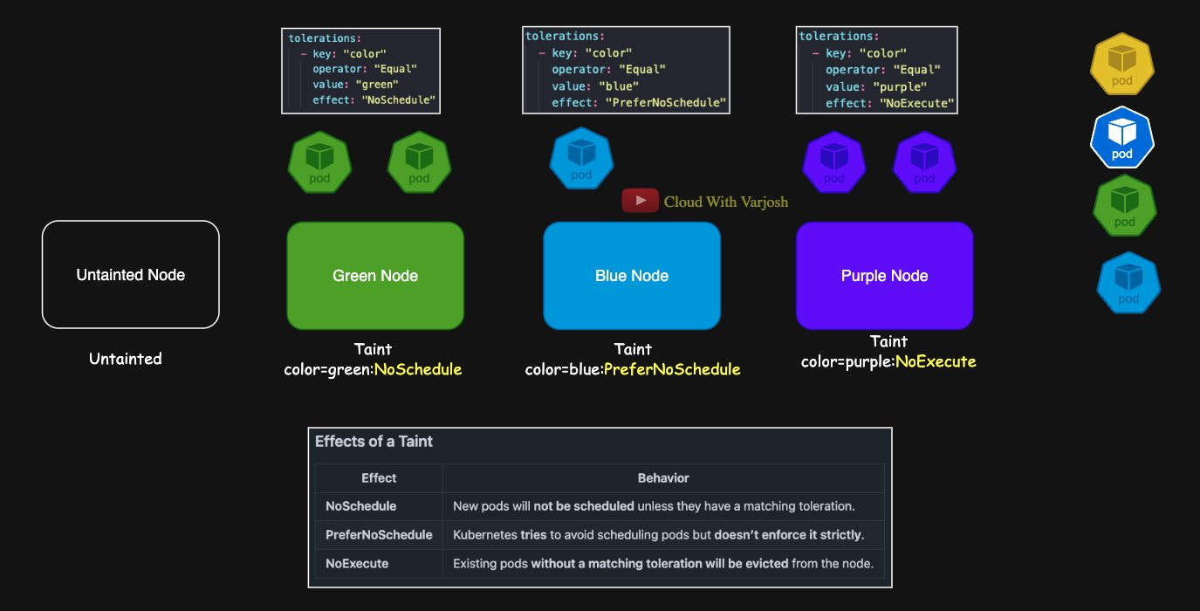
Coloured nodes
Node | Taint | Existing Pods
Green | color=green:NoSchedule | 2 green Pods – unaffected
Blue | color=blue:PreferNoSchedule | 1 blue Pod – unaffected
Purple | color=green:NoExecute | 2 purple Pods – evicted (they don't tolerate it)
New, untainted | none | –

Where do new Pods go?
New Pod | Toleration | Placement
Yellow | color=yellow (matches nothing – behaves like a normal Pod) | Untainted node first; Blue only if untainted is full
Normal | none | Untainted first; Blue as backup. Never Green/Purple
Green | color=green | Green or untainted (spread by resources); Blue only if both are full. (It also tolerates Purple's color=green:NoExecute)
Blue | color=blue | Untainted first (scheduler avoids PreferNoSchedule), then Blue

Lesson: a toleration doesn't attract a Pod to a node. If Green is reserved for Project A and the untainted node belongs to Project B, Project A Pods can still drift onto B's node. To truly pin workloads you combine taints/tolerations with node affinity (Days 17–18).

Day 17 — nodeSelector and Node Affinity
Both use node labels to attract Pods to nodes (where taints repel).

nodeSelector (simple)
BASH
kubectl get nodes --show-labels
kubectl label nodes my-second-cluster-worker storage=ssd
kubectl label nodes my-second-cluster-worker env=prod
kubectl label nodes my-second-cluster-worker storage- # remove a label (trailing -)
YAML
apiVersion: apps/v1
kind: Deployment
metadata:
name: ns-deploy
spec:
replicas: 3
selector:
matchLabels:
app: app1
template:
metadata:
labels:
app: app1
spec:
nodeSelector:
storage: ssd
env: prod # node must have ALL listed labels
containers:
- name: nginx
image: nginx
Limitations: exact matches only, all labels must match (AND only, no OR), no soft preference — if no node matches the Pod stays Pending.

Node affinity (advanced)
Type | Behaviour
requiredDuringSchedulingIgnoredDuringExecution | Hard rule: only matching nodes; otherwise Pending
preferredDuringSchedulingIgnoredDuringExecution | Soft rule: prefer matching nodes, but can go elsewhere

"IgnoredDuringExecution" = if the node's labels change later, running Pods are not moved.
Required affinity (like nodeSelector):
YAML
affinity:
nodeAffinity:
requiredDuringSchedulingIgnoredDuringExecution:
nodeSelectorTerms:
- matchExpressions:
- key: storage
operator: In
values: [ssd]
OR – several values in one In:
YAML
- key: storage
operator: In
values: [ssd, hdd] # ssd OR hdd
AND – several expressions in the same term:
YAML
nodeSelectorTerms:
- matchExpressions:
- {key: storage, operator: In, values: [ssd]}
- {key: env, operator: In, values: [prod]} # ssd AND prod
Rule of thumb: expressions inside one nodeSelectorTerms item are ANDed; separate nodeSelectorTerms items are ORed.

Operators
Operator | Matches when
In | Label value is one of the values
NotIn | Label value is not one of the values
Exists | Label key is present
DoesNotExist | Label key is absent
Gt | Label value (number) greater than value
Lt | Label value (number) less than value

YAML
- matchExpressions:
- {key: storage, operator: In, values: [ssd, hdd]}
- {key: env, operator: NotIn, values: [dev]}
- {key: high-memory, operator: Exists}
- {key: dedicated, operator: DoesNotExist}
- {key: cpu, operator: Gt, values: ["4"]}
- {key: disk, operator: Lt, values: ["500"]}
Node anti-affinity: use NotIn / DoesNotExist to keep Pods away from certain nodes (or use taints).

Preferred affinity with weights
Weights (1–100) are added up per node; the highest score is preferred, but CPU/memory and other rules still count.
YAML
apiVersion: apps/v1
kind: Deployment
metadata:
name: preferred-na-deploy
spec:
replicas: 5
selector:
matchLabels:
app: app1
template:
metadata:
labels:
app: app1
spec:
affinity:
nodeAffinity:
requiredDuringSchedulingIgnoredDuringExecution:
nodeSelectorTerms:
- matchExpressions:
- {key: storage, operator: In, values: [ssd, hdd]} # must be ssd or hdd
preferredDuringSchedulingIgnoredDuringExecution:
- weight: 10
preference:
matchExpressions:
- {key: storage, operator: In, values: [ssd]} # prefer ssd strongly
- weight: 5
preference:
matchExpressions:
- {key: storage, operator: In, values: [hdd]} # hdd is second choice
containers:
- name: nginx
image: nginx
Pods favour the SSD worker; with many replicas (the repo uses 20) you'll see most go there and some spill onto HDD. Weight influences, never guarantees.

Retroactivity
- nodeSelector and node affinity are evaluated only at scheduling time. Changing node labels later does not evict Pods.
- Only taints with NoExecute are re-evaluated for running Pods.

Day 18 — Taints & Tolerations vs Node Affinity (use both!)
 | Taints & tolerations | Node affinity
Works on | Node repels Pods | Pod is attracted to labelled nodes
Guarantee | Keeps other Pods off the node | Puts this Pod on the right node
Weakness | A tolerating Pod may still land on an untainted node | Doesn't stop other Pods from using that node

Scenario
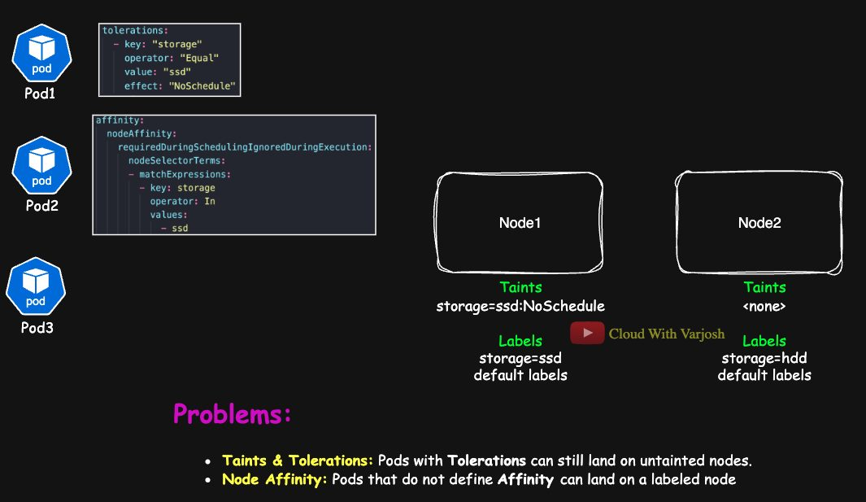
Taints vs affinity
Node | Label | Taint
Node1 | storage=ssd | storage=ssd:NoSchedule
Node2 | storage=hdd | none

(Default node labels such as kubernetes.io/hostname and topology.kubernetes.io/region differ by platform; clouds add their own.)
- Pod1 – toleration only: can go to Node1 or Node2. It might end up on HDD. ✗
- Pod2 – affinity only (storage In [ssd]): Node1 matches the label but its taint isn't tolerated; Node2 fails the label. → Pending. Common misconception: "affinity alone is enough".
- Pod3 – neither: goes to Node2 only. If it actually needs SSD, wrong place.

The fix: toleration plus required affinity
YAML
tolerations:
- key: "storage"
operator: "Equal"
value: "ssd"
effect: "NoSchedule"
affinity:
nodeAffinity:
requiredDuringSchedulingIgnoredDuringExecution:
nodeSelectorTerms:
- matchExpressions:
- key: storage
operator: In
values:
- ssd
Now the Pod lands only on Node1, and Pods without the toleration are kept off Node1.
Why admins still want taints even if apps use affinity: taints are the admin's enforcement layer. They stop random workloads (without affinity) from consuming reserved, specialised, critical or maintenance nodes.
Concept | Behaviour
Taints & tolerations | Allow onto tainted nodes; don't guarantee placement
Node affinity | Forces Pod to labelled nodes; doesn't repel others
Neither | Pods may land anywhere
Best practice | Use both for predictable placement

Part 6 — Resources and Autoscaling (Days 19–20)

Day 19 — Requests, Limits, LimitRange and Metrics Server

Why we need them: the noisy-neighbour problem
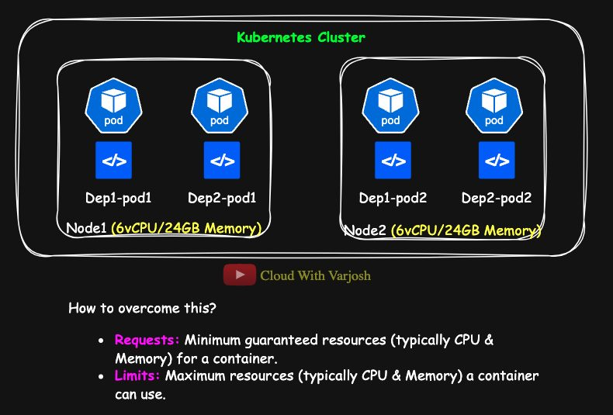
Noisy neighbour
Two nodes (6 vCPU, 24 GB each) run two Deployments with two Pods each. A bug in deployment-2 makes its Pods eat all CPU and memory, starving deployment-1. One workload hurting others is the noisy neighbour problem.
Requests and limits fix it:
- Request = the minimum a container is guaranteed. Used by the scheduler to pick a node.
- Limit = the maximum a container may use. Enforced by the Linux kernel (cgroups) at runtime.
Benefits: efficient allocation, no starvation, cluster stability, protection from noisy neighbours.
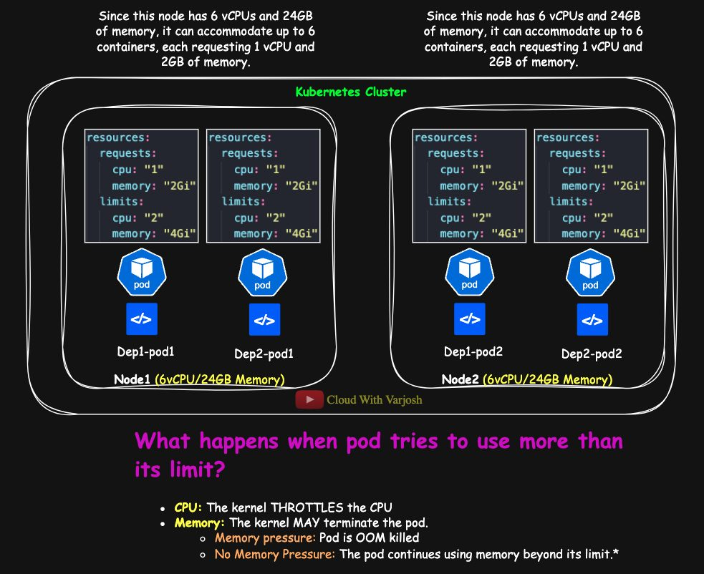
Requests and limits example
YAML
resources:
requests:
memory: "2Gi"
cpu: "1"
limits:
memory: "4Gi"
cpu: "2"
With 6 vCPUs per node and each container requesting 1 CPU, only 6 such containers fit per node — even though memory is still free. The scheduler sums requests, not actual usage.

Resource types and units
Resource | Unit | Example
CPU | cores / millicores (1 CPU = 1000m) | 500m = half a core
Memory | bytes (Mi, Gi) | 512Mi, 1Gi
Ephemeral storage | bytes | 2Gi
GPU | vendor-specific | nvidia.com/gpu: 1
HugePages | bytes | hugepages-2Mi: 512Mi
Custom devices | vendor-specific | example.com/fpga: 1

Requests and limits are set per container.

What happens at runtime
- Using more than the request: allowed if the node has spare capacity. The request is just what's reserved for you.
- Hitting the CPU limit: the container is throttled (slowed down). CPU is compressible.
- Hitting the memory limit: the container is OOM-killed (OOMKilled). Memory is incompressible.
Resource | When limit is exceeded
CPU | Throttled
Memory | Killed (Out Of Memory)

Why is it killed even when the node has free memory? The kubelet passes limits to the container runtime, which creates a cgroup for the container. The kernel's cgroup OOM killer enforces the limit per container, regardless of free memory on the node. (The docs say "may" because unusual kernel overcommit settings can change this, but by default exceeding the limit means an OOM kill.)
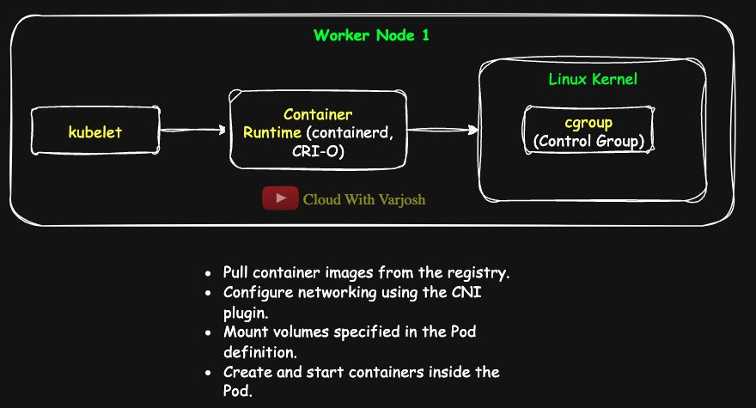
cgroup OOM

Metrics: how kubectl top works
kubectl top nodes fails with error: Metrics API not available until you install the Metrics Server.
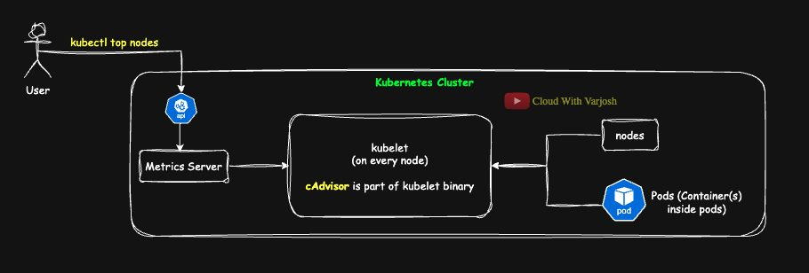
Metrics pipeline
- cAdvisor (built into the kubelet) collects CPU, memory, filesystem and network stats for containers and the node.
- The kubelet exposes them over HTTPS on port 10250 — /metrics/resource (and the older /stats/summary).
- Metrics Server pulls (scrapes) every kubelet periodically (v0.6+ uses /metrics/resource) and keeps the latest values in memory.
- It registers the metrics.k8s.io API with the API server's aggregation layer. kubectl top and the HPA query that API.

Installing Metrics Server
Get the manifest from the latest release (github.com/kubernetes-sigs/metrics-server/releases). On kind, add --kubelet-insecure-tls because kind's kubelets use self-signed certificates:
YAML
spec:
containers:
- args:
- --cert-dir=/tmp
- --secure-port=443
- --kubelet-preferred-address-types=InternalIP,ExternalIP,Hostname
- --kubelet-insecure-tls
BASH
kubectl apply -f components.yaml # edited copy (repo: Day 19/components.yaml)
kubectl get pods -n kube-system # metrics-server-xxxx 1/1 Running
kubectl top nodes # give it a minute
kubectl top pods

Demo: memory limit
YAML
apiVersion: v1
kind: Pod
metadata:
name: memory-demo
spec:
containers:
- name: memory-demo-ctr
image: polinux/stress
resources:
requests:
memory: "100Mi"
limits:
memory: "200Mi"
command: ["stress"]
args: ["--vm", "1", "--vm-bytes", "190M", "--vm-hang", "1"]
Allocating 190M (under 200Mi) runs fine. Change to --vm-bytes 250M and the container is OOMKilled — check with kubectl get pods -o wide and kubectl describe pod memory-demo.

Demo: CPU limit
YAML
apiVersion: v1
kind: Pod
metadata:
name: cpu-demo
spec:
containers:
- name: cpu-container
image: vish/stress
resources:
requests:
cpu: "500m" # the repo file uses 400m
limits:
cpu: "900m"
args: ["-cpus", "1"] # tries to burn 1 full CPU
kubectl top pods shows it capped around 900m — throttled, not killed.

Checking what's assigned
Level | Command
Node (see "Allocated resources") | kubectl describe node <node>
Pod | kubectl get pod <pod> -o yaml
Deployment | kubectl describe deployment <name>

LimitRange: namespace defaults and bounds
If containers don't set requests/limits, a LimitRange in the namespace can fill them in and enforce min/max.
YAML
apiVersion: v1
kind: LimitRange
metadata:
name: resource-limits
namespace: default
spec:
limits:
- type: Container
default: # default LIMIT if none given
cpu: "2"
memory: "4Gi"
defaultRequest: # default REQUEST if none given
cpu: "1"
memory: "2Gi"
max: # nobody may ask for more than this
cpu: "4"
memory: "8Gi"
min: # nobody may ask for less than this
cpu: "500m"
memory: "512Mi"
BASH
kubectl apply -f limitrange.yaml
kubectl describe limitrange resource-limits
LimitRange is enforced by an admission controller when Pods are created; it doesn't change running Pods. (A ResourceQuota is different: it caps the total for the whole namespace.)
Best practices: always set CPU and memory requests/limits in production, size memory limits to avoid OOM kills, monitor with kubectl top, use LimitRange for defaults.

Day 20 — Autoscaling: HPA and VPA

Scaling basics
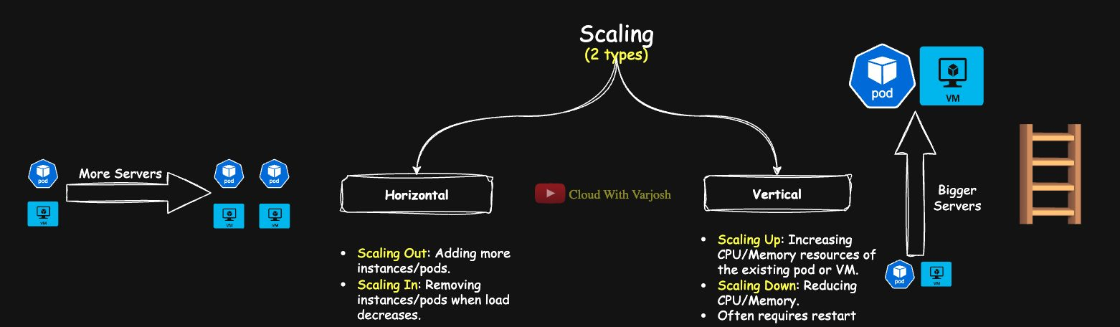
Scaling
Scaling = matching resources to demand: enough for peaks, no waste at quiet times (elastic).
- Horizontal – change the number of Pods/VMs. Scale out (add) / scale in (remove). Works well for stateless apps.
- Vertical – change the size (CPU/memory) of a Pod/VM. Scale up / scale down. Usually needs a restart.
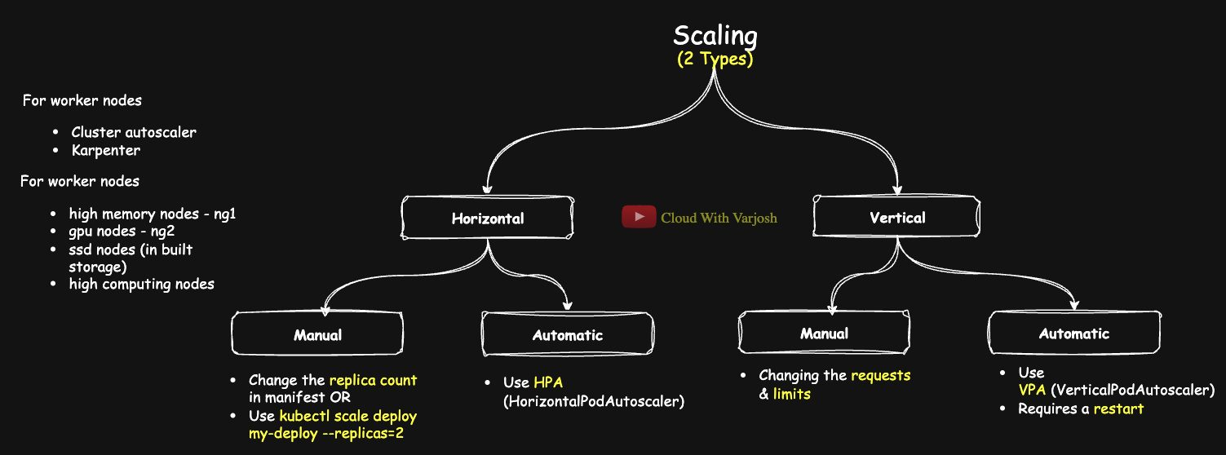
Scaling approaches
 | Pods (workloads) | Worker nodes (infrastructure)
Horizontal, manual | Edit replicas or kubectl scale deploy my-deploy --replicas=2 | Possible via cloud console, rare in prod
Horizontal, automatic | HPA | Cluster Autoscaler, or Karpenter on EKS
Vertical, manual | Edit requests/limits (Pod restart) | Not practical – resizing a VM restarts it and evicts Pods
Vertical, automatic | VPA (Pod restart, or in-place in newer versions) | Not used

In production, clusters usually have several node groups (high-memory, high-CPU, GPU…) that each scale horizontally and automatically.

Horizontal Pod Autoscaler (HPA)
- A control loop (every 15 s by default) that changes a workload's replica count to keep a metric near a target.
- Works with Deployments, StatefulSets, ReplicaSets and ReplicationControllers (Deployments/StatefulSets in practice).
- Requests are mandatory for the metric you scale on: "scale at 50% CPU" means 50% of the request. If a Pod requests 200m, HPA reacts when average usage passes 100m.
Resource metrics flow (CPU/memory)
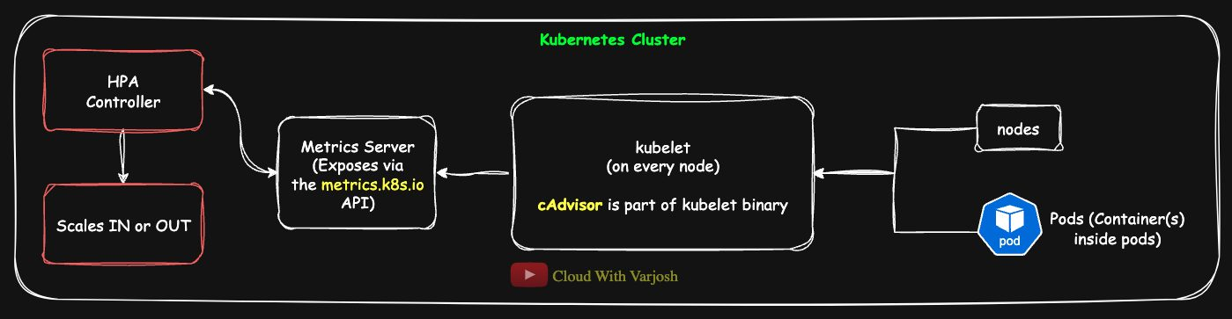
HPA resource metrics
kubelet + cAdvisor collect usage → Metrics Server aggregates → HPA controller reads metrics.k8s.io → computes utilisation vs requests → adjusts replicas.
Custom and external metrics
When CPU isn't a good signal (requests per second, queue length, DB connections):
Type | Relates to | API
Custom (internal) | Kubernetes objects (Pods, Deployments) | Custom Metrics API
External | Things outside Kubernetes | External Metrics API

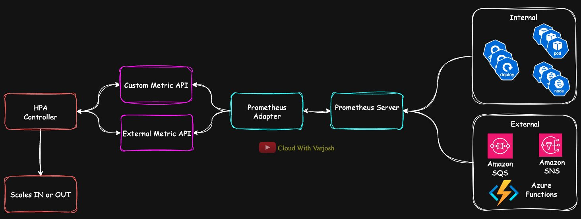
HPA custom metrics
Needs extra components: e.g. Prometheus + Prometheus Adapter (or Datadog, etc.). Apps send metrics to Prometheus → the adapter translates and serves them on the custom/external metrics APIs → HPA queries them.

HPA demo
YAML
apiVersion: apps/v1
kind: Deployment
metadata:
name: nginx-deploy
spec:
replicas: 1
selector:
matchLabels:
app: nginx
template:
metadata:
labels:
app: nginx
spec:
containers:
- name: nginx
image: nginx
resources:
requests:
cpu: "100m"
limits:
cpu: "200m"
ports:
- containerPort: 80
---
apiVersion: v1
kind: Service
metadata:
name: nginx-svc
spec:
selector:
app: nginx
ports:
- protocol: TCP
port: 80
targetPort: 80
type: ClusterIP
BASH
kubectl apply -f nginx-hpa.yaml
kubectl autoscale deployment nginx-deploy --cpu-percent=50 --min=1 --max=5
kubectl get hpa
kubectl describe hpa nginx-deploy

# generate load
kubectl run -it --rm load-generator --image=busybox -- /bin/sh -c \
"while true; do wget -q -O- http://nginx-svc; done"

# watch it scale out (up to 5), then stop the load and watch it scale back in
kubectl get hpa
kubectl get pods -w
If you omit --cpu-percent, kubectl autoscale uses a default target of 80% CPU.
Equivalent declarative HPA (autoscaling/v2):
YAML
apiVersion: autoscaling/v2
kind: HorizontalPodAutoscaler
metadata:
name: nginx-deploy
spec:
scaleTargetRef:
apiVersion: apps/v1
kind: Deployment
name: nginx-deploy
minReplicas: 1
maxReplicas: 5
metrics:
- type: Resource
resource:
name: cpu
target:
type: Utilization
averageUtilization: 50

Vertical Pod Autoscaler (VPA)
Automatically adjusts CPU/memory requests (and limits) to match real usage. It does not change the replica count.
- Traditionally VPA must evict and recreate Pods to apply new values. Newer Kubernetes versions (v1.33+) support in-place resizing, which VPA can use if the kubelet and VPA are configured for it — test before production.
- Good for stateful or single-replica apps where HPA doesn't help, and for workloads whose needs change.
- Not built in — it's an add-on.
Mode | What VPA does
Off | Only gives recommendations
Initial | Sets resources when a Pod is created; never changes it after
Auto | Updates resources on running Pods (evicting/restarting as needed)

With only 1 replica, VPA avoids evicting it even in Auto mode (to avoid downtime) — use 2+ replicas to see it act.
Components
- Recommender – studies past and current usage and calculates ideal requests.
- Updater – finds Pods that need new values and evicts them, respecting PodDisruptionBudgets (Day 55).
- Admission controller – rewrites requests on new Pods as they're created.
VPA as a sizing tool: even if you never let it change things, run it in Off mode to get realistic request/limit numbers when developers don't know them.
HPA vs VPA
- Use HPA when the app scales horizontally. Requests are required.
- Use VPA to find the right size, or for apps that can't scale out. Requests aren't required, but still set initial ones so scheduling is correct.
- They can be combined (e.g. batch jobs: VPA sizes each Pod, HPA scales on queue length) — but don't let both act on the same CPU/memory metric.

VPA demo
BASH
git clone https://github.com/kubernetes/autoscaler.git
cd autoscaler/vertical-pod-autoscaler
./hack/vpa-up.sh # install (./hack/vpa-down.sh to remove)
Deployment with 2 replicas, cpu request and limit 100m, plus the nginx-svc Service (file nginx-vpa.yaml), then:
YAML
apiVersion: autoscaling.k8s.io/v1
kind: VerticalPodAutoscaler
metadata:
name: nginx-vpa
spec:
targetRef:
apiVersion: "apps/v1"
kind: Deployment
name: nginx-deploy
updatePolicy:
updateMode: "Auto" # Off | Initial | Auto
BASH
kubectl apply -f nginx-vpa.yaml
kubectl apply -f vpa.yaml
kubectl describe vpa nginx-vpa
kubectl get events # see evictions done by VPA
Sample recommendation:
Container Name: nginx
Lower Bound: Cpu: 25m Memory: 262144k
Target: Cpu: 25m Memory: 262144k
Uncapped Target: Cpu: 25m Memory: 262144k
Upper Bound: Cpu: 25m Memory: 262144k
Field | Meaning
Lower Bound | Smallest safe request
Target | Recommended request (what VPA applies)
Uncapped Target | Pure recommendation ignoring any min/max policies
Upper Bound | Largest useful request

Target = Uncapped Target adjusted to any constraints (VPA resource policies, LimitRanges…). With no constraints they're the same.

Part 7 — Pods in Depth (Days 21–22)

Day 21 — Multi-Container Pods: Init, Sidecar, Ambassador, Adapter

Why put several containers in one Pod?
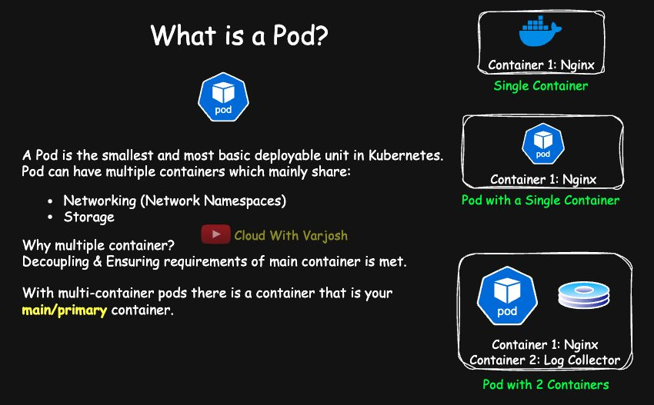
Why multi-container
A Pod is a shared execution environment. Put containers together when they must work tightly together:
- They share the network (talk via localhost) and can share volumes.
- Their startup and shutdown can be coordinated.
- One unit to deploy and manage instead of several scattered Pods.
Usually there's one main container plus one or more helper containers.

What is shared and what isn't
Resource | Shared? | Notes
Network namespace | Yes | Same IP and ports; reach each other on localhost:<port>
Volumes | Yes | Defined at Pod level; any container that mounts one can use it (e.g. sidecar reads the app's logs)
PID namespace | No (by default) | Each container sees only its own processes (can be enabled with shareProcessNamespace)
Root filesystem | No | Each container has its own; share data only via mounted volumes
Environment variables | No | Per container; share common config via ConfigMaps/Secrets

The four patterns
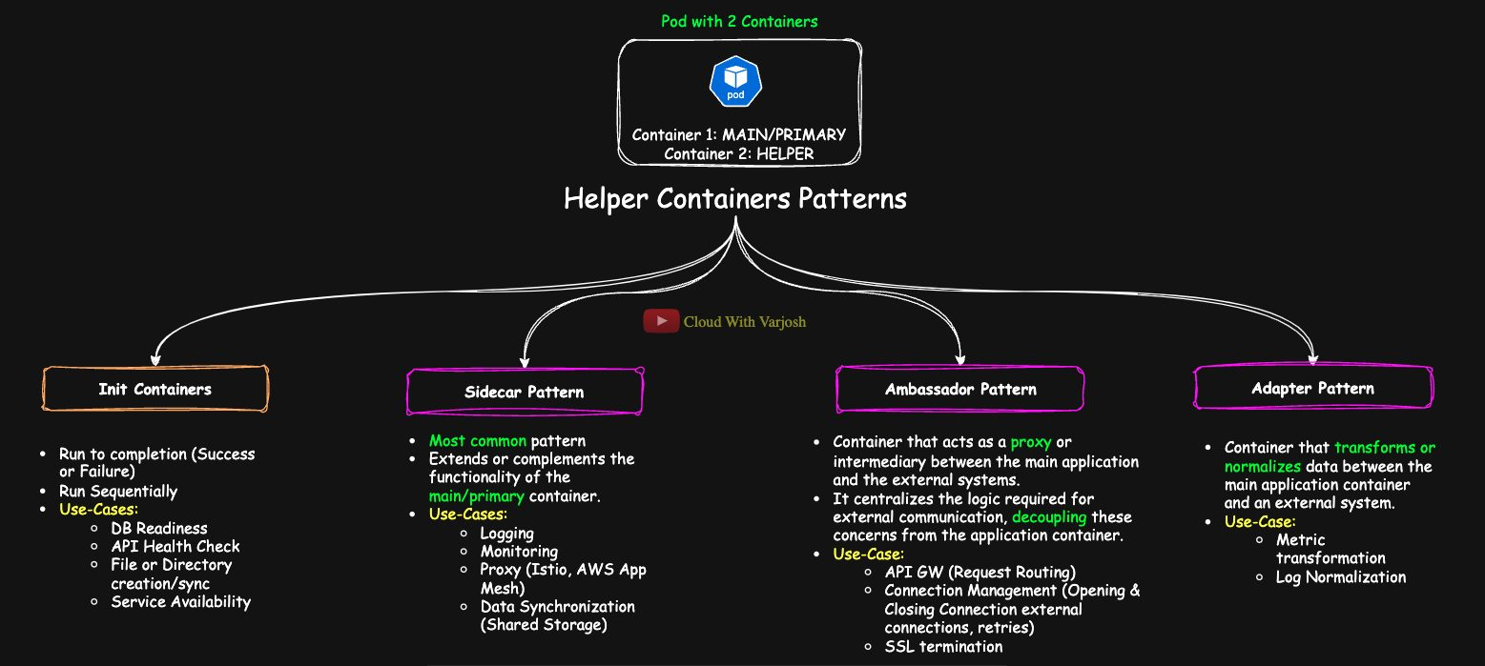
Patterns
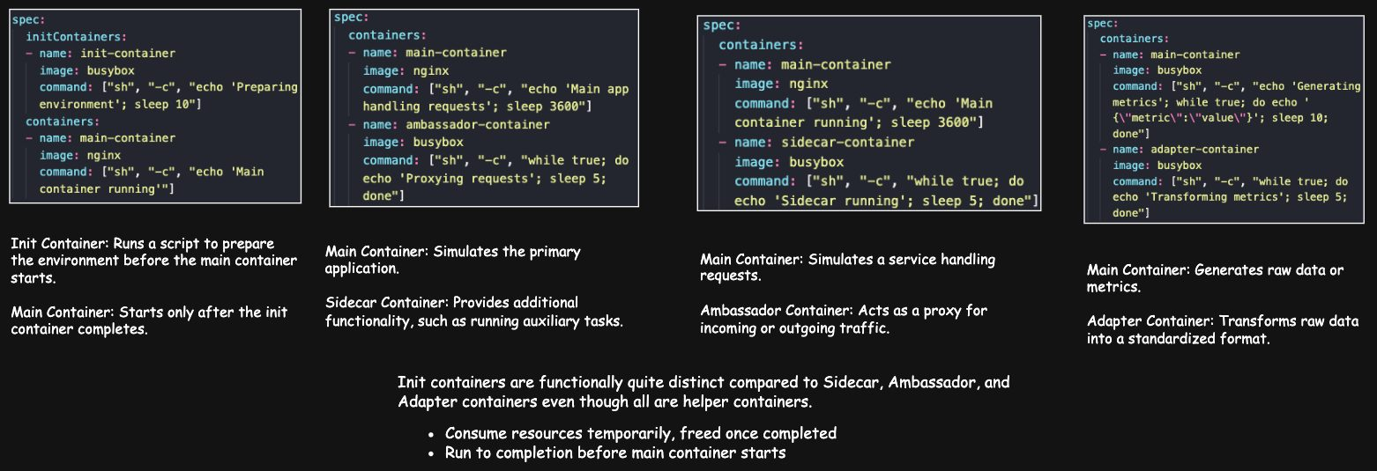
Patterns 2
1. Init containers – run before the app, one after another, and each must finish successfully. If one fails, the app container never starts (the Pod retries according to its restart policy). Uses:
- wait for a database or API to be ready
- run DB schema migrations
- create directories/files, set permissions
- fetch secrets or config
- clean up old temporary files
2. Sidecar – runs alongside the main container for the Pod's whole life and extends it. Uses: log shipping (Fluentd/Fluent Bit), metrics exporters, service-mesh proxies (Envoy/Istio, AWS App Mesh), syncing files.
3. Ambassador – a proxy that handles the Pod's communication with external systems. Uses: connection pooling to an external DB (e.g. PostgreSQL/RDS), routing to external APIs/queues (SQS), adding TLS or auth (OAuth token checks).
 | Sidecar | Ambassador
Scope | Inside the cluster / around the app | Outbound to external systems
Purpose | Enhance the main container | Mediate talk with external services
Example | Envoy between microservices | Proxy to an external API or DB

4. Adapter – transforms the app's output into a standard format. Examples: convert JSON metrics into Prometheus format; normalise log format for a central system.
Native sidecars: since Kubernetes v1.29 you can declare a sidecar as an init container with restartPolicy: Always. It starts before the app and keeps running alongside it.

Init vs helper containers
Aspect | Init containers | Sidecar / Ambassador / Adapter
Lifecycle | Run to completion before the app | Run with the app for the Pod's life
Order | Sequential | In parallel with the app
Dependency | App starts only if all succeed | App can run without them (but may lose features)
Resources | Used briefly, then freed | Used the whole time
Failure impact | Pod doesn't progress | Pod keeps running, functionality degraded
Typical uses | Migrations, config fetch, waiting for deps, permissions | Logging, proxying, external comms, format adaptation

All patterns can be mixed in the same Pod.

Demo 1: init container that waits for an API
YAML
apiVersion: v1
kind: Pod
metadata:
name: init-demo
spec:
initContainers:
- name: check-api
image: curlimages/curl:latest
command:
- sh
- -c
- |
echo 'Checking API availability...'
sleep 25
until curl -s https://kubernetes.io > /dev/null; do
echo 'Waiting for API...'
sleep 5
done
echo 'API is accessible, proceeding to main-app container!'
containers:
- name: main-app
image: nginx:latest
How the script works:
- sh -c runs the whole text as one shell script.
- | is YAML's block scalar: everything below it is one multi-line string, line breaks kept. Much easier to read than one long line.
- sleep 25 just gives you time to watch the Init phase.
- until curl -s ... > /dev/null; do ... done retries every 5 s until curl succeeds (exit code 0). -s = silent; > /dev/null discards output.
- The final echo runs only after the loop ends successfully.
BASH
kubectl apply -f init-c.yaml
kubectl get pods # STATUS shows Init:0/1, then Running
kubectl logs init-demo -c check-api
kubectl logs init-demo -c main-app

Demo 2: two init containers (external API + internal Service)
YAML
apiVersion: v1
kind: Pod
metadata:
name: init-demo-2
labels:
app: main-app
spec:
initContainers:
- name: check-api
image: curlimages/curl:latest
command:
- sh
- -c
- |
echo 'Checking external API availability...'
sleep 25
until curl -s https://kubernetes.io > /dev/null; do
echo 'Waiting for external API...'
sleep 5
done
echo 'External API is accessible, proceeding to next init container!'
- name: check-svc
image: curlimages/curl:latest
command:
- sh
- -c
- |
echo 'Checking main-app Service availability...'
until nslookup main-app-svc.default.svc.cluster.local; do
echo 'Waiting for Service DNS resolution...'
sleep 5
done
echo 'Service is reachable, proceeding to main-app container!'
containers:
- name: main-app
image: nginx:latest
---
apiVersion: v1
kind: Service
metadata:
name: main-app-svc
spec:
selector:
app: main-app
ports:
- protocol: TCP
port: 80
targetPort: 80
check-svc loops until the Service's DNS name resolves. If you create the Pod before the Service, the Pod sits in Init:1/2 until you apply the Service.
BASH
kubectl apply -f svc.yaml
kubectl apply -f 2-init-c.yaml
kubectl logs init-demo-2 -c check-api
kubectl logs init-demo-2 -c check-svc
kubectl logs init-demo-2 -c main-app

Demo 3: sidecar health logger
YAML
apiVersion: v1
kind: Pod
metadata:
name: sidecar-logging-demo
spec:
containers:
- name: main-app
image: nginx:latest
ports:
- containerPort: 80
- name: health-logger
image: curlimages/curl:latest
command:
- sh
- -c
- |
while true; do
curl -s http://localhost:80 > /dev/null && echo 'Main app is healthy' || echo 'Main app is unhealthy'
sleep 5
done
- The sidecar reaches nginx on localhost:80 because they share the network namespace.
- cmd1 && cmd2 runs cmd2 only if cmd1 succeeded; cmd1 || cmd3 runs cmd3 only if it failed.
BASH
kubectl apply -f sidecar.yaml
kubectl logs sidecar-logging-demo -c health-logger # Main app is healthy
kubectl exec -it sidecar-logging-demo -c main-app -- /bin/sh
kill 1 # stop nginx (PID 1)
kubectl logs sidecar-logging-demo -c health-logger # Main app is unhealthy
(The repo version sets restartPolicy: Never so nginx stays down and you can see the "unhealthy" messages.)

Day 22 — Pod Termination, Restart Policy, Image Pull Policy, Lifecycle and Errors

What happens on kubectl delete pod
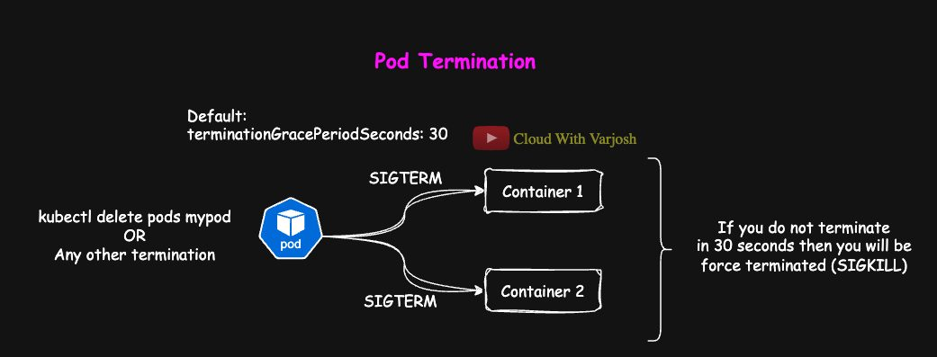
Termination
- Kubernetes sends SIGTERM to the main process of every container: "please shut down cleanly".
- It waits the grace period – terminationGracePeriodSeconds, default 30 s – for the app to close connections, flush data, finish work.
- If still running, it sends SIGKILL (immediate kill).
YAML
apiVersion: v1
kind: Pod
metadata:
name: nginx-graceful
spec:
terminationGracePeriodSeconds: 30
containers:
- name: nginx
image: nginx:latest

Force delete
BASH
kubectl delete pod mypod --force=true --grace-period=0
The Pod object is removed from the API server immediately and the runtime is told to kill the container right away (like SIGKILL). Kubernetes itself doesn't send Unix signals – the container runtime (containerd etc.) does.
Command | API object | Container on the node
kubectl delete pod mypod | Deleted gracefully | SIGTERM → wait grace period → SIGKILL
... --force=true | Removed immediately | kubelet still honours the grace period
... --force=true --grace-period=0 | Removed immediately | Killed instantly, no grace

Restart policy (Pod level, applies to all containers)
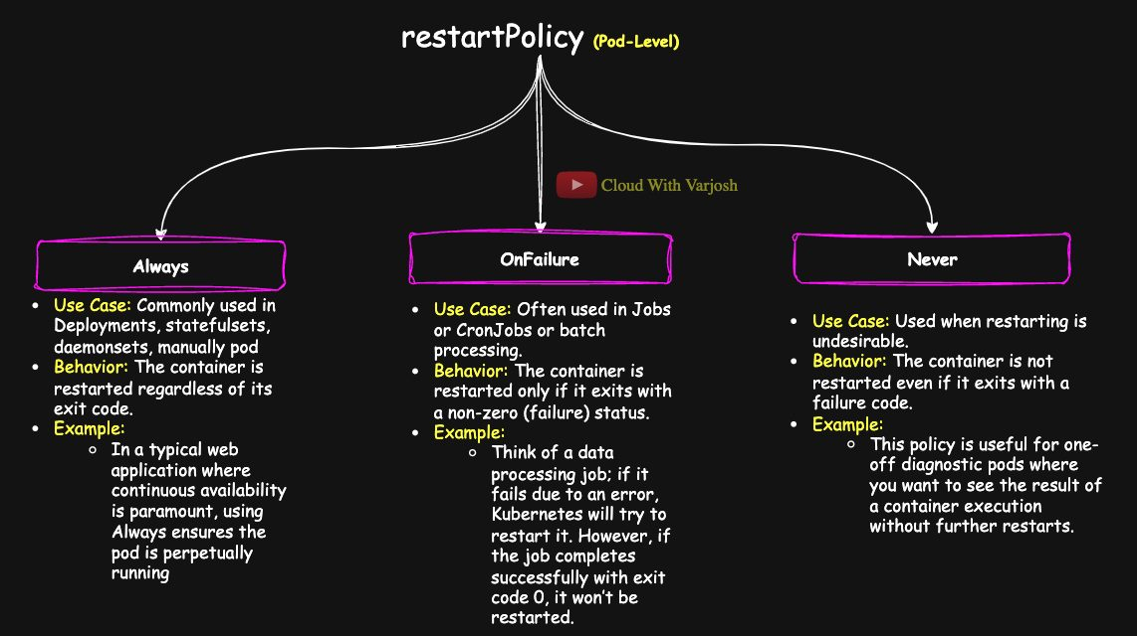
Restart policies
Policy | Restarts container when… | Typical use
Always (default) | It exits for any reason | Long-running apps. Deployments, ReplicaSets, StatefulSets, DaemonSets only allow Always
OnFailure | It exits with a non-zero code | Batch work – Jobs, CronJobs
Never | Never | One-off diagnostics / debug Pods; also allowed for Jobs

YAML
# Deployment – Always
apiVersion: apps/v1
kind: Deployment
metadata:
name: web-server-deployment
spec:
replicas: 3
selector:
matchLabels:
app: web-server
template:
metadata:
labels:
app: web-server
spec:
restartPolicy: Always
containers:
- name: nginx
image: nginx:latest
YAML
# Job – OnFailure
apiVersion: batch/v1
kind: Job
metadata:
name: batch-job-example
spec:
template:
spec:
restartPolicy: OnFailure
containers:
- name: processor
image: my-batch-job:latest
YAML
# Diagnostic Pod – Never
apiVersion: v1
kind: Pod
metadata:
name: diagnostic-pod
spec:
restartPolicy: Never
containers:
- name: debug-container
image: busybox
command: ["nslookup", "kubernetes.default.svc.cluster.local"]

Image pull policy (per container)
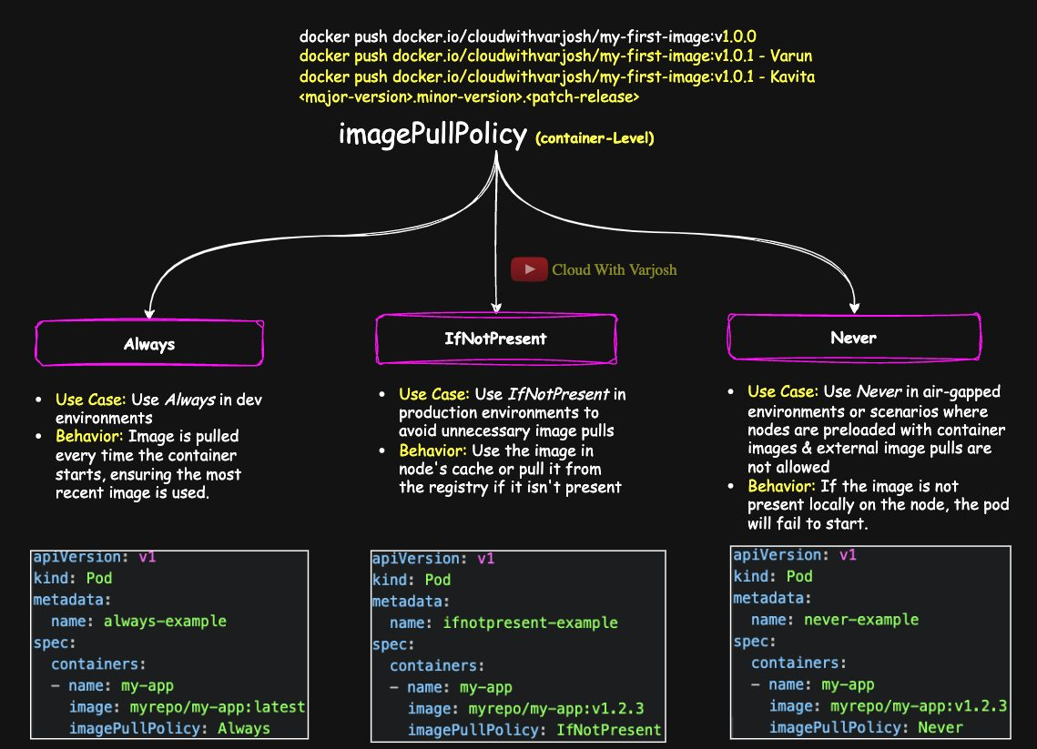
Image pull policy
Policy | Behaviour | When to use
Always | Contact the registry every time a container starts (re-uses cached layers if the digest is unchanged) | Dev, or when using mutable tags like latest
IfNotPresent | Pull only if the image isn't already on the node | Production with fixed tags like v1.2.3 – faster starts, less bandwidth
Never | Never pull; fail if the image isn't on the node | Air-gapped clusters, pre-loaded images

Defaults: tag is :latest or no tag → Always. Any other tag → IfNotPresent. Best practice: set it explicitly and avoid latest in production — use immutable version tags.

Pod phases
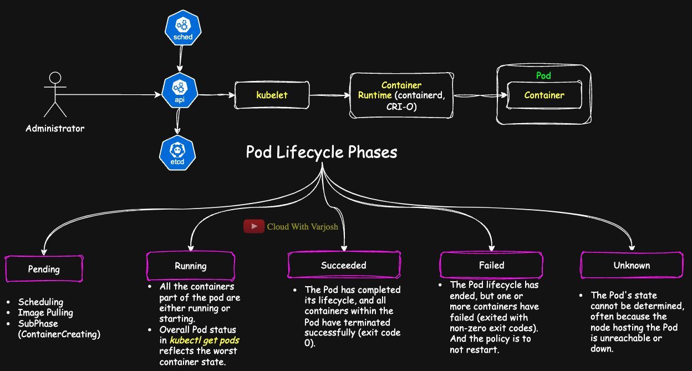
Pod lifecycle
Phase | Meaning
Pending | Accepted, but containers aren't running yet: waiting to be scheduled, pulling images, or ContainerCreating (volumes, network, env being set up). Common causes: not enough CPU/memory, affinity/taint rules, image pull errors
Running | Bound to a node and at least one container is running (or starting/restarting)
Succeeded | All containers exited with code 0 and won't restart. kubectl get pods shows this as Completed
Failed | All containers stopped and at least one failed (non-zero) with no restart
Unknown | State can't be read — usually the node is unreachable

- kubectl get pods shows a summary status that highlights the worst container, e.g. 3 Running + 1 ErrImagePull → shows ErrImagePull.
- Succeeded is the official phase (kubectl describe pod → Status: Succeeded); Completed is the friendly label in kubectl get pods.
Demo – short task: kubectl run ubuntu-2 --image=ubuntu --restart=Never -- ls while watching kubectl get pods -w → Pending → ContainerCreating → Completed (too fast to show Running).
Demo – longer task: kubectl run ubuntu-2 --image=ubuntu --restart=Never -- sleep 5 → Pending → ContainerCreating → Running → Completed.

Common errors
Status | Meaning | Usual causes | How to debug
CrashLoopBackOff | Container keeps crashing; restarts are delayed more each time (exponential back-off) | App bug, bad config/missing env, missing dependency, OOMKilled, failing liveness probe | kubectl logs <pod> --previous, check env/ConfigMaps/Secrets, probe settings
ErrImagePull | Image pull just failed | Wrong name/tag, registry auth, network | kubectl describe pod Events
ImagePullBackOff | Kubernetes is retrying the failed pull with back-off | Same as above | Verify image name/tag, try pulling manually, check imagePullSecrets
OOMKilled | Exceeded memory limit | Memory leak, limit too low | kubectl describe pod, kubectl top pod, raise limit
Unknown | Node not reporting | Node down / network | kubectl get nodes, node logs

A debugging routine
- kubectl get pods – look at STATUS and RESTARTS.
- kubectl describe pod <pod> – read Events at the bottom ("Failed to pull image", "FailedScheduling", "Back-off restarting failed container").
- kubectl logs <pod> [-c <container>], and --previous for the crashed instance.
- Check the YAML: image name, command/args (remember CMD vs ENTRYPOINT), env vars, resources.
- Reproduce with a minimal test Pod if needed.

Part 8 — Health Probes, Docker Storage and Kubernetes Extensions (Days 23–25)

Day 23 — Health Probes: Readiness, Liveness, Startup
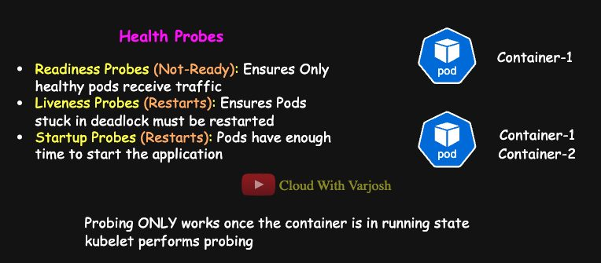
Probes overview
The kubelet runs probes against each container to decide whether it should get traffic or be restarted.
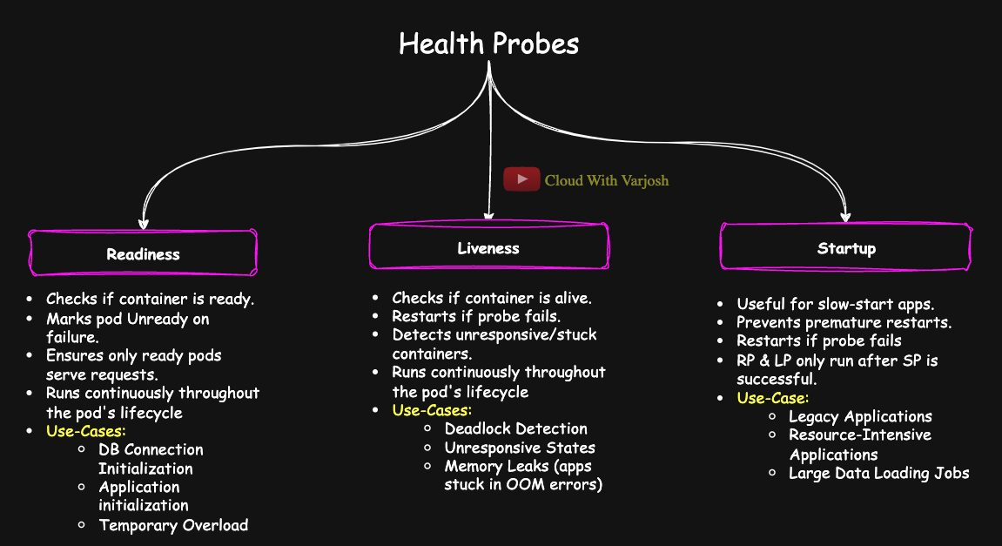
Probe types

1. Readiness probe — "can I receive traffic?"
If it fails, the Pod is marked Not Ready and removed from Service endpoints. The container is not restarted. When the probe passes again, traffic returns.
YAML
readinessProbe:
httpGet:
path: /readyz
port: 8080
initialDelaySeconds: 5 # wait 5 s after start
periodSeconds: 10 # check every 10 s
Use case: the app temporarily loses its database connection; stop sending it users until it recovers.

2. Liveness probe — "am I still alive?"
If it fails (beyond the threshold), the kubelet kills and restarts the container. Catches deadlocks, hangs and stuck processes.
YAML
livenessProbe:
exec:
command: ["cat", "/tmp/healthy"]
initialDelaySeconds: 3
periodSeconds: 5

3. Startup probe — "have I finished starting?"
For slow or unpredictable starters (legacy apps, big Java apps). Readiness and liveness probes don't run until the startup probe succeeds. It replaces guessing a huge initialDelaySeconds (too high = slow; too low = restart loops).
YAML
startupProbe:
httpGet:
path: /healthz
port: 8080
failureThreshold: 30 # up to 30 attempts
periodSeconds: 10 # every 10 s → up to 300 s (5 min) to start
If it never succeeds within failureThreshold × periodSeconds, the container is killed and handled by the restart policy.

Why use both readiness and liveness?
- Readiness handles temporary issues (high load, DB blip) without needless restarts.
- Liveness handles unrecoverable issues where only a restart helps.
- Without readiness, users hit Pods that can't serve. Without liveness, hung Pods sit there forever wasting resources.

Probe timing settings
Field | Meaning | Default
initialDelaySeconds | Wait before the first probe | 0
periodSeconds | Time between probes | 10
timeoutSeconds | How long to wait for a reply | 1
successThreshold | Consecutive successes to count as healthy (must be 1 for liveness/startup) | 1
failureThreshold | Consecutive failures to count as failed | 3

Probe mechanisms
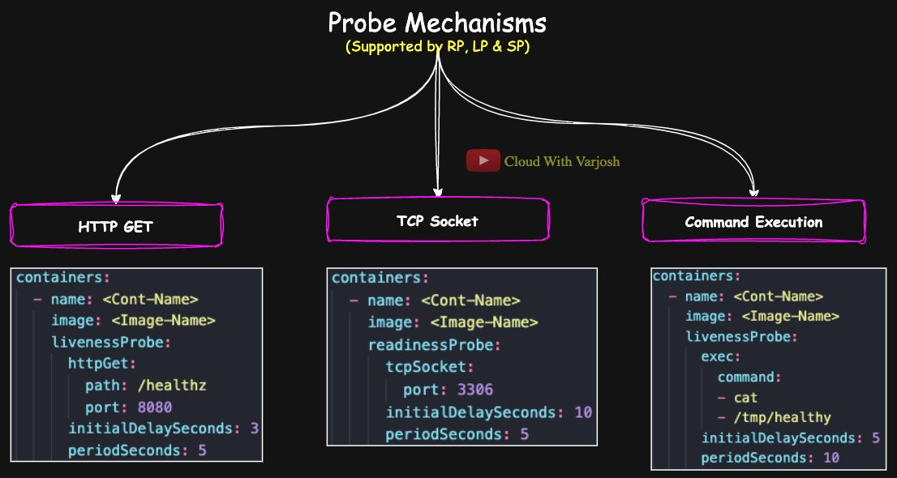
Mechanisms
Mechanism | Success when | Example
httpGet | HTTP status 200–399 | httpGet: {path: /healthz, port: 8080}
tcpSocket | TCP connection opens | tcpSocket: {port: 3306} (good for databases)
exec | Command exits with code 0 | exec: {command: [cat, /tmp/healthy]}

(There is also a grpc probe for gRPC health checks.)

Probes in multi-container Pods
- Probes are per container.
- Startup failing affects only that container.
- Readiness failing in any container marks the whole Pod Not Ready (no traffic).
- Liveness failing restarts only that container.
- kubectl get pods shows the worst state (Error, ImagePullBackOff, CrashLoopBackOff, RunContainerError…).

Comparison
 | Startup | Readiness | Liveness
Question | Has it started? | Can it take traffic? | Is it alive?
Starts | When the container starts | After startup probe succeeds | After startup probe succeeds
On failure | Container restarted after threshold | Removed from Service endpoints, no restart | Container restarted
Affects traffic? | No | Yes | No
Runs until | It succeeds once | Whole life of container | Whole life of container
Typical case | Java app taking >60 s to boot | Waiting for DB/config | Deadlock, frozen app, memory leak

Demo: readiness probe (exec)
YAML
apiVersion: v1
kind: Pod
metadata:
name: readiness-probe-demo
spec:
containers:
- name: busybox-app
image: busybox
command: ["sh", "-c", "touch /tmp/ready; sleep 3600"]
readinessProbe:
exec:
command: ["cat", "/tmp/ready"]
initialDelaySeconds: 5
periodSeconds: 5
failureThreshold: 1
BASH
kubectl exec -it readiness-probe-demo -- rm /tmp/ready # READY becomes 0/1 within ~5 s
kubectl get pod readiness-probe-demo
kubectl exec -it readiness-probe-demo -- touch /tmp/ready # READY back to 1/1
The RESTARTS count stays 0 — readiness never restarts.

Demo: liveness probe (HTTP)
YAML
apiVersion: v1
kind: Pod
metadata:
name: liveness-probe-demo
labels:
test: liveness
spec:
containers:
- name: liveness
image: registry.k8s.io/e2e-test-images/agnhost:2.40
args: ["liveness"]
livenessProbe:
httpGet:
path: /healthz
port: 8080
httpHeaders:
- name: Custom-Header
value: Awesome
initialDelaySeconds: 3
periodSeconds: 3
timeoutSeconds: 1
failureThreshold: 1
The test app returns 200 on /healthz for its first 10 seconds and 500 afterwards. The probe fails, the kubelet restarts the container, and the cycle repeats. Watch RESTARTS rise with kubectl get pod liveness-probe-demo and see events in kubectl describe pod liveness-probe-demo.

Demo: startup probe (TCP)
YAML
apiVersion: v1
kind: Pod
metadata:
name: startup-probe-demo
spec:
containers:
- name: tcp-app
image: ubuntu:latest
command:
- sh
- -c
- |
apt update && \
apt install -y netcat-openbsd && \
nc -l -p 9444 && \
sleep 3600
startupProbe:
tcpSocket:
port: 9444
failureThreshold: 15 # 15 × 5 s = up to 75 s to start
periodSeconds: 5
Installing netcat takes a while; the startup probe keeps checking port 9444 (nc -l -p 9444 = listen on 9444) and only declares success once the port opens, so the container isn't restarted prematurely.

Day 24 — Docker Storage and Volumes (foundation for K8s storage)

Image layers and the writable layer
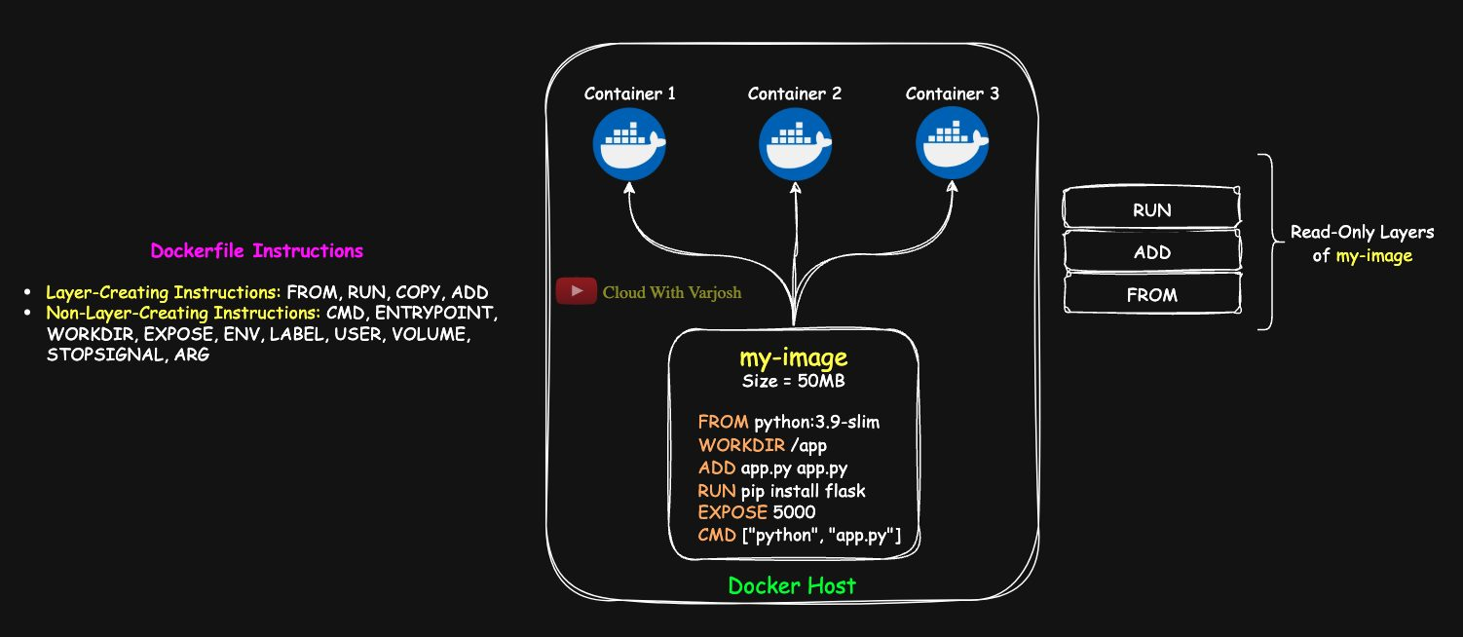
Docker storage
Using the Day 3 Flask Dockerfile (image my-image):
DOCKERFILE
FROM python:3.9-slim
WORKDIR /app
ADD app.py app.py
RUN pip install flask
EXPOSE 5000
CMD ["python", "app.py"]
Layer-creating: FROM, ADD, RUN (also COPY). Metadata only: WORKDIR, EXPOSE, CMD (and ENTRYPOINT, ENV, LABEL, USER, VOLUME, ARG…). See them with:
BASH
docker image history my-image
CMD ["python" "app.py"] 0B
EXPOSE map[5000/tcp:{}] 0B
RUN /bin/sh -c pip install flask 11.5MB
ADD app.py app.py 170B
WORKDIR /app 0B
FROM python:3.9-slim 97.1MB
- Image layers are read-only and shared by every container from that image.
- Each container gets its own thin writable layer for changes ("delta data").
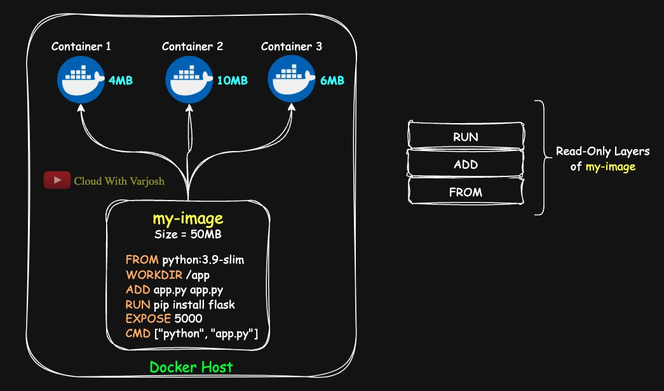
Storage maths
Example: image 50 MB; three containers add 4 MB, 10 MB and 6 MB → total disk = 50 + 20 = 70 MB (not 3 × 50).
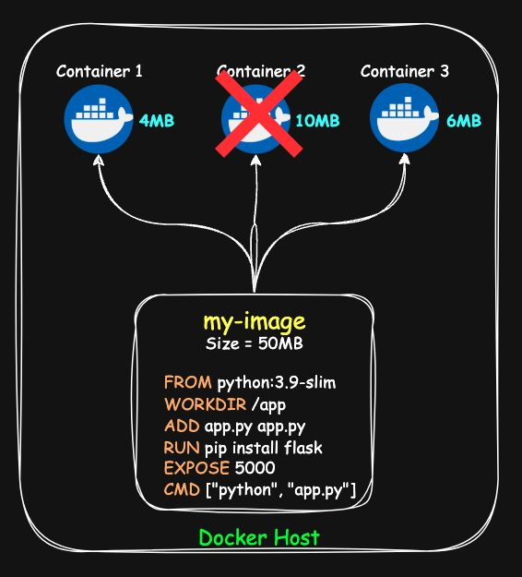
Data loss
When a container is removed, its writable layer — and its data — is gone. Hence volumes.

Storage drivers vs volume drivers
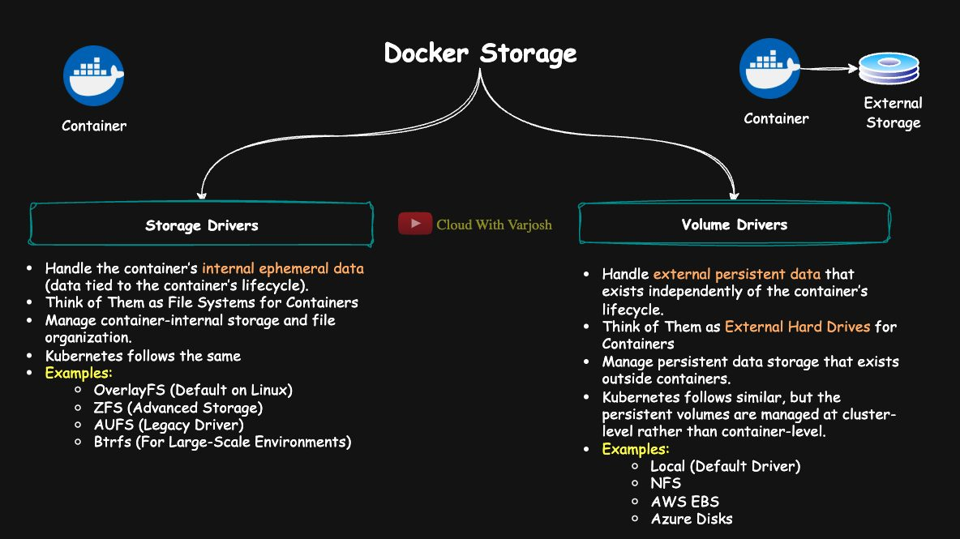
Drivers
 | Storage drivers | Volume drivers
Handle | Ephemeral container data: image layers + writable layer | Persistent data outside the container lifecycle
Analogy | The container's filesystem | An external hard drive
Examples | overlay2/OverlayFS (default), AUFS (legacy), ZFS, Btrfs | local (default), NFS, AWS EBS, Azure Disk
Check | docker info → Storage Driver: overlay2 | docker volume inspect <vol> → "Driver": "local"
In Kubernetes | containerd/CRI-O use the same kind of drivers for container layers | Replaced by PV / PVC backed by CSI drivers

Docker on Linux vs macOS/Windows
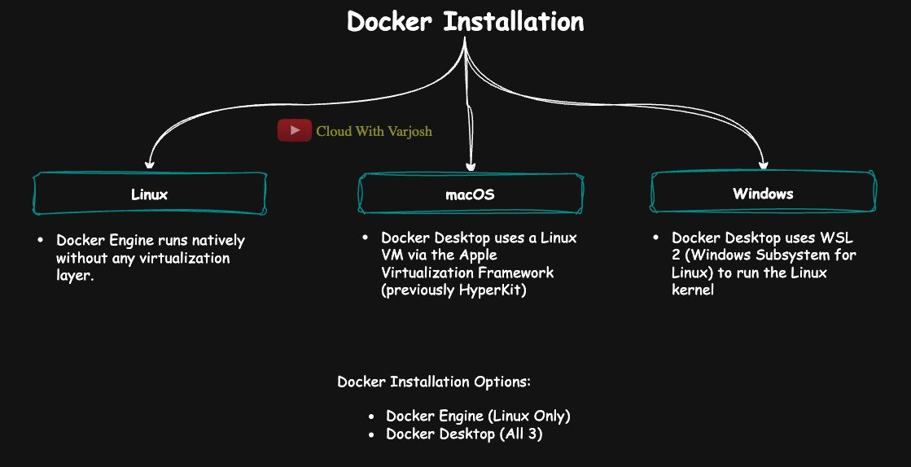
Platforms
- Linux: Docker runs natively. Volumes live in /var/lib/docker/volumes.
- macOS: Docker Desktop runs a Linux VM (Apple Virtualization Framework, previously HyperKit).
- Windows: Docker Desktop uses WSL 2.
Docker Engine needs Linux kernel features (cgroups, namespaces, overlay filesystems), so on Mac/Windows volumes live inside the VM — you won't find /var/lib/docker/volumes on your Mac. Docker Desktop on Linux is possible but adds an unnecessary VM.

Volumes demo
BASH
docker volume create my-vol
docker run -d --name my-cont-1 -v my-vol:/app my-image
docker exec -it my-cont-1 bash
cd /app && echo "This is my delta data" > file.txt && cat file.txt
exit
docker rm -f my-cont-1
sudo cat /var/lib/docker/volumes/my-vol/_data/file.txt # still there!
On macOS/Windows, look inside the volume via a container, or copy files out:
BASH
docker run -it --rm -v my-vol:/app alpine sh # then: ls -l /app
docker cp <container>:/app/file.txt .
Bind-mount a host folder: docker run -v /Users/you/data:/app/data ... (macOS) or docker run -v C:\Users\you\data:/app/data ... (Windows).
Benefits of volumes: data persists, can be shared between containers, can use faster/external storage.

Volume types
Type | Use | Pros | Cons
Named volume | Docker-managed (my-vol) | Easy, portable, survives container deletion | Path is abstracted
Bind mount | A specific host folder | Full control, live code sync for dev | Tied to host path, permission issues
tmpfs | In memory only | Very fast, nothing on disk | Lost on stop

Production → named volumes. Local dev → bind mounts.

Day 25 — Kubernetes Core vs Extensions: CRI, CNI, CSI, Add-ons
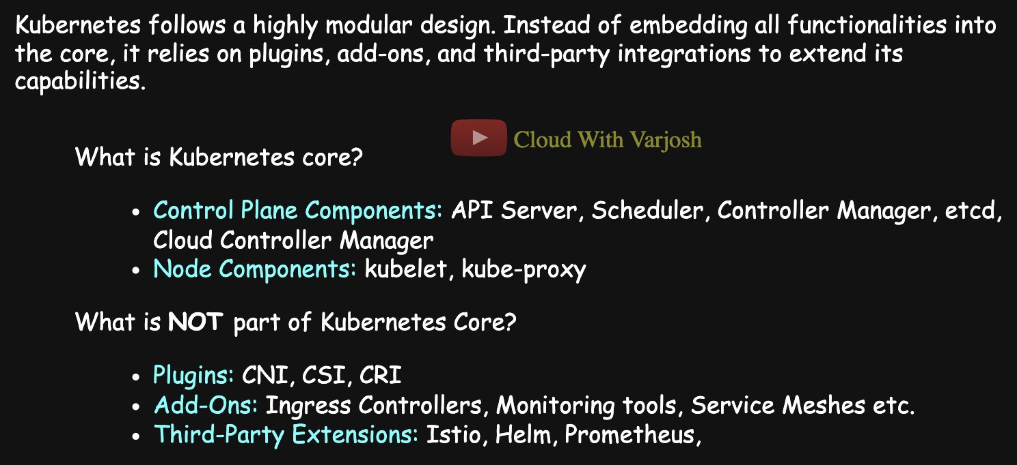
Core and extensions
Kubernetes keeps a small core and pushes everything else into pluggable extensions.
Core – control plane: API server (validates/processes all REST requests, enforces security), scheduler, controller manager, etcd, cloud-controller-manager (cloud load balancers, storage, node lifecycle).
Core – node: kubelet (node agent), kube-proxy (Service networking rules).

Plugins: the three standard interfaces
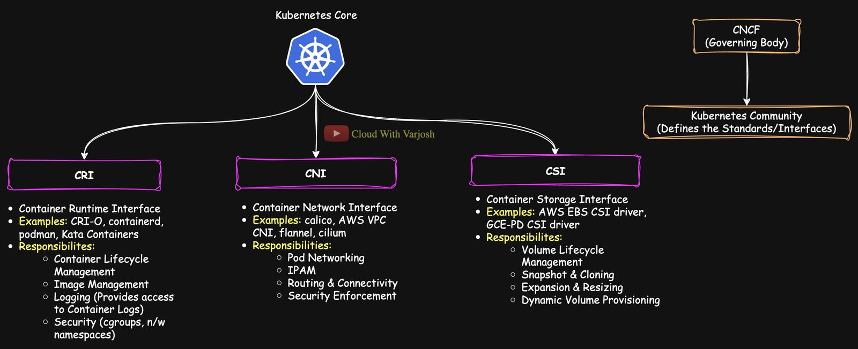
Plugins
CRI, CNI and CSI are open specifications maintained by the Kubernetes/CNCF community. Anyone can write a plugin that follows the spec.
Interface | Job | Examples
CRI – Container Runtime Interface | Run containers: pull images, create/start/stop/delete containers, logs, apply CPU/memory limits. gRPC API | containerd (most common), CRI-O (minimal, used by OpenShift), Kata Containers (lightweight VMs for isolation), gVisor (user-space sandbox). Docker via dockershim was removed in v1.24
CNI – Container Network Interface | Pod networking: assign Pod IPs, Pod-to-Pod routing across nodes, network policies | Calico (network policies, BGP), Cilium (eBPF, observability), Flannel (simple, no network policies), Weave Net (encryption), AWS VPC CNI
CSI – Container Storage Interface | Storage: dynamic provisioning, attach/mount, resize, snapshots | AWS EBS CSI, Azure Disk CSI, Google PD CSI, Ceph RBD, Portworx, OpenEBS, Longhorn

Add-ons and third-party extensions
- Add-ons: Ingress controllers, CoreDNS, monitoring (Prometheus, Grafana), service meshes (Istio, Linkerd), dashboards.
- Third-party tools: Helm (package manager), Prometheus, Istio, and many more.

Why a plugin architecture?
- Interoperability – works with many network, storage and runtime products.
- Vendor neutrality – choose the best tool, no lock-in.
- Innovation – plugins evolve independently of Kubernetes releases (e.g. Cilium's eBPF features need no core changes).
- Maintainability – components can be upgraded and scaled separately.

Part 9 — Kubernetes Storage (Days 26–27)

Day 26 — Ephemeral Volumes: emptyDir and the Downward API
Ephemeral storage lives only as long as the Pod. Delete the Pod, lose the data.

emptyDir
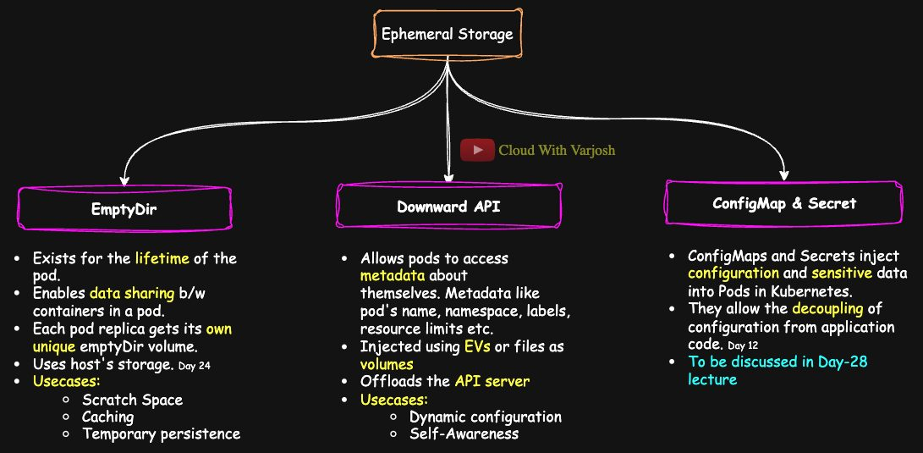
emptyDir
- An empty folder created when the Pod lands on a node; removed when the Pod is removed. (It survives container restarts inside the Pod.)
- In a Deployment, each replica gets its own emptyDir — nothing is shared between Pods.
- Uses: scratch space, caches, temporary processing, and sharing files between containers in the same Pod.
Why it's needed (Day 24 recap): if three containers in a Pod use the same image, they share the read-only image layers, but each has its own writable layer — files written by one aren't visible to the others. Mount the same emptyDir in all of them and they get a shared writable space.
YAML
apiVersion: v1
kind: Pod
metadata:
name: emptydir-example
spec:
containers:
- name: busybox-container
image: busybox
command: ["/bin/sh", "-c", "sleep 3600"]
volumeMounts:
- mountPath: /data
name: temp-storage
- name: busybox-container-2
image: busybox
command: ["/bin/sh", "-c", "sleep 3600"]
volumeMounts:
- mountPath: /data
name: temp-storage
volumes:
- name: temp-storage # must match volumeMounts.name
emptyDir: {} # use emptyDir: {medium: Memory} for a RAM-backed tmpfs
BASH
kubectl exec emptydir-example -c busybox-container -- sh -c 'echo "What a file!" > /data/myfile.txt'
kubectl exec emptydir-example -c busybox-container-2 -- cat /data/myfile.txt
# What a file!

The Downward API
Lets a container learn facts about its own Pod — name, namespace, labels, annotations, node name, Pod IP, CPU/memory requests and limits — without calling the API server. Two ways to receive it:
- Environment variables (fieldRef / resourceFieldRef)
- Files in a downwardAPI volume
Why: apps and especially sidecars (logging/monitoring agents) need to know which Pod/namespace they're in to label their data. Without the Downward API they'd have to keep polling the API server, adding load and network traffic.
As environment variables
YAML
apiVersion: v1
kind: Pod
metadata:
name: downwardapi-example
labels:
app: demo
spec:
containers:
- name: metadata-container
image: busybox
command: ["/bin/sh", "-c", "env && sleep 3600"]
env:
- name: POD_NAME
valueFrom:
fieldRef:
fieldPath: metadata.name
- name: POD_NAMESPACE
valueFrom:
fieldRef:
fieldPath: metadata.namespace
BASH
kubectl exec downwardapi-example -- env | grep POD_
# POD_NAME=downwardapi-example
# POD_NAMESPACE=default
As files in a volume
YAML
apiVersion: v1
kind: Pod
metadata:
name: downwardapi-volume
labels:
app: good_app
owner: hr
annotations:
version: "good_version"
spec:
containers:
- name: metadata-container
image: busybox
command: ["/bin/sh", "-c", "cat /etc/podinfo/* && sleep 3600"]
volumeMounts:
- name: downwardapi-volume
mountPath: /etc/podinfo
volumes:
- name: downwardapi-volume
downwardAPI:
items:
- path: "labels"
fieldRef:
fieldPath: metadata.labels
- path: "annotations"
fieldRef:
fieldPath: metadata.annotations
BASH
kubectl exec -it downwardapi-volume -- sh
ls -l /etc/podinfo
# annotations -> ..data/annotations
# labels -> ..data/labels
cat /etc/podinfo/labels # app="good_app" owner="hr"
cat /etc/podinfo/annotations # version="good_version"
kubectl logs downwardapi-volume # same content, printed at start-up
The files are symlinks into a ..data/ folder. Kubernetes swaps that folder atomically, so when labels/annotations change, the files update cleanly. (Volume files update live; environment variables do not change after the container starts.)
ConfigMaps and Secrets (Day 28) can also be mounted as volumes; the objects outlive Pods, but the mounted copy exists only for the Pod's life.

Day 27 — Persistent Storage: hostPath, PV, PVC and StorageClass

From in-tree plugins to CSI
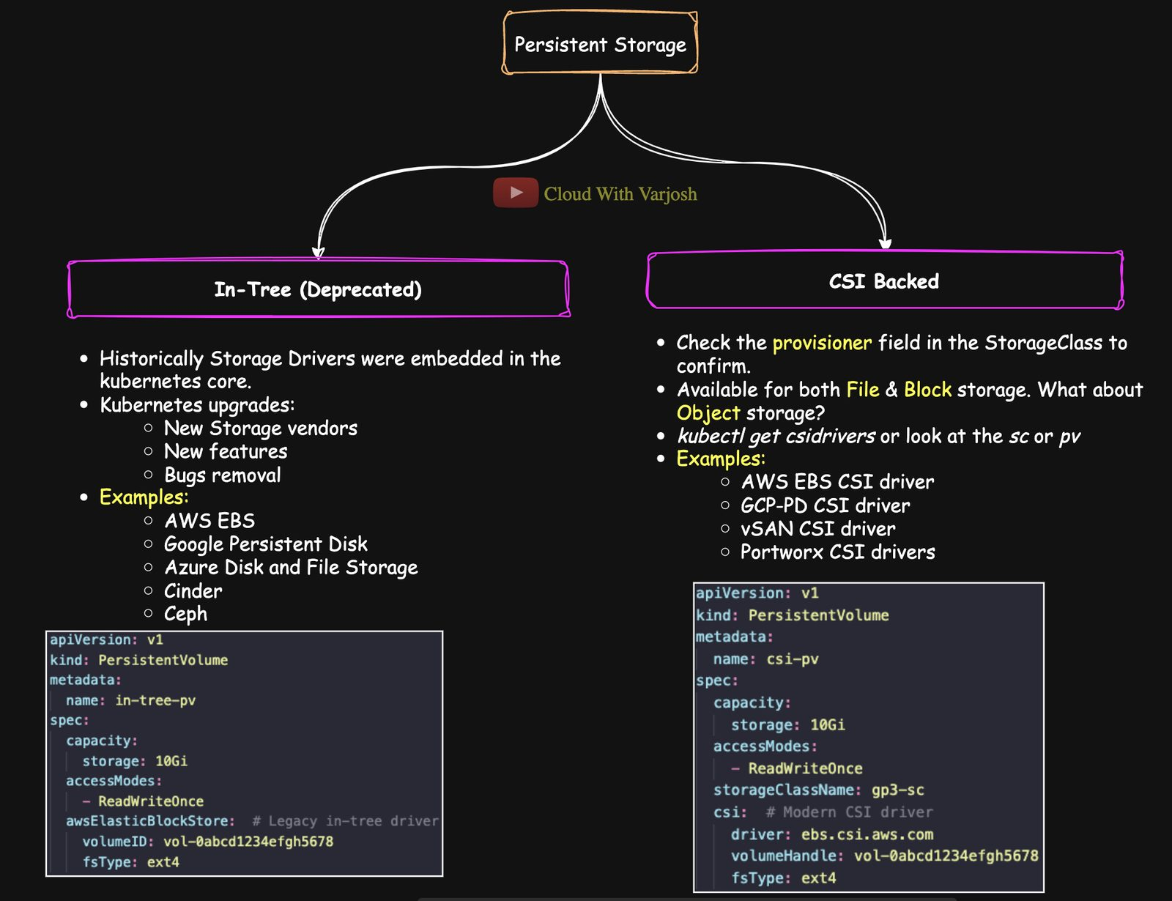
Evolution
- In-tree plugins – storage drivers compiled into Kubernetes itself: awsElasticBlockStore, azureDisk, azureFile, gcePersistentDisk, nfs, glusterfs, rbd, iscsi, fc. Problems: tied to Kubernetes releases, vendors couldn't ship fixes independently, driver bugs could hurt the core. Mostly deprecated (from ~v1.21) and migrated to CSI.
- CSI drivers – vendors ship their own drivers that plug into Kubernetes: ebs.csi.aws.com, pd.csi.storage.gke.io, disk.csi.azure.com, Ceph, OpenEBS, Portworx, vSphere. Independent releases, snapshots, resizing, cloning, monitoring.
- hostPath – in-tree only (no CSI). Testing only.
- local volumes – a disk physically attached to a node; used as a PV with node affinity; in-tree or CSI.
YAML
# Legacy in-tree
apiVersion: v1
kind: PersistentVolume
metadata:
name: in-tree-pv
spec:
capacity:
storage: 10Gi
accessModes: [ReadWriteOnce]
awsElasticBlockStore:
volumeID: vol-0abcd1234efgh5678
fsType: ext4
---
# Modern CSI
apiVersion: v1
kind: PersistentVolume
metadata:
name: csi-pv
spec:
capacity:
storage: 10Gi
accessModes: [ReadWriteOnce]
storageClassName: gp3-sc
csi:
driver: ebs.csi.aws.com
volumeHandle: vol-0abcd1234efgh5678
fsType: ext4
File, block and object storage
- Block (EBS, Persistent Disk) and file (NFS, EFS, Azure Files) storage can be mounted into Pods via CSI.
- Object storage (S3, Azure Blob, GCS) is not mounted as a volume — apps use the provider's SDK/API.

hostPath
Mounts a file or folder from the node's filesystem into the Pod.
- Node-specific: any Pod on the same node using the same path sees the same data; Pods on other nodes don't.
- Uses: debugging, reading node logs/config, node agents.
- Avoid in production: security risk (access to host files), ties Pods to a node. Prefer PV/PVC or local PVs.
 | emptyDir | hostPath
Shared between | Containers in one Pod | Pods on the same node
Lifetime | Pod's life | Node's life

Where hostPath really points in kind
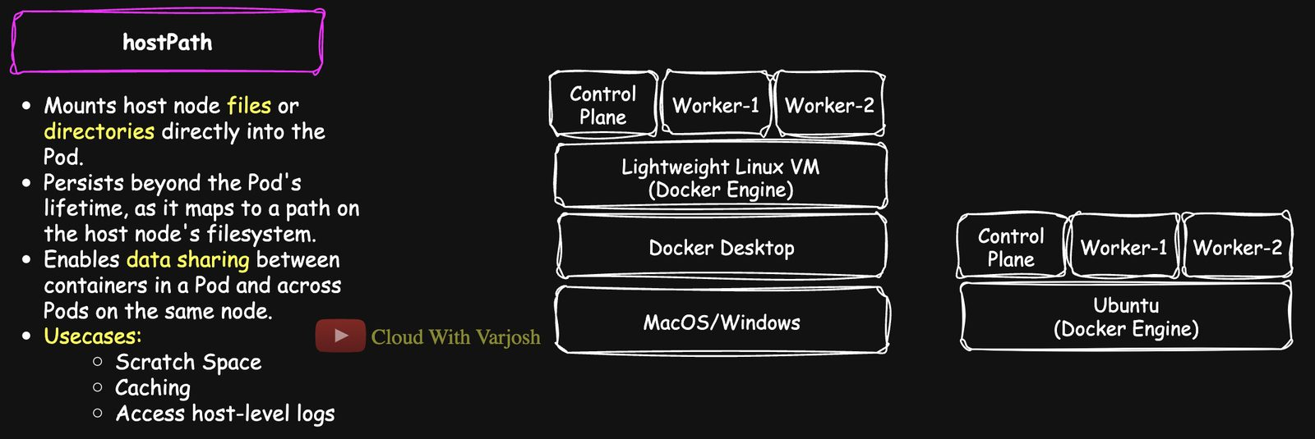
hostPath in kind
Platform | Docker runs | hostPath points to
Linux | Natively | The real host filesystem
macOS / Windows | Inside a Linux VM | The filesystem inside the kind node container — not your Mac/PC, and not even the VM directly

So on Mac/Windows the data disappears when the kind node container is deleted.
Demo
YAML
apiVersion: v1
kind: Pod
metadata:
name: hostpath-example
spec:
containers:
- name: busybox-container
image: busybox
command: ["sh", "-c", "cat /data && sleep 3600"]
volumeMounts:
- mountPath: /data
name: host-volume
volumes:
- name: host-volume
hostPath:
path: /tmp/hostfile
type: FileOrCreate # create an empty file if missing
BASH
kubectl exec -it hostpath-example -- sh -c 'echo "Hey you!!" > /data'
kubectl get pods -o wide # note the node, e.g. my-second-cluster-worker2
Create a second Pod hostpath-verify with the same volume and nodeName: my-second-cluster-worker2, then kubectl exec hostpath-verify -- cat /data → Hey you!!. Other type values: Directory, DirectoryOrCreate, File, Socket, CharDevice, BlockDevice.

PersistentVolumes and PersistentVolumeClaims
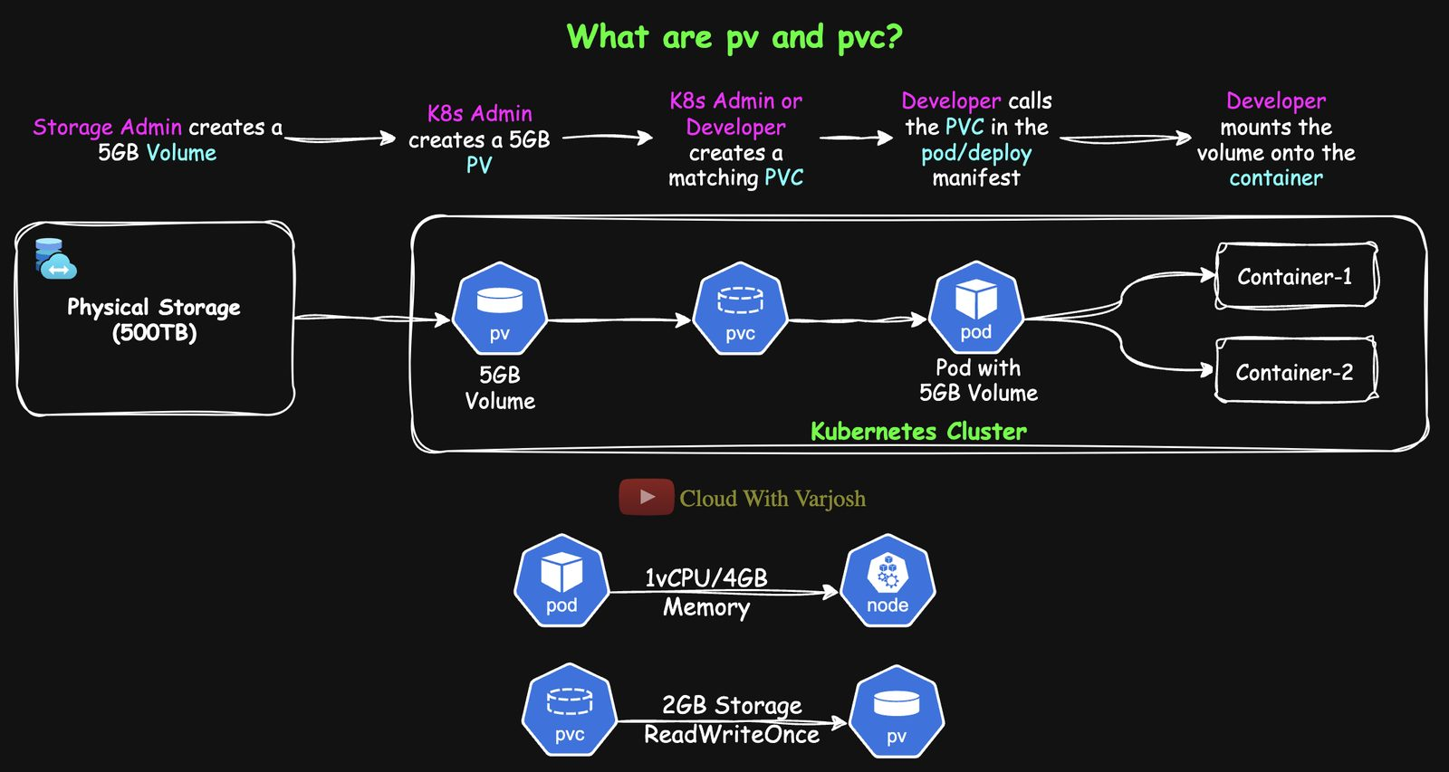
PV and PVC
- PersistentVolume (PV) – a piece of real storage made available to the cluster, created by an admin (static) or automatically by a StorageClass (dynamic). Lives independently of any Pod. Has capacity, access modes, reclaim policy.
- PersistentVolumeClaim (PVC) – a request for storage ("I need 5Gi, RWO"), like a Pod requesting CPU. Kubernetes binds it to a matching PV. Pods mount the PVC, never the PV directly.
Compute comes from nodes; storage comes from PVs via PVCs — separated so each can be managed independently.
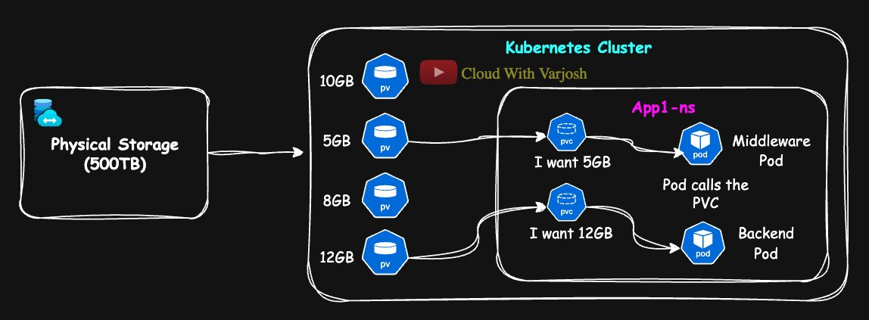
Scope
 | PV | PVC
Scope | Cluster-wide (no namespace) | Namespaced
Check | kubectl api-resources \| grep persistentvolume | same
Used by | Bound to exactly one PVC | Pods in the same namespace only

- 1-to-1 binding: one PVC ↔ one PV. Once bound, the PV's claimRef records the PVC's name and namespace so nothing else can claim it.
- A Pod in app2-ns referencing a PVC in app1-ns fails with persistentvolumeclaims "data-pvc" not found.
Manual (static) provisioning flow
Step | Who | What
1 | Developer | Needs 5Gi of persistent storage
2 | K8s admin | Asks the storage team for a backend volume
3 | Storage admin | Carves a LUN / NFS export from the storage pool (e.g. 500Ti)
4 | K8s admin | Creates a PV describing it (capacity, accessModes, volumeMode, storageClassName)
5 | Developer | Creates a PVC (5Gi, access mode, volume mode)
6 | Kubernetes | Binds the PVC to a matching PV
7 | Pod | Mounts the PVC

StorageClasses automate steps 2–4 (dynamic provisioning).

Access modes (how a volume can be mounted across nodes)
Mode | Meaning | Typical storage
ReadWriteOnce (RWO) | Read-write by one node (several Pods on that node may share it) | Block: EBS, GCE PD, Azure Disk
ReadOnlyMany (ROX) | Read-only by many nodes | File: NFS, Azure Files
ReadWriteMany (RWX) | Read-write by many nodes | File: EFS, Azure Files, NFS
ReadWriteOncePod (RWOP) | Read-write by exactly one Pod in the whole cluster (GA in v1.29) | CSI block storage

- Block storage – raw disk, fast, low latency, one node at a time (like a USB drive plugged into one computer). For databases.
- File storage – a shared network filesystem many nodes can use at once (like a network drive). For shared content, CMS, shared config.
- "Many" in the mode name usually means file storage.

Reclaim policies — what happens to the PV when its PVC is deleted
Policy | Behaviour | Typical use
Delete | PV and the backend disk are deleted | Dynamic cloud storage (EBS, PD, Azure Disk); default for StorageClasses
Retain | PV stays, status Released, data kept. Admin must clean up, or remove claimRef to reuse it | Audit, compliance, manual recovery, on-prem
Recycle | Basic rm -rf then make available again | Deprecated – don't use

PVC ↔ PV binding rules
Condition | Requirement
StorageClass | storageClassName must match (or both empty)
Access mode | PV must support the requested mode
Capacity | PV size ≥ PVC request
Volume mode | Same volumeMode: Filesystem (formatted, default) or Block (raw device – for DBs that manage the disk themselves)
State | PV must be Available
claimRef | If set on the PV, only that PVC can bind
Binding mode | Immediate binds at once; WaitForFirstConsumer waits for a Pod using the PVC to be scheduled

Demo: static PV + PVC with Retain
kind ships a default StorageClass that would dynamically create volumes and get in the way, so back it up and delete it first:
BASH
kubectl get storageclasses
# standard (default) rancher.io/local-path Delete WaitForFirstConsumer false
kubectl get sc standard -o yaml > sc.yaml
kubectl delete sc standard
YAML
apiVersion: v1
kind: PersistentVolume
metadata:
name: example-pv
spec:
capacity:
storage: 5Gi
accessModes:
- ReadWriteOnce
persistentVolumeReclaimPolicy: Retain
hostPath:
path: /mnt/data # demo only
---
apiVersion: v1
kind: PersistentVolumeClaim
metadata:
name: example-pvc
spec:
accessModes:
- ReadWriteOnce
resources:
requests:
storage: 2Gi # 2Gi ≤ 5Gi, so it can bind to example-pv
---
apiVersion: v1
kind: Pod
metadata:
name: example-pod
spec:
containers:
- name: nginx-container
image: nginx
volumeMounts:
- mountPath: /usr/share/nginx/html
name: persistent-storage
volumes:
- name: persistent-storage
persistentVolumeClaim:
claimName: example-pvc
BASH
kubectl apply -f pv.yaml && kubectl get pv
kubectl apply -f pvc.yaml && kubectl get pvc # Bound to example-pv
kubectl apply -f pod.yaml && kubectl describe pod example-pod
Note the PVC gets the whole 5Gi PV even though it asked for 2Gi (1-to-1 binding). Delete the PVC and the PV becomes Released, with its data still there.

StorageClasses and dynamic provisioning
A StorageClass describes a "type" of storage (provisioner/CSI driver + parameters + reclaim policy + binding mode). When a PVC names a StorageClass, the provisioner creates the PV automatically. You can have many classes (fast SSD, cheap HDD…). Size, access mode and volume mode still come from the PVC.
YAML
apiVersion: storage.k8s.io/v1
kind: StorageClass
metadata:
name: ebs-sc-gp3
provisioner: ebs.csi.aws.com
parameters:
type: gp3 # general-purpose SSD
reclaimPolicy: Delete
volumeBindingMode: WaitForFirstConsumer
---
apiVersion: storage.k8s.io/v1
kind: StorageClass
metadata:
name: ebs-sc-io1
provisioner: ebs.csi.aws.com
parameters:
type: io1 # high-performance SSD
reclaimPolicy: Delete
volumeBindingMode: WaitForFirstConsumer
Why WaitForFirstConsumer?
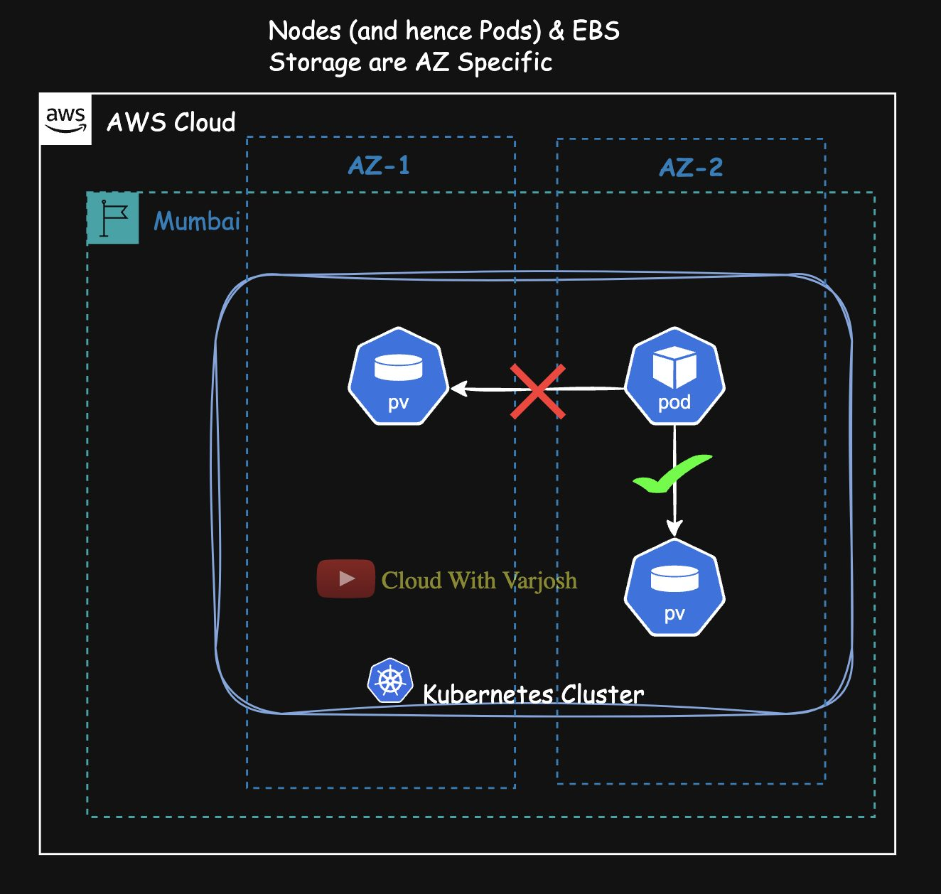
WaitForFirstConsumer
EBS volumes and EC2 nodes live in a specific Availability Zone. If the disk were created immediately in AZ-1 and the Pod then scheduled in AZ-2, it couldn't attach. Waiting until the Pod is scheduled means the disk is created in the same AZ as the Pod — and no disks are created for Pods that never run.
Using it
YAML
apiVersion: v1
kind: PersistentVolumeClaim
metadata:
name: ebs-csi-pvc
spec:
accessModes: [ReadWriteOnce]
resources:
requests:
storage: 10Gi
storageClassName: ebs-sc-gp3
---
apiVersion: v1
kind: Pod
metadata:
name: ebs-csi-pod
spec:
containers:
- name: app-container
image: nginx
volumeMounts:
- mountPath: /usr/share/nginx/html
name: ebs-storage
volumes:
- name: ebs-storage
persistentVolumeClaim:
claimName: ebs-csi-pvc
The CSI driver then creates a PV like this automatically:
YAML
apiVersion: v1
kind: PersistentVolume
metadata:
name: ebs-csi-pv
spec:
capacity:
storage: 10Gi
volumeMode: Filesystem
accessModes: [ReadWriteOnce]
persistentVolumeReclaimPolicy: Delete
storageClassName: ebs-sc-gp3
csi:
driver: ebs.csi.aws.com
volumeHandle: vol-0abcd1234efgh5678
fsType: ext4

Demo: dynamic provisioning in kind
BASH
kubectl apply -f sc.yaml # restore the 'standard' default class
kubectl describe sc standard
# storageclass.kubernetes.io/is-default-class: "true"
# provisioner: rancher.io/local-path
# reclaimPolicy: Delete
# volumeBindingMode: WaitForFirstConsumer
- Apply the example-pvc PVC (no storageClassName) → it uses the default class and stays Pending (WaitForFirstConsumer).
- Apply example-pod that uses it → a PV is created automatically and the PVC becomes Bound.
kubectl get pv
NAME CAPACITY ACCESS MODES RECLAIM POLICY STATUS CLAIM STORAGECLASS
pvc-24d1f4ee-d3f8-40eb-8120-21f232087a19 2Gi RWO Delete Bound default/example-pvc standard
This time the PV is exactly 2Gi (made to order). Deleting the PVC deletes the PV too (Delete policy).
Key points: no storageClassName → default class (annotation storageclass.kubernetes.io/is-default-class: "true"); WaitForFirstConsumer delays creation until a Pod is scheduled; Delete cleans up automatically.

Part 10 — Configuration and Other Workload Types (Days 28–29)

Day 28 — ConfigMaps and Secrets

Why separate configuration from code?
- Long lists of hard-coded env vars in Pod specs become unmanageable.
- You want to change settings without rebuilding the image.
- The same image should run in dev, staging and prod with different settings.
Environment variables in plain Linux terms:
BASH
export APP_NAME=frontend
export ENVIRONMENT=production
echo $APP_NAME # frontend
Hard-coded in a Deployment (works, but not reusable):
YAML
env:
- name: APP
value: frontend
- name: ENVIRONMENT
value: production

ConfigMaps
A ConfigMap stores non-sensitive key/value configuration. Pods can use it as:
- Environment variables
- Command-line arguments (via env vars, less common)
- Files in a mounted volume
ConfigMaps are plain text — no encoding, no secrecy. Use Secrets for sensitive data.
Demo 1 – as environment variables
YAML
apiVersion: v1
kind: ConfigMap
metadata:
name: frontend-cm
data:
APP: "frontend"
ENVIRONMENT: "production"
YAML
apiVersion: apps/v1
kind: Deployment
metadata:
name: frontend-deploy
spec:
replicas: 3
selector:
matchLabels:
app: frontend
template:
metadata:
labels:
app: frontend
spec:
containers:
- name: frontend-container
image: nginx
env:
- name: APP # variable name inside the container
valueFrom:
configMapKeyRef:
name: frontend-cm # which ConfigMap
key: APP # which key
- name: ENVIRONMENT
valueFrom:
configMapKeyRef:
name: frontend-cm
key: ENVIRONMENT
The env var name doesn't have to equal the key (e.g. name: SERVICE, key: APP). Apply the ConfigMap before the Deployment.
BASH
kubectl apply -f frontend-cm.yaml
kubectl apply -f frontend-deploy.yaml
kubectl exec -it <pod> -- printenv | grep -E 'APP|ENVIRONMENT'
Shortcut to load all keys as env vars: envFrom: [{configMapRef: {name: frontend-cm}}].
Imperative creation
BASH
kubectl create configmap frontend-cm --from-literal=APP=frontend --from-literal=ENVIRONMENT=production
kubectl create configmap app-config --from-file=app.properties
Imperative = quick tests and demos. Declarative YAML in Git = production (versioned, reviewed, repeatable).
Demo 2 – as a file (volume)
YAML
apiVersion: v1
kind: ConfigMap
metadata:
name: frontend-cm
data:
APP: "frontend"
ENVIRONMENT: "production"
index.html: |
<!DOCTYPE html>
<html>
<head><title>Welcome</title></head>
<body>
<h1>This page is served by nginx. Welcome to Cloud With VarJosh!!</h1>
</body>
</html>
| = YAML literal block: keep the following lines exactly, including line breaks — ideal for HTML, scripts and config files.
YAML
spec:
containers:
- name: frontend-container
image: nginx
volumeMounts:
- name: html-volume
mountPath: /usr/share/nginx/html # a directory
readOnly: true
volumes:
- name: html-volume
configMap:
name: frontend-cm
items: # only mount this key
- key: index.html
path: index.html
Expose with the NodePort Service frontend-svc (port 80 → nodePort 31000) and check:
BASH
kubectl exec -it <pod> -- cat /usr/share/nginx/html/index.html
curl http://localhost:31000 # kind with port mapping (Day 12)
Mounting rules to remember
- A ConfigMap volume is mounted as a directory; each key becomes a file. It hides whatever was in that directory before.
- You can't mount a directory over an existing file (e.g. .../index.html) — the container fails to start.
- Without items:, every key becomes a file (APP, ENVIRONMENT, index.html). Use items: to pick keys.
- To place a single file without hiding the rest of the directory, use subPath:
YAML
volumeMounts:
- name: html-volume
mountPath: /usr/share/nginx/html/index.html
subPath: index.html
subPath pros | subPath cons
Fine-grained: replace one file, keep the image's other files | File is not updated when the ConfigMap changes (needs Pod restart)
Mix image content with ConfigMap content | Slightly more complex

ConfigMap best practices: no sensitive data; mount only needed keys; manage with Git/Helm/Kustomize; use subPath for single files.

Secrets
For sensitive data: DB credentials, API tokens, SSH keys, TLS certificates. Pods use them as env vars or files (or args).
Secret values are only base64-encoded, not encrypted. Anyone who can read the Secret object can decode it. By default they're stored unencrypted in etcd.
Make Secrets actually safer by: enabling encryption at rest for etcd, restricting access with RBAC, and/or using external managers (HashiCorp Vault, AWS Secrets Manager, Sealed Secrets).
 | Encoding | Encryption
Purpose | Make data safe to transport as text | Keep data confidential
Reversible | Yes, by anyone | Only with the key
Secure? | No | Yes
Examples | Base64, URL encoding | AES, RSA, TLS

Demo – Secret as env vars
BASH
echo -n 'frontenduser' | base64 # ZnJvbnRlbmR1c2Vy
echo -n 'frontendpass' | base64 # ZnJvbnRlbmRwYXNz
echo 'ZnJvbnRlbmR1c2Vy' | base64 --decode # frontenduser
(-n stops echo adding a newline that would be encoded too.)
YAML
apiVersion: v1
kind: Secret
metadata:
name: frontend-secret
type: Opaque # arbitrary user-defined data
data: # values must be base64
DB_USER: ZnJvbnRlbmR1c2Vy
DB_PASSWORD: ZnJvbnRlbmRwYXNz
(Use stringData: instead of data: to write plain text and let Kubernetes encode it.)
YAML
containers:
- name: frontend-container
image: nginx
env:
- name: DB_USER
valueFrom:
secretKeyRef:
name: frontend-secret
key: DB_USER
- name: DB_PASSWORD
valueFrom:
secretKeyRef:
name: frontend-secret
key: DB_PASSWORD
BASH
kubectl apply -f frontend-secret.yaml
kubectl apply -f frontend-deploy.yaml
kubectl exec -it <pod> -- sh -c 'echo $DB_USER $DB_PASSWORD' # frontenduser frontendpass
Inside the container the values are plain text — Kubernetes decodes them.
Imperative: kubectl create secret generic frontend-secret --from-literal=DB_USER=frontenduser --from-literal=DB_PASSWORD=frontendpass (no manual base64 needed).
Secret as files
YAML
volumeMounts:
- name: secret-volume
mountPath: /etc/secrets
readOnly: true
volumes:
- name: secret-volume
secret:
secretName: frontend-secret
# items: # optional – choose keys / file names
# - key: DB_USER
# path: db-user.txt
Creates /etc/secrets/DB_USER and /etc/secrets/DB_PASSWORD containing the decoded values. (Secret volumes are stored in memory/tmpfs on the node.)
Secret best practices: never commit Secrets to Git; use kubectl create secret or Helm; encryption at rest; tight RBAC; external secret managers; subPath for single files.

Do running Pods see updates?
How it's consumed | Updated when the ConfigMap/Secret changes?
Env vars (configMapKeyRef, secretKeyRef, envFrom) | No – read once at container start. Restart Pods (e.g. kubectl rollout restart deployment/<name>)
Volume mount (no subPath) | Yes, after a short delay – via symlink swap. The app must re-read the file (hot reload or a config-reloader sidecar)
Volume mount with subPath | No – the file is copied, not symlinked

Day 29 — DaemonSets, Jobs and CronJobs

DaemonSet: one Pod per node
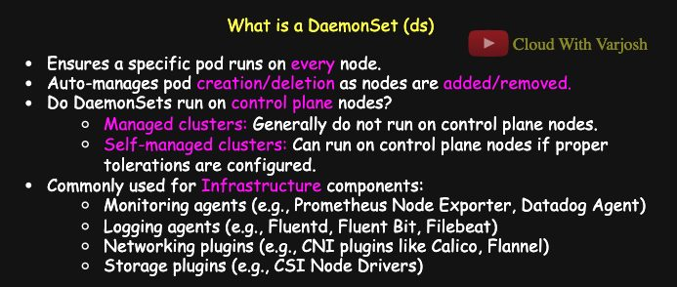
DaemonSet
A DaemonSet runs exactly one copy of a Pod on every node (or on selected nodes).
- New node joins → a Pod is added there automatically.
- Node removed → its Pod is garbage-collected.
- Pod deleted by hand → the DaemonSet controller recreates it.
- Delete the DaemonSet → all its Pods go.
Typical uses: node-level agents —
- monitoring (Prometheus Node Exporter, Datadog agent)
- logging (Fluentd, Fluent Bit, Filebeat)
- networking — kube-proxy and CNI plugins (Calico, Flannel, Cilium, AWS VPC CNI, Azure CNI)
- storage — CSI node plugins (EBS CSI, EFS CSI, GCP PD CSI)
- security (Falco), telemetry (OpenTelemetry Collector)
BASH
kubectl get daemonsets.apps -n kube-system kube-proxy
kubectl get pods -n kube-system -o wide | grep -i kube-proxy
Do DaemonSets run on control-plane nodes?
- Managed clusters (EKS, GKE, AKS): no — the control plane is hidden and managed by the provider.
- Self-managed (kubeadm, kind): only if the DaemonSet tolerates the control-plane taint node-role.kubernetes.io/control-plane:NoSchedule.
kube-proxy uses the broadest toleration possible:
YAML
tolerations:
- operator: Exists # no key = tolerate EVERY taint
It must run on every node, whatever taints exist.
Demo – dummy logging agent
BASH
kubectl create namespace logging-ns
kubectl config set-context --current --namespace=logging-ns
YAML
apiVersion: apps/v1
kind: DaemonSet
metadata:
name: log-collector
namespace: logging-ns # system agents usually get their own namespace
labels:
app: log-collector
spec:
selector:
matchLabels:
app: log-collector
template:
metadata:
labels:
app: log-collector
spec:
tolerations:
- key: "node-role.kubernetes.io/control-plane"
operator: "Exists"
effect: "NoSchedule" # also run on the control-plane node
containers:
- name: log-collector
image: busybox
command: ["/bin/sh", "-c", "while true; do echo 'Collecting logs...'; sleep 30; done"]
resources:
requests: {cpu: "50m", memory: "50Mi"}
limits: {cpu: "100m", memory: "100Mi"}
volumeMounts:
- name: varlog
mountPath: /var/log
volumes:
- name: varlog
hostPath:
path: /var/log # the node's log directory
type: Directory
A real agent (Fluentd, Fluent Bit, Filebeat) would read /var/log and ship logs to central storage (NFS/EFS, S3/GCS) or a log platform (Elasticsearch, Loki, Splunk).
BASH
kubectl apply -f ds.yaml
kubectl get daemonset
kubectl describe daemonset log-collector
kubectl get pods -o wide
# log-collector-4krdf ... my-second-cluster-worker
# log-collector-bzsln ... my-second-cluster-worker2
# log-collector-nvvz4 ... my-second-cluster-control-plane
kubectl delete pod <one-of-them> # instantly recreated on the same node

Job: run to completion
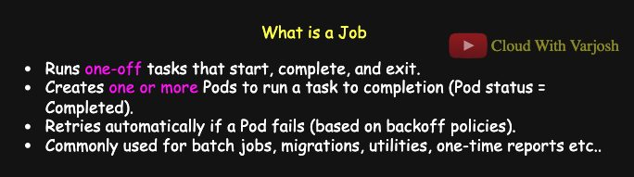
Job
A Job creates Pods that run a task until it succeeds, then stops. Failed Pods are retried (up to backoffLimit).
Uses: batch processing, database migrations, cleanup scripts, backups, one-off reports.
YAML
apiVersion: batch/v1
kind: Job
metadata:
name: hello-job
spec:
ttlSecondsAfterFinished: 60 # auto-delete the Job 60 s after it finishes
completions: 2 # need 2 successful Pods
parallelism: 2 # run up to 2 at the same time
backoffLimit: 4 # give up after 4 failed retries
template:
spec:
containers:
- name: hello
image: busybox
command: ["/bin/sh", "-c", "echo Hello from the Job! && sleep 10"]
restartPolicy: Never # Jobs need Never or OnFailure
- completions: 2, parallelism: 1 → two Pods one after the other. parallelism: 2 → both at once.
Who restarts what?
- The kubelet restarts containers inside an existing Pod — only with restartPolicy: Always or OnFailure.
- Nobody "restarts" a Pod: Pods are immutable. Controllers (Job, ReplicaSet…) create new Pods.
- With restartPolicy: Never, a failing container leaves the Pod Failed; the Job controller creates a new Pod, counting toward backoffLimit.
BASH
kubectl apply -f job.yaml
kubectl get jobs
kubectl get pods -o wide # Pods end in Completed
kubectl describe job hello-job
kubectl create job test --image=busybox -- echo hi # imperative

CronJob: Jobs on a schedule
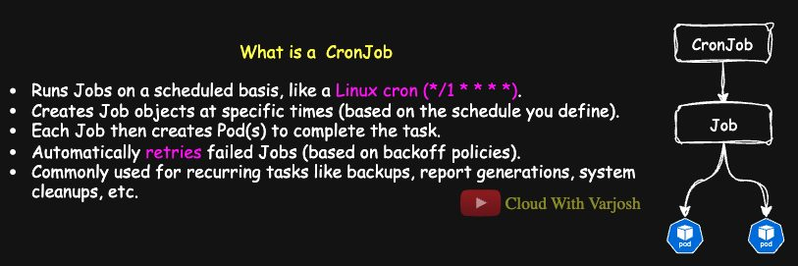
CronJob
A CronJob is a scheduler: at each scheduled time it creates a Job, and the Job runs the Pods. Uses: nightly backups, reports, log rotation, scheduled notifications.
Cron format (5 fields):
TEXT
┌───────────── minute (0-59)
│ ┌───────────── hour (0-23)
│ │ ┌───────────── day of month (1-31)
│ │ │ ┌───────────── month (1-12)
│ │ │ │ ┌───────────── day of week (0-6, Sunday = 0)
│ │ │ │ │
* * * * *
* = every value, 1,3,5 = list, 1-5 = range, */5 = every 5.
Expression | Meaning
*/5 * * * * | Every 5 minutes
0 * * * * | Every hour on the hour
0 2 * * * | Every day at 02:00
0 0 * * 0 | Every Sunday at midnight
30 9 * * 1-5 | 09:30 Monday–Friday

CronJobs use the controller's time zone — normally UTC — unless you set spec.timeZone. crontab.guru helps build expressions.
YAML
apiVersion: batch/v1
kind: CronJob
metadata:
name: hello-cronjob
spec:
schedule: "*/1 * * * *" # every minute
jobTemplate:
spec:
backoffLimit: 4
ttlSecondsAfterFinished: 60 # clean up each Job 60 s after it finishes
completions: 2
parallelism: 2
template:
spec:
containers:
- name: hello
image: busybox
command: ["/bin/sh", "-c", "echo Hello from CronJob! && sleep 10"]
restartPolicy: Never
BASH
kubectl apply -f cronjob.yaml
kubectl get cronjob
kubectl get jobs # a new Job appears every minute
kubectl get pods -o wide

Comparison
 | Deployment | DaemonSet | Job | CronJob
Purpose | Long-running, scalable apps with rolling updates | One Pod per node | Run a task to completion | Run Jobs on a schedule
Examples | Web servers, APIs, frontends | kube-proxy, Fluentd, Calico, EBS CSI node | DB migration, backup, cleanup | Nightly backup, weekly log rotation, monthly invoices

Part 11 — Encryption, TLS and kubeconfig (Days 30–32)

Day 30 — How Encryption, HTTPS and SSH Work
Encryption turns readable plaintext into unreadable ciphertext, so only authorised parties can read it. It provides confidentiality (nobody can read it), integrity (nobody can change it unnoticed) and authenticity (you know who sent it). It protects passwords and tokens on the network and stops eavesdropping.

Symmetric vs asymmetric
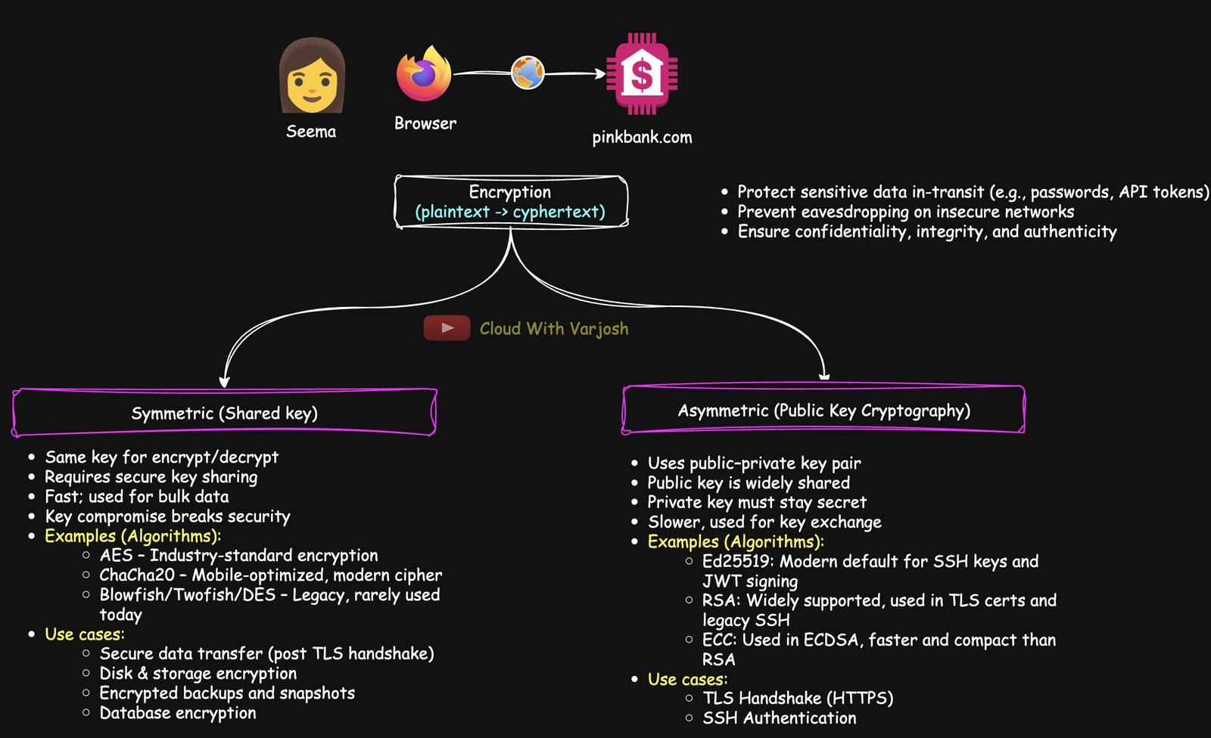
Encryption types
Symmetric (shared/secret key) — one key both encrypts and decrypts.
- Fast, great for bulk data. Easy to accelerate in hardware.
- Problem: both sides need the same key, and sharing it safely is hard. If it leaks, everything is exposed.
- Algorithms: AES (industry standard), ChaCha20 (mobile/low-power), older Blowfish, Twofish, DES.
- Uses: the data part of HTTPS after the handshake; disk encryption (EBS, Azure Managed Disks, GCP PD — usually AES-256 with keys in a KMS); encrypted backups; database encryption (MySQL TDE, MongoDB); Kubernetes Secrets encryption at rest (AES-CBC / AES-GCM providers on the API server).
Asymmetric (public-key cryptography) — a key pair: a public key you can give to anyone and a private key you never share.
- Encrypt with the public key → only the private key can decrypt.
- Sign with the private key → anyone with the public key can verify.
- Slower, so used for identity, signatures and exchanging keys, not bulk data.
- Algorithms: Ed25519 (modern SSH default), RSA (TLS certs, Kubernetes, older SSH), ECC/ECDSA (faster and smaller than RSA).
- Uses: TLS handshake, SSH login, Kubernetes x.509 certificates (API server, kubelet, etcd, kubectl), signing (GPG commits, JWTs, service-account tokens), Sealed Secrets/Vault.
 | Symmetric | Asymmetric
Keys | One shared key | Public + private pair
Speed | Fast | Slower
Weak spot | Sharing the key | Compute cost
Use | Bulk data | Identity, key exchange, signatures
Example | AES | RSA, Ed25519, ECDSA

Real systems combine them: asymmetric crypto establishes trust and agrees on a key, then symmetric crypto encrypts the actual data.

In transit vs at rest
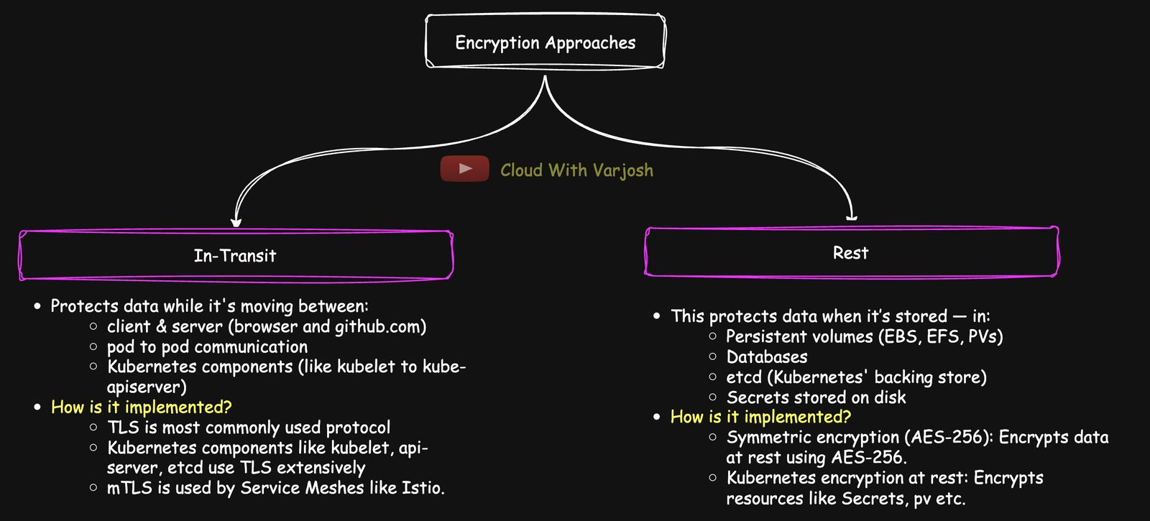
In transit vs at rest
 | In transit | At rest
Protects | Data moving across a network (browser↔server, Pod↔Pod, kubelet↔API server) | Stored data (PVs/EBS/EFS, databases, etcd, Secrets)
How | TLS, mTLS (e.g. Istio sidecars), VPN | AES-256, KMS, disk encryption, K8s encryption providers
Stops | Eavesdropping, man-in-the-middle, session hijack | Reading stolen disks/snapshots; needed for GDPR, HIPAA, PCI-DSS

A secure system needs both.

Four scenarios with Seema
1. Disk encryption (symmetric) — BitLocker on Seema's laptop uses AES. She enters a PIN to unlock the key; a stolen laptop or removed disk shows only ciphertext.
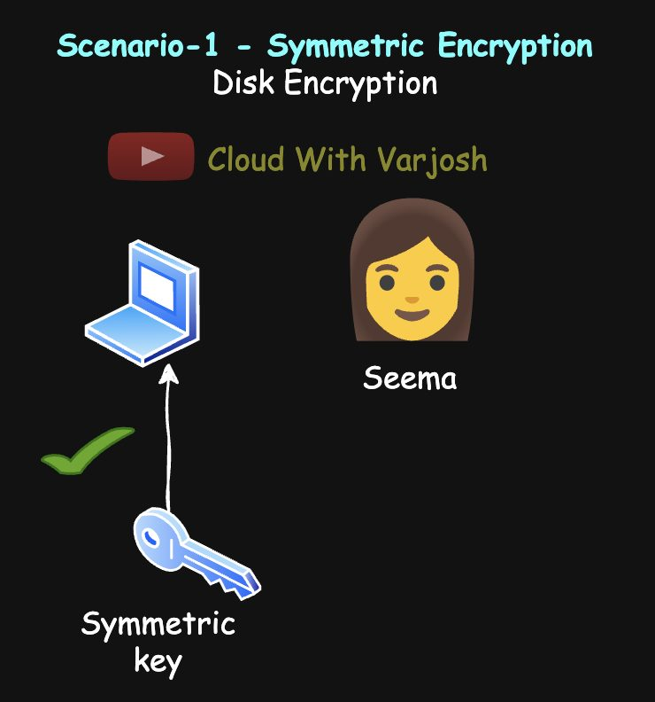
BitLocker
2. Why symmetric alone fails on the internet — if Seema encrypts her bank login with a symmetric key, pinkbank.com can't decrypt it without the key, and sending the key across the internet lets attackers grab it.
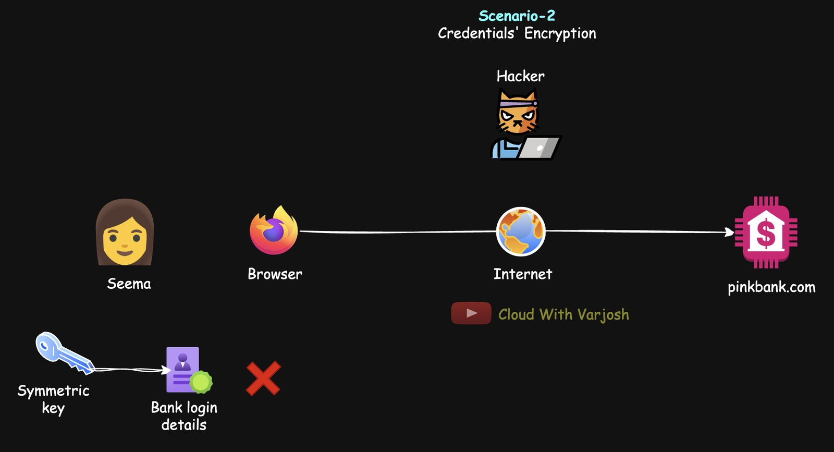
Key sharing problem
3. SSH to an EC2 instance (asymmetric)
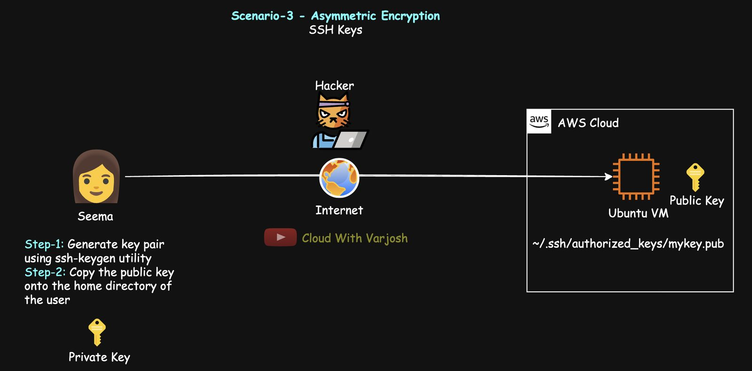
SSH
- Generate a key pair with ssh-keygen.
- Put the public key on the server (~/.ssh/authorized_keys).
- Set strict file permissions on the private key.
- Connect with the private key.
The server sends a random challenge; Seema's client signs it with her private key; the server verifies with her public key. Identity proven, private key never sent.
Common file extensions — public: .pub, .crt, .cer, .pem, .der; private: .key, .pem, .ppk, .pfx. SSH: .pub public / no-extension or .key private.
4. HTTPS: symmetric + asymmetric together (TLS)
TLS (Transport Layer Security) is the modern successor of SSL (people still say "SSL certificate"). It secures HTTPS and also FTPS, SMTPS, IMAPS/POP3S, LDAPS, gRPC, MQTT and all Kubernetes component traffic. The padlock in your browser = TLS.
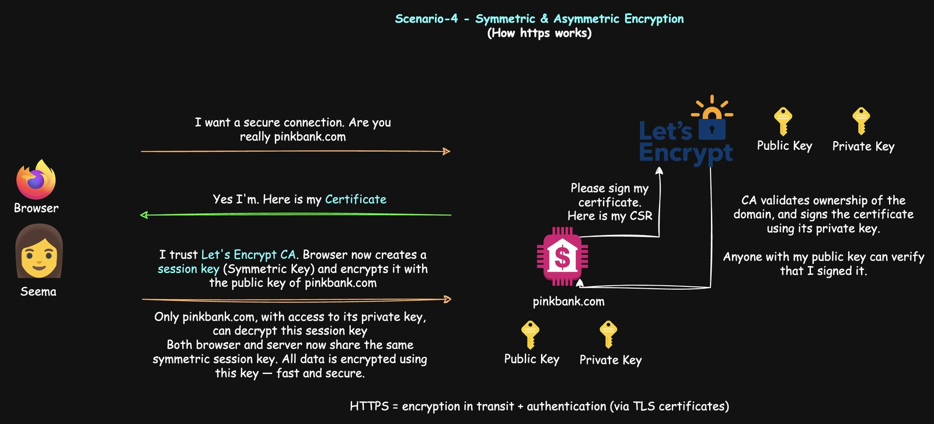
TLS handshake
- Browser: "Hello, prove you are pinkbank.com."
- Server sends its certificate: its public key + domain name + a CA signature (e.g. Let's Encrypt). The CA verified domain ownership and signed with its private key.
- Browser checks with the CA's public key (pre-installed in browsers): trusted CA? not expired? domain matches?
- Browser creates a random symmetric session key (e.g. AES-256).
- Encrypts it with the server's public key (classic RSA key exchange).
- Server decrypts it with its private key.
- Both now encrypt everything with the fast session key.
Takeaways: the CA's private key signs → the browser verifies with the CA's public key. Private keys never travel. After the handshake, symmetric encryption does the work. (Enterprise alternatives to Let's Encrypt: DigiCert, Sectigo, AWS Certificate Manager.)

Day 31 — Public Key Cryptography, Mutual Authentication and Certificate Authorities

Client vs server
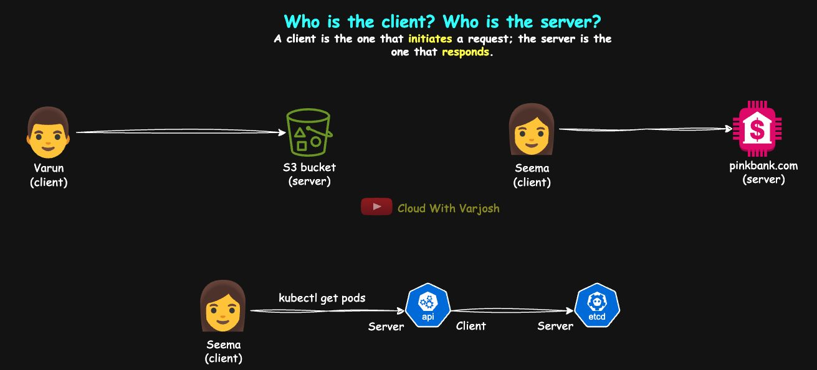
Client and server
The client starts the request; the server answers. Seema → pinkbank.com; Varun → his S3 bucket. In Kubernetes: kubectl is a client of the API server; the API server is a client of etcd. Direction matters for client certificates and mTLS.

PKC tools for DevOps: ssh-keygen and openssl
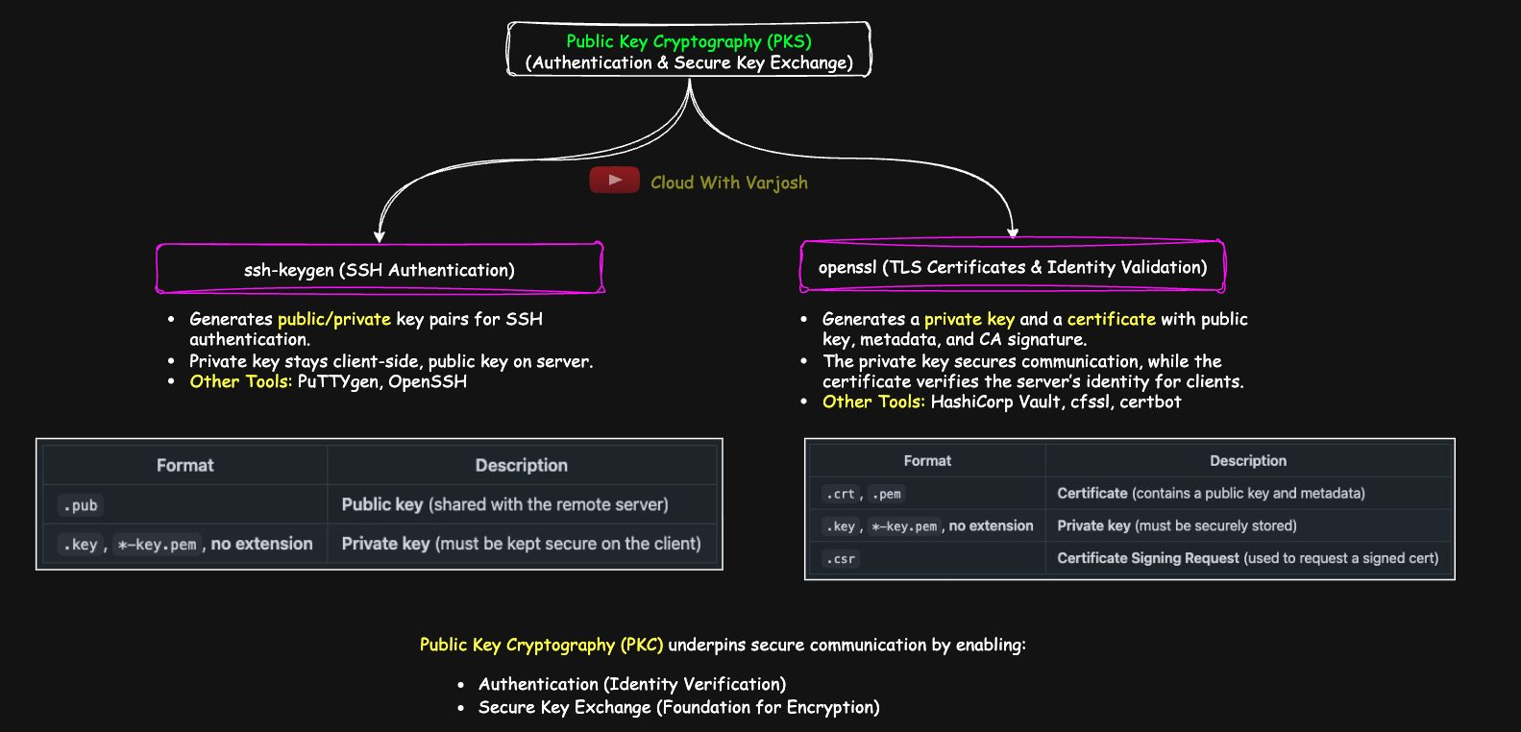
PKC
ssh-keygen — creates SSH key pairs for passwordless login to servers, Git, CI/CD. Private key on the client; public key in the server's ~/.ssh/authorized_keys. Alternatives: PuTTYgen, OpenSSH, Mosh.
openssl — creates private keys, CSRs and X.509 certificates (public key + metadata like issuer and validity + CA signature). Despite the old "SSL" name it supports all modern TLS (incl. 1.3) and much more: key pairs, signing certs, encrypt/decrypt, hashing, PEM/DER/PKCS#12 formats, TLS debugging. Alternatives: CFSSL (Cloudflare), HashiCorp Vault, Certbot (Let's Encrypt automation).
Protect private keys: HSMs, secure enclaves/TPM, cloud KMS (AWS KMS, Azure Key Vault), password-protected key files, smart cards/USB tokens (YubiKey), air-gapped systems. Rotate and audit keys regularly.
SSH files
.pub | Public key (goes on the server)
.key, *-key.pem, no extension | Private key (stays on the client)

TLS files
.crt, .pem | Certificate (public key + metadata)
.key, *-key.pem | Private key
.csr | Certificate Signing Request

What PKC gives you: 1) authentication
SSH is mutual authentication:
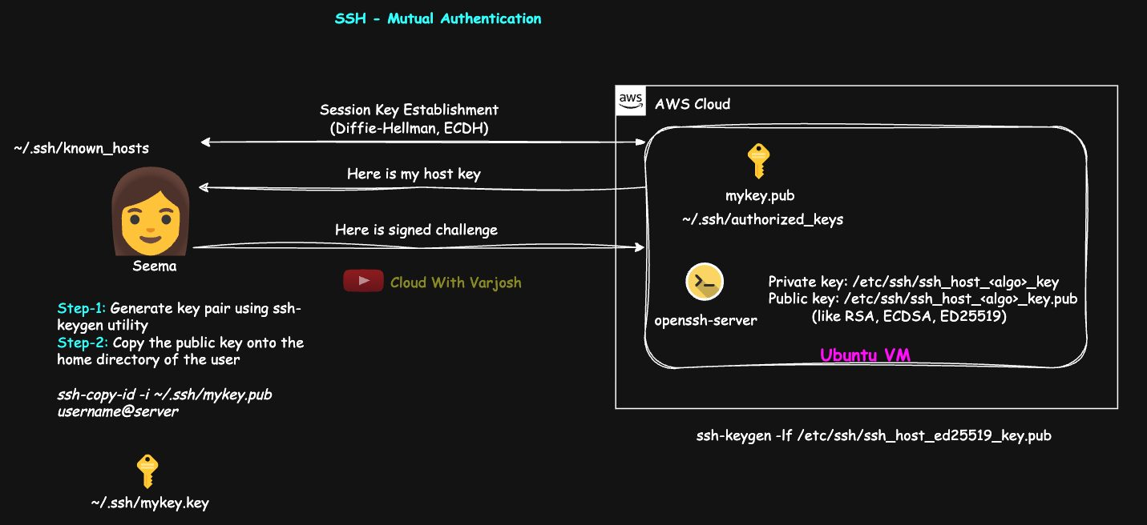
SSH mutual auth
Server proves itself first (host key). On install, the SSH server creates host key pairs (/etc/ssh/ssh_host_<algo>_key and .pub). On connect it sends its public host key; the client checks ~/.ssh/known_hosts. First time you see:
The authenticity of host 'server.com (192.168.1.10)' can't be established.
ED25519 key fingerprint is SHA256:abc123...
Are you sure you want to continue connecting (yes/no)?
Verify on the server with ssh-keygen -lf /etc/ssh/ssh_host_ed25519_key.pub (-l fingerprint, -f file). Saying yes stores the key = TOFU (Trust On First Use). Other ways to establish trust: ask a colleague who has access ("phone a friend"), compare out-of-band (Slack, docs portal), push known hosts with Ansible/Puppet/Chef, pre-load with ssh-keyscan server.example.com >> ~/.ssh/known_hosts, or use an SSH CA that signs host keys. If the key later changes (reinstall or man-in-the-middle), SSH warns loudly. In clouds, changing public IPs can also trigger warnings.
Then the client proves itself: the server sends a challenge, the client signs it with its private key, and the server verifies with the public key in authorized_keys.
TLS: the server presents a CA-signed certificate; the client checks the CA is trusted and the name matches. In mutual TLS the client also presents a certificate.
In both SSH and mTLS, the server authenticates first — so the client never sends secrets to an impostor, and MITM attacks are blocked.

2) secure key exchange
PKC is used to agree on a symmetric session key, not to encrypt all traffic.
- SSH: client and server run Diffie-Hellman / ECDH. Each contributes a random part and both compute the same key — it's never sent. Encryption starts before client authentication, so even passwords/signatures travel encrypted.
- Old TLS (TLS 1.2 with RSA key exchange): client makes the session key, encrypts it with the server's public key. Weakness: no forward secrecy — if the server key leaks later, recorded past sessions can be decrypted.
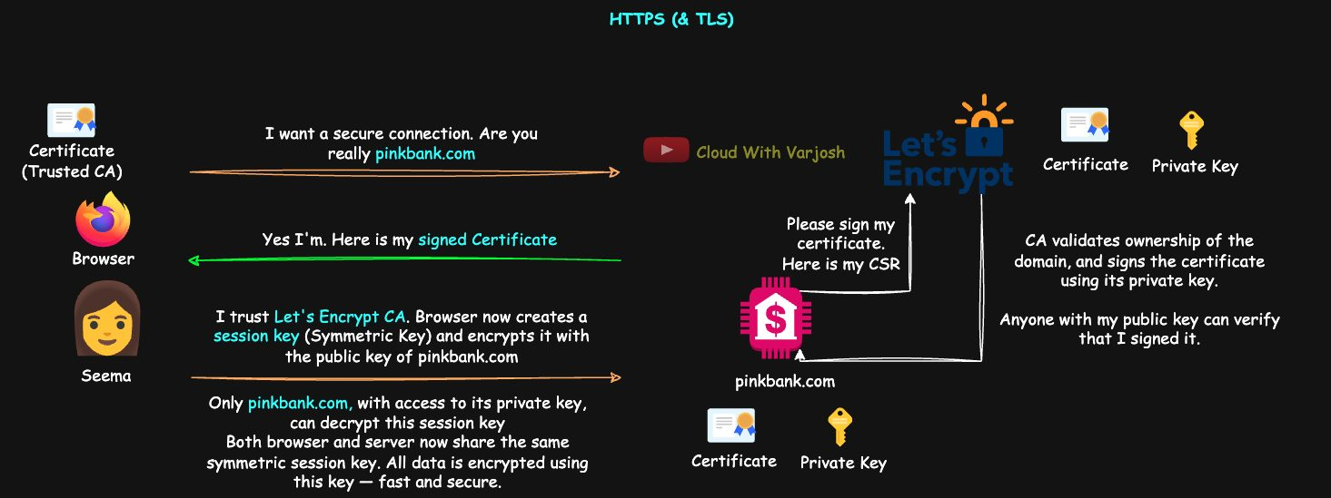
TLS 1.2 RSA
- Modern TLS (TLS 1.3, or 1.2 with ECDHE): ephemeral ECDHE — both sides derive the key together; it's never transmitted. Forward secrecy: past sessions stay safe even if the server key leaks.
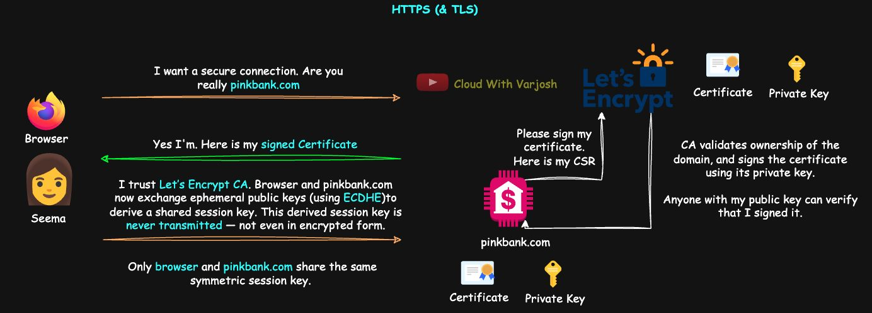
TLS 1.3
SSH: encryption first, then authentication. HTTPS: the server authenticates (certificate) as part of setting up encryption.

Types of certificate authority
Type | For | Trusted by | Examples
Public CA | Public internet sites | All browsers/OSes | Let's Encrypt, DigiCert, GlobalSign
Private CA | Internal services (*.internal) | Only machines you configure | Your enterprise CA
Self-signed | Dev/testing | Nobody by default (browser warning) | –

Public CA
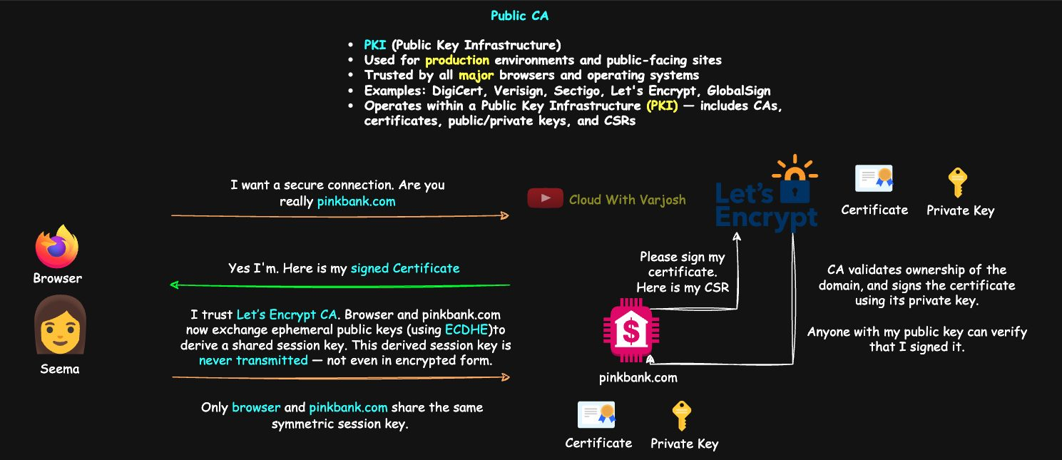
Public CA
pinkbank.com creates a key + CSR with openssl and has it signed by a CA such as Let's Encrypt. Browsers already have the CAs' public keys, so they can verify. Let's Encrypt is free and automated and widely used in production; commercial CAs (DigiCert, GlobalSign, Entrust, Google Trust Services) add EV/OV validation, SLAs and support.
PKI (Public Key Infrastructure) = the whole framework of CAs, keys, certificates and CSRs that makes this trust work.
Private CA
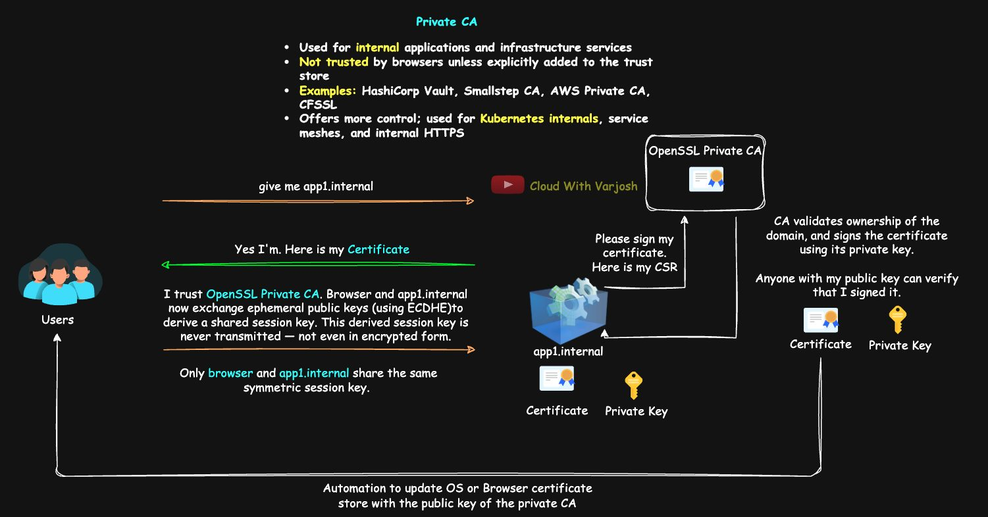
Private CA
To serve https://app1.internal with no warnings: run a private CA, issue a cert for app1.internal, and install the CA's root certificate on every user machine — Windows via Group Policy (Trusted Root Certification Authorities), macOS via MDM or Keychain Access, Linux by copying to /usr/local/share/ca-certificates/ then sudo update-ca-certificates. Make internal DNS resolve the name.
Self-signed
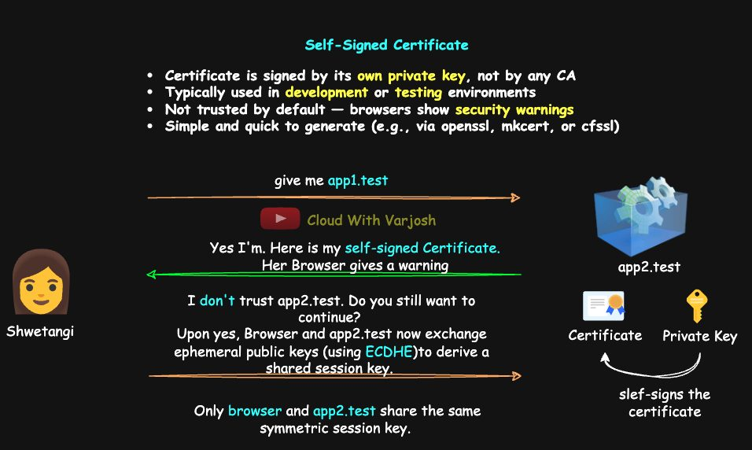
Self-signed
Signed with its own private key. Shwetangi uses one to test HTTPS on app2.test. Good for local dev, internal tools, prototypes, lab clusters. Browsers warn: Chrome "Your connection is not private (NET::ERR_CERT_AUTHORITY_INVALID)", Firefox "Potential Security Risk Ahead".
Safe test domain suffixes: .test (RFC 6761), .local (mDNS), .internal, .example.

Day 32 — kubeconfig, Contexts and Mutual TLS

Why kubeconfig exists
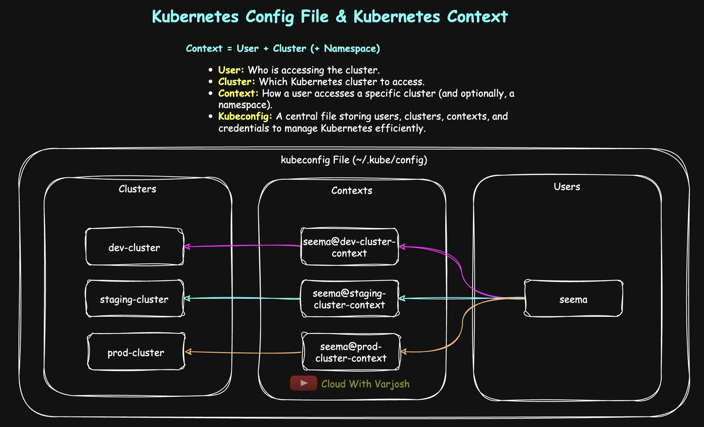
kubeconfig
The kubeconfig stores clusters (API server URL + CA cert), users (certs/tokens) and contexts (cluster + user + namespace). Without it, every command would look like:
BASH
kubectl get pods \
--server=https://<API_SERVER_URL> \
--certificate-authority=<CA_CERT_FILE> \
--client-key=<CLIENT_KEY_FILE> \
--client-certificate=<CLIENT_CERT_FILE>
Default location: ~/.kube/config (override with $KUBECONFIG or --kubeconfig).

Contexts
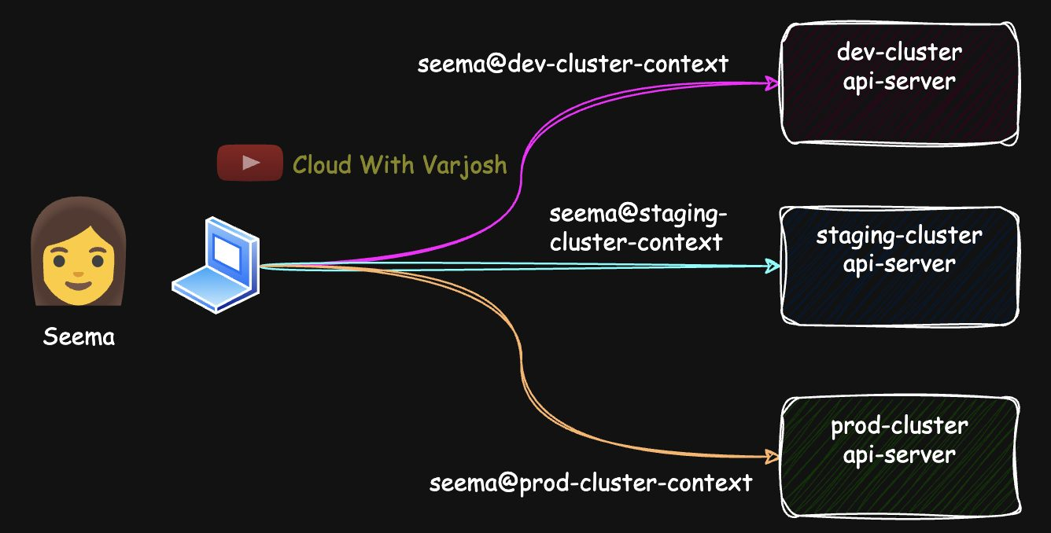
Contexts
Seema uses dev-cluster, staging-cluster and prod-cluster, with namespaces app1-dev-ns, app1-staging-ns, app1-prod-ns.
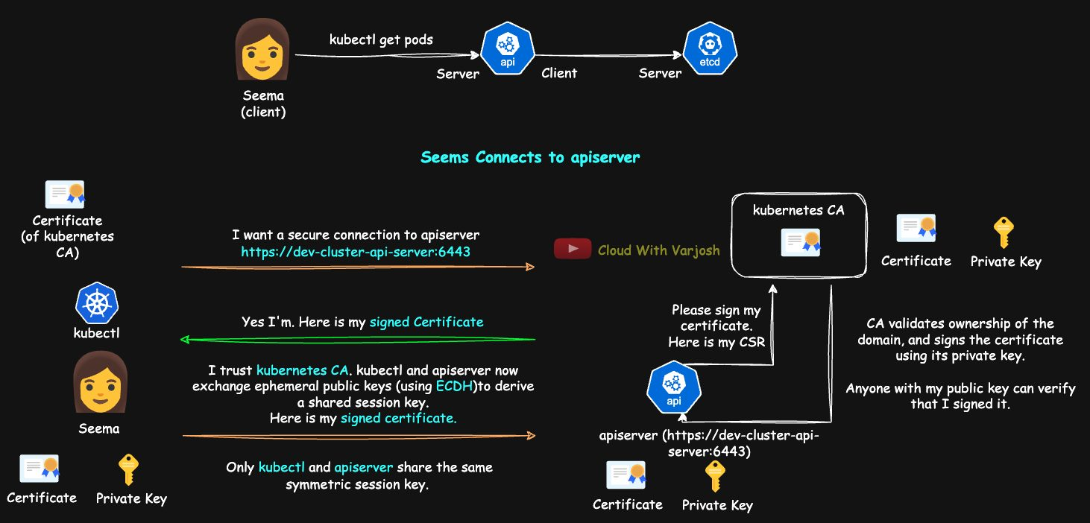
kubeconfig file
YAML
apiVersion: v1
clusters:
- name: dev-cluster
cluster:
server: https://dev-cluster-api-server:6443 # API server (port 6443)
certificate-authority-data: <certificate-data> # cluster CA – verifies the API server
- name: staging-cluster
cluster:
server: https://staging-cluster-api-server:6443
certificate-authority-data: <certificate-data>
- name: prod-cluster
cluster:
server: https://prod-cluster-api-server:6443
certificate-authority-data: <certificate-data>
users:
- name: seema
user:
client-certificate-data: <client-cert-data> # Seema's certificate (who she is)
client-key-data: <client-key-data> # her private key – keep safe!
contexts:
- name: seema@dev-cluster-context
context: {cluster: dev-cluster, user: seema, namespace: app1-dev-ns}
- name: seema@staging-cluster-context
context: {cluster: staging-cluster, user: seema, namespace: app1-staging-ns}
- name: seema@prod-cluster-context
context: {cluster: prod-cluster, user: seema, namespace: app1-prod-ns}
current-context: seema@dev-cluster-context
- certificate-authority-data — the cluster CA's certificate (base64). kubectl uses it to verify the API server.
- client-certificate-data — the user's certificate, sent to the API server to prove identity.
- client-key-data — the matching private key. Anyone with it can impersonate the user.
Together these give mutual TLS between kubectl and the API server.

kubectl config cheat sheet (prefer these to hand-editing)
Task | Command
Current context | kubectl config current-context
List contexts | kubectl config get-contexts
Switch | kubectl config use-context seema@prod-cluster-context
View config | kubectl config view (add --raw for full data, --minify for active context only)
Which file? | echo $KUBECONFIG (empty = ~/.kube/config)
Default namespace | kubectl config set-context --current --namespace=app1-staging-ns
One-off namespace | kubectl get pods --namespace=app1-prod-ns
Use another file | kubectl config view --kubeconfig=~/kubeconfigs/custom.yaml
Add user | kubectl config set-credentials varun --client-certificate=varun-cert.pem --client-key=varun-key.pem
Add cluster | kubectl config set-cluster dev-cluster --server=https://dev-cluster-api-server:6443 --certificate-authority=ca.crt --embed-certs=true
Add context | kubectl config set-context seema@dev-cluster-context --cluster=dev-cluster --user=seema --namespace=app1-dev-ns
Rename / delete context | kubectl config rename-context old new / kubectl config delete-context name
Delete user / cluster | kubectl config unset users.seema / kubectl config unset clusters.staging-cluster

Multiple kubeconfig files
BASH
kubectl get pods --kubeconfig=~/.kube/dev-kubeconfig
echo 'export KUBECONFIG=$HOME/.kube/my-2nd-kubeconfig-file' >> ~/.bashrc && source ~/.bashrc
Building a new kubeconfig step by step
BASH
kubectl config set-credentials varun \
--client-certificate=~/kubeconfigs/varun-cert.pem \
--client-key=~/kubeconfigs/varun-key.pem \
--kubeconfig=~/kubeconfigs/my-2nd-kubeconfig-file
kubectl config set-cluster aws-cluster \
--server=https://aws-api-server:6443 \
--certificate-authority=~/kubeconfigs/aws-ca.crt --embed-certs=true \
--kubeconfig=~/kubeconfigs/my-2nd-kubeconfig-file
kubectl config set-context varun@aws-cluster-context \
--cluster=aws-cluster --user=varun --namespace=default \
--kubeconfig=~/kubeconfigs/my-2nd-kubeconfig-file
kubectl config use-context varun@aws-cluster-context --kubeconfig=~/kubeconfigs/my-2nd-kubeconfig-file
kubectl config view --kubeconfig=~/kubeconfigs/my-2nd-kubeconfig-file --minify
--embed-certs=true copies the file contents into the kubeconfig as base64 instead of storing a path.

Mutual TLS (mTLS)
In mTLS, both client and server present certificates and verify each other. Public websites for humans use one-way TLS (only the server proves identity). Machine-to-machine systems — microservices, service meshes, Kubernetes — use mTLS. EKS, GKE and AKS use mTLS for control-plane traffic (API server ↔ kubelet ↔ controller manager ↔ etcd) by default. The server still authenticates first.
Why in Kubernetes: stops rogue components talking to the cluster, ensures only genuine API servers/kubelets connect, and is especially important for etcd, kubelet and kube-apiserver.
 | TLS (one-way) | mTLS (two-way)
Who is authenticated | Server only | Both
Certificates needed | Server only | Server and client
Typical use | Public websites/APIs | Microservices, Kubernetes
Security | Strong | Stronger

Part 12 — TLS Inside Kubernetes, User Access and Authorization (Days 33–35)

Day 33 — Private CAs and mTLS Between Kubernetes Components

Private CAs in a cluster
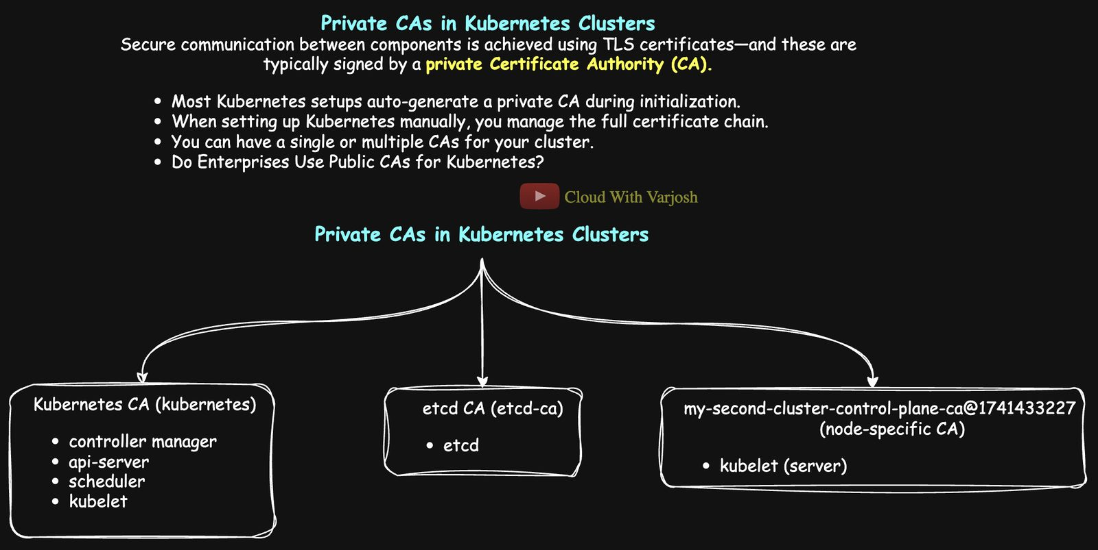
Private CAs
All internal Kubernetes certificates are signed by a private CA created when the cluster is built (kubeadm, k3s, EKS/GKE/AKS all do this automatically; in managed services it's hidden from you). Components trust each other because they all trust that CA's certificate.
- One CA for everything — simplest.
- Several CAs — e.g. a separate CA for etcd. etcd holds the whole cluster state, so isolating its trust limits the blast radius if a key leaks.
- Building a cluster "the hard way" (Kelsey Hightower's guide) means you create the root CA, sign every component cert and distribute them yourself.
Public CAs are not used for cluster internals. They're used for public-facing things — Ingress controllers, load balancers, Gateway API — so browsers trust them.

Who is the client, who is the server?
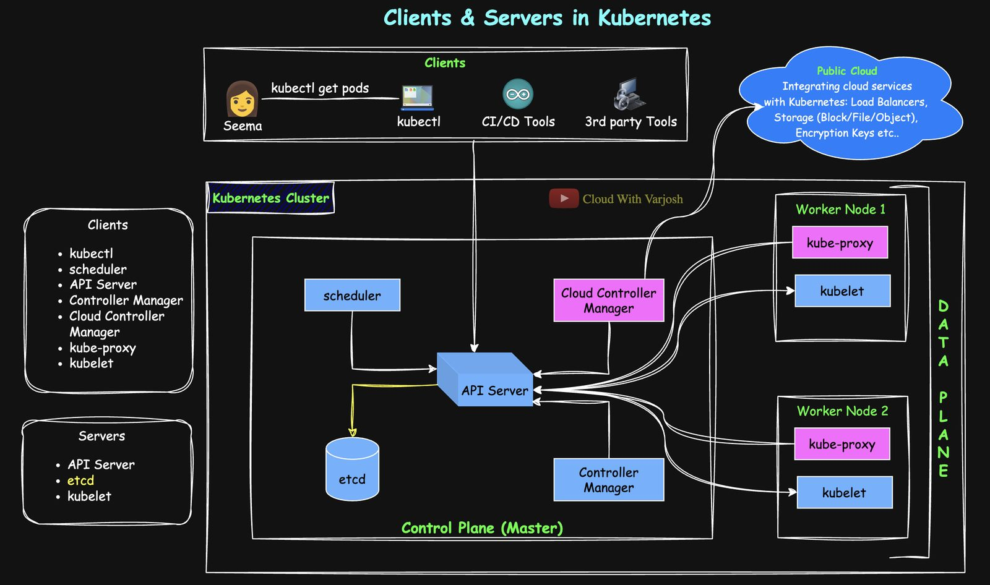
Clients and servers
Arrow tail = client, arrowhead = server.
Always a client of the API server | Server
kubectl, scheduler, controller-manager, kube-proxy | API server – serves all of them
kubelet (reports status, reads Secrets/ConfigMaps) | etcd – always a server; only the API server talks to it
API server (when talking to etcd or kubelet) | kubelet – server for kubectl logs/exec/port-forward and metrics

So the API server is both: a server for clients, and a client of etcd and kubelets. (In HA etcd, etcd members are also clients of each other for replication.)

The golden rule: don't memorise paths — read the config
Everything that connects to the API server uses a kubeconfig file. kubectl uses ~/.kube/config; the scheduler uses /etc/kubernetes/scheduler.conf; kube-proxy (a DaemonSet) has one mounted at /var/lib/kube-proxy/kubeconfig.
What | Typical location (kubeadm/kind)
Component kubeconfigs | /etc/kubernetes/*.conf
Static Pod manifests (API server, scheduler, controller-manager, etcd) | /etc/kubernetes/manifests/
Control-plane certs | /etc/kubernetes/pki/
etcd certs | /etc/kubernetes/pki/etcd/
Kubelet certs (every node) | /var/lib/kubelet/pki/
Kubelet config | /var/lib/kubelet/config.yaml

Inspect any certificate with:
BASH
openssl x509 -in <file.crt> -text -noout # look at Subject (CN) and Issuer
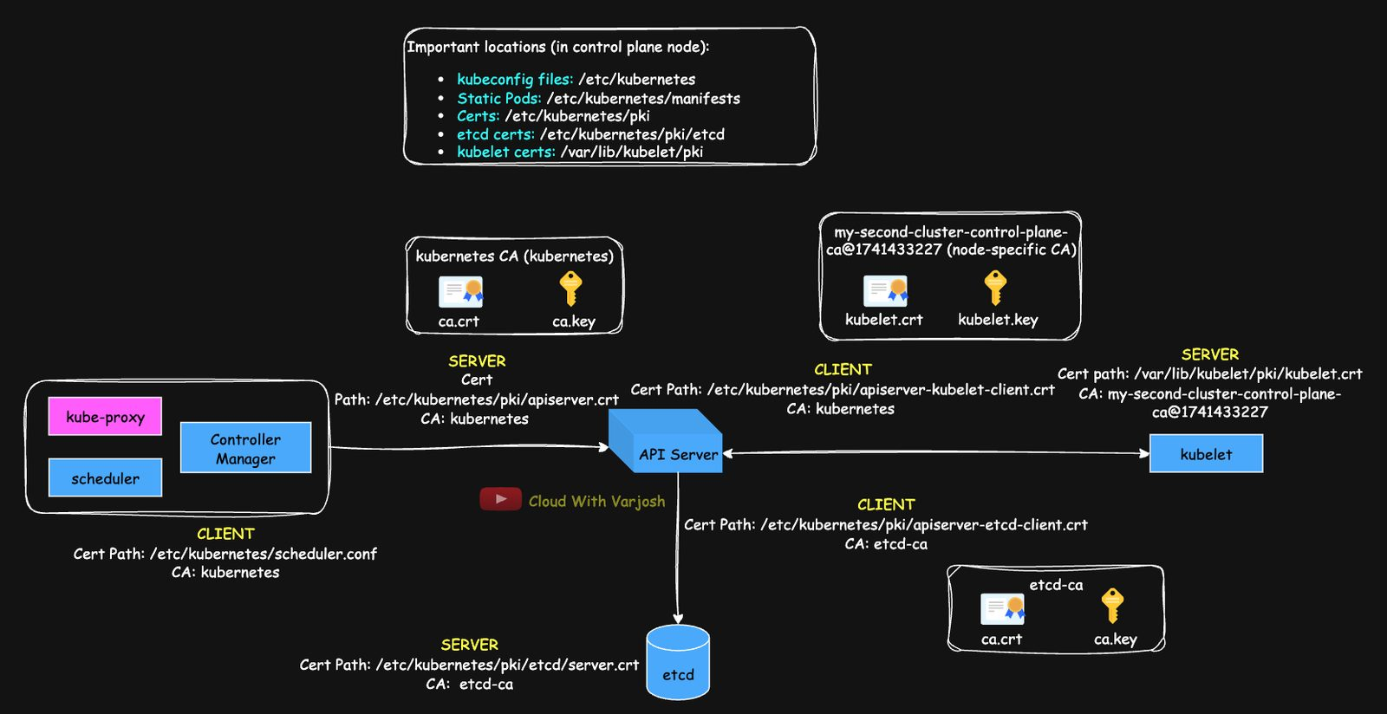
mTLS flows

Example 1 — Scheduler (client) → API server (server)
Server side: what the API server presents
BASH
cat /etc/kubernetes/manifests/kube-apiserver.yaml # --tls-cert-file=/etc/kubernetes/pki/apiserver.crt
openssl x509 -in /etc/kubernetes/pki/apiserver.crt -text -noout
# Subject: CN=kube-apiserver Issuer: CN=kubernetes (the cluster CA)
How the scheduler trusts it: the scheduler manifest has --kubeconfig=/etc/kubernetes/scheduler.conf. Its certificate-authority-data is the cluster CA:
BASH
echo -n "<certificate-authority-data>" | base64 --decode > ca.crt
openssl x509 -in ca.crt -text -noout
# Subject: CN=kubernetes Issuer: CN=kubernetes (self-signed root CA)
Client side: how the scheduler proves itself — same kubeconfig, users: section:
YAML
users:
- name: system:kube-scheduler
user:
client-certificate-data: <base64 cert>
client-key-data: <base64 key>
Decoded: Subject: CN=system:kube-scheduler, Issuer: CN=kubernetes. The API server validates it using --client-ca-file=/etc/kubernetes/pki/ca.crt.
Component | Look in | Flags/fields
API server | /etc/kubernetes/manifests/kube-apiserver.yaml | --tls-cert-file, --client-ca-file
Scheduler | /etc/kubernetes/scheduler.conf | certificate-authority-data, client-certificate-data, client-key-data

Root and intermediate CAs. A root CA is at the top of the trust chain and is always self-signed (nobody is above it). That's fine because it is explicitly trusted. Public CAs keep the root key offline and issue certificates from intermediate CAs, so a compromised intermediate can be revoked without touching the root.
Chain for pinkbank.com with Let's Encrypt:
pinkbank.com (leaf certificate)
⬅ signed by Let's Encrypt intermediate (R3 / E1)
⬅ signed by ISRG Root X2 (root – already in the browser, NOT sent by the server)
The server sends the leaf + intermediate; the browser verifies the leaf with the intermediate's public key and the intermediate with the pre-installed root.

Example 2 — API server (client) → etcd (server)
etcd presents (from /etc/kubernetes/manifests/etcd.yaml):
YAML
--cert-file=/etc/kubernetes/pki/etcd/server.crt
--key-file=/etc/kubernetes/pki/etcd/server.key
--client-cert-auth=true # require client certificates
--trusted-ca-file=/etc/kubernetes/pki/etcd/ca.crt
server.crt: Subject CN=my-second-cluster-control-plane, Issuer CN=etcd-ca.
API server side (from kube-apiserver.yaml):
YAML
--etcd-cafile=/etc/kubernetes/pki/etcd/ca.crt # to verify etcd
--etcd-certfile=/etc/kubernetes/pki/apiserver-etcd-client.crt # its client cert
--etcd-keyfile=/etc/kubernetes/pki/apiserver-etcd-client.key
etcd/ca.crt is self-signed CN=etcd-ca. The client cert is CN=kube-apiserver-etcd-client, issued by etcd-ca, which etcd trusts via --trusted-ca-file.
Full mTLS: etcd shows server.crt → API server checks it with --etcd-cafile; API server shows apiserver-etcd-client.crt → etcd checks it with --trusted-ca-file.
Component | Role | File | Flags
etcd | Server | etcd.yaml | --cert-file, --key-file, --trusted-ca-file
kube-apiserver | Client | kube-apiserver.yaml | --etcd-cafile, --etcd-certfile, --etcd-keyfile

Example 3 — API server (client) → kubelet (server)
Used for kubectl logs, exec, port-forward and metrics.
The kubelet is not a Pod — it's a systemd service (/usr/bin/kubelet). Find its config through the process:
BASH
ps -ef | grep kubelet # --config=/var/lib/kubelet/config.yaml
ls /var/lib/kubelet/pki/
File | Purpose
kubelet.crt / kubelet.key | Serving cert (kubelet as server)
kubelet-client-current.pem | Client cert (kubelet → API server)
kubelet-client-<timestamp>.pem | Older rotated client certs

BASH
openssl x509 -in /var/lib/kubelet/pki/kubelet.crt -text -noout
# Subject: CN=<node-name>... Issuer: CN=my-second-cluster-control-plane-ca@1741433227
TLS bootstrapping: a new kubelet has no certificate. It authenticates with a bootstrap token (API server flag --enable-bootstrap-token-auth=true), submits a CSR, and gets a client certificate signed by the cluster CA, which it uses from then on.
Asymmetric trust (default kubeadm/kind behaviour): by default the kubelet's serving certificate is signed by the kubelet's own small self-signed CA (that's the <node>-ca@<timestamp> issuer), and the API server is not configured to verify it (no --kubelet-certificate-authority). So:
- the kubelet strictly verifies the API server's client certificate;
- the API server does not strictly verify the kubelet's serving certificate.
It can be hardened (serving-cert bootstrapping + --kubelet-certificate-authority), but that's not the default. Kubelet access is further restricted by RBAC, the Node authorizer and the NodeRestriction admission plugin.
API server's client certificate to the kubelet:
YAML
--kubelet-client-certificate=/etc/kubernetes/pki/apiserver-kubelet-client.crt
--kubelet-client-key=/etc/kubernetes/pki/apiserver-kubelet-client.key
Subject: CN=kube-apiserver-kubelet-client, Issuer: CN=kubernetes. The kubelet checks it against clientCAFile: /etc/kubernetes/pki/ca.crt in /var/lib/kubelet/config.yaml.
Role | Component | Certificate | Notes
Server | Kubelet | /var/lib/kubelet/pki/kubelet.crt | Self-signed kubelet CA by default
Client | API server | /etc/kubernetes/pki/apiserver-kubelet-client.crt | Presented to the kubelet
Trust root | Kubelet | /etc/kubernetes/pki/ca.crt | Verifies the API server's client cert
(optional) | API server | not enforced by default | Doesn't verify kubelet's serving cert

Practice tasks
- Controller-manager → API server – start from kube-controller-manager.yaml and its kubeconfig (controller-manager.conf).
- Kubelet → API server – find the kubelet's --kubeconfig (usually /etc/kubernetes/kubelet.conf) and its client cert.
- kube-proxy → API server – kubectl exec into a kube-proxy Pod and inspect its kubeconfig and credentials (research this one yourself).

Day 34 — Giving a New User (Seema) Access with a CSR and RBAC
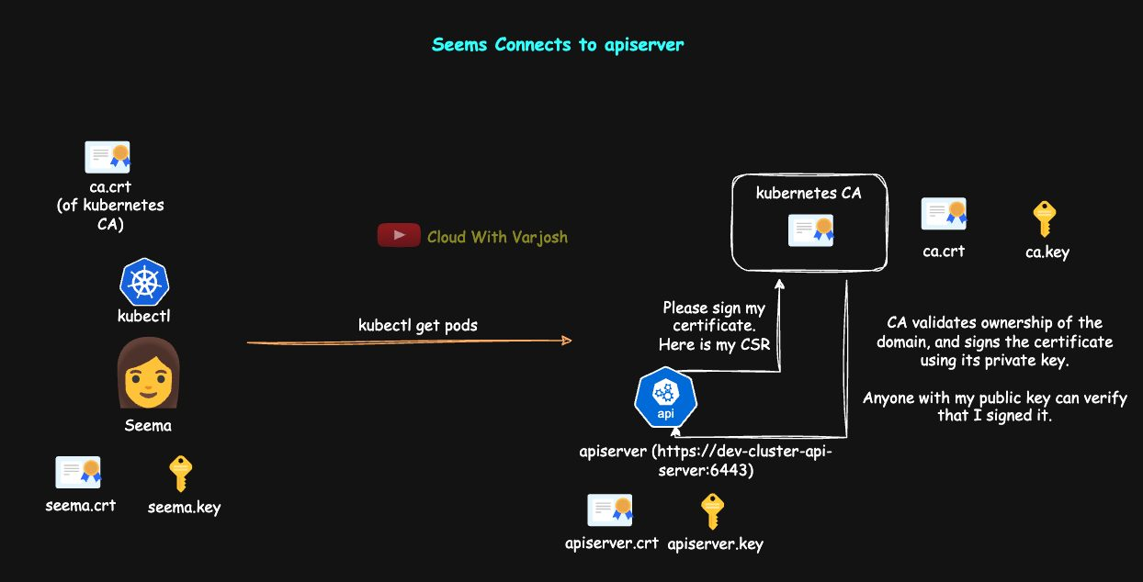
User access flow
Kubernetes has no "User" object. A user is whoever presents a certificate signed by the cluster CA — the certificate's CN is the username and any O (organisation) fields are groups. RBAC then decides what they can do.
Step 1 – Seema creates a private key
BASH
openssl genrsa -out seema.key 2048
Step 2 – Seema creates a CSR (CN = her Kubernetes username)
BASH
openssl req -new -key seema.key -out seema.csr -subj "/CN=seema"
# add groups with e.g. -subj "/CN=seema/O=dev-team"
Step 3 – base64 the CSR as one line for YAML
BASH
cat seema.csr | base64 | tr -d "\n"
Step 4 – Admin creates a CertificateSigningRequest object
YAML
apiVersion: certificates.k8s.io/v1
kind: CertificateSigningRequest
metadata:
name: seema
spec:
request: <BASE64_ENCODED_CSR>
signerName: kubernetes.io/kube-apiserver-client # a client-auth cert for the API server
expirationSeconds: 7776000 # 90 days
usages:
- client auth
Step 5 – Approve it
BASH
kubectl get csr
kubectl certificate approve seema # (or: kubectl certificate deny seema)
Step 6 – Retrieve the signed certificate
BASH
kubectl get csr seema -o jsonpath='{.status.certificate}' | base64 -d > seema.crt
Send seema.crt (and the cluster ca.crt) to Seema.
Step 7 – Seema configures her kubeconfig
BASH
kubectl config set-credentials seema \
--client-certificate=seema.crt --client-key=seema.key --embed-certs=true
kubectl config set-cluster kind-my-second-cluster \
--server=https://127.0.0.1:59599 \
--certificate-authority=ca.crt --embed-certs=true
kubectl config set-context seema@kind-my-second-cluster-context \
--cluster=kind-my-second-cluster --user=seema --namespace=default
Step 8 – Admin grants permissions with RBAC
YAML
kind: Role
apiVersion: rbac.authorization.k8s.io/v1
metadata:
namespace: default
name: seema-role
rules:
- apiGroups: [""]
resources: ["pods"]
verbs: ["get", "list", "delete"]
BASH
kubectl create rolebinding seema-binding --role=seema-role --user=seema --namespace=default
Step 9 – Admin checks with impersonation
BASH
kubectl auth can-i delete pods --namespace=default --as=seema # yes
kubectl auth can-i create deployments --namespace=default --as=seema # no
Step 10 – Seema switches context
BASH
kubectl config use-context seema@kind-my-second-cluster-context
kubectl get pods
Other ways to connect
BASH
curl https://<API-SERVER-IP>:<PORT>/api/v1/namespaces/default/pods \
--cacert ca.crt --cert seema.crt --key seema.key
kubectl get pods --kubeconfig=myconfig.yaml
Step 11 – Check expiry
BASH
openssl x509 -noout -dates -in seema.crt # notBefore / notAfter

Day 35 — The Kubernetes API and Authorization Modes

The Kubernetes API
The API is a RESTful, resource-based HTTPS interface. kubectl is just a REST client:
kubectl get pods → GET /api/v1/namespaces/default/pods
HTTP verbs: GET (read), POST (create), PUT/PATCH (update), DELETE.
API vs API server: the API is the logical set of endpoints; the API server is the program that serves it and also does authentication → authorization → admission control → validation, then stores to etcd.

Endpoints
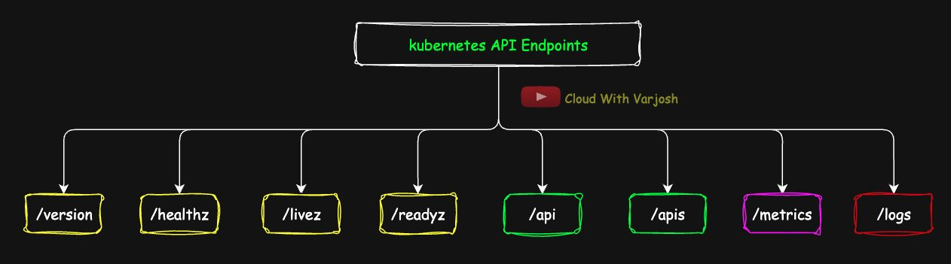
API endpoints
Endpoint | Purpose
/version | API server version (unauthenticated)
/healthz, /livez, /readyz | Health of the API server (livez/readyz preferred)
/api | Core group (Pods, Services, ConfigMaps, Secrets, Namespaces, PVs, PVCs, RCs)
/apis | Named groups (apps, batch, rbac, networking…)
/metrics | Prometheus-format metrics
/logs | API server's own logs (only with some flags). kubectl logs goes to the kubelet, not here

- Resource endpoints (/api, /apis) – CRUD on objects.
- Non-resource endpoints (/version, /healthz, /metrics) – metadata and utilities.

API groups
Group | apiVersion | Resources
Core ("") | v1 | Pods, Services, ConfigMaps, Secrets, Namespaces, PV, PVC, RC
apps | apps/v1 | Deployments, StatefulSets, ReplicaSets, DaemonSets
batch | batch/v1 | Jobs, CronJobs
rbac.authorization.k8s.io | .../v1 | Roles, ClusterRoles, (Cluster)RoleBindings
autoscaling | autoscaling/v2 | HPA
networking.k8s.io | .../v1 | Ingress, NetworkPolicy
policy | policy/v1 | PodDisruptionBudget
certificates.k8s.io | .../v1 | CertificateSigningRequest
admissionregistration.k8s.io | .../v1 | Validating/Mutating webhook configs
apiextensions.k8s.io | .../v1 | CustomResourceDefinitions
storage.k8s.io | .../v1 | StorageClasses, VolumeAttachments, CSIDrivers

kubectl api-resources shows every resource's group, short name and whether it's namespaced.
Why core is just v1: originally there was only one group at /api/v1. Named groups came later at /apis/<group>/<version>. To keep old manifests valid, core resources still say apiVersion: v1 (the core group's name is the empty string ""). apiVersion names the group/version, not the URL.
URL pattern: /<api|apis>/<group>/<version>/namespaces/<ns>/<resource>/<name>
- GET /api/v1/namespaces/default/pods
- POST /apis/apps/v1/namespaces/prod/deployments
- GET /apis/rbac.authorization.k8s.io/v1/clusterroles/admin (cluster-scoped — no namespace)

Calling the API directly
BASH
kubectl config view --minify # find the server URL
curl https://127.0.0.1:53856/version # fails – your OS doesn't trust the cluster CA
curl -k https://127.0.0.1:53856/version # -k skips verification (labs only)
curl -k https://127.0.0.1:53856/livez # ok

# authenticated – extract and base64-decode these from your kubeconfig first
curl https://127.0.0.1:53856/api --cert client.crt --key client.key --cacert ca.crt
Bearer tokens (e.g. ServiceAccount tokens) are another way to authenticate (Day 37).
kubectl proxy – a local HTTP proxy that authenticates with your kubeconfig and forwards to the API server over HTTPS:
BASH
kubectl proxy # Starting to serve on 127.0.0.1:8001
curl http://127.0.0.1:8001/api/v1/namespaces/default/pods

Authorization
- Authentication – who are you?
- Authorization – what may you do?
- Admission control – is this specific object acceptable? (Day 38)
Authorization looks at: user and groups, verb, resource, resource name, namespace, API group, and non-resource URL. Failure → 403 Forbidden.

Authorization modes
1. RBAC (Role-Based Access Control) — the standard.
- Role – permissions inside one namespace.
- ClusterRole – permissions cluster-wide, or reusable in many namespaces.
- RoleBinding – gives a Role or ClusterRole to subjects in one namespace.
- ClusterRoleBinding – gives a ClusterRole to subjects across the whole cluster.
YAML
apiVersion: rbac.authorization.k8s.io/v1
kind: Role
metadata:
name: pod-reader
namespace: default
rules:
- apiGroups: [""] # core group
resources: ["pods"]
verbs: ["get", "watch", "list"]
---
apiVersion: rbac.authorization.k8s.io/v1
kind: RoleBinding
metadata:
name: read-pods-binding
namespace: default
subjects:
- kind: User # or Group / ServiceAccount
name: seema
apiGroup: rbac.authorization.k8s.io
roleRef:
kind: Role
name: pod-reader
apiGroup: rbac.authorization.k8s.io
2. ABAC (Attribute-Based Access Control) — flat rules in a JSON file; every change needs an API server restart. Legacy; not for production.
JSON
[
{"apiVersion": "abac.authorization.kubernetes.io/v1beta1", "kind": "Policy",
"spec": {"user": "seema", "namespace": "default", "resource": "pods", "verb": "get"}},
{"apiVersion": "abac.authorization.kubernetes.io/v1beta1", "kind": "Policy",
"spec": {"user": "seema", "namespace": "default", "resource": "pods", "verb": "list"}}
]
BASH
kube-apiserver --authorization-mode=ABAC --authorization-policy-file=/etc/kubernetes/abac-policy.json
3. Webhook — the API server sends the request details (JSON) to an external service that answers allow/deny. Tools: OPA, Gatekeeper, Kyverno, in-house services. Enables rules RBAC can't express — "only the security team may delete Pods in production", time- or network-based access, external identity checks. Configure with --authorization-mode=Webhook and --authorization-webhook-config-file. More flexible but adds an external dependency and latency. (Not to be confused with admission webhooks, Day 38.)
4. Node — a special authorizer for kubelets. After a kubelet authenticates (as system:node:<name>), it may only read/update things for its own node: its Pods, their Secrets, ConfigMaps and volumes. It cannot touch another node's Pods. Limits damage if a node is compromised. Enabled via --authorization-mode=Node,...; no Roles needed.
5. AlwaysAllow / AlwaysDeny — allow or reject everything. Only for testing/demos (AlwaysAllow = zero security) or emergency lockdown (AlwaysDeny locks out everyone).

Checking and changing the mode
On kubeadm/kind/minikube the API server is a static Pod:
BASH
grep authorization-mode /etc/kubernetes/manifests/kube-apiserver.yaml
# - --authorization-mode=Node,RBAC
Edit the file and the kubelet restarts the API server automatically. On EKS/AKS/GKE the control plane is hidden — you can't change it.

Multiple modes and evaluation order
--authorization-mode=Node,RBAC,Webhook — evaluated left to right. Each answers Allow, Deny or No opinion; the first Allow or Deny stops evaluation. (RBAC only ever allows or says no opinion — it has no deny rules.)
Example for Seema: Node → no opinion (she's not a kubelet) → RBAC → allow if she has a binding, else no opinion → Webhook decides. If everyone says no opinion, the request is denied.

RBAC + Webhook + admission together
Requirement: Seema may create Pods only with images from registry.pinkcompany.com.
- RBAC can say "Seema may create Pods" but can't look inside the Pod spec.
- A webhook authorizer (e.g. OPA) sees only request metadata (user, verb, namespace, time, source IP) — not the Pod spec either.
- The image check needs OPA/Gatekeeper/Kyverno as a validating admission controller, which sees the full object.
Put the webhook first if it must see every request: --authorization-mode=Webhook,RBAC.
Scenario 1 – Node,Webhook
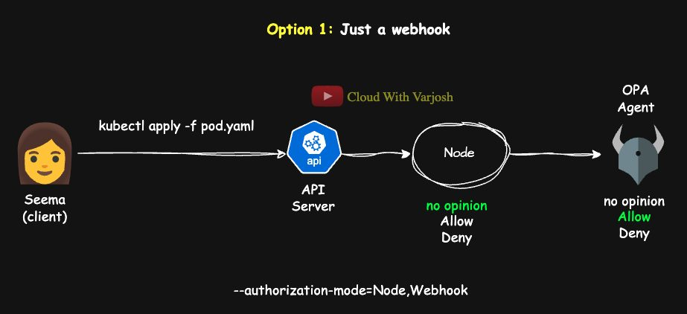
Node + Webhook
Node: no opinion → Webhook (OPA) checks identity/time/group → allow → admission OPA checks the image → admit or reject.
Scenario 2 – Node,Webhook,RBAC
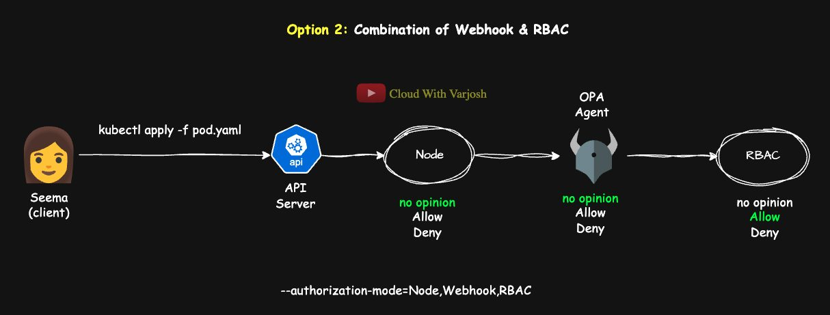
Node + Webhook + RBAC
Node: no opinion → Webhook: deny if a policy is broken, otherwise no opinion → RBAC: allow if Seema can create Pods → admission OPA validates the image.
Phase | Who | What's checked
Authorization | Node / Webhook / RBAC | Request metadata (user, groups, verb, resource, namespace)
Admission | OPA/Gatekeeper/Kyverno admission webhook | The full object (images, labels, security settings)

Part 13 — RBAC and Service Accounts (Days 36–37)

Day 36 — RBAC in Depth
Prerequisite: a certificate-based user such as seema (Day 34).

Building blocks
- Resources are either namespaced (Pods, Deployments, Services…) or cluster-scoped (Nodes, PersistentVolumes, Namespaces, StorageClasses…). Check with kubectl api-resources.
- Every resource supports certain verbs: kubectl api-resources -o wide.
Verb | Meaning | kubectl example
create | Create | kubectl create deployment nginx
delete | Delete one | kubectl delete pod nginx
deletecollection | Delete many | kubectl delete pods --all
get | Read one | kubectl get pod nginx -o yaml
list | List | kubectl get pods
patch | Partial change | kubectl patch deployment nginx ...
update | Replace/change | kubectl apply -f deployment.yaml
watch | Stream changes | kubectl get pods --watch

RBAC answers: who (user/group/service account), what resource, which action, where (namespace or cluster).
Object | Scope | Purpose | Used by
Role | Namespace | Permissions inside one namespace | RoleBinding
RoleBinding | Namespace | Gives a Role or ClusterRole to subjects in that namespace | –
ClusterRole | Cluster | Cluster-wide permissions, or a reusable set for many namespaces | RoleBinding or ClusterRoleBinding
ClusterRoleBinding | Cluster | Gives a ClusterRole to subjects everywhere | –

Set up a working namespace
BASH
kubectl create ns dev
kubectl create ns prod
kubectl config set-context --current --namespace=dev

1. Role + RoleBinding (namespaced)
A Role always lives in a namespace and cannot grant cluster-scoped resources such as nodes.
Seema (and the group junior-admins) should create and list Pods and Deployments in dev:
YAML
apiVersion: rbac.authorization.k8s.io/v1
kind: Role
metadata:
namespace: dev
name: workload-editor
rules:
- apiGroups: [""] # core group → pods
resources: ["pods"]
verbs: ["create", "list"]
- apiGroups: ["apps"] # apps group → deployments
resources: ["deployments"]
verbs: ["create", "list"]
---
apiVersion: rbac.authorization.k8s.io/v1
kind: RoleBinding
metadata:
name: bind-workload-editor
namespace: dev
subjects:
- kind: User
name: seema
apiGroup: rbac.authorization.k8s.io
- kind: Group
name: junior-admins
apiGroup: rbac.authorization.k8s.io
roleRef:
kind: Role
name: workload-editor
apiGroup: rbac.authorization.k8s.io
- A Role can have many rules; a binding can list many subjects (User, Group, ServiceAccount).
- roleRef can't be changed after creation — delete and recreate the binding instead.
ServiceAccount subjects need apiGroup: "" (or omit it) and the SA's namespace:
YAML
- kind: ServiceAccount
name: my-service-account
namespace: dev
apiGroup: ""
What happens on kubectl create deployment nginx --image=nginx -n dev as Seema: the API server authenticates her (cert CN=seema), finds RoleBindings in dev naming her, sees workload-editor allows create on deployments in apps, and lets the request through.
Imperative equivalents:
BASH
kubectl create role workload-editor --verb=create,list --resource=pods,deployments.apps -n dev
kubectl create rolebinding bind-workload-editor --role=workload-editor --user=seema --group=junior-admins -n dev

2. ClusterRole + ClusterRoleBinding
ClusterRoles aren't only for cluster-scoped resources. Bound with a ClusterRoleBinding, a ClusterRole on a namespaced resource (e.g. Deployments) grants it in every namespace.
Seema needs to read nodes (cluster-scoped, so a Role can't do it):
YAML
apiVersion: rbac.authorization.k8s.io/v1
kind: ClusterRole
metadata:
name: node-reader
rules:
- apiGroups: [""]
resources: ["nodes"]
verbs: ["get", "list", "watch"]
---
apiVersion: rbac.authorization.k8s.io/v1
kind: ClusterRoleBinding
metadata:
name: bind-node-reader
subjects:
- kind: User
name: seema
apiGroup: rbac.authorization.k8s.io
roleRef:
kind: ClusterRole
name: node-reader
apiGroup: rbac.authorization.k8s.io
BASH
kubectl auth can-i create pods --namespace=dev --as=seema # yes
kubectl auth can-i get nodes --as=seema # yes
kubectl auth can-i --list --as=seema -n dev # everything she can do

3. Reusing a ClusterRole in one namespace (RoleBinding → ClusterRole)
Define the permission set once as a ClusterRole, then grant it per namespace with RoleBindings. The rules apply only in the RoleBinding's namespace.
YAML
apiVersion: rbac.authorization.k8s.io/v1
kind: ClusterRole
metadata:
name: elevated-workload-editor
rules:
- apiGroups: [""]
resources: ["pods"]
verbs: ["create", "delete", "update"]
- apiGroups: ["apps"]
resources: ["deployments"]
verbs: ["create", "delete", "update", "patch"]
---
apiVersion: rbac.authorization.k8s.io/v1
kind: RoleBinding
metadata:
name: use-clusterrole-in-prod
namespace: prod # only valid in prod
roleRef:
kind: ClusterRole
name: elevated-workload-editor
apiGroup: rbac.authorization.k8s.io
subjects:
- kind: User
name: seema
apiGroup: rbac.authorization.k8s.io
Create more RoleBindings in staging, test… to reuse it without duplicating rules. Kubernetes ships useful built-in ClusterRoles: view, edit, admin, cluster-admin.

Best practices
- Least privilege – grant only what's needed.
- Role + RoleBinding for namespace work; ClusterRole + ClusterRoleBinding only for genuinely cluster-wide needs.
- Bind to groups and service accounts rather than many individuals.
- ServiceAccount subjects: apiGroup: "" plus namespace.
- Reuse ClusterRoles via RoleBindings.
- Audit regularly and verify with kubectl auth can-i.

Day 37 — Authentication and Service Accounts

How Kubernetes authenticates
Authentication is always the first step, and it is always done by the API server. Kubernetes has no built-in user database — you can't create user. Humans are managed outside (certificates, OIDC, proxies). ServiceAccounts are the one kind of identity Kubernetes creates itself, for non-human access.
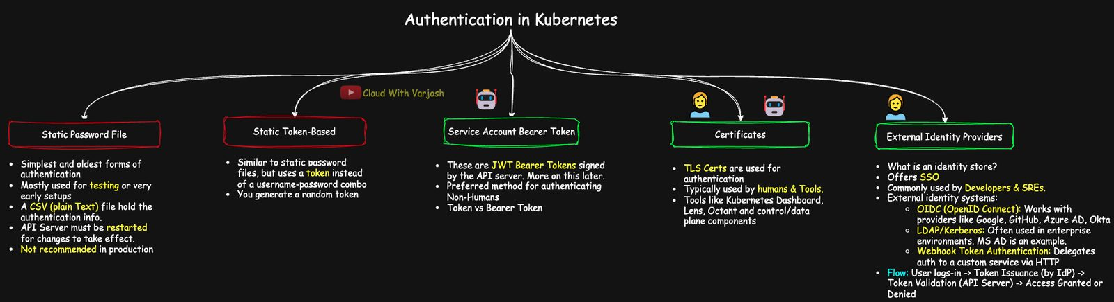
Authentication methods
1. Static password file (basic auth) — CSV password,username,uid,"group1,group2" passed with --basic-auth-file. Plain text, no rotation, no audit — and removed in Kubernetes v1.19. History only.
2a. Static token file — CSV token,username,uid,"groups" via --token-auth-file=/etc/kubernetes/tokens.csv; used as curl -H "Authorization: Bearer abcd1234token" https://<cluster>/api. Needs an API server restart to change; plain text; not for production.
2b. ServiceAccount tokens — the most common tokens. JWTs signed by the control plane, sent as bearer tokens:
BASH
TOKEN=$(cat /var/run/secrets/kubernetes.io/serviceaccount/token)
curl -H "Authorization: Bearer $TOKEN" https://<cluster-endpoint>/api
A bearer token means "whoever holds it is authenticated" — protect it like a password.
3. Client certificates (X.509) — present a certificate signed by a CA listed in --client-ca-file. Used by kubelet, controller-manager, kubectl and human users (Day 34). Strong and recommended.
4. External identity providers — centralised identity, SSO and MFA:
- OIDC (Google, GitHub, Azure AD/Entra ID, Okta):
BASH
--oidc-issuer-url=<issuer-url>
--oidc-client-id=<client-id>
--oidc-username-claim=<claim> # default "sub"
--oidc-groups-claim=<claim>
--oidc-ca-file=<ca-file>
- Webhook token authentication – --authentication-token-webhook-config-file=/path/to/webhook-config.yaml; an external service validates tokens.
- LDAP / Kerberos / Active Directory – no native flags; integrate through an authenticating proxy or a webhook.
Flow: user logs in to the IdP → IdP issues a token (JWT) → user sends it to Kubernetes → API server validates it → access granted/denied (then RBAC).

Who talks to the cluster?
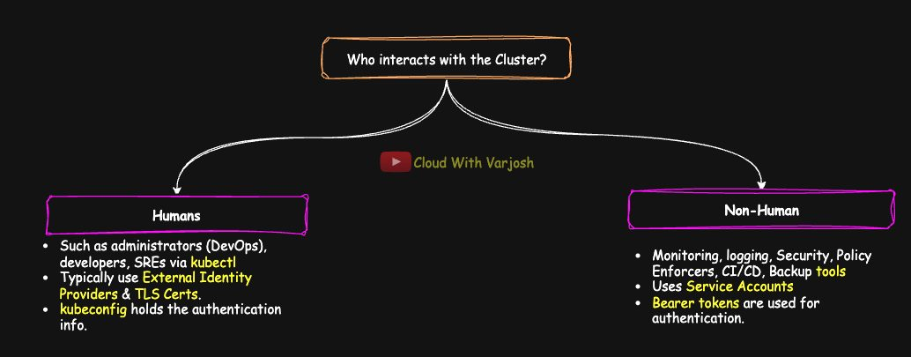
Humans and machines
- Humans – admins, developers, SREs via kubectl, dashboards, client tools.
- Non-humans – automation, inside or outside the cluster → should use ServiceAccounts.

Service Accounts
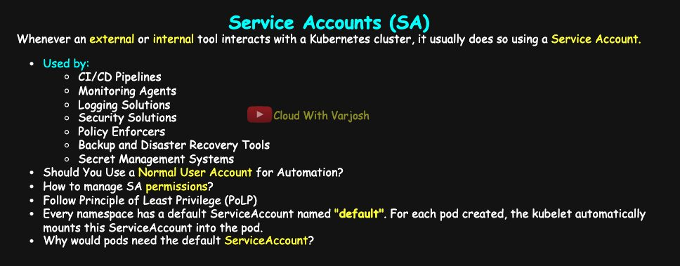
Service accounts
Identities for workloads and tools: CI/CD (Jenkins, GitLab), monitoring (Prometheus, Datadog), logging (Fluentd, Loki), security (Falco, Aqua), policy (OPA/Gatekeeper, Kyverno), backup (Velero), secret managers (Vault).
Why not use a human account for automation? Audit logs become ambiguous (User 'admin' created a pod vs ServiceAccount 'jenkins-deployer' created a pod), a compromised account affects both humans and pipelines, and permissions end up too broad. Give SAs clear names (cicd-account, monitoring-agent) and least-privilege RBAC: a monitoring agent needs only get/list/watch; a pipeline needs create/patch in specific namespaces, not cluster-admin.

Pods and ServiceAccounts
- Every namespace automatically gets a default ServiceAccount; Pods use it unless told otherwise. It has no RBAC permissions beyond basic API discovery unless you grant some.
- Choose an SA with serviceAccountName; stop token mounting with automountServiceAccountToken: false.
YAML
apiVersion: apps/v1
kind: Deployment
metadata:
name: my-app
spec:
replicas: 1
selector:
matchLabels:
app: my-app
template:
metadata:
labels:
app: my-app
spec:
serviceAccountName: jenkins-sa
automountServiceAccountToken: true # false = mount no token
containers:
- name: my-app-container
image: my-app-image:v1
Token evolution
 | Before v1.24 | v1.24 and later
Creation | A Secret with a token auto-created for every SA | No Secret created
Lifetime | Never expires | Short-lived (about 1 h, auto-refreshed)
Storage | In etcd as a Secret | Projected into the Pod, not stored
Risk if leaked | Usable forever | Time-bound and audience-bound

What's mounted — kubectl describe pod shows /var/run/secrets/kubernetes.io/serviceaccount from kube-api-access-xxxxx (ro):
- ca.crt – cluster CA, to verify the API server
- namespace – the Pod's namespace
- token – the JWT (decode it at jwt.io to see iss, sub, aud, exp, and the kid header naming the signing key)

How a Pod authenticates
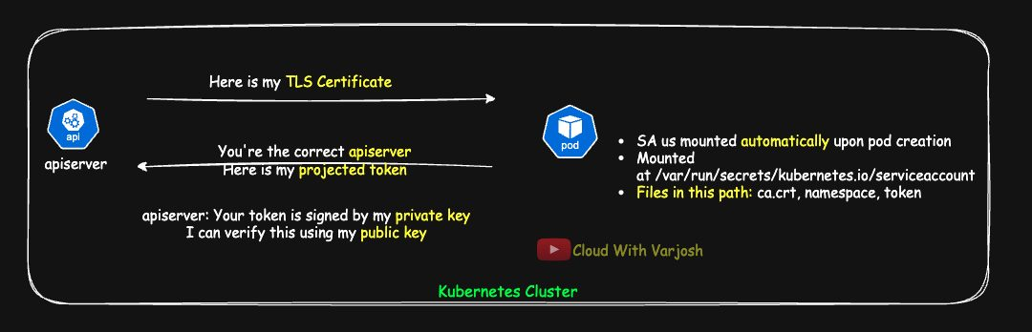
Pod authentication
- A ServiceAccount is attached to every Pod (Deployments, StatefulSets, Jobs, DaemonSets… or bare Pods).
- Its credentials are projected into /var/run/secrets/kubernetes.io/serviceaccount.
- The Pod (client) connects to the API server; it verifies the API server's certificate using ca.crt, then sends the token in Authorization: Bearer. (Only the server presents a certificate — not full mTLS.)
- The API server checks the token's signature with its public key and identifies the caller as system:serviceaccount:<ns>:<name>, in groups system:serviceaccounts and system:serviceaccounts:<ns>.
- RBAC then decides what it may do.
Tools such as monitoring/logging DaemonSets are usually installed with Helm, which creates their ServiceAccount, RBAC rules, DaemonSet, Services and CRDs together.

Three kinds of SA token
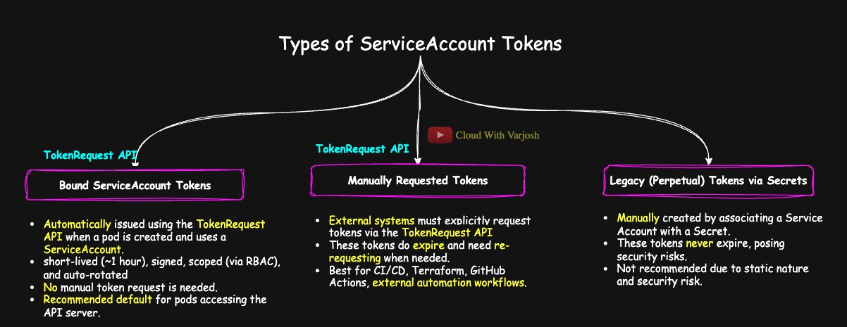
Token types
Type | Who | How obtained | Lifetime | Rotation | Recommended
Projected (bound) token | Pods | Automatically via the TokenRequest API | ~1 h | Automatic (kubelet) | ✅
Manual TokenRequest | External tools | kubectl create token / API call | You choose | Tool must request again | ✅
Legacy Secret token | Old systems | Secret of type kubernetes.io/service-account-token | Never expires | None | ❌

Non-human access patterns
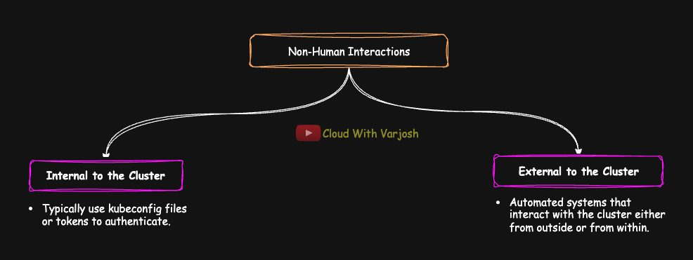
Non-human access
Inside the cluster (projected tokens + RBAC):
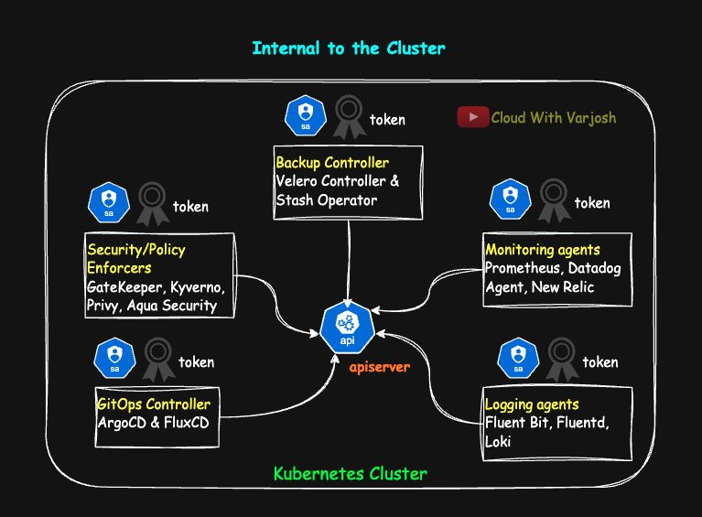
Internal
monitoring (Prometheus, Datadog), logging (Fluent Bit, Loki), security (Trivy Operator, Aqua, Prisma defenders), policy (Kyverno, Gatekeeper, Falco), exporters (node-exporter, kube-state-metrics), GitOps (Argo CD, Flux — pull from Git and apply), backup controllers (Velero, Stash). Prometheus needs get/list/watch on endpoints, pods, services; Argo CD may need much more. Give each tool its own SA with minimum rights.
Agent–controller model: the in-cluster agent talks to the API server and pushes data to an external dashboard; the dashboard itself never calls the API server.
Outside the cluster:
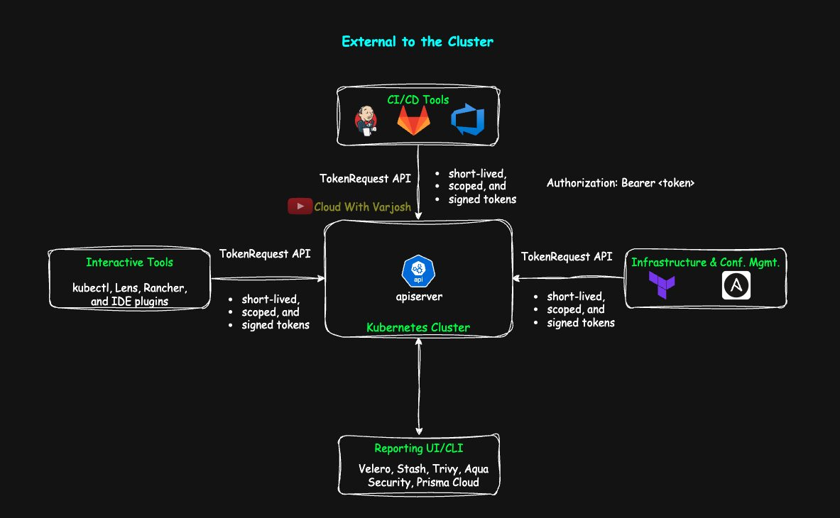
External
CI/CD (Jenkins, GitLab, GitHub Actions), IaC (Terraform, Pulumi, Ansible), config management (Chef, Puppet), CLIs (Velero, Trivy). Best: short-lived tokens from the TokenRequest API (since v1.12). Long-lived tokens or client certs in kubeconfigs are legacy — phase them out.
TokenRequest flow: admin creates the SA + RBAC (and allows create on serviceaccounts/token for whoever requests tokens) → the tool requests a token → the API server returns a signed, short-lived, audience-bound JWT → the tool uses it as a bearer token → when it expires the tool requests a new one.
Category | Runs | Auth method | Examples
CI/CD | External | TokenRequest token | Jenkins, GitLab CI, GitHub Actions
Infra automation | External | TokenRequest token | Terraform, Pulumi, Ansible
Monitoring/logging/security agents | Internal | Projected token | Prometheus, Fluent Bit, Falco
Backup controllers | Internal | Projected token | Velero, Stash
GitOps | Internal | Projected token | Argo CD, Flux
Hybrid with external UI | Both | Agents use SA; UI gets pushed data | Prisma Cloud, Velero, Argo CD

Demo: a ServiceAccount for Jenkins
1. Create the SA
BASH
kubectl create ns jenkins
kubectl create sa jenkins-sa -n jenkins
2. Grant permissions
YAML
apiVersion: rbac.authorization.k8s.io/v1
kind: ClusterRole
metadata:
name: jenkins-cluster-role
rules:
- apiGroups: [""]
resources: ["pods", "services", "endpoints"]
verbs: ["get", "list", "watch", "create", "delete", "patch", "update"]
- apiGroups: ["apps"]
resources: ["deployments", "replicasets"]
verbs: ["get", "list", "watch", "create", "delete", "patch", "update"]
---
apiVersion: rbac.authorization.k8s.io/v1
kind: ClusterRoleBinding
metadata:
name: jenkins-cluster-rolebinding
subjects:
- kind: ServiceAccount
name: jenkins-sa
namespace: jenkins
apiGroup: ""
roleRef:
kind: ClusterRole
name: jenkins-cluster-role
apiGroup: rbac.authorization.k8s.io
3. Legacy long-lived token (avoid in production)
YAML
apiVersion: v1
kind: Secret
metadata:
name: jenkins-sa-secret
namespace: jenkins
annotations:
kubernetes.io/service-account.name: jenkins-sa
type: kubernetes.io/service-account-token
BASH
kubectl apply -f secret.yaml
kubectl describe -n jenkins secret jenkins-sa-secret # token shown; no "exp" claim on jwt.io
4. Short-lived token (recommended)
BASH
kubectl create token jenkins-sa --namespace=jenkins # default ~1 h
kubectl create token jenkins-sa -n jenkins --duration=30m
Or call the TokenRequest API directly:
BASH
curl -X POST "https://<api-server-url>/api/v1/namespaces/jenkins/serviceaccounts/jenkins-sa/token" \
-H "Authorization: Bearer $TOKEN" \
-H "Content-Type: application/json" \
-d '{"kind":"TokenRequest","apiVersion":"authentication.k8s.io/v1",
"spec":{"audiences":["kubernetes"],"expirationSeconds":3600}}'
5. Use it
BASH
curl -H "Authorization: Bearer <TOKEN>" https://<api-server-url>/api/v1/pods -k
kubectl auth can-i list pods --as=system:serviceaccount:jenkins:jenkins-sa
Takeaways: Secret-based tokens are legacy; projected tokens rotate themselves; external tools should request tokens on demand instead of storing long-lived credentials.

Part 14 — Admission Controllers, CRDs and Operators (Days 38–40)

Day 38 — Admission Controllers (Mutating and Validating)

Where admission fits
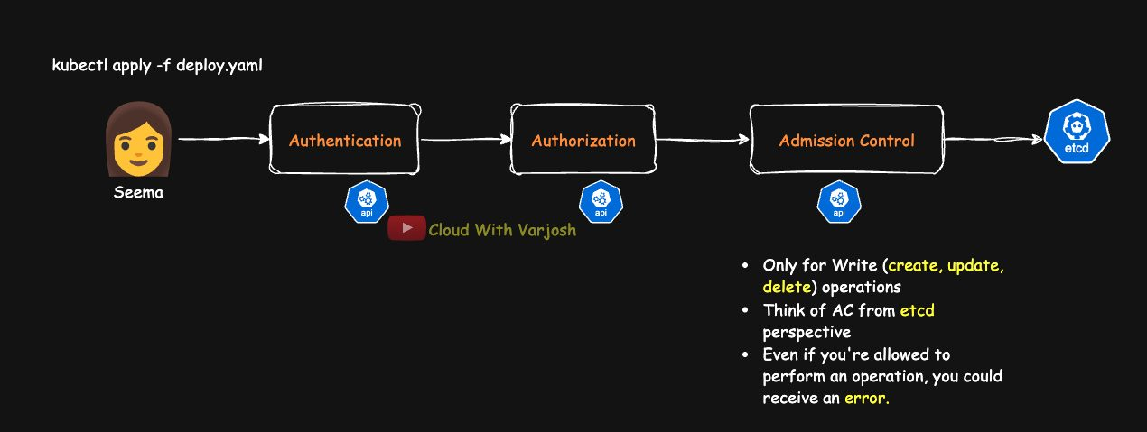
Request lifecycle
kubectl → Authentication → Authorization → Admission control → etcd
Admission controllers are the last gate before an object is saved to etcd. They don't decide who can access the cluster (authN/authZ did that) — they decide whether this object is acceptable, and may change it first.
- They act only on write requests: CREATE, UPDATE, DELETE (and CONNECT) — never on GET, LIST, WATCH.
- If admission rejects, nothing is stored.
Uses: enforce security and governance, validate configuration, apply defaults, ensure compliance.
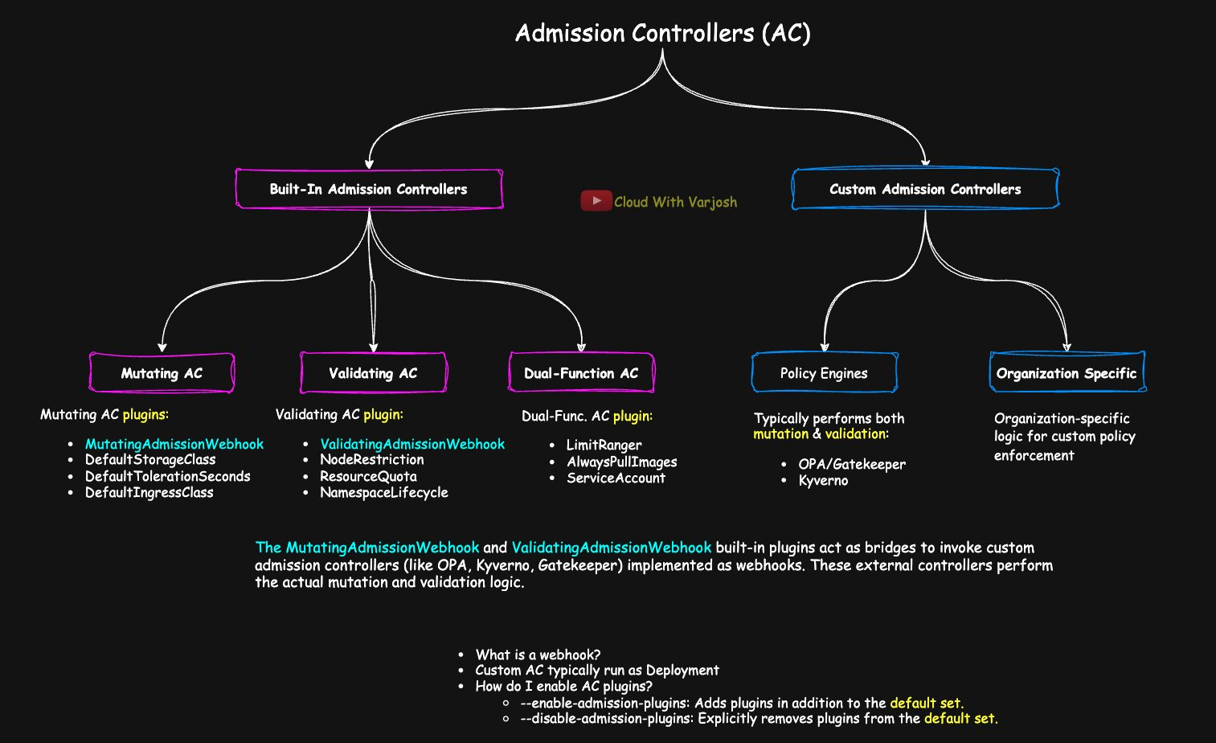
Admission overview

Mutating vs validating
- Mutating controllers change the object (add defaults, inject sidecars, set a ServiceAccount).
- Validating controllers accept or reject the final object, without changing it.
- All mutating run first, then all validating, so validation sees the final version. Any validating rejection denies the request.
- Mutating webhooks are designed to transform; enforcement is the validating phase's job.
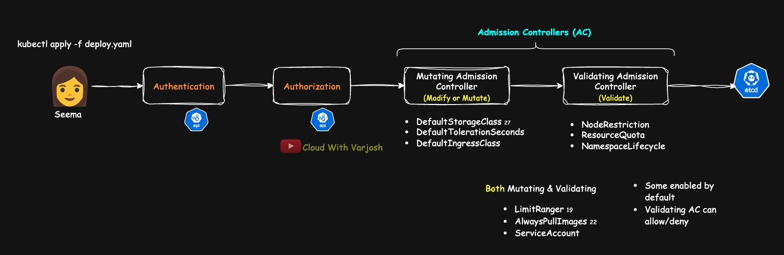
Built-in categories

Built-in admission plugins (a selection)
Mutating
Plugin | What it does | Default on
MutatingAdmissionWebhook | Calls external mutating webhooks (e.g. Istio sidecar injection, default labels) | Yes
DefaultStorageClass | Adds the default StorageClass to PVCs that don't name one | Yes
DefaultTolerationSeconds | Adds default tolerationSeconds (300 s) for not-ready/unreachable NoExecute taints | Yes
DefaultIngressClass | Adds the default IngressClass to Ingresses without one | Yes

Validating
Plugin | What it does | Default on
NodeRestriction | Kubelets may only modify their own Node and Pods bound to them | Enabled by kubeadm
ValidatingAdmissionWebhook | Calls external validating webhooks (OPA/Gatekeeper, Kyverno…) | Yes
PodSecurity | Enforces Pod Security Standards (Privileged, Baseline, Restricted) per namespace; replaced PodSecurityPolicy | Yes (since v1.25)
ResourceQuota | Enforces namespace quotas | Yes
NamespaceLifecycle | Blocks creating objects in missing or terminating namespaces; protects system namespaces | Yes

Both (mutate + validate)
Plugin | What it does | Default on
LimitRanger | Applies LimitRange defaults and checks min/max | Yes
ServiceAccount | Assigns the default SA, mounts its token, checks the SA exists | Yes
AlwaysPullImages | Forces imagePullPolicy: Always so cached images can't be reused by others | No

Enabling and checking plugins
BASH
grep admission-plugins /etc/kubernetes/manifests/kube-apiserver.yaml
# --enable-admission-plugins=NodeRestriction
ps -aux | grep kube-apiserver # if it runs as a systemd service
Even if only NodeRestriction is listed, the default set is still active (ServiceAccount, NamespaceLifecycle, LimitRanger, ResourceQuota, DefaultStorageClass…).
- --enable-admission-plugins=... adds plugins on top of the defaults.
- --disable-admission-plugins=... turns defaults off.
BASH
kube-apiserver --enable-admission-plugins=NamespaceLifecycle,LimitRanger,PodSecurity
On kubeadm edit the static Pod manifest; for systemd, the unit file.

Custom admission controllers = webhooks
A webhook is an HTTP callback: "Before I accept this, do you want to approve, reject or modify it?"
- Run a webhook server — usually a Deployment inside the cluster (outside is possible but adds networking/TLS/availability complexity).
- Register it with a MutatingWebhookConfiguration or ValidatingWebhookConfiguration (which operations/resources to send).
- The API server sends matching requests (an AdmissionReview); the webhook replies allowed: true/false, optionally with a JSON patch.
MutatingAdmissionWebhook and ValidatingAdmissionWebhook are the bridges to these custom controllers.
Use case | Tooling
Require labels on all Deployments | Kyverno (mutating/validating webhook)
Deny containers running as root | PodSecurity / validating webhook
Auto-inject sidecars | Istio (mutating webhook)
Block images from public registries | OPA/Gatekeeper (validating webhook)
Default tolerations | DefaultTolerationSeconds

OPA: authorization webhook vs admission controller
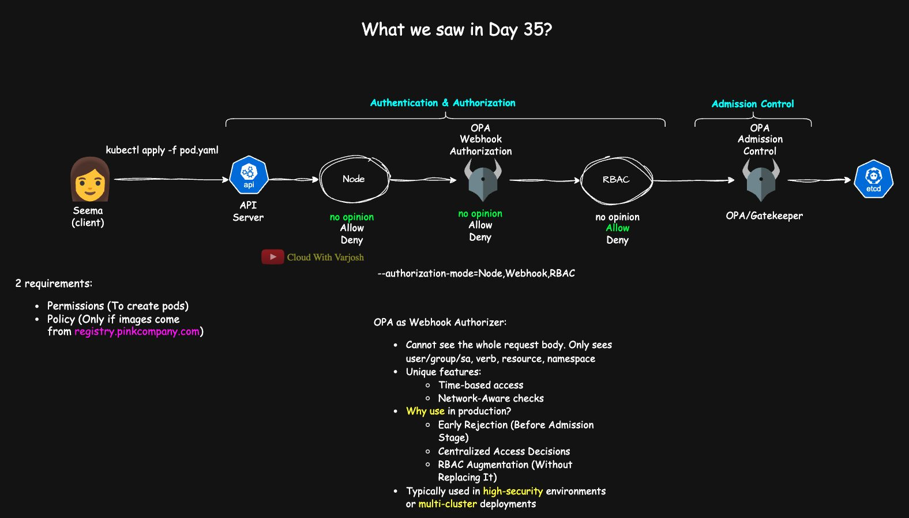
OPA in two roles
Open Policy Agent (OPA) is a general policy engine (CNCF graduated) using the Rego language. Gatekeeper is its Kubernetes-native sub-project.
Role | Configured via | Answers | Sees | Results
Webhook authorizer | --authorization-mode=Webhook | Who may do what? | User, groups, verb, resource, namespace — not the object | Allow / Deny / No opinion
Admission controller | Validating/Mutating webhooks | Under what conditions? | Full object (spec, images, labels…) | Validate / Mutate

OPA as webhook authorizer — for context RBAC can't express: is the user active in HR? is it after business hours? did the request come from the corporate VPN? only team X may touch prod. Benefits: rejects early, centralised decisions across many clusters, augments (doesn't replace) RBAC. Rare in practice — mainly high-security or multi-cluster environments.
Gatekeeper as admission controller — sees the whole request: Pod/Deployment specs, images and registries, security contexts (privileged, runAsUser, capabilities), labels, annotations, limits, CRD fields, volumes, probes, init containers.
- Validation (its strength) via Rego ConstraintTemplate + Constraint CRDs: trusted registries, no privileged containers, mandatory team/env labels, naming rules.
- Mutation only through mutation CRDs (Assign, AssignMetadata, ModifySet) — not free-form Rego.
- Also audit and dry-run modes.
- Limits: can't decide who (that's RBAC); limited mutation; no resource generation; Rego learning curve; no native image-signature verification.
Kyverno vs Gatekeeper
 | Kyverno | Gatekeeper
Policy language | Plain Kubernetes YAML | Rego
Mutation | Powerful (patches, conditions, add sidecars, nested lists) | Limited CRDs
Generate resources | Yes (default NetworkPolicies, quotas, ConfigMaps, namespace templates) | No
Image signature verification | Yes | No (natively)
Best for | Easy authoring, mutation, automation | Strict, complex validation and compliance

Rule of thumb: user-based rules → authorization (RBAC, maybe webhook). Object-content rules → admission. The "only images from registry.pinkcompany.com" rule from Day 35 is an admission policy.

What production clusters typically run
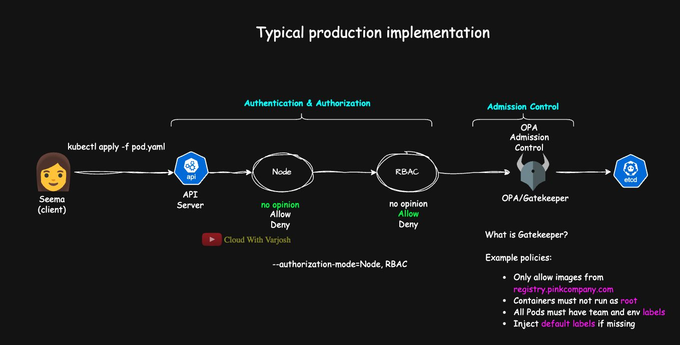
Production model
BASH
--authorization-mode=Node,RBAC
--enable-admission-plugins=MutatingAdmissionWebhook,ValidatingAdmissionWebhook,PodSecurity,ResourceQuota
Node authorizer for kubelets, RBAC as the backbone, webhook authorization rarely, and admission webhooks (Gatekeeper or Kyverno) widely. The exact mix depends on compliance needs (CIS, PCI, HIPAA), latency tolerance and tenancy model. You can also write your own webhook in Go/Java/Python.
Scenario | Webhook authorization | Admission controllers
Identity-based access | ✅ | ❌
Rules on object specs | ❌ | ✅
Mutate/inject values | ❌ | ✅
Multi-cluster governance | ✅ | ✅

Execution sequence
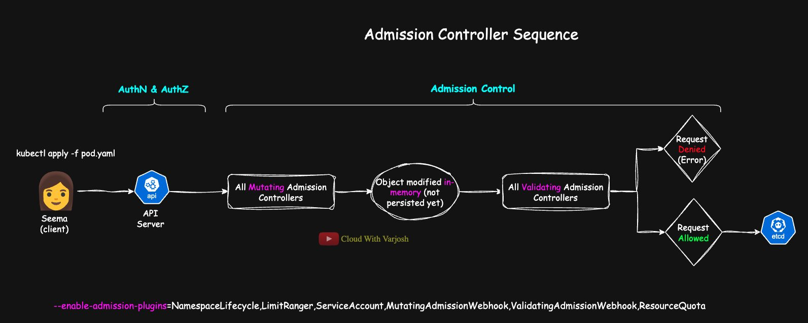
Execution order
- Mutating phase — every plugin with mutating logic (pure mutators plus the mutating half of dual plugins like LimitRanger and ServiceAccount), then the mutating webhooks.
- The object is changed in memory.
- Schema validation of the mutated object.
- Validating phase — every plugin with validating logic (PodSecurity, ResourceQuota, NamespaceLifecycle, the validating half of dual plugins), then validating webhooks.
- Any rejection → error to the user. All pass → saved to etcd.
The API server runs plugins in its own fixed internal order; the order you type in --enable-admission-plugins doesn't change it. Dual-function plugins are split: their mutating part runs in phase 1, their validating part in phase 4.

Day 39 — Custom Resources (CR) and Custom Resource Definitions (CRD)

Resources and custom resources
Everything you manage in Kubernetes is a resource exposed by the API (kubectl api-resources).
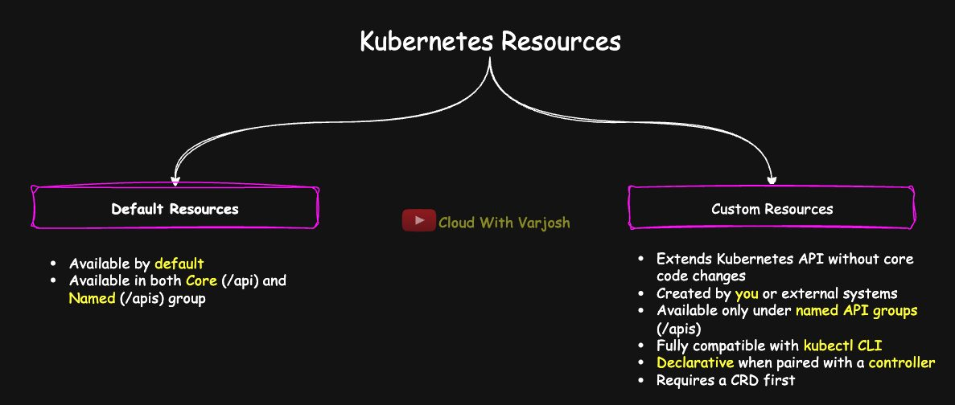
Custom resources
A Custom Resource (CR) is a new type of object you add to the API.
- Created by you or by an external tool.
- Lives only under named groups (/apis/<group>/<version>), never the core /api.
- Extends the API without changing or rebuilding Kubernetes.
- Works with kubectl like any built-in (get, describe, apply, delete).
- Represents desired state; paired with a controller it becomes declarative automation.
A CustomResourceDefinition (CRD) is itself a Kubernetes object that registers the new type: group, version(s), names (plural, singular, kind, shortNames), scope, and an OpenAPI v3 validation schema.
Built-in resources have the same kind of definition, compiled into the API server. Explore them with:
BASH
kubectl explain deployment.spec
kubectl explain pod.spec.containers
kubectl get --raw /openapi/v2 | jq .
or the Kubernetes API reference docs.

Controllers and the control loop
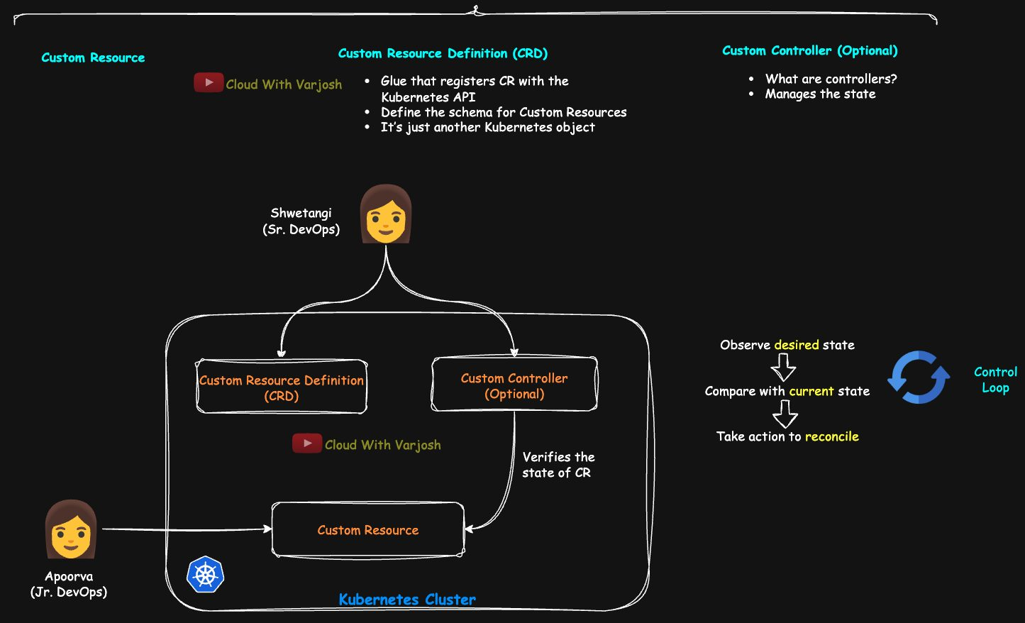
Controllers
kube-controller-manager bundles many built-in controllers. Each runs a control loop:
Observe current state → compare with desired state (.spec) → act to reconcile.
Thermostat analogy: set 22°C, room is 18°C, heater turns on until it reaches 22°C.
Example: a Deployment with replicas: 3 loses a Pod → the controller sees 2, wants 3, creates one.
A CRD alone is passive — Kubernetes stores CRs but does nothing with them. A custom controller watches your CRs (via informers/cache), compares .spec with reality and creates Jobs, ConfigMaps, Deployments, etc. It writes what actually happened into .status.
GO
for {
// 1. read the latest custom resource
// 2. compare desired vs actual
// 3. act if they differ
}
Tools: Kubebuilder, controller-runtime, Operator SDK (with OLM). Writing controllers isn't on the CKA, but understanding the loop is.
Not every resource has a controller. ConfigMaps, Secrets and standalone Pods don't. Deployments, StatefulSets, DaemonSets, ReplicaSets, Jobs, CronJobs and HPAs do. Rule: if it defines a desired state that can drift, it gets a controller.

Demo: a BackupPolicy CRD
Why not just a CronJob? A CRD + controller can offer PVC awareness, retention (retentionDays), backup validation, app-specific hooks and one declarative config object.
Feature | CronJob | BackupPolicy CRD + controller
Scheduling | ✅ | ✅
PVC awareness | Manual volumeMounts | Field in the CR
Retention | ❌ | ✅ retentionDays
Validation / hooks | Extra scripts | Built into controller
Single declarative config | ❌ | ✅

YAML
apiVersion: apiextensions.k8s.io/v1
kind: CustomResourceDefinition
metadata:
name: backuppolicies.ops.cloudwithvarjosh # must be <plural>.<group>
spec:
group: ops.cloudwithvarjosh # used in apiVersion
names:
plural: backuppolicies # URL / CLI name
singular: backuppolicy
kind: BackupPolicy # used in 'kind:'
shortNames: [bp] # kubectl get bp
scope: Namespaced # or Cluster
versions:
- name: v1
served: true # exposed by the API
storage: true # the version stored in etcd
schema:
openAPIV3Schema:
type: object
properties:
spec:
type: object
properties:
schedule:
type: string # cron, e.g. "0 1 * * *"
retentionDays:
type: integer # how long to keep backups
targetPVC:
type: string # PVC to back up
BASH
kubectl apply -f crd.yaml
kubectl get crd backuppolicies.ops.cloudwithvarjosh
kubectl api-resources | grep backup
# backuppolicies bp ops.cloudwithvarjosh/v1 true BackupPolicy
The custom resource:
YAML
apiVersion: ops.cloudwithvarjosh/v1
kind: BackupPolicy
metadata:
name: mysql-backup
namespace: default
spec:
schedule: "0 1 * * *" # 01:00 every day
retentionDays: 7
targetPVC: mysql-data-pvc
BASH
kubectl apply -f cr.yaml
kubectl get backuppolicies # or: kubectl get bp
kubectl describe backuppolicy mysql-backup
kubectl get backuppolicy mysql-backup -o yaml
kubectl delete -f cr.yaml && kubectl delete -f crd.yaml
Nothing is backed up — there's no controller yet. A real controller would create CronJobs/Jobs mounting the PVC, upload to S3, tag backups, delete expired ones, alert on failures and record lastBackupTime/success in .status. Teams write only intent; platform engineers encode the logic. Real examples: Velero, internal platform abstractions, GitOps DR workflows.

Day 40 — Kubernetes Operators

Stateless vs stateful
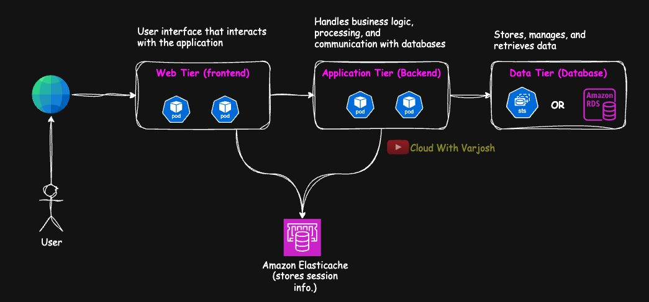
Stateless
Stateless: the app keeps no user/session data inside the Pod; it uses external stores (e.g. sessions in Redis/ElastiCache). Pod-1 dies → Pod-2 reads the same session. Any Pod can serve any request, so it scales and recovers freely (Deployments).
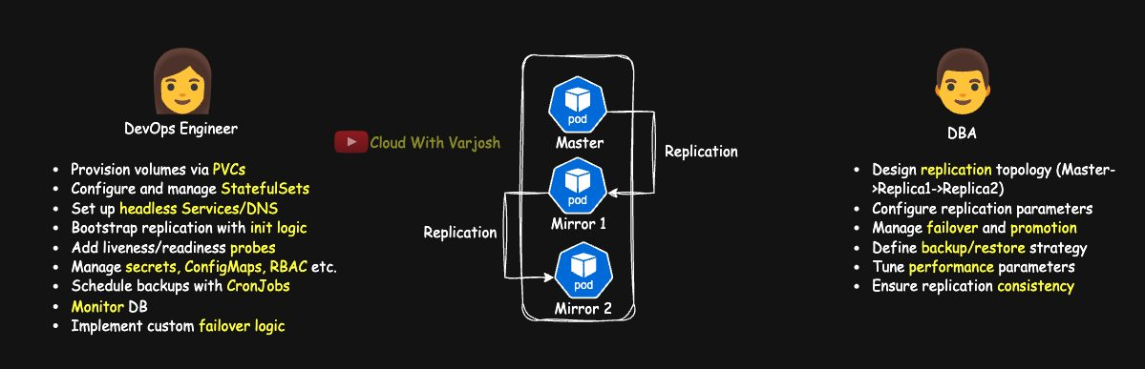
Stateful
Stateful: data lives with the app (databases — PostgreSQL, MySQL, MongoDB). Replicas must stay consistent; failover needs promotion logic; Pods need stable identity, their own volumes and ordered start-up (StatefulSets, PVCs, headless Services — Day 44).
Running a database by hand on Kubernetes needs:
- DevOps: PVCs/StorageClasses, StatefulSets, headless Services/DNS, replication bootstrap scripts, probes, Secrets/SAs/RBAC, backup CronJobs, Prometheus/Grafana monitoring, failover scripts.
- DBA: replication topology, replication settings (WAL, slots, credentials), promotion during failover, backup/restore, tuning, zero-downtime schema migrations, detecting drift/split-brain.

What an Operator is
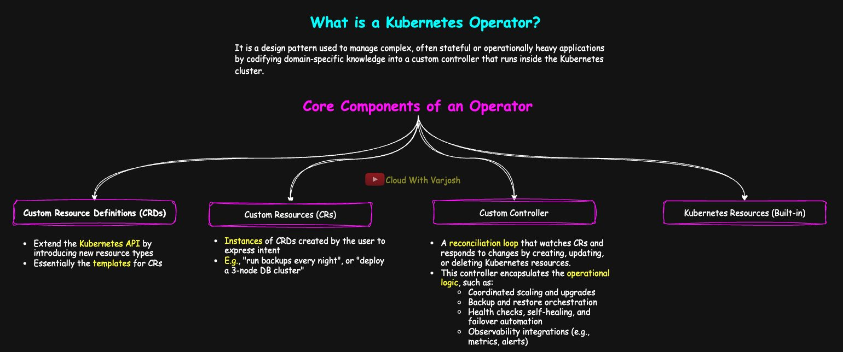
Operator
An Operator is a pattern: a custom controller + CRDs that encodes a human operator's knowledge so the software manages an application's whole lifecycle — install, configuration, upgrades, scaling, backups, failover, monitoring — continuously reconciling desired and actual state.
Components
- CRDs – new types such as KafkaCluster, BackupPolicy, MySQLReplicaSet.
- CRs – your intent ("3-node DB cluster", "back up nightly").
- Custom controller – reconciliation logic: coordinated scaling/upgrades, backup/restore, health checks, self-healing, failover, metrics/alerts.
- Built-in resources it creates – StatefulSets, Deployments, Jobs, Services, Ingress, PVCs, Secrets, ConfigMaps, ServiceAccounts.
Installing an operator brings its CRDs and controller; you interact by creating CRs.
Operator
└── Custom controller
├── watches: Custom Resources
├── reads: CRDs
└── creates: StatefulSets/Deployments, Services/Ingress,
ConfigMaps/Secrets, PVCs, Jobs/CronJobs…
Operators aren't just for databases — monitoring (Prometheus, Thanos), security (cert-manager, Kyverno), backup (Velero), networking (Istio, Cilium), CI/CD/GitOps (Argo CD, Flux), and your own internal apps. If something must be continuously reconciled, it's a good Operator candidate. Browse OperatorHub.io.
Helm/Kustomize are still relevant — they template and install resources; Operators manage runtime lifecycle. Use them together: install an Operator with Helm, template CRs with Helm; some operators are even built from Helm charts.

Revisited: the BackupPolicy operator
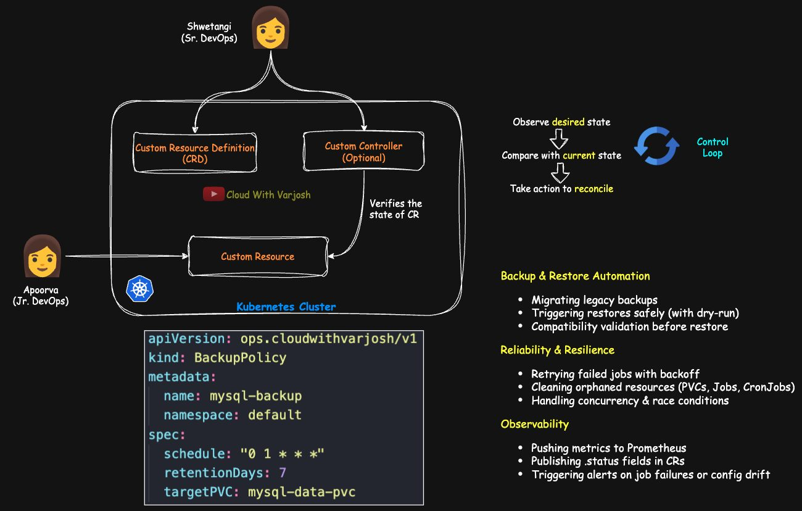
BackupPolicy operator
A basic controller would schedule CronJobs, clean expired backups and react to Pod restarts/PVC re-attachments. A mature operator adds: restore automation (dry-run, compatibility checks, migrating legacy backups); retries with back-off, orphan cleanup, concurrency safety; Prometheus metrics, .status updates, alerts on failure or drift; dynamic parallelism and staggering jobs to avoid I/O spikes.

Building operators
Framework | Language | Notes
Operator SDK (Go) | Go | Production-grade, built on controller-runtime
Kubebuilder | Go | Scaffolds APIs/controllers (used by Operator SDK)
Operator SDK (Ansible) | Ansible | Operators from playbooks
Operator SDK (Helm) | Helm | Operators from existing charts, no code
Metacontroller | Any (webhooks) | Lightweight
Java Operator SDK | Java | Quarkus / Spring Boot

Go-based operators are the most common in production.

Demo: the kube-green operator
kube-green scales down non-critical workloads at night/weekends (e.g. dev/staging) to save money.
1. Install OLM (Operator Lifecycle Manager) – manages installing and upgrading operators:
BASH
curl -sL https://github.com/operator-framework/operator-lifecycle-manager/releases/download/v0.32.0/install.sh | bash -s v0.32.0
2. Install kube-green (creates a Subscription in the operators namespace):
BASH
kubectl create -f https://operatorhub.io/install/kube-green.yaml
YAML
apiVersion: operators.coreos.com/v1alpha1
kind: Subscription
metadata:
name: my-kube-green
namespace: operators
spec:
channel: alpha
name: kube-green
source: operatorhubio-catalog
sourceNamespace: olm
3. Verify
BASH
kubectl get csv -n operators # ClusterServiceVersion → Succeeded
kubectl api-resources | grep sleepinfo # sleepinfos kube-green.com/v1alpha1 true SleepInfo
kubectl get crd | grep sleepinfo
4. Sample app – nginx Deployment with 2 replicas.
5. SleepInfo CR
YAML
apiVersion: kube-green.com/v1alpha1
kind: SleepInfo
metadata:
labels:
app: kube-green
name: sleepinfo-sample
spec:
excludeRef:
- apiVersion: apps/v1
kind: Deployment
name: critical-app # never put this one to sleep
sleepAt: '17:55'
wakeUpAt: '08:00'
weekdays: 0-6 # every day (0 = Sunday)
suspendCronJobs: true
timeZone: Asia/Kolkata
Field | Meaning
excludeRef | Objects to leave alone
sleepAt / wakeUpAt | When to scale down / restore
weekdays | Days it applies (cron notation)
suspendCronJobs | Also suspend CronJobs
timeZone | IANA time zone (default UTC)

6. Watch it work
BASH
kubectl apply -f sleepinfo.yaml
kubectl get deployment nginx -w # replicas drop to 0 at sleepAt
kubectl describe deployment nginx # events from kube-green
The operator's CRD (sleepinfos.kube-green.com) also shows a status subresource with lastScheduleTime and operation (SLEEP / WAKE_UP) — the controller reporting what it did.

Part 15 — Pod Security and Kustomize (Days 41–42)

Day 41 — Security Context and Linux Capabilities

Why bother? Containers often run as root
BASH
kubectl run debugpod --image=busybox -it --restart=Never -- sh
id
# uid=0(root) gid=0(root) groups=0(root),10(wheel)
- UID 0 is what makes you root — names like "root" are just labels from /etc/passwd//etc/group.
- wheel traditionally means "may use sudo".
Risks of root in a container: privilege escalation and container breakout if compromised; more access to host resources when isolation is weak; accidental damage to important files; failing compliance standards that require least privilege.
Some images already run as non-root (USER 1000 in the Dockerfile; distroless, Bitnami), but don't rely on the image — set the security context in the manifest yourself and enforce it with Pod Security Standards, Gatekeeper or Kyverno.
Kubernetes gives two main tools: security context (Pod + container level) and Linux capabilities (container level).

Security context fields
Pod level — spec.securityContext (applies to all containers):
Field | Meaning | Recommendation
runAsUser | UID for the processes (e.g. 1000); no username needed | Non-zero
runAsGroup | Primary GID for the processes | A non-root GID that fits your volumes
fsGroup | Supplementary GID; mounted volumes become group-owned by it, new files get this group | Set so non-root users can write volumes
runAsNonRoot | Kubelet refuses to start the container if it would run as UID 0 | Always true

Container level — spec.containers[].securityContext:
Field | Meaning | Recommendation
allowPrivilegeEscalation | Can a process gain more privileges than it started with (e.g. via setuid binaries, which run with the file owner's rights)? | false
privileged | Full host access – all capabilities and devices; effectively no isolation | Avoid (false) except for special system workloads
readOnlyRootFilesystem | Makes / read-only — no tampering with /etc, /var, binaries | true where possible
capabilities | Add/drop Linux capabilities | drop: ["ALL"], add only what's needed

Field | Pod | Container | Notes
runAsUser / runAsGroup / runAsNonRoot | ✅ | ✅ | Container overrides Pod
fsGroup | ✅ | ❌ | Pod only
allowPrivilegeEscalation, privileged, readOnlyRootFilesystem, capabilities | ❌ | ✅ | Container only

Demo 1: locked-down Pod
YAML
apiVersion: v1
kind: Pod
metadata:
name: secure-pod
spec:
securityContext:
runAsUser: 1000
runAsGroup: 3000
fsGroup: 2000
runAsNonRoot: true
containers:
- name: app
image: busybox
command: ["sh", "-c", "sleep 3600"]
securityContext:
allowPrivilegeEscalation: false
readOnlyRootFilesystem: true
BASH
kubectl exec -it secure-pod -- sh
id # uid=1000 gid=3000 groups=2000,3000
mkdir test_dir # Read-only file system
sudo su # sudo: not found
su - # su: must be suid to work properly
whoami # whoami: unknown uid 1000
- uid=1000 ← runAsUser; gid=3000 ← runAsGroup; groups=2000,3000 ← fsGroup + primary group.
- whoami fails only because UID 1000 has no entry in the image's /etc/passwd — harmless; Linux works with numbers, names are cosmetic.
- Escalation fails: no sudo in the image, and allowPrivilegeEscalation: false blocks setuid tricks anyway.

Demo 2: read-only root, but a writable volume via fsGroup
YAML
apiVersion: v1
kind: Pod
metadata:
name: secure-writable
spec:
securityContext:
runAsUser: 1000
runAsGroup: 3000
fsGroup: 2000
runAsNonRoot: true
containers:
- name: app
image: busybox
command: ["sh", "-c", "sleep 3600"]
securityContext:
allowPrivilegeEscalation: false
readOnlyRootFilesystem: true
volumeMounts:
- name: writable-vol
mountPath: /writable
volumes:
- name: writable-vol
emptyDir: {}
BASH
kubectl exec -it secure-writable -- sh
mkdir /tmp/test # Read-only file system
cd /writable && mkdir test_dir && touch myfile && ls -l
# drwxr-sr-x 2 1000 2000 test_dir
# -rw-r--r-- 1 1000 2000 myfile
The volume is group-owned by 2000 (fsGroup) and the process is in group 2000, so it can write. The s in drwxr-sr-x is the setgid bit: new files inherit the directory's group.
Secure pattern: immutable root filesystem + a dedicated writable volume (logs, temp, cache) + fsGroup for access.

Linux capabilities
"Root" is really a bundle of separate kernel privileges called capabilities. Kubernetes lets you manage them per container (securityContext.capabilities; not at Pod level).
Container runtimes give a reduced default set (e.g. CHOWN, SETUID, SETGID, KILL, NET_BIND_SERVICE, DAC_OVERRIDE, and in some runtimes NET_RAW). Best practice: drop ALL, add back only what the app needs. With all dropped, even root (UID 0) can't do much — UID alone doesn't equal power.
Capability | Allows
NET_ADMIN | Change interfaces, routes, firewall rules
SYS_ADMIN | Very broad: mount filesystems, kernel/system settings (avoid!)
SYS_TIME | Set the system clock
CHOWN | Change file ownership
SETUID | Change a process's user ID
DAC_OVERRIDE | Bypass file permission checks
NET_BIND_SERVICE | Bind to ports below 1024

Demo: drop all, add two
YAML
apiVersion: v1
kind: Pod
metadata:
name: cap-pod
spec:
containers:
- name: app
image: busybox
command: ["sh", "-c", "sleep 3600"]
securityContext:
allowPrivilegeEscalation: false
capabilities:
drop: ["ALL"]
add: ["NET_ADMIN", "SYS_TIME"]
BASH
kubectl exec -it cap-pod -- sh
date -s "2025-06-01 12:00:00" # allowed by SYS_TIME (may be blocked in some environments, e.g. kind)
ip link set eth0 down # allowed by NET_ADMIN (permissive environments)
touch myfile && chown 1000:1000 myfile # chown: Operation not permitted (CHOWN dropped)
Only the capabilities you add back are available.

Day 42 — Kustomize

The problem
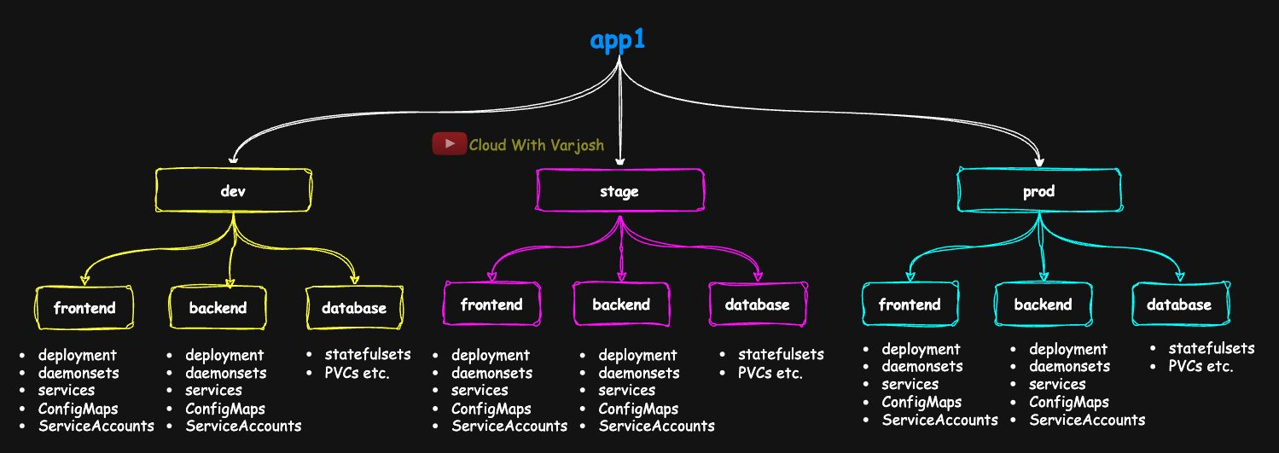
Many YAMLs
app1 runs in dev, stage and prod, each with frontend, backend and data tiers, each tier with ~5 objects (Deployments, StatefulSets, Services, ConfigMaps, PVCs, ServiceAccounts…). That's ~15 objects per environment, ~45 for one app — real apps with many microservices have far more. Adding a label, annotation, new image tag, naming rule or replica change by hand across all of them is slow and error-prone.
We want one shared base + small per-environment overlays that say only what differs.
Environment | Image | Replicas | Label
Dev | nginx:1.22 | 2 | env: dev
Staging | nginx:1.20 | 3 | env: staging
Prod | nginx:1.20 | 5 | env: prod

What Kustomize is
A template-free, declarative tool that customises plain YAML using overlays and patches — no variables, no templating language. It's built into kubectl (kubectl kustomize, kubectl apply -k) and fits GitOps/CI-CD.
[ base manifests + kustomization.yaml ]
│
┌──────────────┼──────────────┐
▼ ▼ ▼
overlays/dev overlays/staging overlays/prod
▼ ▼ ▼
final dev final stage final prod

Kustomize vs Helm
Feature | Kustomize | Helm
Built into kubectl | Yes | No (separate CLI)
Templating | No – plain YAML + patches | Yes – Go templates
Variables | No | Yes (values.yaml)
Overlays | Native base/overlays | Indirect (different values files)
Packaging / versions / releases | No | Yes (charts, release history, rollback)
Logic (if/loops) | No | Yes
Hooks / tests | No | Yes
Complexity | Low | Medium–high
Best for | Simple–medium apps, per-environment differences | Medium–complex apps, distributing software

Use Kustomize for environment differences without new syntax; Helm for packaging, templating and reuse (Day 43).

Installing
Bundled with kubectl ≥ 1.14. For the latest standalone binary:
BASH
curl -s "https://raw.githubusercontent.com/kubernetes-sigs/kustomize/master/hack/install_kustomize.sh" | bash

kustomization.yaml
Every Kustomize directory needs a file named exactly kustomization.yaml (not .yml, not capitalised) — otherwise Error: no kustomization file found.
Base — lists the shared manifests, no environment specifics:
YAML
apiVersion: kustomize.config.k8s.io/v1beta1
kind: Kustomization
resources:
- deploy.yaml
- svc.yaml
Overlay — points at the base and customises:
YAML
apiVersion: kustomize.config.k8s.io/v1beta1
kind: Kustomization
resources:
- ../../base # relative path: up two levels, into base/
nameSuffix: -dev
The names base/ and overlays/ are only conventions — Kustomize just follows the relative paths between directories that contain kustomization.yaml.

Demo 1: nameSuffix
Day42/
├── base/
│ ├── deploy.yaml
│ ├── svc.yaml
│ └── kustomization.yaml
└── overlays/
├── dev/kustomization.yaml (nameSuffix: -dev)
├── stage/kustomization.yaml (nameSuffix: -stage)
└── prod/kustomization.yaml (nameSuffix: -prod)
base/deploy.yaml – Deployment nginx-deploy (label app: nginx, 2 replicas, image nginx, port 80). base/svc.yaml – NodePort Service nginx-svc selecting app: nginx, port 80 → 80.
BASH
kubectl kustomize base # render without changes
kubectl kustomize overlays/dev # names become nginx-deploy-dev, nginx-svc-dev
kubectl create namespace dev; kubectl create namespace stage; kubectl create namespace prod
kubectl apply -k overlays/dev -n dev
kubectl apply -k overlays/stage -n stage
kubectl apply -k overlays/prod -n prod
Use -k (a Kustomize directory), not -f. You can run kubectl kustomize . inside a directory that has kustomization.yaml, or point at one.

Demo 2: more transformers
YAML
apiVersion: kustomize.config.k8s.io/v1beta1
kind: Kustomization
resources:
- ../../base
namePrefix: app1- # nginx-deploy → app1-nginx-deploy-dev
nameSuffix: -dev
namespace: dev # every resource goes to 'dev'
labels:
- pairs:
env: dev
includeSelectors: true # also add to selectors and Pod template labels
commonAnnotations:
branch: dev
support: 800-800-700
images:
- name: nginx # match containers using image 'nginx'
newName: nginx
newTag: "latest"
replicas:
- name: nginx-deploy # base name
count: 2
Stage/prod: env: stage|prod, namespace: stage|prod, nameSuffix: -stage|-prod, newTag: "1.20", and their own replica counts.
Rendered (excerpt):
YAML
apiVersion: apps/v1
kind: Deployment
metadata:
annotations: {branch: dev, support: 800-800-700}
labels: {app: nginx, env: dev}
name: app1-nginx-deploy-dev
namespace: dev
spec:
replicas: 2
selector:
matchLabels: {app: nginx, env: dev}
template:
metadata:
labels: {app: nginx, env: dev}
spec:
containers:
- image: nginx:latest
name: nginx
kubectl apply -k overlays/dev → deployment.apps/app1-nginx-deploy-dev created (no -n needed now). Prefer labels: over the deprecated commonLabels:.

Transformers and their limits
Transformers are built-in, declarative changes: namePrefix/nameSuffix, namespace, images, replicas, labels, commonAnnotations/commonLabels, plus resources to include files.
They can't edit arbitrary nested fields: add/change a container's resources, ports, env vars, volume mounts or probes, or remove fields. For that you use patches — and you can mix transformers and patches in one overlay.

Patches
Type | Format | Status
patches | Inline or file; JSON Patch (RFC 6902) or strategic-merge, with a target selector | ✅ Preferred
patchesJson6902 | JSON Patch in a separate file | ⚠️ Deprecated
patchesStrategicMerge | Partial Kubernetes YAML in a file | ⚠️ Deprecated

Since Kustomize v5 the single patches: field covers both styles, inline or from files. Run kustomize edit fix inside an overlay to migrate old fields automatically.
JSON Patch operations (RFC 6902)
Op | Effect
add | Add a field or list item
replace | Replace an existing value
remove | Delete a field or list item
copy / move | Copy or move a value
test | Check a value before patching

Demo 3: inline patches (preferred)
YAML
apiVersion: kustomize.config.k8s.io/v1beta1
kind: Kustomization
resources:
- ../../base
namePrefix: app1-
nameSuffix: -dev
namespace: dev
labels:
- pairs: {env: dev}
includeSelectors: true
commonAnnotations:
branch: dev
support: 800-800
images:
- {name: nginx, newName: nginx, newTag: "latest"}
replicas:
- {name: nginx-deploy, count: 2}
patches:
- target:
group: apps
version: v1
kind: Deployment
name: nginx-deploy
patch: |-
- op: add
path: /spec/template/spec/containers/0/env
value:
- name: LOG_LEVEL
value: debug
- op: add
path: /spec/template/spec/containers/0/resources
value:
requests: {cpu: "100m", memory: "128Mi"}
limits: {cpu: "500m", memory: "256Mi"}
- op: remove
path: /metadata/labels/unused
- target:
version: v1
kind: Service
name: nginx-svc
patch: |-
- op: add
path: /spec/ports/0/nodePort
value: 31000
What it does: adds LOG_LEVEL=debug; sets requests/limits; removes a label called unused (only works if that label exists in the base — otherwise the patch errors); pins the NodePort to 31000 for stable firewall/proxy rules.
Use add for fields that don't exist yet in the base and replace only for fields that do. (The course's original example used replace for resources/nodePort; add is the safe choice.)

Demo 4: patchesJson6902 (deprecated, still common)
YAML
# overlays/dev/kustomization.yaml (same transformers as above) plus:
patchesJson6902:
- target:
group: apps
version: v1
kind: Deployment
name: nginx-deploy
path: patch-container.yaml
YAML
# overlays/dev/patch-container.yaml
- op: replace
path: /spec/template/spec/containers/0/image
value: nginx:1.22
- op: add
path: /spec/template/spec/containers/0/env
value:
- name: LOG_LEVEL
value: debug
The images: transformer says latest, but the patch runs after transformers, so the final image is nginx:1.22 — patches win. Why it was popular: patch logic in separate, reviewable, reusable files. (Real world: dev often pins versions too, to reproduce bugs and run regression tests.)

Demo 5: patchesStrategicMerge (deprecated, original style)
YAML
patchesStrategicMerge:
- patch-container.yaml
YAML
# patch-container.yaml – a partial Deployment; Kustomize merges it in
apiVersion: apps/v1
kind: Deployment
metadata:
name: nginx-deploy
spec:
template:
spec:
containers:
- name: nginx # merge key: matches the container by name
env:
- name: LOG_LEVEL
value: debug
resources:
requests: {cpu: "100m", memory: "128Mi"}
limits: {cpu: "500m", memory: "256Mi"}
Easy to write (plain YAML), but relies on Kubernetes merge keys and schema knowledge, which is brittle for custom resources. Migrate with kustomize edit fix.
Use case | Method | Status
Inline or file patches, maximum flexibility | patches | ✅ Use for all new work
File-based JSON Patch | patchesJson6902 | ⚠️ Deprecated
Partial-YAML overrides | patchesStrategicMerge | ⚠️ Deprecated

Part 16 — Helm and StatefulSets (Days 43–44)

Day 43 — Helm, the Kubernetes Package Manager

Why Helm when we have Kustomize?
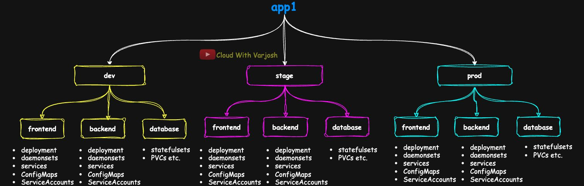
The problem
As an app grows you manage StatefulSets, ConfigMaps, Secrets, Ingresses, PVCs, StorageClasses, NetworkPolicies, autoscalers and even custom resources (cert-manager, Prometheus, Vault). For app1 across dev/stage/prod that's 60+ YAMLs, and hundreds once you add tools. You need to inject values, know what's deployed where, upgrade safely, roll back, and package/share the app.
Kustomize stops at configuration. Helm adds:
- Templating with Go templates (if, range, reusable helpers)
- Versioned packages (charts)
- Release tracking and rollback
- install / upgrade / uninstall in one command
- Chart repositories to distribute apps
- Hooks and tests
BASH
helm install myapp ./my-chart
helm upgrade myapp ./my-chart --set image.tag=1.2.0
helm rollback myapp 1

What Helm is
The package manager for Kubernetes — like apt (Debian), Homebrew (macOS) or Chocolatey (Windows). Use it for your own apps, third-party tools (Prometheus, Grafana, cert-manager) and operators.
Kubernetes itself sees only separate objects. Helm groups them into one chart, installed as one release, so it can install, upgrade, roll back and uninstall the whole app together.

Installing
Follow helm.sh/docs/intro/install, then helm version (e.g. v3.18.x). Helm 3 has no Tiller (Helm 2's in-cluster component) — it runs on your machine and uses your current kubeconfig context, just like kubectl.

Core concepts
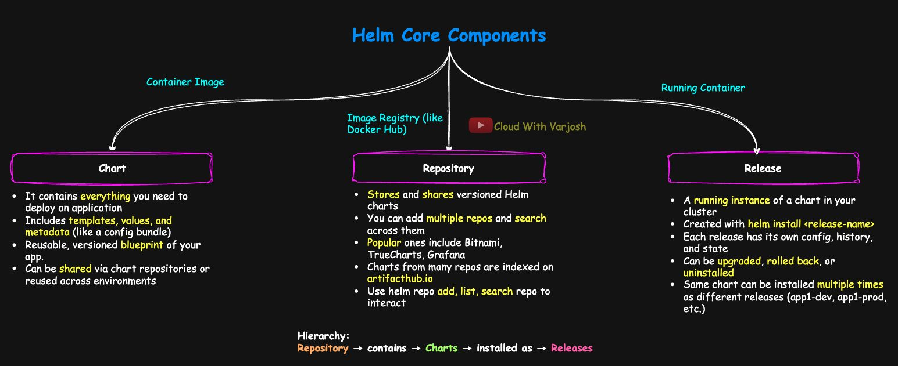
Helm concepts
- Chart – the package: templates + default values.yaml + Chart.yaml metadata (+ optional helpers, tests, dependencies). A versioned blueprint.
- Repository – where charts are stored and shared (Bitnami, TrueCharts, Grafana, Jetstack…). Artifact Hub (artifacthub.io) indexes hundreds of repos in one search.
- Release – a running instance of a chart in a cluster, with a unique name (helm install app1-prod ./my-app-chart).
Repository → contains charts → installed as releases.
The same chart can be installed many times as separate releases (e.g. app1-prod and a test copy app1-prod-test), each with its own values, revision history and lifecycle. Every install/upgrade/rollback creates a numbered revision:
BASH
helm history app1-prod-test
helm rollback app1-prod-test 2
Helm | Docker
Chart | Image | Packaged, versioned definition
Chart repository | Registry (Docker Hub) | Where packages are stored
Release | Running container | Live instance

 | Build | Share | Run
Docker | docker build | docker push | docker run → container
Helm | helm package (optional) | helm push / repo | helm install → release

Everyday commands
BASH
helm repo add my-bitnami https://charts.bitnami.com/bitnami # alias is your choice
helm repo list
helm repo update
helm search repo my-bitnami | grep -i nginx # searches ADDED repos (local index)
helm search hub nginx | grep -i bitnami # searches Artifact Hub online
helm install my-nginx my-bitnami/nginx # release name + chart
helm upgrade my-nginx my-bitnami/nginx --set image.tag=1.2.3
helm uninstall my-nginx
helm list -A # releases in all namespaces
helm status <release>
helm get values <release>

Chart structure
BASH
helm create my-chart
tree my-chart
my-chart
├── Chart.yaml # metadata – REQUIRED
├── values.yaml # default input values – REQUIRED
├── charts/ # dependency charts (optional)
└── templates/ # templated manifests – REQUIRED
├── _helpers.tpl # reusable template snippets
├── deployment.yaml
├── hpa.yaml
├── ingress.yaml
├── NOTES.txt # message printed after install
├── service.yaml
├── serviceaccount.yaml
└── tests/
└── test-connection.yaml

Demo 1: build a chart from scratch
- helm create app1-chart, then empty templates/.
- Add plain deploy.yaml (Deployment nginx-deploy, 2 replicas, nginx:1.22) and svc.yaml (NodePort nginx-svc).
Even without templating it installs: helm install app1 ./app1-chart. But a second install helm install app1-test ./app1-chart fails — "rendered manifests contain a resource that already exists" — because the names are fixed. Fix: put the release name into resource names.
- Templatize:
YAML
# templates/deploy.yaml
apiVersion: apps/v1
kind: Deployment
metadata:
name: {{ .Release.Name }}-nginx
labels:
app: nginx
spec:
replicas: {{ .Values.replicaCount }}
selector:
matchLabels:
app: nginx
template:
metadata:
labels:
app: nginx
spec:
containers:
- name: nginx
image: {{ .Values.image.repository }}:{{ .Values.image.tag }}
ports:
- containerPort: 80
YAML
# templates/svc.yaml
apiVersion: v1
kind: Service
metadata:
name: {{ .Release.Name }}-nginx
spec:
type: NodePort
selector:
app: nginx
ports:
- port: 80
targetPort: 80
- values.yaml:
YAML
replicaCount: 2
image:
repository: nginx
tag: "1.22"
- Chart.yaml:
YAML
apiVersion: v2
name: app1-chart
description: A Helm chart to deploy nginx using NodePort service
type: application
version: 0.1.0 # version of the CHART
appVersion: "1.22" # version of the APP inside it
home: https://www.youtube.com/@CloudWithVarJosh
maintainers:
- name: Varun Joshi
email: cloudwithvarjosh@gmail.com
keywords: [nginx, demo, kubernetes, helm]

Template basics
{{ ... }} means "evaluate this". The leading . is the current context. With release name app1, {{ .Release.Name }}-nginx renders as app1-nginx.
Built-in object | Examples
.Values | Your inputs: .Values.replicaCount, .Values.image.repository
.Release | .Release.Name, .Release.Namespace, .Release.Revision, .Release.IsInstall, .Release.IsUpgrade
.Chart | .Chart.Name, .Chart.Version, .Chart.AppVersion
.Capabilities | .Capabilities.KubeVersion.Version, .Capabilities.APIVersions.Has "apps/v1"

Convention: your keys under .Values are lowercase/camelCase; built-ins are PascalCase.

Verify before installing
BASH
helm lint ./app1-chart # chart structure + YAML syntax
helm template app1 ./app1-chart --debug # render manifests locally
helm install app1 ./app1-chart --dry-run # render + simulate a release install
Command | Does
helm lint | Checks chart structure and syntax
helm template | Renders templates to YAML; no release simulation
helm install --dry-run | Renders and simulates the install without creating anything

Install and check:
BASH
helm install app1 ./app1-chart
helm list; helm status app1; helm history app1
kubectl get deploy,svc,pods
helm uninstall app1
Now helm install app1-prod ./app1-chart and helm install app1-prod-test ./app1-chart can coexist — handy for hotfix testing, blue/green and multi-tenant setups.

Demo 2: upgrade and rollback
BASH
helm list # app1 REVISION 1 app1-chart-0.1.0 APP VERSION 1.22
helm history app1
Edit Chart.yaml → version: 0.1.1, appVersion: "1.23"; edit values.yaml → tag: "1.23".
BASH
helm upgrade app1 ./app1-chart
helm history app1
# 1 superseded app1-chart-0.1.0 1.22
# 2 deployed app1-chart-0.1.1 1.23
kubectl get deploy -o wide # image nginx:1.23

helm rollback app1 1
helm history app1
# 1 superseded 0.1.0 1.22
# 2 superseded 0.1.1 1.23
# 3 deployed 0.1.0 1.22 ← a rollback is a NEW revision
kubectl describe deployment app1-nginx | grep Image # nginx:1.22
helm upgrade app1 ./app1-chart --reuse-values keeps the values used last time (useful when only the chart's templates changed).
Command | Purpose
helm upgrade | Upgrade a release
helm rollback <rel> <rev> | Go back to a revision
helm history | All revisions
helm list | Releases and versions
helm status | Details of one release

Demo 3: one chart, three environments
BASH
helm list -A && helm uninstall <old-releases>
kubectl create ns dev; kubectl create ns stage; kubectl create ns prod
Templates add namespace: {{ .Values.namespace }} and name containers {{ .Release.Name }}-cont. Chart.yaml: version: 0.2.0, appVersion: "1.22".
appVersion should reflect the production version. Chart.yaml is shared by every environment and can't be changed per release; per-environment versions live in the values files.
YAML
# values-dev.yaml
namespace: dev
replicaCount: 1
image: {repository: nginx, tag: "1.23"}
---
# values-stage.yaml
namespace: stage
replicaCount: 2
image: {repository: nginx, tag: "1.22"}
---
# values-prod.yaml
namespace: prod
replicaCount: 3
image: {repository: nginx, tag: "1.22"}
BASH
helm lint ./app1-chart -f ./app1-chart/values-dev.yaml
helm template app1-dev ./app1-chart -f ./app1-chart/values-dev.yaml

helm install app1-dev ./app1-chart -f ./app1-chart/values-dev.yaml --namespace dev
helm install app1-stage ./app1-chart -f ./app1-chart/values-stage.yaml --namespace stage
helm install app1-prod ./app1-chart -f ./app1-chart/values-prod.yaml --namespace prod
Where Helm stores the release vs where objects go: objects go to the namespace in their metadata.namespace, but Helm records the release in the namespace given by --namespace (default: default). Without --namespace, helm list shows all three releases under default even though the Pods are in dev/stage/prod. Always pass --namespace so release tracking matches the environment. (A cleaner chart uses {{ .Release.Namespace }} instead of a namespace value.)
BASH
helm list -A
# app1-dev dev 1 deployed app1-chart-0.2.0 1.22
# app1-stage stage 1 deployed app1-chart-0.2.0 1.22
# app1-prod prod 1 deployed app1-chart-0.2.0 1.22
kubectl get deploy,svc -n dev # app1-dev-nginx 1/1
kubectl get deploy,svc -n stage # app1-stage-nginx 2/2
kubectl get deploy,svc -n prod # app1-prod-nginx 3/3

helm upgrade app1-dev ./app1-chart -f ./app1-chart/values-dev.yaml --set image.tag=1.24 -n dev
helm rollback app1-dev 1 -n dev
Env | Release | Namespace | Image | Replicas
dev | app1-dev | dev | nginx:1.23 | 1
stage | app1-stage | stage | nginx:1.22 | 2
prod | app1-prod | prod | nginx:1.22 | 3

Namespaces scope releases, avoid name clashes, and support RBAC, network policies and log separation.

Day 44 — StatefulSets (Multi-AZ MySQL on Amazon EKS)

Stateless vs stateful
- Stateless = just code. Stop, restart or move it and nothing is lost.
- Stateful = code + data tightly coupled. Behaviour depends on data it holds.
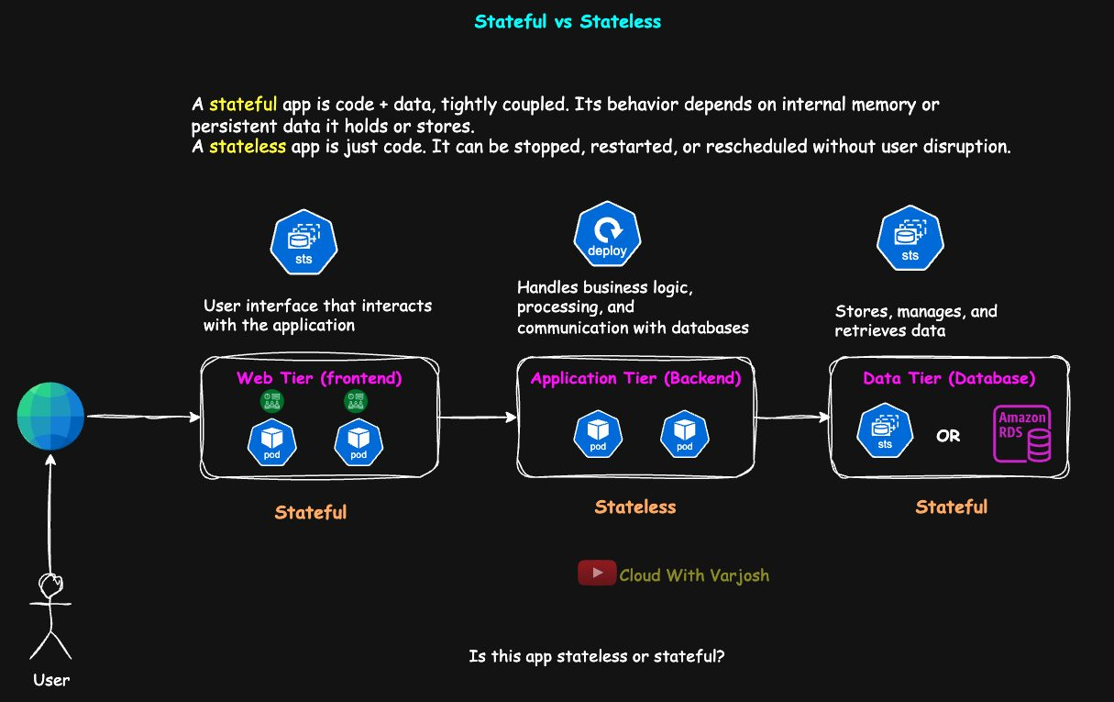
3-tier app
Most apps are mixed. In a 3-tier app: a frontend that keeps session info (language, currency, UI mode, last page) in the Pod is stateful — if the Pod dies the user loses context. The backend that holds only code is stateless — ideal for Deployments. The database is always stateful.
Stateless parts are easier to scale, heal and run cheaply, so modern designs move state out of Pods:
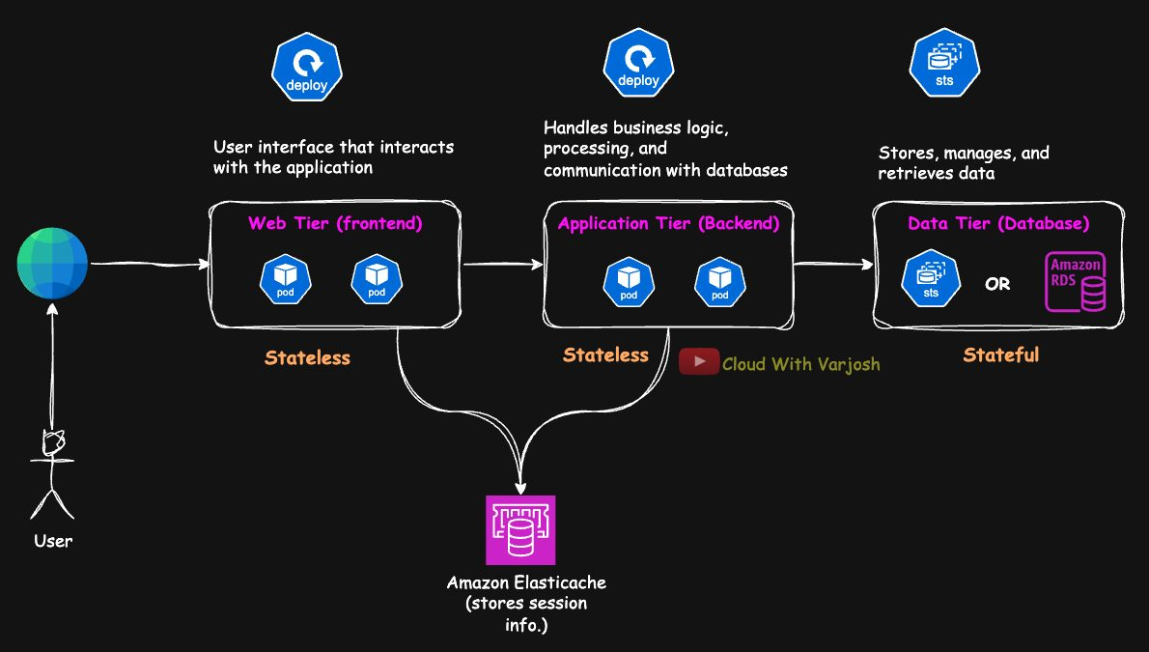
ElastiCache
Store sessions in Amazon ElastiCache (Redis). Pod-1 dies → Pod-2 reads the session from Redis → the user continues. The backend can also use ElastiCache as a cache in front of the database, cutting DB load and latency.
Don't label a whole app stateful/stateless — check each tier: what state does it keep, and where? Deployments for stateless parts; StatefulSets + PVCs for stateful parts.

What it takes to run a database
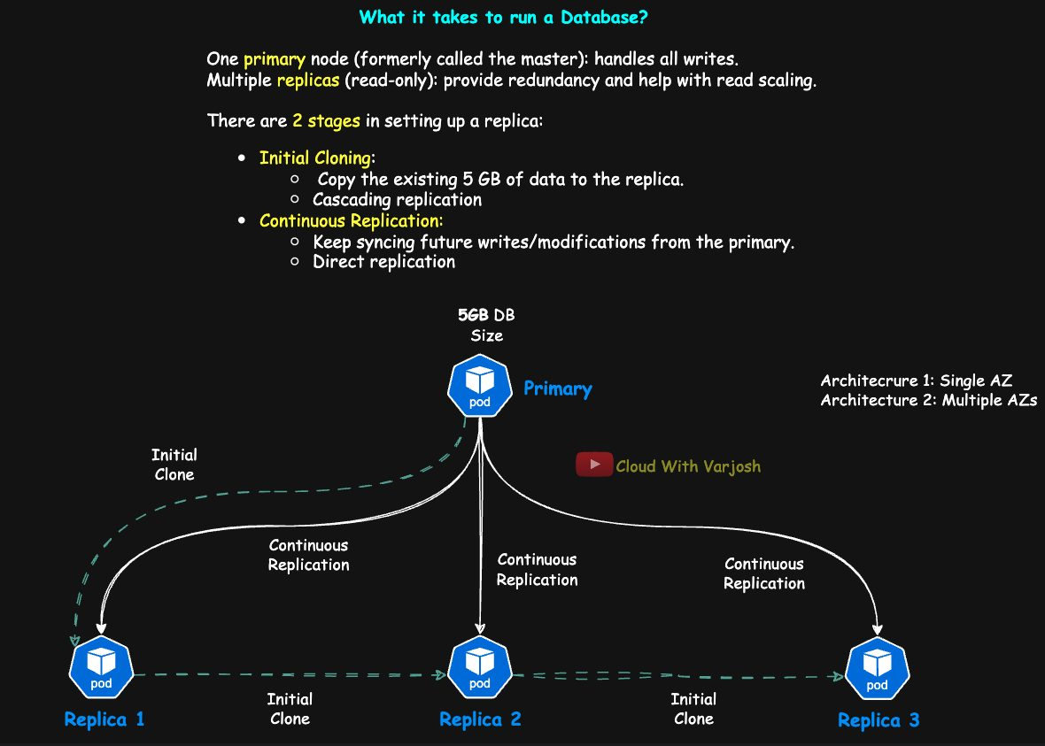
DB cluster
A production DB has one primary (all writes) and several read-only replicas (redundancy, read scaling). Adding a replica to a primary holding, say, 5 GB:
- Initial clone – copy the full dataset. Often chained/cascading: replica-1 clones from the primary, replica-2 from replica-1, etc., to spare the primary.
- Continuous replication – stream new changes (MySQL binlog, PostgreSQL WAL, MongoDB oplog).
  - Direct (star): every replica replicates from the primary — common, low lag.
  - Chained: replica-2 follows replica-1 — less load on primary but more lag and more failure points.
Most systems use chained cloning but direct replication.
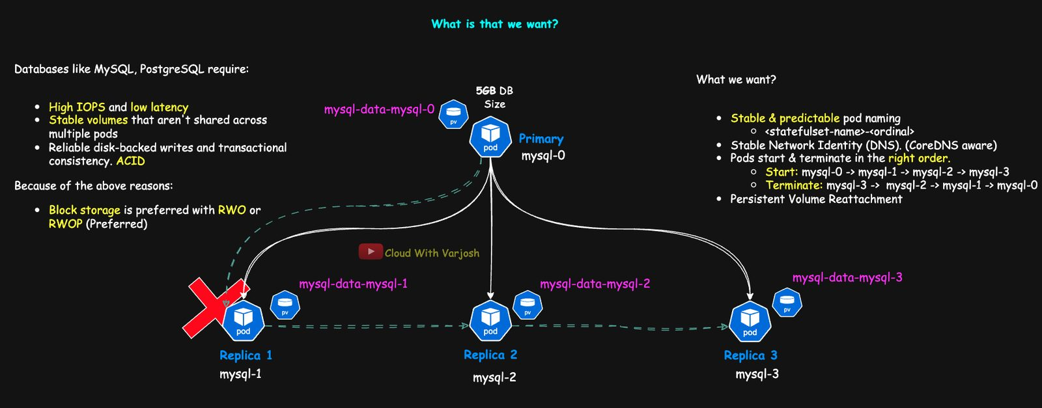
Replica identity
The identity problem: replication is configured with fixed identifiers — hostnames (mysql-1), MySQL server IDs, PostgreSQL replication slots. If replica-1 crashes and comes back as mysql-4 with a new DNS name, the primary treats it as an unknown node and replication breaks. So each replica needs: a stable name/DNS, its own volume re-attached, and ordered start-up (primary first).

Why Deployments can't do this
- Random Pod names (mysql-5f69b67f96-dx2ml) — no fixed identity for replication configs.
- No per-Pod DNS — CoreDNS creates records for Services, not bare Pod names.
- No ordering — Pods are created/deleted in parallel; replicas may start before the primary, shutdown order can corrupt data.
- No per-Pod volumes — Pods share a PVC or you wire PVCs by hand.

StatefulSets
A StatefulSet manages Pods that need identity, their own storage and order. Used for MySQL, PostgreSQL, MongoDB, Kafka, RabbitMQ, Cassandra, Elasticsearch, Zookeeper, Redis Cluster. Works with a headless Service and volumeClaimTemplates.
# | Guarantee | Detail
1 | Stable names | <statefulset>-<ordinal>: mysql-0 (often primary), mysql-1, mysql-2
2 | Stable DNS | Via a headless Service: <pod>.<svc>.<ns>.svc.cluster.local, e.g. mysql-0.mysql.mysql-ha.svc.cluster.local
3 | Ordered rollout | OrderedReady (default): mysql-1 starts only after mysql-0 is Running and Ready; deletion goes in reverse (highest first)
4 | Sticky volumes | Each Pod gets its own PVC (mysql-data-mysql-0, …) that re-attaches when the Pod is recreated
5 | volumeClaimTemplates | One PVC template → one PVC per Pod; PVCs survive Pod and StatefulSet deletion

 | Deployment | StatefulSet
Stable Pod names | ❌ | ✅ -0, -1…
Ordered start/stop | ❌ | ✅
Volume per Pod | Manual at best | ✅ volumeClaimTemplates
Stable DNS per Pod | ❌ | ✅ (with headless Service)
For databases | Not recommended | Designed for it

Storage for databases
Databases need high IOPS, low latency, reliable durable writes and volumes not shared between Pods → block storage (EBS, GCP PD, Azure Disk), not file storage (NFS/SMB is shared but slower).
ACID (single-database transactions): Atomicity (all or nothing), Consistency (valid state to valid state), Isolation (concurrent transactions don't interfere), Durability (committed = permanent). Don't confuse with CAP (distributed systems trade-off between Consistency, Availability, Partition tolerance); many NoSQL/distributed DBs relax ACID for availability.
Access mode | Meaning | Use
RWO / RWOP | One node / one Pod | Databases, Kafka, Redis
ROX | Read-only, many | Shared config, static data
RWX | Read-write, many | Web content, shared logs (EFS/NFS/CephFS — never for transactional DBs)

EBS does not support RWX. Never use hostPath or emptyDir for production stateful data — if the node goes, the data goes. Use EBS, PD, Azure Disk, SAN/iSCSI CSI, Ceph, Portworx or Longhorn.

Demo 1: MySQL StatefulSet across 3 AZs on EKS
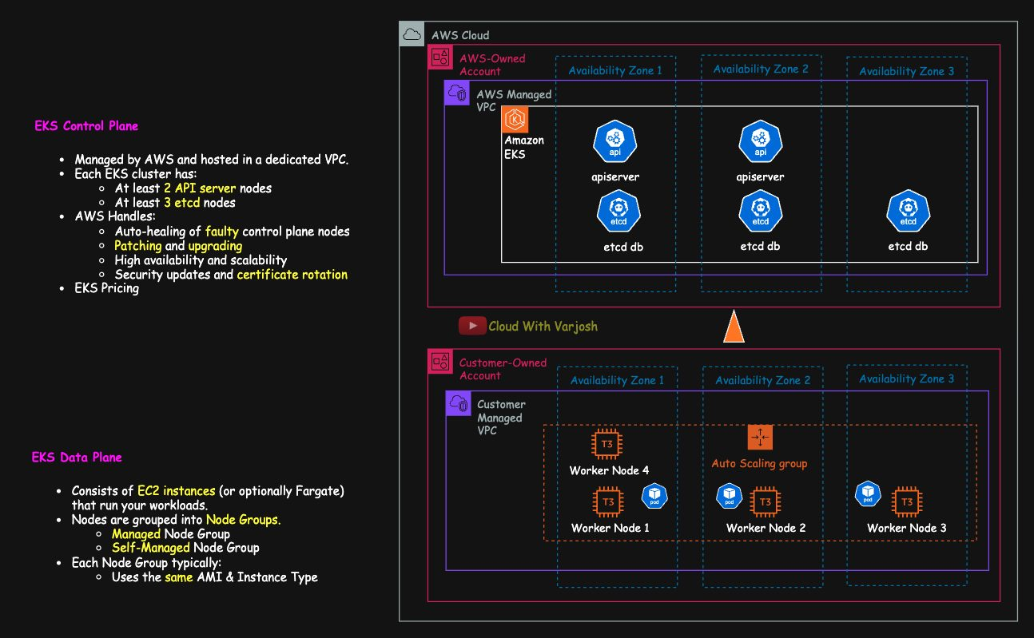
Cluster
EKS in us-east-2 across us-east-2a/b/c, 4 × t3.small worker nodes (one AZ gets two). Prerequisites: Day 27 storage concepts, AWS CLI and eksctl.
YAML
# eks-config.yaml
apiVersion: eksctl.io/v1alpha5
kind: ClusterConfig
metadata:
name: cwvj-eks-cluster
region: us-east-2
tags: {owner: varun-joshi, bu: cwvj, environment: prod, project: statefulsets-training}
availabilityZones: [us-east-2a, us-east-2b, us-east-2c]
iam:
withOIDC: true
managedNodeGroups:
- name: cwvj-eks-priv-ng
instanceType: t3.small
minSize: 4
maxSize: 5
privateNetworking: true
volumeSize: 20
iam:
withAddonPolicies: {autoScaler: true, ebs: true, albIngress: true}
labels: {lifecycle: ec2-autoscaler}
BASH
eksctl create cluster -f eks-config.yaml
kubectl get nodes --show-labels | grep topology.kubernetes.io/zone
Install the EBS CSI driver (without it EBS volumes can't be provisioned/attached and Pods stay Pending). It's installed via Kustomize:
BASH
kubectl apply -k "github.com/kubernetes-sigs/aws-ebs-csi-driver/deploy/kubernetes/overlays/stable/?ref=release-1.44"
kubectl get daemonset ebs-csi-node -n kube-system # per-node: attach + mount
kubectl get deploy ebs-csi-controller -n kube-system # central: create/delete via AWS API
Step 1 – StorageClass (gp3, AZ-aware)
YAML
apiVersion: storage.k8s.io/v1
kind: StorageClass
metadata:
name: ebs-sc-gp3
annotations:
storageclass.kubernetes.io/is-default-class: "true"
provisioner: ebs.csi.aws.com
parameters:
type: gp3
volumeBindingMode: WaitForFirstConsumer # create the disk in the Pod's AZ
reclaimPolicy: Delete
allowVolumeExpansion: true
Step 2 – Namespace
BASH
kubectl create namespace mysql-ha
kubectl config set-context --current --namespace=mysql-ha
A separate namespace isolates the DB tier, lets NetworkPolicies/RBAC block frontends from talking to it directly, and helps when one DB server hosts databases for several apps.
Step 3 – Headless Service
YAML
apiVersion: v1
kind: Service
metadata:
name: mysql
namespace: mysql-ha
spec:
clusterIP: None # headless – no virtual IP, no load balancing
selector:
app: mysql
ports:
- port: 3306
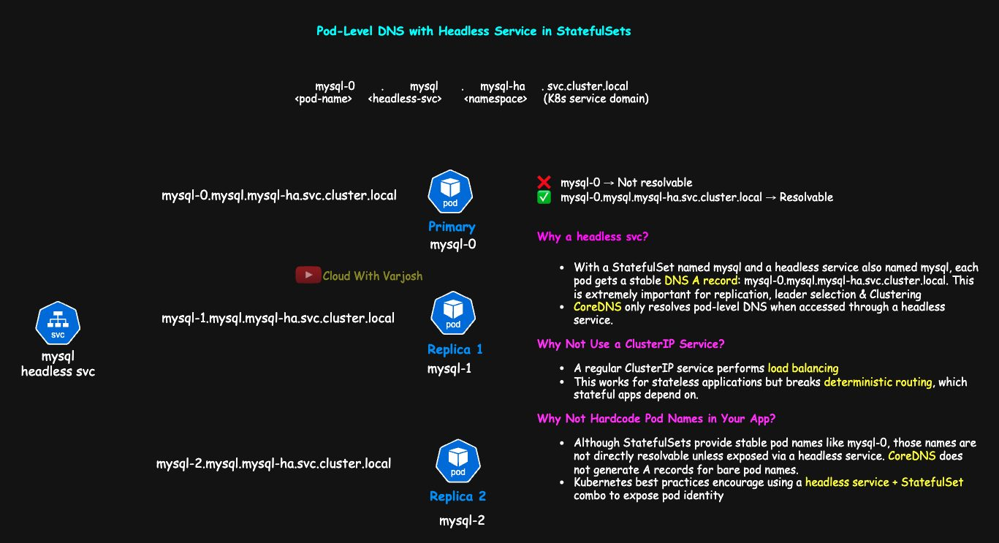
Headless service
- A headless Service returns the Pod IPs and creates a DNS A record per Pod: mysql-0.mysql.mysql-ha.svc.cluster.local. Replicas, leader election and clustering can target a specific peer.
- A normal ClusterIP Service load-balances to a random Pod — fine for stateless apps, wrong when a replica must reach the primary.
- Bare Pod names aren't resolvable, and hard-coding them couples the app to cluster topology; headless + StatefulSet gives stable, discoverable addresses.
Step 4 – The StatefulSet
YAML
apiVersion: apps/v1
kind: StatefulSet
metadata:
name: mysql
namespace: mysql-ha
spec:
serviceName: mysql # must match the headless Service
replicas: 3
podManagementPolicy: OrderedReady # default; 'Parallel' starts/stops all at once
selector:
matchLabels:
app: mysql
template:
metadata:
labels:
app: mysql
spec:
terminationGracePeriodSeconds: 10 # time for a clean DB shutdown (default 30)
affinity:
podAntiAffinity:
requiredDuringSchedulingIgnoredDuringExecution:
- labelSelector:
matchLabels:
app: mysql
topologyKey: topology.kubernetes.io/zone # never two mysql Pods in one AZ
containers:
- name: mysql
image: mysql:8.0
ports:
- containerPort: 3306
env:
- name: MYSQL_ROOT_PASSWORD
value: "password123" # demo only – use a Secret in real life
volumeMounts:
- name: mysql-data
mountPath: /var/lib/mysql
volumeClaimTemplates:
- metadata:
name: mysql-data # PVCs: mysql-data-mysql-0, -1, -2
spec:
accessModes: ["ReadWriteOncePod"]
storageClassName: ebs-sc-gp3
resources:
requests:
storage: 5Gi
Pod anti-affinity keeps Pods with the same label apart within a topology domain (topologyKey): topology.kubernetes.io/zone = different AZs; kubernetes.io/hostname = different nodes (use this in a single-AZ cluster). terminationGracePeriodSeconds should be long enough for the DB to flush buffers — too short risks corruption.
Step 6 – Observe
BASH
kubectl apply -f 03-mysql-sts.yaml
kubectl get pods -o wide # mysql-0 → mysql-1 → mysql-2, one per AZ
kubectl get pvc # three PVCs
kubectl get pv # three EBS volumes (also in EC2 → Volumes)
Each volume lands in its Pod's AZ thanks to WaitForFirstConsumer + zone anti-affinity. Scale to 4 replicas with only 3 AZs and the 4th stays Pending (hard rule). To allow it, use a soft rule:
YAML
affinity:
podAntiAffinity:
preferredDuringSchedulingIgnoredDuringExecution:
- weight: 100
podAffinityTerm:
labelSelector:
matchLabels:
app: mysql
topologyKey: topology.kubernetes.io/zone
Step 7 – Delete a Pod
BASH
kubectl delete pod mysql-1
kubectl get pods -w
mysql-1 comes back with the same name and the same PVC. Because an EBS volume can't leave its AZ, the volume's node affinity means it's rescheduled onto a node in that same AZ.
PVC lifecycle
- PVCs are kept when Pods or even the StatefulSet are deleted.
- Recreate the StatefulSet with the same name/template and mysql-0 re-binds mysql-data-mysql-0, etc. — no data loss, no re-seeding.
- A misbehaving Pod can safely be deleted; it returns with its data.
- To wipe everything: delete the StatefulSet first, then its PVCs (with Delete reclaim policy the EBS disks go too).
Component | Role
StatefulSet | Stable identity and ordering
Headless Service | Per-Pod DNS
volumeClaimTemplates | One PVC per Pod
WaitForFirstConsumer | Disk created in the Pod's AZ
Pod anti-affinity | Spread across AZs
gp3 EBS StorageClass | Fast block storage

Demo 2: chaos test — kill a node
- Find the AZ with two nodes: kubectl get nodes --show-labels | grep topology.kubernetes.io/zone.
- Find the Pod running there: kubectl get pods -o wide (say mysql-1).
- Write data:
BASH
kubectl exec -it mysql-1 -- bash
cd /var/lib/mysql && echo "This is CloudWithVarJosh" >> myfile && cat myfile
- Terminate that EC2 node in the console. Watch kubectl get pods -w — mysql-1 is recreated on the other node in the same AZ (a while in ContainerCreating while EBS detaches/re-attaches).
- Verify:
BASH
kubectl exec -it mysql-1 -- cat /var/lib/mysql/myfile # This is CloudWithVarJosh
kubectl get pvc mysql-data-mysql-1 # same VOLUME and AGE
Proves: PVC identity is sticky, data survives node loss, and StatefulSet + EBS + WaitForFirstConsumer give fault tolerance.

Who does what: DevOps vs DBA
DevOps engineer | DBA
PVCs and StorageClasses | Replication topology
StatefulSets (identity, volumes, order) | Replication parameters
Headless Services / DNS | Failover and promotion
Liveness/readiness probes | Backup and restore strategy
Secrets, ConfigMaps, ServiceAccounts, RBAC | Performance tuning (buffers, logs, cache)
Backup CronJobs / tools | Consistency and integrity
App ↔ DB connectivity | App-aware failover logic

Roles overlap depending on the organisation. For production databases on Kubernetes, Operators (Day 40) automate StatefulSets/PVCs, replication setup, backups, upgrades, healing and failover.

Part 17 — Private Images and Pod Priority (Days 45–46)

Day 45 — Pulling Private Images with imagePullSecrets and ServiceAccounts

Registry, repository, image, tag
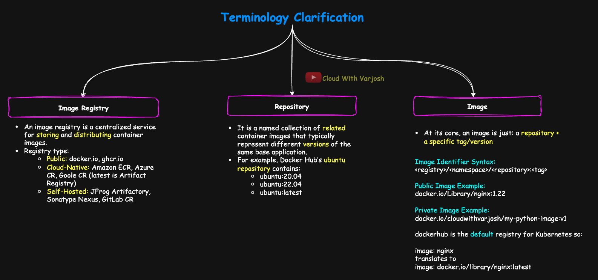
Registry nomenclature
Image registry — a service that stores and serves images; nodes pull from it.
Type | Examples
Public | docker.io (Docker Hub), ghcr.io (GitHub), quay.io
Cloud | *.amazonaws.com (ECR), *.gcr.io / *.pkg.dev (Google Artifact Registry), *.azurecr.io (ACR)
Self-hosted | Harbor, Nexus, JFrog Artifactory, GitLab Container Registry

Repository — a named collection of versions of one image, e.g. the ubuntu repo holds ubuntu:20.04, ubuntu:22.04, ubuntu:latest. Format <registry>/<namespace>/<repository>, e.g. docker.io/cloudwithvarjosh/my-python-image. Lives under a namespace (user or org). Tags are mutable — prefer specific versions like v1.2.3 over latest.
Image = repository + tag: <registry>/<namespace>/<repository>:<tag>
Part | Example | Meaning
Registry | docker.io | Where to pull from
Namespace | cloudwithvarjosh | User or organisation
Repository | my-python-image | Application image name
Tag | v1 | Version

Defaults: no registry → docker.io; no namespace → library/ (official images); no tag → latest. So image: nginx means docker.io/library/nginx:latest.
YAML
image: ghcr.io/my-org/app:v2
image: gcr.io/my-project/my-api:latest
image: myregistry.azurecr.io/team/app:v3
image: <aws_account>.dkr.ecr.us-west-2.amazonaws.com/my-image:stable
Vendors differ: ECR puts account ID and region in the hostname; Harbor allows nested project paths (harbor.mycompany.com/dev/backend/app:v1). Check the vendor's format before scripting.

Public vs private
Everything so far used public images (no login). Real companies keep their images in private repos (Docker Hub private, ECR, GHCR, GCR, Harbor) for security, IP protection and governance. Kubernetes can't pull them without credentials.

The symptom: ErrImagePull / ImagePullBackOff
YAML
apiVersion: v1
kind: Pod
metadata:
name: mypod
spec:
containers:
- name: python-cont
image: docker.io/cloudwithvarjosh/my-python-image:v1
BASH
kubectl get pods # mypod 0/1 ErrImagePull
kubectl describe pod mypod
# Failed to pull image ... pull access denied, repository does not exist or may require
# authorization: server message: insufficient_scope: authorization failed

How private pulls work
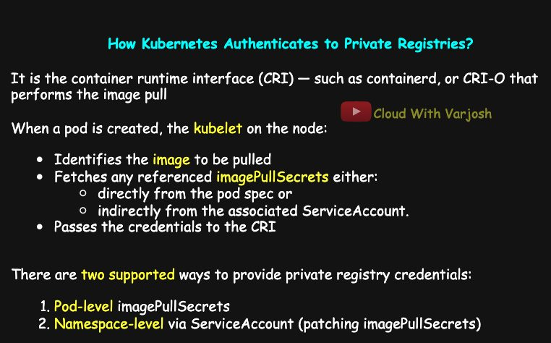
Pull flow
Kubernetes doesn't pull images — the container runtime (containerd, CRI-O) does. Credentials are stored in a Secret of type kubernetes.io/dockerconfigjson (registry URL, username, password/token).
When a Pod is scheduled, the kubelet:
- reads the image from the Pod spec,
- collects imagePullSecrets from the Pod spec or from the Pod's ServiceAccount,
- hands the credentials to the runtime, which logs in and pulls.
Every namespace has a default ServiceAccount; Pods without serviceAccountName use it. Its API token is mounted at /var/run/secrets/kubernetes.io/serviceaccount/ (disable with automountServiceAccountToken: false) — that token is for API access, not image pulls; but an SA can carry imagePullSecrets.
Two ways to supply credentials:
- Per Pod — imagePullSecrets in the Pod spec (most explicit).
- Via a ServiceAccount — attach the secret to an SA so every Pod using it inherits the credentials.
Pull credentials are only used at pull time; they're never mounted into the container or exposed as env vars.

Demo 0: build and push a private image
PYTHON
# app.py
from flask import Flask
app = Flask(__name__)

@app.route("/")
def home():
return "Hello, Docker!"

if __name__ == "__main__":
app.run(host="0.0.0.0", port=5000)
DOCKERFILE
FROM python:3.9-slim
WORKDIR /app
ADD app.py app.py
RUN pip install flask
EXPOSE 5000
CMD ["python", "app.py"]
BASH
docker login # Docker Desktop: just be signed in
docker build -t cloudwithvarjosh/app1:1.0.0 . # semantic version major.minor.patch
docker push cloudwithvarjosh/app1:1.0.0
On hub.docker.com → My Hub → the app1 repository → Settings → Visibility → Private.

Demo 1: imagePullSecrets in the Pod
BASH
kubectl create secret docker-registry dockerhub-secret \
--docker-server=https://index.docker.io/v1/ \
--docker-username=cloudwithvarjosh \
--docker-password=YOUR_PASSWORD \
--docker-email=cloudwithvarjosh@gmail.com
kubectl get secret dockerhub-secret -o yaml # type: kubernetes.io/dockerconfigjson
The docker-registry type works for any registry using Docker-style login, not just Docker Hub — just set --docker-server (name them ecr-secret, ghcr-secret etc. for clarity).
YAML
apiVersion: v1
kind: Pod
metadata:
name: mypod
spec:
containers:
- name: python-cont
image: docker.io/cloudwithvarjosh/app1:1.0.0
imagePullSecrets:
- name: dockerhub-secret
The Pod now reaches Running.
The secret contains real credentials — decoding is trivial:
BASH
echo -n <base64-value> | base64 --decode
# {"auths":{"https://index.docker.io/v1/":{"username":"...","password":"...","email":"...","auth":"Y2x..."}}}
Protect it:
- RBAC – don't grant get/list on secrets broadly.
- Keep sensitive secrets in separate namespaces, not everything in default.
- Never log secret values in pipelines.
- Prefer cloud workload identity — IRSA on EKS (or GKE/AKS equivalents) gets ECR tokens dynamically, no static secret.
- Rotate credentials regularly.
- Use external secret managers (AWS Secrets Manager, Vault, Sealed Secrets).

Demo 2: patch the namespace's default ServiceAccount
BASH
kubectl create ns app1-ns
kubectl get sa -n app1-ns # default
kubectl create secret docker-registry dockerhub-secret \
--docker-server=https://index.docker.io/v1/ \
--docker-username=cloudwithvarjosh --docker-password=YOUR_PASSWORD \
--docker-email=cloudwithvarjosh@gmail.com -n app1-ns # secrets are namespace-scoped!
kubectl patch serviceaccount default -n app1-ns \
-p '{"imagePullSecrets": [{"name": "dockerhub-secret"}]}'
# or: kubectl edit serviceaccount default -n app1-ns and add imagePullSecrets
kubectl get serviceaccount default -n app1-ns -o yaml
Now a Pod in app1-ns needs no imagePullSecrets:
YAML
apiVersion: v1
kind: Pod
metadata:
name: mypod
namespace: app1-ns
spec:
containers:
- name: python-cont
image: docker.io/cloudwithvarjosh/app1:1.0.0
If it still fails: is the secret in app1-ns? attached to the SA? are the credentials and image name correct?

Demo 3: a custom ServiceAccount
New SAs don't get pull secrets automatically — attach them yourself.
BASH
kubectl create serviceaccount app1-sa -n app1-ns
kubectl patch serviceaccount app1-sa -n app1-ns \
-p '{"imagePullSecrets": [{"name": "dockerhub-secret"}]}'
kubectl get sa app1-sa -n app1-ns -o yaml
YAML
apiVersion: v1
kind: Pod
metadata:
name: app1-pod
namespace: app1-ns
spec:
serviceAccountName: app1-sa
containers:
- name: python-cont
image: docker.io/cloudwithvarjosh/app1:1.0.0
Takeaways: custom SAs need explicit pull secrets; reference them with serviceAccountName; the secret, SA and Pod must be in the same namespace. This per-workload SA pattern is common in production. The same ideas apply to Docker Hub, GHCR, ECR, Artifact Registry, ACR, Harbor and Nexus.

Day 46 — Pod Priority, PriorityClass and Preemption

Why
Not all workloads are equal: a payment service matters more than a dev dashboard or a batch job.
- Priority tells the scheduler which pending Pods to place first.
- Preemption: when the cluster is full and a high-priority Pod can't be scheduled, the scheduler evicts lower-priority Pods to make room.

PriorityClass
A cluster-scoped object that maps a name to a number; Pods refer to it by name.
YAML
apiVersion: scheduling.k8s.io/v1
kind: PriorityClass
metadata:
name: high-priority
value: 1000
globalDefault: false
description: "Critical production workloads"
YAML
spec:
priorityClassName: high-priority
- Higher number = higher priority.
- User classes: from -2,147,483,648 up to 1,000,000,000. Larger values are rejected.
- Built-in system classes use reserved values above 2 billion: system-cluster-critical = 2000000000, system-node-critical = 2000001000 (used by etcd, kube-apiserver, CoreDNS, kube-proxy…).
- A Pod with no class gets priority 0, unless a class has globalDefault: true — only one such class is allowed per cluster, and it applies to Pods created after it exists.
BASH
kubectl get pc # 'pc' = priorityclass

Preemption details
- Preemption happens only when a pending Pod can't fit anywhere — it's a scheduler action. The victims are terminated gracefully and may be rescheduled later.
- If the cluster just gets busy (CPU spikes, node failure) and no new Pod is waiting, nothing is preempted. Runtime pressure (CPU throttling, OOM kills, node-pressure eviction) is handled by the kubelet, not by priority/preemption.
- preemptionPolicy: default PreemptLowerPriority. Set Never and the Pod is still placed ahead of lower-priority Pods in the queue, but it will wait rather than evict anyone. Good for "important but non-disruptive" work.
YAML
apiVersion: scheduling.k8s.io/v1
kind: PriorityClass
metadata:
name: high-non-disruptive
value: 900
globalDefault: false
preemptionPolicy: Never
description: "High priority, but should not preempt running pods"
Priority affects scheduling order; preemption controls eviction.
QoS classes are a different thing. Based on requests/limits each Pod is Guaranteed (requests = limits for every container), Burstable (some requests/limits set) or BestEffort (none set). Under node resource pressure the kubelet evicts BestEffort first and Guaranteed last.
Best practices: meaningful names (batch-low, api-medium, critical-high); consider preemptionPolicy: Never for logging agents and stateful apps; at most one globalDefault; test preemption before production.

Demo (single-node kind cluster)
BASH
kind create cluster --name cka-2025
kubectl get nodes
kubectl describe node cka-2025-control-plane # Allocatable cpu: 11 in this demo
kubectl get pc
# system-cluster-critical 2000000000
# system-node-critical 2000001000
kubectl describe pod -n kube-system etcd-cka-2025-control-plane | grep -i priority
# Priority: 2000001000 Priority Class Name: system-node-critical
A value above the limit fails, e.g. cannot unmarshal number 100000000000 into Go struct field PriorityClass.value of type int32.
Create three classes (01-priorityclass.yaml):
YAML
apiVersion: scheduling.k8s.io/v1
kind: PriorityClass
metadata:
name: high-priority
value: 1000
globalDefault: false
description: "Critical production workloads that must preempt lower-priority pods if needed"
---
apiVersion: scheduling.k8s.io/v1
kind: PriorityClass
metadata:
name: medium-priority
value: 100
globalDefault: false
description: "Important batch or background workloads that can tolerate delay"
---
apiVersion: scheduling.k8s.io/v1
kind: PriorityClass
metadata:
name: low-priority
value: 10
globalDefault: true # Pods without a class now get 10
description: "Default for development and non-critical test workloads"
Low-priority workload — 5 Pods × 1 CPU, no class (so it gets low-priority):
YAML
apiVersion: apps/v1
kind: Deployment
metadata:
name: lp-nginx
spec:
replicas: 5
selector:
matchLabels:
app: nginx
template:
metadata:
labels:
app: nginx
spec:
containers:
- name: nginx
image: nginx:latest
resources:
requests:
memory: "64Mi"
cpu: "1000m"
BASH
kubectl apply -f 02-low-priority-nginx.yaml
kubectl describe pod <lp-nginx-pod> | grep -i priority # Priority: 10, low-priority
kubectl describe node cka-2025-control-plane # ~0.95 CPU system + 5 CPU = ~5.95 of 11
High-priority workload — 5 Pods × 3 CPU = 15 CPU requested:
YAML
apiVersion: apps/v1
kind: Deployment
metadata:
name: hp-nginx
spec:
replicas: 5
selector:
matchLabels:
app: nginx
template:
metadata:
labels:
app: nginx
spec:
priorityClassName: high-priority
containers:
- name: nginx
image: nginx:latest
resources:
requests:
memory: "64Mi"
cpu: "3000m"
BASH
kubectl get pods -w # in a second terminal
kubectl apply -f 03-high-priority-nginx.yaml
kubectl describe node cka-2025-control-plane
Only ~5 CPU is free, so the scheduler evicts lp-nginx Pods to fit hp-nginx Pods (3 CPU each). The more hp Pods are placed, the more lp Pods are terminated; the rest of each Deployment stays Pending. (In real manifests, give the two Deployments different labels so their selectors don't overlap.)
Takeaways: priority drives both scheduling order and preemption; lower-priority Pods are evicted only when a higher-priority Pod can't otherwise be scheduled; PriorityClasses give consistent, reusable rules across teams and environments.

Part 18 — Network Policies and DNS (Days 47–48)

Day 47 — Network Policies

The 3-tier app used in the demo
Tier | Image / command | Port | Object
Frontend (web tier) | nginx | 80 (443 + TLS in production) | Deployment frontend-deploy
Backend (app tier) | python:3.11-slim, python3 -m http.server 5678 | 5678 | Deployment backend-deploy
Database (DB tier) | mysql:8.0 | 3306 | StatefulSet db-sts

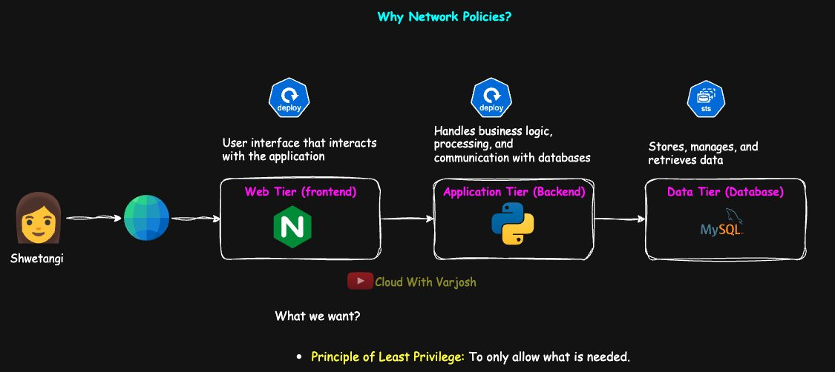
App flow
User (Shwetangi) → frontend → backend (business logic) → database → back to the user.

Why NetworkPolicies?
By default every Pod can talk to every other Pod — no isolation. A compromised Pod can move sideways anywhere. We want least privilege: only required traffic, e.g. the web tier must not reach the DB directly; only the app tier may, and only on 3306.

What they are
NetworkPolicies filter traffic to/from Pods by IP and port — Layer 3/4. They define ingress (incoming) and egress (outgoing) rules, for Pod-to-Pod and Pod-to-external traffic.
Kubernetes doesn't enforce them — the CNI plugin does.
Supports NetworkPolicy | Doesn't
Calico, Cilium, Kube-router, Antrea, AWS VPC CNI (with policy enabled), OVN-Kubernetes | Flannel, Weave Net, kindnet (kind's default)

Check your CNI: kubectl get ds -n kube-system (e.g. calico-node, cilium). Always confirm in the CNI's docs.

Ingress vs egress
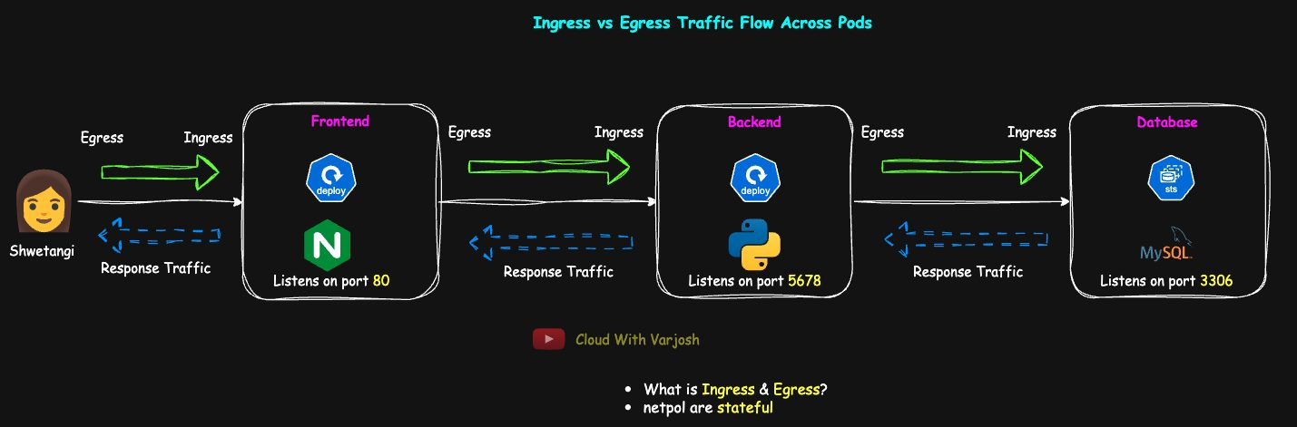
Ingress vs egress
- Ingress = traffic into a Pod.
- Egress = traffic out of a Pod.
- frontend → backend is egress from frontend and ingress to backend; backend → DB is egress from backend and ingress to DB.

Least privilege for our app
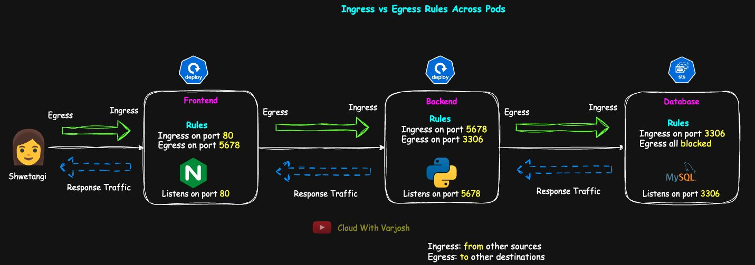
Least privilege
Tier | Ingress allowed | Egress allowed
Frontend | Port 80 from clients (LB / browser) | Backend on 5678 (+ DNS)
Backend | Port 5678 from frontend | DB on 3306 (+ DNS)
DB | Port 3306 from backend only | Nothing

The same idea applies to VMs and bare metal with host firewalls or security groups.

How they behave
- No policy selects a Pod → all traffic allowed.
- Once any policy selects a Pod for a direction (ingress/egress), everything not explicitly allowed in that direction is denied. Unselected Pods stay open.
- Multiple policies are additive (union of allows) — there are no "deny" rules.
- Policies are stateful: if a request is allowed, its reply is allowed automatically (like AWS Security Groups; unlike stateless NACLs).
- Set policyTypes explicitly. If Egress is listed but there are no egress rules, all egress is denied.

Three ways to select peers
1. podSelector — Pods in the same namespace with matching labels:
YAML
podSelector:
matchLabels:
role: backend
2. namespaceSelector — Pods in namespaces whose labels match (not names). E.g. every namespace labelled app=app1 (app1-dev, app1-staging, app1-prod):
YAML
namespaceSelector:
matchLabels:
app: app1
Every namespace automatically has the label kubernetes.io/metadata.name: <name>, handy for selecting one namespace by name.
3. ipBlock — IP ranges outside the cluster (e.g. an external backup server):
YAML
ipBlock:
cidr: 10.0.0.0/24
except:
- 10.0.0.5/32

Demo setup: kind + Calico
kind's default kindnet doesn't enforce policies, so disable it and install Calico:
BASH
kind get clusters
kind delete cluster --name=<old>
YAML
# kind-cluster.yaml
kind: Cluster
apiVersion: kind.x-k8s.io/v1alpha4
networking:
disableDefaultCNI: true # no kindnet
nodes:
- role: control-plane
image: kindest/node:v1.33.1@sha256:050072256b9a903bd914c0b2866828150cb229cea0efe5892e2b644d5dd3b34f
extraPortMappings:
- containerPort: 31000
hostPort: 31000
- role: worker
image: kindest/node:v1.33.1@sha256:050072256b9a903bd914c0b2866828150cb229cea0efe5892e2b644d5dd3b34f
- role: worker
image: kindest/node:v1.33.1@sha256:050072256b9a903bd914c0b2866828150cb229cea0efe5892e2b644d5dd3b34f
BASH
kind create cluster --config kind-cluster.yaml --name=cka-2025
kubectl get nodes # NotReady: "CNI plugin not initialized" – expected
kubectl apply -f https://raw.githubusercontent.com/projectcalico/calico/v3.30.2/manifests/calico.yaml
kubectl get daemonset -n kube-system # calico-node 3/3
kubectl get nodes # Ready

Deploy the app
YAML
# 00-namespace.yaml
apiVersion: v1
kind: Namespace
metadata:
name: app1-ns
labels:
app: app1
BASH
kubectl apply -f 00-namespace.yaml
kubectl config set-context --current --namespace=app1-ns
YAML
# 01-frontend.yaml
apiVersion: apps/v1
kind: Deployment
metadata:
name: frontend-deploy
namespace: app1-ns
spec:
replicas: 1
selector:
matchLabels: {app: app1, role: frontend}
template:
metadata:
labels: {app: app1, role: frontend}
spec:
containers:
- name: frontend-container
image: nginx
ports:
- containerPort: 80
---
apiVersion: v1
kind: Service
metadata:
name: frontend-svc
namespace: app1-ns
spec:
type: NodePort
selector: {app: app1, role: frontend}
ports:
- {protocol: TCP, port: 80, targetPort: 80, nodePort: 31000}
YAML
# 02-backend.yaml
apiVersion: apps/v1
kind: Deployment
metadata:
name: backend-deploy
namespace: app1-ns
spec:
replicas: 1
selector:
matchLabels: {app: app1, role: backend}
template:
metadata:
labels: {app: app1, role: backend}
spec:
containers:
- name: backend
image: python:3.11-slim
command: ["python3", "-m", "http.server", "5678"]
ports:
- containerPort: 5678
---
apiVersion: v1
kind: Service
metadata:
name: backend-svc
namespace: app1-ns
spec:
type: ClusterIP
selector: {app: app1, role: backend}
ports:
- {protocol: TCP, port: 5678, targetPort: 5678}
YAML
# 03-db.yaml
apiVersion: v1
kind: Service
metadata:
name: db-svc
namespace: app1-ns
spec:
clusterIP: None
selector: {app: app1, role: db}
ports:
- {protocol: TCP, port: 3306, targetPort: 3306}
---
apiVersion: apps/v1
kind: StatefulSet
metadata:
name: db-sts
namespace: app1-ns
spec:
serviceName: db-svc
replicas: 1
selector:
matchLabels: {app: app1, role: db}
template:
metadata:
labels: {app: app1, role: db}
spec:
containers:
- name: mysql
image: mysql:8.0
ports:
- containerPort: 3306
env:
- name: MYSQL_ROOT_PASSWORD
value: "password123"
(In production: Ingress + TLS instead of NodePort, an HPA, and a replicated DB with storage classes.)

Before policies: everyone talks to everyone
BASH
kubectl get pods,svc
kubectl exec -it <frontend-pod> -- bash
apt update && apt install -y telnet
telnet backend-svc 5678 # Connected
telnet db-svc 3306 # Connected (headless → Pod IP)
telnet db-sts-0.db-svc.app1-ns.svc.cluster.local 3306 # Connected (specific Pod)
From the backend (apt install -y telnet curl), frontend-svc 80 and the DB both connect. From the DB (microdnf install -y telnet — the MySQL image is RHEL-based), frontend and backend both connect. None of that is what we want: frontend shouldn't reach the DB, backend shouldn't initiate to the frontend, DB shouldn't initiate anything.

Policy 1: database
YAML
apiVersion: networking.k8s.io/v1
kind: NetworkPolicy
metadata:
name: db-policy
namespace: app1-ns
spec:
podSelector:
matchLabels: {app: app1, role: db} # applies to DB Pods
policyTypes:
- Ingress
- Egress # no egress rules below → all egress denied
ingress:
- from:
- podSelector:
matchLabels: {app: app1, role: backend}
ports:
- {protocol: TCP, port: 3306}
BASH
kubectl apply -f 04-db-netpol.yaml
kubectl get netpol
kubectl describe netpol db-policy

Policy 2: backend (allow DNS!)
YAML
apiVersion: networking.k8s.io/v1
kind: NetworkPolicy
metadata:
name: backend-policy
namespace: app1-ns
spec:
podSelector:
matchLabels: {app: app1, role: backend}
policyTypes: [Ingress, Egress]
ingress:
- from:
- podSelector:
matchLabels: {app: app1, role: frontend} # must match the frontend Pods' real labels
ports:
- {protocol: TCP, port: 5678}
egress:
- to:
- podSelector:
matchLabels: {app: app1, role: db}
ports:
- {protocol: TCP, port: 3306}
- to:
- namespaceSelector: # same list item as podSelector → AND
matchLabels:
kubernetes.io/metadata.name: kube-system
podSelector:
matchLabels:
k8s-app: kube-dns # CoreDNS Pods only
ports:
- {protocol: UDP, port: 53}
- {protocol: TCP, port: 53}
Why DNS? Calling db-svc first means a DNS lookup to CoreDNS in kube-system. If egress is locked down and DNS isn't allowed, name resolution fails and everything breaks. Allow UDP and TCP 53 to CoreDNS.

AND vs OR — the most common mistake
YAML
# AND – ONE list item containing both selectors
- to:
- namespaceSelector:
matchLabels: {kubernetes.io/metadata.name: kube-system}
podSelector:
matchLabels: {k8s-app: kube-dns}
Only Pods that are in kube-system and labelled k8s-app=kube-dns → exactly CoreDNS. ✅
YAML
# OR – TWO list items (note the second dash)
- to:
- namespaceSelector:
matchLabels: {kubernetes.io/metadata.name: kube-system}
- podSelector:
matchLabels: {k8s-app: kube-dns}
Any Pod in kube-system, or any Pod labelled k8s-app=kube-dns (in the policy's own namespace — a podSelector alone means "same namespace"). Far too broad; someone could label their own Pod k8s-app=kube-dns. ❌
Structure | Logic | Allows
Selectors in one entry | AND | Only kube-dns Pods in kube-system
Selectors in separate entries | OR | Anything matching either

Same rule for from: — namespaceSelector: team=analytics + podSelector: access=true:
- one entry → only Pods labelled access=true inside namespaces labelled team=analytics;
- two entries → every Pod in team=analytics namespaces, plus Pods labelled access=true in the policy's namespace.
Choose AND for "only authorised Pods inside that namespace"; OR when you really want either group.

Policy 3: frontend
YAML
apiVersion: networking.k8s.io/v1
kind: NetworkPolicy
metadata:
name: frontend-policy
namespace: app1-ns
spec:
podSelector:
matchLabels: {app: app1, role: frontend}
policyTypes: [Ingress, Egress]
ingress:
- from:
- ipBlock:
cidr: 0.0.0.0/0 # any client (kind: localhost:31000); in prod, the LB/Ingress range on 443
ports:
- {protocol: TCP, port: 80}
egress:
- to:
- podSelector:
matchLabels: {app: app1, role: backend}
ports:
- {protocol: TCP, port: 5678}
- to:
- namespaceSelector:
matchLabels: {kubernetes.io/metadata.name: kube-system}
podSelector:
matchLabels: {k8s-app: kube-dns}
ports:
- {protocol: UDP, port: 53}
- {protocol: TCP, port: 53}

Verify
From | Test | Expected
DB | telnet frontend-svc 80, telnet backend-svc 5678 | Hang / fail
Backend | telnet db-sts-0.db-svc.app1-ns.svc.cluster.local 3306 | Connects
Backend | telnet frontend-svc 80 | Hang / fail
Frontend | telnet backend-svc 5678 | Connects
Frontend | telnet db-sts-0.db-svc.app1-ns.svc.cluster.local 3306 | Hang / fail

Exercise
Move the DB StatefulSet and Service into a new namespace db-ns, keep frontend/backend in app1-ns, and recreate the same rules (frontend→backend ✓, backend→db ✓, frontend→db ✗, backend→frontend ✗, db→anything ✗). Hint: you'll need namespaceSelector + podSelector in the same entry for cross-namespace rules.

Day 48 — DNS in Kubernetes (CoreDNS)
Prerequisites: basic DNS and StatefulSets (Day 44).

CoreDNS
CoreDNS is the cluster DNS server (default since v1.13, replacing kube-dns). Workloads use names, not changing IPs.
- Runs as a Deployment in kube-system (usually 2+ replicas).
- Exposed by a ClusterIP Service still named kube-dns (often 10.96.0.10).
- Plugin-based: the kubernetes plugin answers for Services/Pods; forward sends other names upstream; it exposes Prometheus metrics.
BASH
kubectl get deploy -n kube-system # coredns 2/2
kubectl get svc -n kube-system # kube-dns 10.96.0.10 53/UDP,53/TCP,9153/TCP
Port | Protocol | Purpose
53 | UDP/TCP | DNS queries
9153 | TCP | Prometheus metrics (request counts, response codes, cache hits, latency)

Name formats
Resource | FQDN | Example | Notes
Service | <svc>.<ns>.svc.cluster.local | nginx-svc.default.svc.cluster.local | Created for every Service; resolves to the ClusterIP
Pod (by IP) | <ip-with-dashes>.<ns>.pod.cluster.local | 10-244-2-10.default.pod.cluster.local | Only if the CoreDNS pods option is enabled
StatefulSet Pod via headless Service | <pod>.<headless-svc>.<ns>.svc.cluster.local | pod-0.headless-svc.default.svc.cluster.local | Stable per-Pod name

A trailing dot (...cluster.local.) marks a fully qualified name; usually omitted on the command line.
Level | Example (Service) | Example (Pod) | Meaning
Cluster domain | cluster.local | cluster.local | Root of the cluster's private DNS
Type | svc | pod | Service or Pod
Namespace | default | default | Namespace
Host | nginx-svc | 10-244-44-55 | Service name, or Pod IP with dashes

To resolve nginx-svc from the same namespace, the resolver completes it to nginx-svc.default.svc.cluster.local and CoreDNS answers from the cluster.local → svc → default → nginx-svc hierarchy. Kubernetes DNS borrows public-DNS ideas, but cluster.local is its own private root with Kubernetes-specific svc/pod subdomains.
Record | FQDN | Resolves to
Service nginx-svc (default) | nginx-svc.default.svc.cluster.local. | ClusterIP, e.g. 10.96.48.49
Service app1-svc (app1-ns) | app1-svc.app1-ns.svc.cluster.local. | ClusterIP
Pod | 10-244-2-10.app1-ns.pod.cluster.local. | 10.244.2.10
StatefulSet Pod | pod-0.headless-svc.app1-ns.svc.cluster.local. | That Pod's IP
Headless Service | headless-svc.app1-ns.svc.cluster.local. | All ready Pod IPs (several A records, no ClusterIP) + SRV records

Inside a Pod: resolv.conf
BASH
kubectl run debug-pod -it --image=nicolaka/netshoot --rm -- bash
netshoot bundles network tools: dig, nslookup, curl, ping, telnet, tcpdump…
BASH
nslookup debug-pod # NXDOMAIN – bare Pod names have no DNS record
nslookup kubernetes.io # works – CoreDNS forwards external names upstream
cat /etc/resolv.conf
# search default.svc.cluster.local svc.cluster.local cluster.local
# nameserver 10.96.0.10
# options ndots:5
- nameserver = the kube-dns Service IP → every lookup goes to CoreDNS.
- search suffixes are tried in order for short names: x.default.svc.cluster.local, then x.svc.cluster.local, then x.cluster.local. The first hit wins.
- ndots:5 — names with fewer than 5 dots try the search list first.
- So short names work within your own namespace; for other namespaces use svc.namespace or the full FQDN. Prefer FQDNs in multi-namespace setups to avoid surprises.

/etc/hosts vs DNS
/etc/hosts holds static mappings and is checked before DNS (order set by /etc/nsswitch.conf: hosts: files dns). E.g. 10.244.2.3 www.kubernetes.io overrides DNS for that name.
nslookup and dig skip /etc/hosts and query the nameserver directly. So ping myhost may work (via /etc/hosts) while nslookup myhost fails.

Testing records
Same namespace
BASH
kubectl create deployment nginx-deploy --image=nginx
kubectl expose deployment nginx-deploy --name=nginx-svc --port=80
kubectl run debug-pod -it --image=nicolaka/netshoot --rm -- bash
nslookup nginx-svc
# Name: nginx-svc.default.svc.cluster.local Address: 10.96.48.49
Cross namespace
BASH
kubectl create ns app1-ns
kubectl create deployment app1-deploy --image=nginx -n app1-ns
kubectl expose deployment app1-deploy --name=app1-svc --port=80 -n app1-ns
# from a Pod in default:
nslookup app1-svc # fails – search list only covers default.*
nslookup app1-svc.app1-ns # works → app1-svc.app1-ns.svc.cluster.local
# from a Pod in app1-ns:
kubectl run debug-pod-app1 -n app1-ns -it --image=nicolaka/netshoot --rm -- bash
nslookup app1-svc # works – its search list starts with app1-ns.svc.cluster.local

The Corefile
CoreDNS config lives in the coredns ConfigMap:
BASH
kubectl get cm -n kube-system coredns -o yaml
.:53 {
errors
health {
lameduck 5s
}
ready
kubernetes cluster.local in-addr.arpa ip6.arpa {
pods insecure
fallthrough in-addr.arpa ip6.arpa
ttl 30
}
prometheus :9153
forward . /etc/resolv.conf {
max_concurrent 1000
}
cache 30 {
disable success cluster.local
disable denial cluster.local
}
loop
reload
loadbalance
}
Directive | Purpose
.:53 | Server block: all zones, port 53
errors | Log errors
health { lameduck 5s } | /health endpoint for liveness; drain 5 s on shutdown
ready | /ready endpoint for readiness
kubernetes cluster.local in-addr.arpa ip6.arpa | Answer cluster names and reverse lookups
pods insecure | Pod-IP names without verifying the Pod exists (legacy, spoofable)
fallthrough in-addr.arpa ip6.arpa | Pass unanswered reverse lookups to the next plugin
ttl 30 | TTL for cluster records
prometheus :9153 | Metrics
forward . /etc/resolv.conf | Send everything else to upstream resolvers (max 1000 concurrent)
cache 30 {...} | Cache answers 30 s, but not for cluster.local
loop | Detect forwarding loops
reload | Reload when the Corefile changes
loadbalance | Randomise the order of A records in answers

Pod record modes: pods insecure (no checks, legacy, avoid in production) · pods verified (only if a matching Pod really exists in that namespace — recommended when you need Pod records) · pods disabled (default if omitted — no Pod records). Pods can also get names via their hostname/subdomain fields, which is how StatefulSet Pods get pod-0.svc... names.

DNS troubleshooting checklist
- CoreDNS running? kubectl get pods -n kube-system -l k8s-app=kube-dns
- Logs: kubectl logs -n kube-system -l k8s-app=kube-dns --tail=100 (loops, forward failures)
- Test from a Pod: kubectl run dns-test --rm -it --image=nicolaka/netshoot -- bash → nslookup kubernetes.default, dig nginx-svc.default.svc.cluster.local
- /etc/resolv.conf in the Pod points to the cluster DNS IP with the right search list
- /etc/nsswitch.conf has hosts: files dns
- Corefile kubernetes block has the right domain (cluster.local)
- NetworkPolicies/firewalls allow UDP+TCP 53 to CoreDNS (classic cause after Day 47!)
- kubelet DNS settings (clusterDNS / --cluster-dns) on custom clusters
- External names failing too? Check forward . /etc/resolv.conf and the upstream resolvers of the CoreDNS Pods

Part 19 — Ingress (Days 49–51)

Day 49 — Ingress Part 1: What, Why and How

Why Services alone aren't enough
- NodePort — fine for dev/test, but node IPs change as nodes scale; you can't hand those to users.
- LoadBalancer — gives a cloud LB, but:
  - it's Layer 4 (TCP/UDP): no HTTP routing by path or host;
  - one cloud load balancer per Service → expensive and messy with many microservices;
  - TLS must be terminated in the app, since an L4 LB can't decrypt HTTPS.
What we want: HTTP(S)-aware routing (/android, /iphone, iphone.myapp.com), one load balancer for many apps, and routing rules kept as declarative, version-controlled manifests.

Ingress and the Ingress controller
An Ingress is a Kubernetes object describing how external HTTP(S) traffic reaches internal Services — a Layer 7 router definition:
- path-based routing (/android → android-svc)
- host-based routing (iphone.myapp.com → ios-svc)
- TLS termination at the edge instead of in every app
- one central entry point for all web traffic
The Ingress object is only a declaration — it routes nothing by itself. An Ingress controller (running in the cluster) watches Ingress objects and turns them into real load-balancer configuration: listeners (80/443), routing rules, health checks, targets.
Ingress says what should happen; the controller decides how. (Strictly, Ingress handles HTTP and HTTPS only — "HTTP(S) load balancer" is more precise than "L7".)

Real-world flow
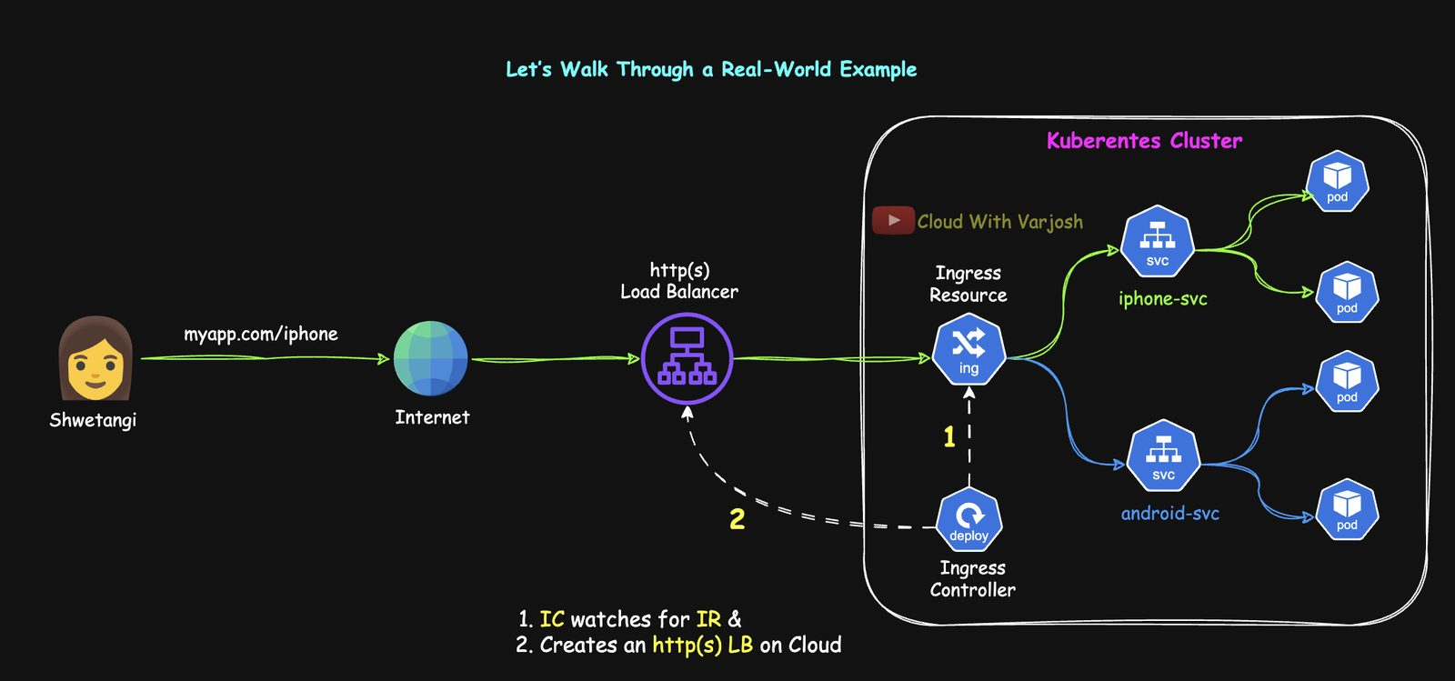
Ingress flow
Shwetangi opens myapp.com/iphone:
- The request crosses the internet to an external load balancer.
- That LB was created because of the Ingress controller:
  - Cloud-native controller (AWS Load Balancer Controller, GKE Ingress): the controller itself provisions an L7 HTTP(S) LB in the cloud.
  - Third-party controller (NGINX, HAProxy — common on-prem/hybrid): you expose the controller Pods with a Service of type LoadBalancer, which creates an L4 LB that just forwards everything to the controller Pods.
- The controller reads the Ingress rules (e.g. /iphone → iphone-svc).
- It either programs the cloud LB (cloud-native) or does the routing itself (third-party).
- Traffic reaches iphone-svc and then one of its Pods.
The Ingress object is never a network hop.
 | Cloud-native (e.g. AWS LBC → ALB) | Third-party (NGINX, HAProxy)
Where routing/TLS happens | In the cloud LB, outside the cluster | In controller Pods inside the cluster
How it's exposed | Controller creates an L7 ALB | A LoadBalancer Service → L4 LB → controller Pods

Popular controllers
Controller | Notes
AWS Load Balancer Controller | Creates ALBs/NLBs on EKS; deep AWS integration
NGINX Ingress | Most widely used; very configurable
HAProxy Ingress | High performance, low latency
Traefik | Cloud-native; automatic Let's Encrypt TLS; dynamic config
Contour | Envoy-based; multi-team traffic management
Istio Ingress Gateway | Part of the Istio mesh; mTLS, policies, fine traffic control

All implement the standard Ingress API but differ in features and operating model.

Day 50 — Ingress Part 2: Path-Based Routing on EKS with an ALB

What we deploy
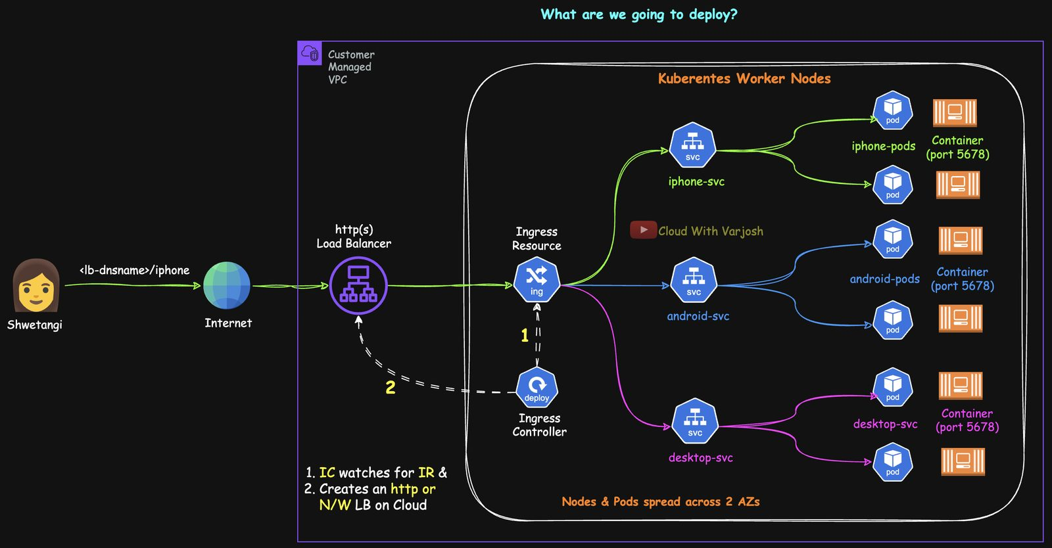
Architecture
In namespace app1-ns, three tiny web apps:
- iphone-svc for /iphone
- android-svc for /android
- desktop-svc as the catch-all for / and anything unmatched
One Ingress maps paths to Services. The AWS Load Balancer Controller (LBC) creates an internet-facing ALB, target groups and rules. With target-type: ip the ALB sends traffic straight to Pod IPs on port 5678. Everything is spread across two AZs.
In real life users don't type paths: the Android app is coded to call myapp.com/android, the iPhone app myapp.com/iphone, and browsers hitting myapp.com fall through to desktop — one domain, split by platform.

Cluster
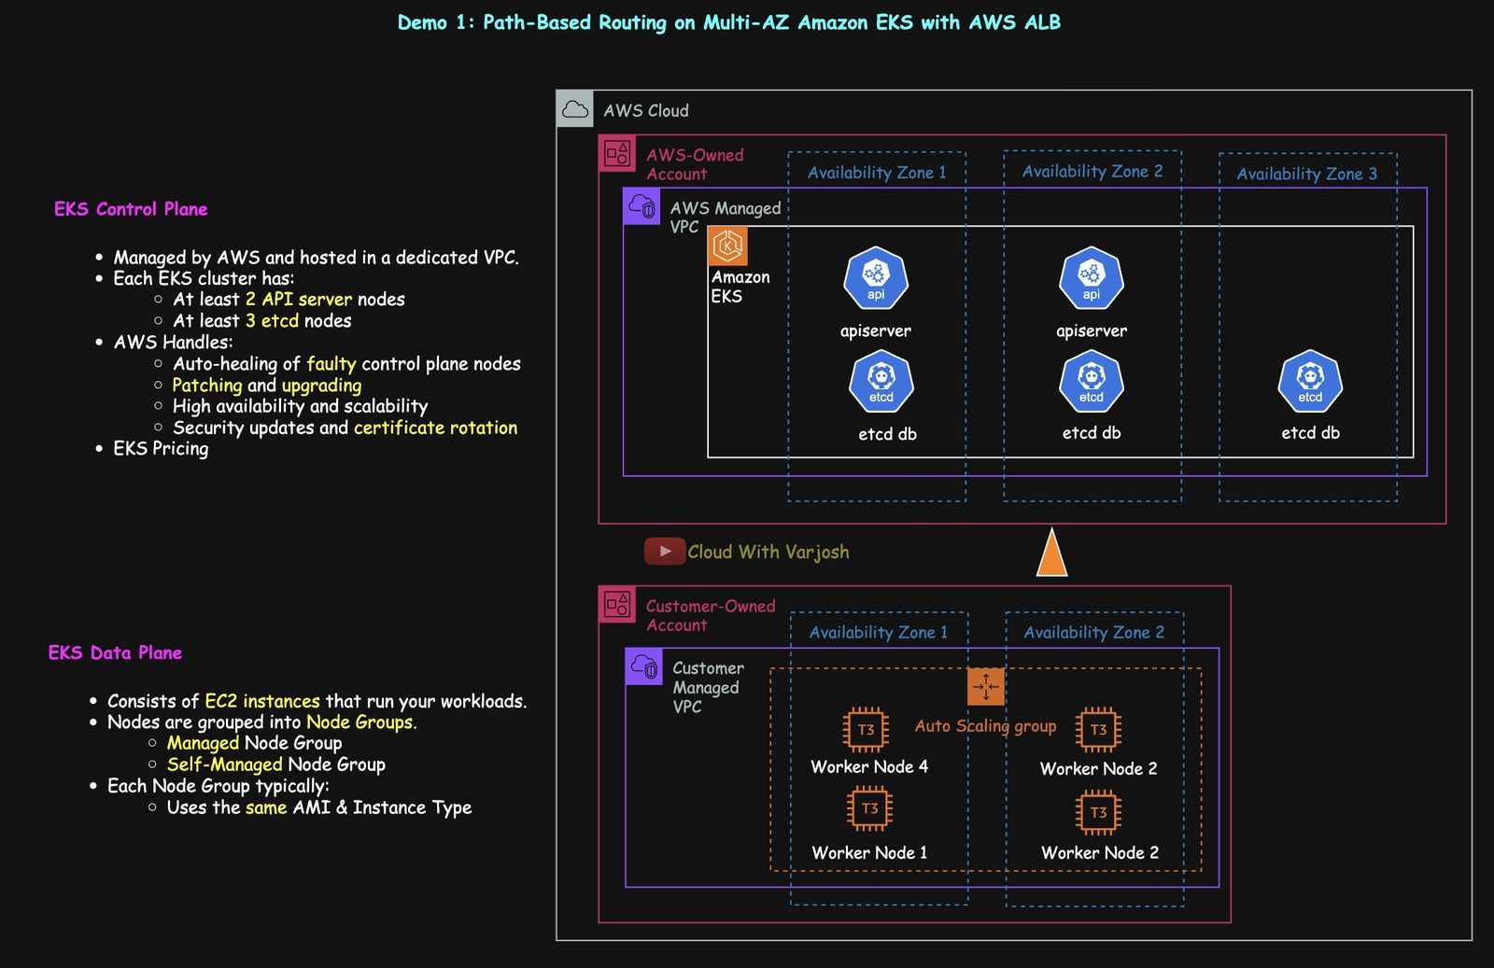
Cluster
EKS in us-east-2, AZs us-east-2a/2b, 4 × t3.small (4 nodes to show topologySpreadConstraints; 2 is enough otherwise). Tools: AWS CLI, eksctl, helm. Prerequisite: Services (Day 12).
YAML
# eks-config.yaml
apiVersion: eksctl.io/v1alpha5
kind: ClusterConfig
metadata:
name: cwvj-ingress-demo
region: us-east-2
tags: {owner: varun-joshi, bu: cwvj, project: ingress-demo}
availabilityZones: [us-east-2a, us-east-2b]
iam:
withOIDC: true # needed for IAM Roles for Service Accounts (IRSA)
managedNodeGroups:
- name: cwvj-eks-priv-ng
instanceType: t3.small
minSize: 4
maxSize: 4
privateNetworking: true # nodes in private subnets
volumeSize: 20
iam:
withAddonPolicies:
autoScaler: true
certManager: true
albIngress: true # permissions for the AWS LBC
labels: {lifecycle: ec2-autoscaler}
BASH
eksctl create cluster -f eks-config.yaml
kubectl get nodes --show-labels | grep topology.kubernetes.io/zone

Install the AWS Load Balancer Controller
1. IAM policy — permissions to manage ELB, EC2 and related APIs:
BASH
curl -O https://raw.githubusercontent.com/kubernetes-sigs/aws-load-balancer-controller/v2.13.3/docs/install/iam_policy.json
aws iam create-policy --policy-name AWSLoadBalancerControllerIAMPolicy \
--policy-document file://iam_policy.json
2. IAM-backed ServiceAccount (IRSA) — eksctl creates an IAM role with that policy (via CloudFormation) and annotates a Kubernetes SA so the controller Pods can assume it:
BASH
eksctl create iamserviceaccount \
--cluster=cwvj-ingress-demo \
--namespace=kube-system \
--name=aws-load-balancer-controller \
--attach-policy-arn=arn:aws:iam::<ACCOUNT_ID>:policy/AWSLoadBalancerControllerIAMPolicy \
--override-existing-serviceaccounts \
--region us-east-2 \
--approve
kubectl get sa -n kube-system aws-load-balancer-controller -o yaml
# annotations:
# eks.amazonaws.com/role-arn: arn:aws:iam::<ACCOUNT_ID>:role/eksctl-...
3. Helm install (the controller used to be called the "ALB Ingress Controller"):
BASH
helm repo add eks https://aws.github.io/eks-charts
helm repo update eks
helm install aws-load-balancer-controller eks/aws-load-balancer-controller \
-n kube-system \
--set clusterName=cwvj-ingress-demo \
--set serviceAccount.create=false \
--set serviceAccount.name=aws-load-balancer-controller \
--version 1.13.0
helm list -n kube-system # plain 'helm list' only shows the current namespace
kubectl get deployment -n kube-system aws-load-balancer-controller # 2/2
kubectl describe pods -n kube-system -l app.kubernetes.io/name=aws-load-balancer-controller | grep "Service Account"
serviceAccount.create=false reuses the IRSA-annotated SA created by eksctl.

The three apps
BASH
kubectl apply -f 01-ns.yaml # Namespace app1-ns
kubectl config set-context --current --namespace=app1-ns
YAML
# 02-iphone.yaml
apiVersion: apps/v1
kind: Deployment
metadata:
name: iphone-deploy
namespace: app1-ns
spec:
replicas: 2
selector:
matchLabels:
app: iphone-page
template:
metadata:
labels:
app: iphone-page
spec:
topologySpreadConstraints:
- maxSkew: 1 # zones may differ by at most 1 Pod
topologyKey: topology.kubernetes.io/zone
whenUnsatisfiable: ScheduleAnyway # soft – still schedule if impossible
labelSelector:
matchLabels:
app: iphone-page
containers:
- name: python-http
image: python:alpine
command: ["/bin/sh", "-c"]
args:
- |
mkdir -p /iphone && echo '<html>
<head><title>iPhone Users</title></head>
<body>
<h1>iPhone Users</h1>
<p>Welcome to Cloud With VarJosh</p>
</body>
</html>' > /iphone/index.html && cd / && python3 -m http.server 5678
ports:
- containerPort: 5678
---
apiVersion: v1
kind: Service
metadata:
name: iphone-svc
namespace: app1-ns
annotations:
alb.ingress.kubernetes.io/healthcheck-path: /iphone/index.html # per-app health check
spec:
selector:
app: iphone-page
ports:
- protocol: TCP
port: 80
targetPort: 5678
03-android.yaml is identical with android (page at /android/index.html, health check /android/index.html). 04-desktop.yaml writes /index.html at the root with health check /index.html — the catch-all.
topologySpreadConstraints spread Pods evenly over a topology (here zones): maxSkew: 1 means the Pod count per zone can differ by at most one; whenUnsatisfiable: ScheduleAnyway makes it a preference (DoNotSchedule makes it strict).
BASH
kubectl get deployments,services
kubectl get pods -o wide --sort-by='.spec.nodeName' # spread across both AZs

The Ingress
YAML
# 05-ingress.yaml
apiVersion: networking.k8s.io/v1
kind: Ingress
metadata:
name: ingress-demo1
namespace: app1-ns
annotations:
alb.ingress.kubernetes.io/scheme: internet-facing # or 'internal'
alb.ingress.kubernetes.io/load-balancer-name: cwvj-ingress-demo1
alb.ingress.kubernetes.io/target-type: ip # register Pod IPs directly
alb.ingress.kubernetes.io/listen-ports: '[{"HTTP": 80}]'
alb.ingress.kubernetes.io/healthcheck-protocol: HTTP
alb.ingress.kubernetes.io/healthcheck-port: traffic-port
alb.ingress.kubernetes.io/healthcheck-interval-seconds: '15'
alb.ingress.kubernetes.io/healthcheck-timeout-seconds: '5'
alb.ingress.kubernetes.io/healthy-threshold-count: '2'
alb.ingress.kubernetes.io/unhealthy-threshold-count: '2'
alb.ingress.kubernetes.io/success-codes: '200'
spec:
ingressClassName: alb # which controller handles this Ingress
rules:
- http:
paths:
- path: /iphone
pathType: Prefix
backend:
service:
name: iphone-svc
port:
number: 80
- path: /android
pathType: Prefix
backend:
service:
name: android-svc
port:
number: 80
- path: /
pathType: Prefix # catch-all
backend:
service:
name: desktop-svc
port:
number: 80
pathType: Prefix matches by path prefix (Exact matches only that exact path). The longest matching prefix wins, so / only catches what doesn't match /iphone or /android.

ALB target types
target-type: ip — straight to Pods
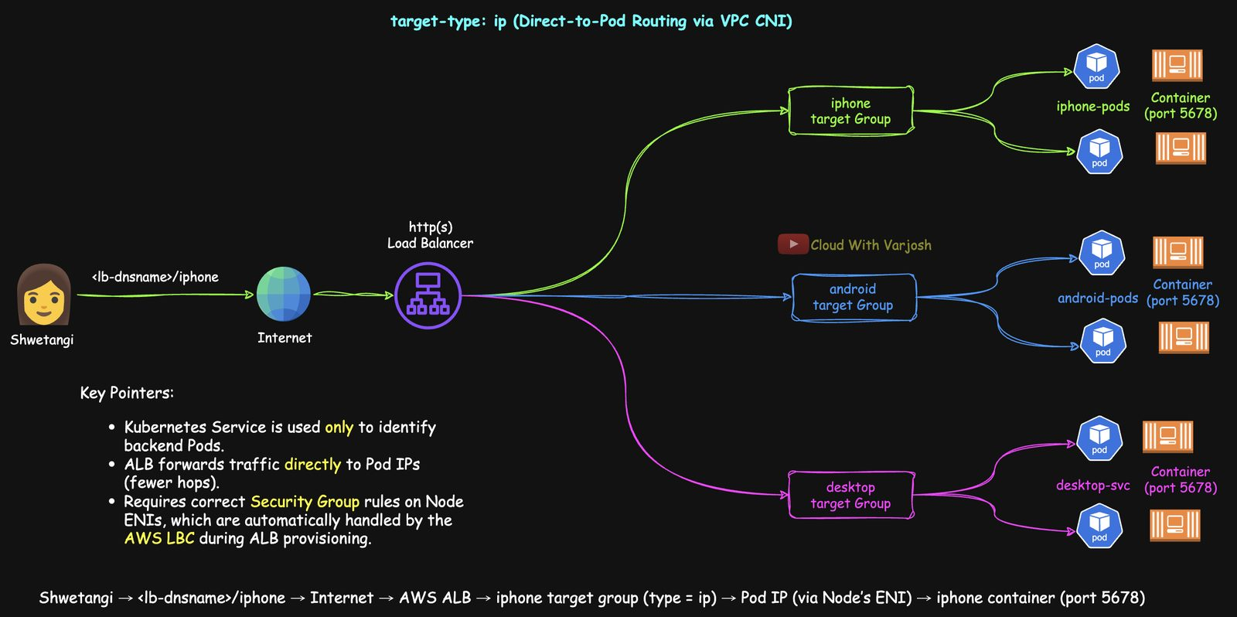
Target type ip
The ALB registers Pod IPs in its target groups. Works because the AWS VPC CNI gives every Pod a real VPC IP. The Service is used only to find the Pods, not to forward traffic. Fewer hops, Pod-level health checks; the LBC sets up the security-group rules.
user → ALB → target group (ip) → Pod IP (via node ENI) → container :5678
target-type: instance — via NodePort
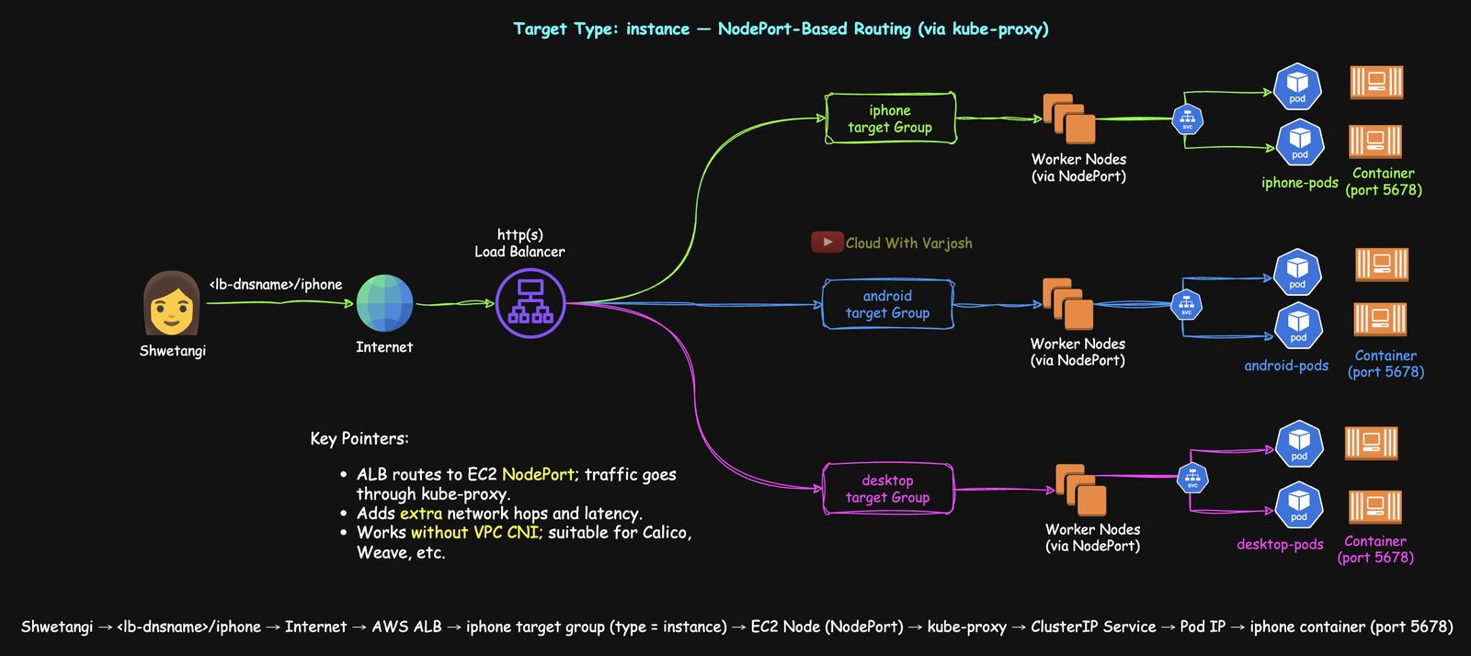
Target type instance
The ALB registers EC2 nodes; the Service must be NodePort; traffic goes node → kube-proxy → Pod. More hops and node-level health checks only, but works with any CNI (Calico, Weave…).
user → ALB → target group (instance) → node:NodePort → kube-proxy → Pod → container

IngressClass
Like StorageClass selects a storage provisioner, IngressClass selects which controller handles an Ingress. The AWS LBC install created one named alb:
BASH
kubectl get ingressclass
# alb ingress.k8s.aws/alb
Why run several controllers? Protocol needs (e.g. HAProxy for TCP/UDP alongside ALB for HTTP), multi-tenant teams wanting different controllers, or different behaviour per environment/region (lenient NGINX in staging, strict ALB in prod). One IngressClass can be marked default.

Verify
BASH
kubectl get ingress
# ingress-demo1 alb * cwvj-ingress-demo1-351634829.us-east-2.elb.amazonaws.com 80
Allow ~3 minutes for the ALB. Then:
- http://<alb-dns>/iphone → "iPhone Users – Welcome to Cloud With VarJosh"
- http://<alb-dns>/android → "Android Users…"
- http://<alb-dns>/ → "Desktop Users…"
kubectl describe ingress ingress-demo1 shows class, address, rules and sync events. In the console (EC2 → Load Balancers → cwvj-ingress-demo1): scheme internet-facing, listener on 80, three target groups of type ip, health-check settings from the Service annotations, rules mapping /iphone, /android, /.

Cleanup
BASH
kubectl delete -f . # deleting the Ingress also deletes the ALB, target groups, listeners, SGs
# eksctl delete cluster --name cwvj-ingress-demo # only when you're done with all demos

Day 51 — Ingress Part 3: TLS, Custom Domain and Host-Based Routing
Prerequisites: DNS basics, Days 49–50.

Demo 2: HTTPS with ACM and a Route 53 domain
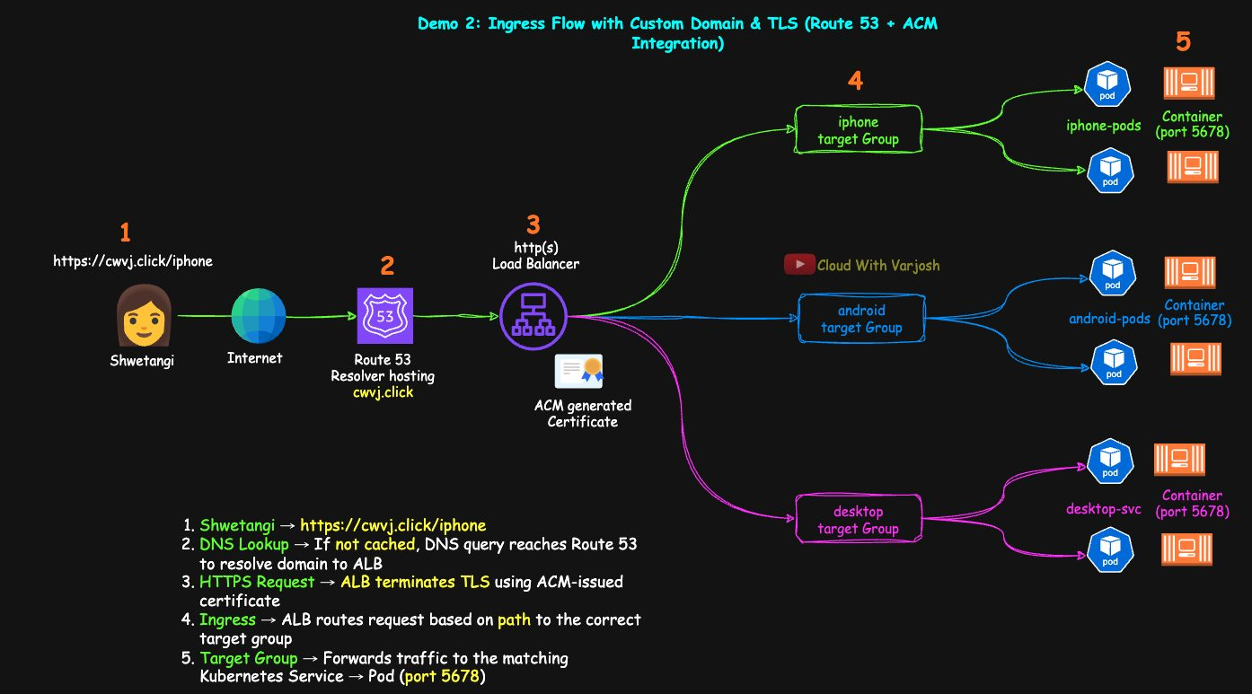
TLS demo
1. Domain and certificate
- Route 53 → Domains → register a domain (e.g. cwvj.click, ~$3/year for .click — not free-tier). A hosted zone with 4 name servers is created automatically.
- AWS Certificate Manager (ACM) → Request a public certificate for cwvj.click.
- Choose DNS validation and let ACM create the CNAME validation records in Route 53. The certificate is issued once validated.
2. Ingress with HTTPS
YAML
apiVersion: networking.k8s.io/v1
kind: Ingress
metadata:
name: ingress-demo2
namespace: app1-ns
annotations:
alb.ingress.kubernetes.io/scheme: internet-facing
alb.ingress.kubernetes.io/load-balancer-name: cwvj-ingress-demo2
alb.ingress.kubernetes.io/target-type: ip
alb.ingress.kubernetes.io/listen-ports: '[{"HTTPS":443}, {"HTTP":80}]'
alb.ingress.kubernetes.io/certificate-arn: arn:aws:acm:us-east-2:<ACCOUNT_ID>:certificate/<CERT_ID>
alb.ingress.kubernetes.io/ssl-redirect: '443' # HTTP → HTTPS redirect
alb.ingress.kubernetes.io/healthcheck-protocol: HTTP
alb.ingress.kubernetes.io/healthcheck-port: traffic-port
alb.ingress.kubernetes.io/healthcheck-interval-seconds: '15'
alb.ingress.kubernetes.io/healthcheck-timeout-seconds: '5'
alb.ingress.kubernetes.io/healthy-threshold-count: '2'
alb.ingress.kubernetes.io/unhealthy-threshold-count: '2'
alb.ingress.kubernetes.io/success-codes: '200'
spec:
ingressClassName: alb
rules: # same three paths as Demo 1
- http:
paths:
- {path: /iphone, pathType: Prefix, backend: {service: {name: iphone-svc, port: {number: 80}}}}
- {path: /android, pathType: Prefix, backend: {service: {name: android-svc, port: {number: 80}}}}
- {path: /, pathType: Prefix, backend: {service: {name: desktop-svc, port: {number: 80}}}}
BASH
kubectl apply -f . # from demo2/
TLS now terminates at the ALB using the ACM certificate; traffic to Pods stays HTTP inside the VPC.
3. Route 53 alias record — Hosted zone cwvj.click → Create record → leave the name blank (apex) → Alias → "Application and Classic Load Balancer" → region us-east-2 → pick the cwvj-ingress-demo2 ALB.
4. Verify
- https://cwvj.click/ → Desktop; /iphone/ → iPhone; /android/ → Android.
- http:// requests redirect to HTTPS.
- The padlock shows your certificate.
- Console: EC2 → Load Balancers → Listeners → HTTPS:443 → rules.
Wildcard caveat: a certificate for *.cwvj.click does not cover the apex cwvj.click. Include both names (or use two certificates).
5. Cleanup: kubectl delete -f . (ALB removed automatically), delete the ACM certificate, delete the alias record; keep the hosted zone/domain and the cluster for Demo 3.

Demo 3: host-based (name-based) routing
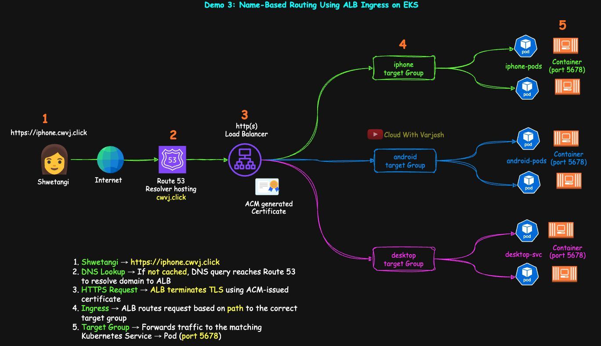
Host routing
Goal: iphone.cwvj.click → iPhone app, android.cwvj.click → Android app, cwvj.click → desktop — one ALB.
1. Certificates: in ACM request public certificates for cwvj.click and *`.cwvj.click`** (DNS validation).
2. Apps serve from /: change each Deployment to write /index.html (not /iphone/index.html) and set every Service's health check to /index.html:
YAML
args:
- |
echo '<html>
<head><title>iPhone Users</title></head>
<body>
<h1>iPhone Users</h1>
<p>Welcome to Cloud With VarJosh</p>
</body>
</html>' > /index.html && python3 -m http.server 5678
---
metadata:
annotations:
alb.ingress.kubernetes.io/healthcheck-path: /index.html
3. Ingress with host rules:
YAML
apiVersion: networking.k8s.io/v1
kind: Ingress
metadata:
name: ingress-demo3
namespace: app1-ns
annotations:
alb.ingress.kubernetes.io/scheme: internet-facing
alb.ingress.kubernetes.io/load-balancer-name: cwvj-ingress-demo3
alb.ingress.kubernetes.io/target-type: ip
alb.ingress.kubernetes.io/listen-ports: '[{"HTTPS":443}, {"HTTP":80}]'
alb.ingress.kubernetes.io/healthcheck-protocol: HTTP
alb.ingress.kubernetes.io/healthcheck-port: traffic-port
alb.ingress.kubernetes.io/healthcheck-interval-seconds: '15'
alb.ingress.kubernetes.io/healthcheck-timeout-seconds: '5'
alb.ingress.kubernetes.io/healthy-threshold-count: '2'
alb.ingress.kubernetes.io/unhealthy-threshold-count: '2'
alb.ingress.kubernetes.io/success-codes: '200'
# comma-separated list: apex cert + wildcard cert
alb.ingress.kubernetes.io/certificate-arn: arn:aws:acm:...:certificate/<APEX>,arn:aws:acm:...:certificate/<WILDCARD>
alb.ingress.kubernetes.io/ssl-redirect: '443'
spec:
ingressClassName: alb
rules:
- host: iphone.cwvj.click
http:
paths:
- {path: /, pathType: Prefix, backend: {service: {name: iphone-svc, port: {number: 80}}}}
- host: android.cwvj.click
http:
paths:
- {path: /, pathType: Prefix, backend: {service: {name: android-svc, port: {number: 80}}}}
- host: cwvj.click
http:
paths:
- {path: /, pathType: Prefix, backend: {service: {name: desktop-svc, port: {number: 80}}}}
BASH
kubectl apply -f . # from demo3/
4. DNS: create alias A records for iphone.cwvj.click, android.cwvj.click and cwvj.click, all pointing to the ALB. (ExternalDNS can create these automatically from Ingress/Service objects in production.)
5. Verify: https://iphone.cwvj.click → iPhone, https://android.cwvj.click → Android, https://cwvj.click → Desktop. ALB listener rules show host-header conditions.
6. Cleanup:
BASH
kubectl delete -f .
# ACM: delete both certificates; Route 53: delete the three alias records
eksctl delete cluster --name cwvj-ingress-demo --region us-east-2
You now know: TLS with ACM, domains with Route 53, path and host routing, and ALB configuration through annotations — a production-style ingress setup.

Part 20 — Gateway API (Days 52–53)

Day 52 — Gateway API Part 1: Concepts
Prerequisites: the Ingress series (Days 49–51) and CRDs/Operators (Days 39–40).

What we know about Ingress
- Native but minimal — the Ingress spec covers only HTTP(S) host and path routing.
- Extras come from the controller — SSL redirects, custom health checks, rate limiting, canary/weighted splits, TCP/UDP… all vendor features.
- …exposed through annotations — e.g. the AWS LBC annotations we used for SSL policy, health checks, redirects, weighted target groups. Kubernetes doesn't validate annotations; only the controller reads them.

What's missing in Ingress
1. Cross-namespace, multi-tenancy and RBAC
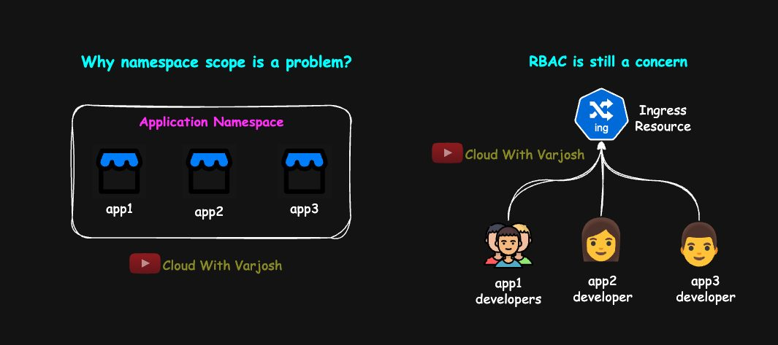
Ingress limitations
- An Ingress is namespaced and can only point to Services in its own namespace. To put app1…app10 behind one Ingress they'd all have to share a namespace — against the best practice of one namespace per app/team.
- If teams share one Ingress object, every team needs write access to it and can break each other's routes. There's no API-level way to delegate "you own this host/path".
- Some controllers work around this (AWS LBC IngressGroup lets Ingresses from many namespaces share one ALB), but that's vendor-specific and not portable.
2. Protocol and feature scope — only HTTP(S) host/path. No native TCP, UDP or gRPC (a fast RPC protocol over HTTP/2 for service-to-service calls across languages), and no built-in SSL redirect, health checks, rate limits, weighted/canary splits, or header/query/method matching. Controllers add these via annotations → lock-in.
3. Annotations aren't validated — a typo is silently ignored (hidden misconfiguration), annotations differ per vendor, and switching controllers means rewriting manifests.

What Gateway API is
A Kubernetes-standard networking API from SIG-Network (a Special Interest Group owns an area of Kubernetes; SIG-Network owns Services, Ingress, Gateway API). It is not built in — you install its CRDs plus a conforming controller. It:
- separates infrastructure (Gateways) from application routing (Routes);
- supports multi-tenancy with API-level isolation;
- supports HTTP, HTTPS, gRPC, TCP, UDP;
- moves advanced traffic features into the spec (validated, portable).

Resource model and roles
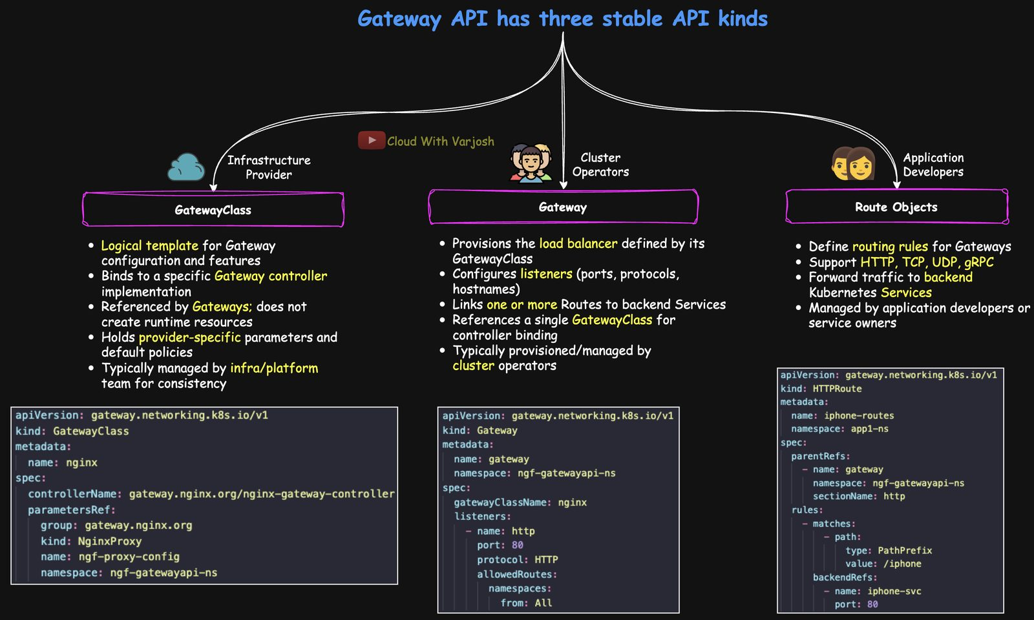
Roles
Resource | What it is | Analogy | Typical owner
GatewayClass (cluster-scoped) | A type of gateway and which controller implements it; optional vendor parameters. Creates nothing by itself | Like a StorageClass | Infrastructure provider / platform team
Gateway | An actual traffic entry point with listeners (port, protocol, hostname, TLS). Creating one usually provisions the load balancer/proxy | The LB instance | Cluster operator / platform team
Routes — HTTPRoute, GRPCRoute, TCPRoute, UDPRoute (TLSRoute for SNI passthrough) | Rules attached to a Gateway listener that match traffic (paths, headers, methods…) and send it to backends (Services), even across namespaces when allowed | The routing table | Application developers

What you get
- Multiple protocols through one model.
- Spec-defined traffic management (portable, validated by the API server): weighted/canary splits, path and header rewrites, timeouts and retries, request/response filters, header/query/method matching.
- Safe cross-namespace routing: a Gateway's allowedRoutes decides which namespaces may attach Routes; a ReferenceGrant in the target namespace must allow a Route to reference a Service there.
- Far fewer vendor annotations — the portable core is the same everywhere; vendors can still add extensions.

How it works (NGINX Gateway Fabric example)
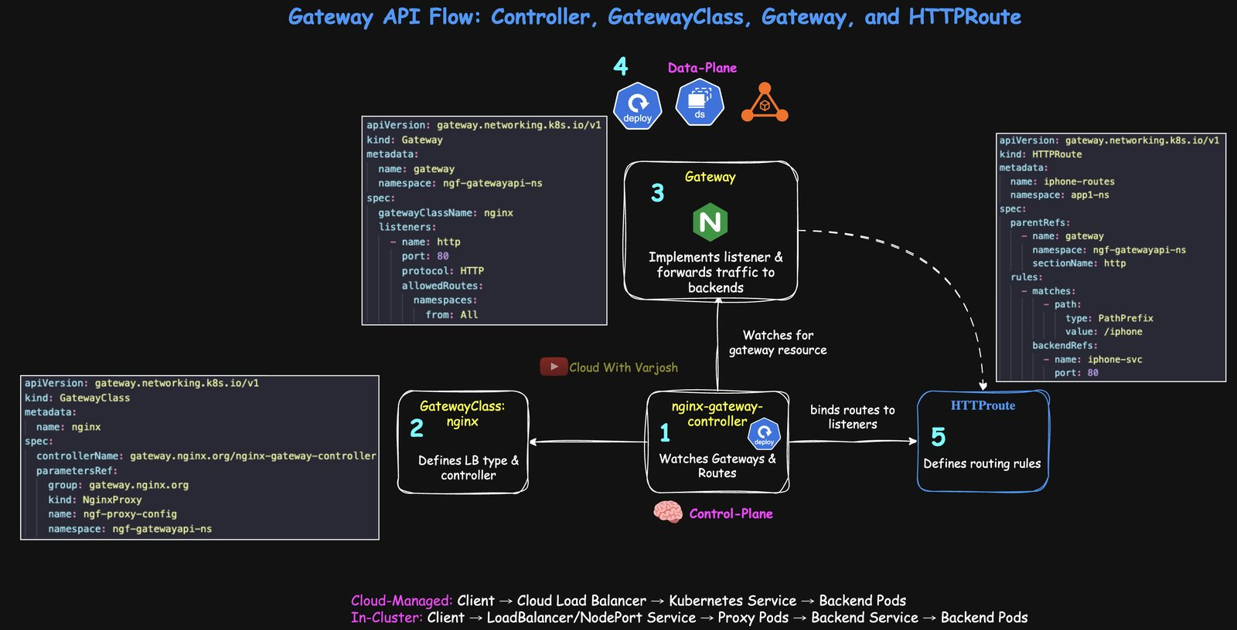
Gateway flow
- Controller — e.g. the nginx-gateway-fabric Deployment — watches GatewayClass, Gateway and Route objects and reconciles.
- GatewayClass (e.g. nginx) names the controller/LB type. Pure configuration.
- Gateway — when the controller sees one using its class, it sets up listeners (HTTP 80, HTTPS 443) and provisions the data plane: a cloud LB (cloud-managed) or proxy Pods (in-cluster).
- Data plane — where packets actually flow (cloud LB or NGINX/Envoy Pods) → Services → Pods.
- HTTPRoute — attaches to the Gateway via parentRefs, with matches (e.g. PathPrefix /iphone) and backendRefs (Service + port). The controller binds it to the listener.
Control plane vs data plane: the controller decides and programs configuration; the data plane forwards traffic. The controller is never on the traffic path (some lightweight demo setups blur this).
Cloud-managed: Client → cloud load balancer → Service → Pods
In-cluster: Client → LoadBalancer/NodePort Service → proxy Pods → Service → Pods

Cloud-managed vs in-cluster data planes
- Cloud-managed: controller in the cluster programs an external LB. AWS Gateway API Controller → VPC Lattice (other variants use ALB/NLB); GKE Gateway → Google Cloud Load Balancers; Azure → Application Gateway for Containers.
- In-cluster: controller configures proxy Pods (NGINX Gateway Fabric, Envoy Gateway, Istio, HAProxy, Traefik) that do L4/L7 routing and TLS; exposed via a LoadBalancer Service in clouds or NodePort on-prem/kind.
Scenario | Controller | Data plane | Examples
Cloud-managed | In cluster | External cloud LB | AWS VPC Lattice/ALB, GCP GCLB, Azure App Gateway
In-cluster | In cluster | Proxy Pods in cluster | NGINX Gateway Fabric, Envoy Gateway, Istio, HAProxy, Traefik

Day 53 — Gateway API Part 2: Demo with NGINX Gateway Fabric on kind
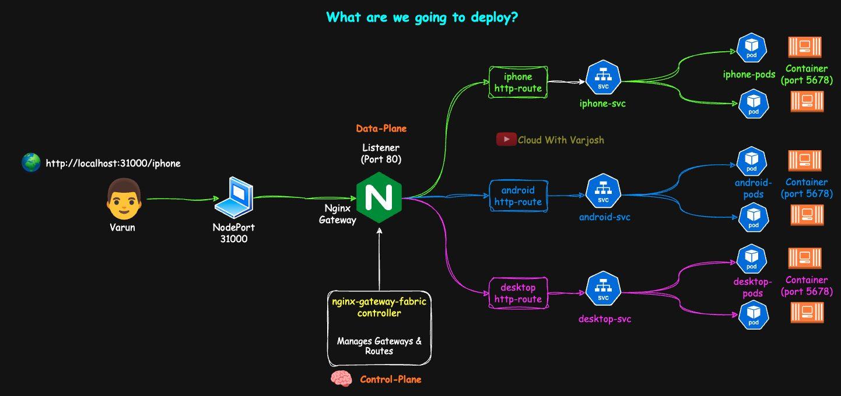
Demo
Goal: install NGINX Gateway Fabric (NGF) with Helm, expose it on NodePort 31000, create a Gateway and HTTPRoutes, and route /iphone, /android and / to three apps — no annotations.
browser http://localhost:31000/iphone → NodePort 31000 → Gateway listener :80
→ HTTPRoute iphone-routes → iphone-svc → Pods → HTML
Tools: kind, Helm, kubectl (with built-in Kustomize).

1. kind cluster
BASH
kind get clusters
kind delete cluster --name=<old>
YAML
# 00-kind-cluster.yaml
kind: Cluster
apiVersion: kind.x-k8s.io/v1alpha4
nodes:
- role: control-plane
image: kindest/node:v1.33.1@sha256:050072256b9a903bd914c0b2866828150cb229cea0efe5892e2b644d5dd3b34f
extraPortMappings:
- containerPort: 31000
hostPort: 31000 # localhost:31000 → NodePort 31000
BASH
kind create cluster --name=gateway-api --config=00-kind-cluster.yaml

2. Install the Gateway API CRDs
BASH
kubectl kustomize "https://github.com/nginx/nginx-gateway-fabric/config/crd/gateway-api/standard?ref=v2.1.0" | kubectl apply -f -
kubectl api-resources | grep gateway
Match versions. Helm installs the latest NGF controller by default, so use the CRD version listed in the current NGF install docs (e.g. ?ref=v2.3.0). Old CRDs + new controller can crash the controller or miss resources (e.g. BackendTLSPolicy).
Installed kinds: GatewayClass, Gateway, HTTPRoute, GRPCRoute, ReferenceGrant. NGF supports HTTPRoute and GRPCRoute from the standard channel; TLSRoute/TCPRoute/UDPRoute aren't supported by NGF yet.

3. Install the NGF controller
BASH
helm install ngf oci://ghcr.io/nginx/charts/nginx-gateway-fabric \
--create-namespace -n ngf-gatewayapi-ns \
--set nginx.service.type=NodePort \
--set-json 'nginx.service.nodePorts=[{"port":31000,"listenerPort":80}]'
- nginx.service.type=NodePort — expose the NGINX data plane via NodePort.
- The nodePorts mapping ties the Gateway's listener port 80 to NodePort 31000.
BASH
kubectl get deploy -n ngf-gatewayapi-ns # ngf-nginx-gateway-fabric
kubectl get gatewayclasses.gateway.networking.k8s.io -o wide
# nginx gateway.nginx.org/nginx-gateway-controller True
The nginx GatewayClass is created automatically and is cluster-scoped.

4. The three apps
Create the namespace first (kubectl create ns app1-ns or 01-ns.yaml). Same apps as the Ingress demo, without ALB annotations:
YAML
# 02-iphone.yaml
apiVersion: apps/v1
kind: Deployment
metadata:
name: iphone-deploy
namespace: app1-ns
spec:
replicas: 2
selector:
matchLabels:
app: iphone-page
template:
metadata:
labels:
app: iphone-page
spec:
containers:
- name: python-http
image: python:alpine
command: ["/bin/sh", "-c"]
args:
- |
mkdir -p /iphone && echo '<html>
<head><title>iPhone Users</title></head>
<body>
<h1>iPhone Users</h1>
<p>Welcome to Cloud With VarJosh</p>
</body>
</html>' > /iphone/index.html && cd / && python3 -m http.server 5678
ports:
- containerPort: 5678
---
apiVersion: v1
kind: Service
metadata:
name: iphone-svc
namespace: app1-ns
spec:
selector:
app: iphone-page
ports:
- protocol: TCP
port: 80
targetPort: 5678
03-android.yaml (page under /android/) and 04-desktop.yaml (page at /index.html) follow the same pattern.
BASH
kubectl apply -f 02-iphone.yaml -f 03-android.yaml -f 04-desktop.yaml
kubectl get all -n app1-ns

5. The Gateway
YAML
# 05-gateway.yaml
apiVersion: gateway.networking.k8s.io/v1
kind: Gateway
metadata:
name: gateway
namespace: ngf-gatewayapi-ns
spec:
gatewayClassName: nginx # which implementation
listeners:
- name: http # referenced by Routes via sectionName
port: 80
protocol: HTTP
allowedRoutes:
namespaces:
from: All # Routes from any namespace may attach (Same / Selector are stricter)
BASH
kubectl apply -f 05-gateway.yaml
kubectl get gateway -n ngf-gatewayapi-ns
kubectl describe gateway gateway -n ngf-gatewayapi-ns # listener http:80; Accepted/Programmed = True
kubectl get svc -n ngf-gatewayapi-ns # gateway-nginx NodePort 80:31000/TCP
kubectl get pods -n ngf-gatewayapi-ns -o wide # controller + NGINX data-plane Pod
kubectl get events -n ngf-gatewayapi-ns --sort-by=.lastTimestamp | tail -n 20
NGF sees the Gateway and programs an NGINX data plane listening on 80, exposed at <NodeIP>:31000 (= localhost:31000 via kind). With no routes yet you'll get a default 404.

6. HTTPRoutes
YAML
# 06-routes.yaml
apiVersion: gateway.networking.k8s.io/v1
kind: HTTPRoute
metadata:
name: iphone-routes
namespace: app1-ns # the app team's own namespace
spec:
parentRefs: # attach to this Gateway listener
- name: gateway
namespace: ngf-gatewayapi-ns
sectionName: http
rules:
- matches:
- path:
type: PathPrefix
value: /iphone
backendRefs:
- name: iphone-svc
port: 80
---
apiVersion: gateway.networking.k8s.io/v1
kind: HTTPRoute
metadata:
name: android-routes
namespace: app1-ns
spec:
parentRefs:
- {name: gateway, namespace: ngf-gatewayapi-ns, sectionName: http}
rules:
- matches:
- path: {type: PathPrefix, value: /android}
backendRefs:
- {name: android-svc, port: 80}
---
apiVersion: gateway.networking.k8s.io/v1
kind: HTTPRoute
metadata:
name: desktop-routes
namespace: app1-ns
spec:
parentRefs:
- {name: gateway, namespace: ngf-gatewayapi-ns, sectionName: http}
rules:
- matches:
- path: {type: PathPrefix, value: /} # catch-all
backendRefs:
- {name: desktop-svc, port: 80}
Note the multi-tenancy win: the Gateway lives in the platform namespace, while each team's HTTPRoute lives in the team's namespace — no shared object to fight over.
BASH
kubectl apply -f 06-routes.yaml
kubectl get httproutes -n app1-ns
kubectl describe -n app1-ns httproutes.gateway.networking.k8s.io iphone-routes
# look for: Accepted = True, ResolvedRefs = True
Other route kinds: GRPCRoute (L7 gRPC), TLSRoute (SNI passthrough, no decryption), TCPRoute (L4 TCP), UDPRoute (L4 UDP, e.g. DNS/syslog).

7. Test
BASH
curl http://localhost:31000/iphone # iPhone Users page
curl http://localhost:31000/android # Android Users page
curl http://localhost:31000/ # Desktop Users page (catch-all)
kubectl logs -f -n ngf-gatewayapi-ns <gateway-nginx-pod> # requests hitting the proxy
Takeaways: clean separation of roles (GatewayClass / Gateway / HTTPRoute); declarative routing without annotations; NGF already supports HTTP and gRPC with more protocols coming. Next steps to try: header-based matching, filters, weighted backends and TLS listeners.

Part 21 — Building a Cluster with kubeadm

Day 54 — Multi-Node Kubernetes Cluster with kubeadm (v1.32) and Calico

What we are building
This day builds a real, self-managed Kubernetes cluster from scratch, the way the CKA exam expects you to understand it:
- 1 control-plane node (runs the API server, etcd, scheduler, controller manager).
- 2 worker nodes (run your application Pods).
- OS: Ubuntu 22.04 or 24.04 (for example on AWS EC2).
- Container runtime: containerd.
- Kubernetes version: v1.32, installed with kubeadm.
- Network (CNI): Calico, installed with the Tigera operator.
kubeadm does not create machines or networks for you. It only turns existing Linux machines into a Kubernetes cluster. You prepare the machines, kubeadm does the bootstrapping.

Before you start: security groups (firewall rules)
Nodes must be able to talk to each other on specific ports. On AWS, create two security groups.
control-plane-sg (attached to the control-plane node):
Port | Protocol | Source | Why
22 | TCP | Your IP | SSH access
6443 | TCP | data-plane-sg | Kubernetes API server (workers and kubectl talk to it)
5473 | TCP | data-plane-sg | Calico Typha (calico-node talks to Typha)
4789 | UDP | data-plane-sg | VXLAN overlay traffic between Pods

data-plane-sg (attached to the worker nodes):
Port | Protocol | Source | Why
22 | TCP | Your IP | SSH access
10250 | TCP | control-plane-sg | Kubelet API (logs, exec, metrics from the API server)
4789 | UDP | control-plane-sg and data-plane-sg | VXLAN Pod traffic
5473 | TCP | control-plane-sg and data-plane-sg | Calico Typha
30000–32767 | TCP | Your IP (optional) | NodePort Services for testing

For a highly available setup with several control-plane nodes you also need 2379–2380 (etcd), 10257 (controller manager) and 10259 (scheduler) open between control-plane nodes. TCP 179 is only needed if you use Calico in BGP mode.
Other preparation:
- Create an SSH key pair and use it for all three instances.
- The control-plane node needs at least 2 vCPUs and 2 GB RAM. If you use a smaller machine for practice, kubeadm init fails its preflight check unless you add --ignore-preflight-errors=NumCPU.
- Give each machine a clear hostname so kubectl get nodes is readable:
BASH
sudo hostnamectl set-hostname control-plane # on the CP node
sudo hostnamectl set-hostname worker-1 # on worker 1
sudo hostnamectl set-hostname worker-2 # on worker 2

Step 1 — Prepare every node (all 3 machines)
Turn off swap. The kubelet expects swap to be off (by default it refuses to start with swap on). Disable it now and stop it coming back after a reboot:
BASH
sudo swapoff -a
sudo sed -i '/ swap / s/^/#/' /etc/fstab
Load kernel modules needed by container networking:
- overlay – used by containerd for layered container file systems.
- br_netfilter – lets iptables see traffic crossing Linux bridges, so Kubernetes Services and NetworkPolicies work.
BASH
cat <<EOF | sudo tee /etc/modules-load.d/k8s.conf
overlay
br_netfilter
EOF

sudo modprobe overlay
sudo modprobe br_netfilter
Set networking sysctls so bridged traffic goes through iptables and the node can forward packets between Pods:
BASH
cat <<EOF | sudo tee /etc/sysctl.d/k8s.conf
net.bridge.bridge-nf-call-iptables = 1
net.bridge.bridge-nf-call-ip6tables = 1
net.ipv4.ip_forward = 1
EOF

sudo sysctl --system

Step 2 — Install and configure containerd (all nodes)
BASH
sudo apt-get update
sudo apt-get install -y containerd

sudo mkdir -p /etc/containerd
containerd config default | sudo tee /etc/containerd/config.toml
Two important edits in /etc/containerd/config.toml:
- SystemdCgroup = true – makes containerd use the systemd cgroup driver, the same driver the kubelet uses. If they don't match, Pods restart randomly and the node is unstable.
- sandbox_image = "registry.k8s.io/pause:3.9" – the "pause" image that holds each Pod's network namespace. It should match the version kubeadm expects.
BASH
sudo sed -i 's/SystemdCgroup = false/SystemdCgroup = true/' /etc/containerd/config.toml
sudo sed -i 's#sandbox_image = .*#sandbox_image = "registry.k8s.io/pause:3.9"#' /etc/containerd/config.toml

sudo systemctl restart containerd
sudo systemctl enable containerd

Step 3 — Install kubeadm, kubelet and kubectl (all nodes)
Add the official Kubernetes package repository for v1.32 (pkgs.k8s.io) and install the three tools:
BASH
sudo apt-get update
sudo apt-get install -y apt-transport-https ca-certificates curl gpg

sudo mkdir -p -m 755 /etc/apt/keyrings
curl -fsSL https://pkgs.k8s.io/core:/stable:/v1.32/deb/Release.key | \
sudo gpg --dearmor -o /etc/apt/keyrings/kubernetes-apt-keyring.gpg

echo 'deb [signed-by=/etc/apt/keyrings/kubernetes-apt-keyring.gpg] https://pkgs.k8s.io/core:/stable:/v1.32/deb/ /' | \
sudo tee /etc/apt/sources.list.d/kubernetes.list

sudo apt-get update
sudo apt-get install -y kubelet kubeadm kubectl
sudo apt-mark hold kubelet kubeadm kubectl
sudo systemctl enable --now kubelet
- kubeadm – bootstraps the cluster (init / join / upgrade).
- kubelet – the node agent that actually runs Pods. It keeps restarting until kubeadm init or join gives it a config; that is normal.
- kubectl – the command-line client.
- apt-mark hold stops a normal apt upgrade from accidentally upgrading Kubernetes. Upgrades must be done deliberately (see Day 55).
Optional quality-of-life setup:
BASH
echo 'source <(kubectl completion bash)' >> ~/.bashrc
echo 'alias k=kubectl' >> ~/.bashrc
echo 'complete -o default -F __start_kubectl k' >> ~/.bashrc
source ~/.bashrc
To use kubectl from a worker node, copy /etc/kubernetes/admin.conf (or ~/.kube/config) from the control plane to ~/.kube/config on the worker. Treat this file like a root password: it has full admin rights.

Step 4 — Initialize the control plane (control-plane node only)
BASH
sudo kubeadm init \
--control-plane-endpoint=<CP_PRIVATE_IP>:6443 \
--apiserver-advertise-address=<CP_PRIVATE_IP> \
--pod-network-cidr=192.168.0.0/16
- --control-plane-endpoint – the stable address of the API server. With one CP node it is that node's IP; in HA you would put a load balancer address here.
- --apiserver-advertise-address – the IP the API server listens on and advertises to the other nodes.
- --pod-network-cidr – the IP range for Pods. It must match the Calico IP pool (192.168.0.0/16 below) and must not overlap with your VPC or node network.
kubeadm runs preflight checks, generates all certificates under /etc/kubernetes/pki, writes kubeconfig files, starts the control-plane components as static Pods (manifests in /etc/kubernetes/manifests) and prints a kubeadm join command.
Set up kubectl for your normal user:
BASH
mkdir -p $HOME/.kube
sudo cp -i /etc/kubernetes/admin.conf $HOME/.kube/config
sudo chown $(id -u):$(id -g) $HOME/.kube/config

kubectl get nodes # control plane shows NotReady until a CNI is installed

Step 5 — Install Calico (control-plane node)
Install the Calico CRDs and the Tigera operator (v3.30.2):
BASH
kubectl create -f https://raw.githubusercontent.com/projectcalico/calico/v3.30.2/manifests/operator-crds.yaml
kubectl create -f https://raw.githubusercontent.com/projectcalico/calico/v3.30.2/manifests/tigera-operator.yaml
Then tell the operator how to configure Calico with an Installation resource:
YAML
apiVersion: operator.tigera.io/v1
kind: Installation
metadata:
name: default
spec:
calicoNetwork:
bgp: Disabled
ipPools:
- cidr: 192.168.0.0/16
blockSize: 26
encapsulation: VXLANCrossSubnet
natOutgoing: Enabled
nodeSelector: all()
What each setting means:
- bgp: Disabled – we don't use BGP routing; Pod traffic is carried in VXLAN tunnels instead. This works in cloud VPCs without extra routing setup.
- cidr: 192.168.0.0/16 – the Pod IP pool; matches --pod-network-cidr.
- blockSize: 26 – each node gets blocks of 64 Pod IPs at a time.
- encapsulation: VXLANCrossSubnet – encapsulate only when traffic crosses subnets; same-subnet traffic is routed directly (faster).
- natOutgoing: Enabled – Pods can reach the internet via the node's IP.
- nodeSelector: all() – the pool applies to all nodes.
BASH
kubectl apply -f installation.yaml
kubectl get pods -n calico-system -w
kubectl get nodes # becomes Ready once calico-node is running

Step 6 — Join the worker nodes
On the control plane, print a fresh join command (tokens expire after 24 hours):
BASH
kubeadm token create --print-join-command
Run the printed command with sudo on each worker:
BASH
sudo kubeadm join <CP_PRIVATE_IP>:6443 --token <token> \
--discovery-token-ca-cert-hash sha256:<hash>
The token authenticates the worker the first time it connects. The CA cert hash lets the worker verify it is talking to the real control plane.

Step 7 — Verify the cluster
BASH
kubectl get nodes -o wide
kubectl get pods -A

kubectl create deployment nginx --image=nginx --replicas=3
kubectl expose deployment nginx --type=NodePort --port=80
kubectl get svc nginx # note the NodePort (30000-32767)
curl http://<any-node-ip>:<nodeport>
If you get the nginx welcome page, Pods are scheduled across the workers and Service networking works.

Troubleshooting Calico
- BIRD / BGP errors and calico-node not Ready: BGP may be enabled by default. Disable it and restart calico-node:
BASH
kubectl patch installation default --type=merge \
-p '{"spec":{"calicoNetwork":{"bgp":"Disabled"}}}'
kubectl rollout restart ds/calico-node -n calico-system
- calico-node can't reach Typha: make sure TCP 5473 is open between all nodes.
- Pods on different nodes can't talk: check UDP 4789 (VXLAN) is open between all nodes.
- TCP 179 only matters if you deliberately use BGP.

Rebooting and starting over
- After a reboot, swap must stay off (done via /etc/fstab) and the modules/sysctls load automatically from the files created in Step 1. containerd and kubelet are enabled, so the cluster comes back by itself.
- To fully reset a node and try again:
BASH
sudo kubeadm reset -f
sudo rm -rf /etc/cni/net.d /var/lib/cni /var/lib/kubelet /etc/kubernetes $HOME/.kube
sudo ip link delete cni0 2>/dev/null
sudo ip link delete vxlan.calico 2>/dev/null
sudo ip link delete tunl0 2>/dev/null
sudo systemctl restart containerd
Exam tip: know the order: prepare node (swap, modules, sysctl) → container runtime → kubeadm/kubelet/kubectl → kubeadm init → CNI → kubeadm join. Without a CNI, nodes stay NotReady.

Part 22 — Upgrading a Cluster with kubeadm

Day 55 — Upgrade a Multi-Node Cluster (1.32.8 → 1.33.4)

Why upgrades matter
Kubernetes upgrades are routine maintenance, not an optional extra:
- Security and compliance – security fixes (CVEs) are only released for supported versions.
- Features and APIs – new features, GA promotions and API removals arrive in minor releases.
- Ecosystem compatibility – CNI, CSI, ingress controllers and other add-ons test against currently supported Kubernetes versions. An old cluster can make a newer add-on fail to start because an API or field it needs is missing.

Version numbers and release cadence
Kubernetes versions use MAJOR.MINOR.PATCH. For 1.32.8: major = 1, minor = 32, patch = 8.
- Minor releases come out about every 4 months (about 3 per year).
- Patch releases come out roughly monthly for each supported minor, and more often (every 1–2 weeks) right after a new minor while early bugs are fixed.

Support window
- Upstream Kubernetes supports only the three newest minors: N, N-1 and N-2 (about 12 months of patches per minor). When 1.33 is the newest, 1.33, 1.32 and 1.31 get fixes; 1.30 does not.
- Managed services have their own rules:
  - Amazon EKS – about 14 months standard support plus 12 months paid extended support (up to about 26 months).
  - Azure AKS / Google GKE – generally keep you within N-2; timelines vary, so check the provider's docs.
- For a managed cluster, support comes from the cloud provider, not the Kubernetes project.
A common patch policy:
- On N-1 and N-2 clusters, run the latest patch of that minor.
- On production at N, pin a known-good patch and only move to newer patches after testing in staging/canary. Production often lags the very latest patch on purpose.
- Many teams upgrade every other minor (about every 6–8 months), with monthly patches in between. Urgent CVEs are the exception.

Rules for sequencing
- Never skip a minor version. 1.31 → 1.33 directly is unsupported. Go 1.31 → 1.32 → 1.33.
- Control plane first, then workers. In production, upgrade one node at a time in each tier.

Version skew (which versions can run together)
Component | Rule
kube-apiserver | Defines the cluster version. In HA, API servers may differ by at most one minor while rolling.
controller-manager, scheduler, cloud-controller-manager | Must never be newer than the API server. Same minor preferred; one minor older tolerated during upgrade.
kubelet | Must never be newer than the API server. Can be older during the roll (the README says up to two minors; recent Kubernetes versions allow up to three).
kubectl | Supported within ±1 minor of the API server.

Safe rule of thumb: never run any component newer than the API server, and bring everything to the same minor quickly.
Working with several clusters on different versions? Keep kubectl within ±1 minor of each. Options: a version manager like asdf, multiple binaries (kubectl-1.31, kubectl-1.32) with aliases, or pinned container images such as bitnami/kubectl:1.xx. Naming contexts with the minor (e.g. prod-1.32) helps too.

Production upgrade flow (high level)
- Pre-checks – control plane and etcd healthy; spare capacity (or temporarily scale up); PodDisruptionBudgets, readiness probes and enough replicas in place; take an etcd snapshot and back up /etc/kubernetes (manifests and PKI).
- Control plane, one node at a time – upgrade kubeadm → kubeadm upgrade plan → kubeadm upgrade apply <version> on the first CP node → kubeadm upgrade node on the other CP nodes → upgrade kubelet/kubectl and restart kubelet.
- Workers, one node at a time – cordon + drain → kubeadm upgrade node → upgrade kubelet/kubectl → restart kubelet → uncordon.
- Add-ons – check CoreDNS and kube-proxy moved to their new versions; confirm CNI/CSI/CRI support the new minor.
- Post-validation – check versions, component health and logs, run test traffic, and undo any temporary scale-outs.

Upgrade strategies
- All at once – fine for dev/test clusters with no uptime requirements.
- Rolling (one node at a time) – best practice for production. Keep spare capacity so performance stays stable.
- Blue/Green – build new ("green") nodes or a whole new cluster next to the old ("blue") one, test green, switch traffic (DNS/load balancer/Gateway), then remove blue. More cost and effort, but instant rollback. Good for tight SLOs or risky OS/runtime/CNI changes.

Demo setup and prerequisites
- Ubuntu/Debian, containerd 1.7.27 with SystemdCgroup=true.
- Calico v3.30 (supports Kubernetes 1.31–1.33).
- Upgrading v1.32.8 → v1.33.4 (Debian package version 1.33.4-1.1).
- Check CNI and container runtime support the target version first (containerd --version).
- HA notes: run kubeadm upgrade apply on one control-plane node only; other CP nodes use kubeadm upgrade node. The API load balancer should health-check /readyz so it stops sending traffic to an API server while it restarts. With stacked etcd, upgrade one CP at a time to keep etcd quorum.

Control-plane upgrade
Step 1 – Point APT at the v1.33 repository. The pkgs.k8s.io repos are per minor version, so change v1.32 to v1.33:
BASH
pager /etc/apt/sources.list.d/kubernetes.list
sudo vim /etc/apt/sources.list.d/kubernetes.list
# Final line:
# deb [signed-by=/etc/apt/keyrings/kubernetes-apt-keyring.gpg] https://pkgs.k8s.io/core:/stable:/v1.33/deb/ /
Remove any old apt.kubernetes.io entries so you don't mix repos.
Step 2 – Find the exact version string:
BASH
sudo apt-get update
sudo apt-cache madison kubeadm
# kubeadm | 1.33.4-1.1 | https://pkgs.k8s.io/core:/stable:/v1.33/deb Packages
# kubeadm | 1.33.3-1.1 | ...
If no 1.33 versions appear, re-check the repo file and run apt-get update again.
Step 3 – Upgrade kubeadm only:
BASH
sudo apt-mark unhold kubeadm
sudo apt-get update && sudo apt-get install -y kubeadm=1.33.4-1.1
sudo apt-mark hold kubeadm
kubeadm version # should show v1.33.4
The pattern unhold → install exact version → hold prevents accidental upgrades outside your maintenance window. Optionally pre-pull the new images with sudo kubeadm config images pull to shorten restarts.
Step 4 – Plan (a dry run, like "terraform plan"):
BASH
sudo kubeadm upgrade plan
It checks the cluster can be upgraded and lists current and target versions:
TEXT
Components that must be upgraded manually after you have upgraded the control plane with 'kubeadm upgrade apply':
COMPONENT NODE CURRENT TARGET
kubelet control-plane v1.32.8 v1.33.4
kubelet worker-1 v1.32.8 v1.33.4

Upgrade to the latest stable version:
COMPONENT NODE CURRENT TARGET
kube-apiserver control-plane v1.32.8 v1.33.4
kube-controller-manager control-plane v1.32.8 v1.33.4
kube-scheduler control-plane v1.32.8 v1.33.4
kube-proxy 1.32.8 v1.33.4
CoreDNS v1.11.3 v1.12.0
etcd control-plane 3.5.16-0 3.5.21-0
Note that the kubelet is not upgraded by kubeadm – you upgrade it yourself with apt. Optionally preview manifest changes with sudo kubeadm upgrade diff v1.33.4.
Step 5 – Apply:
BASH
sudo kubeadm upgrade apply v1.33.4
# [upgrade] SUCCESS! A control plane node of your cluster was upgraded to "v1.33.4".
- kubeadm rewrites the static Pod manifests in /etc/kubernetes/manifests with new image tags/flags; the kubelet notices and restarts those components.
- It also upgrades etcd, CoreDNS and kube-proxy.
- It renews the certificates it manages by default (opt out with --certificate-renewal=false).
Step 6 – Verify:
BASH
kubectl version
# Client Version: v1.32.8
# Server Version: v1.33.4 <- control plane upgraded

kubectl get nodes # VERSION column = kubelet version, still v1.32.8
Step 7 – Upgrade kubelet and kubectl on the control-plane node:
BASH
sudo apt-mark unhold kubelet kubectl || true
sudo apt-get install -y kubelet=1.33.4-1.1 kubectl=1.33.4-1.1
sudo systemctl daemon-reload && sudo systemctl restart kubelet
sudo apt-mark hold kubeadm kubelet kubectl

kubectl get nodes
# control-plane Ready control-plane ... v1.33.4
# worker-1 Ready <none> ... v1.32.8
# worker-2 Ready <none> ... v1.32.8
In real life, cordon and drain the control-plane node too before upgrading its kubelet if it runs workloads. A reboot afterwards is recommended so everything restarts cleanly.
HA clusters – on each remaining control-plane node, one at a time:
BASH
sudo apt-mark unhold kubeadm
sudo apt-get install -y kubeadm=1.33.4-1.1
sudo apt-mark hold kubeadm

sudo kubeadm upgrade node # NOT "apply" on the extra CP nodes

sudo apt-mark unhold kubelet kubectl
sudo apt-get install -y kubelet=1.33.4-1.1 kubectl=1.33.4-1.1
sudo systemctl daemon-reload && sudo systemctl restart kubelet
sudo apt-mark hold kubeadm kubelet kubectl

Worker node upgrade (one at a time)
Step 1 – Cordon and drain (from an admin shell):
BASH
kubectl cordon worker-1
kubectl drain worker-1 --ignore-daemonsets --delete-emptydir-data
- cordon marks the node unschedulable: no new Pods land there; existing Pods keep running.
- drain evicts the Pods (it also cordons automatically) using the Eviction API, which respects PodDisruptionBudgets.
- --ignore-daemonsets – DaemonSet Pods can't be moved, so skip them.
- --delete-emptydir-data – allow eviction of Pods using emptyDir (that data is lost).
Cordoning first is safer: it gives you time to check what runs on the node, check PDBs, let jobs finish, and easily back out with uncordon.
BASH
kubectl cordon <node>
kubectl get pods -A -o wide | grep <node>
kubectl drain <node> --ignore-daemonsets --delete-emptydir-data --grace-period=60 --timeout=10m
# ...maintenance...
kubectl uncordon <node>
Step 2 – Upgrade the worker (on the worker itself):
BASH
sudo vim /etc/apt/sources.list.d/kubernetes.list # switch to v1.33

sudo apt-mark unhold kubeadm kubelet kubectl
sudo apt-get update
sudo apt-get install -y kubeadm=1.33.4-1.1
sudo kubeadm upgrade node # updates the local kubelet config
sudo apt-get install -y kubelet=1.33.4-1.1 kubectl=1.33.4-1.1
sudo systemctl daemon-reload && sudo systemctl restart kubelet
sudo apt-mark hold kubeadm kubelet kubectl
Step 3 – Uncordon and verify:
BASH
kubectl uncordon worker-1
kubectl get nodes -o wide
Repeat for worker-2 and any other workers. After any maintenance (OS patches, runtime updates, Kubernetes upgrades), do a controlled reboot before signing off: it applies kernel changes, proves everything comes back on its own, and avoids a leftover pending reboot confusing a later change.

Calico problems after an upgrade
Symptom: calico-node Pods show Running but 0/1 Ready, with messages like "Error querying BIRD" or "BGP not established", even though the cluster uses VXLAN.
Cause: with the Tigera operator, BGP is enabled unless you explicitly disable it. In a VXLAN-only cluster that causes BIRD readiness failures. Nodes may also show "Felix not ready" if they cannot reach Typha on TCP 5473.
Fix:
BASH
# 1) Check the BGP setting (empty or "Enabled" means on)
kubectl get installation.operator.tigera.io default \
-o jsonpath='{.spec.calicoNetwork.bgp}{"\n"}'

# 2) Disable BGP
kubectl patch installation.operator.tigera.io default --type=merge \
-p '{"spec":{"calicoNetwork":{"bgp":"Disabled"}}}'

# 3) Restart calico-node
kubectl -n calico-system rollout restart ds/calico-node
kubectl -n calico-system rollout status ds/calico-node

# 4) Still Felix/Typha errors? Check Typha and logs
kubectl -n calico-system get deploy,svc,endpoints -l k8s-app=calico-typha
kubectl -n calico-system logs ds/calico-node -c calico-node | grep -i typha
Make sure TCP 5473 (Typha) and UDP 4789 (VXLAN) are open between nodes. TCP 179 is only needed if you really use BGP (routed networking without an overlay).

Draining safely with a PodDisruptionBudget
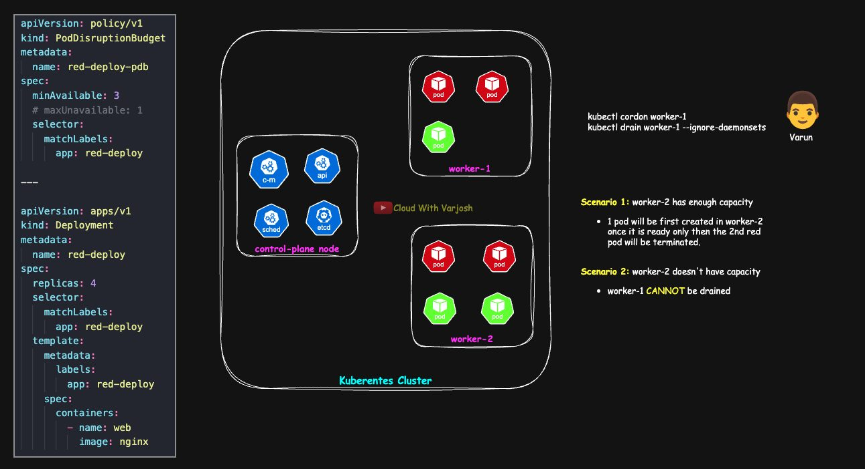
Draining a node protected by a PodDisruptionBudget
A PodDisruptionBudget (PDB) limits how many Pods of an app can be down at the same time during voluntary disruptions such as kubectl drain.
YAML
apiVersion: policy/v1
kind: PodDisruptionBudget
metadata:
name: red-deploy-pdb
spec:
minAvailable: 3
# maxUnavailable: 1
selector:
matchLabels:
app: red-deploy
---
apiVersion: apps/v1
kind: Deployment
metadata:
name: red-deploy
spec:
replicas: 4
selector:
matchLabels:
app: red-deploy
template:
metadata:
labels:
app: red-deploy
spec:
containers:
- name: web
image: nginx
With 4 replicas and minAvailable: 3, at least 3 Pods must be Ready at all times during a drain. You can use either minAvailable or maxUnavailable, not both.
- Scenario 1 – there is spare capacity: the first Pod on worker-1 is evicted (Ready 4 → 3, still OK). Its replacement is scheduled elsewhere and becomes Ready (3 → 4). Then the next eviction is allowed, and so on until the node is empty.
- Scenario 2 – capacity is tight: the first eviction succeeds (4 → 3), but the next one is blocked because Ready would drop to 2. The drain keeps retrying until capacity frees up, you add replicas/nodes, or you relax the PDB.
A PDB counts Ready Pods only. A replacement that is scheduled but not yet Ready does not count.
Priority vs PDB: PriorityClass affects scheduling and preemption, not kubectl drain. Drain uses the Eviction API and honors PDBs; a high priority does not protect a Pod from being drained. (When the kubelet evicts Pods because the node is short of resources – an involuntary eviction – lower-priority Pods do go first, but that is a different mechanism.) To protect apps during maintenance, use PDBs plus cordon → drain.
Exam tip: memorize the flow: repo → kubeadm → upgrade plan → upgrade apply (first CP) / upgrade node (others) → drain → kubelet + kubectl → restart kubelet → uncordon.

Part 23 — Monitoring and Logging

Day 56 — Kubernetes Monitoring and Logging

What is observability?
Observability is the ability to understand what is happening inside a system by looking at the signals it produces: metrics, logs and traces.
In Kubernetes, Pods are created, moved and deleted all the time, so you can't rely on logging into a machine to see what's wrong. You need tools that collect these signals for you.
Analogy: a doctor doesn't open up a patient to find the problem. They read pulse, blood pressure and temperature. In Kubernetes, metrics, logs and traces are those vital signs.

Two views: infrastructure and application
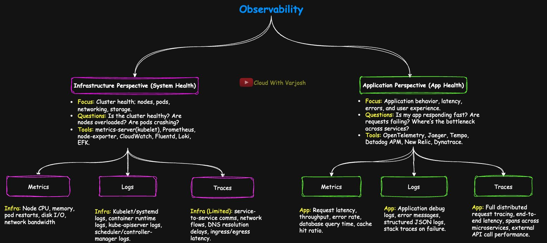
Infrastructure vs application observability and the three pillars
A DevOps/SRE engineer looks at a system from two angles.
1. Infrastructure observability – is the cluster healthy? Are nodes overloaded? Are Pods crashing?
Tool | What it does | How it's used
kubelet | Exposes Pod/container stats (through built-in cAdvisor) and node-level logs | The base source of signals
metrics-server | Collects current CPU/memory from kubelets; powers kubectl top and HPA | Lightweight; no history
Prometheus | Scrapes, stores and queries metrics (time-series database) | Core monitoring, usually with Alertmanager and Grafana
node-exporter | Host metrics: disk I/O, network, filesystem | Runs as a DaemonSet, feeds Prometheus
Fluentd / Fluent Bit | Collect and forward logs (to Elasticsearch, Loki, Splunk, ...) | Cluster-wide log shipping
Loki | Log store that indexes labels, not full text, so storage is cheap | Often used with Grafana and Prometheus
EFK stack | Elasticsearch (store/search) + Fluentd (collect) + Kibana (view) | Classic enterprise log pipeline

2. Application observability (APM – Application Performance Monitoring) – is the app fast? Are requests failing? Where is the bottleneck between services?
Tool | What it does | How it's used
OpenTelemetry | Standard way to instrument apps for metrics, logs and traces | SDKs in the app export to Jaeger, Datadog, etc.
Jaeger | Open-source distributed tracing | Shows request flow; debug latency in microservices
Tempo | Grafana's scalable tracing backend | Cheap trace storage; works with Loki and Prometheus
Datadog APM | SaaS observability platform | Traces, metrics and logs at scale
New Relic | Cloud APM | Transactions, errors, user experience
Dynatrace | Enterprise platform with AI-driven root-cause analysis | Common in regulated industries

Platforms like Datadog and Dynatrace cover both infrastructure and applications, so many companies use one of them instead of running separate stacks.

Observability with AWS native services
CloudWatch is the central AWS service; Amazon Managed Service for Prometheus (AMP) and Amazon Managed Grafana (AMG) suit teams that prefer Kubernetes-native tools.
- Infrastructure
  - Metrics: CloudWatch Metrics, Container Insights, AMP
  - Logs: CloudWatch Logs, Logs Insights, Container Insights, CloudTrail (audit/security events)
  - Network telemetry: VPC Flow Logs, AWS Distro for OpenTelemetry (ADOT)
- Applications
  - Metrics: CloudWatch Metrics, Application Signals, AMP
  - Logs: CloudWatch Logs (from Lambda, ECS/EKS, app runtimes)
  - Traces: AWS X-Ray, CloudWatch RUM (real user monitoring), CloudWatch Synthetics, Application Signals, ADOT

The three pillars
- Metrics (numbers over time)
  - Infra: node CPU and memory, Pod restarts, disk I/O, network bandwidth.
  - App: request latency, throughput, error rate, database query time, cache hit ratio.
- Logs (text records of events)
  - Infra: kubelet/systemd logs, container runtime logs, API server, scheduler and controller-manager logs.
  - App: debug logs, error messages, structured JSON logs, stack traces.
- Traces (the path of one request through many services)
  - Infra: limited – network flows, DNS delays, ingress/egress latency.
  - App: full distributed tracing with spans across microservices and external calls.
APM is not a fourth pillar. It is the practice of applying metrics, logs and traces to applications – just as DevOps is a culture, not a tool.

Lab: install metrics-server
Step 1 – Install:
BASH
kubectl apply -f https://github.com/kubernetes-sigs/metrics-server/releases/latest/download/components.yaml
Step 2 – Edit the Deployment (kubectl edit deployment -n kube-system metrics-server) and set the container args:
YAML
spec:
template:
spec:
containers:
- name: metrics-server
args:
- --kubelet-insecure-tls # skip kubelet cert verification (lab only)
- --cert-dir=/tmp
- --secure-port=10250
- --kubelet-preferred-address-types=InternalIP,ExternalIP,Hostname
- --kubelet-use-node-status-port
- --metric-resolution=15s
--kubelet-insecure-tls is needed in labs because kubeadm kubelets use self-signed serving certificates. Never use it in production – give kubelets proper certificates signed by a trusted CA instead.
Step 3 – Verify after a minute or two:
BASH
kubectl top nodes
kubectl top pods
Extra step for the Day 54 cluster (kubeadm + Calico operator): switch the Calico IP pool to always use VXLAN:
BASH
kubectl patch ippool default-ipv4-ippool --type=merge -p \
'{"spec":{"vxlanMode":"Always","ipipMode":"Never"}}'

kubectl -n calico-system rollout restart ds/calico-node
kubectl -n calico-system rollout status ds/calico-node
Why: with vxlanMode: CrossSubnet traffic within the same subnet is not encapsulated and relies on routes normally learned via BGP. Since BGP is disabled, traffic from the host (the API server) to Pod/Service IPs on the same subnet can't get back, so the Metrics API times out (FailedDiscoveryCheck). With Always, all Pod traffic goes through the vxlan.calico tunnel, v1beta1.metrics.k8s.io becomes Available, and kubectl top works.

Monitoring in Kubernetes
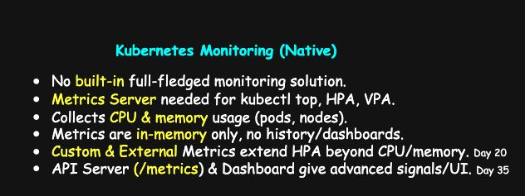
Out-of-the-box Kubernetes monitoring
Kubernetes does not come with a complete monitoring system. Until you install metrics-server, even kubectl top doesn't work.
What do we want to monitor?
- Number of nodes, Pods, Deployments, volumes.
- CPU, memory, storage and network usage.
- Pod restarts, crashes and Pending Pods.
- API server latency and errors (advanced).
metrics-server recap:
- Collects CPU and memory from every kubelet (which gets them from its built-in cAdvisor).
- Supplies the resource metrics that HPA and VPA need – without it they can't scale.
- Powers kubectl top.
- Keeps data in memory only – just the latest values, no history.

How kubectl top works
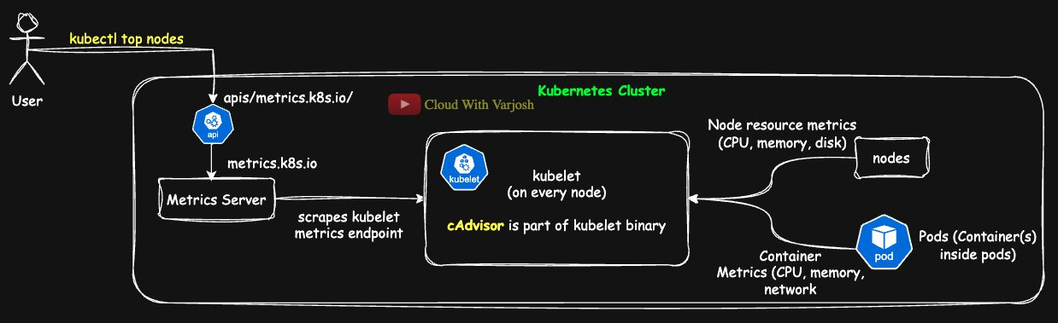
metrics-server architecture
- You run kubectl top nodes or kubectl top pods. kubectl calls the API server at /apis/metrics.k8s.io/v1beta1/....
- The API server's aggregation layer forwards (proxies) the request to the metrics-server Service. (metrics-server registers itself with an APIService object.)
- metrics-server answers from memory. It fills its memory by regularly scraping every kubelet over HTTPS port 10250, using the kubelet Summary API (/stats/summary).
- On each node, the kubelet's built-in cAdvisor gathers container and node stats (CPU, memory, network, filesystem).
You get current CPU and memory for Pods and nodes – used by kubectl top, HPA and VPA. It is not a full monitoring stack: no history, alerts or dashboards, so pair it with Prometheus/Grafana or a SaaS tool.
If kubectl top fails: check the APIService status (kubectl get apiservice v1beta1.metrics.k8s.io), the metrics-server logs, and that metrics-server can reach kubelets on port 10250.

Types of metrics for autoscaling
- Resource metrics – CPU and memory from kubelet/cAdvisor via metrics-server. Used directly by HPA and VPA.
- Custom metrics – metrics from your app (e.g. requests per second, queue length), exposed through the Custom Metrics API using an adapter such as Prometheus Adapter.
- External metrics – metrics from outside the cluster (e.g. AWS SQS queue size, Kafka lag), exposed through the External Metrics API.
Custom and external metrics let you scale on what really matters to your app, not just CPU and memory.

Beyond metrics-server
Component | Type | What it gives you | Use it for | Watch out
kube-state-metrics (KSM) | Add-on | The state of Kubernetes objects as Prometheus metrics: desired vs available replicas, rollout status, Pod phases/restarts, node conditions, HPA targets | Availability alerts ("Deployment not fully available"), rollout dashboards | Not CPU/memory usage; can create many metrics (high cardinality) – export only what you need
API server and kubelet /metrics | Built in | Prometheus-format internals: API request rate/latency/errors, kubelet evictions, Pod lifecycle, runtime stats | Control-plane and node health alerts; Prometheus, Datadog etc. scrape these | Sensitive – scrape inside the cluster with RBAC, never expose publicly
Kubernetes Dashboard | Add-on UI | Web UI for objects, logs and basic metrics | Quick checks in dev/test, demos | Security risk if misconfigured – lock down with OIDC/RBAC; prefer Grafana in prod

Mental model: KSM = object health, /metrics = control-plane and node internals, Dashboard = convenience UI.

Logging in Kubernetes
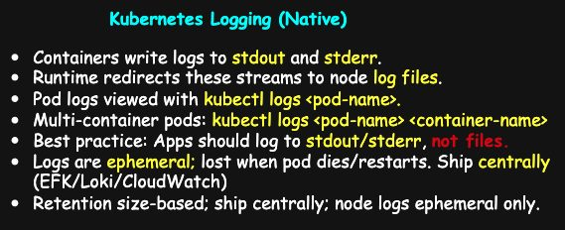
Where Kubernetes logs live
What runs as a system service vs as a Pod?
- systemd services on the node: kubelet, containerd (or cri-o), and on some older setups kube-proxy.
- Pods (run by the kubelet): the kubeadm control plane as static Pods (API server, controller manager, scheduler, etcd), kube-proxy (usually a DaemonSet), CoreDNS, and your applications.
1. Node services → journald. Read them with journalctl:
BASH
journalctl -u kubelet -f # follow kubelet logs
journalctl -u containerd -f # follow containerd logs
journalctl -u kubelet --since "1 hour ago"
journalctl -u containerd -p warning # warnings and above
- -u = unit (service name), -f = follow.
- journald keeps logs by size/time. If /var/log/journal/ exists, logs survive reboots; otherwise they are lost on reboot. Limits are set in /etc/systemd/journald.conf (e.g. SystemMaxUse).
- If the node is lost, its logs are lost unless they were shipped elsewhere.
Even with journald you still find text logs in /var/log/ (e.g. syslog, kern.log).
2. Pods → container logs.
Preferred: use kubectl.
BASH
kubectl logs <pod> # single-container Pod
kubectl logs <pod> <container> # pick a container (or -c <container>)
kubectl logs -f <pod> [<container>] # stream
kubectl logs <pod> <container> --previous # logs of the previous (crashed) instance
kubectl logs shows stdout and stderr together.
On the node, the files live here:
BASH
ls -l /var/log/containers/ # symlinks, one per container
ls -l /var/log/pods/<namespace>_<pod>_<uid>/ # the real log files
Container logs are rotated by size/file count, and are lost if the node dies.
Demo Pod – nginx logs to stdout/stderr automatically; busybox writes one line to stdout and one to stderr every 10 seconds:
YAML
apiVersion: v1
kind: Pod
metadata:
name: demo-pod
labels:
app: logging-demo
spec:
containers:
- name: nginx-container
image: nginx:1.25
ports:
- containerPort: 80
# Nginx automatically logs access/error logs to stdout/stderr

- name: busybox-container
image: busybox:1.36
command: ["sh", "-c"]
args:
- |
while true; do
# ">&1" = write to STDOUT (file descriptor 1)
echo "Busybox log: $(date) - processing data" >&1
# ">&2" = write to STDERR (file descriptor 2)
echo "Busybox error: $(date) - something went wrong" >&2
sleep 10
done
BASH
kubectl apply -f 01-demo-pod.yaml
kubectl logs demo-pod -c busybox-container -f # both log and error lines appear
kubectl logs demo-pod -c nginx-container
3. Why you need centralized logging. Node logs are short-lived and spread across many machines. In production, ship them somewhere central for search, alerts and retention:
- SaaS: Datadog, Splunk, New Relic, Dynatrace
- Cloud: Amazon CloudWatch, Google Cloud Logging, Azure Monitor
- Open source: EFK/ELK (Fluent Bit/Fluentd → Elasticsearch → Kibana), or Loki (Promtail/Fluent Bit → Loki → Grafana)
A typical log agent (DaemonSet) tails /var/log/containers/*.log for workloads and reads journald for node services.

Cheat sheet
- Services → journald: journalctl -u kubelet -f, journalctl -u containerd -f
- Pods → kubectl logs [-f] <pod> [-c <container>] [--previous]
- On the node: /var/log/containers → symlinks into /var/log/pods
- Retention: journald by size/time; container logs by size/count; both lost if the node dies
- Production: ship logs to a central system
Key takeaway for developers: always log to stdout and stderr, not to files inside the container. Kubernetes then captures the logs automatically for kubectl logs and for central logging.

Part 24 — Troubleshooting the Control Plane

Day 57 — Control-Plane Troubleshooting on kubeadm Clusters
This day is an exam-style playbook for the most common control-plane failures: the API server is unreachable, etcd is unhealthy, the scheduler isn't placing Pods, the controller manager isn't reconciling, and certificates have expired. Each scenario gives the symptoms, quick checks and the smallest fix.
Helpful background: Day 7 (architecture), Day 15 (static Pods), and the TLS days (30–33).

Control-plane basics on kubeadm
Control-plane components are static Pods. On a kubeadm cluster, the API server, controller manager, scheduler and etcd are started directly by the kubelet, not by the scheduler. Their manifests are in /etc/kubernetes/manifests/:
- kube-apiserver.yaml
- kube-controller-manager.yaml
- kube-scheduler.yaml
- etcd.yaml
The kubelet watches this folder (its staticPodPath). When you save a change to a file, the kubelet recreates that Pod automatically. The file is the source of truth.
Mirror Pods. For each static Pod, the kubelet creates a read-only mirror Pod in the API server so you can see it with kubectl.
- Name pattern: <podName>-<nodeName>, for example kube-apiserver-control-plane.
- You can view status and logs through it, but editing or deleting the mirror Pod does not change the real Pod (a deleted mirror Pod simply comes back). To change or remove the real Pod, edit or move the file in /etc/kubernetes/manifests/.
When the API server itself is down, kubectl can't show anything. Then use the container runtime directly: crictl ps -a, crictl logs <id>, and the files in /var/log/containers/ and /var/log/pods/.

kubeconfig refresher
kubectl reads a kubeconfig (default ~/.kube/config) containing clusters, users (credentials) and contexts (cluster + user + namespace). On a kubeadm control plane the admin kubeconfig is /etc/kubernetes/admin.conf.
BASH
kubectl config get-contexts
kubectl config use-context <name>
kubectl config view --minify
kubectl config set-context --current --namespace dev # default namespace for this context

Scenario 1 — API server unreachable / kubectl times out
Symptom: kubectl get nodes hangs or shows connection refused / i/o timeout on port 6443.
Likely causes:
- Wrong flags or paths in /etc/kubernetes/manifests/kube-apiserver.yaml (cert/key files, --advertise-address, --client-ca-file, admission plugins).
- Nothing listening on 6443, or another process using it.
- Firewall / security group blocking 6443.
- etcd unreachable (see Scenario 2).
Checks:
BASH
sudo ss -lntp | grep 6443 # is anything listening on 6443?
sudo crictl ps -a | grep kube-apiserver # running or crash-looping?
sudo tail -n 50 /var/log/containers/kube-apiserver-*.log # what is it complaining about?
sudo sed -n '1,120p' /etc/kubernetes/manifests/kube-apiserver.yaml # typos in the manifest?
Fix: correct the cert/key paths (under /etc/kubernetes/pki/), set --advertise-address to the node's reachable IP, clean up --enable-admission-plugins, and save. The kubelet restarts the static Pod by itself. Open port 6443 if a firewall blocks it.
Example: --advertise-address=127.0.0.1 on a multi-node cluster – other machines can't reach the API. Change it to the control-plane node's IP (e.g. 172.31.x.x).

Tool primer: ss (socket statistics)
ss shows listening sockets and live connections.
Flag | Meaning
-t | TCP only
-l | listening sockets only (servers waiting for connections)
-p | show the owning process
-n | numeric output (no DNS/service name lookups)
-s | summary totals

Example ss -tlpn output on a control-plane node:
TEXT
State Recv-Q Send-Q Local Address:Port Peer Address:Port Process
LISTEN 0 4096 127.0.0.1:2379 0.0.0.0:* users:(("etcd",pid=1183,fd=7))
LISTEN 0 4096 127.0.0.1:2381 0.0.0.0:* users:(("etcd",pid=1183,fd=14))
LISTEN 0 4096 127.0.0.1:10248 0.0.0.0:* users:(("kubelet",pid=927,fd=14))
LISTEN 0 4096 127.0.0.1:10249 0.0.0.0:* users:(("kube-proxy",pid=1538,fd=18))
LISTEN 0 4096 127.0.0.1:10257 0.0.0.0:* users:(("kube-controller",pid=4600,fd=3))
LISTEN 0 4096 127.0.0.1:10259 0.0.0.0:* users:(("kube-scheduler",pid=4561,fd=3))
LISTEN 0 4096 172.31.35.156:2379 0.0.0.0:* users:(("etcd",pid=1183,fd=8))
LISTEN 0 4096 172.31.35.156:2380 0.0.0.0:* users:(("etcd",pid=1183,fd=6))
LISTEN 0 4096 *:5473 *:* users:(("calico-typha",pid=1578,fd=6))
LISTEN 0 4096 *:10250 *:* users:(("kubelet",pid=927,fd=16))
LISTEN 0 4096 *:10256 *:* users:(("kube-proxy",pid=1538,fd=17))
LISTEN 0 4096 *:6443 *:* users:(("kube-apiserver",pid=7103,fd=3))
LISTEN 0 4096 0.0.0.0:22 0.0.0.0:* users:(("sshd",pid=3924,fd=3))
How to read it:
- Local Address:Port – where this machine is listening. 127.0.0.1 means local-only; * or 0.0.0.0 means all interfaces.
- Peer Address:Port on a LISTEN row is always a wildcard – nobody is connected yet. Firewalls still decide who may connect.
- Recv-Q / Send-Q – queued connections vs backlog size.
Useful ports to recognize: 6443 API server, 2379/2380 etcd client/peer, 10250 kubelet API, 10257 controller manager, 10259 scheduler, 10248 kubelet healthz, 10249/10256 kube-proxy, 5473 Calico Typha.
Established connections – drop -l to see who is actually talking to whom:
BASH
ss -tnp state established | grep -i 172.31.44.224
TEXT
# control-plane view (Local = this machine)
[::ffff:172.31.35.156]:6443 [::ffff:172.31.44.224]:32192 # worker -> apiserver
[::ffff:172.31.35.156]:10250 [::ffff:172.31.44.224]:40342 # client -> control-plane kubelet
[::ffff:172.31.35.156]:5473 [::ffff:172.31.44.224]:47678 # calico felix -> typha

# worker-1 view
172.31.44.224:34778 172.31.35.156:6443 # worker client -> apiserver
172.31.44.224:10250 192.168.226.86:45078 # kubelet server <- scraper (e.g. metrics-server)
172.31.44.224:47662 172.31.35.156:5473 # calico felix -> typha
172.31.44.224:22 223.228.207.145:35358 # your SSH session
Rule: if the Local port is the well-known one (6443, 10250), this machine is the server. If the Peer port is the well-known one, this machine is the client.

Scenario 2 — etcd unhealthy → API server crash-loops
Symptom: API server logs show timeouts to 127.0.0.1:2379, or the etcd Pod is in CrashLoopBackOff. Because the API server stores everything in etcd, it fails too.
Likely causes and fixes:
- Wrong --data-dir or missing hostPath mount – point --data-dir back to the host-mounted path (kubeadm default /var/lib/etcd), make sure the volume mount covers it, permissions root:root 0700.
- Localhost removed from --listen-client-urls / --advertise-client-urls – for kubeadm "stacked" etcd keep https://127.0.0.1:2379, or change the API server's --etcd-servers to the node IP (and check cert SANs).
- Wrong TLS cert/key paths or SANs – fix paths in etcd.yaml; if SANs are wrong, renew/reissue the etcd certificates with kubeadm.
- Disk full or slow – free space on the filesystem holding /var/lib/etcd; investigate I/O; consider etcdctl defrag for a large, fragmented database once healthy.
- Firewall (multi-node etcd) – allow 2379/tcp (clients) and 2380/tcp (peers) between members.
- Clock skew – TLS and the Raft consensus protocol misbehave; sync time with chrony/systemd-timesyncd.
Checks:
BASH
sudo crictl ps -a | grep etcd # running or crashing?
sudo tail -n 100 /var/log/containers/etcd-*.log # path / TLS / disk errors
sudo ss -lntp | grep -E ':2379|:2380' # listening on etcd ports?
df -h # disk full?
sudo grep -E -- '--data-dir|listen-client-urls|advertise-client-urls' \
/etc/kubernetes/manifests/etcd.yaml # effective flags

# etcd health with kubeadm default cert paths
export ETCDCTL_API=3
export ETCDCTL_CACERT=/etc/kubernetes/pki/etcd/ca.crt
export ETCDCTL_CERT=/etc/kubernetes/pki/etcd/server.crt
export ETCDCTL_KEY=/etc/kubernetes/pki/etcd/server.key
etcdctl endpoint health # is it alive?
etcdctl endpoint status --write-out=table # DB size, leader, alarms
(The -- after grep -E stops grep treating --data-dir as one of its own options. If etcdctl isn't installed on the host, you can run it inside the etcd Pod with kubectl -n kube-system exec etcd-<node> -- etcdctl ... while the API server works.)
Log clues:
- Bad data dir: "data-dir":"…" / "opened backend db","path":"…" show an unexpected path; a tiny DB and "started as single-node" mean etcd started with a fresh, empty store (your cluster objects seem to have vanished).
- TLS: x509 errors, or "no such file or directory" for cert/key files.
- Connectivity: API server times out on 127.0.0.1:2379 while etcd listens only on the node IP (or the other way round).
- Disk: "no space left on device", slow WAL sync.

Scenario 3 — Pods stay Pending
Symptom: new Pods stay Pending and have no Scheduled event.
Fast triage:
BASH
kubectl get pod <p> -o wide # NODE empty = not scheduled
kubectl describe pod <p> | sed -n '/Events:/,$p' # "0/N nodes are available: ..." reasons
kubectl -n kube-system get pods | grep scheduler # is the scheduler healthy?
There are two very different causes.
A) The scheduler is not working. If there are no events at all, the scheduler is probably down.
- Wrong --kubeconfig in kube-scheduler.yaml, so it can't authenticate to the API.
- Health/secure port broken (e.g. --secure-port=0), so the liveness probe fails and it keeps restarting.
- Clock skew breaking leader election.
BASH
kubectl -n kube-system logs -l component=kube-scheduler --tail=80
sudo grep -E 'kubeconfig|secure-port|port' /etc/kubernetes/manifests/kube-scheduler.yaml
timedatectl status
Fix: set --kubeconfig=/etc/kubernetes/scheduler.conf (and make sure the file exists), restore --secure-port=10259, sync the clock.
B) The scheduler runs but no node fits. The Pod's events show a FailedScheduling message with reasons:
- Not enough resources – the Pod's CPU/memory/ephemeral-storage requests don't fit anywhere.
- Taints without tolerations – e.g. the control-plane taint.
- Labels/affinity/topology – nodeSelector, affinity, anti-affinity or spread constraints can't be met.
- PVC Pending or storage topology problems (StorageClass, access mode, zone).
- Extended resources (GPUs, hugepages) requested but not available.
BASH
kubectl describe pod <p> | sed -n '/Events:/,$p'
kubectl get nodes -o custom-columns=NAME:.metadata.name,TAINTS:.spec.taints
kubectl get pvc
Fix: lower requests or add capacity; add tolerations or adjust taints; correct labels/affinity; fix the StorageClass/zone/access mode so the PVC binds.

Scenario 4 — Controller manager down (nothing reconciles)
Symptom: you create or scale a Deployment and no new Pods appear. Other things stall too: Endpoints/EndpointSlices stay empty, CSR approvals hang, node lifecycle taints don't update, garbage collection of owned objects stops. All of these are controllers inside kube-controller-manager.
Likely causes:
- kube-controller-manager not running, crash-looping, or not leader.
- Wrong --kubeconfig in kube-controller-manager.yaml.
- Broken health port (e.g. --secure-port=0) so the liveness probe fails.
- Missing/wrong --cluster-signing-cert-file / --cluster-signing-key-file (used to sign CSRs).
- Clock skew breaking leader election.
Checks:
BASH
kubectl -n kube-system get pods -l component=kube-controller-manager
kubectl -n kube-system logs -l component=kube-controller-manager --tail=80
sudo grep -E 'kubeconfig|secure-port|cluster-signing|feature-gates' \
/etc/kubernetes/manifests/kube-controller-manager.yaml
kubectl get leases -n kube-system | grep controller-manager # leader election lease
sudo ss -lntp | grep 10257 # health port listening?
Prove reconciliation has stopped:
BASH
kubectl create deploy cm-test --image=nginx --replicas=1
kubectl scale deploy cm-test --replicas=3
kubectl get deploy cm-test ; kubectl get rs,pods -l app=cm-test
# desired = 3, but the ReplicaSet/Pods do not increase
kubectl describe deploy cm-test | sed -n '/Events:/,$p'
# no "Scaled up replica set ..." event
Fix: restore --kubeconfig=/etc/kubernetes/controller-manager.conf, restore --secure-port=10257, point the cluster-signing flags at valid files in /etc/kubernetes/pki/, sync time. Save the manifest; the kubelet restarts the Pod and leadership resumes.
Example: --cluster-signing-key-file points to a missing file → CSRs stay Pending and new nodes can't join. Fix the path; CSR approvals and Deployment scaling resume.

Scenario 5 — Expired certificates (very common exam task)
Symptom: x509: certificate has expired (or "not yet valid") in API server or kubelet logs; nodes go NotReady; kubectl fails with TLS errors.
Causes: kubeadm-managed certificates (valid for 1 year by default) passed their NotAfter date, or the clock is wrong so valid certs look expired or not yet valid.
Check:
BASH
sudo kubeadm certs check-expiration
openssl x509 -in /etc/kubernetes/pki/apiserver.crt -noout -enddate
journalctl -u kubelet -p err --since "2h" | grep -i x509
Demo – simulate expiry by moving the clock forward:
BASH
sudo systemctl stop systemd-timesyncd 2>/dev/null || true # stop time sync
sudo systemctl stop chronyd 2>/dev/null || true
sudo date -s '2027-12-01 12:00:00' # jump to the future

sudo kubeadm certs check-expiration # now shows expired
journalctl -u kubelet -p err --since "15m" | grep -i x509
Fix – renew with kubeadm and refresh kubeconfigs:
BASH
sudo kubeadm certs renew all # renew control-plane certs (incl. certs inside admin/controller-manager/scheduler kubeconfigs)
sudo kubeadm init phase kubeconfig all # (as in the course) regenerate kubeconfig files
sudo systemctl restart kubelet

mkdir -p ~/.kube
sudo cp -f /etc/kubernetes/admin.conf ~/.kube/config
sudo chown $(id -u):$(id -g) ~/.kube/config

kubectl get nodes
sudo kubeadm certs check-expiration
After kubeadm certs renew, the control-plane static Pods must be restarted to load the new certificates. The official way is to move each manifest out of /etc/kubernetes/manifests/ for about 20 seconds and then back, which forces the kubelet to recreate the Pod. Also remember kubeadm upgrade renews certificates automatically, so regularly upgraded clusters rarely hit expiry.
Cleanup – restore the real time and renew again. Certificates issued while the clock was in 2027 have a NotBefore date in 2027, so they are "not yet valid" once you go back to today:
BASH
sudo date -s 'NOW'
sudo systemctl start systemd-timesyncd 2>/dev/null || true
sudo systemctl start chronyd 2>/dev/null || true

sudo kubeadm certs renew all
sudo kubeadm init phase kubeconfig all
sudo systemctl restart kubelet

mkdir -p ~/.kube
sudo cp -f /etc/kubernetes/admin.conf ~/.kube/config
sudo chown $(id -u):$(id -g) ~/.kube/config

kubectl get nodes
sudo kubeadm certs check-expiration

After renewal: controller manager and scheduler stuck
Two reasons this can happen:
- Certs issued with the wrong clock – fixed by renewing again with the correct time and regenerating kubeconfigs (above).
- Stale containers in containerd. After many rapid restarts, containerd can keep a dead container record that still "owns" the container name. The kubelet then can't create the new container:
TEXT
Error: failed to reserve container name "...": name "..._kube-system_..." is reserved for "<old-container-id>"
This is a runtime bookkeeping problem, not a manifest or image problem. Remove the stale containers (and the Pod sandbox if needed) and restart the kubelet:
BASH
# controller manager
sudo crictl ps -a | grep -i kube-controller-manager
sudo crictl rm -f <CONTAINER_ID_1> <CONTAINER_ID_2>
sudo crictl pods | grep -i kube-controller-manager
sudo crictl stopp <POD_SANDBOX_ID>; sudo crictl rmp <POD_SANDBOX_ID>
sudo systemctl restart kubelet

# scheduler – same pattern
sudo crictl ps -a | grep -i kube-scheduler
sudo crictl rm -f <CONTAINER_IDs>
sudo crictl pods | grep -i kube-scheduler
sudo crictl stopp <POD_SANDBOX_ID>; sudo crictl rmp <POD_SANDBOX_ID>
sudo systemctl restart kubelet
Verify:
BASH
kubectl -n kube-system get pods -l component=kube-controller-manager
kubectl -n kube-system get pods -l component=kube-scheduler
kubectl -n kube-system get lease | grep -E 'controller-manager|scheduler'
sudo kubeadm certs check-expiration
kubectl get nodes

Troubleshooting rhythm (summary)
- Probe the socket – ss -lntp for 6443 / 10257 / 10259 / 2379; drop -l to see live connections.
- Read the logs where the process runs – crictl logs, /var/log/containers/*.log, journalctl -u kubelet.
- Trust the manifest – fix flags and paths in /etc/kubernetes/manifests/; the kubelet recreates the static Pod.
- Check etcd health before blaming the API server.
- Check leader election and time sync for the scheduler and controller manager.
- Renew kubeadm certificates when x509 errors appear, then verify again.
Make small changes and verify after each step.

Part 25 — Troubleshooting the Data Plane

Day 58 — Data-Plane Troubleshooting Guide
The data plane is where your workloads actually run and get their traffic: the kubelet, the container runtime (containerd/CRI-O), the CNI plugin, kube-proxy, CoreDNS and CSI storage drivers. This day is a fast, exam-style guide to the most likely failures in these pieces.
Almost everything earlier in the course affects the data plane: priority and preemption, admission control, security contexts and capabilities, requests/limits and probes, and storage. Make sure those basics are clear first.
Work in this order: control plane OK → node/kubelet → CNI / Pod IPs → Services/Endpoints (kube-proxy) → DNS (CoreDNS) → storage (CSI) → the app itself (probes, limits, args).

Quick refresher: the data-plane pieces
- kubelet (node agent) – registers the node, starts/stops Pods through the CRI, runs probes, reports status. Uses /etc/kubernetes/kubelet.conf to talk to the API server. If it's unhealthy, the node goes NotReady and logs/exec/probes stall. Ask: is the node alive and manageable?
- Container runtime (containerd/CRI-O) – pulls images, creates containers and Pod sandboxes, exposes the CRI socket to the kubelet. If it's down or the kubelet points at the wrong socket, no new Pods start and pulls fail; existing containers may keep running but nobody manages them. Ask: is the runtime up and is the kubelet using the right socket?
- CNI (Pod networking) – gives Pods IP addresses, creates veth pairs and routes, enforces NetworkPolicy (if the plugin supports it). Config is in /etc/cni/net.d; the plugin usually runs as a DaemonSet. If it's missing, Pods stay ContainerCreating ("CNI plugin not initialized"). Ask: does a new Pod get an IP immediately?
- kube-proxy (traffic director) – programs iptables/IPVS rules that send traffic for Service IPs and NodePorts to healthy Pod endpoints. It watches Endpoints/EndpointSlices and honours sessionAffinity and externalTrafficPolicy. If unhealthy, ClusterIP/NodePort traffic fails or is flaky. Ask: do Services have endpoints, and are the rules in place?
- CoreDNS (cluster DNS) – resolves Service names for Pods through the kube-dns Service; forwards external names upstream. It depends on kube-proxy and endpoints. If it's down, nslookup kubernetes.default fails inside Pods. Ask: can a Pod resolve names right now?
- CSI (storage) – controller and node plugins provision and mount volumes using StorageClass/PVC/PV. If unhealthy: PVC Pending or mount errors. A default StorageClass stops PVCs without a class from hanging. Ask: do PVCs bind and do Pods mount them?

How to use the scenarios
Each scenario is Problem → Likely causes → Checks → Fix. Assume a lab with kubeadm + containerd + Calico.
- Start with node health (kubelet, runtime, conditions, pressure).
- Then CNI and Pod IPs, then Services and endpoints and kube-proxy, then DNS, then storage, then the app.
- Read the Events first – kubectl describe usually tells you exactly what's wrong.
- Make the smallest fix that turns things green and verify immediately.
- Use a throwaway busybox Pod for nslookup / wget tests, and delete it afterwards.

Scenario 1 — Node NotReady / kubelet not registered
Problem: kubectl get nodes shows NotReady (or the node never appears); new Pods won't be scheduled there.
Likely causes and fixes:
- kubelet stopped or stuck – sudo systemctl start kubelet, then recheck.
- Swap is on – sudo swapoff -a, remove swap from /etc/fstab, start the kubelet.
- Bad kubelet kubeconfig or certs (wrong server: address/port, wrong CA path, expired cert) – fix /etc/kubernetes/kubelet.conf (server: https://<apiserver>:6443, valid CA), then sudo systemctl restart kubelet.
- Container runtime down – sudo systemctl start containerd (or cri-o), then restart the kubelet.
- Clock skew or can't reach the API – restart time sync (systemd-timesyncd or chrony), fix /etc/hosts/DNS, make sure port 6443 is reachable.
- Resource pressure (disk, memory, PIDs) – free disk space/inodes and reduce load; the node recovers once below the thresholds.
- cgroup driver mismatch – make kubelet and runtime use the same driver (systemd), restart both.
Checks:
BASH
# Cluster view
kubectl get nodes -o wide
kubectl describe node <node> # Conditions: Ready, MemoryPressure, DiskPressure, PIDPressure

# On the node
sudo systemctl status kubelet
sudo journalctl -u kubelet -b -o cat | tail -n 80
sudo systemctl status containerd
crictl info | head -20 # CRI status and cgroup driver

# Swap / resources
swapon --show
free -h
df -h

# API reachability and time
getent hosts <api-server-hostname>
nc -vz <api-server-hostname> 6443 # or: curl -vk https://<api>:6443
timedatectl
What the kubelet logs tell you:
Log message | Meaning
running with swap on is not supported | Swap is on
x509: certificate signed by unknown authority, certificate has expired or is not yet valid, no such file or directory (CA/key) | Certificate / CA problem
cannot connect ... :6443, connection refused, i/o timeout | Can't reach the API server
container runtime network not ready, failed to connect to CRI | Runtime or CNI problem
eviction manager: ..., imagefs has insufficient space | Resource pressure

Scenario 2 — Pods stuck in ContainerCreating / CNI not initialized
Problem: Pods never get IPs; Events show "CNI plugin not initialized" or "failed to set up sandbox".
Likely causes and fixes:
- CNI DaemonSet not running or scaled to zero – check kubectl -n kube-system get ds (Calico operator installs use calico-system); restore it or re-apply the CNI manifest.
- /etc/cni/net.d missing, empty or wrong – restore the config or reinstall the add-on, then restart the kubelet.
- Pod CIDR mismatch – make the CNI's IP pool match the cluster's Pod CIDR; re-apply and restart the kubelet.
Checks:
BASH
kubectl -n kube-system get pods -o wide | egrep -i 'calico|cilium|flannel|weave' # CNI Pods healthy?
kubectl -n kube-system get ds -o wide | egrep -i 'calico|cilium|flannel|weave' # desired = ready?
kubectl describe pod <p> | sed -n '/Events:/,$p' # exact CNI error
ls -l /etc/cni/net.d/ # config present?
sudo journalctl -u kubelet -b -o cat | egrep -i 'cni|sandbox|plugin|network' | tail
Fix and verify:
BASH
kubectl -n kube-system rollout restart ds/<cni-daemonset> # or scale it back up
# restore/re-apply the CNI config if missing, then:
sudo systemctl restart kubelet

kubectl delete pod <p>; kubectl get pod <p> -o wide # new Pod gets an IP and runs
Example: Events say "CNI plugin not initialized" and /etc/cni/net.d is empty → re-apply the CNI add-on → restart kubelet → new Pods get IPs and run.

Scenario 3 — Pod-to-Pod across nodes or Service ClusterIP not reachable
Problem: Pods on different nodes can't talk, or curl http://<svc-name>:<port> fails.
Likely causes and fixes:
- Service has no endpoints – selector doesn't match the Pod labels, or the Pods aren't Ready. Fix the selector/labels; make sure backends are Running and Ready.
- Wrong targetPort or the app isn't listening on it – set targetPort to the port the container actually listens on.
- kube-proxy not programming rules – check and restart the kube-proxy DaemonSet.
- A NetworkPolicy blocks the traffic – inspect policies; add an allow rule or remove the blocking one.
Checks:
BASH
kubectl get svc <svc> -o wide
kubectl describe svc <svc> # selector, port/targetPort
kubectl get endpoints,endpointslices -o wide # endpoints for the Service?
kubectl get pods -l <svc-selector> -o wide # Ready? right labels?

kubectl -n kube-system get ds kube-proxy -o wide
kubectl -n kube-system logs -l k8s-app=kube-proxy --tail=100

kubectl get netpol
Fix and verify:
BASH
# Empty endpoints: fix the selector (or the Pod labels)
kubectl patch svc <svc> -p '{"spec":{"selector":{"app":"<correct-label>"}}}'

# Wrong targetPort (example)
kubectl patch svc <svc> -p '{"spec":{"ports":[{"port":80,"targetPort":8080}]}}'

# kube-proxy unhealthy
kubectl -n kube-system rollout restart ds/kube-proxy

# Verify
kubectl get endpoints <svc> -o wide
kubectl run curl --image=busybox:1.36 --restart=Never -- sh -c 'wget -qO- http://<svc>:<port> || echo FAIL'
kubectl logs curl
Example: endpoints show <none> → change the selector to match the Pod label (e.g. app=web) → endpoints appear → wget succeeds.

Scenario 4 — DNS failures (CoreDNS)
Problem: Pods report no such host; Service names don't resolve.
Likely causes:
- CoreDNS Pods down or crashing (or scaled to 0).
- The kubelet's cluster DNS setting is wrong, so Pods' /etc/resolv.conf points at the wrong IP.
- A NetworkPolicy blocks DNS (UDP/TCP 53), or CoreDNS can't reach its upstream resolvers.
Checks:
BASH
kubectl -n kube-system get pods -l k8s-app=kube-dns -o wide # CoreDNS healthy?
kubectl -n kube-system logs -l k8s-app=kube-dns --tail=80 # loop / forward errors?
kubectl get svc -n kube-system kube-dns -o wide # DNS Service ClusterIP

# From inside a test Pod:
nslookup kubernetes.default.svc.cluster.local 10.96.0.10 # use your DNS ClusterIP
cat /etc/resolv.conf # nameserver / search domains
Fix: restart or repair CoreDNS (scale it back up); correct the cluster DNS IP used by the kubelet; remove blocking NetworkPolicies; make sure upstream resolvers are reachable.
Example: the Pod's resolv.conf shows the wrong nameserver → set the kubelet's cluster DNS to 10.96.0.10 and restart the kubelet → new Pods resolve names. (On kubeadm, this setting is clusterDNS in /var/lib/kubelet/config.yaml; existing Pods need to be recreated to get the new resolv.conf.)

Scenario 5 — ImagePullBackOff / ErrImagePull
Problem: the Pod can't start because the image can't be pulled.
Likely causes and fixes:
- Wrong image name or tag (Events say e.g. manifest unknown or not found) – fix image: and redeploy.
- Private registry needs credentials – create an imagePullSecret and reference it in the Pod or attach it to the ServiceAccount.
- Stale local image / pull policy – use the correct tag and delete the Pod (or rollout restart) to force a new pull.
BASH
kubectl describe pod <p> | sed -n '/Events:/,$p' # exact pull error
crictl pull <image:tag> # try the pull on the node
kubectl get sa <sa> -o yaml | grep -A2 imagePullSecrets # secret attached?

kubectl create secret docker-registry regcred \
--docker-server=<REG> --docker-username=<U> --docker-password=<P> --docker-email=<E>
# reference it in the Pod spec (imagePullSecrets) or attach it to the ServiceAccount
kubectl delete pod <p>
kubectl get pods -w

Scenario 6 — CrashLoopBackOff / OOMKilled / probe failures
Problem: the container starts and then keeps exiting, or never becomes Ready.
Likely causes and fixes:
- Wrong command/args, or missing config, env var or volume – fix command/args, env and mounts.
- Probes too aggressive (the app needs time to warm up) – increase initialDelaySeconds, periodSeconds, timeoutSeconds, or add a startup probe.
- OOMKilled (exit code 137) – the memory limit is too low; raise memory requests/limits (or reduce the app's usage).
BASH
kubectl logs <p> --previous # output of the crashed run
kubectl describe pod <p> | sed -n '/State:/,/Events:/p' # Reason: OOMKilled? Exit Code?
kubectl get deploy <d> -o yaml | sed -n '/livenessProbe:/,/readinessProbe:/p'

# Example: give it more memory
kubectl set resources deploy/<d> --requests=memory=256Mi --limits=memory=512Mi
kubectl get pods -w
(kubectl set resources changes the Pod template, which already triggers a rollout; a separate rollout restart isn't needed.)

Scenario 7 — PVC Pending / volume mount errors (CSI)
Problem: the Pod is Pending because its PVC isn't Bound, or it fails with CreateContainerError / mount or permission errors.
Likely causes and fixes:
- No default StorageClass, or wrong access mode/size – mark a StorageClass as default; make the PVC's size and access modes match what's available.
- CSI driver unhealthy – make sure the CSI controller and node Pods are Running.
- Bad mount spec (volume name, path, fsType, permissions) – fix volumes/volumeMounts; set fsType or fsGroup if needed.
BASH
kubectl get pvc,pv,sc
kubectl describe pvc <pvc> # why isn't it Bound?
kubectl -n kube-system get pods | grep -i csi # driver health
kubectl describe pod <p> | sed -n '/Mounts:/,/Events:/p'

# Make a StorageClass the default
kubectl annotate sc <sc-name> storageclass.kubernetes.io/is-default-class=true --overwrite
kubectl delete pod <p> && kubectl apply -f <pod>.yaml
kubectl get pvc && kubectl get pod <p> -o wide
A default StorageClass only applies to new PVCs created without a class. An existing PVC with no class may need to be recreated. Also, with volumeBindingMode: WaitForFirstConsumer a PVC stays Pending until a Pod uses it – that is normal.

Scenario 8 — NodePort or LoadBalancer not reachable
Problem: curl http://<nodeIP>:<nodePort> (or the load balancer address) fails.
Likely causes and fixes:
- Selector or targetPort mismatch – fix them so the Service has endpoints on the right port.
- externalTrafficPolicy: Local but no backend Pod on that node – with Local, a node only forwards to Pods running on itself. Run a backend on that node, or switch to Cluster.
- kube-proxy rules missing – check and restart the kube-proxy DaemonSet.
BASH
kubectl describe svc <svc> # type, nodePort, targetPort, externalTrafficPolicy
kubectl get endpoints <svc> -o wide # endpoints exist? on this node (for Local)?
kubectl -n kube-system get ds kube-proxy -o wide
sudo ss -lnt 'sport = :<nodePort>' # see note below

kubectl -n kube-system rollout restart ds/kube-proxy # if kube-proxy is unhealthy
kubectl get endpoints <svc> -o wide
Note: in iptables/IPVS mode, modern kube-proxy does not keep a listening socket on the NodePort, so ss may show nothing even when NodePort works. Check the rules instead, e.g. sudo iptables-save | grep <nodePort>.
Example: the Service uses externalTrafficPolicy: Local and the node you're curling has no backend → place a Pod there (or switch to Cluster) → NodePort works.

Summary
Follow a fixed path: kubelet + runtime → Pods get IPs (CNI) → Services have endpoints and kube-proxy programs rules → DNS works from inside a Pod → PVC/CSI → finally the application (probes, resources, args). Read Events before editing, make the smallest change that works, and re-test with a quick busybox Pod. Fast, minimal, verified.

Part 26 — JSONPath with kubectl

Day 59 — Kubernetes JSONPath with kubectl
The goal of this day is to pull exactly the fields you need from Kubernetes objects instead of scrolling through huge YAML/JSON output. That is fast, precise and easy to script, and it comes up in the CKA exam.
What you'll learn:
- Think in JSON, write in YAML.
- Root $, dots ., array wildcard [*].
- Indexing [0] and filters ?(@.field=="value").
- {range}{end} loops for table-like output.
- Quoting awkward keys and adding newlines/tabs.
- -o jsonpath-as-json to get valid JSON for jq.
- Use selectors first, then JSONPath.
Prerequisite: be comfortable with YAML (Day 9).

What happens when you run kubectl get pods
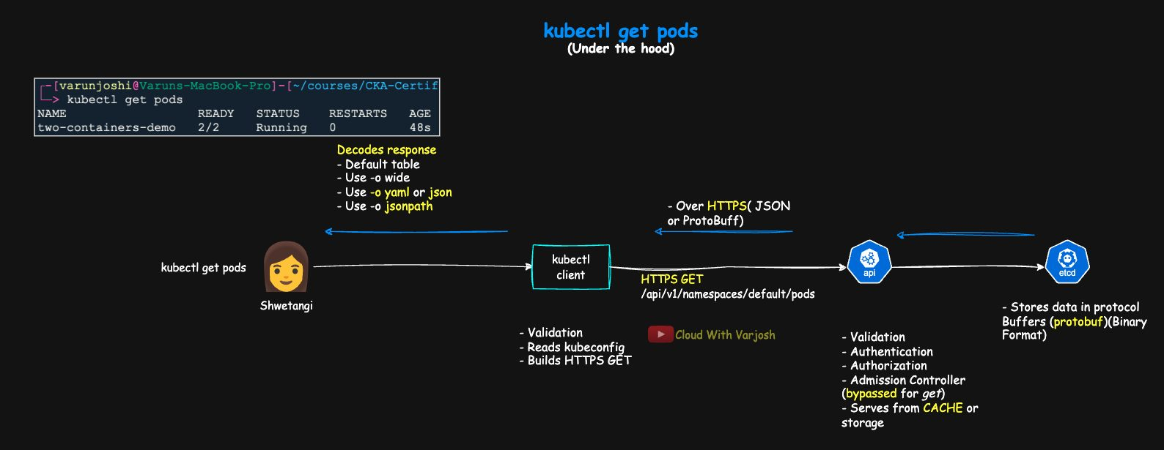
What happens behind kubectl get pods
1. kubectl builds the request.
- It reads your kubeconfig (cluster URL, CA, credentials) and opens an HTTPS connection to the API server.
- For get/list, it sends an HTTPS GET to /api/v1/namespaces/<ns>/pods (or /api/v1/pods for -A) with an Accept header (e.g. asking for a Table view). There is no request body.
- For create/update/patch, it converts your YAML into JSON and sends it as the request body (Content-Type: application/json; patches use application/strategic-merge-patch+json, application/merge-patch+json or application/json-patch+json). JSON manifests are sent as-is.
2. The API server processes it.
- Authentication → Authorization (RBAC) → Admission (admission control only applies to writes, not reads).
- Reads are usually answered from the API server's in-memory watch cache, so not every request hits etcd. Otherwise data comes from etcd, where objects are stored as Protocol Buffers (protobuf).
3. The response comes back over HTTPS – as protobuf for many built-in resources, or JSON for others (Table views, discovery, most CRDs). This is called content negotiation.
4. kubectl decodes and displays it.
- Default: a short, human-readable table.
- -o wide: the table plus a few extra columns (still not everything).
- -o yaml / -o json: the whole object.
- -o jsonpath=...: only the fields you ask for.
Why this matters: JSONPath runs inside kubectl on the decoded object, so the wire format doesn't matter. What you write in YAML maps one-to-one onto JSON fields, e.g. .spec.containers[*].image – exactly the tree JSONPath walks.

YAML and JSON
- JSON – a text format for structured data made of objects {} and arrays []. Keys and strings must be in double quotes. No comments.
- YAML – a human-friendly format for configuration. Uses indentation and - for list items, supports comments (#), multi-line strings and anchors.
- All JSON is valid YAML (YAML 1.2 is a superset of JSON), but not all YAML is valid JSON.
- kubectl accepts both. We usually write YAML for readability but should think in JSON for querying – JSONPath, jq and the API docs all use JSON.
Both represent the same data (objects/maps, arrays/lists, strings, numbers, booleans, null) and can be converted without loss.
Feature | YAML | JSON
Readability | Very human-friendly (indentation) | Machine-friendly, more explicit
Syntax | Indentation and - for lists | {} objects, [] arrays, commas
Comments | Yes (#) | No
Typical use | Config files (Kubernetes, Ansible) | APIs, tools, web payloads
File extensions | .yml / .yaml | .json

Mental model: YAML indentation = JSON braces/brackets; YAML - list items = JSON array elements.
The same Pod in YAML:
YAML
apiVersion: v1
kind: Pod
metadata:
name: two-containers-demo
namespace: default
labels:
app: two-containers
spec:
containers:
- name: web
image: nginx:1.27
ports:
- containerPort: 80
- name: helper
image: busybox:1.36
args:
- sh
- -c
- while true; do echo two-containers running; sleep 10; done
And in JSON (this is pod.json, used for practice below):
JSON
{
"apiVersion": "v1",
"kind": "Pod",
"metadata": {
"name": "two-containers-demo",
"namespace": "default",
"labels": { "app": "two-containers" }
},
"spec": {
"containers": [
{
"name": "web",
"image": "nginx:1.27",
"ports": [{ "containerPort": 80 }]
},
{
"name": "helper",
"image": "busybox:1.36",
"args": ["sh", "-c", "while true; do echo two-containers running; sleep 10; done"]
}
]
}
}
Why does it start with {? A manifest describes one resource, so it is a top-level object. Even list responses from the API are objects (e.g. kind: PodList) with an items array inside – which is why kubectl JSONPath on a list starts with .items. You only see a top-level [ if you extract an array yourself (e.g. jq '.items').

Why JSONPath?
The API returns JSON; kubectl turns it into tables. -o json / -o yaml show everything, but in a real cluster with thousands of objects that's far too much. JSONPath extracts exactly the fields you care about, so you can script, filter and decide quickly.

What is JSONPath?
A small query language for navigating JSON: start at the root and select nested fields, array items, or only items that match a filter.
Core operators (90% of what you need):
Operator | Meaning | Example
$ | Root of the document | $.kind
. | Child field | $.metadata.name
[n] | Array element by index (from 0) | $.spec.containers[0]
[*] | All elements of an array | $.spec.containers[*].image
?() | Filter array elements; @ = current element | $.spec.containers[?(@.name=="web")]

Kubernetes examples:
- Kind → $.kind
- Name → $.metadata.name
- All container names → $.spec.containers[*].name
- Image of the web container → $.spec.containers[?(@.name=="web")].image
- Port of the web container → $.spec.containers[?(@.name=="web")].ports[*].containerPort

Practice locally with pod.json
You can practice with a local CLI such as @jsonpath-plus/cli (jsonpath <file> '<expr>').
BASH
# Basics – every path starts at the root $
jsonpath pod.json '$.kind' # "Pod"
jsonpath pod.json '$.metadata.name' # "two-containers-demo"
jsonpath pod.json '$.metadata.namespace'
jsonpath pod.json '$.metadata.labels.app'

# Arrays and wildcards
jsonpath pod.json '$.spec.containers[*].name' # web, helper
jsonpath pod.json '$.spec.containers[*].image'
jsonpath pod.json '$.spec.containers[*].ports[*].containerPort' # 80
jsonpath pod.json '$.spec.containers[*].args'

# Indexing and filtering
jsonpath pod.json '$.spec.containers[0].image' # nginx:1.27
jsonpath pod.json '$.spec.containers[?(@.name=="web")].image'
jsonpath pod.json '$.spec.containers[?(@.name=="web")].ports[*].containerPort'

Using JSONPath with kubectl
BASH
# General form
kubectl get <kind> [<name>] [-n <ns>] -o jsonpath='{<JSONPath>}'

# Need valid JSON output (arrays/objects)? Use:
kubectl get <kind> -o jsonpath-as-json='{<JSONPath>}'
Essentials:
- With kubectl you wrap expressions in { } and the leading $ is optional: {.metadata.name}.
- Use single quotes around the template so the shell doesn't touch it.
- Add newlines/tabs with {"\n"} and {"\t"}.
- Keys containing dots or slashes need special handling. The documented kubectl way is to escape dots with a backslash, e.g. {.metadata.labels.app\.kubernetes\.io/name}; the course also shows a quoted form such as .metadata.annotations."checksum/config".
- kubectl adds {range ...}{end} loops; array filters ?(@.field=="value") work as usual.
- For real JSON to pipe into jq, use -o jsonpath-as-json.

Examples on live objects
Pods:
BASH
# .items -> list responses hold objects in an "items" array
# [*] -> every element
# {"\n"} / {"\t"} -> newline / tab
# {range ...}{end} -> loop

kubectl get pods -o jsonpath='{.items[*].metadata.name}{"\n"}' # all Pod names
kubectl get pod <pod> -o jsonpath='{.status.podIP}{"\t"}{.spec.nodeName}{"\n"}' # IP <tab> node
kubectl get pods -o jsonpath='{range .items[*]}{.spec.containers[*].image}{"\n"}{end}' # images, one Pod per line
Deployments:
BASH
kubectl get deploy <deploy> -o jsonpath='{.spec.template.spec.containers[*].image}{"\n"}'
kubectl get deploy <deploy> -o jsonpath='{.spec.replicas}{" / "}{.status.readyReplicas}{"\n"}' # desired / ready
Note that a Deployment's containers are under .spec.template.spec, because spec.template is the Pod template.
Services and Endpoints:
BASH
kubectl get svc <svc> -o jsonpath='{.spec.clusterIP}{"\t"}{.spec.ports[*].port}{"\n"}'
kubectl get svc <svc> -o jsonpath='{.spec.ports[*].nodePort}{"\n"}'
kubectl get endpoints <svc> -o jsonpath='{range .subsets[*].addresses[*]}{.ip}{"\n"}{end}'
Nodes:
BASH
kubectl get nodes -o jsonpath='{.items[*].metadata.name}{"\n"}'

# Each node with all its conditions as Type=Status (nested range loops)
kubectl get nodes -o jsonpath='{range .items[*]}{.metadata.name}{"\t"}{range .status.conditions[*]}{.type}{"="}{.status}{" "}{end}{"\n"}{end}'
ConfigMaps and Secrets:
BASH
kubectl get cm <cm> -o jsonpath='{.data.key\.with\.dots}{"\n"}' # key containing dots
kubectl get secret <sec> -o jsonpath='{.data.password}' | base64 -d; echo # Secret data is base64

Quick legend
- .items – the array of objects in a list response (e.g. PodList.items).
- [*] – every element of an array.
- {range X}...{end} – loop over X.
- {"\n"} / {"\t"} – newline / tab.
- Escape or quote keys with dots/slashes.

Pro tips
- Filter with selectors first, then use JSONPath:
BASH
kubectl get pods -l app=web -o jsonpath='{.items[*].metadata.name}'
kubectl get pods --field-selector=status.phase=Running -o jsonpath='{.items[*].metadata.name}'
- Filters work on arrays: ?(@.status.phase=="Running").
- Need valid JSON? kubectl get pods -o jsonpath-as-json='{.items[*].metadata.name}' | jq length
- Template getting complicated? Switch to JSON + jq:
BASH
kubectl get pods -o json | jq -r '.items[] | select(.status.phase=="Running") | .metadata.name'
- Related: -o custom-columns=NAME:.metadata.name,NODE:.spec.nodeName gives a neat table using the same paths, and --sort-by=.metadata.creationTimestamp sorts output by a JSONPath field.

