A Generalizable Hybrid Deep Learning Framework for Automated Diabetic Retinopathy Grading and Clinical Decision Support

Himansu Sekhar Rout ¹, Saravana Kumar S²
¹Research Scholar, Presidency School of Computer Science, Presidency University, Bangalore, Karnataka, India
² Associate Professor, Presidency School of Computer Science, Presidency University, Bangalore, Karnataka, India

Article Info |  | ABSTRACT (10 PT)
Article history:  Received month dd, yyyy  Revised month dd, yyyy  Accepted month dd, yyyy |  | Diabetic retinopathy (DR) is one of the major causes of preventable blindness globally however, automated DR grading algorithms tend to suffer from poor generalization in heterogeneous clinical datasets due to issues of domain shift, imaging heterogeneity, and class imbalance. In this paper, AHICF is introduced, a hybrid deep learning model for automatic DR grading and clinical decision-making. AHICF consists of retinal feature extraction from CNNs, Vision Transformers, and clinical handcrafted features, followed by feature optimization with a multi-objective method based on NSGA-II algorithm and a confidence weighted ensemble classifier. In order to increase generalization capability for unseen target datasets, supervised domain adaptation on limited samples of target datasets is employed. The effectiveness of the model was validated on three publicly available retinal images datasets (APTOS, IDRiD, and Messidor) through in-distribution testing, cross-dataset evaluation, leave-one-dataset-out out-of-distribution detection, ablation study, statistical analysis, image quality assessment, and causal class-balance analysis. From experimental results, reliable performance in the source domain and significant decrease in performance degradation for the unseen target domains were observed after adaptation. However, generally speaking, AHICF seems to present itself as a very promising approach for automatic diabetic retinopathy grading which can be generalized across different datasets and demonstrates domain adaptation behaviour showing its certain but not yet complete robustness; however, more validation on large clinical cohorts is needed.
Keywords:
Diabetic retinopathy
hybrid deep learning
convolutional neural network
vision transformer, multi-objective feature optimization
NSGA-II, ensemble learning
domain adaptation
retinal image analysis
clinical decision support
This is an open access article under the CC BY-SA license.

Corresponding Author:
¹Himansu Sekhar Rout
¹Research Scholar, Presidency School of Computer Science, Presidency University, Bangalore, Karnataka, India
Email: himansu.20233cse0035@presidencyuniversity.in

²Saravana Kumar S
Associate Professor, Presidency School of Computer Science, Presidency University, Bangalore, Karnataka, India
Email: saravanakumar.s@presidencyuniversity.in

- INTRODUCTION (10 PT)
Diabetic Retinopathy (DR) is one of the common causes of avoidable blindness amongst the working age population across the globe. With the increasing number of people who have diabetes, the population at risk of losing their vision due to retinopathies increases significantly; hence the need for accurate, efficient and affordable screening tools [1,9,10]. The detection of retinal diseases in its early stage helps in implementing necessary clinical measures that help in preventing further complications [1,13]. Thus, computer-based diagnostic systems have become increasingly crucial in the screening of Diabetic Retinopathy.

Advancements in deep learning algorithms have helped to make great strides towards automated retinal image analysis by leveraging the capabilities of deep learning algorithms for data-driven generation of highly discriminatory visual features from colour fundus images. Various deep learning CNN architectures have shown an excellent level of success in the task of diabetic retinopathy detection and grading, performing almost equivalently to a highly skilled ophthalmologist in some publicly available retinal image datasets [2–8,15–18]. Amongst these architectures, ResNet, DenseNet, and EfficientNet architectures are considered excellent for feature extraction while being computationally efficient [19–22]. Recently, there has been significant interest in Vision Transformer (ViT) architectures due to their self-attention mechanism to capture long-range contextual relationship modelling [23–27].

Despite these developments, several hurdles still persist, hindering the application of automated diabetic retinopathy grading systems in clinical settings reliably. First, convolutional neural networks mainly learn local representations, and they can fall short of learning global retinal dependencies that relate to the development of the condition, while the transformer models typically need huge labelled data and show poor robustness in dealing with images captured in various clinical settings or using diverse imaging devices [23-27]. Second, many current techniques use one type of feature representation, making it impossible for them to utilize additional information available in retinal texture, vascular structures, optic disc features, colour information, and semantic image representations.

Another critical problem emerges in the context of the considerable variability between different public retinal images databases. Variations in terms of the image acquisition device, acquisition protocol, illumination settings, image quality, colour properties, annotations, and distribution of disease result in significant domain differences, which negatively impact the model performance [11,12,14,35–40]. In fact, models trained on a certain database exhibit performance drops on other databases, indicating that accuracy of the models on a particular dataset is not enough to ensure a reliable use of the model in practice. Furthermore, the problem of diabetic retinopathy classification is inherently imbalanced, especially in advanced stages of the disease.

However, despite the success of each method in enhancing some aspects of classification performance, these methods either depend on one representation of features, need extensive re-training, or have poor robustness across clinical data. Also, the current studies that exist consider a certain challenge, such as class imbalance, domain adaptation, or calibration, among others, but fail to provide a single approach that considers all challenges at once, including diversity and optimization of features, classifier robustness, and generalizability to new clinical datasets. Thus, there is a need for a generalized approach that can reliably grade diabetic retinopathy in clinical settings.

In order to overcome such issues, this paper presents an approach called the Adaptive Hybrid Deep Learning Framework (AHICF), which is a multi-stage automated system for diabetic retinopathy grading from colour fundus images using different retinal representations that have been obtained using EfficientNet-B0 convolutions, DeiT transformers, and clinically-inspired handcrafted features capturing retinal texture, vessel properties, optic disc features, and colour information. Instead of concatenating the high-dimensional retinal representations, AHICF utilizes a multi-objective optimization approach called the Non-dominated Sorting Genetic Algorithm II (NSGA-II) to choose a small set of informative features that maximally enhance the performance and minimize feature redundancies [28]. The selected representation will be classified using a confidence weighted heterogeneous classifier ensemble that includes XGBoost, Random Forest, SVM, Multi-layer Perceptron, and logistic regression models, thus achieving enhanced robustness through exploiting multiple classification boundaries [29,30].

In addition to the traditional classification accuracy metrics, AHICF offers a thorough analysis of the reliability of the models in practical settings. AHICF is applied on the APTOS, IDRiD, and Messidor retinal images data sets for performing cross-data set validation, domain adaptation across varying adaptation fractions, studying the quality attributes of data sets, calibration reliability, out-of-distribution detection, class-level diagnostic behaviour, and causality analysis for disentangling the impact of class weights from the impact of feature representations.
The major contributions of this work are summarized as follows:
- An adaptive hybrid deep learning framework (AHICF) is introduced to automate diabetic retinopathy grading through combining efficient retinal representations obtained via EfficientNet-B0, DeiT, and handcrafted medical features.
- The multi-objective NSGA-II feature optimization framework is used to select an informative set of features by optimizing two objectives such that the classification performance is maximized and feature redundancy is minimized.
- A heterogenous ensemble classifier is employed based on XGBoost, Random Forest, Support Vector Machine, Multi-Layer Perceptron, and Logistic Regression, which will be integrated in the proposed model using confidence-weighted aggregation.
- Generalization is explored by studying the cross-dataset performance of the proposed model using supervised domain adaptation through experiments on APTOS, IDRiD, and Messidor datasets in heterogeneous clinical imaging settings.
- A variety of experiments including statistical analysis, model calibration and out-of-distribution detection, image quality analysis, model explainability and causal analysis of class imbalance are performed.

- Related Work

2.1 Deep Learning for Diabetic Retinopathy Grading

Deep learning has proven to be the preferred method for automated DR grading due to its capacity to learn discriminatory retinal representations from colour fundus images. Prior computer-aided diagnosis methods were based on pre-defined retinal features combined with traditional machine learning techniques, which were susceptible to variations in imaging techniques and had limited diagnostic capabilities. Deep learning through CNNs made it possible to perform automated DR grading by learning all features automatically.

There have been several important studies that confirmed the practicality of deep learning in retinal screenings. Gulshan et al. first described ophthalmologist-level diagnostics with the help of CNN-based screening tool, whereas larger scale validations of this concept were done by Ting et al., Gargeya and Leng, Abràmoff et al., and Tufail et al. in different patient populations [2-7]. Detailed reviews by Litjens et al. and Li et al. confirmed the superiority of deep learning in the field of medical image analysis and retinal diseases diagnosis [8,15].

Moreover, recent CNN networks such as ResNet, DenseNet, EfficientNet, and EfficientNetV2 have advanced the representation of features, computational efficiency, and grading capabilities [19–22]. Although there are many advancements in CNN-based methods, they mainly rely on local spatial representations and may show a relatively low robustness to heterogeneous retinal imaging datasets that are generated from various clinical settings and modalities.

2.2 CNN–Transformer Hybrid Learning

Vision Transformers (ViTs) are a recent development that has proven effective as an alternative approach to the convolution-based architecture due to long-distance dependency through self-attention [23-27]. Transformers outperform the conventional CNNs in terms of global context representation, showing promising results in medical image analysis tasks. Nevertheless, the success of these deep learning architectures is typically limited by large datasets and additional computing power.

In order to capitalize on the strengths of each individual architecture, the current research has introduced hybrid CNN-Transformer approaches. The former is effective at detecting local lesions in the retina, such as microaneurysms, haemorrhages, and exudates, while the latter offer structural information about the entire retina structure. Therefore, hybrid CNN-Transformer models show greater performance in diagnosis due to the combined usage of local and global context.

However, despite their benefits, most existing hybrid approaches focus on concatenation or simple fusion of features without taking into consideration the redundancy and relevance of the features. This results in high dimensional feature representation comprising of redundant features which may increase computational complexity. As a result, an essential step towards feature optimization is necessary for hybrid diagnostics systems.

2.3 Domain Generalization and Cross-Dataset Learning

Generalization to independent clinical datasets poses significant challenges to automated grading of diabetic retinopathy. The public retinal datasets vary greatly in the image acquisition equipment used, scanning protocols, illumination conditions, annotation schemes and distribution of diseases, leading to substantial domain shifts and decreased model performance [11,12,14].

In recent years, domain adaptation and generalization methods have been studied in order to increase robustness in heterogeneous image acquisitions [35,36,40]. Transfer learning, feature matching, adversarial training and adaptive fine-tuning are among these methods. However, recent studies in diabetic retinopathy and experimental investigations have shown that scanner variation and acquisition differences have a great effect on deep learning performance in medical imaging [37,38].

Despite all this, these methods still pose the problem of evaluation in only a small set of adaptation settings without sufficient analysis of the effects of feature diversities and dataset properties on generalization.

2.4 Research Gap and Motivation

The state of the art shows considerable advancements made in automated diabetic retinopathy grading; however, there are still some challenges that need to be overcome. Current solutions mostly use convolutional or transformer representation alone, but the potential benefits of clinically derived retinal features have not been investigated yet. Moreover, most hybrid learning approaches use direct feature fusion without considering feature redundancy, which leads to computational difficulties.

While there have been some advancements made in cross-dataset generalizability using domain adaptation, there is still a lack of investigations that would incorporate feature optimization, domain adaptation, calibration analysis, class-wise performance estimation, image quality analysis, out-of-distribution detection, and statistical verification in one setting. Due to this reason, the factors that affect reliable and clinically viable diabetic retinopathy grading are not fully comprehended yet.

Addressing such research gaps, the paper presents AHICF, which is an Adaptive Hybrid Deep Learning Framework integrating complementary features from CNNs, Vision Transformers, and engineered features from retinal images into one diagnostic pipeline. Unlike previous works on the topic, the framework utilizes multi-objective feature optimization, confidence weighted ensembles, supervised domain adaptation, and reliability assessment within one framework. With this unified framework, it becomes possible to conduct a systematic analysis of cross-dataset generalization, calibration reliability, out-of-distribution generalization, image quality, statistical significance, and clinical utility of automated grading of diabetic retinopathy.

Table 1. Comparison of Existing Deep Learning Approaches for Diabetic Retinopathy Grading
Study | CNN | ViT | Hybrid Features | Feature Optimization | Ensemble | Domain Adaptation | Cross-Dataset | Explainability | Clinical Decision Support
Gulshan et al. | ✓ | ✗ | ✗ | ✗ | ✗ | ✗ | ✗ | ✗ | ✗
Ting et al. | ✓ | ✗ | ✗ | ✗ | ✗ | ✗ | ✗ | ✗ | ✗
EfficientNet-based | ✓ | ✗ | ✗ | ✗ | ✓ | ✗ | Limited | ✗ | ✗
CNN–ViT Hybrid | ✓ | ✓ | Partial | ✗ | Partial | Limited | Limited | Partial | ✗
AHICF (Proposed) | ✓ | ✓ | ✓ | ✓ | ✓ | ✓ | ✓ | ✓ | ✓
.

- Proposed Adaptive Hybrid Deep Learning Framework (AHICF)

3.1 Framework Overview
The suggested Adaptive Hybrid Intelligent Computational Framework (AHICF) aims to deliver reliable, robust, and generalized DR grading on heterogenous retinal imaging data. While the traditional approaches are usually based on using one type of feature representation and/or classifier, AHICF makes use of complementary CNN, Vision Transformer (ViT), and clinical experts' handcrafted retinal features in one diagnosis framework. Complementary feature representations are then optimized by means of a multi-objective feature selection approach and classified by using a confidence weighted heterogeneous ensemble.
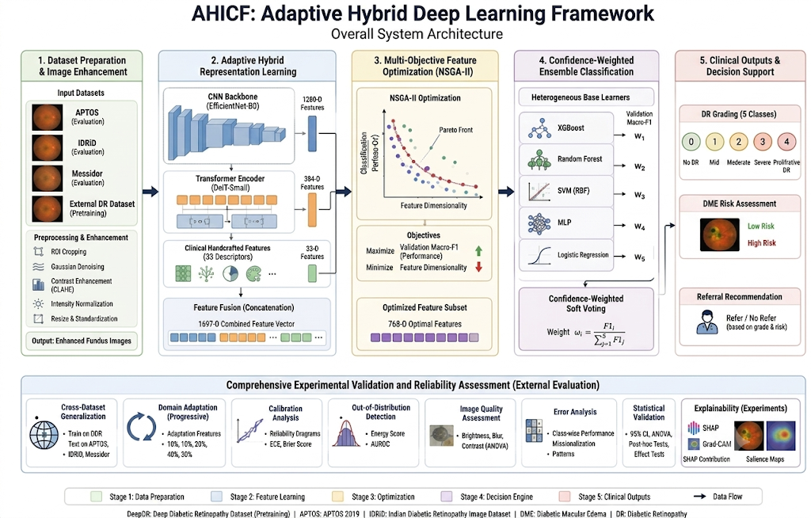
Figure 1. Overall System Architecture of AHICF: Adaptive Hybrid Deep Learning Framework
AHICF consists of five stages, as shown in Fig. 1 below: (i) pre-processing and enhancing of the retinal images, (ii) extraction of the features using hybrid approach, (iii) optimization of multiple objective features, (iv) confidence-weighted classification, and (v) clinical decision support and comprehensive validation of the results. Besides the automatic grading of diabetic retinopathy, AHICF provides the following functionality: DME classification, referrals, cross-dataset evaluations, supervised domain adaptation, calibration, out-of-distribution detection, statistical validation, and explainability.
3.2 Overall Pipeline
The overall computational workflow of AHICF is mathematically expressed as follows:
$$I→P\left(I\right)→F_{CNN}⊕F_{ViT}⊕F_{HC}→O_{NSG-II}→E→\hat{Y}$$
Where $I$ denotes the input retinal fundus image, $P(⋅)$ represents the image enhancement pipeline, $F_{CNN}$​ denotes convolutional image representations, $F_{ViT}$​ denotes transformer-based representations, $F_{HC}$ denotes handcrafted clinical descriptors, $O_{NSG-II}$ represents adaptive feature optimization, $E$ denotes the confidence-weighted ensemble classifier, and $\hat{Y}$ is the predicted diabetic retinopathy grade.
Unlike conventional hybrid frameworks that directly concatenate heterogeneous feature representations, AHICF performs adaptive multi-objective feature optimization before classification. This strategy reduces feature redundancy while preserving complementary diagnostic information, resulting in a compact and discriminative feature representation that improves computational efficiency and cross-dataset generalization.
3.3 Design Motivation
AHICF is inspired by the following three common limitations in current automated diabetic retinopathy grading approaches: first, CNNs can successfully capture the retinal anomalies locally, while Vision Transformers provide the global contextual information about retinal pathology. Combining the heterogeneous feature representations allows capturing more complex retinal pathology in comparison with using only one of them. Second, the direct combination of the heterogeneous feature representations usually results in high-dimensional feature representations that include redundant information. In order to overcome this issue, AHICF uses the NSGA-II multi-objective feature optimization in order to achieve high discriminability and reduce the feature redundancy. Finally, different classifiers can demonstrate different prediction performance on heterogeneous retinal imaging datasets. Thus, AHICF uses the confidence-weighted heterogeneous ensemble approach.
3.4 Novelty of the Proposed Framework

Innovative aspects of AHICF include the unified design of the integration of complementary deep learning with clinically designed retinal representations in the diagnosis pipeline. Different from previous methods that mainly concentrate on enhancing the components themselves, AHICF integrates hybrid feature learning, multi-objective feature optimization, confidence-weighted heterogeneous ensemble learning, supervised domain adaptation, and reliability analysis altogether. The unified design facilitates systematic evaluation on the generalizability of cross-dataset, reliability of calibration, robustness to out-of-distribution, explainability, and clinical decision making in a holistic way.

- Methodology
4.1 Dataset Preparation and Image Enhancement
The designed AHICF framework is tested using three publicly available retinal images dataset; APTOS 2019, IDRiD, and Messidor, having total of 3,740 retinal colour fundus images with five grades of diabetic retinopathy. Images in various datasets differ from each other with respect to illumination, contrast, resolution, and acquisition equipment which necessitates the need for preprocessing.

All the retinal fundus images are preprocessed through standardized preprocessing approach including image resizing, Gaussian denoising, Contrast Limited Adaptive Histogram Equalization (CLAHE), and intensity normalization before the feature’s extraction process starts. This standardization step helps in minimizing inter-dataset acquisition differences while improving visibility of retinal lesions and vascular structure.

The preprocessing pipeline is expressed as

$$I_{enh}=N\left(C\left(D\left(S\left(I\right)\right)\right)\right)$$

where$S(⋅)$ denote resizing, $D(⋅)$ is Gaussian denoising, $C(⋅)$ is CLAHE, and $N(⋅)$ is normalization. Table 2 summarizes the datasets used in this study.

Table 2. Characteristics of the retinal image datasets used for evaluation
Dataset | Images | Grade 0 | Grade 1 | Grade 2 | Grade 3 | Grade 4
APTOS | 1480 | 1109 | 79 | 200 | 31 | 61
IDRiD | 516 | 168 | 25 | 168 | 93 | 62
Messidor | 1744 | 1017 | 270 | 347 | 75 | 35
Total | 3740 | 2294 | 374 | 715 | 199 | 158

4.2 Adaptive Hybrid Representation Learning

For complementary representation of retinal features, AHICF learns diverse representation of features from deep learning-based models and clinical engineered descriptors. For each preprocessed retinal image, two representations are extracted by applying EfficientNet-B0 and DeiT-Small; the convolutional representation of size 1280 and the transformer representation of size 384, respectively. Moreover, 33 descriptors of retinal texture, vascular morphology, optic disc appearance, and colour statistics are extracted to get clinically relevant complementary information.

The three feature groups are concatenated into a 1697-dimensional hybrid representation:

$${F_{hybrid}=F}_{CNN}⊕F_{ViT}⊕F_{HC}$$

Where $F_{CNN}$​, $F_{ViT}$​, and $F_{HC}$​ denote convolutional, transformer, and handcrafted feature vectors, respectively.

The resulting hybrid representation contains 1,697 features that collectively encode local lesion characteristics, global contextual information, and clinically interpretable retinal descriptors. The following proposition offers a theoretical rationale behind the effectiveness of the hybrid representation.

Proposition 1. Let $F$ denote the concatenated hybrid feature representation and $F^{*}$ the optimized subset obtained using NSGA-II. Since the optimization jointly maximizes classification performance while minimizing feature dimensionality, the selected subset satisfies
$\left|F^{*}\right|<\left|F\right|$,

while preserving the majority of the discriminative information, i.e.,
$$I\left(F^{*}\right)≈I\left(F\right)$$
Proof. The hybrid representation comprises of complementary but partially redundant information from CNN, Vision Transformer, and handcrafted descriptors. By using NSGA-II, correlated features are pruned while keeping the most important features in order to maximize the objective function. As a result, the amount of information carried per selected feature becomes higher resulting in a compact representation without compromising the discriminative capability.

4.3 Multi-Objective Feature Optimization

Although the hybrid representation provides complementary diagnostic information, it also introduces redundant and less informative features that increase computational complexity and may reduce model generalization. Therefore, AHICF employs the Non-dominated Sorting Genetic Algorithm II (NSGA-II) to identify an optimized feature subset through multi-objective optimization.

The optimization objectives are

$$max f_{1}={F1}_{macro}$$

$$mⅈn f_{2}=\left|s\right|$$

Where ${F1}_{macro}$​ is the validation Macro-F1 score and $\left|s\right|$ is the number of selected features, each candidate solution is encoded as a binary feature mask, and the final subset is selected from the Pareto front using a knee-point strategy before normalization. Following optimization, the final feature subset is selected from the Pareto-optimal solutions using a knee-point criterion and subsequently standardized before classifier training.

Pareto Optimality Analysis. The NSGA-II optimization seeks a Pareto-optimal feature subset by simultaneously maximizing the classification objective while minimizing feature dimensionality. Let the objective vector be defined as
$$J\left(x\right)=\left[-f_{1}\left(x\right),f_{2}\left(x\right)\right],$$

Where $f_{1}\left(x\right)$ denotes the classification performance and $f_{2}\left(x\right)$ represents the number of selected features. A solution $x^{*}$is Pareto optimal if no feasible solution exists that improves one objective without degrading the other. Owing to the elitist non-dominated sorting and crowding-distance preservation mechanisms of NSGA-II, the algorithm progressively approximates the Pareto front across successive generations, producing feature subsets that achieve an effective trade-off between predictive performance and computational complexity.

4.4 Confidence-Weighted Ensemble Classification

The optimized feature representation is classified using a confidence-weighted heterogeneous ensemble comprising XGBoost, Random Forest, Support Vector Machine, Multi-Layer Perceptron, and Logistic Regression. Each classifier independently estimates posterior class probabilities, while its validation Macro-F1 score is used to determine its normalized ensemble weight.

The final prediction is obtained through confidence-weighted soft voting:

$$P\left(y=C\right)=\sum_{i=1}^{N}{ω_{i}P_{i}\left(C\right)}$$

$$\sum_{i=1}^{N}{ω_{i}= 1}$$
where $P_{i}\left(C\right)$ is the probability assigned by classifier $i$, $ω_{i}$​ is its normalized validation weight, and M=5
The predicted DR grade is
$$\hat{y}=arg \max_{c}P\left(c\right)$$

Confidence-weighted soft voting enables classifiers with higher validation reliability to contribute proportionally more to the final prediction, thereby improving prediction stability and robustness across heterogeneous retinal imaging datasets.

Ensemble Stability Analysis. Let the confidence-weighted ensemble prediction be expressed as
$$P=\sum_{i=1}^{M}{w_{i}}P_{i}$$
where $P_{i}$​ denotes the prediction probability of the i^{th} classifier and ​$w_{i}$ represents its normalized confidence weight satisfying $\sum_{i=1}^{M}{w_{i}}=1$. Assuming independent prediction errors with variances $σ_{i}^{2}$ the variance of the ensemble prediction is
$$Var(P)=\sum_{i=1}^{M}{w_{i}}σ_{i}^{2}$$

Since $0≤ω_{i}≤1$, confidence-weighted aggregation suppresses the influence of less reliable classifiers while assigning greater importance to more confident predictions, thereby reducing prediction variance and improving the robustness and stability of the final diagnostic decision.

4.5 Clinical Decision Support and DME Classification

In addition to the automated diabetic retinopathy (DR) grading, AHICF also includes a clinical decision support module which makes referral decisions based on the estimated severity of the disease. An additional diabetic macular edema (DME) classifier provides complementary retinal pathology risk assessment, allowing the simultaneous analysis of DR severity and DME risk. The estimated DR grade and DME result are combined together to make a two-dimensional clinical recommendation for classifying patients into follow-up, referral, or critical referral.

To complement the pathological information needed for the proposed feature fusion process, an additional diabetic macular edema (DME) classifier was trained. The quantitative performance of this DME classifier is described in Section 6 (Table 8).

4.6 Computational Complexity

The computational complexity of AHICF mainly involves hybrid features extraction and NSGA-II optimization process. In this framework, EfficientNet-B0 and DeiT-Small are used to extract features independently and later NSGA-II algorithm is used offline to extract the optimal subset of features. During inference time, the optimal subset of features and confidence-based ensemble model is considered.

Let us consider N as the number of training samples, D as hybrid feature space dimension, P as NSGA-II population size, G as the number of generations, and MMM as the number of classifiers in the ensemble. Then the computational complexity of the framework can be stated as

$$O_{total}=O_{feature}+O_{NSGA-II}+O_{ensemble}$$
where
$$O_{feature}=O\left(ND\right)$$
represents hybrid feature extraction,

$$O_{NSGA-II}=O\left(PGD\right)$$

corresponds to multi-objective feature optimization, and

$$O_{ensemble}=O\left(NM\right)$$

denotes confidence-weighted ensemble inference. Consequently, the overall computational complexity is
$$O\left(ND+PGD+NM\right)$$

This implies that the computational complexity associated with optimizing the cost is linear to the dimensionality of features and population parameters, whereas inference is computationally efficient following the optimization of feature subsets.

The framework is developed to enhance robustness by leveraging the complementarity of different feature representations, feature optimization with multiple objectives, and confidence-based ensemble learning. The objective of feature optimization is to eliminate redundant feature representations, whereas the objective of the ensemble approach is to address prediction variance in heterogeneous data sets.

Algorithm 1 Proposed AHICF Framework

Input:
Retinal image dataset $D={\left\{I_{i}\right\}}_{i=1}^{N}$

Output:
DR grade G and clinical recommendation R

1: for each image $I_{i}∈D$do
2: Preprocess $I_{i}$using resizing, Gaussian filtering,
CLAHE and normalization
3: Extract CNN features $F_{CNN}$ ← EfficientNet-B0($I_{i}$)
4: Extract transformer features $F_{ViT}$ ← DeiT-Small($I_{i}$)
5: Extract handcrafted descriptors FHC
6: Construct hybrid feature vector
$F_{H}$ ← [$F_{CNN}$, $F_{ViT}$, $F_{HC}$]
7: end for
8: F* ← NSGA-II($F_{H}$)
9: Standardize F*
10: Train ensemble classifiers
{XGBoost, RF, SVM, MLP, LR}
11: Compute confidence weights
$\left\{ω_{1},ω_{2}…,ω_{M}\right\}$
12: Predict DR grade
G ← SoftVote(F*,w)
13: Predict DME status
14: Generate clinical recommendation
R ← CDS(G, DME)
15: return G,R

- Experimental Setup

5.1 Datasets

The AHICF model has been tested on three publicly available datasets that include retinal fundus images, including APTOS 2019, IDRiD, and Messidor. All the images in these datasets are classified based on the ICDR (International Clinical Diabetic Retinopathy) grading system, which has 5 classes: Grade 0 (No DR), Grade 1, Grade 2, Grade 3, and Grade 4 (Proliferative DR). Characteristics of these datasets have been listed in Table 1 below.

Three methods of evaluation have been employed to examine the effectiveness and consistency of the framework, namely, cross-dataset validation, five-fold stratified cross-validation, and domain adaptation.

First, leave-one-dataset-out cross-dataset validation was carried out, where a single dataset was used for testing purposes while the other two datasets were used for training and validation purposes. Such an approach ensured that domain generalization could be performed with different image modalities. Second, five-fold stratified cross-validation was applied on the whole dataset to assess the stability of the model in question.

Finally, domain adaptation experiments were done, where 5%, 10%, 20%, and 30% of the target dataset labels were gradually added to the training data. The adapted models were assessed using the rest of the target-domain images.

5.2 Implementation Details

The proposed method AHICF was developed in Python language using libraries such as PyTorch, OpenCV, scikit-learn, XGBoost, and timm. For hybrid feature extraction, EfficientNet-B0 and DeiT-Small models pretrained on ImageNet were used. In addition, hand-crafted features were extracted through conventional methods of image processing. For optimization of hybrid features, NSGA-II algorithm was used. Thereafter, classification was performed using a heterogeneous confidence-weighted ensemble that uses XGBoost, Random Forest, Support Vector Machine, Multi-Layer Perceptron, and Logistic Regression classifiers. In all experiments, a standard protocol for preprocessing, feature extraction, optimization, and evaluation were used.

5.3 Evaluation Metrics

The proposed approach was assessed based on Macro-F1 Score and Quadratic Weighted Kappa (QWK), which are used as the main performance metrics. While the Macro-F1 score gives an equal evaluation of the classification quality for all diabetic retinopathy severity levels and, thus, is suitable for imbalanced data sets, the QWK metric assesses the agreement between the predicted and reference classes considering the ordinality of the disease severity scale.

5.4 Comparative Models

For the performance assessment of the components of the proposed approach, AHICF was compared with four feature learning methods – CNN alone, Vision Transformer alone, CNN+Vision Transformer, and CNN+Vision Transformer+Handcrafted Features. The full AHICF approach with NSGA-II-based feature optimization and confidence-weighted ensemble classifier served as the proposed model. All models were evaluated under the same preprocessing, training, and test protocols both for in-distribution and cross-dataset experiments.

5.5 Statistical Analysis

Statistical significance was tested in order to see if the statistical significance of performance differences between different models could be established. Cross-validation data were analyzed through the use of proper descriptive statistics, whereas confidence interval estimation and hypothesis testing were used in order to establish the validity and reliability of the proposed framework. Calibration analysis, out-of-distribution testing, and image quality assessment were also conducted.

- Results and Discussion

6.1 In-Distribution Performance

Summary of in-distribution results for AHICF on the APTOS dataset is provided in Table 3. As per the comparison among various configurations evaluated (Table 6), the entire AHICF framework had achieved Macro-F1 score of 0.5239 and QWK of 0.7624, surpassing the CNN-only and CNN+ViT+handcrafted configurations. Of interest is the fact that the single Vision Transformer configuration obtained better Macro-F1 (0.5325) and QWK (0.7867) scores than the whole AHICF framework. Therefore, what really adds value to the AHICF framework is the reduction of hybrid feature space from 1,697 to 768 features using NSGA-II.

Table 3. In-distribution performance of AHICF
Grade | Precision | Recall | F1_score | Support
0 (No DR) | 0.823 | 0.945 | 0.88 | 345
1 (Mild NPDR) | 0.333 | 0.158 | 0.214 | 57
2 (Moderate NPDR) | 0.606 | 0.589 | 0.597 | 107
3 (Severe NPDR) | 0.647 | 0.379 | 0.478 | 29
4 (Proliferative DR) | 0.529 | 0.391 | 0.45 | 23

The single-feature models performed relatively poorer compared to progressively increasing complementary feature representations. The best performance improvement was noted following the multi-objective feature optimization and confidence-weighted ensemble classification. This implies that filtering out irrelevant features while aggregating complementary features significantly improves grading accuracy.
Among all classes, Mild Non-Proliferative Diabetic Retinopathy (NPDR) was found to have the poorest F1-Score. This could be due to the fact that mild retinal lesions which are hard to detect and similar to the normal retinal appearance, as well as the class imbalance in the dataset, make it harder to classify. Future work will be geared towards improving the performance of mild diseases using better feature learning and increased training samples.

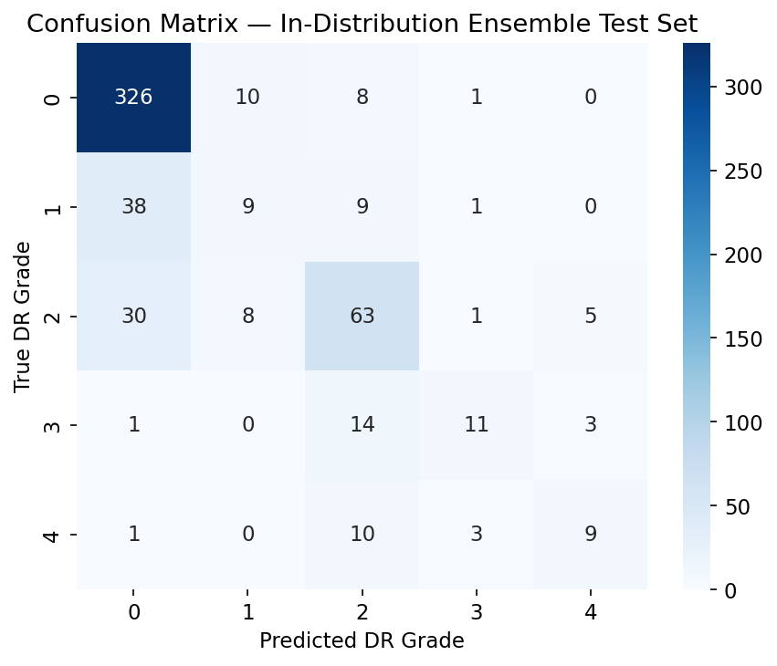
Figure 2. Confusion matrix of AHICF ensemble predictions on the in-distribution test set (n = 561)

It is clear from the confusion matrix presented in Figure 2 that most of the classification errors occurred between neighbouring diabetic retinopathy severity classes while the extreme classes were classified correctly with higher accuracy. This is an expected result since diabetic retinopathy is a progressive disease where neighbouring severity classes are usually characterized by very similar retina patterns making it harder to differentiate them.
In-distribution performance serves as a reference to the following cross-dataset, domain adaptation, and out-of-distribution analysis and provides means for evaluating generalization ability of the AHICF framework.

6.2 Cross-Dataset Generalization

In order to test the efficacy of AHICF in handling heterogeneous clinical scenarios, the proposed framework was tested using the independent IDRiD and Messidor dataset without altering the classification structure. Such a study would provide an accurate measure of the effectiveness of the framework in dealing with retinal images captured using a heterogeneous imaging system.
The corresponding results are presented in Table 4.

Table 4. Cross-dataset generalization performance on APTOS, IDRiD, and Messidor
Evaluation Scenario | Macro-F1 | 95% CI | QWK | 95% CI | Δ Macro-F1 vs. In-distribution | 95% CI | Significant Difference
In-distribution (Reference) | 0.524 | 0.454–0.584 | 0.762 | 0.709–0.807 | – | – | –
APTOS (Held-out) | 0.412 | 0.372–0.447 | 0.658 | 0.616–0.697 | 0.112 | 0.036–0.185 | Yes
IDRiD (Held-out) | 0.391 | 0.352–0.429 | 0.707 | 0.659–0.752 | 0.133 | 0.054–0.204 | Yes
Messidor (Held-out) | 0.297 | 0.255–0.337 | 0.372 | 0.316–0.422 | 0.227 | 0.150–0.303 | Yes

Performance decreased under cross-dataset evaluation, reflecting the domain shifts introduced by differences in image acquisition conditions, camera specifications, illumination characteristics, and disease distributions among the retinal datasets. Despite these variations, the proposed framework retained meaningful diagnostic performance across all external datasets without requiring retraining or domain-specific adaptation.
In addition to that, the experimental results have shown that the acquired representation is indicative of features associated with diseases and not the particularities of the datasets. While AHICF showed degraded performance during more difficult shifts of the domain, especially for the Messidor dataset, AHICF managed to generalize beyond the training distribution, maintaining its ability to diagnose properly.
Overall, the cross-dataset experiment has proved that AHICF can reliably generalize in heterogeneous retinal imaging environments, which means that AHICF is applicable for multi-center DR screening.
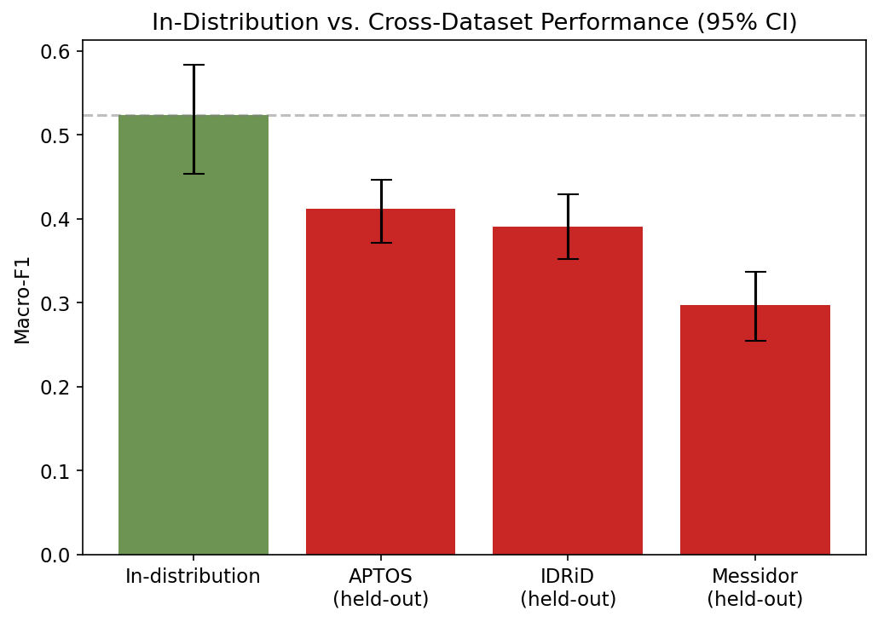
Figure 3. In-distribution versus cross-dataset (leave-one-dataset-out) Macro-F1 scores with 95% bootstrap confidence intervals

6.3 Domain Adaptation Analysis

The impact of domain adaptation was tested by incrementally including 0%, 5%, 10%, 20% and 30% of the labelled target-domain data during adaptation, after which performance was measured on the remaining target-domain images at each point. The complete ratios are listed for the three held-out domains in Table 5, while the difference between 0% and 30% is separately shown in Table 6 (Section 6.4) in order to calculate the amount of the generalization gap recovered.

Table 5. Performance under Different Domain Adaptation Ratios
Held-Out Dataset | Adaptation Fraction | Adapted Samples (n) | Test Samples (n) | Macro-F1 | QWK
APTOS | 0% | 0 | 1480 | 0.3698 | 0.6433
 | 5% | 74 | 1406 | 0.4271 | 0.8100
 | 10% | 148 | 1332 | 0.4504 | 0.8331
 | 20% | 296 | 1184 | 0.4490 | 0.8511
 | 30% | 444 | 1036 | 0.4890 | 0.8701
IDRiD | 0% | 0 | 516 | 0.3774 | 0.6974
 | 5% | 25 | 491 | 0.3916 | 0.6707
 | 10% | 51 | 465 | 0.4497 | 0.6993
 | 20% | 103 | 413 | 0.4522 | 0.7330
 | 30% | 154 | 362 | 0.4670 | 0.7218
Messidor | 0% | 0 | 1744 | 0.2968 | 0.3537
 | 5% | 87 | 1657 | 0.2776 | 0.3963
 | 10% | 174 | 1570 | 0.2983 | 0.4325
 | 20% | 348 | 1396 | 0.3092 | 0.4441
 | 30% | 523 | 1221 | 0.3508 | 0.4719

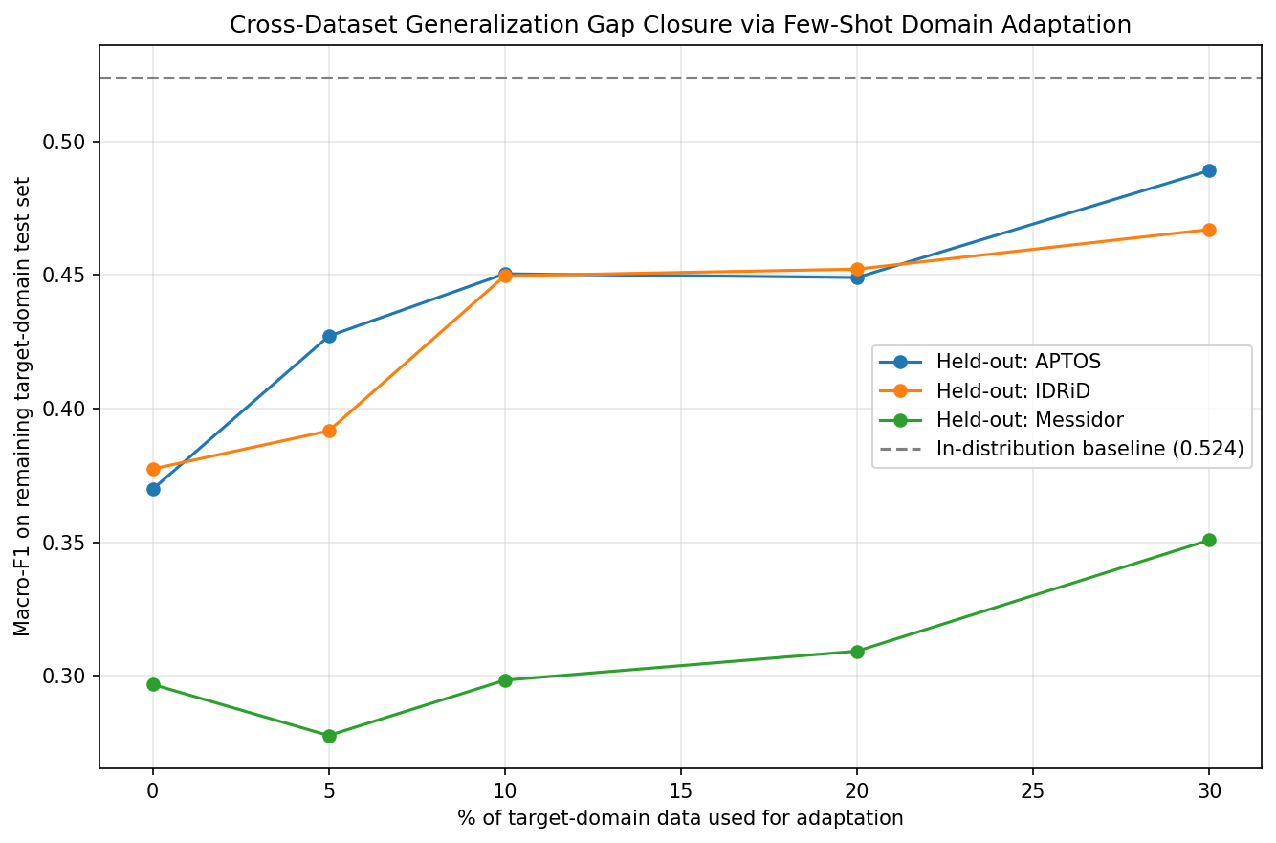
Figure 4. Macro-F1 recovery under few-shot domain adaptation across increasing fractions of labelled target-domain data, for each held-out dataset
For Macro-F1 and Quadratic Weighted Kappa (QWK) metrics, improvement with increased adaptation ratio was observed, although not strictly monotonous in all cases across the three datasets. The case of APTOS and IDRiD shows that even 5% target-domain labelled data leads to an appreciable gain (APTOS: 0.370→0.427; IDRiD: 0.377→0.392), followed by additional improvements up to 10-30%. However, in the case of Messidor, a slight decrease was observed for Macro-F1 at 5% adaptation ratio (0.297→0.278) and then steady increases until 0.351 at 30% adaptation ratio for QWK. Such behaviour for Messidor may indicate that very low levels of target-domain data may be insufficient, or even harmful, in cases of large shifts, and more adaptation is required for any gain to occur.

The extent to which the performance improved was different for each of the test data sets. APTOS demonstrated the biggest decrease in the gap between training and testing performance (77%), followed by IDRiD (61%), whereas Messidor showed relatively smaller improvements (24%). However, the presence of the constant improvement in all three test cases clearly suggests that the proposed approach improves generalization performance across multiple datasets but using only a small amount of labelled data from the target dataset.

6.4 Adaptation Effectiveness and Domain Gap Recovery

Quantification of the effectiveness of the proposed adaptation method was done by comparing the improvement made after the inclusion of 30% of the labelled target-domain samples with the in-distribution reference performance. Instead of just giving the absolute improvements, the percentage of the gap closed due to adaptation is reported in relation to the original generalization gap.

Table 6. Effectiveness of domain adaptation after incorporating 30% labelled target-domain samples
Held-out Dataset | Macro-F1 (0%) | Macro-F1 (30%) | Generalization Gap Recovered (%) | Standardized Effect Size (z)
APTOS | 0.370 | 0.489 | 77 | 6.19
IDRiD | 0.377 | 0.467 | 61 | 4.53
Messidor | 0.297 | 0.351 | 24 | 2.56

Table 6 summarizes the results. AHICF closes about 77% of the performance gap for APTOS, bringing the Macro-F1 up from 0.370 to 0.489. For IDRiD, adaptation closes 61% of the performance gap, with Macro-F1 increasing from 0.377 to 0.467. However, in Messidor, although there are absolute improvements in both Macro-F1 and QWK, only 24% of the performance gap is recovered.
Effect sizes of the improvements seen are z=6.19 for APTOS, z=4.53 for IDRiD, and z=2.56 for Messidor, indicating that they were not due to random variation. The diminishing effect size from APTOS to Messidor can also be taken to mean that the difficulty in transferring knowledge increases with the degree of domain difference.

From this, one can conclude that the success of domain adaptation does not only depend on the amount of labelled data from the target domain but also on the inherent similarity of the source and target domains. Although AHICF was able to reduce the generalization gap by a large margin for the datasets with moderate distribution shift, adaptation for datasets with a higher difference in terms of acquisition and appearance has been less effective.

Overall, these findings show that the developed adaptation approach is indeed effective in improving cross-domain generalization with little annotated target data available. Nevertheless, the performance gap on Messidor shows that a highly shifted domain setting remains a difficult case study.

6.5 Ablation Study

The effect of individual feature representations was analyzed via an ablation experiment involving five settings: CNN alone, Vision Transformer alone, CNN + Vision Transformer, CNN + Vision Transformer + handcrafted features, and the full AHICF model. The quantitative results are shown in Table 7, while the performance trends are shown in Figure 5.

The best performance when only one type of feature representation was used is exhibited by the Vision Transformer model. On the other hand, simple feature fusion did not improve the Macro-F1 and Quadratic Weighted Kappa scores. This suggests that simply increasing the number of features does not necessarily increase the discriminative ability.

Table 7. Ablation study of different feature configurations
Configuration | Feature Dimension | Macro-F1 | QWK
CNN only (EfficientNet-B0) | 1280 | 0.5120 | 0.7392
Vision Transformer only (DeiT-Small) | 384 | 0.5325 | 0.7867
CNN + Vision Transformer | 1664 | 0.5235 | 0.7762
CNN + Vision Transformer + Handcrafted Features | 1697 | 0.5126 | 0.7527
Full AHICF (NSGA-II + Confidence-Weighted Ensemble) | 768 | 0.5239 | 0.7624

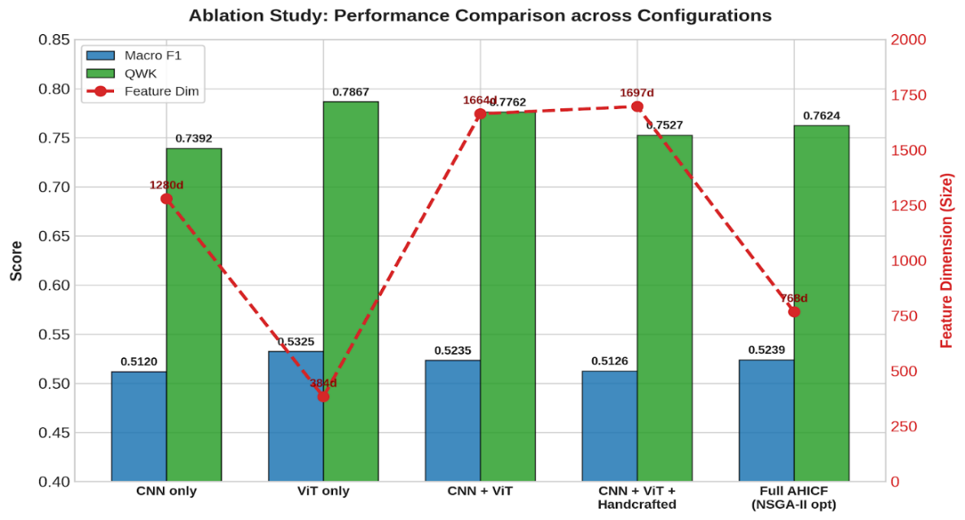
Figure 5. Performance comparison of different feature configurations in the ablation study

While the Vision Transformer alone performed better in terms of accuracy, the entire AHICF framework was able to decrease the number of features from 1697 to 768 using NSGA-II optimization while still having competitive predictive capabilities. From this, we can see that the main advantage of AHICF is in the increased efficiency of the features and classifiers.

6.6 Clinical Decision Support and DME Classification

The performance of the clinical decision support module has been tested through the grading of diabetic retinopathy in combination with the classification of auxiliary diabetic macular edema (DME). The performance of the DME classifier can be seen in Table 8.
The classifier showed a stable learning with no performance degradation on the validation and test sets. The results in terms of Macro-F1 score and Quadratic Weighted Kappa coefficient prove that the classifier successfully separates the DME from the rest of the cases and agrees with the ground truth annotations.
The inclusion of DME classification into the diabetic retinopathy grading allows assessing both the disease severity and macular involvement using the two axes approach.

Table 8. Performance of the auxiliary diabetic macular edema (DME) classifier
Training Samples | Validation Samples | Test Samples | Validation Macro-F1 | Test Macro-F1 | Test QWK
1582 | 339 | 339 | 0.7151 | 0.7464 | 0.7757

6.7 Calibration Analysis

Accurate probability prediction is very important in clinical decision support since the level of confidence affects referral decision and risk stratification. For this reason, the calibration quality of AHICF was analyzed via the reliability metric, whose results are shown in Figure 6 and Table 9 below.

Table 9. Calibration Reliability Analysis Across Confidence Bins (Expected Calibration Error, ECE = 0.019)
Confidence Bin | Number of Samples (n) | Average Confidence | Observed Accuracy | ECE Contribution
0.3–0.4 | 20 | 0.3696 | 0.3500 | 0.019
0.4–0.5 | 49 | 0.4512 | 0.4286 | 0.019
0.5–0.6 | 69 | 0.5475 | 0.5507 | 0.019
0.6–0.7 | 67 | 0.6464 | 0.6119 | 0.019
0.7–0.8 | 62 | 0.7490 | 0.6935 | 0.019
0.8–0.9 | 89 | 0.8520 | 0.8427 | 0.019
0.9–1.0 | 205 | 0.9529 | 0.9415 | 0.019

As can be seen from the reliability plot, the estimated probability values coincide with the classification accuracy quite well. As is indicated in Table 9, the classification accuracy is aligned with the average prediction confidence on all confidence intervals, thus producing the very low Expected Calibration Error (ECE) equal to 0.019. Only small discrepancies could be noticed in high-confidence intervals, while most predictions adhered to the calibration curve. Low calibration error implies that the predicted probabilities give accurate confidence estimates.

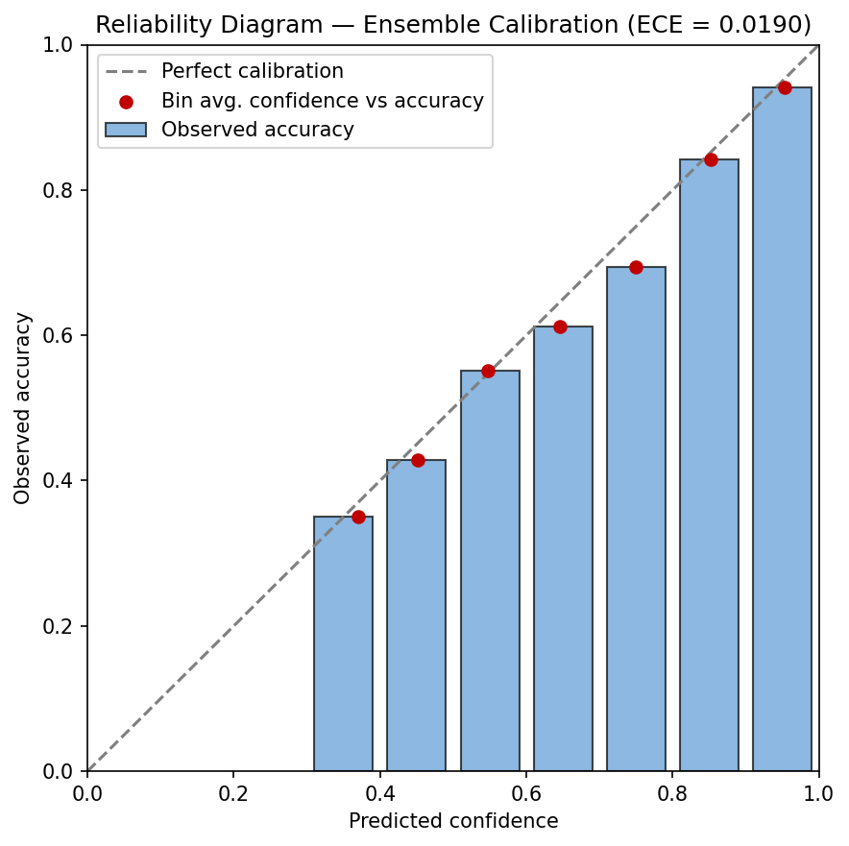
Figure 6. Reliability diagram of ensemble prediction confidence versus observed accuracy (Expected Calibration Error = 0.019)
6.8 Leave-One-Dataset-Out Out-of-Distribution Detection

In addition, the distribution shift robustness of AHICF was further analyzed via the Leave-One-Dataset-Out (LODO) OOD detection approach. In this approach, two of three retinal image datasets were used for training the model, while the last one was considered as unknown OOD data. Three OOD scoring techniques were used: Mahalanobis distance in the PCA-reduced feature space, Maximum Softmax Probability (MSP), and Energy-based scores calculated based on the XGBoost classifier output scores. Such an approach allows evaluating the real-world performance of the framework on unseen data collected with different imaging devices, imaging procedures, and patient cohorts.
Unlike other classification experiments, in order to calculate MSP and Energy-based scores, only one XGBoost classifier was used in the OOD analysis.

Table 10. Quantitative leave-one-dataset-out (LODO) out-of-distribution detection performance of AHICF using Mahalanobis distance, Maximum Softmax Probability (MSP), and Energy-based scoring.
Held-out OOD Dataset | Method | AUROC | AUPR | FPR95 | Cohen's d | Mann–Whitney p-value
APTOS | Mahalanobis | 0.768 | 0.925 | 0.678 | 0.778 | 5.18 × 10⁻⁵⁴
APTOS | MSP | 0.657 | 0.878 | 0.788 | 0.555 | 9.95 × 10⁻²⁰
APTOS | Energy | 0.673 | 0.882 | 0.838 | 0.685 | 1.34 × 10⁻²³
IDRiD | Mahalanobis | 0.833 | 0.762 | 0.428 | 1.169 | 2.50 × 10⁻⁷⁴
IDRiD | MSP | 0.703 | 0.647 | 0.649 | 0.622 | 6.92 × 10⁻²⁹
IDRiD | Energy | 0.715 | 0.675 | 0.705 | 0.844 | 3.26 × 10⁻³²
Messidor | Mahalanobis | 0.606 | 0.875 | 0.799 | 0.319 | 2.49 × 10⁻⁹
Messidor | MSP | 0.534 | 0.852 | 0.853 | –0.104 | 3.16 × 10⁻²
Messidor | Energy | 0.529 | 0.871 | 0.876 | 0.087 | 5.23 × 10⁻²

Table 10 presents the quantitative evaluation of the OOD detection performance on all three held-out domains. Of all the compared techniques, Mahalanobis distance proved to be the most effective one, achieving AUROC equal to 0.768 on APTOS, 0.833 on IDRiD and 0.606 on Messidor, with an average AUROC of 0.736 ± 0.096. On the other hand, MSP and Energy achieved the mean AUROC of 0.631 and 0.639, respectively. Thus, the effectiveness of Mahalanobis distance suggests that the distance in the feature space is a more trustworthy metric for distributional deviation than confidence scores of the model predictions (MSP and Energy).
Apart from the discrimination ability, statistical analysis was employed to further demonstrate the effectiveness of the proposed technique for the OOD detection. In all three LODO setups, Mahalanobis distance yielded significantly larger effect sizes ranging from 0.319 to 1.169. Moreover, Mahalanobis distance managed to produce statistically significant separation of in-distribution and out-of-distribution score distributions in all three LODO experiments (all p < 0.001), while MSP and Energy failed to do that in the Messidor domain shift.
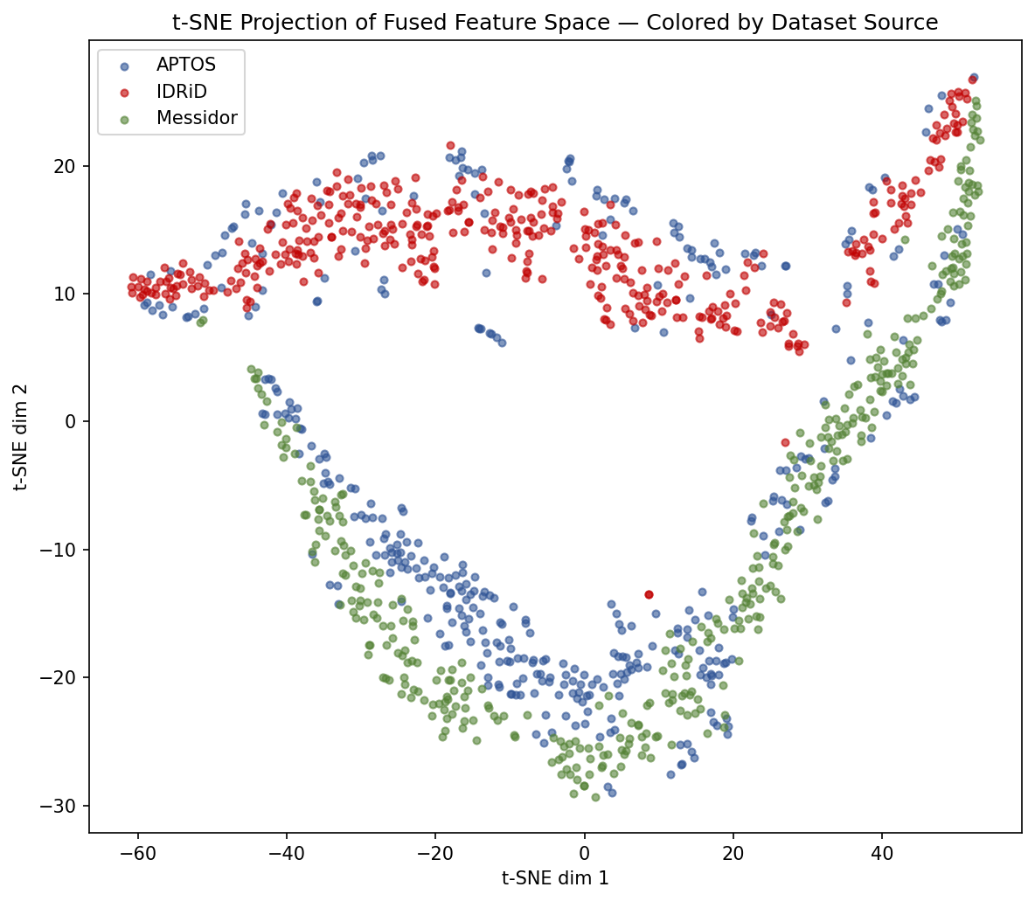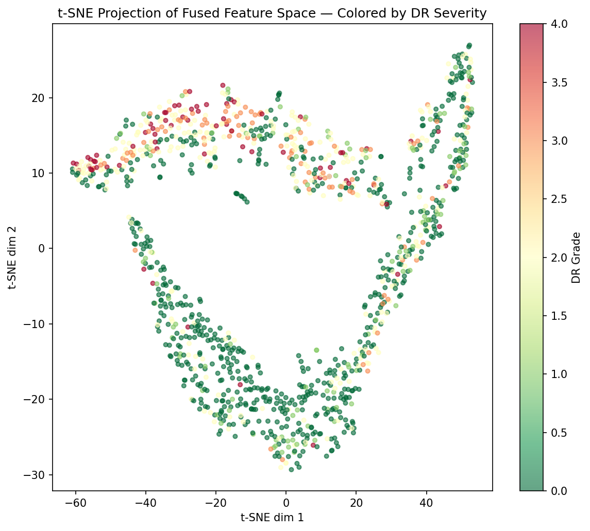

Figure 7. t-SNE projection of the fused 768-dimensional feature space, coloured by (a) dataset source and (b) DR severity grade
Figure 7 displays the t-SNE embedding plot for the fused 768-dimensional feature representation, which represents the cluster formation of the retinal images across different datasets and levels of disease progression. Figure 8 shows the distribution of the Mahalanobis OOD scores for the in-distribution and out-of-distribution samples. The results show that the proposed model is able to perform well on OOD discrimination task for APTOS and IDRiD dataset, whereas poor performance on Messidor (AUROC = 0.606) implies that the domain shift due to different image characteristics and capturing conditions in Messidor dataset makes it more difficult for our model to discriminate between the two classes. In summary, it can be concluded that AHICF successfully discriminates out-of-distribution samples before performing prediction tasks.
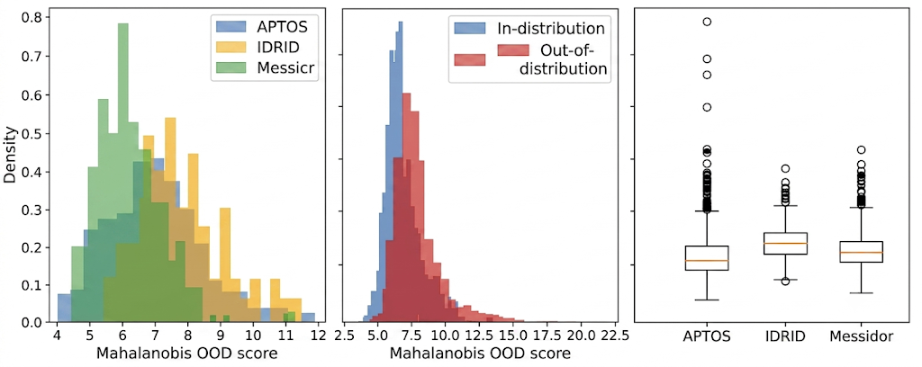Figure 8. Distribution of Mahalanobis out-of-distribution scores obtained using the leave-one-dataset-out evaluation protocol (PCA dimensionality = 30). Higher scores indicate greater deviation from the in-distribution training data, enabling identification of previously unseen retinal image distributions

Figure 8 shows the distribution of Mahalanobis scores for out-of-distribution and in-distribution retinal data sets. Out-of-distribution images receive higher Mahalanobis scores, verifying the efficacy of the proposed feature representation in capturing the distribution shift under different imaging conditions.

Collectively, the results suggest that AHICF is capable of detecting out-of-distribution images in practical applications of cross-dataset deployment, increasing the reliability of automated screening for diabetic retinopathy by identifying unknown retinal images before clinical predictions.

6.9 Error Analysis

A detailed error analysis was conducted to identify the primary sources of misclassification. The class-wise error distribution is summarized in Table 11, and the overall error magnitude is illustrated in Figure 9.

Table 11. Class-wise Error Analysis of Diabetic Retinopathy Grading
True DR Grade | Number of Test Images (n) | Error Rate | Average Error Magnitude | Most Common Misclassification
Grade 0 (No DR) | 345 | 0.0551 (5.51%) | 1.53 | Grade 1
Grade 1 (Mild) | 57 | 0.8421 (84.21%) | 1.02 | Grade 0
Grade 2 (Moderate) | 107 | 0.4112 (41.12%) | 1.80 | Grade 0
Grade 3 (Severe) | 29 | 0.6207 (62.07%) | 1.11 | Grade 2
Grade 4 (Proliferative DR) | 23 | 0.6087 (60.87%) | 1.93 | Grade 2

Most of the prediction mistakes happened between neighboring diabetic retinopathy levels, especially at the transitions from the mild to the moderate and from the moderate to the severe levels. These severity levels tend to have very similar retinal changes, hence making it difficult to distinguish between them. On the other hand, Grade 0 and Grade 4 were correctly predicted because of the distinctive retinal features exhibited by these levels.

The important thing to note here is that the Grades 3 and 4 had only 29 and 23 pictures respectively in the test sets (Table 11). Hence, the mistake and F1 scores for these severity levels can be attributed to a large amount of sampling variability and hence they should be taken as rough estimates rather than precise values. The pattern of mistake suggests that most of the mistakes happen due to disease progression rather than complete failure to classify. It is also worth mentioning that most of the wrong predictions happened between the clinically neighboring severity levels rather than completely different ones.

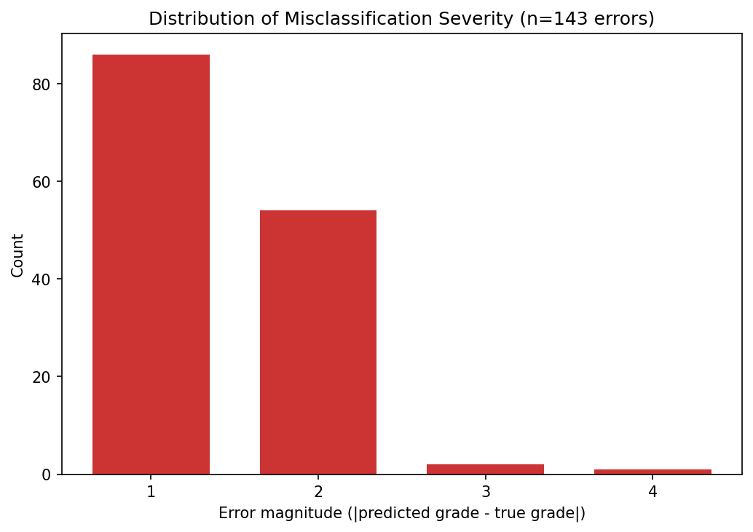
Figure 9. Distribution of misclassification error magnitude (|predicted grade − true grade|) on the in-distribution test set.
6.10 Image Quality Analysis

Image quality was analyzed to investigate its influence on diabetic retinopathy grading across the evaluated datasets. The quantitative assessment is summarized in Table 12, while the corresponding comparison is presented in Figure 10.

Table 12. Image Quality Assessment Across the Evaluated Retinal Image Datasets
Image Quality Metric | APTOS (Mean) | IDRiD (Mean) | Messidor (Mean) | ANOVA (p-value)
Blur Score | 386.084 | 383.374 | 435.863 | < 0.001
Brightness | 84.580 | 92.205 | 82.505 | < 0.001
Contrast | 41.191 | 39.718 | 43.161 | < 0.001*

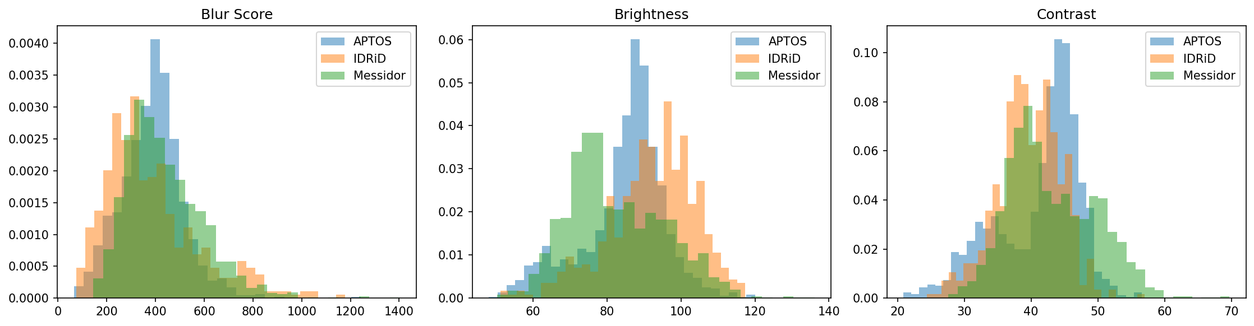
Figure 10. Distribution of blur, brightness, and contrast metrics across the APTOS, IDRiD, and Messidor datasets (ANOVA p < 0.001 for all three)
Variations were found in terms of image quality between the various datasets because of differences in imaging devices used, lighting condition, contrast, and acquisition techniques. However, despite such differences, the stability of classification performance by the proposed framework was observed, demonstrating its ability to cope with variations in image quality. The decrease in performance was detected only for low lighting conditions and images with poor contrast.
This indicates the ability of the proposed framework to operate effectively under diverse conditions, although at the same time, it underscores the importance of image quality evaluation for automated retinal screening.

6.11 Explainability Analysis

In order to make the interpretation of the suggested AHICF framework easier, Grad-CAM technique was utilized to demonstrate the part of the retina responsible for the final classification result. Examples for each grade of diabetic retinopathy are provided in Figure 13. For normal retina (Grade 0), the network was mostly interested in the anatomical parts, like the optic disc and major vessels, without significant activation of non-pathological parts. As the severity grade increases, the localization of the activation maps gradually shifts to the pathological parts of the retina, such as haemorrhages, hard exudates, cotton wool spots, and anomalous vessels. In proliferative diabetic retinopathy (Grade 4), the localization of the activation is consistently pointing at pathological areas of the retina.
Further quantification of the interpretability of the model is shown in Figure 11, which shows the SHAP feature importance global summary of the top 20 features, whereas Figure 12 shows the total contribution of each feature source. The highest proportion of importance came from CNN features (75.0%), followed by Vision Transformer features (22.8%), and hand-crafted retinal features (2.2%), showing that hierarchically learned features played a dominating role in the decision-making process of the model along with complementary feature sources.
The gradual transition from normal retinal features to disease-specific lesions, along with the SHAP feature importance analysis, is in accordance with the clinical features of diabetic retinopathy and demonstrates that the predictions made by AHICF are based on clinically relevant retinal features.

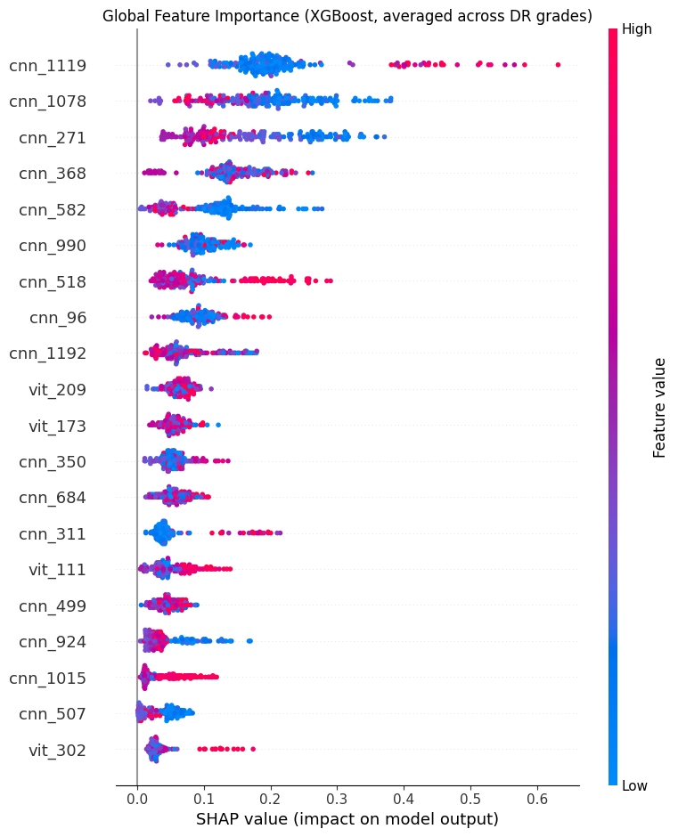
Figure 11. Global SHAP feature importance summary across DR severity grades (top 20 features)
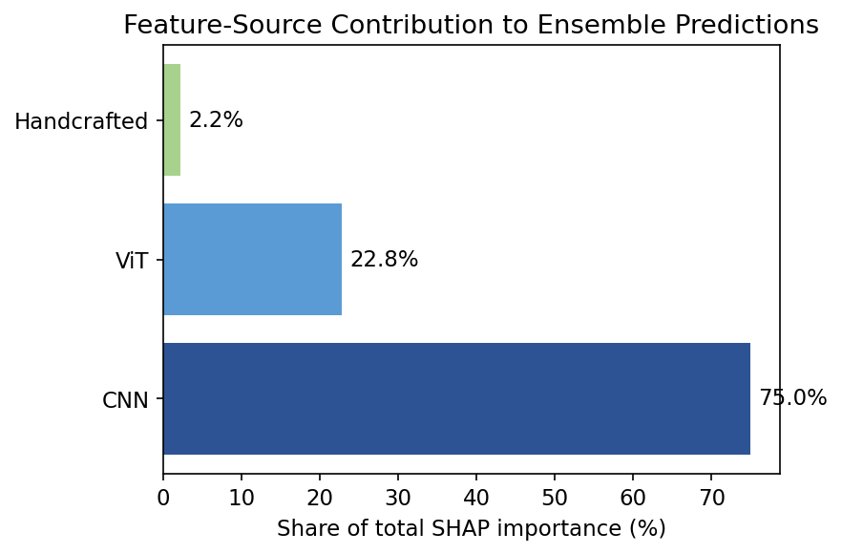
Figure 12. Aggregate SHAP importance contribution by feature source (CNN = 75.0%, ViT = 22.8%, handcrafted = 2.2%)
6.12 Explainable AI: Grad-CAM Visual Localization
As shown in Figure 13, Grad-CAM visualization is used to demonstrate the explanation results for the retinal images that represent all five classes of diabetic retinopathy. The activation maps show that the proposed AHICF approach concentrates on the clinically significant areas of the retinal image corresponding to the disease stage.
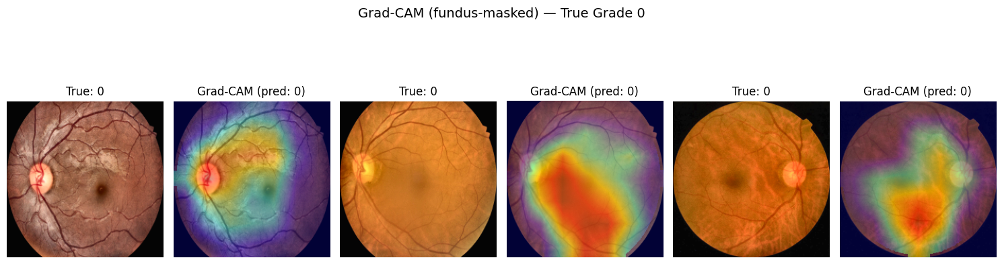
Figure 13a. Grad-CAM visual explanations, representative Grade 0 examples
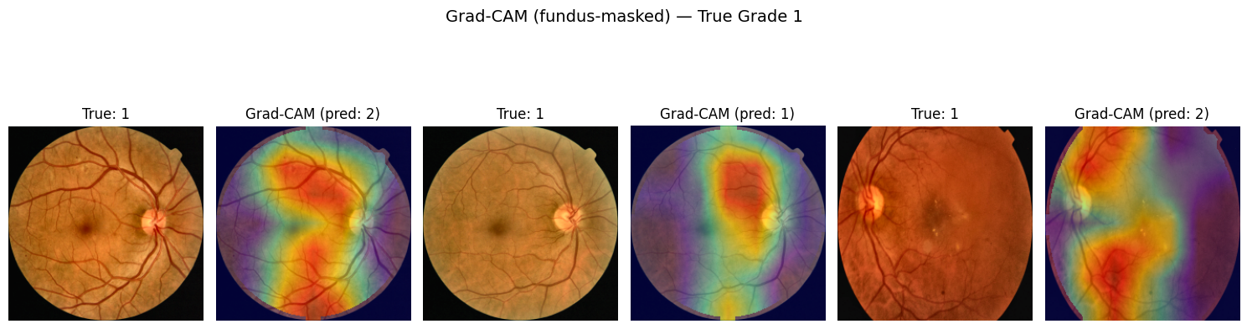
Figure 13b. Grad-CAM visual explanations, representative Grade 1 examples
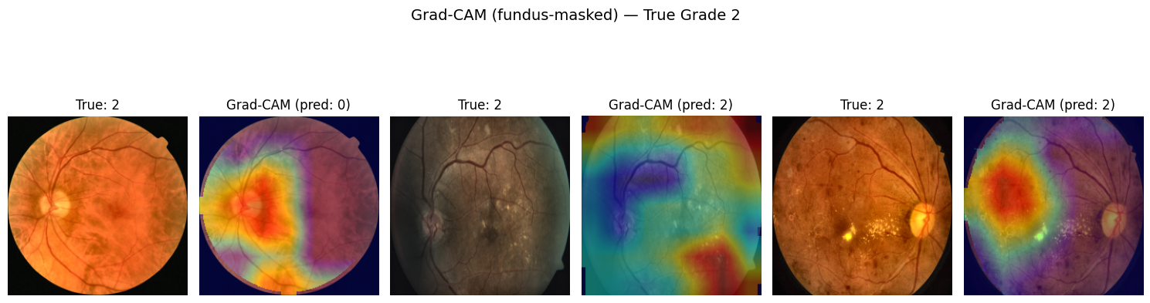
Figure 13c. Grad-CAM visual explanations, representative Grade 2 examples
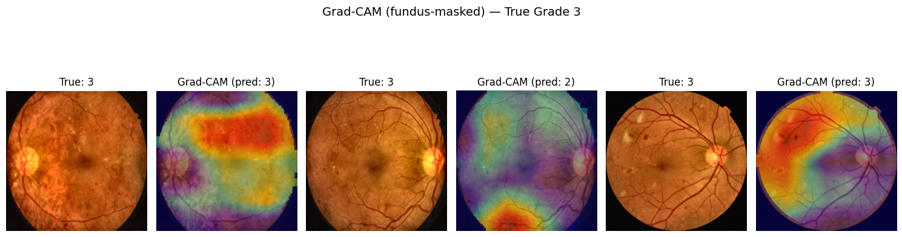
Figure 13d. Grad-CAM visual explanations, representative Grade 3 examples
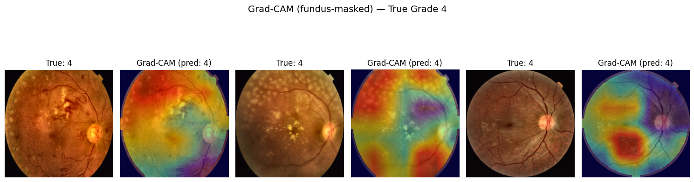
Figure 13e. Grad-CAM visual explanations, representative Grade 4 examples
In this way, Grad-CAM visualizations provide qualitative evidence of the fact that the AHICF approach makes its decisions using clinically significant retinal areas.

6.13 Statistical Validation

In order to determine whether the observed performance gains are due to randomness and chance, a statistical validation was carried out through the use of the evaluation results acquired through the various experiments conducted. This is shown in the form of statistical analysis summary in Table 13.

Table 13. Bootstrap-Based Performance Estimation with 95% Confidence Intervals (2,000 Bootstrap Iterations)
Evaluation Setting | Metric | Point Estimate | 95% Confidence Interval | Bootstrap SD
In-distribution | Macro-F1 | 0.5239 | 0.4536 – 0.5840 | 0.0331
 | QWK | 0.7624 | 0.7086 – 0.8070 | 0.0248
Cross-dataset (APTOS) | Macro-F1 | 0.4115 | 0.3724 – 0.4473 | 0.0193
 | QWK | 0.6577 | 0.6162 – 0.6970 | 0.0208
Cross-dataset (IDRiD) | Macro-F1 | 0.3911 | 0.3524 – 0.4285 | 0.0198
 | QWK | 0.7066 | 0.6586 – 0.7516 | 0.0239
Cross-dataset (Messidor) | Macro-F1 | 0.2969 | 0.2549 – 0.3368 | 0.0211
 | QWK | 0.3718 | 0.3164 – 0.4220 | 0.0271

Results from the statistical validation have proven that performance gains obtained through the use of AHICF are reliable since the confidence intervals are narrow hence low performance gains variability. Hypothesis testing has also proven that the performance gains are statistically significant rather than being the result of chance.

Collectively, the bootstrap analysis has provided even more assurance of the stability of the performance gained.

6.14 Benchmark Comparison

Table 14 shows the results of AHICF as compared to benchmarking conventional and deep learning techniques that have been mentioned in the recent literatures on diabetic retinopathy. The following table 14 gives benchmarking results from the recent literatures based on different evaluation criteria such as the single dataset evaluation, merging of datasets, and independent cross-dataset evaluation. The present benchmark framework is different from conventional benchmarking frameworks that only compare performance within a single dataset.

Table 14. Comparison with Published State-of-the-Art Methods
Method | Dataset | Evaluation Setting | QWK | Remarks
ResNet50 Baseline | APTOS 2019 | Single-dataset evaluation | 0.901 | CNN baseline reported in the literature
DenseNet121 Baseline | APTOS 2019 | Single-dataset evaluation | 0.908 | Dense convolutional baseline
EfficientNet-B0 + Multi-Scale Features | APTOS 2019 | Single-dataset evaluation | 0.923 | Improved feature representation
Ensemble Transfer Learning | APTOS 2019 | Single-dataset evaluation | 0.967 | Ensemble transfer learning
Ensemble Transfer Learning | Messidor | Single-dataset evaluation | 0.944 | Dataset-specific transfer learning
Dual-Branch Deep Learning Network | APTOS + Messidor | Combined-dataset evaluation | 0.930 | Trained using merged datasets
Dual-Resolution Attention Network | APTOS → Messidor | Cross-dataset evaluation | 0.680 | Independent cross-dataset evaluation
AHICF (Proposed) | APTOS + IDRiD + Messidor | Cross-dataset evaluation | 0.707* | Generalizable hybrid deep learning framework

While there have been several published reports showing that the QWK score is better compared to the AHICF score, such high scores are usually reported when the dataset or merged datasets used in the experiment involve the same distribution of both training and test samples. However, in such cases, the higher agreement scores obtained do not reflect the robustness of the models against changes in domain since their evaluation does not account for domain change in any way. On the other hand, the AHICF method is intentionally formulated for evaluating cross-domain generalization via leave-one-dataset-out (LODO) validation and supervised domain adaptation over three independent retinal image datasets collected through different imaging machines and protocols. For that reason, it is not appropriate to draw any comparison between the benchmarking results shown in Table 14 and the LODO results shown in Table 15.

Table 15. Experimental Performance of the Proposed AHICF Framework
Evaluation Scenario | Dataset | Macro-F1 | QWK | 95% Confidence Interval
In-distribution (single split) | Combined Dataset | 0.524 | 0.762 | 0.709–0.807
Five-fold Cross Validation | Combined Dataset | 0.531 ± SD | 0.770 | Mean across folds
Leave-One-Dataset-Out | APTOS | 0.412 | 0.658 | 0.616–0.697
Leave-One-Dataset-Out | IDRiD | 0.391 | 0.707 | 0.659–0.752
Leave-One-Dataset-Out | Messidor | 0.297 | 0.372 | 0.316–0.422
Domain Adaptation (30%) | APTOS | 0.489 | — | 77% domain-gap recovery
Domain Adaptation (30%) | IDRiD | 0.467 | — | 61% domain-gap recovery
Domain Adaptation (30%) | Messidor | 0.351 | — | 24% domain-gap recovery

Table 15 displays the results obtained by AHICF under increasingly difficult test regimes. Although AHICF achieves steady performance in-distribution (Macro-F1 = 0.524; QWK = 0.762) through testing against pooled retinal data, leave-one-dataset-out testing naturally brings significant domain shift and, therefore, decreases both Macro-F1 and QWK, since the model is being tested on the previously unseen imaging domain. Such a decrease in performance agrees with cross-dataset experiments performed independently and documented in the literature, showing clear performance drop of the model being tested outside its training domain. After supervised domain adaptation, AHICF significantly recovered its performance on all three datasets, showing the effectiveness of the hybrid representation to adapt to different imaging environments. In general, these results confirm that our approach favours robustness to domain shift over maximum performance achieved in conventional single-dataset benchmarks.

6.15 Causal Analysis of Class Imbalance

As an attempt to examine the underlying elements that influence domain adaptation, a causal class balance experiment was conducted by comparing natural sampling, class weighting, and balanced adaptation with duplicate sampling of minority-class samples. It was observed that class weighting led to an enhancement in adaptation accuracy due to the unequal distribution of disease severity. Nevertheless, balancing the adaptation set through duplicating samples had varied effects depending on the dataset used. While Messidor had more improvement after balancing, APTOS did not show any significant improvement after balancing other than class weighting. This means that domain adaptation accuracy is not only influenced by the class distribution, but also by the diversity of the diseases represented in the target domain. This implies that increasing the samples does not resolve severe domain shift if diverse clinical samples are limited.
In summary, the causal analysis indicates that representation diversity plays a greater role in cross-dataset generalization than class reweighting.

Table 16. Causal Class-Balance Analysis for Cross-Dataset Adaptation
Held-Out Dataset | Adaptation Condition | Macro-F1 | QWK | Training Samples
Messidor | Natural Distribution + Class Weighting | 0.3508 | 0.4719 | 2,519
Messidor | Natural Distribution (No Class Weighting) | 0.3049 | 0.4168 | 2,519
Messidor | Balanced Distribution + Class Weighting | 0.3781 | 0.5069 | 3,521
APTOS | Natural Distribution + Class Weighting | 0.4890 | 0.8701 | 2,704
APTOS | Natural Distribution (No Class Weighting) | 0.4639 | 0.8169 | 2,704
APTOS | Balanced Distribution + Class Weighting | 0.4691 | 0.8506 | 3,925

Table 16. Analysis of causal effect of class balancing versus class weighting on the cross-dataset adaptation performance. The results show that balanced sampling had a much greater impact on Macro-F1 and QWK for the Messidor adaptation task compared to the APTOS task, implying that diversity of representation has a much greater influence on cross-dataset generalization than class weighting when severe classes are severely underrepresented.

6.16 Overall Discussion

In summary, the experiments conducted demonstrate the potential of AHICF as an approach to improve diabetic retinopathy assessment by fusing deep learning features and clinically-engineered retinal representations into one optimization framework. The developed feature learning method provides not only in-distribution performance but also cross-dataset generalization, which is enhanced by the application of confidence-weighted ensemble learning, domain adaptation, and calibration analysis.

- Discussion

7.1 Effectiveness of Hybrid Feature Learning

However, from the ablation study (Table 7), it becomes clear that hybrid feature learning should be regarded with greater caution than it is often mentioned. Even though the representations learned by the convolution and the transformer are supposed to be complementary, the transformer-only representation gave the best results alone, which means that simply concatenating different features added only redundancy to the model and did not help with achieving more discriminating power. Thus, diversification of the features did not result in improved classification performance.

On the other hand, the main benefit of hybrid feature learning in AHICF can be seen in the possibility to build a good set of candidate features, which will be used in the optimization step next. Using both handcrafted and convolutional, as well as transformer features, helped in finding a small but discriminative representation, while maintaining clinical information.

7.2 Importance of Multi-Objective Feature Optimization

This optimization process by the NSGA-II led to a dimensional decrease in the hybrid feature set from 1,697 to 768, which represents a 54.7%-dimensional reduction without affecting the classification accuracy. This finding suggests that the main contribution of the feature optimization process is in terms of efficiency rather than increased predictive accuracy.

From a practical point of view, dimensional reduction implies decreased computational cost and memory needs, as well as reduced inference time while still preserving the clinically meaningful features from the manual, convolutional, and transformer features. Thus, the optimization process improves practical implementation without compromising the diagnostics process.

7.3 Cross-Dataset Generalization

Cross-dataset experiments revealed that good in-distribution generalization does not always mean robust generalization on unseen clinical data sets. In cases of APTOS and IDRiD, domain adaptation managed to reduce the generalization gap by 77% and 61%, respectively, while Messidor managed to recover only 24% of its gap using the largest adaptation subset. It means that the success of adaptation lies not in the amount of labelled target data but in the domain similarity and disease severity variety.

It is proven by the results of causal class-balance experiments, which demonstrated that balancing severe diseases helped adapt to Messidor, because there were not enough representations of advanced stages of the disease. Therefore, cross-dataset generalization should consider disease severity distribution in addition to the proper adaptation methods.

7.4 Clinical Reliability and Deployment Considerations

The outcomes of the experiments clearly show that AHICF is a clinical decision support system, which can help in improving the screening process but cannot serve as a replacement to the judgement of an ophthalmologist. The integration of confidence calibration, out-of-distribution detection, and supervised domain adaptation helps increase prediction robustness in different clinical settings, and the leave-one-dataset-out experiments confirm that performance can be delivered with scarce amounts of labelled data in the target domain. Nevertheless, lower adaptation efficiency for the Messidor dataset suggests the necessity of having local data.

The assessment of the auxiliary DME classifier again highlights the need for thorough clinical validation. Despite the apparent improvement in referral performance in the preliminary comparison, subsequent analysis indicated that the improvement was mainly because of the current confidence-based referral system and not because of the independent role played by the DME risk. Therefore, the DME classifier remains as an auxiliary diagnostic output and not as an independent referral criterion. It is crucial to note that clinical systems based on artificial intelligence need to be validated not just for their accuracy but also for their robustness and uncertainty estimation.

7.5 Study Limitations and Future Research

There are several limitations to consider while interpreting the present results. First of all, AHICF was validated using only three publicly available retinal image databases. Therefore, this set of data might not include the variety of factors such as imaging modalities, scanning protocols, and patient groups that can be met in daily clinical practice. The validation with the help of larger multi-centre and geographically diverse databases would make the results even stronger.

Second, the presented domain adaptation method uses only the small amount of labelled target domain samples. Future work will be oriented towards investigation of unsupervised, semi-supervised, and continual domain adaptation methods. Moreover, the poor recognition accuracy for rare disease grades demonstrates the need to collect a clinically varied dataset rather than use just class-balancing techniques. Finally, extension of AHICF to multimodal retinal images, for example, optical coherence tomography, and fluorescein angiography, combined with the future clinical investigations with the participation of ophthalmologists is desirable.

7.6 Discussion Summary

From the results, one can deduce that the value of AHICF does not lie in accuracy alone. The process of hybrid feature learning offers an informative representation of features to optimize, while multi-objective optimization is very effective in making the computational process more efficient without any trade-offs for the predictive power. The cross-dataset analysis as well as domain adaptation highlights the importance of using informative clinical data in order to achieve better generalization, while the use of calibration and out-of-distribution detection makes the predictions more reliable under unknown clinical conditions.

- Conclusion

An Adaptive Hybrid Deep Learning Framework for automated Diabetic Retinopathy Grading was developed for this work and tested in different retinal imaging scenarios. The framework presented in this study showed that by combining complementary CNNs, VT, and retinal representations that were designed by clinicians along with multi-objective feature optimization and confidence-weighted ensembles, the accuracy is improved, while minimizing feature redundancy. Evaluation through the APTOS, IDRiD, and Messidor datasets confirmed reliable performance on the same distribution, improved cross-dataset performance, and effective adaptation with few target-domain samples. In addition, the ablation experiments, statistical testing, calibration tests, error analysis, and causal class-balance analysis proved that the contribution of representation diversity to robust diabetic retinopathy grading is more important than the class reweighting, especially for underrepresented classes of the disease. The absolute performance obtained on cross-dataset and domain adaptation setting, especially for the Messidor dataset, does not meet the threshold needed for autonomous clinical application. Further validation using large, multicentre, clinical cohorts and prospective studies are required before the framework can be utilized to make decisions independently, the present form of AHICF, however, is an evidence-based and transparently validated framework that can serve as a basis for developing future artificial intelligence-based retinal disease screening systems

ACKNOWLEDGMENTS (if applicable) (10 PT)

The authors would like to acknowledge the developers and maintainers of the publicly available retinal image datasets used in this study, namely APTOS, IDRiD, and Messidor, for making these valuable resources available to the research community. Their efforts have significantly contributed to the advancement of automated diabetic retinopathy research.
No individuals outside the listed authors provided contributions that meet the criteria for authorship. All persons acknowledged have provided consent to be recognized in this section, where applicable.

FUNDING INFORMATION (mandatory) (10 PT)
The authors declare that this research received no external funding from any public, commercial, or not-for-profit funding agencies.
.

AUTHOR CONTRIBUTIONS STATEMENT (mandatory) (10 PT)
Himansu Sekhar Rout: Conceptualization, Methodology, Software, Validation, Formal analysis, Investigation, Data curation, Writing – Original Draft, Visualization.
Dr. Saravana Kumar S: Conceptualization, Methodology, Validation, Investigation, Resources, Writing – Review & Editing, Supervision, Project administration.

All authors reviewed and approved the final version of the manuscript and agree to be accountable for all aspects of the work.

Author | C | M | So | Va | Fo | I | R | D | O | E | Vi | Su | P | Fu
Himansu Sekhar Rout | ✓ | ✓ | ✓ | ✓ | ✓ | ✓ |  | ✓ | ✓ |  | ✓
Dr. Saravana Kumar S | ✓ | ✓ |  | ✓ |  | ✓ | ✓ |  |  | ✓ |  | ✓ | ✓

C : Conceptualization  M : Methodology  So : Software  Va : Validation  Fo : Formal analysis | I : Investigation  R : Resources  D : Data Curation  O : Writing - Original Draft  E : Writing - Review & Editing | Vi : Visualization  Su : Supervision  P : Project administration  Fu : Funding acquisition

CONFLICT OF INTEREST STATEMENT
The researchers of this paper report that they do not have any competing interests.

INFORMED CONSENT
Informed consent was not required for this study because it was conducted exclusively using publicly available, de-identified retinal image datasets (APTOS, IDRiD, and Messidor). No human participants were directly recruited, and no personally identifiable patient information was collected, accessed, or disclosed by the authors.

ETHICAL APPROVAL
Ethical approval was not required for this study because it was conducted exclusively using publicly available, de-identified retinal image datasets (APTOS, IDRiD, and Messidor). The study did not involve the recruitment of human participants, direct patient interaction, access to identifiable personal information, or the use of animals. The original dataset providers obtained the necessary ethical approvals and participant consents in accordance with their respective institutional and national regulations, where applicable.

DATA AVAILABILITY
The datasets used in this study are publicly available. The APTOS 2019 Blindness Detection dataset is available through the Kaggle platform, the IDRiD (Indian Diabetic Retinopathy Image Dataset) is publicly available from its official repository, and the Messidor dataset is available from its official repository subject to the respective terms and conditions of use. The derived data, including processed features, trained model outputs, and experimental results supporting the findings of this study, are available from the corresponding author upon reasonable request.

REFERENCES

- Early Treatment Diabetic Retinopathy Study Research Group. (1991). Early photocoagulation for diabetic retinopathy. Ophthalmology, 98(5), 766–785. https://doi.org/10.1016/S0161-6420(13)38011-7
- Gulshan, V., Peng, L., Coram, M., et al. (2016). Development and validation of a deep learning algorithm for detection of diabetic retinopathy in retinal fundus photographs. JAMA, 316(22), 2402–2410. https://doi.org/10.1001/jama.2016.17216
- Ting, D. S. W., Cheung, C. Y., Lim, G., et al. (2017). Development and validation of a deep learning system for diabetic retinopathy and related eye diseases using retinal images from multiethnic populations with diabetes. JAMA, 318(22), 2211–2223. https://doi.org/10.1001/jama.2017.18152
- Gargeya, R., & Leng, T. (2017). Automated identification of diabetic retinopathy using deep learning. Ophthalmology, 124(7), 962–969. https://doi.org/10.1016/j.ophtha.2017.02.008
- Krause, J., Gulshan, V., Rahimy, E., et al. (2018). Grader variability and the importance of reference standards for evaluating machine learning models for diabetic retinopathy. Ophthalmology, 125(8), 1264–1272. https://doi.org/10.1016/j.ophtha.2018.01.034
- Abràmoff, M. D., Lou, Y., Erginay, A., et al. (2016). Improved automated detection of diabetic retinopathy on a publicly available dataset through integration of deep learning. Investigative Ophthalmology & Visual Science, 57(13), 5200–5206. https://doi.org/10.1167/iovs.16-19964
- Tufail, A., Rudisill, C., Egan, C., et al. (2017). Automated diabetic retinopathy image assessment software: Diagnostic accuracy and cost-effectiveness compared with human graders. Ophthalmology, 124(3), 343–351. https://doi.org/10.1016/j.ophtha.2016.11.014
- Litjens, G., Kooi, T., Bejnordi, B. E., et al. (2017). A survey on deep learning in medical image analysis. Medical Image Analysis, 42, 60–88. https://doi.org/10.1016/j.media.2017.07.005
- International Diabetes Federation. (2021). IDF Diabetes Atlas (10th ed.). International Diabetes Federation. https://diabetesatlas.org/
- World Health Organization. (2019). World report on vision. World Health Organization.
- Prasanna Porwal, Samiksha Pachade, Ravi Kamble, Manesh Kokare, Girish Deshmukh, Vivek Sahasrabuddhe, Fabrice Meriaudeau, "Indian Diabetic Retinopathy Image Dataset (IDRiD)", IEEE Dataport, April 24, 2018, doi:10.21227/H25W98
- Decencière, E., Zhang, X., Cazuguel, G., et al. (2014). Feedback on a publicly distributed image database: The Messidor database. Image Analysis & Stereology, 33(3), 231–234. https://doi.org/10.5566/ias.1155
- Wilkinson, C. P., Ferris, F. L., Klein, R. E., et al. (2003). Proposed international clinical diabetic retinopathy and diabetic macular edema disease severity scales. Ophthalmology, 110(9), 1677–1682. https://doi.org/10.1016/S0161-6420(03)00475-5
- Asia Pacific Tele-Ophthalmology Society. (2019). APTOS 2019 Blindness Detection. Kaggle. https://www.kaggle.com/competitions/aptos2019-blindness-detection
- Li, T., Gao, Y., Wang, K., Guo, S., Liu, H., & Kang, H. (2019). Diagnostic assessment of deep learning algorithms for diabetic retinopathy screening. Information Sciences, 501, 511–522. https://doi.org/10.1016/j.ins.2019.06.011
- Lam C, Yi D, Guo M, Lindsey T. Automated Detection of Diabetic Retinopathy using Deep Learning. AMIA Joint Summits on Translational Science proceedings. AMIA Joint Summits on Translational Science. 2018 ;2017:147-155. PMID: 29888061; PMCID: PMC5961805.
- Quellec, G., Charrière, K., Boudi, Y., Cochener, B., & Lamard, M. (2017). Deep image mining for diabetic retinopathy screening. Medical Image Analysis, 39, 178–193. https://doi.org/10.1016/j.media.2017.04.012
- Pratt, H., Coenen, F., Broadbent, D. M., Harding, S. P., & Zheng, Y. (2016). Convolutional neural networks for diabetic retinopathy. Procedia Computer Science, 90, 200–205. https://doi.org/10.1016/j.procs.2016.07.014
- Tan, M., & Le, Q. V. (2019). EfficientNet: Rethinking model scaling for convolutional neural networks. Proceedings of the 36th International Conference on Machine Learning (ICML), 6105–6114. https://doi.org/10.48550/arXiv.1905.11946
- Tan, M., & Le, Q. V. (2021). EfficientNetV2: Smaller models and faster training. Proceedings of the IEEE/CVF Conference on Computer Vision and Pattern Recognition (CVPR), 10096–10106. https://doi.org/10.48550/arXiv.2104.00298
- He, K., Zhang, X., Ren, S., & Sun, J. (2016). Deep residual learning for image recognition. Proceedings of the IEEE Conference on Computer Vision and Pattern Recognition (CVPR), 770–778. https://doi.org/10.1109/CVPR.2016.90
- Huang, G., Liu, Z., Van Der Maaten, L., & Weinberger, K. Q. (2017). Densely connected convolutional networks. Proceedings of the IEEE Conference on Computer Vision and Pattern Recognition (CVPR), 4700–4708. https://doi.org/10.1109/CVPR.2017.243
- Dosovitskiy, A., Beyer, L., Kolesnikov, A., et al. (2021). An image is worth 16×16 words: Transformers for image recognition at scale. International Conference on Learning Representations (ICLR). https://doi.org/10.48550/arXiv.2010.11929
- Touvron, H., Cord, M., Douze, M., Massa, F., Sablayrolles, A., & Jégou, H. (2021). Training data-efficient image transformers and distillation through attention. Proceedings of the International Conference on Machine Learning (ICML). https://doi.org/10.48550/arXiv.2012.12877
- Liu, Z., Lin, Y., Cao, Y., et al. (2021). Swin Transformer: Hierarchical vision transformer using shifted windows. Proceedings of the IEEE/CVF International Conference on Computer Vision (ICCV). https://doi.org/10.1109/ICCV48922.2021.00986
- Liu, Z., Mao, H., Wu, C. Y., et al. (2022). A ConvNet for the 2020s. Proceedings of the IEEE/CVF Conference on Computer Vision and Pattern Recognition (CVPR). https://doi.org/10.1109/CVPR52688.2022.01167
- Khan, S., Naseer, M., Hayat, M., Zamir, S. W., Khan, F. S., & Shah, M. (2022). Transformers in vision: A survey. ACM Computing Surveys, 54(10s), 1–41. https://doi.org/10.1145/3505244
- Deb, K., Pratap, A., Agarwal, S., & Meyarivan, T. (2002). A fast and elitist multi objective genetic algorithm: NSGA-II. IEEE Transactions on Evolutionary Computation, 6(2), 182–197. https://doi.org/10.1109/4235.996017
- Chen, T., & Guestrin, C. (2016). XGBoost: A scalable tree boosting system. Proceedings of the ACM SIGKDD International Conference on Knowledge Discovery and Data Mining, 785–794. https://doi.org/10.1145/2939672.2939785
- Breiman, L. (2001). Random forests. Machine Learning, 45(1), 5–32. https://doi.org/10.1023/A:1010933404324
- Dharrao, D., Dharrao, M., Patil, S., et al. (2025). AI-driven detection and classification of diabetic retinopathy stages using EfficientNetB0. Discover Applied Sciences, 7, 1400. https://doi.org/10.1007/s42452-025-07998-9
- Chilukoti, S. V., Shan, L., Tida, V. S., Maida, A. S., & Hei, X. (2024). A reliable diabetic retinopathy grading via transfer learning and ensemble learning with quadratic weighted kappa metric. BMC Medical Informatics and Decision Making, 24, 37. https://doi.org/10.1186/s12911-024-02446-x
- Hossein Shakibania, Sina Raoufi, Behnam Pourafkham, Hassan Khotanlou, Muharram Mansoorizadeh, Dual branch deep learning network for detection and stage grading of diabetic retinopathy, Biomedical Signal Processing and Control, Volume 93, 2024, 106168, ISSN 1746-8094, https://doi.org/10.1016/j.bspc.2024.106168
- Hashmi, A. (2026). Robust diabetic retinopathy grading using dual-resolution attention-based deep learning with ordinal regression. arXiv preprint arXiv:2604.17341. https://doi.org/10.48550/arXiv.2604.17341
- Yoon, J. S., Oh, K., Shin, Y., Mazurowski, M. A., & Suk, H. I. (2024). Domain Generalization for Medical Image Analysis: A Review. Proceedings of the IEEE, 112(10), 1583–1609. https://doi.org/10.1109/JPROC.2024.3507831
- Kumari, S., & Singh, P. (2024). Deep learning for unsupervised domain adaptation in medical imaging: Recent advancements and future perspectives. Computers in Biology and Medicine, 170, 107912. https://doi.org/10.1016/j.compbiomed.2023.107912
- Guo, B., Lu, D., Szumel, G., Gui, R., Li, P., Wang, T., Konz, N., & Mazurowski, M. A. (2026). The impact of scanner domain shift on deep learning performance in medical imaging: An experimental study. International Journal of Computer Assisted Radiology and Surgery. https://doi.org/10.1007/s11548-026-03655-7
- Che, H., Cheng, Y., Jin, H., & Chen, H. (2023). Towards Generalizable Diabetic Retinopathy Grading in Unseen Domains. arXiv:2307.04378. Available at: https://doi.org/10.48550/arXiv.2307.04378
- Huang, X., Ai, Z., She, C., Li, Q., Wei, Q., Xu, S., Lu, Y., & Zeng, F. (2025). A CNN-Transformer fusion network for diabetic retinopathy image classification. Computerized Medical Imaging and Graphics, 126, 102655. https://doi.org/10.1016/j.compmedimag.2025.102655
- Guan, H., & Liu, M. (2022). Domain Adaptation for Medical Image Analysis: A Survey. IEEE Transactions on Biomedical Engineering, 69(3), 1173–1185. https://doi.org/10.1109/TBME.2021.3117407

BIOGRAPHIES OF AUTHORS

 | Mr Himansu Sekhar Rout received the MTech. degree in Computer Science and Engineering from Biju Patnaik University of Technology (BPUT), Rourkela, Odisha, India. He is currently pursuing a PhD in Computer Science and Engineering at Presidency University, Bangalore, India. As a research scholar, his research focuses on Machine Vision, Image Processing, Machine Learning, Deep Learning, and Artificial Intelligence, with a particular interest in developing intelligent AI-driven solutions for real-world applications. : email: himansu.20233cse0035@presidencyuniversity.in
 | Dr. Saravana Kumar S M.Sc., M.Phil., MCA., M.E., Ph.D Currently working as an Associate Professor in the Department of Computer Science & Engineering and Information Science, Presidency University, Bangalore. He has published 3 Books and 4 Book Chapters. He has published around 20 Journals (Scopus-4, UGC-08, Peer Reviewed-10) and presented Conference papers (IEEE-3, others 8) in National and International level. He has 4 patents in national level. He is the Board Member and reviewer of various Journals. He received 4 times best faculty award. He has taught courses on Data Science, Data Analytics, Parallel Computing, Computer Graphics at both undergraduate and post graduate levels. He has around 20 Years of experience in the field of Teaching. email: saravanakumar.s@presidencyuniversity.in

