**PRACTICAL-7**

**QN1.** To display Emp_No, E_Name, Salary, Salary + Salary*15 label as New_salary. **Answer: -**

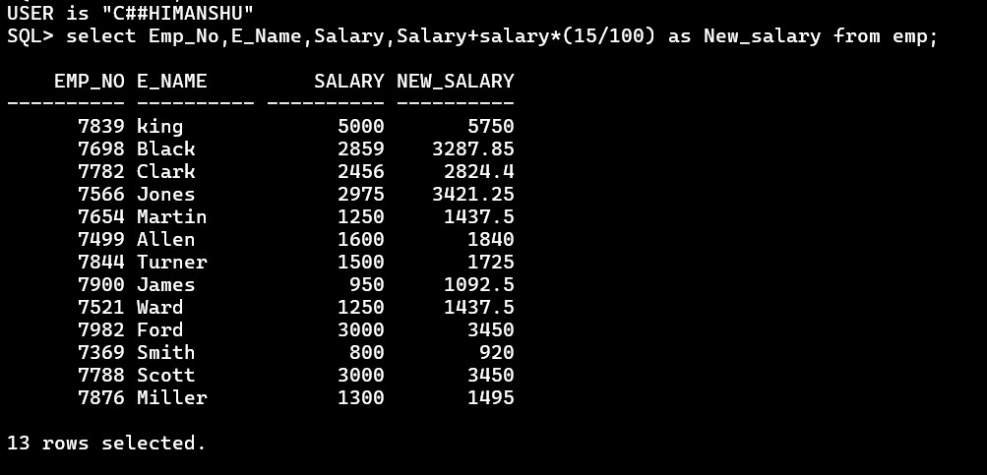

**QN2.** Display E_Name, Salary of the employee whose salary is greater than or equal to 3000. **Answer: -**

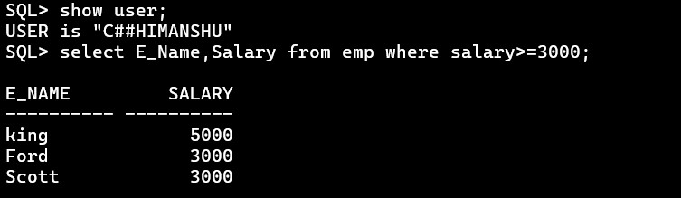

**QN3.** List the detail of employee who earn more commission than their salary.

**Answer: -**

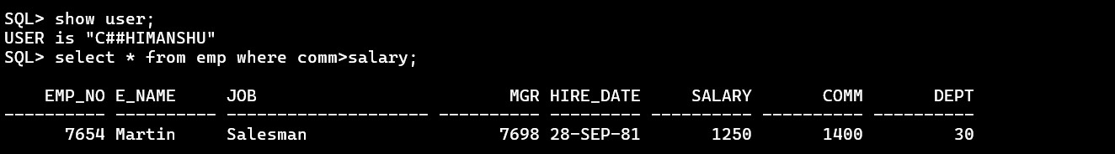

**QN4.** Display the details of all managers whose salary is less than 3000.

**Answer: -**

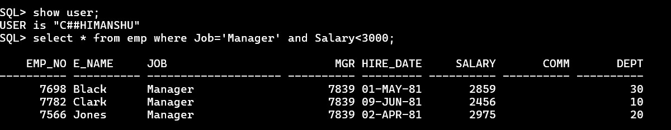

**QN5.** Display the Emp_No, E_Name, Job which don’t belong to any department. **Answer: -**

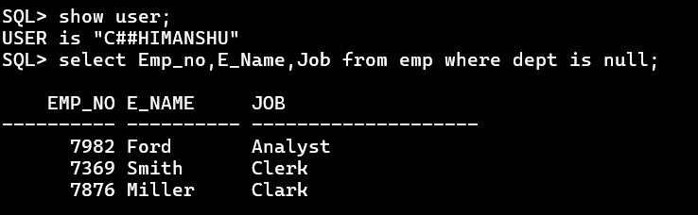

**QN6.** Display distinct dept from emp table.

**Answer: -**

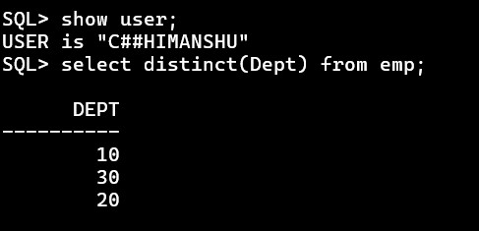

**QN7.** Display the details of employee who joint on 17-Nov-81.

**Answer: -**

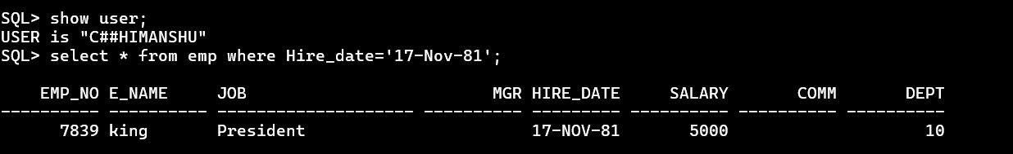

**QN8.**Display the detail of employee who are not getting any commission.

**Answer: -**

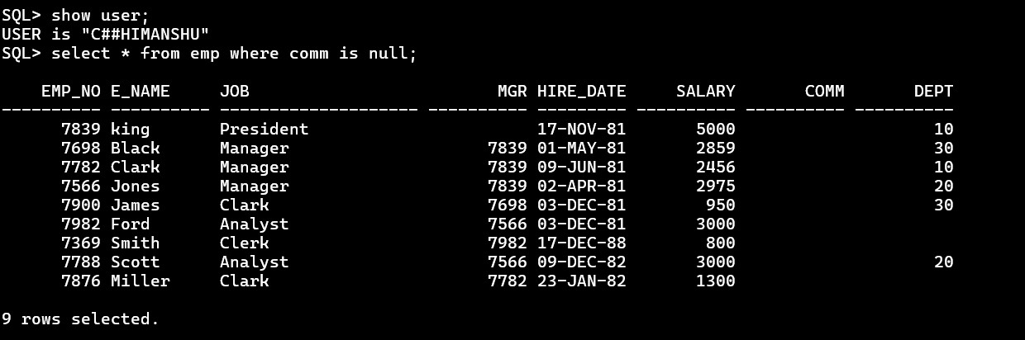

**QN9.** Display the detail of salesman.

**Answer: -**

