EXP:1 NETWORK DEVICES AD.NO:192211707 M.V.S.N.HIMA SAGAR

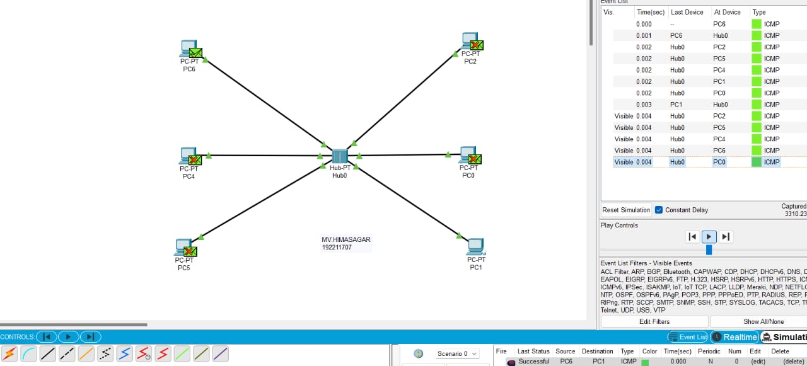

EXP:2 STAR TOPOLOGY

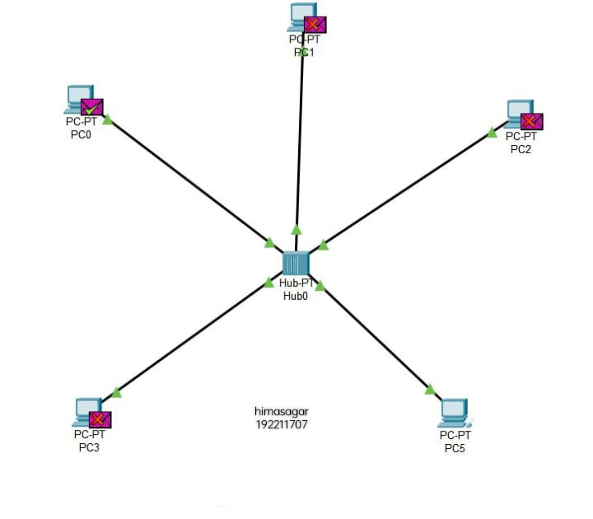

EXP:3 BUS TOPOLOGY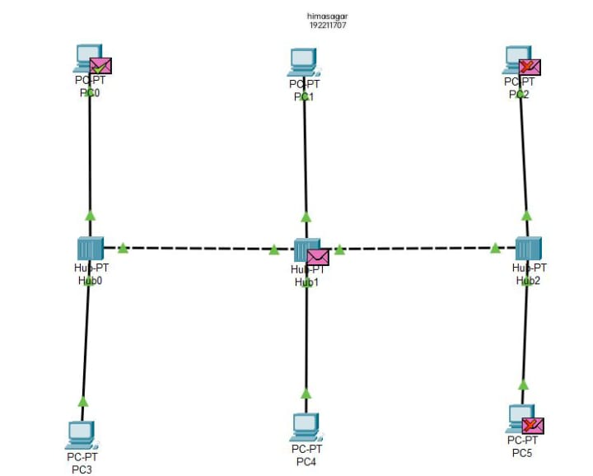

EXP:4 RING TOPOLOGY

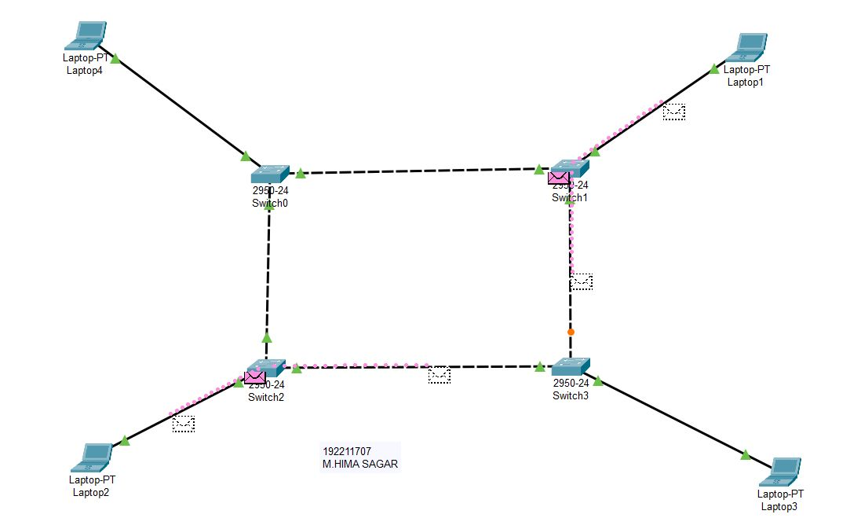

EXP:5 MESH TOPOLOGY

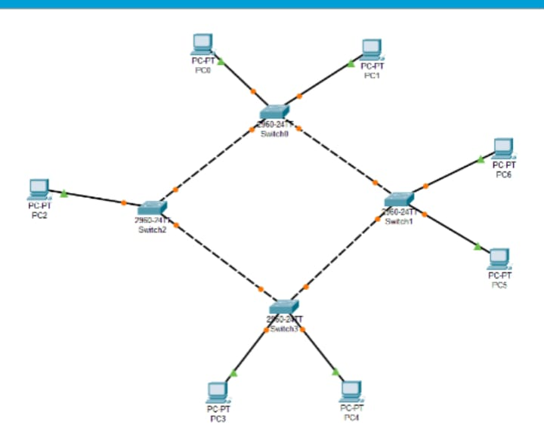

EXP:6 TREE TOPOLOGY

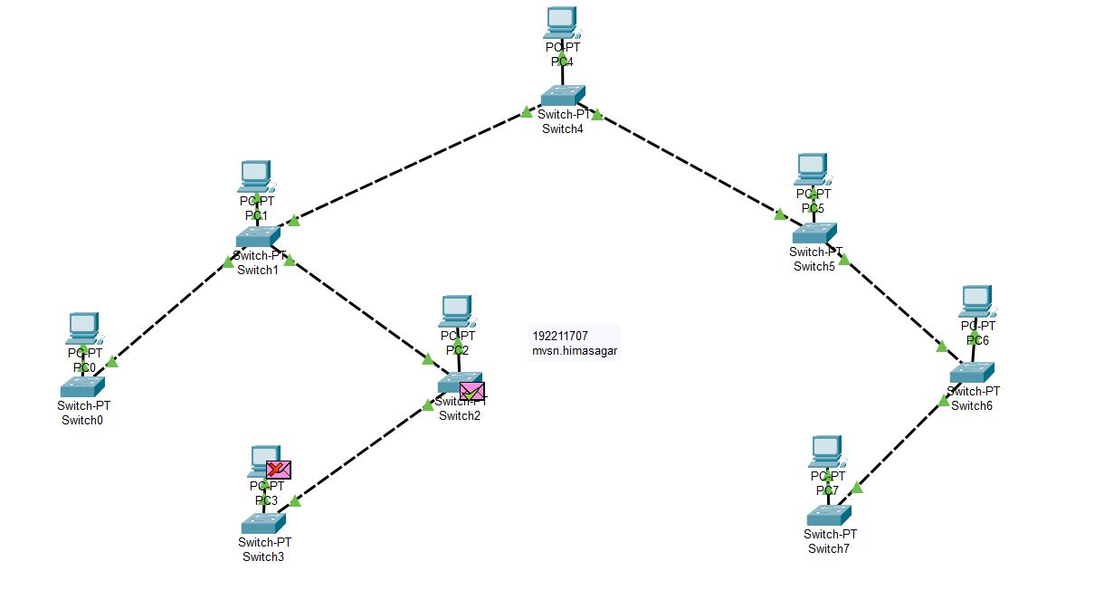

EXP:7 HYBRID TOPOLOGY

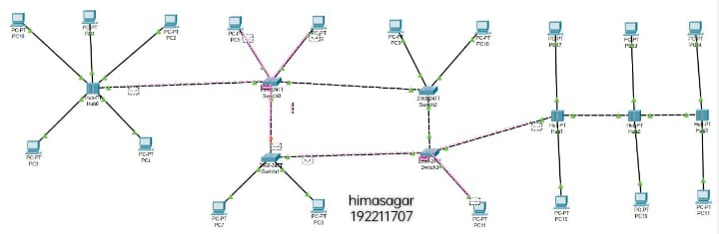

EXP:8 DATA LINK ARP

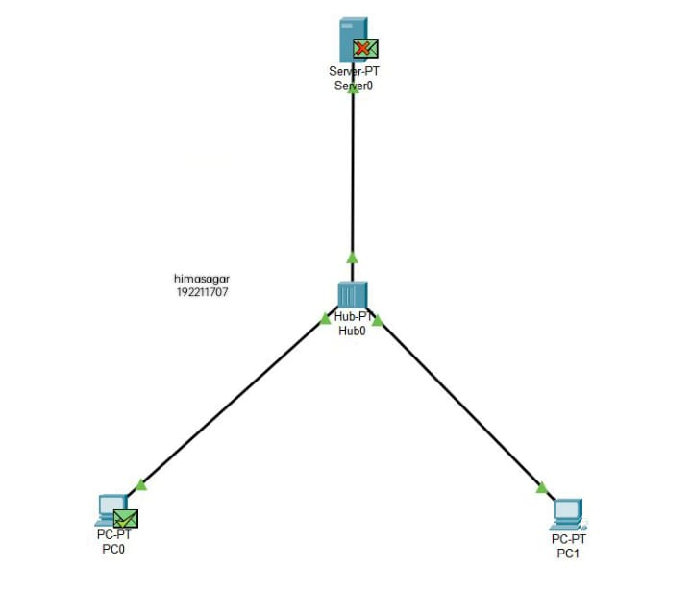

EXP:9 DATA LINK LLDP

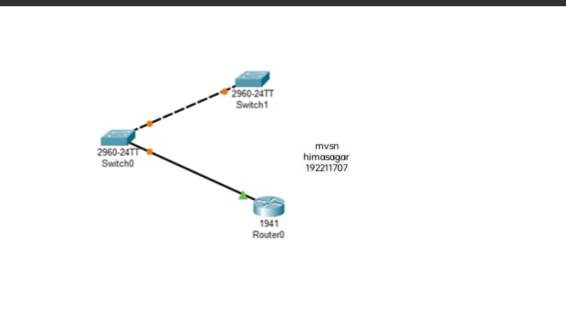

EXP:10 DATA CSMA

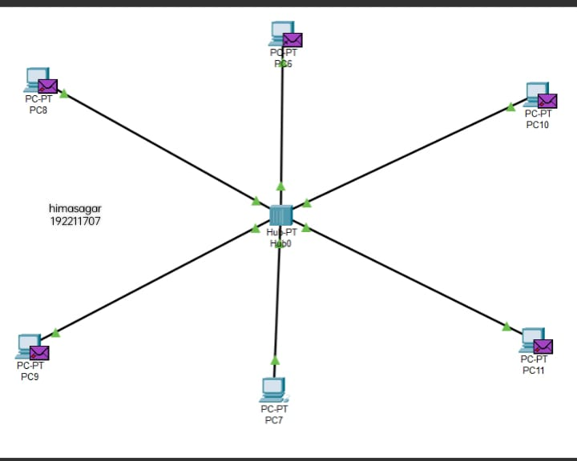

EXP:11 C PROGRAMME FOR BIT STUFFING

11. #include<stdio.h>

#include<string.h>

int main()

{

int a[20],b[30],i,j,k,count,n;

printf("Enter frame size (Example: 8):");

scanf("%d",&n);

printf("Enter the frame in the form of 0 and 1 :");

for(i=0; i<n; i++)

scanf("%d",&a[i]);

i=0;

count=1;

j=0;

while(i<n)

{

if(a[i]==1)

{

b[j]=a[i];

for(k=i+1; a[k]==1 && k<n && count<5; k++)

{

j++;

b[j]=a[k];

count++;

if(count==5)

{

j++;

b[j]=0;

}

i=k;

}

}

else

{

b[j]=a[i];

}

i++;

j++;

}

printf("After Bit Stuffing :");

for(i=0; i<j; i++)

printf("%d",b[i]);

return 0;

}

Enter frame size (Example: 8):12

Enter the frame in the form of 0 and 1 :0 1 0 1 1 1 1 1 1 0 0 1

After Bit Stuffing :0101111101001

EXP:12 STATIC ROUTING

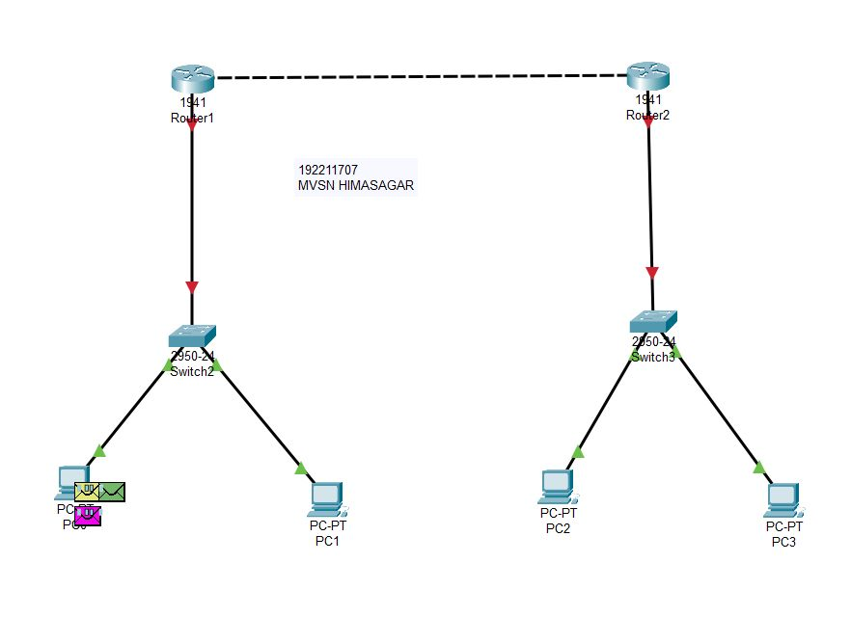

EXP:13 DYNAMIC ROUTING (OSPF)

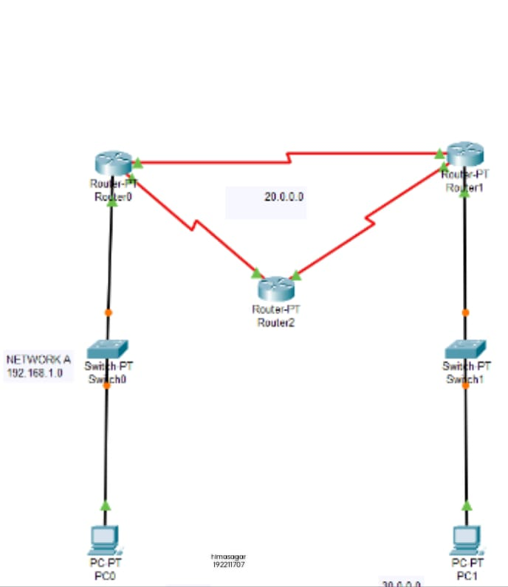

EXP:14 FUNCTIONALITIES OF TCP

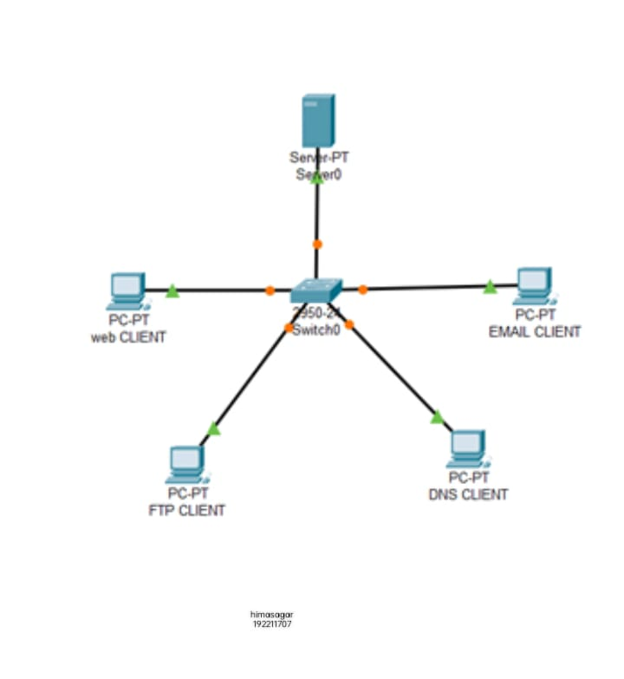

EXP:15 FUNCTIONALITIES OF UDP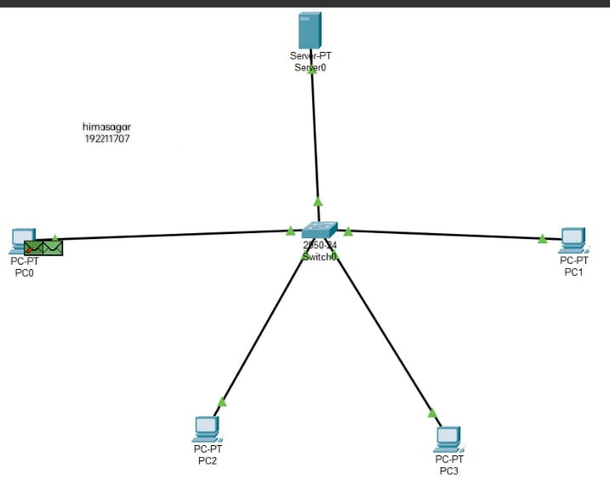

EXP:16 CLASS C ADRESSING

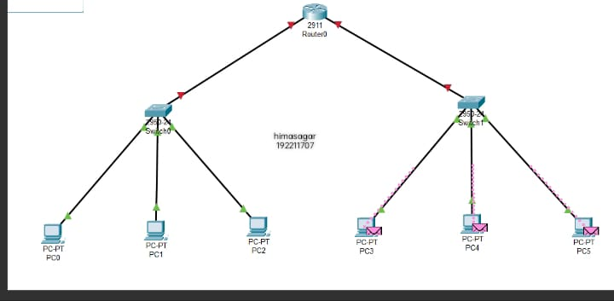

EXP:19 XYZ NETWORKS

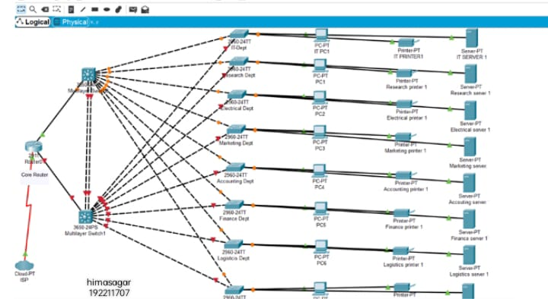

EXP:20 DHCP

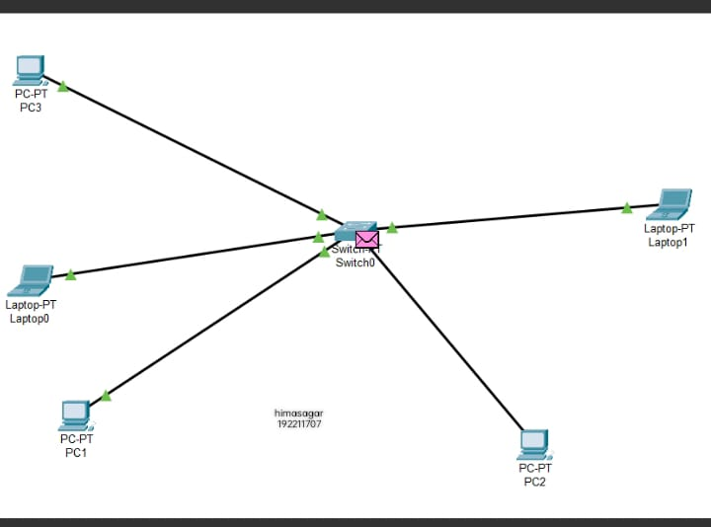

EXP:21 FIRE WALL

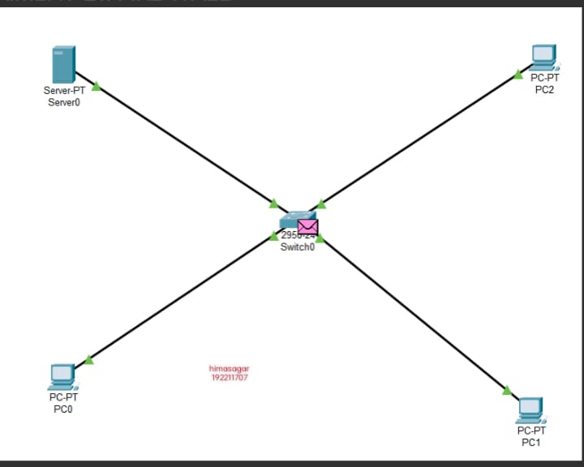

EXP:22 C LAB

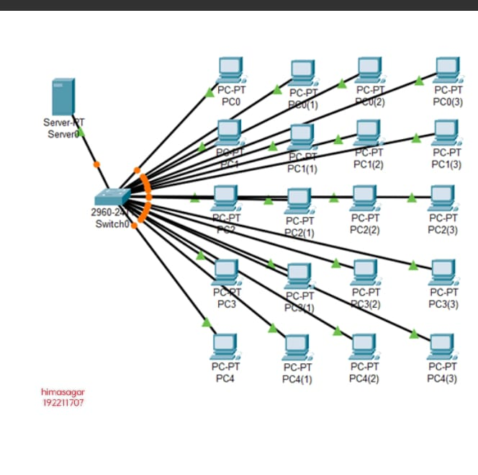

EXP:23 TCP WIRE SHARK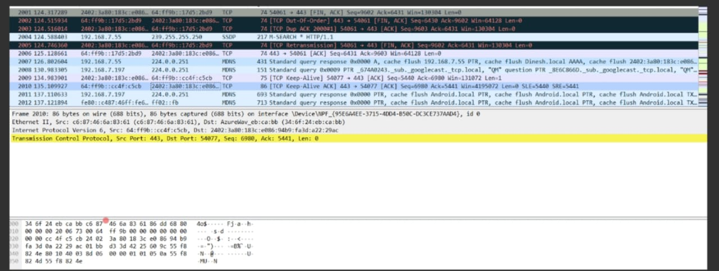

EXP:24 SMDP WIRE SHARK

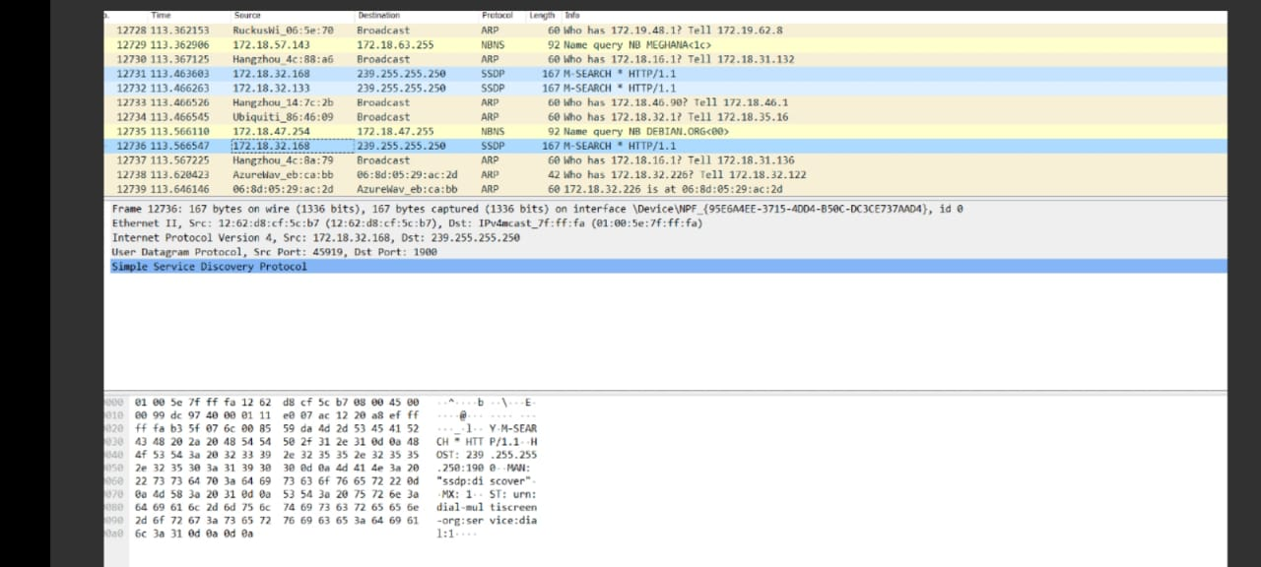

EXP:25 TCP

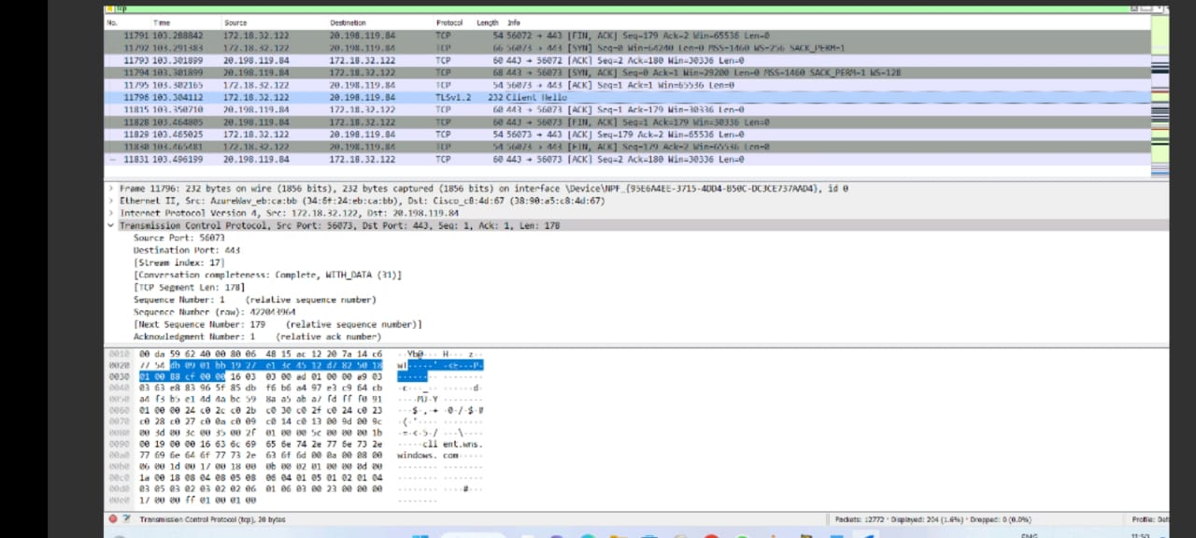

EXP:26 UDP

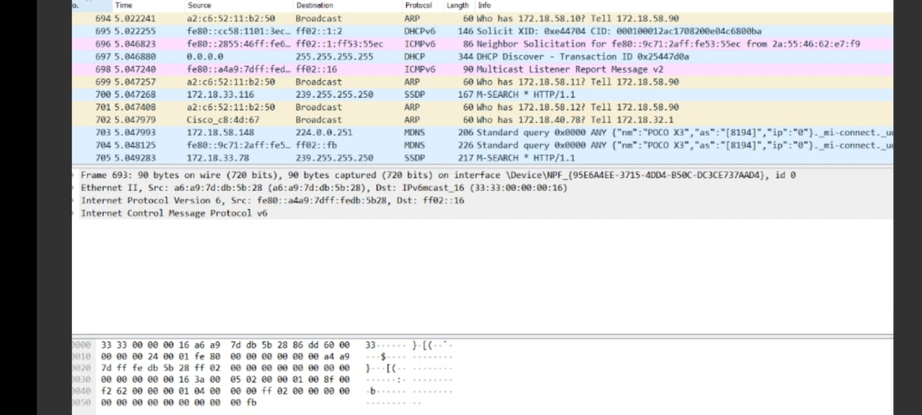

EXP:27 ADP

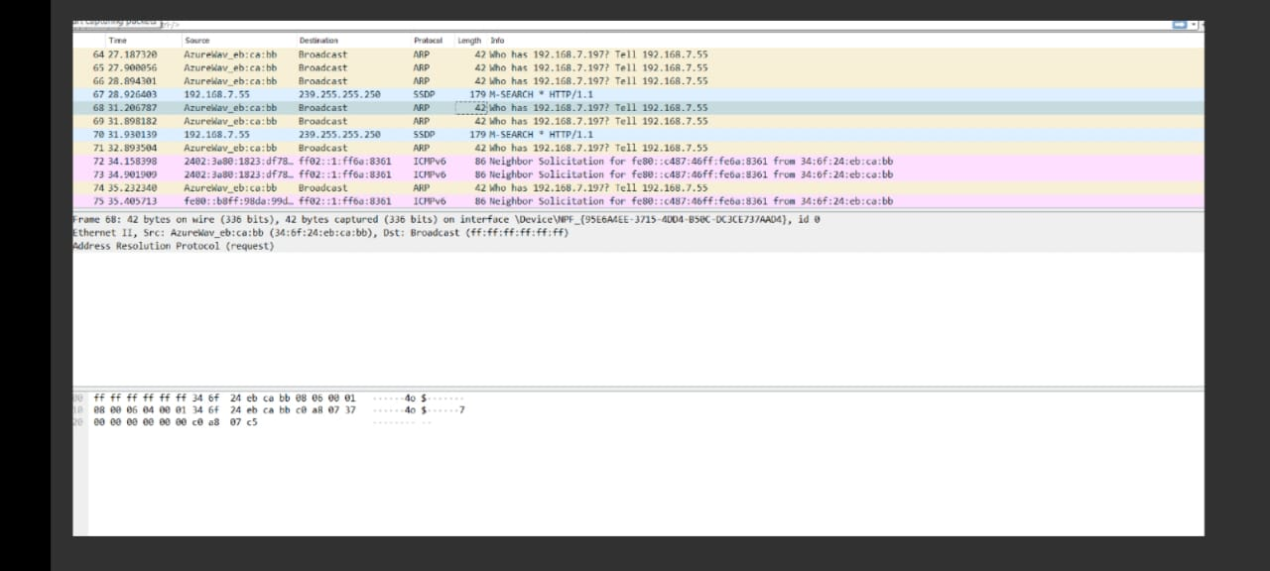

EXP:28 HTTP

