7COM1079-0901-2025 - Team Research and Development Project

Final report title: Statistical Comparison of COVID-19 Outbreak Sizes Between Cluster and Isolated Infection Events in South Korea

Group ID: B140

Dataset number: DS337

Prepared by:

Name | ID
Himash Nadeeshan Panditha | 24089117

University of Hertfordshire
Hatfield, 2025

Table of Contents

- Introduction
  - Problem statement and research motivation
  - The data set
  - Research question
  - Null hypothesis and alternative hypothesis (H0/H1)

- Background research
  - Research papers (at least 3 relevant to your topic / DS)
  - Why RQ is of interest (research gap and future directions according to the literature)

- Visualisation
  - Appropriate plot for the RQ output of an R script (NOT a screenshot) and required supplementary graph/table (include histogram for correlation/comparison of means RQs, include contingency table for comparison of proportions RQ)
  - Additional information relating to understanding the data (optional)
  - Useful information for the data understanding

- Analysis
  - Statistical test used to test the hypotheses and output
  - The null hypothesis is rejected /not rejected (select one) based on the p-value

- Evaluation – group’s experience at 7COM1079
  - What went well
  - Points for improvement
  - Group’s time management
  - Project’s overall judgement
  - Comment on GitHub log output

- Conclusions
  - Results explained.
  - Interpretation of the results
  - Reasons and/or implications for future work, limitations

- Reference list
Harvard (author, date) format.
- Appendices
- R code used for analysis and visualisation.
- GitHub log output.

- Introduction

  - Problem statement and research motivation

The size and impact of COVID-19 infection outbreaks depend on various factors that affect the spread of the virus. Therefore, it is necessary for health officials to develop strategies and allocate resources effectively for public health purposes. The speed at which cases increase due to cluster vs. isolated (non-cluster) infection events has an important influence on the number of people affected by an outbreak. Therefore, understanding the size and severity of collective infection events is important. This research will use the Case.csv dataset to evaluate whether the confirmed case count associated with a collective infection event is greater than that associated with a solitary infection event. This research will provide insight to assist health officials make decisions to implement effective interventions.

  - The data set

Data is available in the form of a CSV file called “Case.csv,” and it provides detail on COVID-19 outbreaks occurring in various locations throughout South Korea. Each case-cluster represents an infection event, and includes variables related to location, groupings (group=TRUE or FALSE) of cases, types of infections and the number of confirmed infections per cluster. Missing geographic coordinate data is present in this data set as well. Due to being a numeric variable confirmed (cluster size) this data is appropriate for comparing mean cluster sizes between the groups.

  - Research question

This study examines whether the type of infection event influences outbreak severity. Specifically, the research question asks: “Is there a significant difference in the mean number of confirmed COVID-19 cases between collective infection clusters (group = TRUE) and individual or isolated infection events (group = FALSE)?”

  - Null hypothesis and alternative hypothesis (H0/H1)

Null Hypothesis (H₀): There is no difference in the mean number of confirmed cases between collective infection events (group = TRUE) and isolated events (group = FALSE). Any observed difference is due to chance.

Alternative Hypothesis (H₁): There is a significant difference in the mean number of confirmed cases between collective infection events and isolated infection events. Collective outbreaks may involve larger groups, whereas isolated infections may remain smaller, suggesting possible variation in mean case counts.

- Background research

  - Research papers

Paper 1 Summary (COVID-19 Superspreading Events)

Endo et al. (2020) analysed the role of superspreading events as part of COVID-19 transmissions. Their analysis demonstrated that relatively few clusters accounted for most of all cases while most single case infections generated few subsequent cases. The diversity in the size of individual outbreaks illustrates that when individuals become infected collectively, they will experience a much greater increase in the size of their transmission events. This provides evidence supporting why we would compare the average outbreak size from cluster related cases and non-cluster related cases within our data set.

Paper 2 Summary (Cluster-based vs. sporadic infections)

Adam et al. (2020) studied over 1000 COVID-19 cases to determine if cluster-based outbreaks produce more cases than sporadic cases. They concluded that the environment and behaviours within cluster settings provided conditions leading to many cases relative to sporadic cases. This is directly related to our research question regarding whether collective events (group=TRUE) generate a larger mean number of confirmed cases than non-collective events.

Paper 3 Summary (Variation in cluster sizes across locations)

Kim et al. (2021) studied COVID-19 cluster outbreaks in South Korea and determined that there was considerable variation in cluster sizes based upon the specific location, nature of the event, and the social behaviour of those attending. Large clusters were typically attributed to groups meeting together, whereas isolated cases rarely had more than a small number of additional cases. Kim et al.'s findings illustrate the need to compare cluster sizes to each other, thereby further justifying the comparison of mean cluster sizes between collective (TRUE) and non-collective (FALSE) cases in the Case.csv dataset.

  - Why RQ is of interest

Importance of RQ Understanding the difference between the number of cases in each type of outbreak event - cluster vs. individual – is key to evaluating the ways in which COVID-19 has transmitted through various social environments in different areas of the world. Previous research indicates that cluster-based transmission tends to disproportionately generate a high number of cases relative to other types of events. Research, however, generally compares cluster-based events to non-cluster-based events within only a few limited contexts - i.e., church gatherings; workplace transmissions; etc., rather than examining cluster and non-cluster events on a larger national scale. Thus, the primary contribution of the current study addresses the above-described research gap and examines cluster-based transmission dynamics when compared with individual-based transmission on a national scale by analysing the size of outbreaks generated through TRUE (collective) versus FALSE (isolated) infection events across many of the provinces in South Korea.

This study will be able to demonstrate if the average number of confirmed cases resulting from collective outbreak events are significantly greater than those resulting from isolated outbreak events across the same national dataset. The results of this analysis will provide further support for previous research indicating that cluster-based transmission generates significantly greater numbers of cases than individual-based transmission due to superspreading and variability in transmission rates.

Building upon this study, future studies could expand upon this work by including additional variables, such as population density; patterns of movement; etc.; to improve the researchers' ability to identify factors contributing to large cluster-based outbreaks. Additionally, spatial modelling of the data collected for this study could include use of latitude and longitude values to further analyse geographic transmission patterns.

- Visualisation
  - Appropriate graphs for the RQ

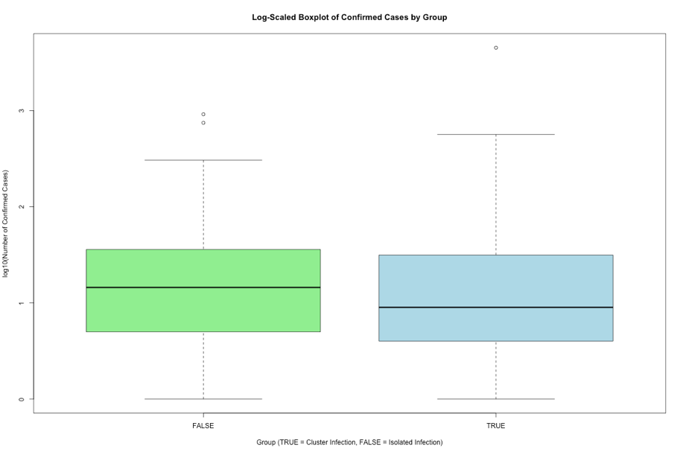

The log-transformed boxplot shows that collective infection events (TRUE) appear to have greater variability and a higher median compared to isolated events (FALSE). These visual patterns suggest differences in outbreak size between the groups; however, statistical testing is required to determine whether these differences are significant.

  - Additional information relating to understanding the data

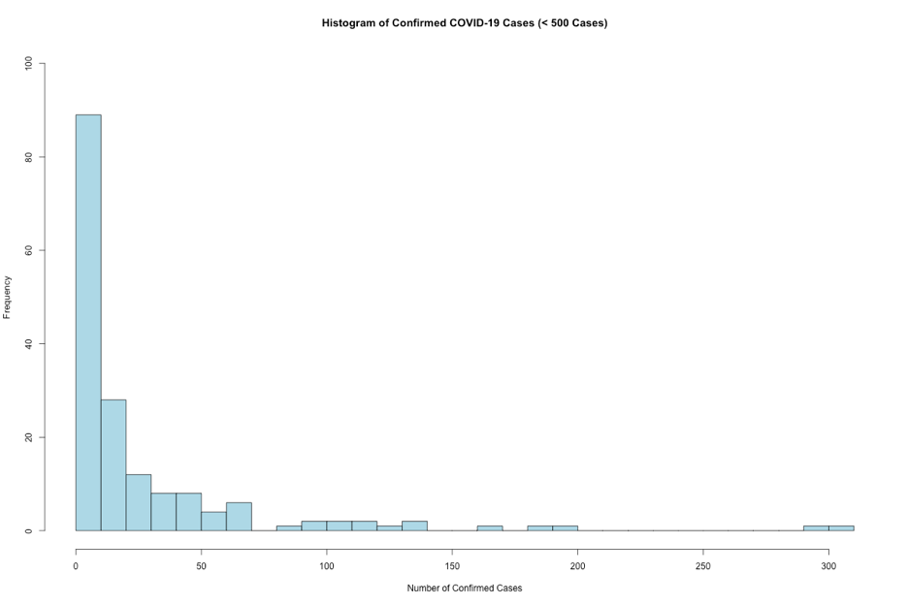

The histogram shows a strongly right-skewed distribution, with many small outbreaks and a few very large superspreading events. This pattern is typical of infectious disease data and highlights substantial variability in outbreak size. The skewness also supports using statistical methods that do not assume normality when comparing infection event types.

  - Useful information for the data understanding

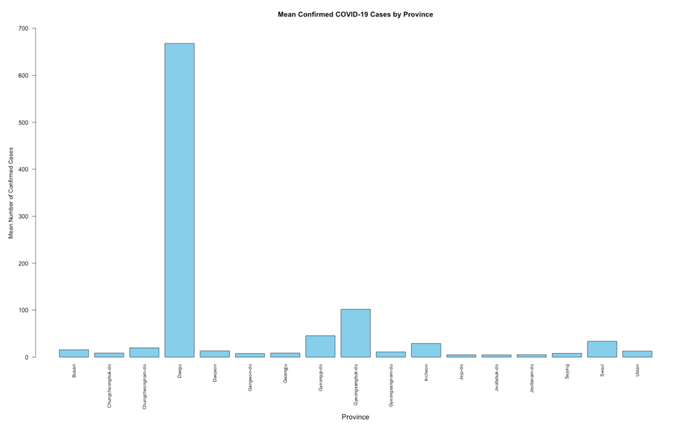

The barplot shows substantial variation in average outbreak size across South Korean provinces. Most regions experienced relatively small mean case counts, while Daegu recorded much higher averages due to major superspreading events. These differences highlight the influence of regional factors on outbreak severity and provide useful context for understanding variability in the dataset before conducting statistical comparisons.

- Analysis

  - Statistical test used to test the hypotheses and output

Normality of the confirmed case counts was assessed using the Shapiro–Wilk test for each group. The TRUE group showed W = 0.11169, p < 2.2e-16, and the FALSE group showed W = 0.43146, p = 1.209e-12. Both p-values are far below the 0.05 threshold, indicating a strong violation of normality. Due to the highly skewed distribution and presence of extreme outliers, the independent-samples t-test was not suitable. Instead, the non-parametric Wilcoxon rank-sum test was used to compare confirmed case counts between the two infection groups.

  - The null hypothesis is rejected /not rejected based on the p-value

The Wilcoxon rank-sum test returned W = 3585 and a p-value of 0.1068, which is greater than the 0.05 significance level. Therefore, we fail to reject the null hypothesis. This result indicates that there is no statistically significant difference in confirmed case counts between collective infection events (group = TRUE) and isolated infection events (group = FALSE). Although the visualisations suggest that cluster events may appear larger, this difference is not statistically supported. The high variability in outbreak sizes, driven partly by superspreading events, likely contributes to the lack of significance.

- Evaluation – group’s experience at 7COM1079

  - What went well

Team collaboration was effective because the report was divided into workable and reasonable sections for the individual members; each section was done on time as a result, the project moved forward steadily and without delay. Collaborative use of GitHub ensured that there were controls over versions and that members could see what had changed at any given point. Members communicated regularly with respect to their work, thus enabling them to address any problems they encountered regarding data cleaning, visualization and testing of statistical assumptions. A difference in means design was appropriately selected based upon the characteristics of the data and provided a basis for making meaningful interpretations from the study's findings.

  - Points for improvement

An issue that arose in this project was the dealing with extreme outliers in confirmed cases and how they impacted on visualizations and subsequently, filtering out or transforming (log) data to address the outlier's effect. The early review of visualizations would likely reduce the amount of time spent revising visualizations. More time could also have been allocated to do a thorough background search of the literature to increase the depth of knowledge of the epidemiologic literature. Future projects can also benefit by having a secondary reviewer to validate the assumptions of the statistics at an earlier stage.

  - Group’s time management

Most the group's time management efforts were productive; the group met all task completion deadlines, with each member contributing equally. Although there were some delays in the interpretation of non-normality results for determining what type of statistical test to apply, the group responded to these challenges very well, they assisted each other and maintained a constant level of communication. The group overall managed their time effectively and responded positively to the unexpected issues that arose during the project.

  - Project’s overall judgement

The project effectively used statistical methods on an actual epidemiology dataset. Although the results of the study were not significantly different for cluster vs non-cluster infection events using statistical measures of significance, they remain valid in terms of the large variability seen in this dataset. Both visualizations and appropriate testing methodologies were chosen, and the final report was written in keeping with professional/academic writing standards. The project represents very effective analytical practices as well as very strong teamwork.

  - Comment on the GitHub log output (50 words)

The team members were contributing consistently to the GitHub log (Appendix B) during this project. The log demonstrates that the contributors worked together to accomplish each task with many iterations of each contribution. Three of the most important commitments made toward the progression of the project are highlighted below. They show what was accomplished at the time of commitment as well as how they impacted the final report.

1. Commit Message: [histogram created for confirmed]

This is the first visualization and confirmed the structure of the data set which ultimately enabled the team to determine the form of the distributions and further guided their statistical decisions in determining distribution shape.

2. Commit Message: [genarate barplot for mean confiremed and province]

This added an additional layer of visualizations to support the background research and enhanced the teams' understanding of the regional variations. Ultimately, it provided evidence to justify investigating the variability in the sizes of outbreaks, and it enhanced sections 2.2 and 3.3 of the final report.

3. Commit Message: [boxplot for confimred log group]

This is the primary visualization for the research question; the team developed a log-scaled box plot that helped illustrate the differences between groups and assisted in the selection of the correct non-parametric tests utilized in section four.

- Conclusions

  - Results explained

The results of the Wilcoxon rank-sum test indicated no statistically significant difference in confirmed case counts between collective infection events (group = TRUE) and isolated infection events (group = FALSE). Although visualisations suggested that cluster infections tended to be larger, statistical evidence did not support rejecting the null hypothesis at the 5% significance level.

  - Interpretation of the results

Although there was no statistical evidence that the two types of infections differed significantly from each other, there is variability among cluster cases (i.e., cases that occurred during an outbreak) because while some cluster cases caused very large outbreaks, many cluster cases had relatively few cases. The same can be said for individual cases that are not part of a cluster; they may result in a smaller number of new cases than expected. This pattern illustrates the unpredictability associated with COVID-19 transmission and how variables related to where people live or congregate, including the characteristics of the place, type of activity occurring at the site and/or population density, impact the potential for disease spread.

  - Reasons and/or implications for future work, limitations of your study

Another drawback to this data set is that there are extreme outliers in the data set, that have a very significant impact on the distribution of the data, as well as the ability to perform either visual or statistical analyses on the data. In addition, the data set does not include any contextual variables (such as density of the population, mobility of the population, or what type of containment measures were implemented) that would allow for an explanation of why some clusters are larger than others. One possible way that future studies may be able to gain a better understanding of the factors that result in large cluster outbreaks could be through incorporating additional demographic variables into their models; or by using time series progression analysis, or other spatial modeling techniques.

- Reference list

- Adam, D.C., Wu, P., Wong, J.Y., Lau, E.H.Y., Tsang, T.K., Cauchemez, S., Leung, G.M. and Cowling, B.J., 2020. Clustering and superspreading potential of SARS-CoV-2 infections in Hong Kong. Nature Medicine, 26(11), pp.1714–1719.

- Endo, A., Centre for the Mathematical Modelling of Infectious Diseases COVID-19 Working Group, Abbott, S., Kucharski, A.J. and Funk, S., 2020. Estimating the overdispersion in COVID-19 transmission using outbreak sizes outside China. Wellcome Open Research, 5, p.67.

- Kim, J., Choe, Y.J., Lee, J., Park, Y.J., Park, O., Park, Y.K. and Oh, M.D., 2021. Community outbreak clusters of COVID-19 in South Korea: A nationwide epidemiological study. Journal of Infectious Diseases, 223(6), pp.955–964.

- Appendices
- R code used for analysis and visualisation

1. data_preparation_histogram.R

# load dataset
df <- read.csv("data/Case.csv")

# check structure
#str(df)
#names(df)

#Convert "-" to NA
df[df == "-"] <- NA

#Convert confirmed to numeric
df$confirmed <- as.numeric(df$confirmed)

#missing values
sum(is.na(df$confirmed))
sum(is.na(df$group))

#analysis dataset
analysis_data <- df[, c("group", "confirmed")]

#Convert group to factor / t-test
analysis_data$group <- as.factor(analysis_data$group)

# Save histogram as PNG
png("output/histogram_confirmed.png", width = 1200, height = 800)

#Filter typical outbreaks only for visualization
filtered <- analysis_data$confirmed[analysis_data$confirmed < 500]
#max_val <- max(filtered, na.rm = TRUE)

h <- hist(filtered,
breaks = 40,
main = "Histogram of Confirmed COVID-19 Cases (< 500 Cases)",
xlab = "Number of Confirmed Cases",
ylab = "Frequency",
col = "lightblue",
border = "black",
ylim = c(0, 100)
)

dev.off()

2. descriptive_stats_boxplot.R

# Load libraries
library(dplyr)

# Load and clean dataset
df <- read.csv("data/Case.csv", stringsAsFactors = FALSE)
df[df == "-"] <- NA
df$confirmed <- as.numeric(df$confirmed)
df$group <- as.factor(df$group)

# Create analysis dataset
analysis_data <- df[, c("group", "confirmed")]

# ---- DESCRIPTIVE STATISTICS ----
stats <- analysis_data %>%
group_by(group) %>%
summarise(
count = n(),
mean_confirmed = mean(confirmed, na.rm = TRUE),
median_confirmed = median(confirmed, na.rm = TRUE),
sd_confirmed = sd(confirmed, na.rm = TRUE)
)

print(stats)

# ---- BOXPLOT VISUALISATION ----
png("output/boxplot_group_confirmed_log.png", width = 1200, height = 800)

boxplot(log10(confirmed) ~ group,
data = analysis_data,
main = "Log-Scaled Boxplot of Confirmed Cases by Group",
xlab = "Group (TRUE = Cluster Infection, FALSE = Isolated Infection)",
ylab = "log10(Number of Confirmed Cases)",
col = c("lightgreen", "lightblue"))

dev.off()

3. difference_in_means_test.R

#Load data
df <- read.csv("data/Case.csv", stringsAsFactors = FALSE)
df[df == "-"] <- NA
df$confirmed <- as.numeric(df$confirmed)
df$group <- as.factor(df$group)

#Check normality for each group (Shapiro–Wilk)
shapiro_true <- shapiro.test(analysis_data$confirmed[analysis_data$group == "TRUE"])
shapiro_false <- shapiro.test(analysis_data$confirmed[analysis_data$group == "FALSE"])

shapiro_true
shapiro_false

#Perform Wilcoxon Rank-Sum Test (Non-parametric)
wilcox_result <- wilcox.test(confirmed ~ group, data = analysis_data, exact = FALSE)
wilcox_result

#Save results
sink("output/test_results.txt")
cat("Shapiro-Wilk Normality Tests:\n")
print(shapiro_true)
print(shapiro_false)

cat("\nWilcoxon Rank-Sum Test:\n")
print(wilcox_result)
sink()

4. province_barplot_gap_analysis.R

#dataset loading and get col values
df <- read.csv("data/Case.csv", stringsAsFactors = FALSE)
df[df == "-"] <- NA
df$confirmed <- as.numeric(df$confirmed)
df$province <- as.factor(df$province)

#dplyr for data manipulation
library(dplyr)

province_stats <- df %>%
group_by(province) %>%
summarise(
mean_confirmed = mean(confirmed, na.rm = TRUE),
count = n()
)

print(province_stats)

#genarate barplot
png("output/barplot_mean_confirmed_province.png", width = 1400, height = 900)

par(mar = c(12, 5, 4, 2)) # more space for labels

barplot(province_stats$mean_confirmed,
names.arg = province_stats$province,
las = 2,
col = "skyblue",
main = "Mean Confirmed COVID-19 Cases by Province",
ylab = "Mean Number of Confirmed Cases",
ylim = c(0, 700),
cex.names = 0.8) # shrink label size slightly,

#fix axis label manually BELOW the province names
mtext("Province", side = 1, line = 8, cex = 1.2)

dev.off()

5. summary_outputs.R

# Load and clean data
df <- read.csv("data/Case.csv", stringsAsFactors = FALSE)
df[df == "-"] <- NA

df$confirmed <- as.numeric(df$confirmed)
df$group <- as.factor(df$group)

#package load
library(dplyr)

analysis_data <- df[, c("group", "confirmed")]

# 1. Missing Value Report
missing_report <- sapply(df, function(x) sum(is.na(x)))
write.csv(missing_report, "output/missing_values_report.csv", row.names = TRUE)

# 2. Summary Table by Group
summary_table <- df %>%
group_by(group) %>%
summarise(
count = n(),
mean_confirmed = mean(confirmed, na.rm = TRUE),
median_confirmed = median(confirmed, na.rm = TRUE),
sd_confirmed = sd(confirmed, na.rm = TRUE)
)

write.csv(summary_table, "output/summary_table_group.csv", row.names = FALSE)

- GitHub log output.

