PDF Vault
SECURE OFFLINE ENGINE • VERSION 1.2.0

Welcome to PDF Vault! 🎉
PDF Vault is a highly secure, 100% offline application developed by the IT Department (AI Team). Your files never leave your computer, ensuring maximum privacy for sensitive company data while offering a modern, easy-to-use interface.
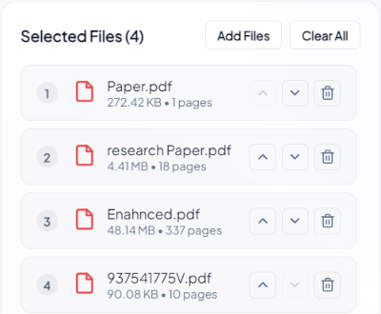

Key Features & Guide

1. Merge PDFs (Combine Files)
• Drag & Drop: Easily drag multiple PDFs into the application area.
• Smart Reordering: Click and drag any file in the list up or down to change the exact merge order before combining.
• Instant Preview: Click the 'Preview' button on any file to quickly view its contents before making changes.

2. PDF to Image Processor
Convert your PDF pages into High-Quality JPEG or PNG images effortlessly.
• Visual Selection Grid: Scroll through large, clear thumbnails of every single page. Click a page to select or deselect it.
• Typing Custom Ranges: Want specific pages? Just type ranges like '1-5, 8, 11' into the text box, and watch the visual grid automatically sync your choices!
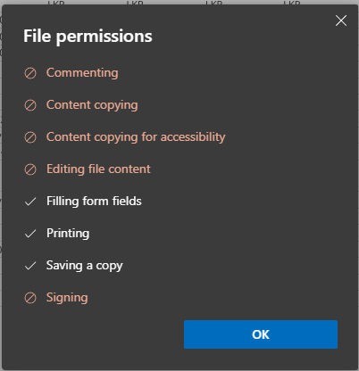

3. Split & Compress Tools
• Split PDF: Extract specific parts of large documents easily.
• Compress PDF: Reduce file sizes for easy Email attachments without losing critical text quality.

4. Automatic CRIB Report Decryption 🔓
Tired of getting 'blank pages' when trying to merge locked or encrypted documents like CRIB Reports? PDF Vault comes with a built-in automated Decryption Engine. It automatically handles permissions in the background so you can merge and extract anything effortlessly.

Developed with ♥ by the AI Team - IT Department

