Case Study: Git operations on Git Code Base
Situation:
Three Developers are working in Aperture Technology co. and are working simultaneously on same block of code which caused problem. There is a requirement in the company for a better Source Code Management System to deal with the redundant code.
Challenges:
- Earlier tool had no tendency to save redundant code
- Multiple developers working simultaneously on same block of code causing conflicts in code
Actions:
- Create a local git repository and move the entire code base to it
- Create a new branch for a new feature you want to add to the application
- Merge back the created branch with the master branch
- Create a remote repository
- Push the local repository to company’s remote repository
Results:
- Create a local git repository and move the entire code base to it
To create a new repo from scratch following are the steps to perform:-

  - Create a directory to contain the project.
  - Go into the new directory.
  - Type git init.
  - Write some code.
  - Type git add to add the files
  - Type git commit.
The first file to create (and add and commit) is probably a ReadMe file
To create a new repo from an existing project following are the steps to perform:-
  - Go into the directory containing the project.
  - Type git init.
  - Type git add to add all of the relevant files.
  - You will probably want to create a “.gitignore” file right away, to indicate all of the files you don’t want to track. Use git add .gitignore, too.
  - Type git commit.
To Connect it to github following are the steps to peform:-
- Go to github.
- Log into github account.
- Click the new repository button in the top-right. You will have an option there to initialize the repository with a README file.
- Click the “Create repository” button.
- To push an existing repository follow the below commands:-
$ git remote add origin https://github.com/username/new_repo
$ git push -u origin master (and then enter the password).
- Create a new branch for a new feature you want to add to the application
First, let’s say you’re working on your project and have a couple of commits already on the masterbranch.
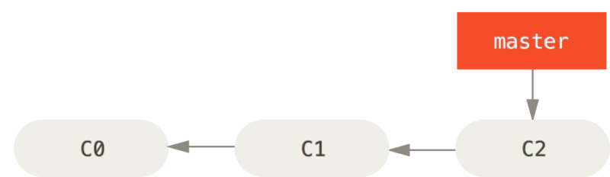
Figure 1. A simple commit history
You’ve decided that you’re going to work on issue #53 in whatever issue-tracking system your company uses. To create a new branch and switch to it at the same time, you can run the git checkout command with the -b switch:
$ git checkout -b iss53
Switched to a new branch "iss53"
This is shorthand for:
$ git branch iss53
$ git checkout iss53
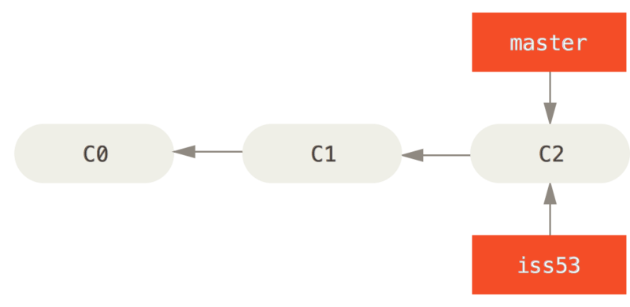
Figure 2. Creating a new branch pointer
You work on your website and do some commits. Doing so moves the iss53 branch forward, because you have it checked out (that is, your HEAD is pointing to it):
$ vim index.html
$ git commit -a -m 'added a new footer [issue 53]'
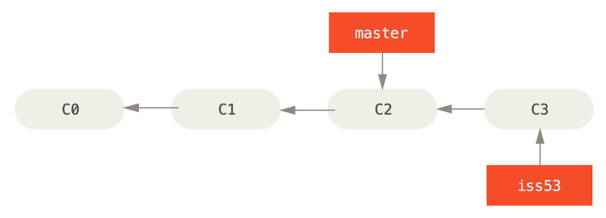
Figure 3. The iss53 branch has moved forward with your work
Now you get the call that there is an issue with the website, and you need to fix it immediately. With Git, you don’t have to deploy your fix along with the iss53 changes you’ve made, and you don’t have to put a lot of effort into reverting those changes before you can work on applying your fix to what is in production. All you have to do is switch back to your master branch.
However, before you do that, note that if your working directory or staging area has uncommitted changes that conflict with the branch you’re checking out, Git won’t let you switch branches. It’s best to have a clean working state when you switch branches. There are ways to get around this (namely, stashing and commit amending) that we’ll cover later on, in Stashing and Cleaning. For now, let’s assume you’ve committed all your changes, so you can switch back to your master branch:
$ git checkout master
Switched to branch 'master'
This is an important point to remember: when you switch branches, Git resets your working directory to look like it did the last time you committed on that branch. It adds, removes, and modifies files automatically to make sure your working copy is what the branch looked like on your last commit to it.
Next, you have a hotfix to make. Let’s create a hotfix branch on which to work until it’s completed:
$ git checkout -b hotfix
Switched to a new branch 'hotfix'
$ vim index.html
$ git commit -a -m 'fixed the broken email address'
[hotfix 1fb7853] fixed the broken email address
1 file changed, 2 insertions(+)
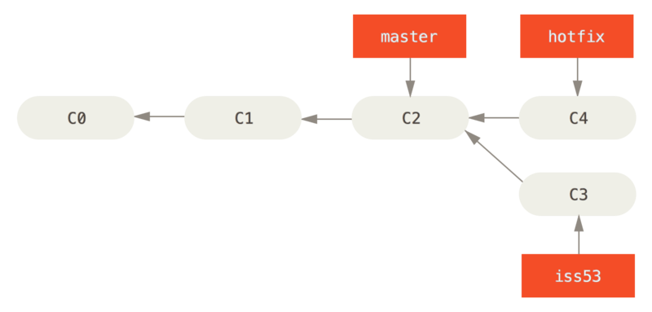
Figure 4. Hotfix branch based on master
You can run your tests, make sure the hotfix is what you want, and finally merge the hotfix branch back into your master branch to deploy to production. You do this with the git merge command:
$ git checkout master
$ git merge hotfix
Updating f42c576..3a0874c
Fast-forward
index.html | 2 ++
1 file changed, 2 insertions(+)
You’ll notice the phrase “fast-forward” in that merge. Because the commit C4 pointed to by the branch hotfix you merged in was directly ahead of the commit C2 you’re on, Git simply moves the pointer forward. To phrase that another way, when you try to merge one commit with a commit that can be reached by following the first commit’s history, Git simplifies things by moving the pointer forward because there is no divergent work to merge together — this is called a “fast-forward.”
Your change is now in the snapshot of the commit pointed to by the master branch, and you can deploy the fix.
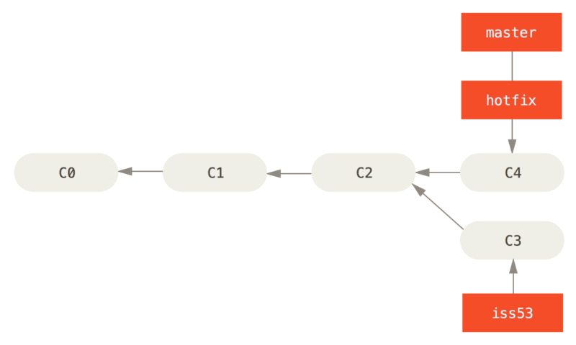
Figure 5. master is fast-forwarded to hotfix
After your super-important fix is deployed, you’re ready to switch back to the work you were doing before you were interrupted. However, first you’ll delete the hotfix branch, because you no longer need it — the master branch points at the same place. You can delete it with the -d option to git branch:
$ git branch -d hotfix
Deleted branch hotfix (3a0874c).
Now you can switch back to your work-in-progress branch on issue #53 and continue working on it.
$ git checkout iss53
Switched to branch "iss53"
$ vim index.html
$ git commit -a -m 'finished the new footer [issue 53]'
[iss53 ad82d7a] finished the new footer [issue 53]
1 file changed, 1 insertion(+)
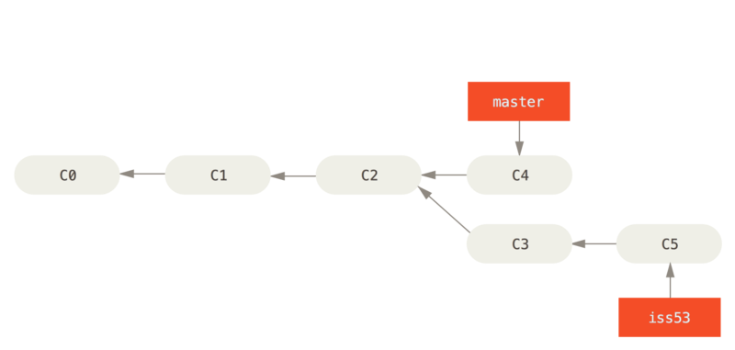
Figure 6. Work continues on iss53
It’s worth noting here that the work you did in your hotfix branch is not contained in the files in your iss53 branch. If you need to pull it in, you can merge your master branch into your iss53 branch by running git merge master, or you can wait to integrate those changes until you decide to pull the iss53 branch back into master later.
- Merge back the created branch with the master branch
In order to do that, you’ll merge your iss53 branch into master, much like you merged your hotfix branch earlier. All you have to do is check out the branch you wish to merge into and then run the git merge command:
$ git checkout master
Switched to branch 'master'
$ git merge iss53
Merge made by the 'recursive' strategy.
index.html | 1 +
1 file changed, 1 insertion(+)
This looks a bit different than the hotfix merge you did earlier. In this case, your development history has diverged from some older point. Because the commit on the branch you’re on isn’t a direct ancestor of the branch you’re merging in, Git has to do some work. In this case, Git does a simple three-way merge, using the two snapshots pointed to by the branch tips and the common ancestor of the two.

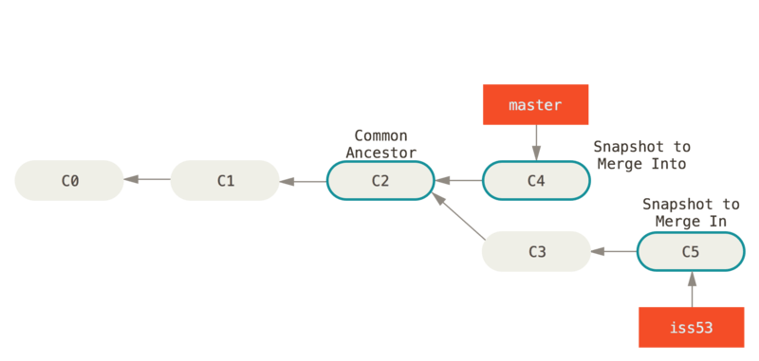
Figure 7. Three snapshots used in a typical merge
Instead of just moving the branch pointer forward, Git creates a new snapshot that results from this three-way merge and automatically creates a new commit that points to it. This is referred to as a merge commit, and is special in that it has more than one parent.
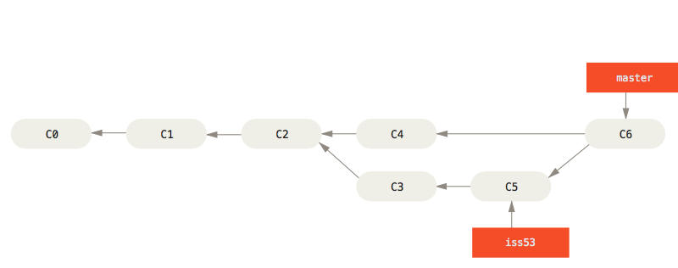
Figure 8. A merge commit
Now that your work is merged in, you have no further need for the iss53 branch. You can close the ticket in your ticket-tracking system, and delete the branch:
$ git branch -d iss53

- Create a remote repository
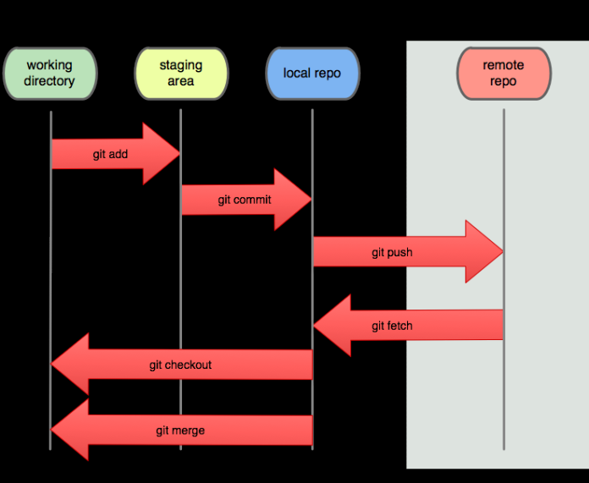
- You can use the git remote add command to match a remote URL with a name. For example, you'd type the following in the command line:git remote add origi
$ git remote add origin <REMOTE_URL>
- This associates the name “origin” with the “REMOTE_URL”.
- You can use the command
$ git remote set-url to change a remote’s URL.

- Push the local repository to company’s remote repository

  - Create a new repository on GitHub. To avoid errors, do not initialize the new repository with README, license, or gitignore files. You can add these files after your project has been pushed to GitHub.
  - Open Git Bash.
  - Change the current working directory to your local project.
  - Initialize the local directory as a Git repository.
$ git init
  - Add the files in your new local repository. This stages them for the first commit.
$ git add
# Adds the files in the local repository and stages them for commit. To unstage a file, use 'git reset HEAD YOUR-FILE'.
  - Commit the files that you've staged in your local repository.
$ git commit -m “First Commit”.
#Commits the tracked changes and prepares them to be pushed to a remote repository. To remove this commit and modify the file, use 'git reset --soft HEAD~1' and commit and add the file again.
  - At the top of your GitHub repository's Quick Setup page, click to copy the remote repository URL.
  - In the Command prompt, add the URL for the remote repository where your local repository will be pushed.
$ git remote add origin remote repository URL
# Sets the new remote
$ git remote -v
# Verifies the new remote URL
  - Push the changes in your local repository to GitHub.
$ git push origin master
# Pushes the changes in your local repository up to the remote repository you specified as the origin

