Case Study: Container Orchestration using Kubernetes
Situation:
You are working as a Devops Administrator. Lately you’ve been asked to deploy a multi-tier application on Kubernetes Cluster. The application is a NodeJS application available on Docker Hub
with the following name:
devopsedu/employee
This NodeJS application works with a mongo database. MongoDB is available on
DockerHub with the following name:
mongo

Challenges:
- Deploy a NodeJS application using the CLI and Dashboard
- Add an employee from the NodeJS application and verify by going to Get Employee page and retrieve input
Actions:
- Deploy a NodeJS application using the CLI and Dashboard
- Add an employee from the NodeJS application and verify by going to Get Employee page and retrieve input
Results:
- Deploy a NodeJS application using the CLI and Dashboard
1. Installing the NodeChef CLI
Make sure Node.js is installed on your computer which should be the case if you are deploying Meteor.js or Node.js.
Install the CLI by running the below command:
npm install -g nodechef-cli
2. Prepare your app for deployment
Generate a package json file in the root directory of your application files. By default, the nodechef platform executes your code using the latest node js version. To specify a different version, use the "engines.node" attribute in the package.json file. Note you must specify the version explicitly. eg: "node" : "0.10.41". By default, the entry point of your application is the index.js script. To specify another script as the entry point, use either the "main" or "scripts.start" attribute.
On deployment, your local node_modules folder is not included in the zip package uploaded to the server. Modules from your package.json are cached on the build server for faster builds.
You can retrieve the Network address to use for the the listening socket from the environment variables process.env.PORT and process.env.BIND_IP. Hardcoded port numbers will not work on the nodechef platform.
Express.js example:
app.listen(process.env.PORT || 3000);
Listening using http:
http.listen(process.env.PORT || 3000, function() {})

Working with NPM scripts
By default to start your application NodeChef searches for a scripts.start in your package.json. In case you want to customize your build, you can also include a postinstall script as well which NodeChef will run after running npm install
In step 5 we will show you how you to start your app with another script other than the start script. This is useful in cases where the same code base serves different functions such as a background worker and also the web app layer
"scripts": { "start": "node app.js", "worker": "node jobs.js", "postinstall": "echo 'meow'" <--- Will run after npm install }

Connecting to your database
The connection string to the database can be retrieved from the process.env.DATABASE_URI or process.env.DATABASE_URL environment variable. This value is a platform default variable that is automatically set on your behalf. You can however override this value if using an external database.
3. Deploy your cluster
Log in and navigate to the Dashboard. Click on deployments and complete the form. You will be required to select the size of your container and the region where your cluster is to be hosted

4. Environment variable
If you will like to launch your app with custom environment variables such as ROOT_URL pointing to your domain, follow the below steps.
  - Create a file in the root directory of your app with name env.json. Env.json is completely arbitrary you could name this file with a name more suitable for your use case such as; env_dev.json or env_prod.json
  - Edit the file using the JSON syntax below and save the file. ROOT_URL is only for demonstration purposes. If you however do not set this variable the default ROOT_URL is http://[appname-][nodechefid].nodechef.com/
{ "ROOT_URL" : "http://nodechef.com/", "MY_OTHER_VAR" : "MY_VAR_VALUE" }
The CLI JSON parser does not accept single quotes. Environment variables can also be configured after deployment from the web dashboard.
5. Log in from the CLI first to deploy
// Type nc login and you will prompted for your credentails. nc login // You could also provide your credentials as parameters to the nc login command nc login -em info@nodechef.com -pw *****

REMAKRS
Once you log in, you will remain logged in on your computer forever until you log out.
** IMPORTANT ** - For accounts that signed up with a third party log in provider such as GitHub, Bitbucket etc. you must first create a password for your account to be able to use the CLI. You can do this from the dashboard under the My Account section. Simply enter a password and save changes.
6. Launching your app
From the command prompt or terminal log in and then deploy your app.
nc deploy -i simple-todos -e env.json

ARGUMENTS
-i
Required. Specify the name of your app. Note this name must match the name used when creating the cluster from the dashboard. If there is a mismatch, the CLI will prompt you to create a new cluster. You must disagree to this action in such a case to avoid possible charges.

-e
Optional. Deploy your app with environment variables created in step 3.

-cmd
Optional. Use this switch to specify another script in your package.json other than the start script to initiate your app.
Reference the package.json script segment shown at step 2 under working with NPM scripts. The below command will start your app using "node jobs.js" instead of the start script "node app.js"
nc deploy -i simple-todos -cmd worker

--startupwait
Optional. Whenever you deploy your app, a new container is created which replaces the old one. The intent is to allow a seamless upgrade without any of your clients ever hitting an empty page. However for this to be possible, the new container has to completely load and ready to accept incomming connections. This parameter allows you to control how long in seconds the container manager will wait before replacing your old container with the new one. The highest value that can be specified is 60. Note the usage of a double hyphen before startupwait. eg: deploy -i simple-todos --startupwait 10

How to deploy with just the command [nc deploy]
In the above steps, we created an environment variable file and we always have to specify the name of the app to be deployed with the [-i] option. You can however create a file with name ncmanifest.json in the root directory of your project folder. You can then enter the name of your app together with your environment variables as seen below:
{ name: "simple-todos", env: { PAYMENT_API_KEY: "", ROOT_URL: "" }, startupwait : 15 }
Whenever the CLI detects the ncmanifest.json file in the root directory of your application, it will automatically attempt to parse the name of your app and other parameters.

Base container image
The NodeChef base image runs Ubuntu 14.04 and comes with the below listed set of packages pre-installed.
node.js build-essential wget putty-tools curl rsync phantomjs ca-certificates imagemagick graphicsmagick libcairo2-dev poppler-utils libjpeg-dev wkhtmltopdf libssl-dev xfonts-base xfonts-75dpi libpoppler-qt4-dev

- Add an employee from the NodeJS application and verify by going to Get Employee page and retrieve input

Using MongoDB and Node.js
MongoDB is one of the most popular databases used along with Node.js.
During this chapter, we will see
How we can establish connections with a MongoDB database
How we can perform the normal operations of reading data from a database as well as inserting, deleting and updating records in a mongoDB database.
For the purpose of this chapter, let's assume that we have the below mongoDB data in place.
Database name: EmployeeDB
Collection name: Employee
Documents
{
{Employeeid : 1, Employee Name : Hima},
{Employeeid : 2, Employee Name : Joe},
{Employeeid : 3, Employee Name : Martin},
}
- Installing the NPM Modules
To access Mongo from within a Node application, a driver is required. There are number of Mongo drivers available, but MongoDB is among the most popular. To install the MongoDB module, run the below command
npm install mongodb

- Creating and closing a connection to a MongoDB database. The below code snippet shows how to create and close a connection to a MongoDB database.
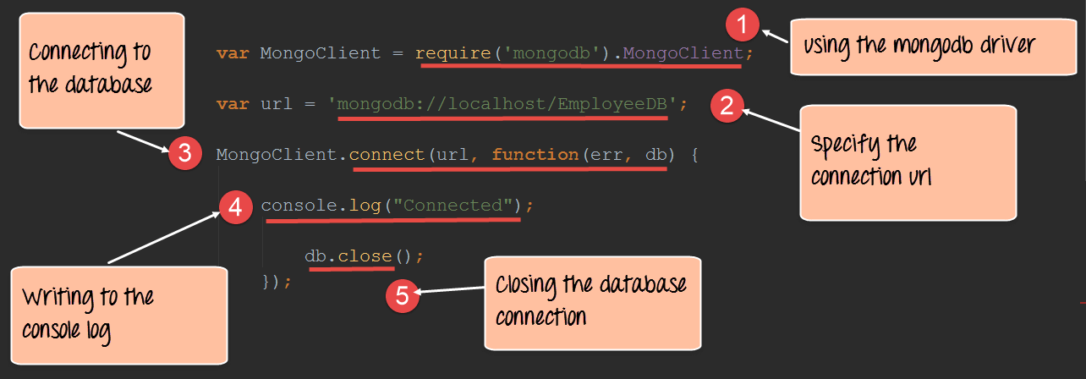
Code Explanation:
- The first step is to include the mongoose module which is done through the require function. Once this module is in place, we can use the necessary functions available in this module to create connections to the database.
- Next we specify our connect string to the database. In the connect string there are 3 key values which are passed.
- The first is 'mongodb' which specifies that we are connecting to a mongoDB database.
- The next is 'localhost' which means we are connecting to a database on the local machine.
- The next is 'EmployeeDB' which is the name of the database defined in our MongoDB database.
- The next step is to actually connect to our database. The connect function takes in our URL and has the facility to specify a callback function. It will be called when the connection is opened to the database. This gives us the opportunity to know if the database connection was successful or not.
- In the function, we are writing the string "Connection established" to the console to indicate that a successful connection was created.
- Finally, we are closing the connection using the db.close statement.
If the above code is executed properly, the string "Connected" will be written to the console as shown below.
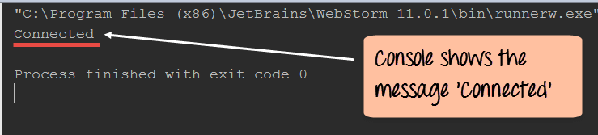
- Querying for data in a MongoDB database – Using the MongoDB driver we can also fetch data from the MongoDB database.
The below section will show how we can use the driver to fetch all of the documents from our Employee collection (This is the collection in our MongoDB database which contains all the employee related documents. Each document has an object id, Employee name and employee id to define the values of the document) in our EmployeeDB database.
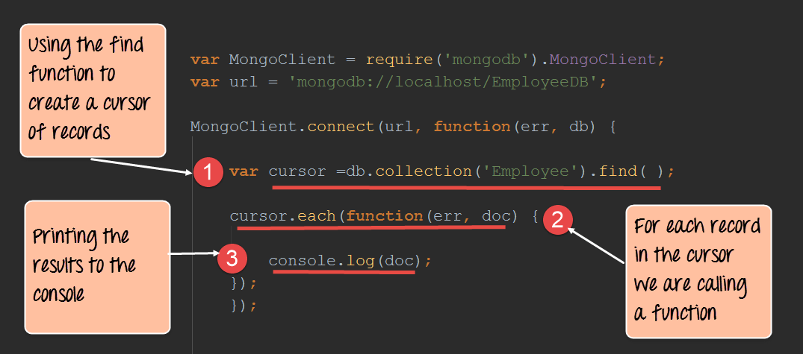
var MongoClient = require('mongodb').MongoClient;
var url = 'mongodb://localhost/EmployeeDB';

MongoClient.connect(url, function(err, db) {

var cursor = db.collection('Employee').find();

cursor.each(function(err, doc) {

console.log(doc);

});
});
Code Explanation:
- In the first step, we are creating a cursor (A cursor is a pointer which is used to point to the various records fetched from a database. The cursor is then used to iterate through the different records in the database. Here we are defining a variable name called cursor which will be used to store the pointer to the records fetched from the database. ) which points to the records which are fetched from the MongoDb collection. We also have the facility of specifying the collection 'Employee' from which to fetch the records. The find() function is used to specify that we want to retrieve all of the documents from the MongoDB collection.
- We are now iterating through our cursor and for each document in the cursor we are going to execute a function.
- Our function is simply going to print the contents of each document to the console.
Note: - It is also possible to fetch a particular record from a database. This can be done by specifying the search condition in the find() function. For example, suppose if you just wanted to fetch the record which has the employee name as Hima then this statement can be written as follows "var cursor=db.collection('Employee').find()."
If the above code is executed successfully, the following output will be displayed in your console.
Output:
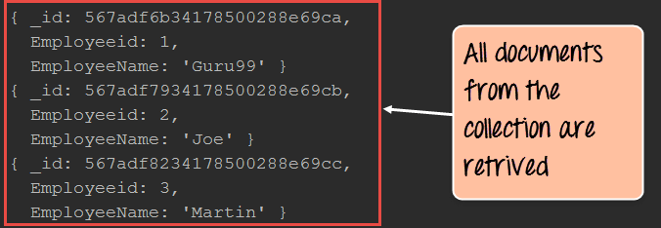
From the output,
- You will be able to clearly see that all the documents from the collection are retrieved. This is possible by using the find() method of the mongoDB connection (db) and iterating through all of the documents using the cursor.
- Inserting documents in a collection – Documents can be inserted into a collection using the insertOne method provided by the MongoDB library. The below code snippet shows how we can insert a document into a mongoDB collection.
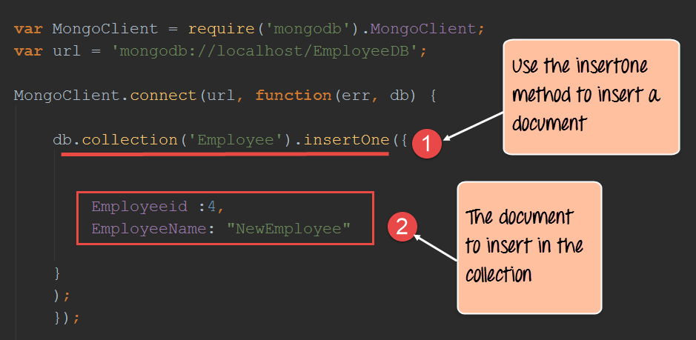
var MongoClient = require('mongodb').MongoClient;
var url = 'mongodb://localhost/EmployeeDB';

MongoClient.connect(url, function(err, db) {

db.collection('Employee').insertOne({
Employeeid: 4,
EmployeeName: "NewEmployee"
});
});
Code Explanation:
- Here we are using the insertOne method from the MongoDB library to insert a document into the Employee collection.
- We are specifying the document details of what needs to be inserted into the Employee collection.
If you now check the contents of your MongoDB database, you will find the record with Employeeid of 4 and EmployeeName of "NewEmployee" inserted into the Employee collection.
Note: The console will not show any output because the record is being inserted in the database and no output can be shown here.

To check that the data has been properly inserted in the database, you need to execute the following commands in MongoDB
- Use EmployeeDB
- db.Employee.find({Employeeid :4 })
The first statement ensures that you are connected to the EmployeeDb database. The second statement searches for the record which has the employee id of 4.
- Updating documents in a collection - Documents can be updated in a collection using the updateOne method provided by the MongoDB library. The below code snippet shows how to update a document in a mongoDB collection.
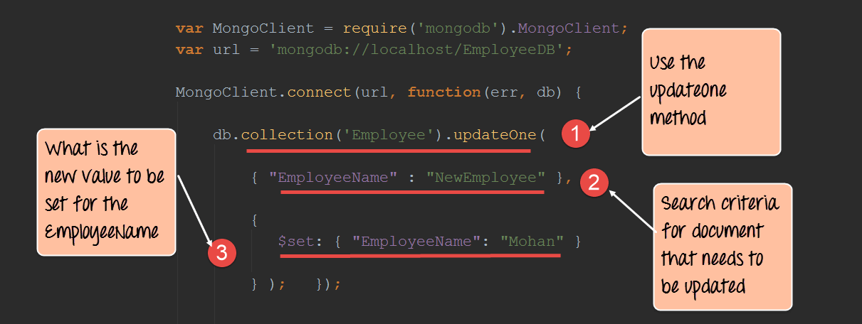
var MongoClient = require('mongodb').MongoClient;
var url = 'mongodb://localhost/EmployeeDB';

MongoClient.connect(url, function(err, db) {

db.collection('Employee').updateOne({
"EmployeeName": "NewEmployee"
}, {
$set: {
"EmployeeName": "Mohan"
}
});
});
Code Explanation:
- Here we are using the "updateOne" method from the MongoDB library, which is used to update a document in a mongoDB collection.
- We are specifying the search criteria of which document needs to be updated. In our case, we want to find the document which has the EmployeeName of "NewEmployee."
- We then want to set the value of the EmployeeName of the document from "NewEmployee" to "Mohan".
If you now check the contents of your MongoDB database, you will find the record with Employeeid of 4 and EmployeeName of "Mohan" updated in the Employee collection.
To check that the data has been properly updated in the database, you need to execute the following commands in MongoDB
- Use EmployeeDB
- db.Employee.find({Employeeid :4 })
The first statement ensures that you are connected to the EmployeeDb database. The second statement searches for the record which has the employee id of 4.
- Deleting documents in a collection - Documents can be deleted in a collection using the "deleteOne" method provided by the MongoDB library. The below code snippet shows how to delete a document in a mongoDB collection.
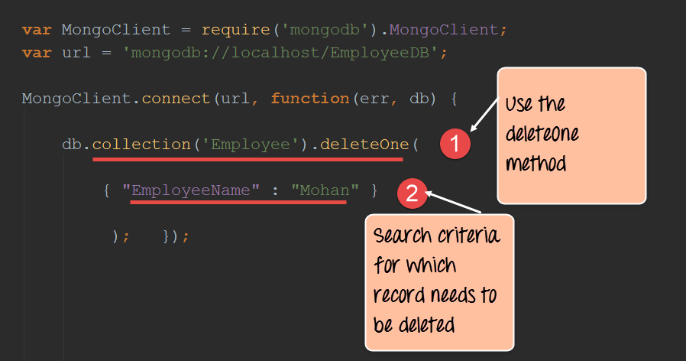
var MongoClient = require('mongodb').MongoClient;
var url = 'mongodb://localhost/EmployeeDB';

MongoClient.connect(url, function(err, db) {

db.collection('Employee').deleteOne(

{
"EmployeeName": "Mohan"
}

);
});
Code Explanation:
- Here we are using the "deleteOne" method from the MongoDB library, which is used to delete a document in a mongoDB collection.
- We are specifying the search criteria of which document needs to be deleted. In our case, we want to find the document which has the EmployeeName of "Mohan" and delete this document.
If you now check the contents of your MongoDB database, you will find the record with Employeeid of 4 and EmployeeName of "Mohan" deleted from the Employee collection.
To check that the data has been properly updated in the database, you need to execute the following commands in MongoDB
- Use EmployeeDB
- db.Employee.find()
The first statement ensures that you are connected to the EmployeeDb database. The second statement searches and display all of the records in the employee collection. Here you can see if the record has been deleted or not.

How to build a node express app with MongoDB to store and serve content
Building an application with a combination of both using express and MongoDB is quite common nowadays.
When working with JavaScript web based applications, one will normally here of the term MEAN stack.
- The term MEAN stack refers to a collection of JavaScript based technologies used to develop web applications.
- MEAN is an acronym for MongoDB, ExpressJS, AngularJS and Node.js.
Hence, it's always good to understand how Node.js and MongoDB work together to deliver applications which interact with backend databases.
Let's look at a simple example of how we can use "express" and "MongoDB" together. Our example will make use of the same Employee collection in the MongoDB EmployeeDB database.
We will now incorporate Express to display the data on our web page when it is requested by the user. When our application runs on Node.js, one might need to browse to the URL http://localhost:3000/Employeeid.
When the page is launched, all the employee id in the Employee collection will be displayed. So let's see the code snippet in sections which will allow us to achieve this.
Step 1) Define all the libraries which need to be used in our application, which in our case is both the MongoDB and express library.
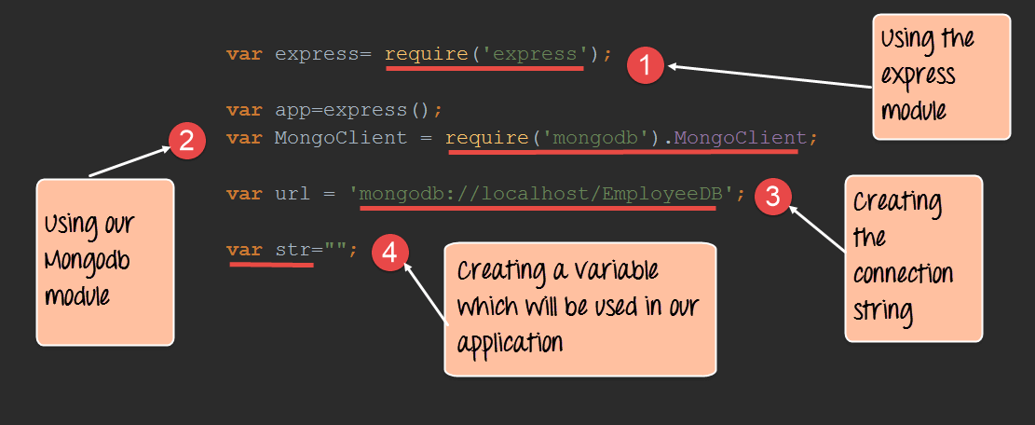
Code Explanation:
- We are defining our 'express' library, which will be used in our application.
- We are defining our 'express' library, which will be used in our application for connecting to our MongoDB database.
- Here we are defining the URL of our database to connect to.
- Finally, we are defining a string which will be used to store our collection of employee id which need to be displayed in the browser later on.
Step 2) In this step, we are now going to get all of the records in our 'Employee' collection and work with them accordingly.
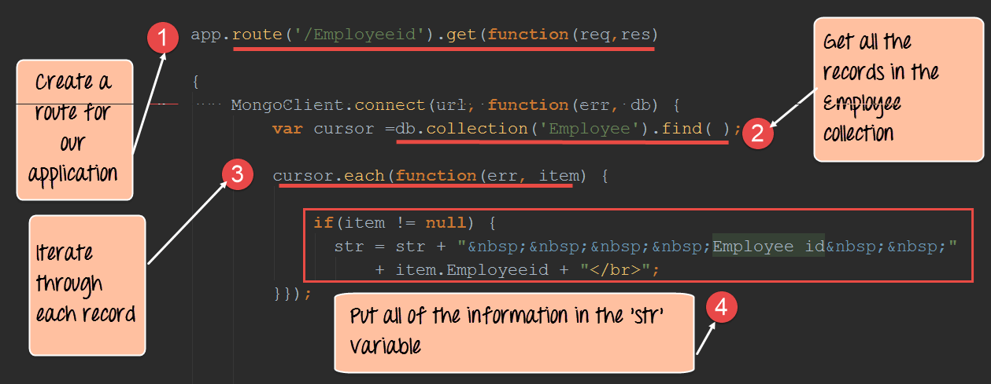

Code Explanation:
- We are creating a route to our application called 'Employeeid.' So whenever anybody browses to http://localhost:3000/Employeeid of our application, the code snippet defined for this route will be executed.
- Here we are getting all of the records in our 'Employee' collection through the db.collection('Employee').find() command. We are then assigning this collection to a variable called cursor. Using this cursor variable, we will be able to browse through all of the records of the collection.
- We are now using the cursor.each() function to navigate through all of the records of our collection. For each record, we are going to define a code snippet on what to do when each record is accessed.
- Finally, we see that if the record returned is not null, then we are taking the employee via the command "item.Employeeid". The rest of the code is just to construct a proper HTML code which will allow our results to be displayed properly in the browser.
Step 3) In this step, we are going to send our output to the web page and make our application listen on a particular port.
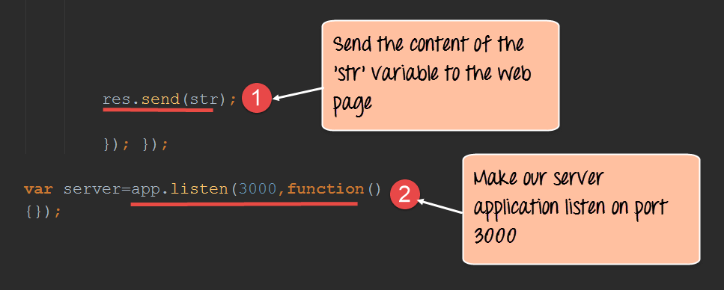
Code Explanation:
- Here we are sending the entire content which was constructed in the earlier step to our web page. The 'res' parameter allows us to send content to our web page as a response.
- We are making our entire Node.js application listen on port 3000.
Output:
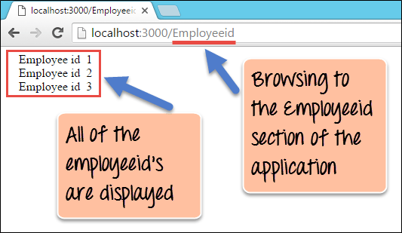
From the output,
- It clearly shows that all of the employeeid's in the Employee collection were retrieved. This is because we use the MongoDB driver to connect to the database and retrieve all the Employee records and subsequently used "express" to display the records.
Here is the code for your reference
var express = require('express');
var app = express();
var MongoClient = require('mongodb').MongoClient;
var url = 'mongodb://localhost/EmployeeDB';
var str = "";

app.route('/Employeeid').get(function(req, res)

{
MongoClient.connect(url, function(err, db) {
var cursor = db.collection('Employee').find();
//noinspection JSDeprecatedSymbols
cursor.each(function(err, item) {

if (item != null) {
str = str + " Employee id " + item.Employeeid + "</br>";
}
});
res.send(str);
db.close();
});
});

var server = app.listen(3000, function() {});
Note: cursor.each maybe deprecated based on version of your MongoDB driver. You can append //noinspection JSDeprecatedSymbols before cursor.each to circumvent the issue. Alternatively, you can use forEach. Below is the sample code using forEach
var express = require('express');
var app = express();
var MongoClient = require('mongodb').MongoClient;
var url = 'mongodb://localhost/EmployeeDB';
var str = "";

app.route('/Employeeid').get(function(req, res) {
MongoClient.connect(url, function(err, db) {
var collection = db.collection('Employee');
var cursor = collection.find({});
str = "";
cursor.forEach(function(item) {
if (item != null) {
str = str + " Employee id " + item.Employeeid + "</br>";
}
}, function(err) {
res.send(str);
db.close();
}
);
});
});
var server = app.listen(8080, function() {});
Summary
- Node.js is used in conjunction with NoSQL databases to build a lot of modern days web applications. Some of the common databases used are MySQL and MongoDB.
- One of the common modules used for working with MongoDB databases is a module called 'MongoDB.' This module is installed via the Node package manager.
- With the MongoDB module, it's possible to query for records in a collection and perform the normal update, delete and insert operations.
- Finally, one of the modern practices is to use the express framework along with MongoDB to deliver modern day applications. The Express framework can make use of the data returned by the MongoDB driver and display the data to the user in the web page accordingly.

