Case Study: Running a Wordpress Application on Local host
Situation:
You are a DevOps Engineer, working in a software company named Parmer
Infotech. You have been assigned the following tasks:
➢Run WordPress on local host
➢Create a Docker swarm with 2 worker node and 1 master node
Challenges:
- Run WordPress on local host
- Create a Docker swarm with 2 worker node and 1 master node
Actions:
- Run WordPress on local host
- Create a Docker swarm with 2 worker node and 1 master node
Results:
- Run WordPress on local host

Install LAMP on Ubuntu
Download the latest WordPress package and extract it by issuing the commands below on the terminal:
$ wget -c http://wordpress.org/latest.tar.gz
$ tar -xzvf latest.tar.gz
Then move the WordPress files from the extracted folder to the Apache default root directory, /var/www/html/:
$ sudo rsync -av wordpress/* /var/www/html/
Next, set the correct permissions on the website directory, that is give ownership of the WordPress files to the web server as follows:
$ sudo chown -R www-data:www-data /var/www/html/
$ sudo chmod -R 755 /var/www/html/

Step 5: Create WordPress Database
Execute the command below and provide the root user password, then hit Enter to move to the mysql shell:
$ mysql -u root -p
At the mysql shell, type the following commands, pressing Enter after each line of a mysql command. Remember to use your own, valid values for database_name, databaseuser, and also use a strong and secure password as databaseuser_password:
mysql> CREATE DATABASE wp_myblog;
mysql> GRANT ALL PRIVILEGES ON wp_myblog.* TO 'your_username_here'@'localhost' IDENTIFIED BY 'your_chosen_password_here';
mysql> FLUSH PRIVILEGES;
mysql> EXIT;
Go the /var/www/html/ directory and rename existing wp-config-sample.php to wp-config.php:
$ sudo mv wp-config-sample.php wp-config.php
then update it with your database information under the MySQL settings section (refer to the highlighted boxes in the image below):
// ** MySQL settings - You can get this info from your web host ** //
/** The name of the database for WordPress */
define('DB_NAME', 'database_name_here'); /** MySQL database username */ define('DB_USER', 'username_here'); /** MySQL database password */ define('DB_PASSWORD', 'password_here'); /** MySQL hostname */ define('DB_HOST', 'localhost'); /** Database Charset to use in creating database tables. */ define('DB_CHARSET', 'utf8'); /** The Database Collate type. Don't change this if in doubt. */ define('DB_COLLATE', '');
Afterwards, restart the web server and mysql service using the commands below:
$ sudo systemctl restart apache2.service
$ sudo systemctl restart mysql.service
Open your web browser, then enter your server address: http://server-address to get the welcome page below. Read through the page and click on “Let’s go!” to proceed further and fill all requested on screen information .
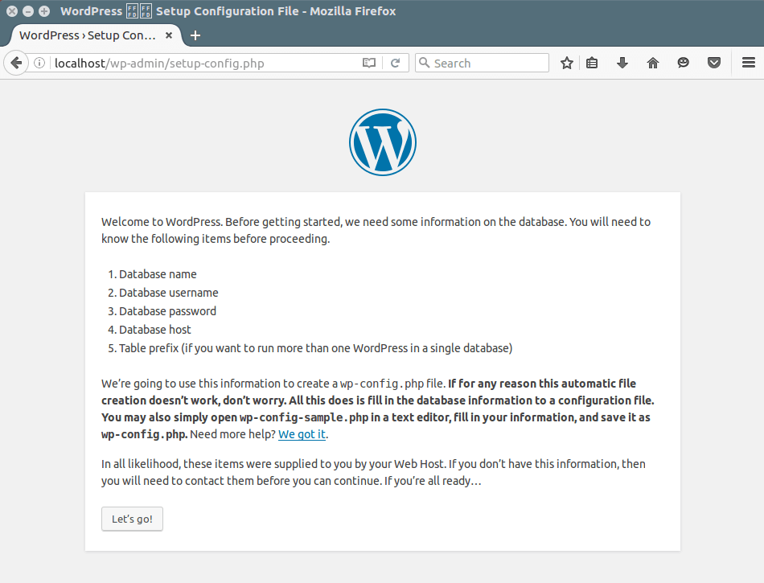

- Create a Docker swarm with 2 worker node and 1 master node

Create a swarm
Estimated reading time: 2 minutes
After you complete the tutorial setup steps, you’re ready to create a swarm. Make sure the Docker Engine daemon is started on the host machines.
- Open a terminal and ssh into the machine where you want to run your manager node. This tutorial uses a machine named manager1. If you use Docker Machine, you can connect to it via SSH using the following command:
$ docker-machine ssh manager1
- Run the following command to create a new swarm:
$ docker swarm init --advertise-addr <MANAGER-IP>
Note: If you are using Docker Desktop for Mac or Docker Desktop for Windows to test single-node swarm, simply run docker swarm init with no arguments. There is no need to specify --advertise-addr in this case. To learn more, see the topic on how to Use Docker Desktop or Mac or Docker Desktop for Windows with Swarm.
In the tutorial, the following command creates a swarm on the manager1 machine:
$ docker swarm init --advertise-addr 192.168.99.100
Swarm initialized: current node (dxn1zf6l61qsb1josjja83ngz) is now a manager.

To add a worker to this swarm, run the following command:

docker swarm join \
--token SWMTKN-1-49nj1cmql0jkz5s954yi3oex3nedyz0fb0xx14ie39trti4wxv-8vxv8rssmk743ojnwacrr2e7c \
192.168.99.100:2377

To add a manager to this swarm, run 'docker swarm join-token manager' and follow the instructions.
The --advertise-addr flag configures the manager node to publish its address as 192.168.99.100. The other nodes in the swarm must be able to access the manager at the IP address.
The output includes the commands to join new nodes to the swarm. Nodes will join as managers or workers depending on the value for the --token flag.
- Run docker info to view the current state of the swarm:
$ docker info

Containers: 2
Running: 0
Paused: 0
Stopped: 2
...snip...
Swarm: active
NodeID: dxn1zf6l61qsb1josjja83ngz
Is Manager: true
Managers: 1
Nodes: 1
...snip...
- Run the docker node ls command to view information about nodes:
$ docker node ls

ID HOSTNAME STATUS AVAILABILITY MANAGER STATUS
dxn1zf6l61qsb1josjja83ngz * manager1 Ready Active Leader

The * next to the node ID indicates that you’re currently connected on this node.
Docker Engine swarm mode automatically names the node for the machine host name. The tutorial covers other columns in later steps.

Add nodes to the swarm
Estimated reading time: 2 minutes
Once you’ve created a swarm with a manager node, you’re ready to add worker nodes.
- Open a terminal and ssh into the machine where you want to run a worker node. This tutorial uses the name worker1.
- Run the command produced by the docker swarm init output from the Create a swarmtutorial step to create a worker node joined to the existing swarm:
$ docker swarm join \
--token SWMTKN-1-49nj1cmql0jkz5s954yi3oex3nedyz0fb0xx14ie39trti4wxv-8vxv8rssmk743ojnwacrr2e7c \
192.168.99.100:2377

This node joined a swarm as a worker.
If you don’t have the command available, you can run the following command on a manager node to retrieve the join command for a worker:
$ docker swarm join-token worker

To add a worker to this swarm, run the following command:

docker swarm join \
--token SWMTKN-1-49nj1cmql0jkz5s954yi3oex3nedyz0fb0xx14ie39trti4wxv-8vxv8rssmk743ojnwacrr2e7c \
192.168.99.100:2377
- Open a terminal and ssh into the machine where you want to run a second worker node. This tutorial uses the name worker2.
- Run the command produced by the docker swarm init output from the Create a swarmtutorial step to create a second worker node joined to the existing swarm:
$ docker swarm join \
--token SWMTKN-1-49nj1cmql0jkz5s954yi3oex3nedyz0fb0xx14ie39trti4wxv-8vxv8rssmk743ojnwacrr2e7c \
192.168.99.100:2377

This node joined a swarm as a worker.
- Open a terminal and ssh into the machine where the manager node runs and run the docker node ls command to see the worker nodes:
ID HOSTNAME STATUS AVAILABILITY MANAGER STATUS
03g1y59jwfg7cf99w4lt0f662 worker2 Ready Active
9j68exjopxe7wfl6yuxml7a7j worker1 Ready Active
dxn1zf6l61qsb1josjja83ngz * manager1 Ready Active Leader
The MANAGER column identifies the manager nodes in the swarm. The empty status in this column for worker1 and worker2 identifies them as worker nodes.
Swarm management commands like docker node ls only work on manager nodes.

