Case Study: Solving Merge Conflict
Situation:
Harry and Kane from Hooli Co., are working separately to implement a new set of features in their feature software. They are facing difficulties to track the changes they’ve made in the original code and are finding difficult to merge their code together.
Challenges:
- Harry and Kane are unable to track the changes made in the original code
- And are finding it difficult to merge their code together
Actions:
- Create two separate branches from master
- Make changes in the same function of the source code in both the branches
- Merge Branches and resolve conflicts
Results:
- Create two separate branches from master
Let suppose you have a project where several developers produce several thousand lines of code. Every developer commits changes to the master branch. Now suppose, you wish to test specific features of the project without interfering with the main branch of the project. To do this, you need to create a separate branch of the code that you could safely test features without breaking the main code.

Working with branches in Git involves several commands:

git branch – List All Branches
This command shows a list of branches. Run the git branch in your terminal.

The * indicates that I am currently on the master branch.

git branch <branch> – Create New Branch
It is easy to create new branches. Remember that a git branch is only a pointer placed on the the master branch when committing a new change. For creating branches, pass the name of branch with command:
git branch <branch name>. In the case of the example, the commands would look like: git branch newbranch
Now, When I run git branch again, the results will show that a new branch is added to the list.

Creating branches does not change the history of the repository. Instead, they add a pointer to the commit.
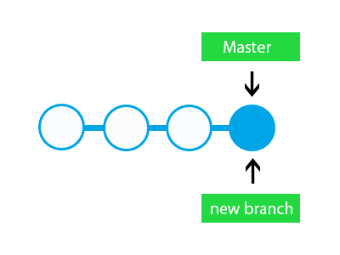
This command could also be used to change the name of the branch. To do this, Pass the new and old name of the branch in the following command:
git branch -m <old name> <new name>. For instance, the command git branch -m example title_branch will rename example branch to title_branch.
when I run the command: cat .git/HEAD. You should see that the reference Head has been also been set to this branch.


git checkout -b <branch> – Create & Switch Branches at the Same Time
You could create and switch to a newly created branch at the same time by this command.
git checkout -b newbranch
The checkout command tells Git to fetch the latest changes of the branch and ensure that the working directory has the latest code of that branch.

- Make changes in the same function of the source code in both the branches
Git does not allow you to switch branches when you have uncommitted changes in the code.
Suppose, I have made changes in index.php. And, now I want to switch to newbranch from master. The command will show uncommitted file like this:
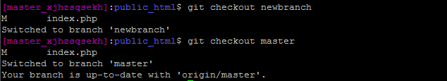
The results shows that there is an uncommitted file index.php.

git diff – Comparing Branches
You can also compare branches to see the changes between the two. For this, Git provides a comparison operator (..). Remember, for this operator to work, all changes should be committed in all the branches. To see the differences, run the command: git diff <branch name>..<branch name>. For instance: git diff master..newbranch
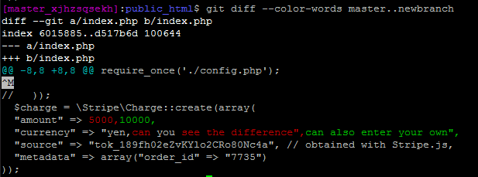
You can see the different versions of same code in the two branches. You need to choose which version is the old one.
If you want to see the differences in same div, you can run the following command:
git diff –color-words master..newbranch. The result is:
You can also check whether the branches have the same version of code or that the branches differ in commits. For instance, you can check which branch has (or hasn’t) all the commits of other branches. Run the following command:
git branch –merged. In my case, the result looks like:
This means that the master branch has all the commits of the example branch, but it does not have all the commits of the newbranch.

git clone – Cloning Branches From the Repository
You probably know about cloning GitHub or Bitbucket projects using the HTTP URL: The command is:. git clone https://github.com/shahroznawaz/testdemo.git
However, remember that when you clone a repository, it creates a local copy of the master branch.
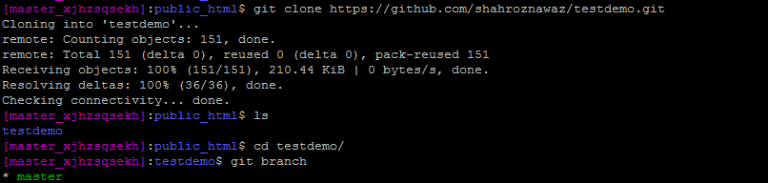
The local copy also has information of other branches, but remember that you need to pull individual branches from the repository. Run git branch -a and you will see the branches highlighted in red. The Head is placed on the master branch which was pulled.
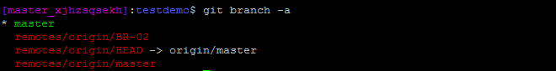
Now to pull up the second branch, which is BR-02. Run the checkout command:
git checkout -b BR-02 origin/BR-02
This command will pull up the branch BR-02 and, additionally, create a local copy with the same name.
Now if you want to clone every branch from GitHub, you need to run some commands. First clone the repository with this clone command with the suffix .git
git clone –mirror https://github.com/shahroznawaz/testdemo.git .git
At this point, you will only see the .git folder because this is just an bear repository. Next run the command: git config –bool core.bare false
The final command is: git reset –hard. Now you will see all the branches from the GitHub repo.

- Merge Branches and resolve conflicts
While working on several branches, you need to merge the commits of individual branches into the master. This should be done when you have successfully tested the new feature code in a separate branch and now you are ready to merge it with the master branch.

Merge Two Branches
So far, I was working with two branches: master and newbranch. I will now add one more branch package and next, add some commits to it. I will now show how to merge the package branch.
First switch to the master branch and run the following Git command:
git merge <branch>. In my example, the command would be git merge package

Do the git log command to see whether the commits merged in the master.Merging branches is a complex process and often leads to merge conflicts. I will now define what conflicts are how to resolve these conflicts!

Why Conflicts Occur
In simple terms, conflicts occur when changes are made to the same line by two different people. Similarly, conflicts could also arise if one person edits a file and another deletes it.
To demonstrate the concept of conflicts, I have made changes in the same line of the index.php file in both branches. Now, when I merge these branches, a conflict message popups like this.
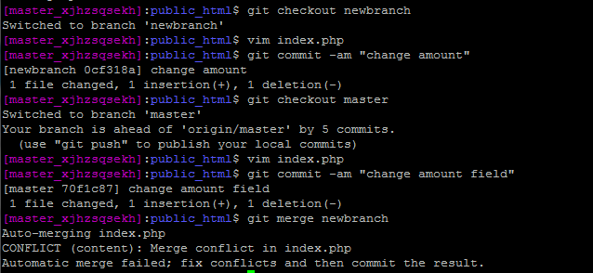
At this stage, when I open index.php, I discover that it contains extra message lines.
Changes in branch master: “amount” -> “total_amount”
Changes in branch newbranch: 10000 -> 50000
It adds the <<<<<<<Head line to indicate that the Head contains this change in master. And >>>>>>>newbranch showing the change in itself.
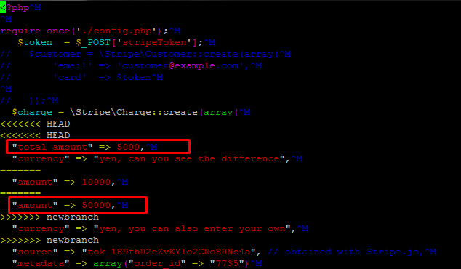
In this scenario, Git is not smart enough to merge changes itself. It will ask you to determine the latest copy of the code yourself.

Resolving Merge Conflicts
Git provides three ways of resolving conflicts:
- Aborting the merge
- Resolving conflicts manually
- Using Tools
If you don’t want to merge the branches, you can simply abort the merge process by following command:
git merge –abort
This command will abort the merge process and get you out of the conflict.
For resolving conflicts manually, you need to look at the file and remove the unwanted version changes in the file. Also remove >>>>>>Head & ====== from the lines and make sure that the file has proper code syntax. Save and commit the file.When you are between merge states, you do not need to write a commit message. Just type git commit and the pop-up window will indicate the conflict in the files. Remove the lines to resolve the conflict.
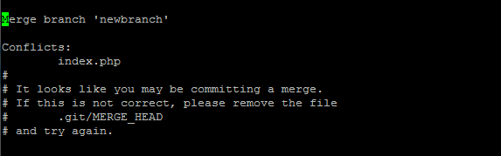
Now press Ctrl+O to overwrite the file. The command will ask you to enter the file’s name and then save it. Now check whetherthe two branches, master and newbranch will merge. Type git log –oneline and it will show all the commits in the master. Check the top most commit.
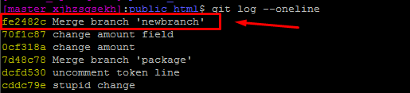
This means that the two branches have been successfully merged. Reconfirm this by running the command git branch –merge. The output will be all the branches that are merged in the master.
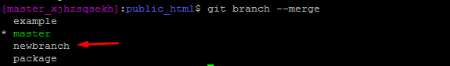
Several open source tools focus on working with Git and especially conflict resolution using a GUI that greatly simplifies matters. I cover some of these tools in a separate article. Git has a command to list all tools which can resolve conflicts. Simply type git mergetool and you will see thee list of available tools.
Using Merge tool:-
git-mergetool - Run merge conflict resolution tools to resolve merge conflicts
$ git mergetool [--tool=<tool>] [-y | --[no-]prompt] [<file>…​]
Use git mergetool to run one of several merge utilities to resolve merge conflicts. It is typically run after git merge.
If one or more <file> parameters are given, the merge tool program will be run to resolve differences on each file (skipping those without conflicts). Specifying a directory will include all unresolved files in that path. If no <file> names are specified, git mergetool will run the merge tool program on every file with merge conflicts.

OPTIONS
-t <tool>
--tool=<tool>
Use the merge resolution program specified by <tool>. Valid values include emerge, gvimdiff, kdiff3, meld, vim diff, and tortoise merge. Run git mergetool --tool-help for the list of valid <tool> settings.
If a merge resolution program is not specified, git mergetool will use the configuration variable merge.tool. If the configuration variable merge.tool is not set, git mergetool will pick a suitable default.
You can explicitly provide a full path to the tool by setting the configuration variable mergetool.<tool>.path. For example, you can configure the absolute path to kdiff3 by settingmergetool.kdiff3.path. Otherwise, git mergetool assumes the tool is available in PATH.
Instead of running one of the known merge tool programs, git mergetool can be customized to run an alternative program by specifying the command line to invoke in a configuration variable mergetool.<tool>.cmd.
When git mergetool is invoked with this tool (either through the -t or --tool option or the merge.tool configuration variable) the configured command line will be invoked with $BASE set to the name of a temporary file containing the common base for the merge, if available; $LOCAL set to the name of a temporary file containing the contents of the file on the current branch; $REMOTE set to the name of a temporary file containing the contents of the file to be merged, and $MERGED set to the name of the file to which the merge tool should write the result of the merge resolution.
If the custom merge tool correctly indicates the success of a merge resolution with its exit code, then the configuration variable mergetool.<tool>.trustExitCode can be set to true. Otherwise, git mergetool will prompt the user to indicate the success of the resolution after the custom tool has exited.
--tool-help
Print a list of merge tools that may be used with --tool.
-y
--no-prompt
Don’t prompt before each invocation of the merge resolution program. This is the default if the merge resolution program is explicitly specified with the --tool option or with the merge.toolconfiguration variable.
--prompt
Prompt before each invocation of the merge resolution program to give the user a chance to skip the path.
-g
--gui
When git-mergetool is invoked with the -g or --gui option the default merge tool will be read from the configured merge.guitool variable instead of merge.tool.
--no-gui
This overrides a previous -g or --gui setting and reads the default merge tool will be read from the configured merge.tool variable.
-O<orderfile>
Process files in the order specified in the <orderfile>, which has one shell glob pattern per line. This overrides the diff.orderFile configuration variable (see git-config[1]). To cancel diff.orderFile, use -O/dev/null.

TEMPORARY FILES
git mergetool creates *.orig backup files while resolving merges. These are safe to remove once a file has been merged and its git mergetool session has completed.
Setting the mergetool.keepBackup configuration variable to false causes git mergetool to automatically remove the backup as files are successfully merged.

