Case Study: Setup a Remote System Using Ansible Role
Situation:
Rashford assoc. are having trouble provisioning their server environment because of the inconsistencies caused by the new update. They have Hired Marcus to solve their problems related to managing servers. Marcus, after researching, introduced Ansible to the system. Now, he needs to provision the production environment for the upcoming update of their software.

Actions:
- Create separate roles for setting up Apache Tomcat and Apache Maven
- Add the necessary logic to the roles to set up the tools
- Create a new playbook and call Tomcat as well as Maven roles inside it
- Execute the playbook on all the hosts
Results:
- Create separate roles for setting up Apache Tomcat and Apache Maven

Install Apache Tomcat 9
In order to install Jenkins we need to deploy the Jenkins war file by using Apache Tomcat. I will use wget command to install specific version of Apache Tomcat i.e. Tomcat 9 in this case.
First, to install wget execute the below command:
sudo yum install wget
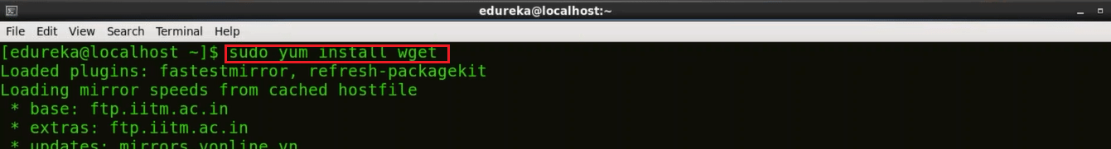
Now I will use wget to download the Tar file for Tomcat 9 using the below command:
wget https://archive.apache.org/dist/tomcat/tomcat-9/v9.0.0.M10/bin/apache-tomcat-9.0.0.M10.tar.gz
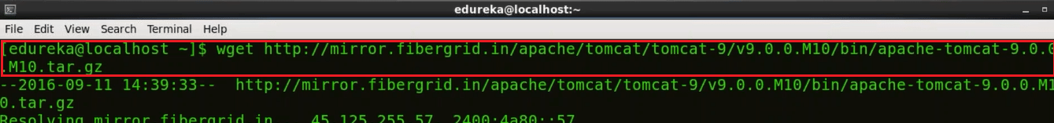
Next, I will show you how to extract the contents from this downloaded Tomcat 9 tar file. For this I will use tar command:
tar xzf apache-tomat-9.0.0.M10.tar.gz
To make it simple I will move this extracted file to a new directory Tomcat9 using the mv command and to do that I will execute the following command:
mv apache-tomcat-9.0.0.M10 tomcat9
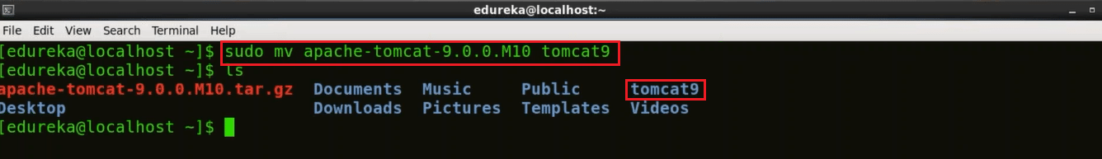
Our next step is to provide a username and password for Apache Tomcat and for that I will use gedit editor, you can use any other editor as per your comfort.
gedit /home/edureka/tomcat9/conf/tomcat-users.xml
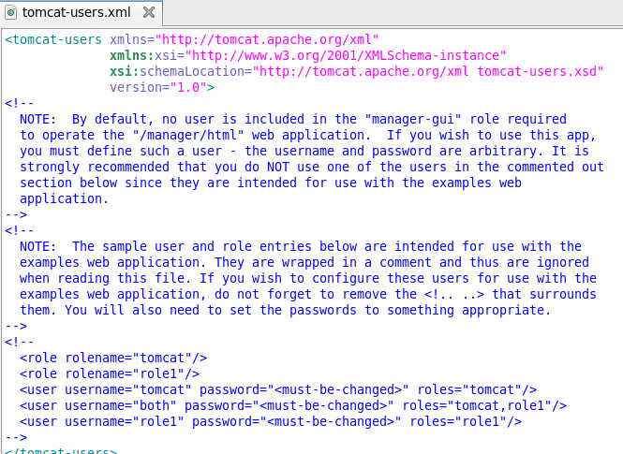
Now delete the content of the tomcat-users.xml file. Copy the below block and paste it in tomcat-users.xml file.
<?xml version='1.0' encoding='utf-8'?>
<tomcat-users>
<role rolename="manager-gui"/>
<role rolename="manager-script"/>
<role rolename="manager-jmx"/>
<role rolename="manager-jmx"/>
<role rolename="admin-gui"/>
<role rolename="admin-script"/>
<user username="edureka" password="edureka" roles="manager-gui,manager-script,manager-jmx,manager-status,admin-gui,admin-script"/>
</tomcat-users>
The updated tomcat-users.xml file will look like this:
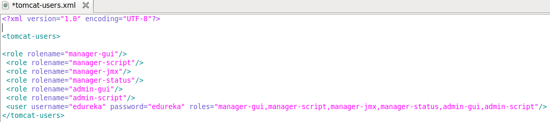
In the above image, as you can see that I have defined several roles and for all these roles I have given one single username and password i.e. edureka. If you want to assign different username and password for different roles you can do that as well.
Now save it and close the file to go back to the terminal.
We need to start Apache Tomcat now, but before that I will change my directory to Tomcat9 by executing the below command:
cd tomcat9
To start Tomcat use the below command:
./bin/startup.sh
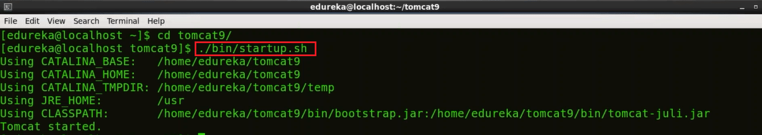
So, Tomcat has now started.
Now open your browser and access localhost:8080 to confirm that Tomcat is up and running. For your information port 8080 is the default port for Apache Tomcat.
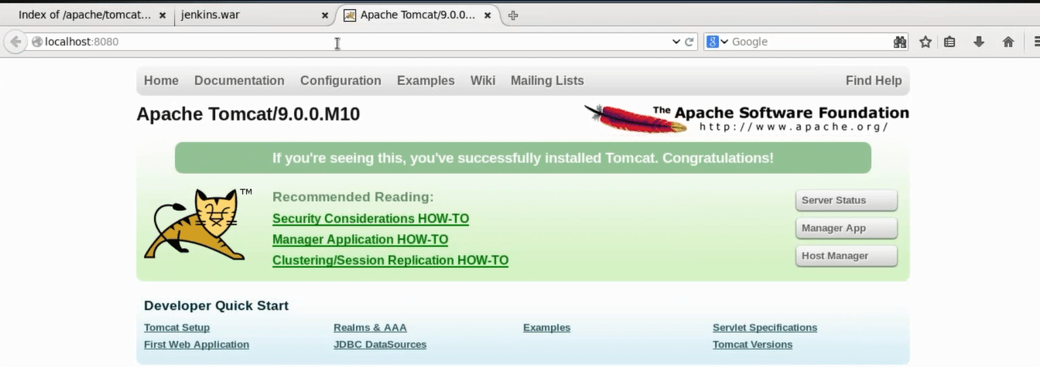Step 3: Download Jenkins war File
I will again use the wget command to download Jenkins war (web archive) file. To get the release list of Jenkins war you can use the URL Jenkins releases
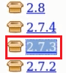
Here copy the link location of the version of Jenkins that you wish to install. I will install Jenkins version 2.7.3, which is highlighted in the snapshot.
Go back to the terminal and move to the home directory by executing the below command.
cd
Now download Jenkins war file by using wget command:
wget http://updates.jenkins-ci.org/download/war/2.7.3/jenkins.war
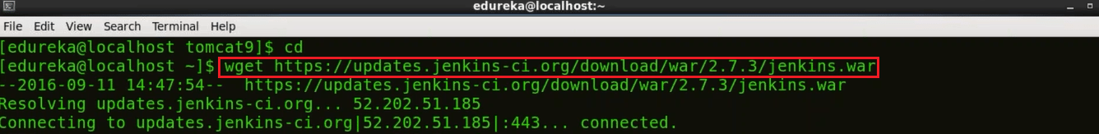

Step 4: Deploy Jenkins war File
To deploy Jenkins war file that you have downloaded in the previous step, open your browser and access localhost:8080 again. Now click on the Manager App.
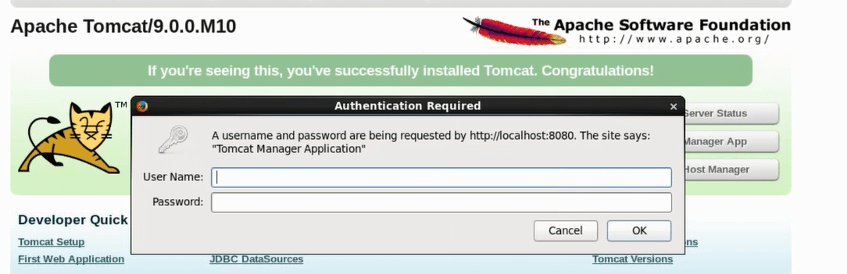
When you click on the Manager app, it will ask for username and password. If you remember I have given one single username and password for all the roles i.e. edureka. Type the below mentioned username and password and click OK.
- Username: edureka
- Password: edureka
Now you will be directed to Tomcat web application manager page. When you scroll down you will find an option called Deploy. Over here you need to give the context path, i.e. /jenkins and directory URL, i.e. location of the Jenkins war file in your system in my case it is /home/edureka/jenkins.war and finally click on Deploy.
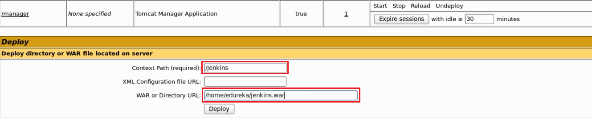
Now in the Tomcat web application manager page you can find Jenkins listed under Applications along with other web apps.
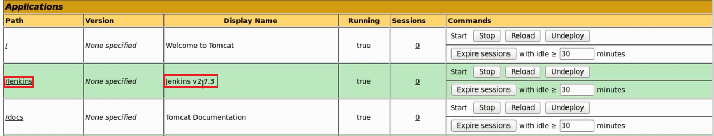
Now I will click on “/jenkins” which is highlighted in the above image.

Step 5: Install Suggested Plugins
When I clicked on jenkins I was directed to Unlock Jenkins page. Please refer to the below snapshot:
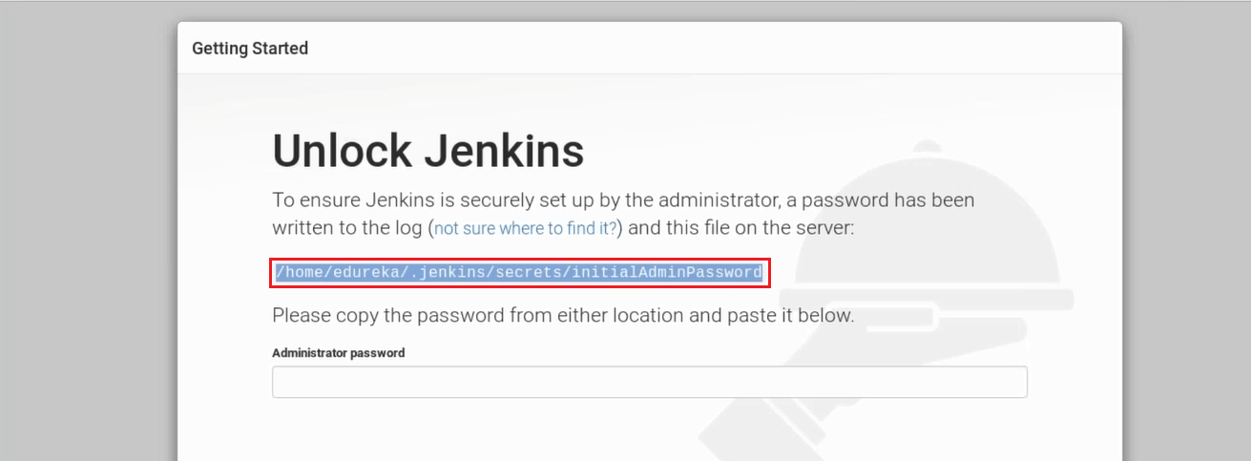
In order to unlock Jenkins first copy the part that I have highlighted in the screenshot above. This is the location that contains your one time password for Jenkins i.e./home/edureka/.jenkins/secrets/initialAdminPassword in my case, it will be different for you. Hence, just copy the path from the screen on your end and go back to the terminal.
Finally, use the following command to get your one time password:
cat <paste the location that you have copied>
This cat command will read the contents of the file that contains the one time password and will display it on the terminal.
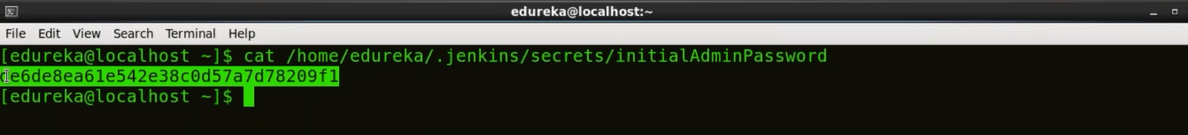
Just copy this password and paste it in the Administrator password text-box in the Unlock Jenkins page. Please refer to the below snapshot.
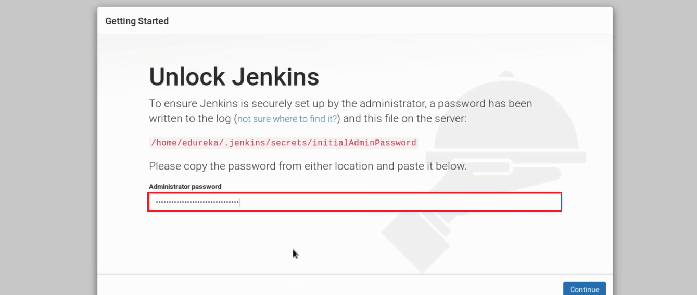
Once you have pasted the password, click on continue.
Now I will install plugins. As you see in the below snapshot there are two options i.e. either I can go with suggested plugins or I can select plugins on my own.

I will go with Install Suggested Plugins.
Snapshot below will give you a list of plugins that will be installed when you click on Install Suggested Plugins.
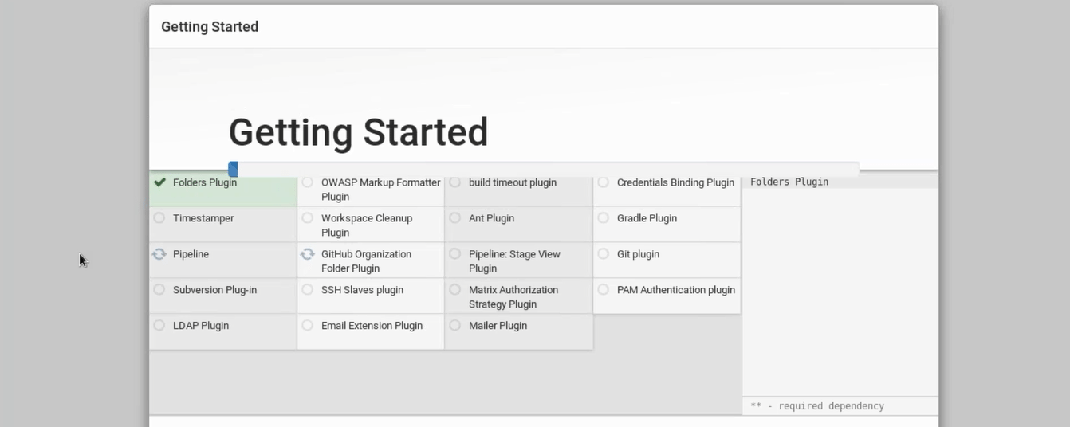
Once the plugins are installed, you will be directed to a page where you have to Create First Admin User. Please fill your relevant details.
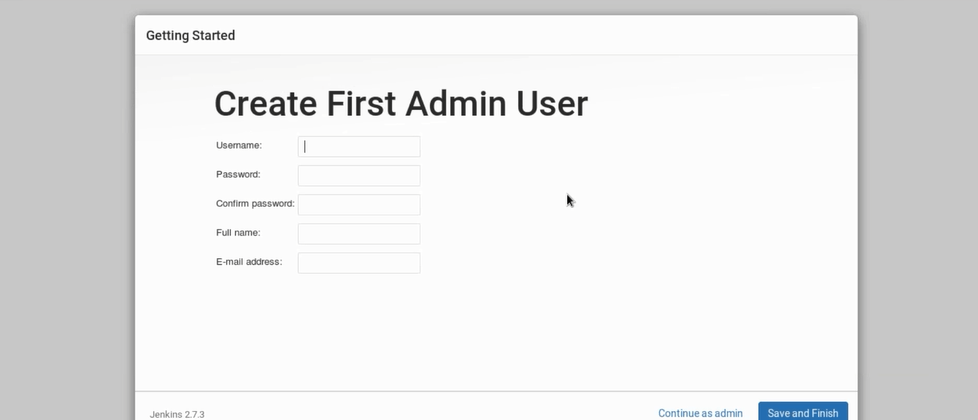
After filling this form, click on save and finish.
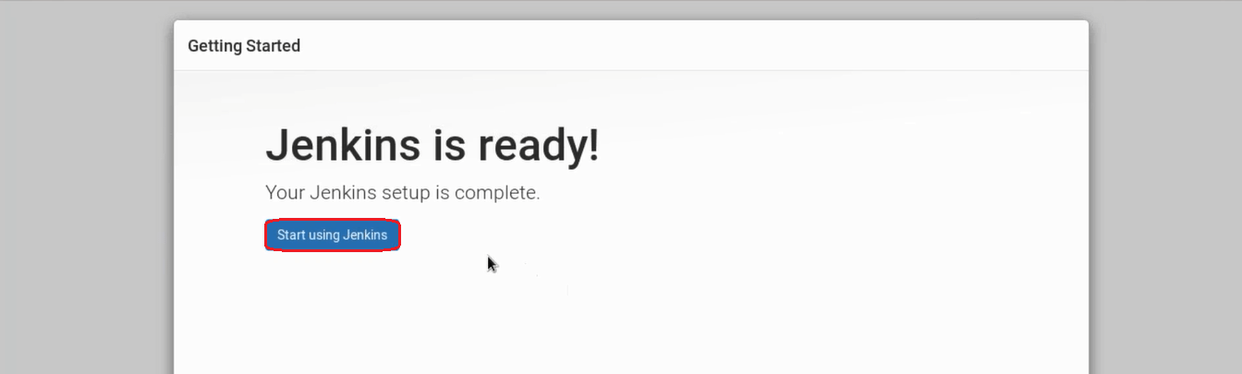
Congratulations! Jenkins is ready now, once you click on start using Jenkins you will be directed to Jenkins dashboard. You can now use Jenkins to continuously trigger build and test for every change made in the source code.
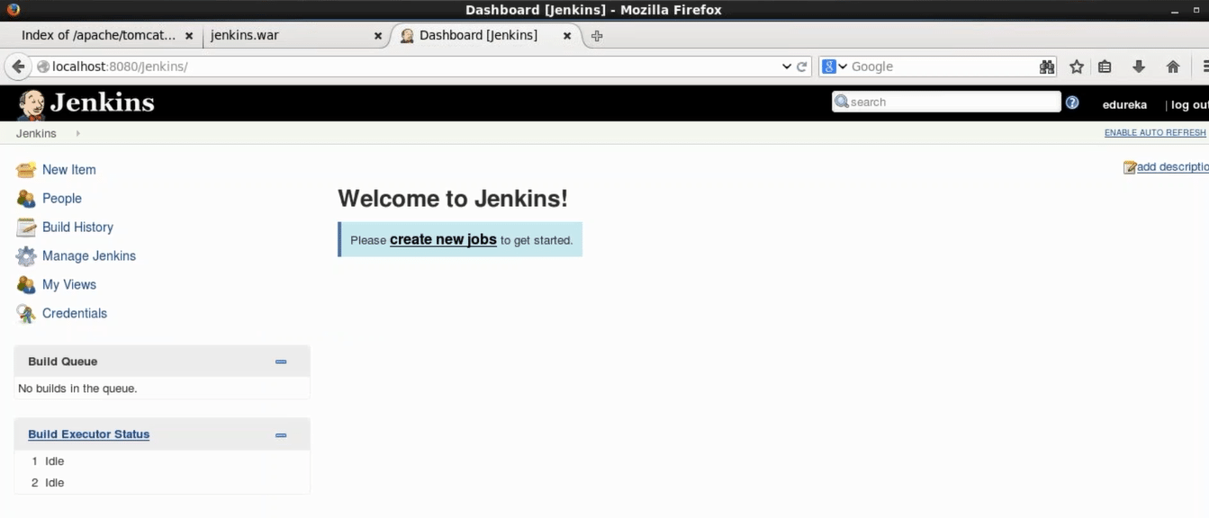
Step 1: Open your Eclipse IDE and create a Maven Project. To create a maven project go to File -> New ->Maven Project. In the dialog box that opens up, mention the Group Id and the Artifact Id and then click on Finish.
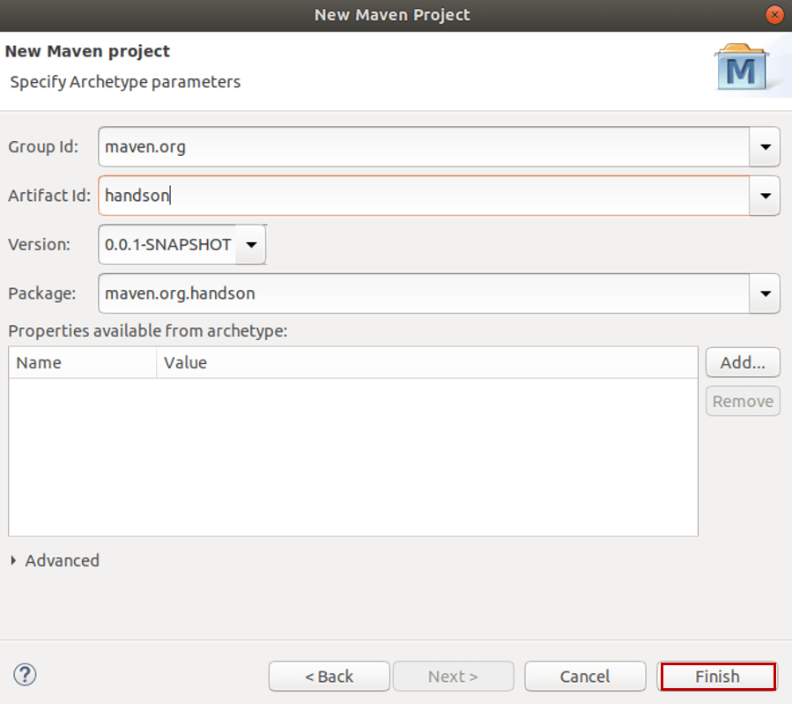
Step 2: Once you create your maven project, include the code of Selenium App in the main Java file and make sure you have inserted the argument to deploy it in the headless mode.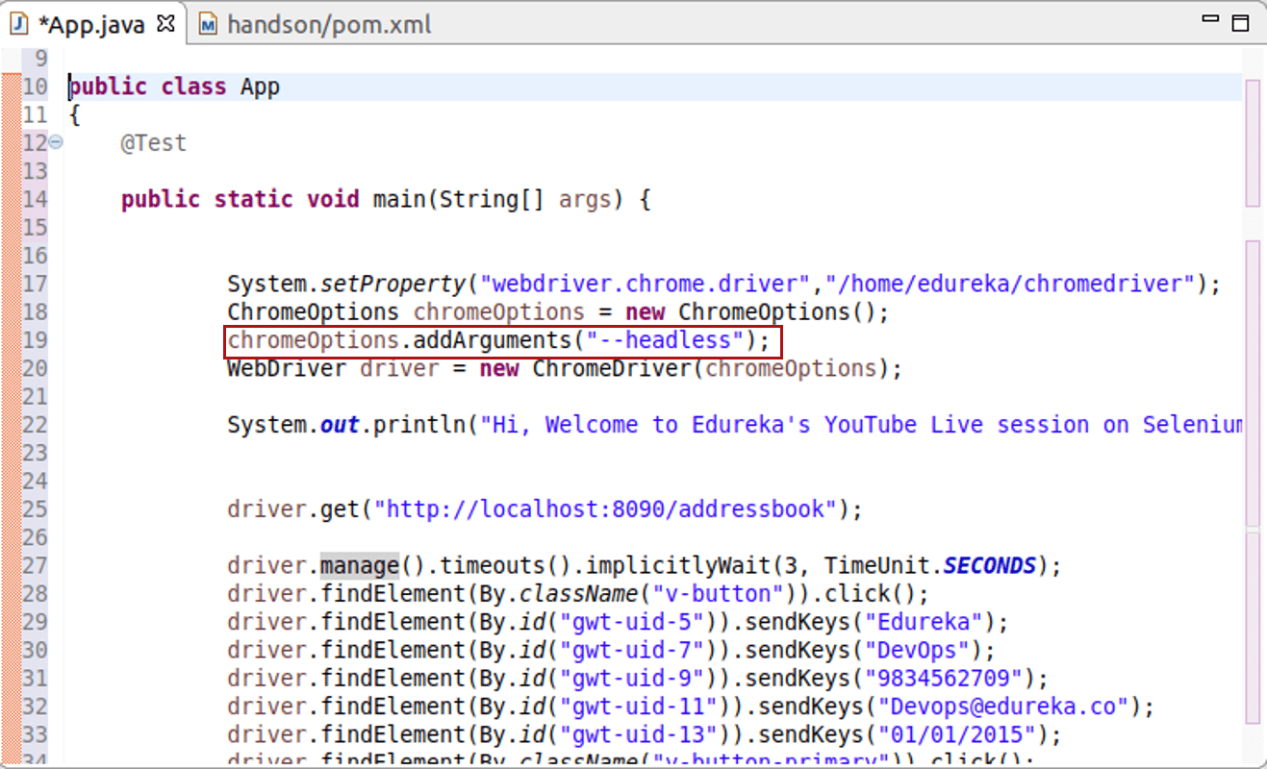
Step 3: After that include the required dependencies in the pom.xml file.
Step 4: After this, your project is ready to run. Since we want to run it in headless mode, we have to deploy this application in the Jenkins Server.
Step 5: So, you have to export your project as a JAR file. To do that, go to File -> Export -> chooseRunnable JAR file. After that click on Next.
Step 6: In the next dialog box, choose the App you want to launch configuration and then choose the directory where you want to export and then click on Finish.
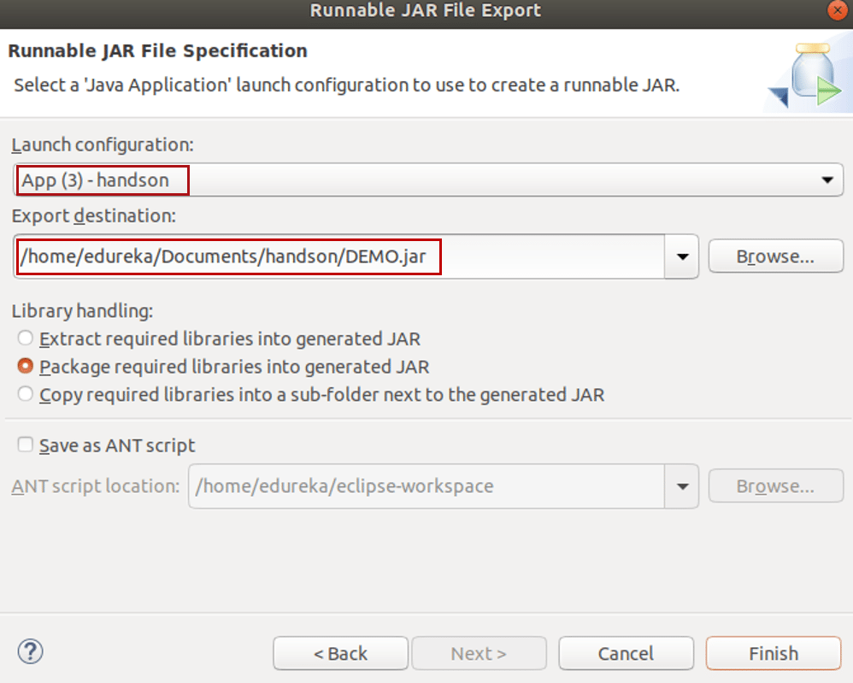
Step 7: After you export your project as a JAR file, you have to push it to a GitHub repository. To push it to the GitHub repository, first, create a new repository in your GitHub account.
Step 7.1: To do that, go to the Repositories tab and choose the option New.
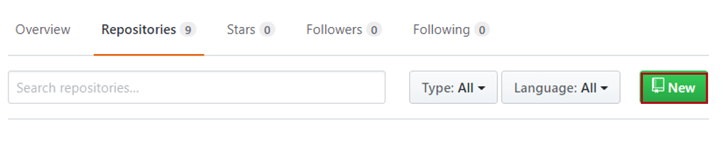
Step 7.2: After that mention the repository name, and choose if you wish your project to be private or public and then finally click on Create Repository.
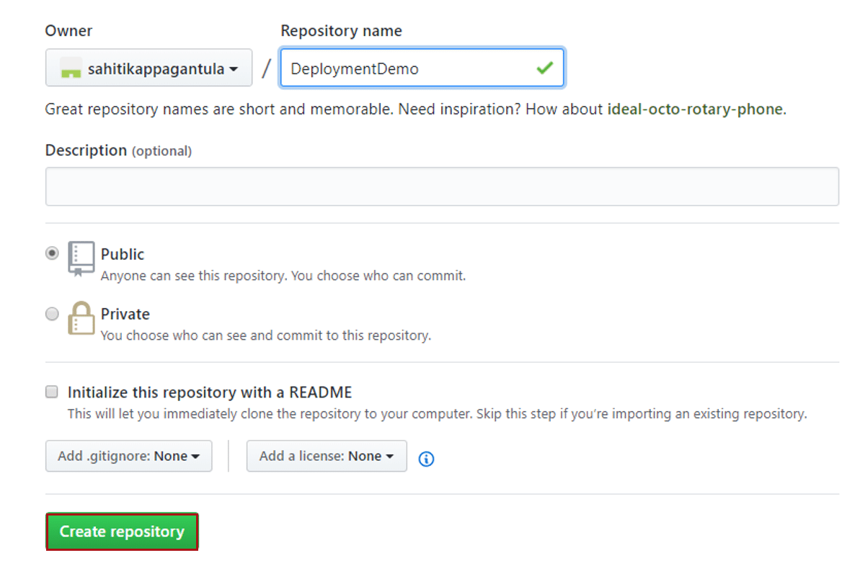
Step 8: To push your project to this repository. Follow the below steps:
Step 8.1: Go to the directory where your jar file is present and initialize git using the command git init.
Step 8.2: After that, perform the git add operation using the command git add.
Step 8.3: Once you are done with that, commit the operation using the command git commit -m ‘Type in your message here’.
Step 8.4: Now connect your GitHub repository to local repository by using the command git remote add origin ‘Link of your repository’(Don’t include quotations)
Step 8.5: Now push your repository by using the command git push -u origin master
Step 9: Once the JAR file has been pushed to the local repository, you have to create a new Job in the Jenkins server. To do that, open your Jenkins Dashboard, and then go to New Item -> Type in the item name -> Click on OK.
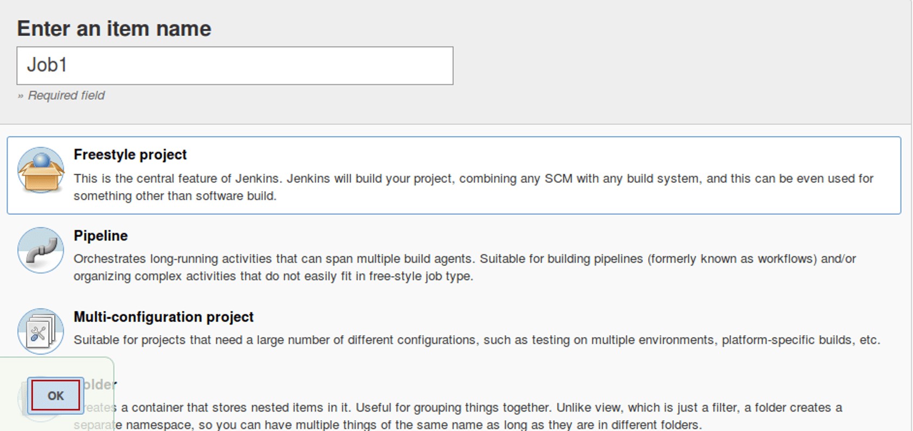
Step 10: Once your job is created, click on the job and go to configure option.
Step 10.1: Go to Source Code Management tab -> Choose Git -> Mention the Repository URL.
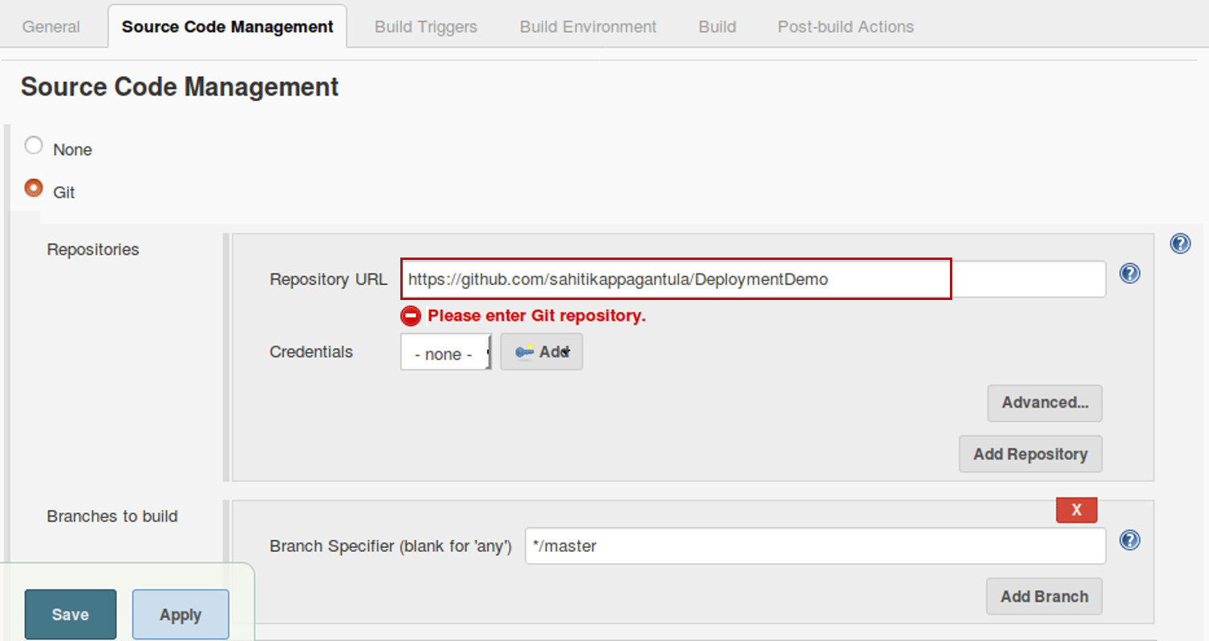
Step 10.2: After that, go to the Build tab and choose the option Execute shell. In this mention the path of the jar file in your Jenkins workspace.
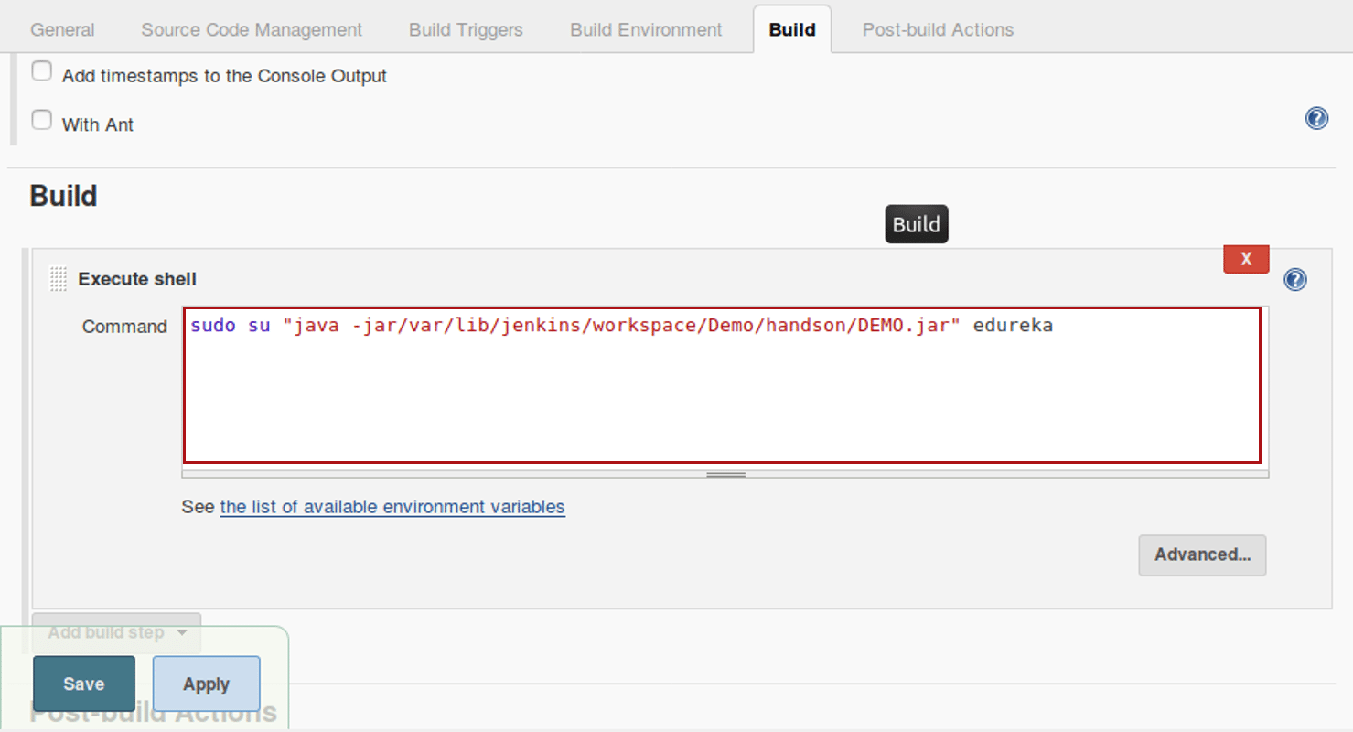
Step 10.3: Once you’re done with the above two steps, save the changes.
Step 11: Click on Build Now, to build the project and see the output.
Since it is continuous deployment, that is the case where this program can be deployed by any person working in the team and the others can only see the output that something has been, changed. They will not know who has deployed it directly onto the production servers.
But, if you run the same project in eclipse then it will run on the browsers which we don’t want in our case presently as in Jenkins we cannot open other browsers!

- Create a new playbook and call Tomcat as well as Maven roles inside it

Step – 1 Compiling The Source Code:
Let’s begin by first creating a Freestyle project in Jenkins. Consider the below screenshot:
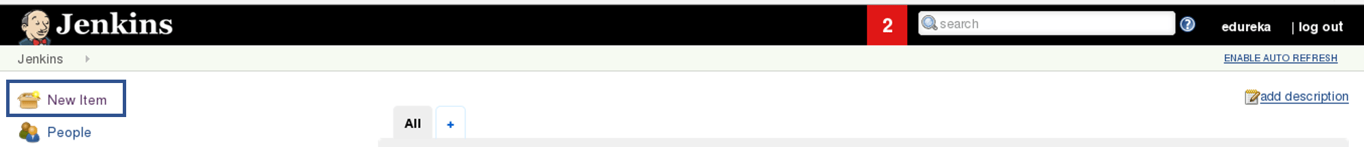
Give a name to your project and select Freestyle Project:
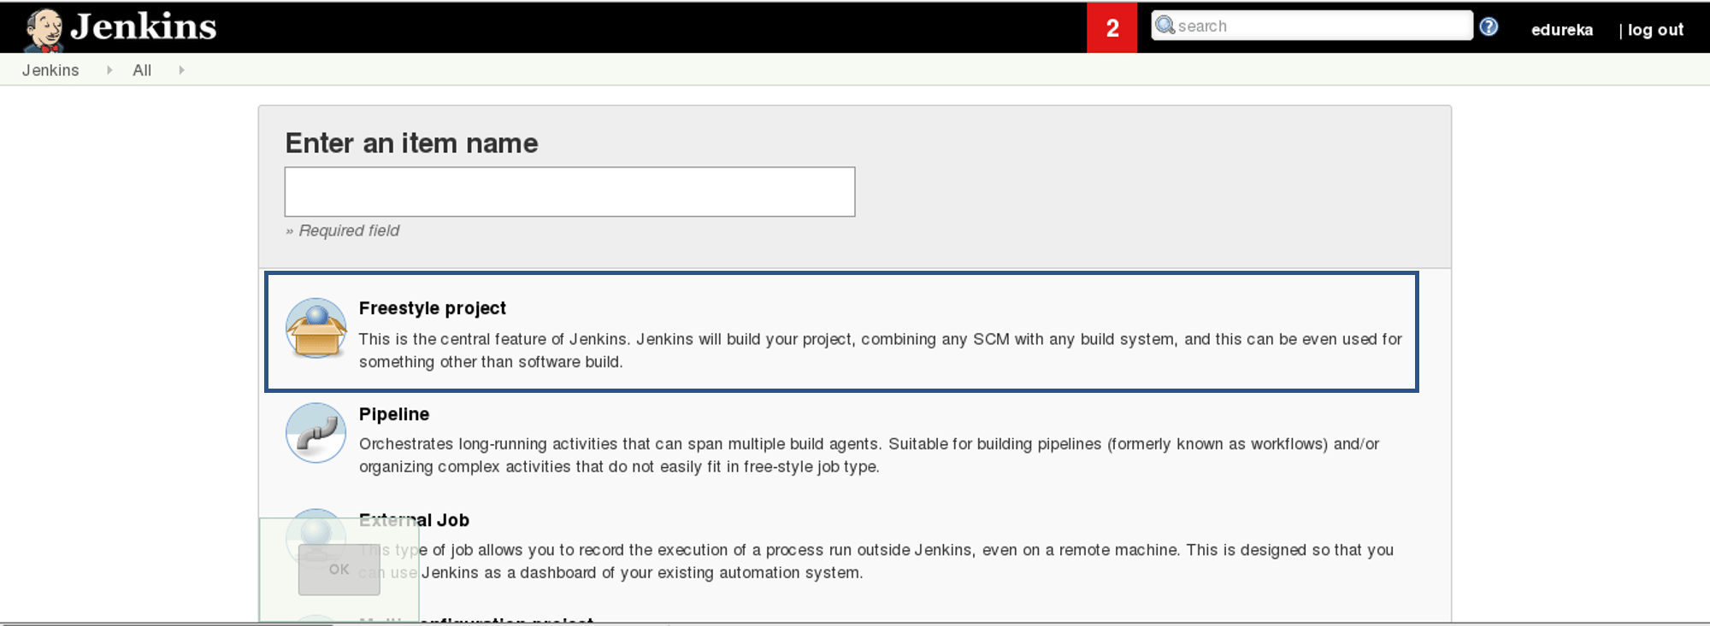
When you scroll down you will find an option to add source code repository, select git and add the repository URL, in that repository there is a pom.xml fine which we will use to build our project. Consider the below screenshot:
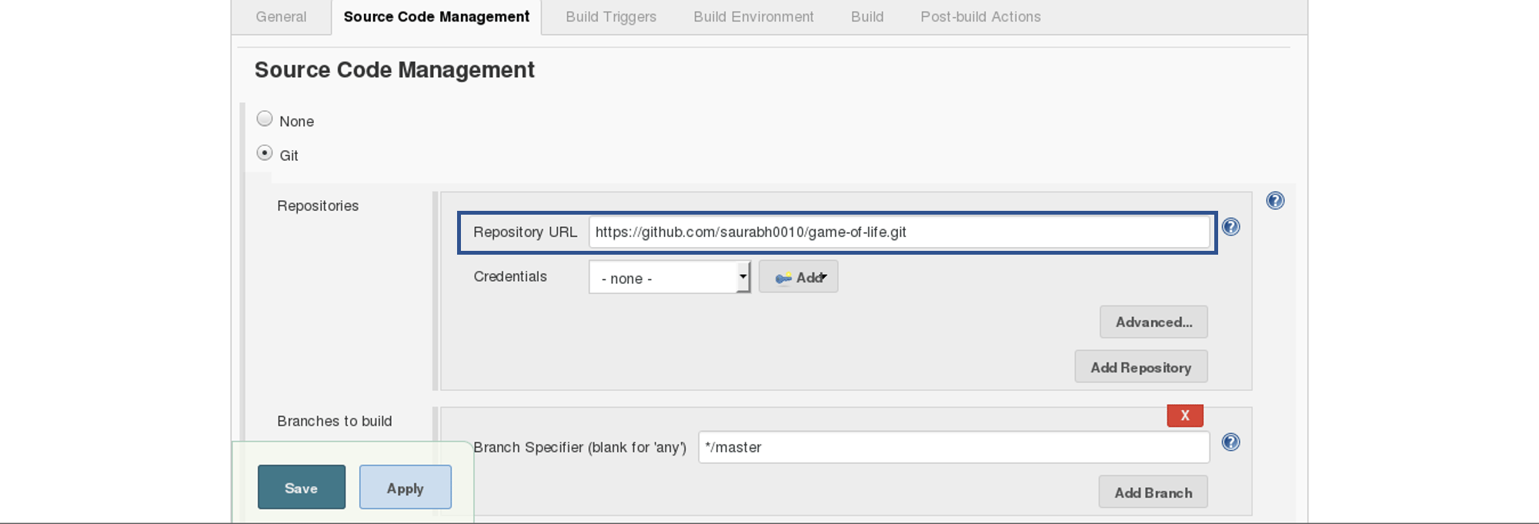
Now we will add a Build Trigger. Pick the poll SCM option, basically, we will configure Jenkins to poll the GitHub repository after every 5 minutes for changes in the code. Consider the below screenshot:
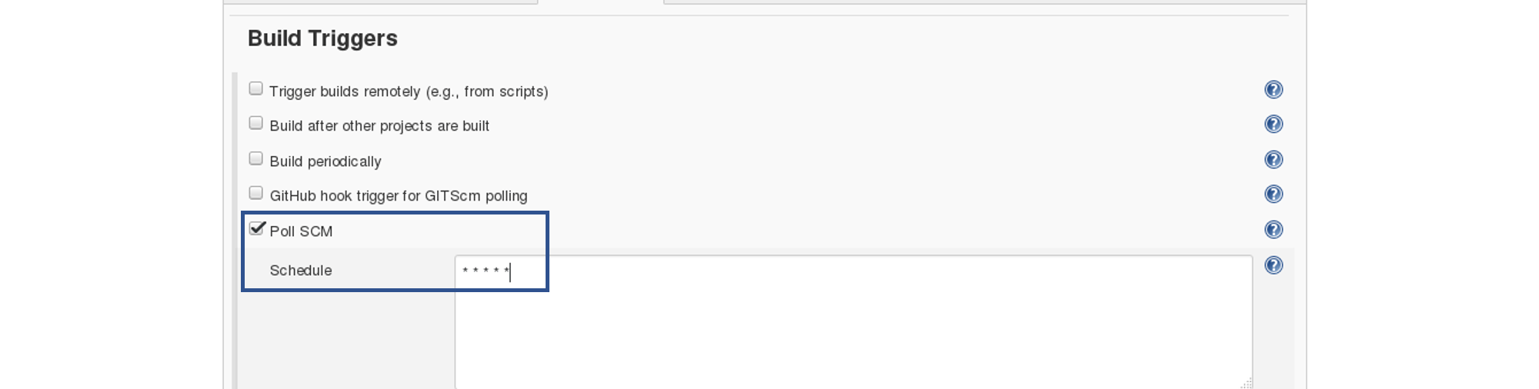
Before I proceed, let me give you a small introduction to the Maven Build Cycle.
Each of the build lifecycles is defined by a different list of build phases, wherein a build phase represents a stage in the lifecycle.
Following is the list of build phases:
- validate – validate the project is correct and all necessary information is available
- compile – compile the source code of the project
- test – test the compiled source code using a suitable unit testing framework. These tests should not require the code be packaged or deployed
- package – take the compiled code and package it in its distributable format, such as a JAR.
- verify – run any checks on results of integration tests to ensure quality criteria are met
- install – install the package into the local repository, for use as a dependency in other projects locally
- deploy – done in the build environment, copies the final package to the remote repository for sharing with other developers and projects.
I can run the below command, for compiling the source code, unit testing and even packaging the application in a war file:
mvn clean package
You can also break down your build job into a number of build steps. This makes it easier to organize builds in clean, separate stages.
So we will begin by compiling the source code. In the build tab, click on invoke top level maven targets and type the below command:
compile
Consider the below screenshot:
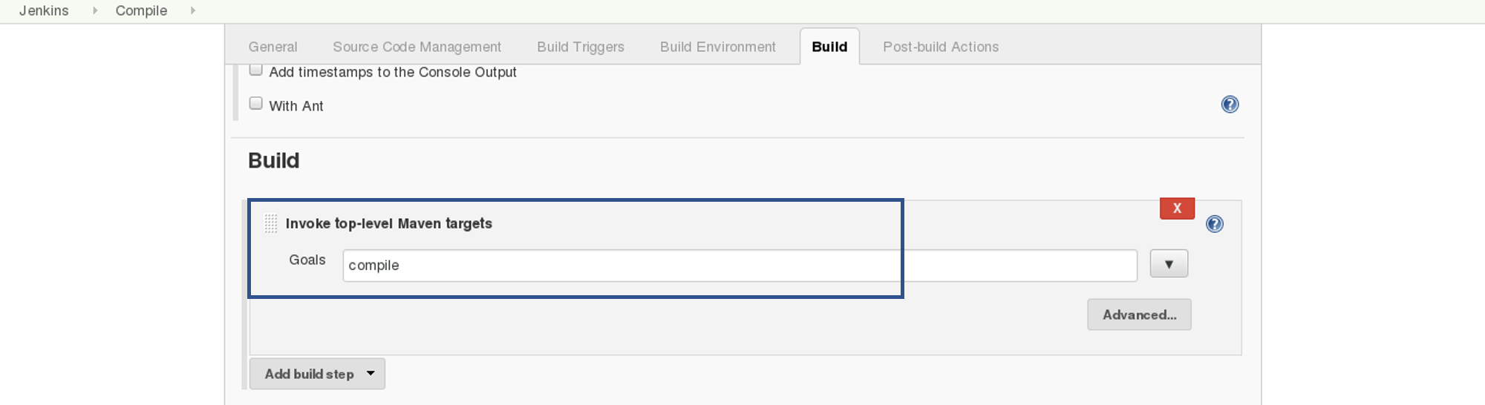
This will pull the source code from the GitHub repository and will also compile it (Maven Compile Phase).
Click on Save and run the project.
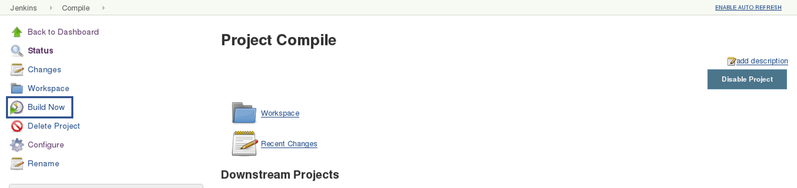
Now, click on the console output to see the result.
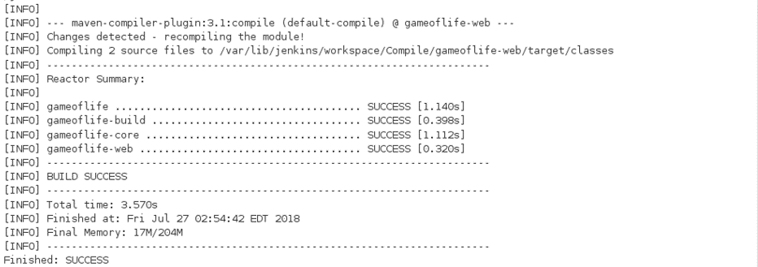

Step – 2 Unit Testing:
Now we will create one more Freestyle Project for unit testing.
Add the same repository URL in the source code management tab, like we did in the previous job.
Now, in the “Buid Trigger” tab click on the “build after other projects are built”. There type the name of the previous project where we are compiling the source code, and you can select any of the below options:
- Trigger only if the build is stable
- Trigger even if the build is unstable
- Trigger even if the build fails
I think the above options are pretty self-explanatory so, select any one. Consider the below screenshot:
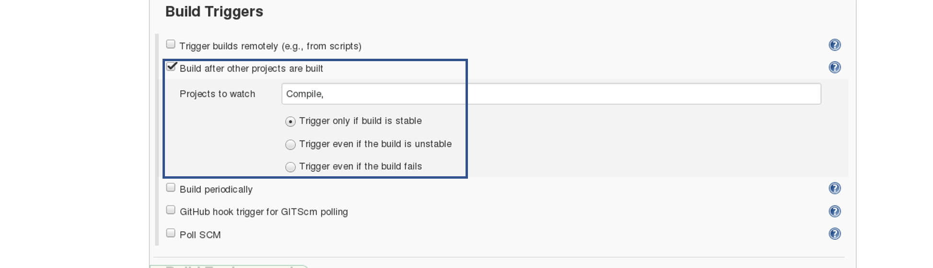In the Build tab, click on invoke top level maven targets and use the below command:
test
Jenkins also does a great job of helping you display your test results and test result trends.
The de facto standard for test reporting in the Java world is an XML format used by JUnit. This format is also used by many other Java testing tools, such as TestNG, Spock, and Easyb. Jenkins understands this format, so if your build produces JUnit XML test results, Jenkins can generate nice graphical test reports and statistics on test results over time, and also let you view the details of any test failures. Jenkins also keeps track of how long your tests take to run, both globally, and per test—this can come in handy if you need to track down performance issues.
So the next thing we need to do is to get Jenkins to keep tabs on our unit tests.
Go to the Post-build Actions section and tick “Publish JUnit test result report” checkbox. When Maven runs unit tests in a project, it automatically generates the XML test reports in a directory called surefire-reports. So enter “**/target/surefire-reports/*.xml” in the “Test report XMLs” field. The two asterisks at the start of the path (“**”) are a best practice to make the configuration a bit more robust: they allow Jenkins to find the target directory no matter how we have configured Jenkins to check out the source code.
**/target/surefire-reports/*.xml
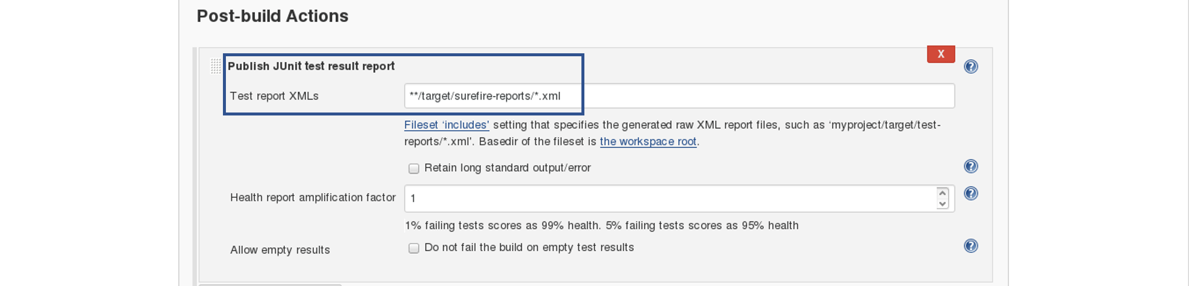
Again save it and click on Build Now.
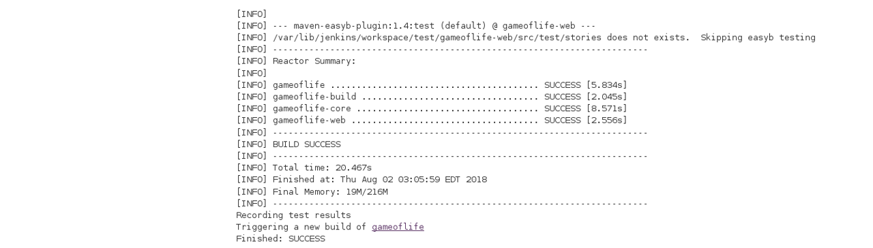
Now, the JUnit report is written to /var/lib/jenkins/workspace/test/gameoflife-core/target/surefire-reports/TEST-behavior.
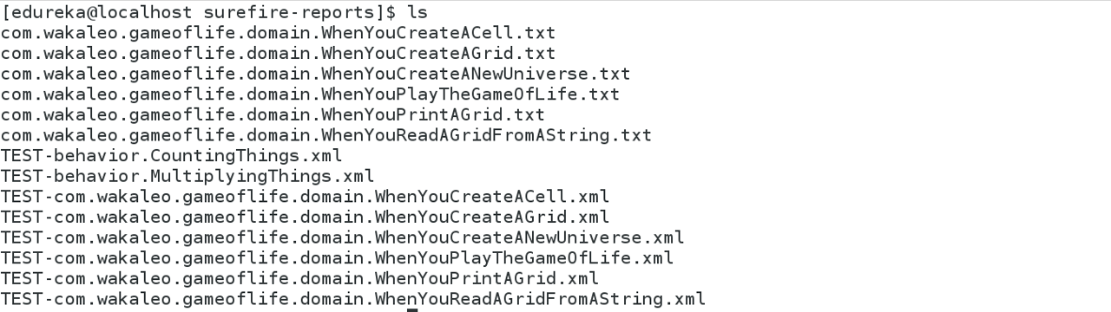
In the Jenkins dashboard you can also notice the test results:
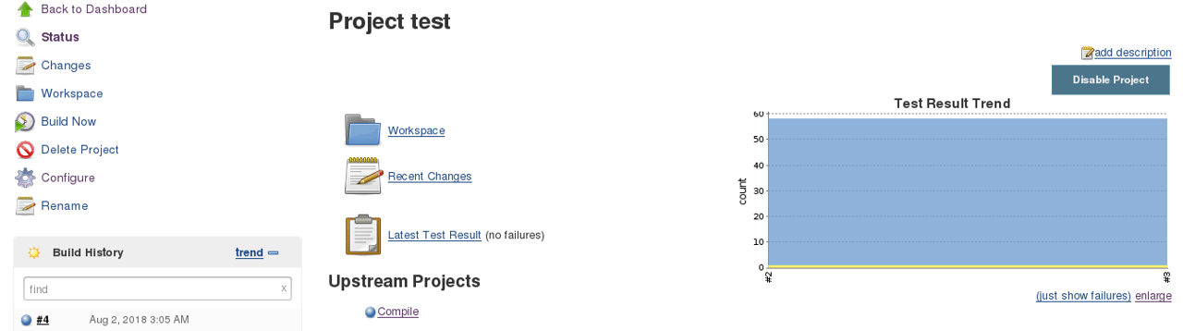
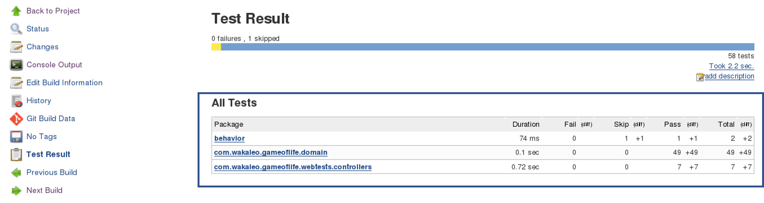

Step – 3 Creating A WAR File And Deploying On The Tomcat Server:
Now, the next step is to package our application in a WAR file and deploy that on the Tomcat server for User Acceptance test.
Create one more freestyle project and add the source code repository URL.
Then in the build trigger tab, select build when other projects are built, consider the below screenshot:

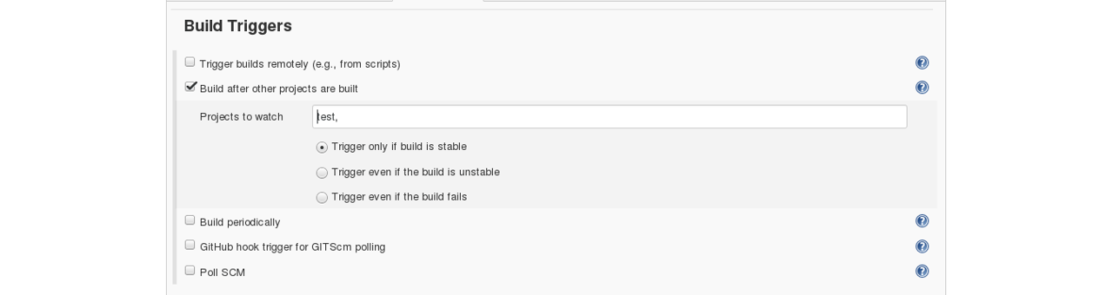
Basically, after the test job, the deployment phase will start automatically.
In the build tab, select shell script. Type the below command to package the application in a WAR file:
mvn package
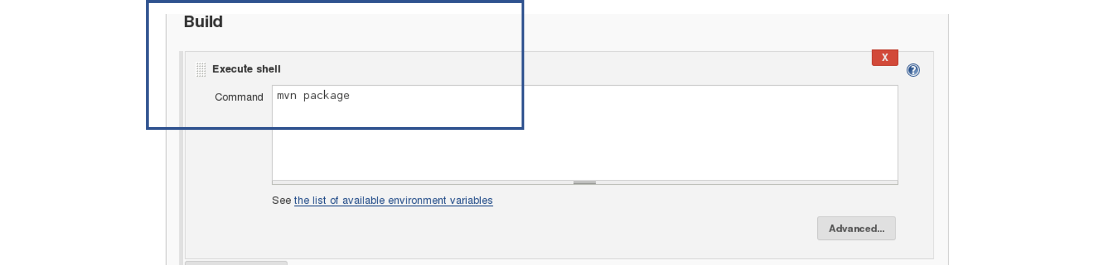
Next step is to deploy this WAR file to the Tomcat server. In the “Post-Build Actions” tab select deploy war/ear to a container. Here, give the path to the war file and give the context path. Consider the below screenshot:
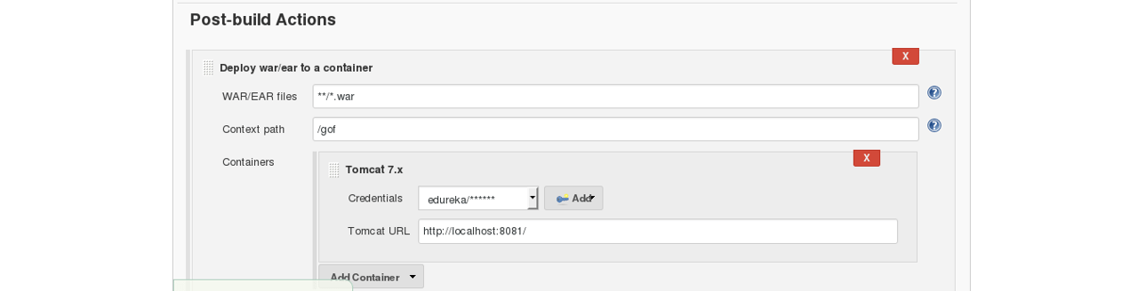
Select the Tomcat credentials and, notice the above screenshot. Also, you need to give the URL of your Tomcat server.
In order to add credentials in Jenkins, click on credentials option on the Jenkins dashboard.

Click on System and select global credentials.
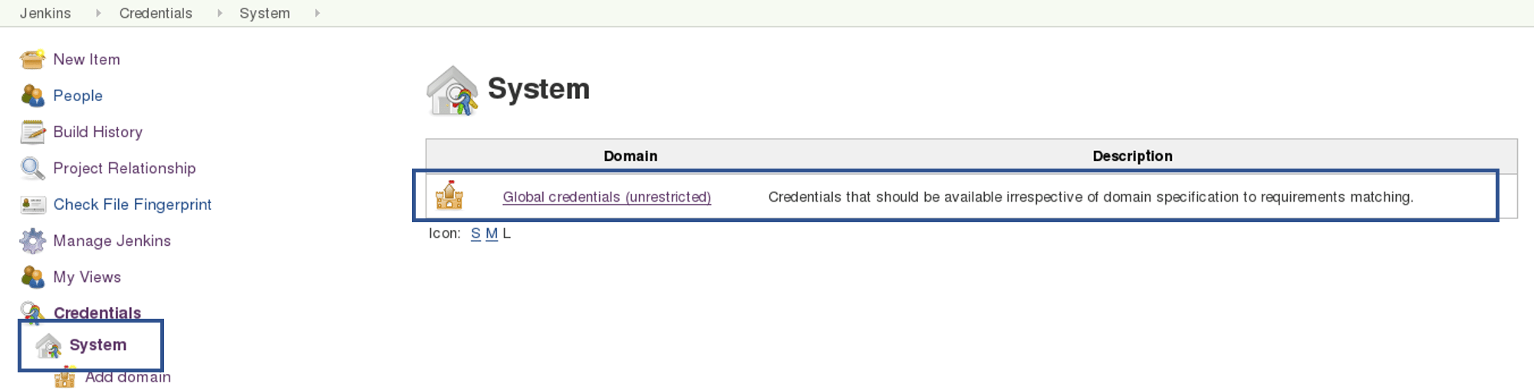
Then you will find an option to add the credentials. Click on it and add credentials.
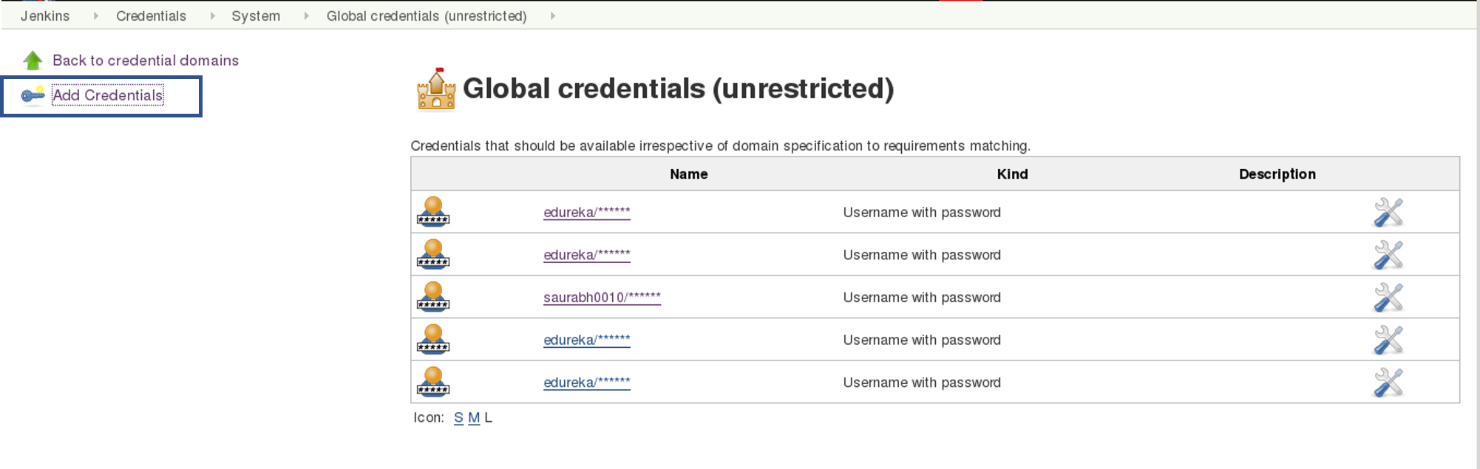
Add the Tomcat credentials, consider the below screenshot.
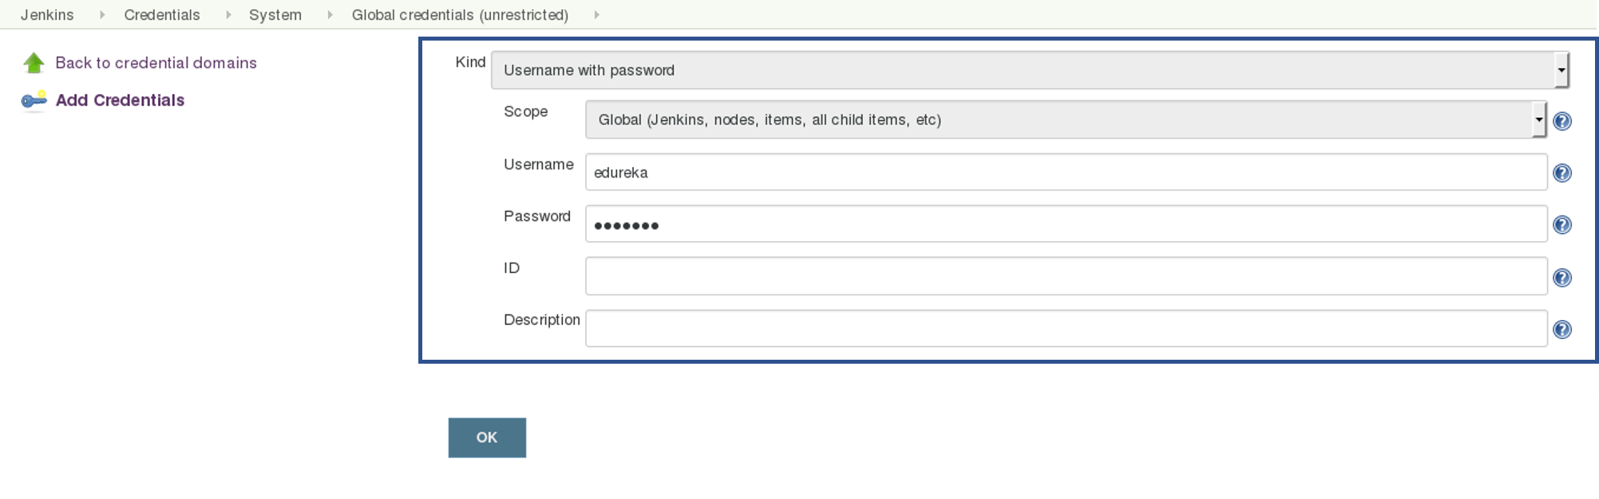
Click on OK.
Now in your Project Configuration, add the tomcat credentials which you have inserted in the previous step.
Click on Save and then select Build Now.
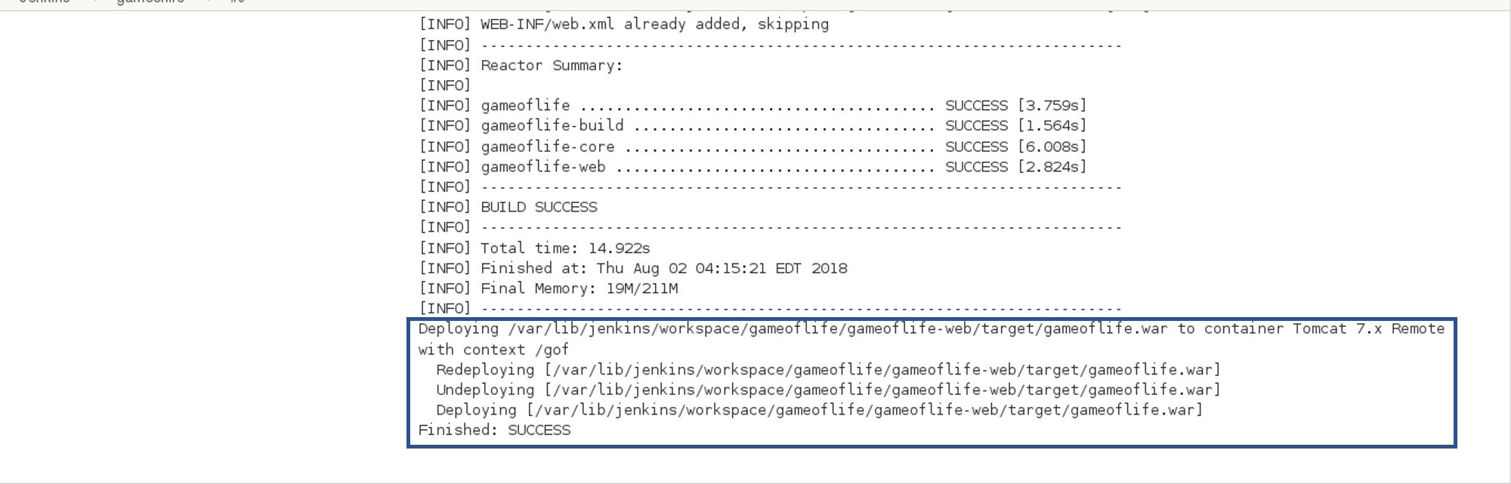
Go to your tomcat URL, with the context path, in my case it is http://localhost:8081. Now add the context path in the end, consider the below Screenshot:

Link - http://localhost:8081/gof
I hope you have understood the meaning of the context path.
Now create a pipeline view, consider the below screenshot:
Click on the plus icon, to create a new view.
Configure the pipeline the way you want, consider the below screenshot:
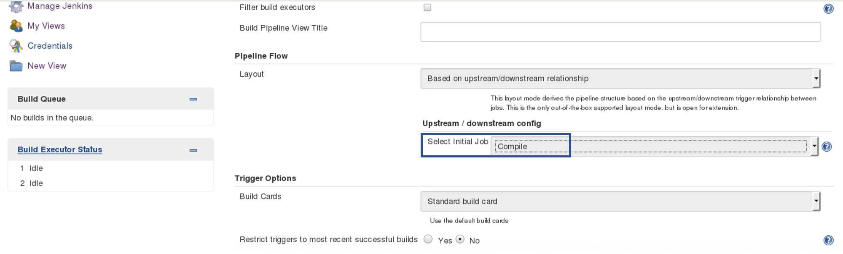
I did not change anything apart from selecting the initial job. So my pipeline will start from compile. Based on the way I have configured other jobs, after compile testing and deployment will happen.
Finally, you can test the pipeline by clicking on RUN. After every five minutes, if there is a change in the source code, the entire pipeline will be executed.
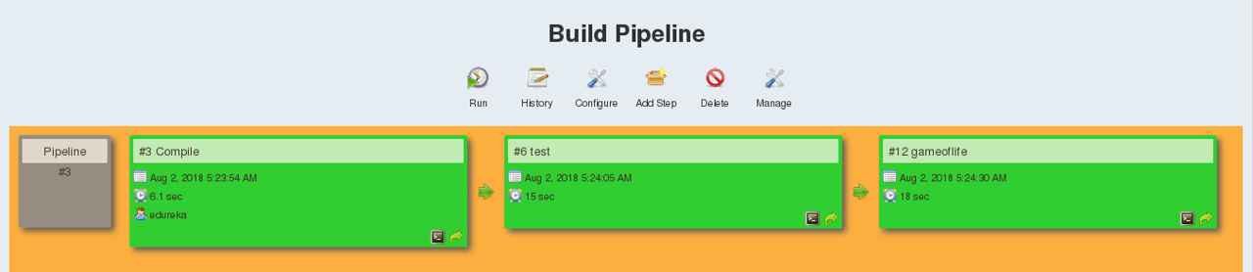
So we are able to continuously deploy our application on the test server for user acceptance test (UAT).

- Execute the playbook on all the hosts

Step 1: Connect to your hosts using SSH. For that, you need to generate a public SSH key.
Use the command below:
ssh-keygen
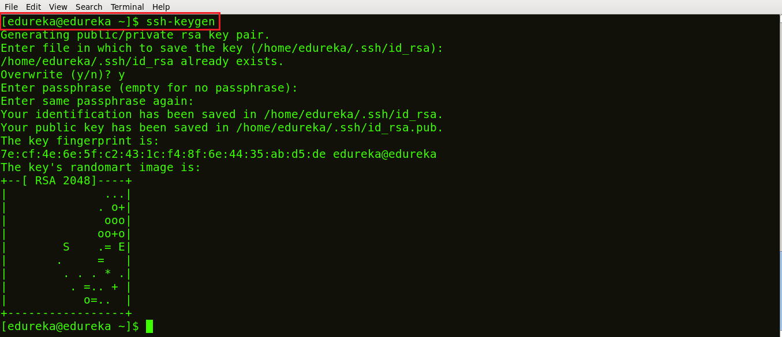
As you can see in the snapshot above, the command ssh-keygen generated a public SSH key.
Step 2: Your next task is to copy the public SSH key on your hosts. In order to do that, use the command below:
ssh-copy-id -i root@<IP address of your host>
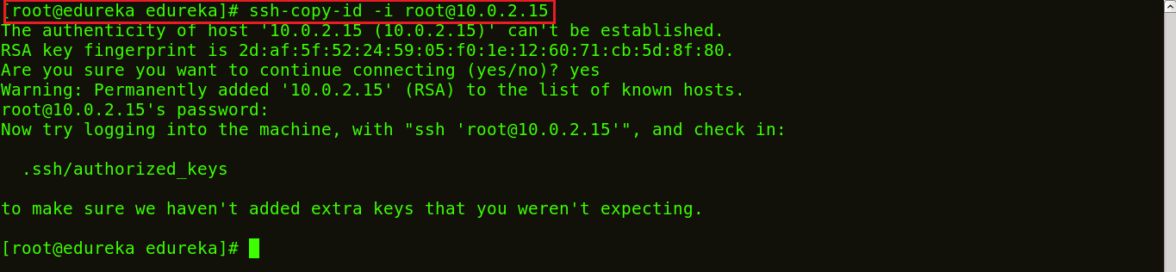
The snapshot above shows the SSH key being copied to the hosts.
Step 3: List the IP addresses of your hosts/nodes in your inventory.
Use the following command:
vi /etc/ansible/hosts
This will open a vi editor where you can list down the IP addresses of your hosts. This is now your inventory.
Step 4: Let’s ping to ensure a connection has been established.
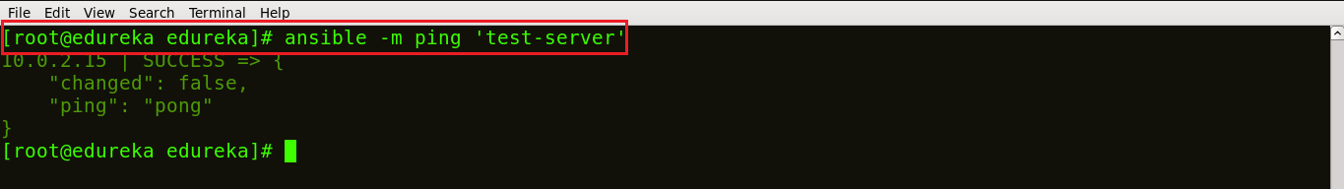
The snapshot above confirms that connection has been made between your control machine and host.
Step 5: Let us now write a playbook to install Nginx on the host machine. You can write your playbook in the vi editor. For that, simply create your playbook, using the command:
vi <name of your file>.yml
The below snapshot shows my playbook to install Nginx written in YAML format.
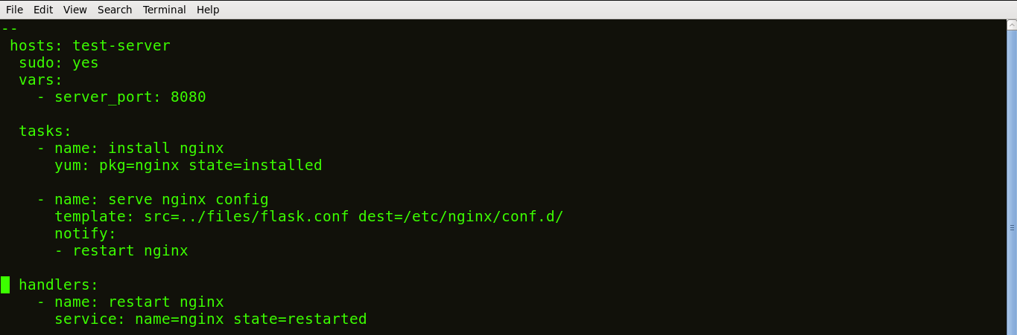
The tasks of a playbook are defined in YAML as a list of dictionaries and executed from top to bottom. If we have several hosts, then each task is tried for each host before moving on to the next one. Each task is defined as a dictionary that can have several keys, such as “name” or “sudo” which signify the name of the task and whether it requires sudo privileges.
A variable server_port is set that listens on TCP port 8080 for incoming requests.
Here, the first task is to get the necessary package for installation of Nginx and then install it. Internally, Ansible will check if the directory exists and create it if it’s not, otherwise it will do nothing.
The next task is to configure Nginx. In Nginx, contexts contain configuration details.
Here, the template is a file you can deploy on hosts. However, template files also include some reference variables which are pulled from variables defined as part of an Ansible playbook or facts gathered from the hosts. Facts containing the configuration details are being pulled from a source directory and being copied to a destination directory.
Handlers here define the action to be performed only upon notification of tasks or state changes. In this playbook, we defined, notify: restart Nginx handler which will restart Nginx once the files and templates are copied to hosts.
Now, save the file and exit.
Step 6: Now let’s run this playbook, using the command below:
ansible-playbook <name of your file>.yml
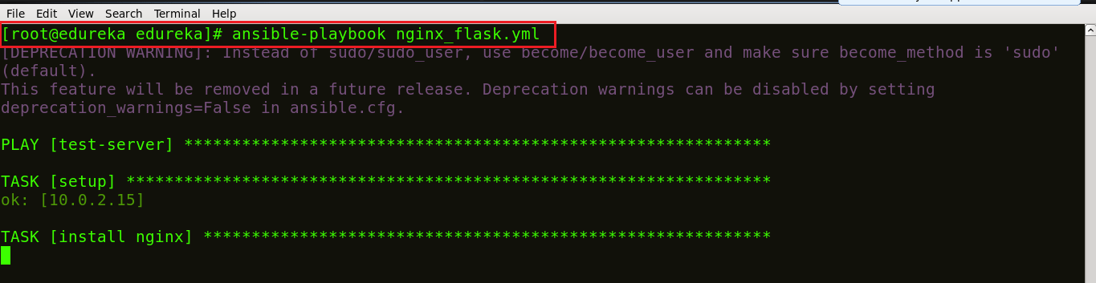
We can see in the screenshot above that our task is getting executed; Nginx being installed.
Step 7: Let’s check if Nginx is installed on my host machine. Use the command below:
ps waux | grep nginx

You can see in the screenshot above, that different process ids 3555 and 103316 are running which ensures that Nginx is running on your host machines.

