Case Study: Build a war file
Situation:
I’m working in a company named Sandres & Fresco Pvt ltd., have been asked to create a Maven Project using Jenkins and to build a war file of that project. Also to deploy it over tomcat server.
Challenges:
Creating a Maven project using Jenkins
Actions:
- Open Jenkins and create a Maven project using it.

Results:
- Open Jenkins and create a Maven project using it
Application Deployment has always been on of the most tedious tasks in project development life cycle. This involves steps like checking out the code from the Code Repository, building it using Maven/Ant and then deploying it to the remote servers. The process is more time/effort taking in case we have multiple servers like Staging, UAT,production.
Jenkins is an open source tool that helps us to automate and centralize the process of deployment.
To deploy WAR to Apache Tomcat using SVN as code repository and Maven as build WAR tool we have to follow the perform the below steps:-
Step 1 : Configure Jenkins
Jenkins comes bundled as WAR file so you need to deploy it to an Application Server. I used Apache Tomcat version 7.0.32. Below are the steps.
1.1. Start the tomcat
1.2. Deploy the jenkins.war Download location for jenkins.war
Note : Some server restrict the size of war file to be uploaded and you get the common error while deploying it from the Tomcat UI Manager. Below is how i resolved it.
a. Open the file $CATELINA_HOME\webapps\manager\WEB-INF web.xml
b. Look out for the below entry, Size 61316110 worked just fine for me
<multipart-config>
<!– 50MB max –>
<max-file-size>61316110</max-file-size>
<max-request-size>61316110</max-request-size>
<file-size-threshold>0</file-size-threshold>
</multipart-config>
c. Restart Tomcat
1.3. Go to the URL http://locahost:8080/jenkins ( Replace local host with the IP of your server )
1.4. Add Deploy to container Plugin this can be done using the Plugin Manager feature of Jenkins. This plugin will be used for deployment of the war that we will build using Jenkins.
1.5. Provide Maven Location to Jenkins – Jenkins interacts with Maven to build code that requires maven. Follow the below steps.
a. Download Maven Link for download
b. Place it on the server and copy its path
c Go to URL http://localhost:8080/jenkins/configure ( Replace localhost with the IP of your server )
d. Provide name ( Any random name ) and location of your maven.
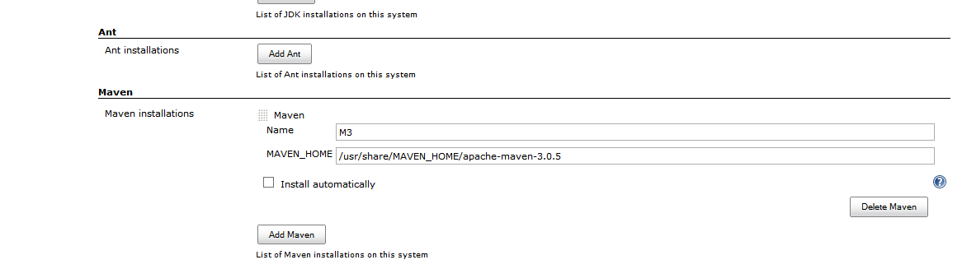
Step 2 : Configure Tomcat for build deployment
We need to configure the server where we will be deploying our build ( This server can be same or different then the one where Jenkins is running ). This involves creating a user on tomcat and assigning him with manager-script role.
Just add the below lines under the node <tomcat-users></tomcat-users> to tomcat-users.xml file and restart the server. This file is located in the conf folder of tomcat.
<role rolename=”manager”/>
<role rolename=”admin”/>
<user username=”harpreet” password=”harpreet” roles=”standard,manager,admin,manager-gui,manager-script” />
Step 3 – Create a Job on Jenkins
3.1 Click On “New Job”
3.2 Enter the name for the Job
3.3 Select Build a maven2/3 project
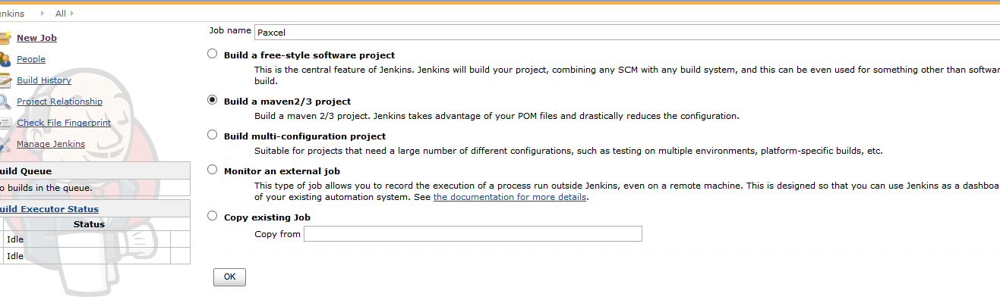
3.4 Look out for section Source Code Management, select Subversion and provide the SVN url of project you will be prompted for your SVN credentials.
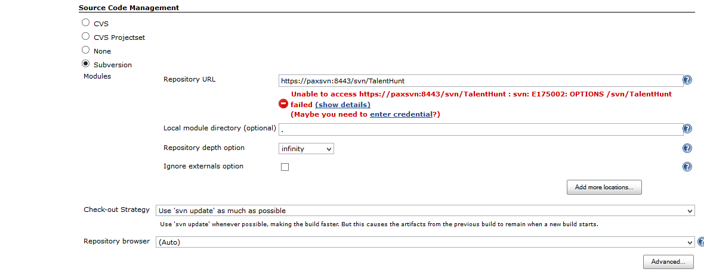3.5 Look out for Build section Provide Maven build parameters e g . clean package.
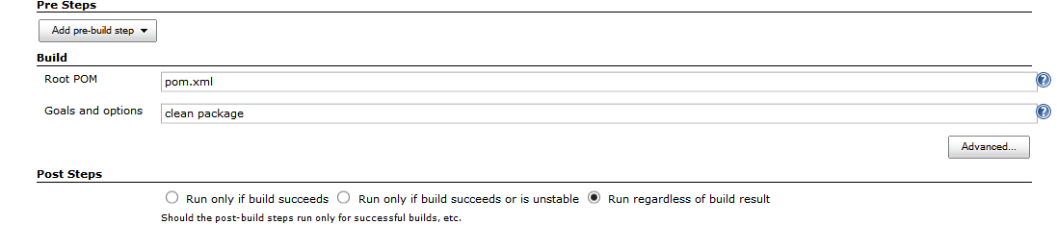
3.6 : Add a post build action that will deployed the war file to remote tomcat server. Follow the below steps
a . Click on button “Add post build action”
b. Select the option ” Deploy war/ear to a container”
C . Enter war file name and path
Important : For every job Jenkins create a folder named as workspace in the jobs folder, this path needs to relative to workspace. Upon successful build war is copied in this folder, and deploy plugin picks it from here. If the war is not in this folder, or you failed to provide the correct path.War will not be deployed to the server.
d Enter the server detail and credential of the user that we created on the tomcat in above steps
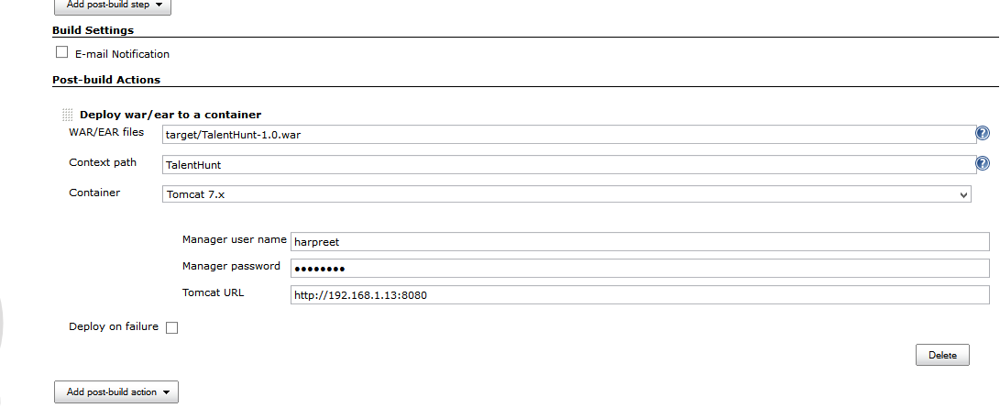
3.7 : Save the job and hit “Build Now”, Check the logs by clicking the ball icons on the left side of the screen.
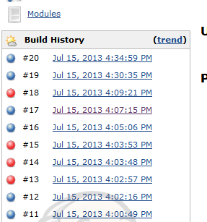
There will be log traces like you have for Maven, when you build it using eclipse or command line args.
And few jenkins log signifying the deployment like below :
Deploying /home/gagan/.jenkins/jobs/TalentHuntV2/workspace/target/TalentHunt-1.0.war to container Tomcat 7.x Remote
3.8 : Verifying you did it correct.In case you did everything right, you can test the deployment of your project on the servers.

